Project : Data cleaning
Name : Prerit Email: masihprerit@gmail.com
Batch: DA Batch-6 Phone: 8470802929

🔹 STEP 0: Inspect Raw Data

SELECT *
FROM customer_orders
LIMIT 10;

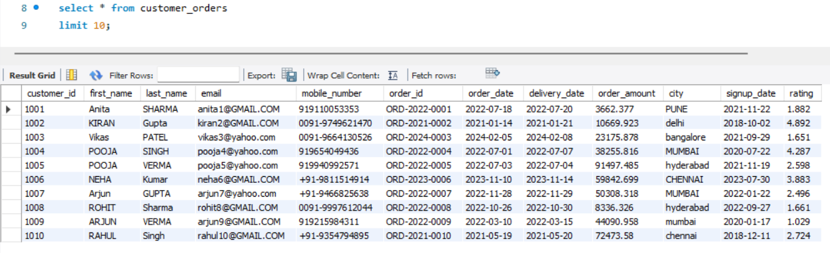

🔹 STEP 1: Clean first_name (Spaces + Case)
SELECT
first_name,
TRIM(first_name) AS step1_trimmed,
UPPER(TRIM(first_name)) AS cleaned_first_name
FROM customer_orders;

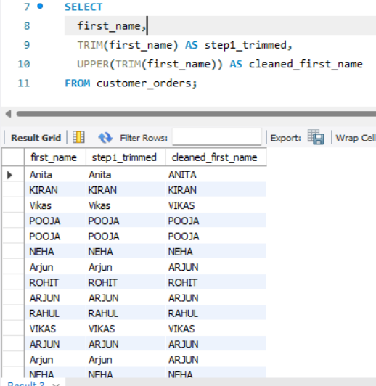

🔹 STEP 2: Clean last_name

SELECT
last_name,
UPPER(TRIM(last_name)) AS cleaned_last_name
FROM customer_orders;

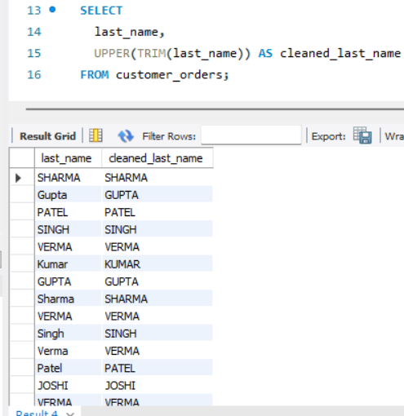

🔹 STEP 3: Create full_name (CONCAT)

SELECT
CONCAT(
UPPER(TRIM(first_name)),
' ',
UPPER(TRIM(last_name))
) AS full_name
FROM customer_orders;

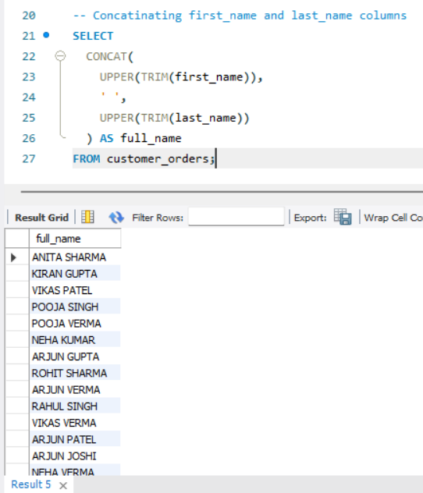

🔹 STEP 4: Clean email (Standardization)
SELECT
email,
LOWER(email) AS cleaned_email
FROM customer_orders;

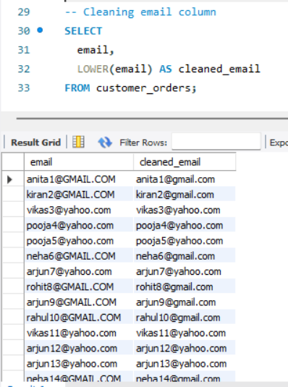

🔹 STEP 5: Clean mobile_number (Extract last 10 digits)

SELECT
mobile_number,
SUBSTR(mobile_number, LENGTH(mobile_number) - 9, 10) AS cleaned_mobile
FROM customer_orders;

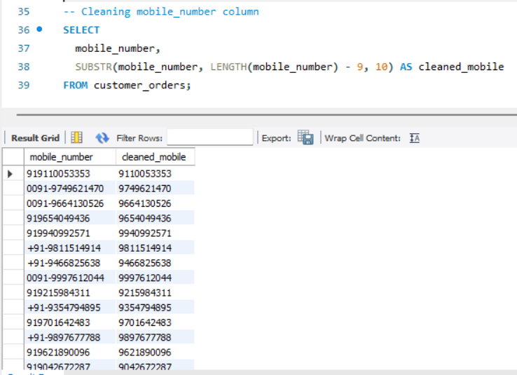

🔹 STEP 6: Extract Year from order_id
SELECT
order_id,
SUBSTR(order_id, 5, 4) AS order_year
FROM customer_orders;

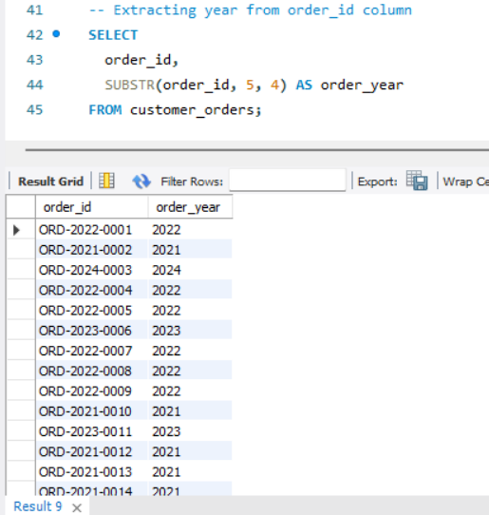

🔹 STEP 7: Round order_amount
SELECT
order_amount,
ROUND(order_amount, 2) AS cleaned_order_amount
FROM customer_orders;

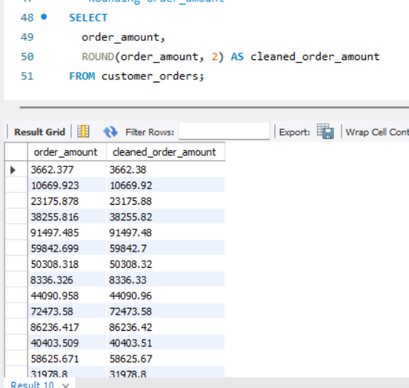

🔹 STEP 8: Round rating
SELECT
rating,
ROUND(rating, 1) AS cleaned_rating
FROM customer_orders;

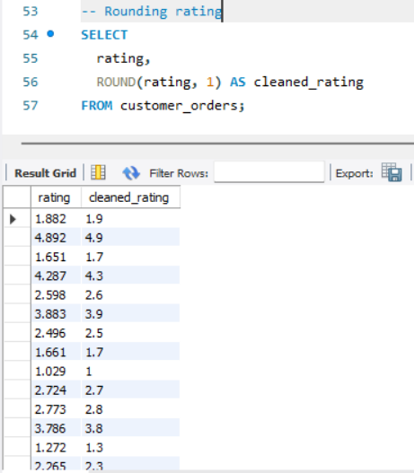

🔹 STEP 9: Standardize city
SELECT
city,
UPPER(city) AS cleaned_city
FROM customer_orders;

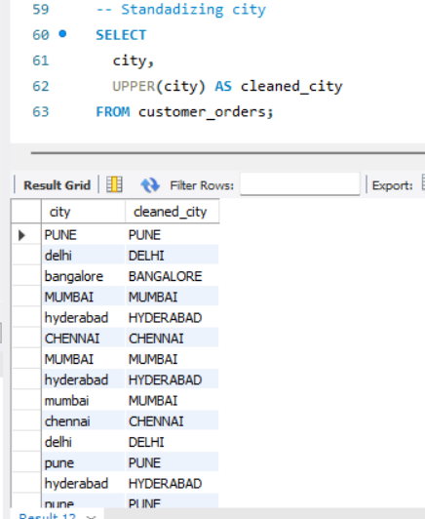

🔹 STEP 10: Delivery Time Calculation (DATEDIFF)
SELECT
order_date,
delivery_date,
DATEDIFF(delivery_date, order_date) AS delivery_days
FROM customer_orders;

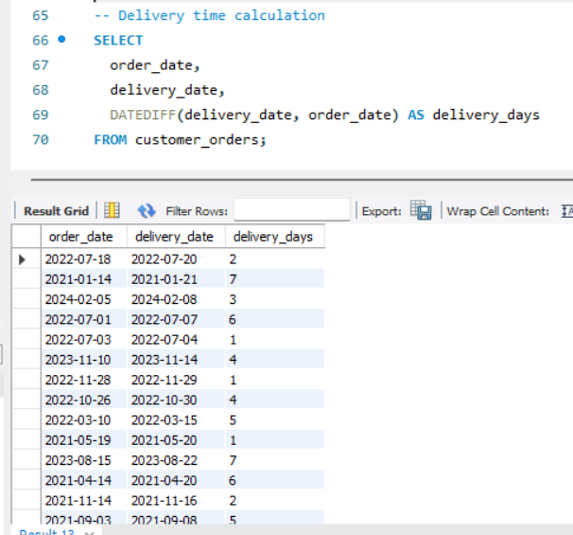

🔹 STEP 11: Customer Tenure Calculation
SELECT
signup_date,
DATEDIFF(NOW(), signup_date) AS days_with_company
FROM customer_orders;

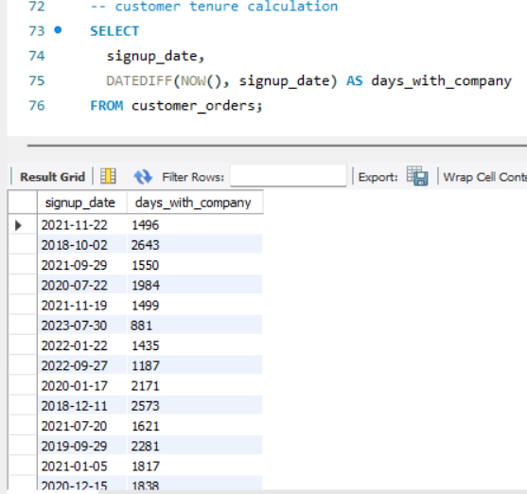

🔹 STEP 12: CASE WHEN – Order Value Category
SELECT
order_amount,
CASE
WHEN order_amount >= 50000 THEN 'High Value'
WHEN order_amount >= 20000 THEN 'Medium Value'
ELSE 'Low Value'
END AS order_category
FROM customer_orders;

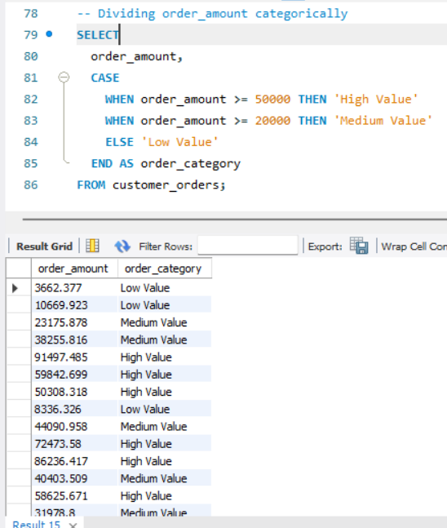

🔹 STEP 13: CASE WHEN – Customer Type

SELECT
signup_date,
CASE
WHEN DATEDIFF(NOW(), signup_date) <= 30 THEN 'New'
WHEN DATEDIFF(NOW(), signup_date) <= 180 THEN 'Regular'
ELSE 'Loyal'
END AS customer_type
FROM customer_orders;

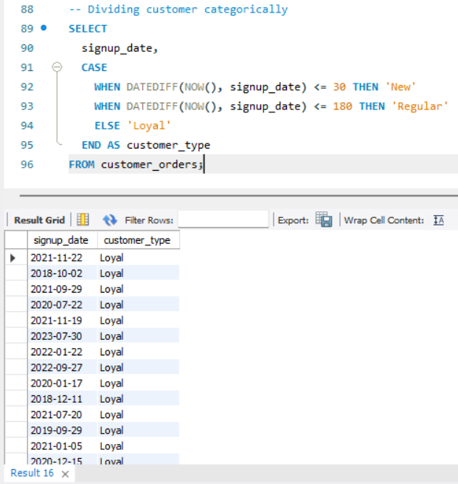

🔹 STEP 14: FINAL CLEANED VIEW (Industry Practice)

CREATE VIEW customer_orders_cleaned AS
SELECT
customer_id,
UPPER(TRIM(first_name)) AS first_name,
UPPER(TRIM(last_name)) AS last_name,
CONCAT(
UPPER(TRIM(first_name)), ' ',
UPPER(TRIM(last_name))
) AS full_name,
LOWER(email) AS email,
SUBSTR(mobile_number, LENGTH(mobile_number) - 9, 10) AS mobile_number,
order_id,
SUBSTR(order_id, 5, 4) AS order_year,
order_date,
delivery_date,
DATEDIFF(delivery_date, order_date) AS delivery_days,
ROUND(order_amount, 2) AS order_amount,
UPPER(city) AS city,
signup_date,
DATEDIFF(NOW(), signup_date) AS customer_tenure_days,
CASE
WHEN order_amount >= 50000 THEN 'High Value'
WHEN order_amount >= 20000 THEN 'Medium Value'
ELSE 'Low Value'
END AS order_category,
ROUND(rating, 1) AS rating
FROM customer_orders;

🔹 STEP 15: Validate Cleaned Data
SELECT *
FROM customer_orders_cleaned
LIMIT 10;

