myEKSCluster created manually:

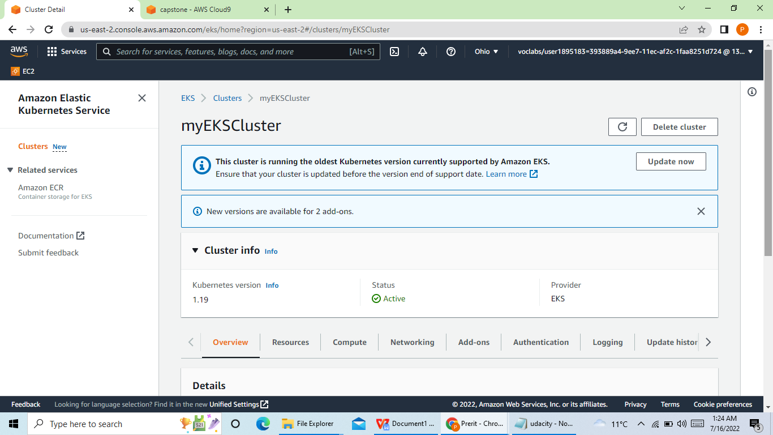

Node group and Nodes created manually

E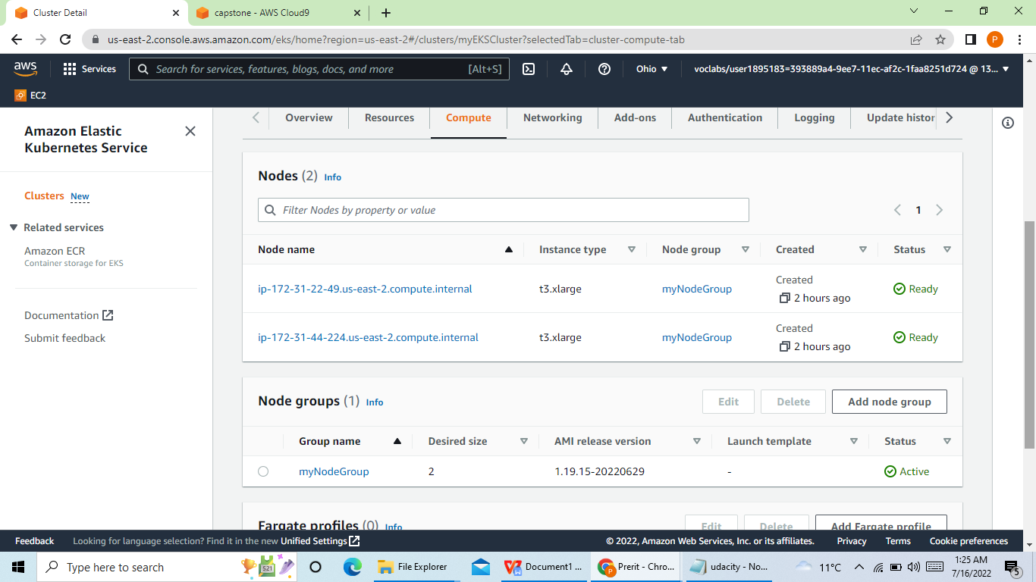

EC2 instances created manually:

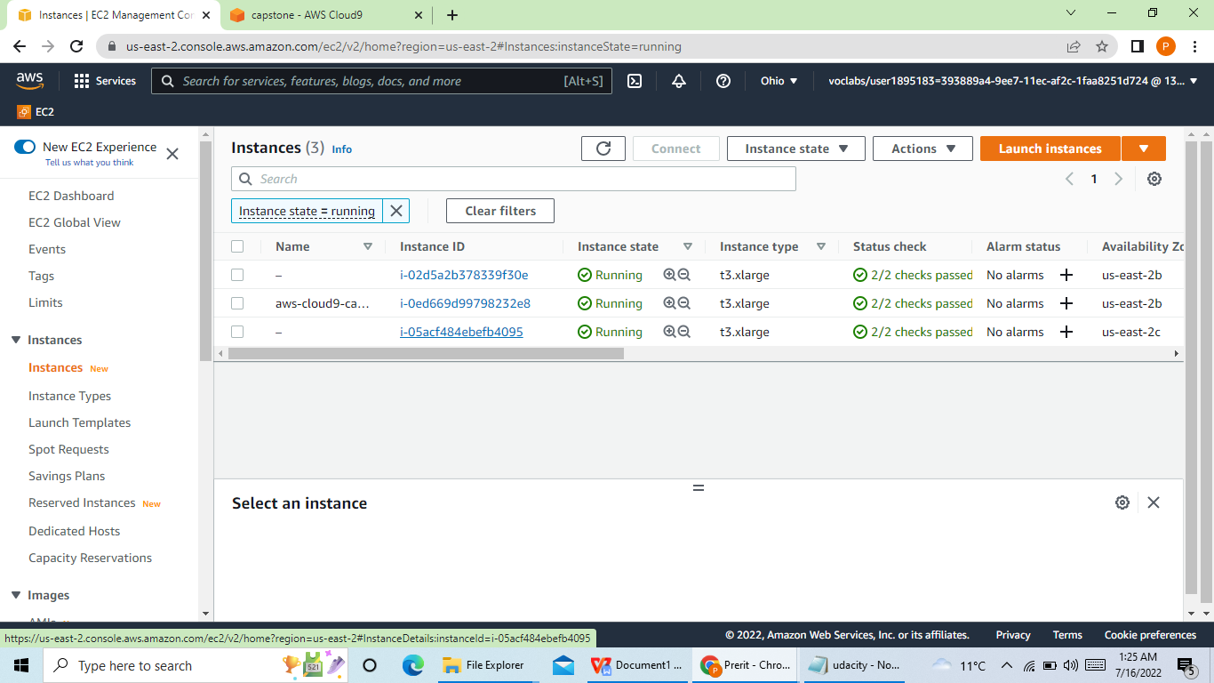

Stack Created manually:

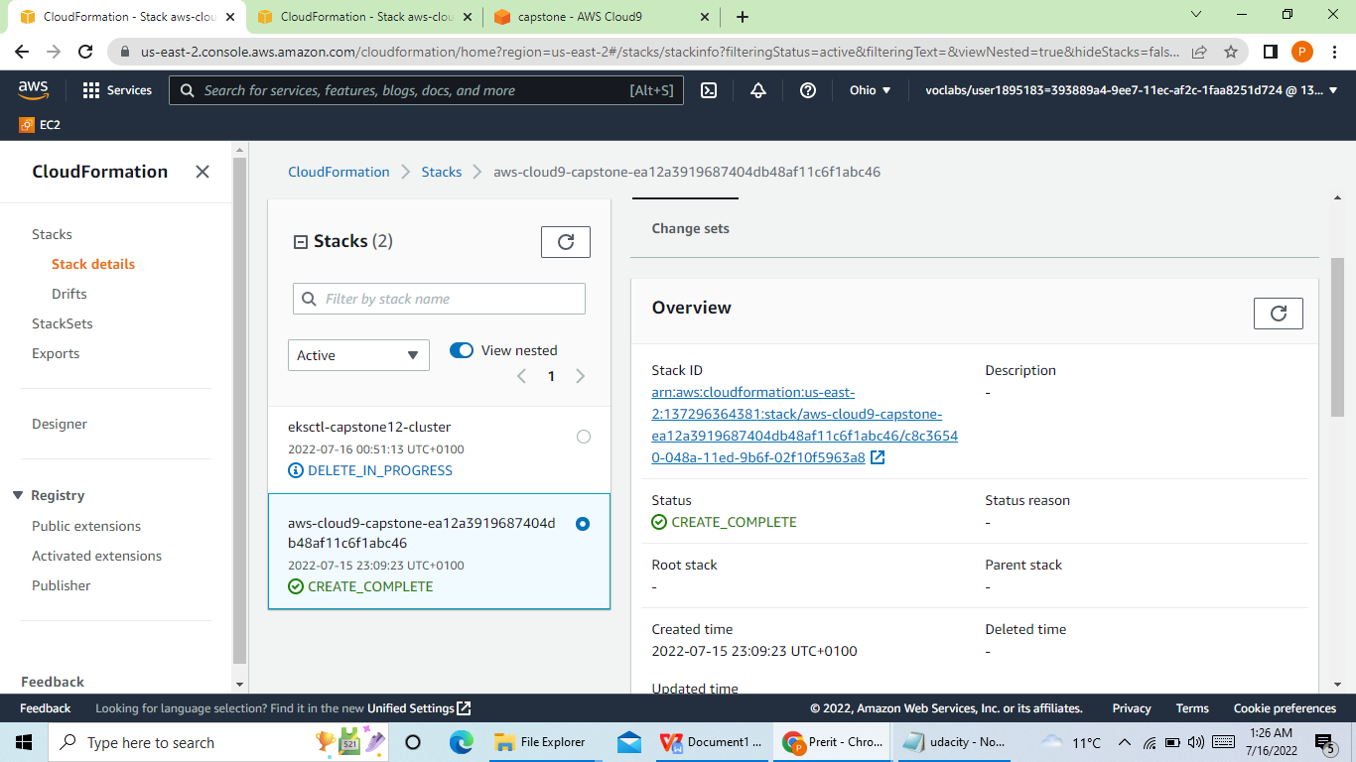

Now Screenshots will show the EKS, Stack, EC2, Nodes which were created by Cloud Formation

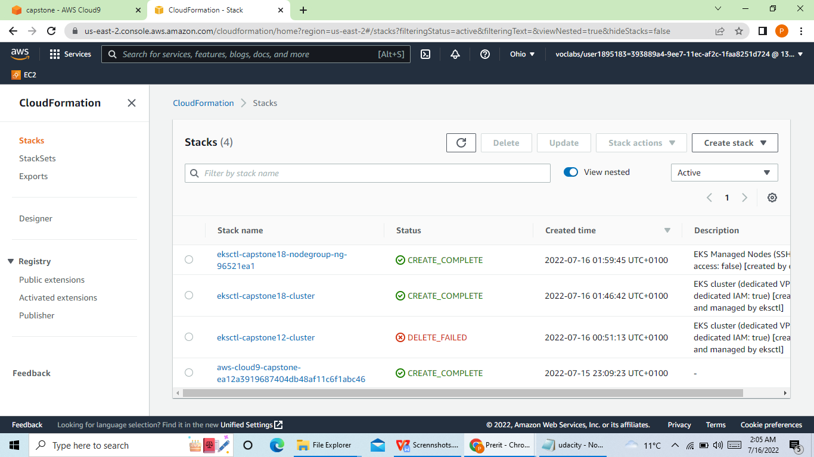

Capstone18 EKS created:

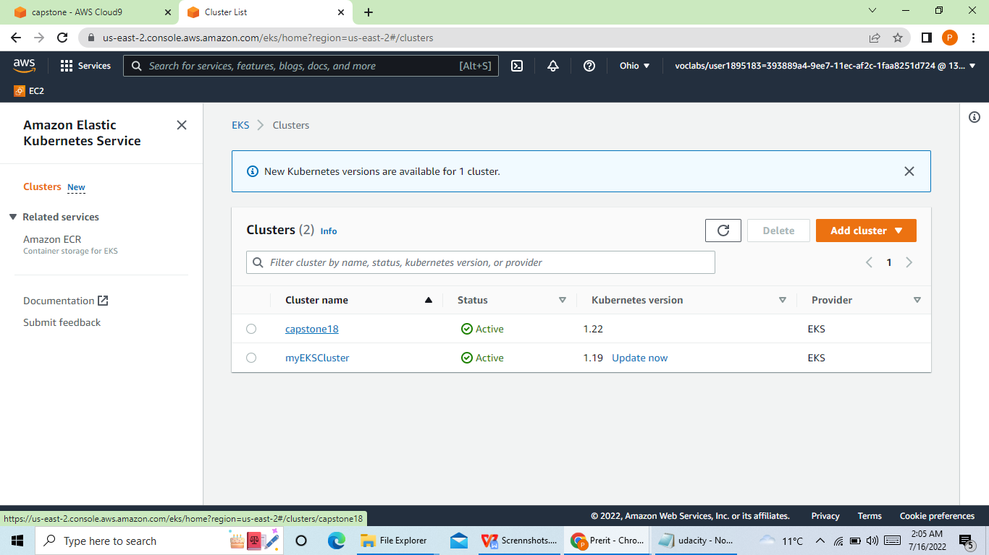

Node created:

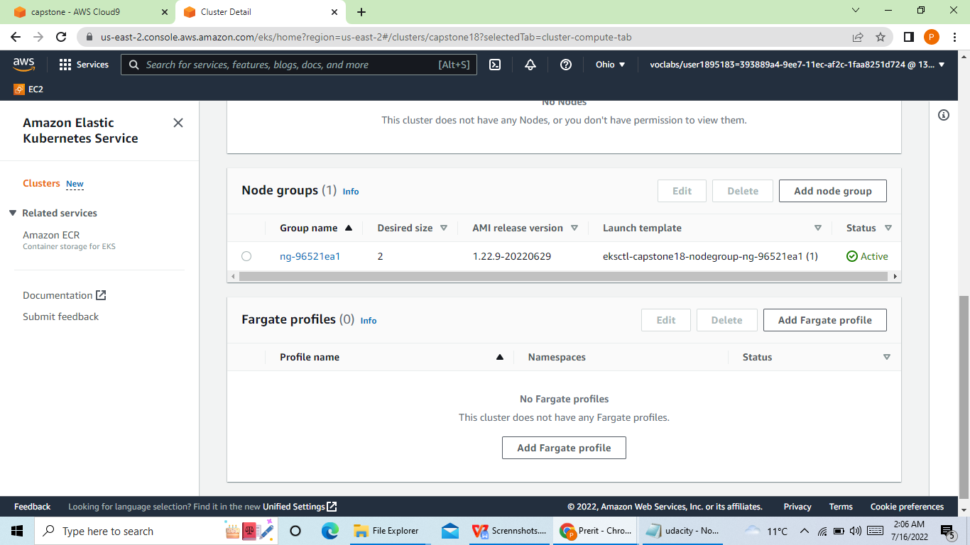

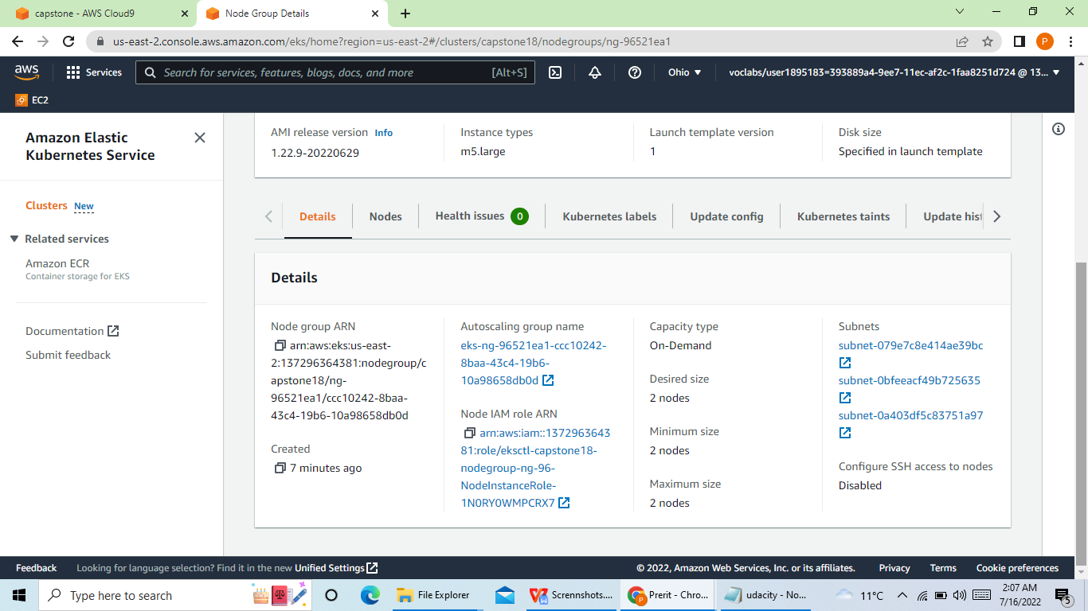

Capstone 18 - EC2 instances also created:

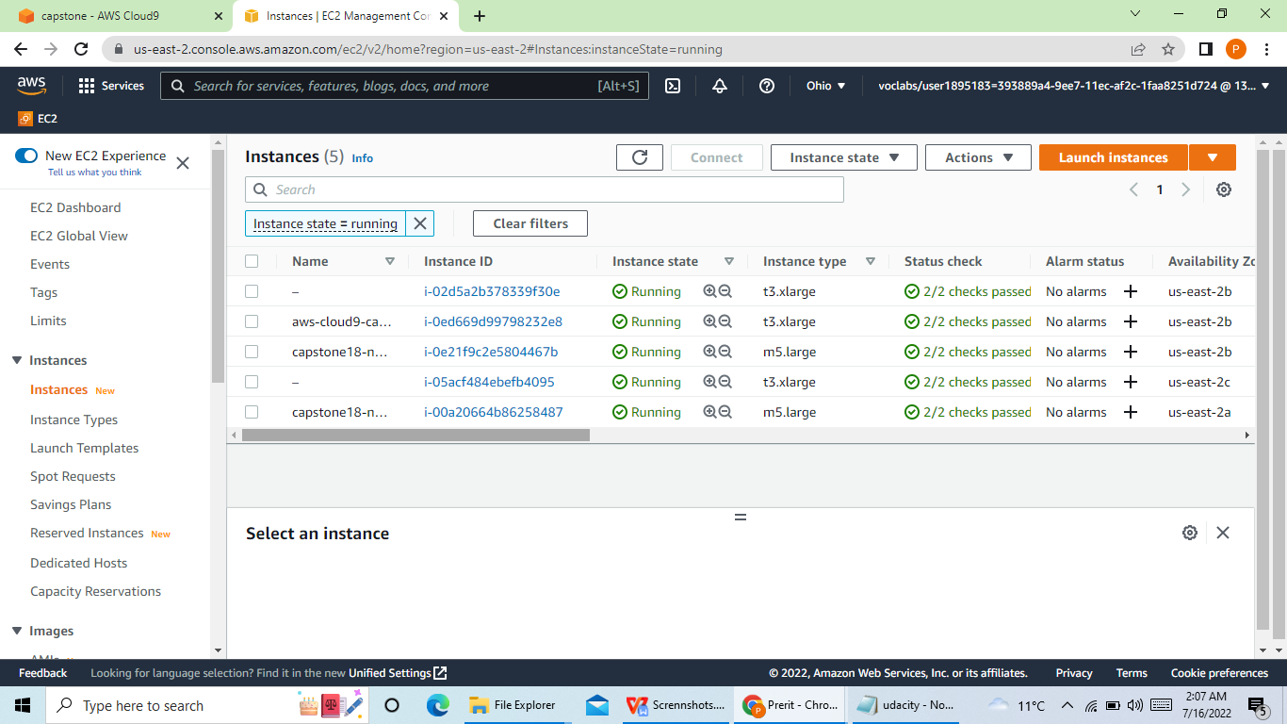

CircleCI Screenshots:

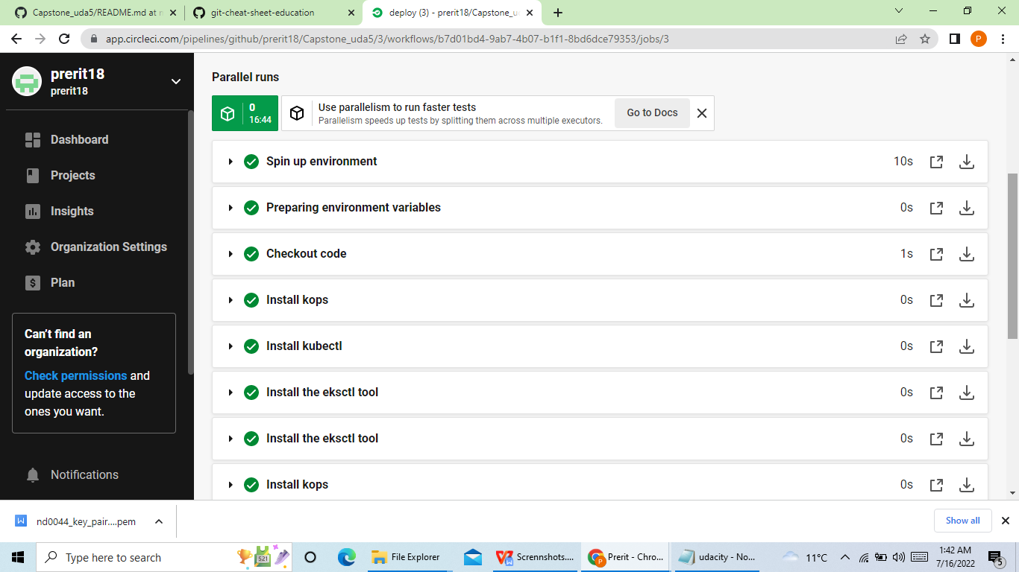

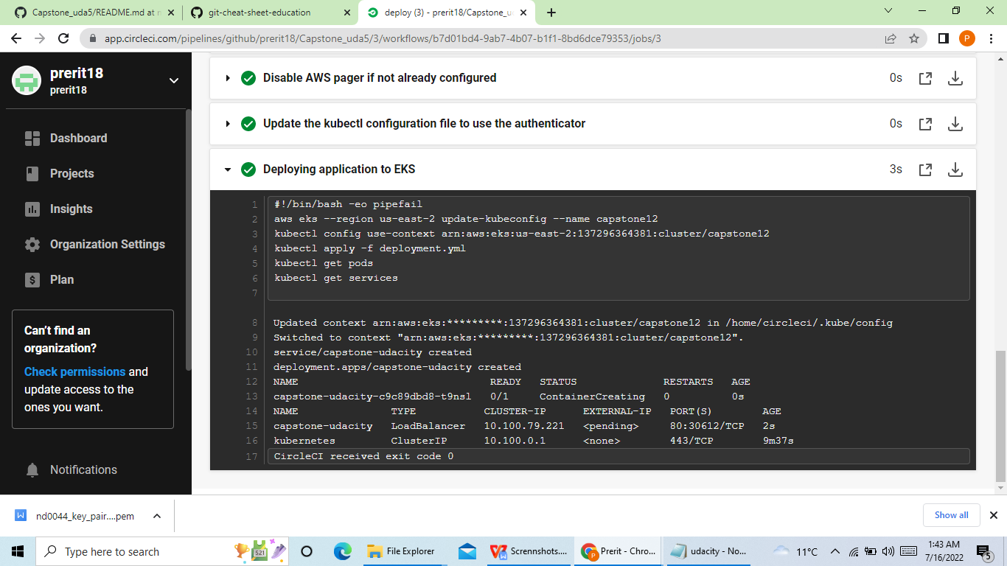

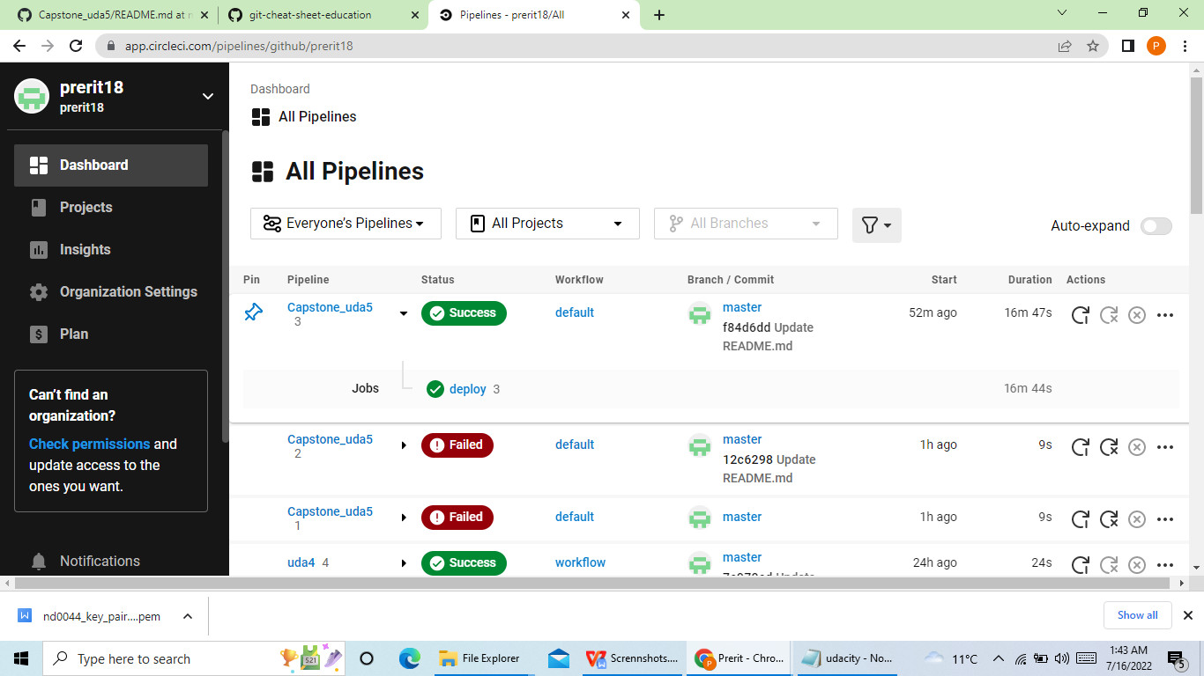

URLs:

Circle CI:

<https://app.circleci.com/pipelines/github/prerit18/Capstone_uda5/5/workflows/98c33d52-762a-4046-a247-a83f480f56ee/jobs/5>

GIt Hub:

<https://github.com/prerit18/Capstone_uda5/tree/master>