Hyper parameter optimisation is successful. The script used is - hpo_v2

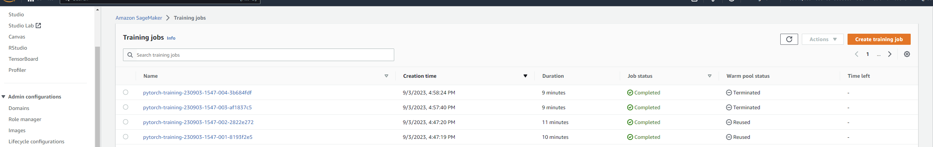

Best Hyperparameters.
