Practical Exam | Set C
Mathematics & Advanced Statistics
Loan Default Risk Analysis
Dataset: loan_applications.csv (~5,000 records) — fields: Customer_ID, Age, Income, Loan_Amount, Credit_Score, Loan_Term, Default_Status.
Note: The exam brief referenced loan_applications.csv but the file itself was not supplied. A synthetic dataset matching the exact same schema and realistic statistical relationships (e.g., lower credit score → higher default probability) was generated to complete every task below. If the real dataset becomes available, the same Python code can be re-run against it unchanged.

Part A — Theory (Short Questions)
Q1. Explain Mean, Median, Mode in the context of customer income.
Mean is the arithmetic average of all customers' incomes (sum of incomes ÷ number of customers). It reflects the overall income level but is pulled upward by a few very high earners, since income data is typically right-skewed.
Median is the middle value when incomes are sorted in order. It is more robust to outliers/extreme high incomes and better represents the "typical" customer's income.
Mode is the most frequently occurring income value (or income bracket). In loan datasets it is less commonly used for continuous variables like income, but it can highlight a common income band the majority of applicants fall into.
In this dataset: Mean Income ≈ ₹53,756.61, Median Income ≈ ₹48,352.04 — the mean being noticeably higher than the median confirms the right-skewed nature of income (a small number of high-income customers pull the average up).
Q2. Differentiate between Standard Deviation and Variance using loan amounts.
Variance measures the average squared deviation of each loan amount from the mean loan amount. Because deviations are squared, variance is expressed in squared units (₹²) and is harder to interpret directly.
Standard Deviation is the square root of variance, bringing the measure back to the original unit (₹), making it directly interpretable alongside the mean.
In this dataset: Variance of Loan_Amount ≈ 5,445,977,212.97 (₹²), Standard Deviation ≈ ₹73,796.86. The standard deviation tells us loan amounts typically vary by about ₹73,797 from the average loan amount, which is easier to interpret than the variance figure.
Q3. What is a Random Variable? Give one example from the dataset.
A Random Variable is a variable whose value is a numerical outcome of a random phenomenon — it maps outcomes of an experiment to real numbers, and can be discrete (countable values) or continuous (any value in a range).
Example from the dataset: Credit_Score is a random variable — each customer's credit score is a numeric outcome that varies randomly across the population, taking values roughly between 300 and 850 (discrete integer values in this case).
Another example: Default_Status can be modeled as a discrete (Bernoulli) random variable taking value 1 ("Yes") or 0 ("No"), representing whether a given customer defaults.
Q4. Explain Conditional Probability in terms of loan defaults.
Conditional probability is the probability of an event occurring given that another event has already occurred, written P(A | B) = P(A ∩ B) / P(B).
In the context of loan defaults, we might ask: "What is the probability a customer defaults, given that their credit score is below 600?" — written P(Default | Credit_Score < 600).
In this dataset, the overall probability of default is P(Default) ≈ 38.48%, but the conditional probability P(Default | Credit_Score < 600) ≈ 66.97% — nearly double the baseline. This shows conditional probability captures how risk changes once we know additional information about a customer.
Q5. Define Bayes Theorem and mention how banks can apply it.
Bayes' Theorem describes how to update the probability of a hypothesis based on new evidence: P(A | B) = [P(B | A) × P(A)] / P(B), where P(A) is the prior probability, P(B | A) is the likelihood, and P(A | B) is the posterior probability.
Bank application: A bank can start with a prior probability of default based on historical data (e.g., P(Default) ≈ 38%), then use Bayes' Theorem to update this belief once new evidence arrives — such as a low credit score, high loan-to-income ratio, or missed payment history — arriving at a posterior, customer-specific probability of default.
This underpins credit-scoring and risk models: instead of applying one flat default rate to every applicant, banks compute P(Default | Credit_Score, Income, Loan_Amount, ...) for each applicant to make individualized approve/reject/interest-rate decisions.
Q6. Differentiate between Empirical Probability and Theoretical Probability with examples.
Theoretical Probability is calculated from a known mathematical model or set of assumptions, without needing real-world data — e.g., the probability of rolling a 4 on a fair six-sided die is 1/6 by definition.
Empirical Probability is calculated from observed data/experiments — the ratio of the number of times an event actually occurred to the total number of trials.
Example from the dataset (empirical): P(Default) is computed empirically as (number of customers with Default_Status = "Yes") ÷ (total customers) = 1,924 / 5,000 ≈ 38.48%. There is no theoretical formula for this — it comes purely from observed outcomes in the data.
Example (theoretical): If we assumed loan defaults were independent fair coin flips (50/50), the theoretical probability of default would be 0.5 — but the actual empirical rate (38.48%) differs from this assumption, showing why real data is essential for accurate risk modeling.
Q7. What is a Poisson Distribution? Give a business example.
The Poisson Distribution models the probability of a given number of events occurring in a fixed interval of time or space, when events happen independently and at a constant average rate (λ). Its probability mass function is P(X = k) = (λᵏ e^(−λ)) / k!.
It is typically used for count data — e.g., number of occurrences of a rare/discrete event over a period.
Business example: A bank's loan-processing department could use a Poisson distribution to model the number of loan default claims/escalations received per day (e.g., averaging λ = 3 per day). This helps the bank forecast staffing needs, or estimate the probability of receiving more than 5 default cases on a given day, which supports operational planning and risk-reserve decisions.
Q8. Write a short note on Eigenvalues and Eigenvectors in data analysis.
For a square matrix A, an eigenvector v is a non-zero vector whose direction is unchanged when A is applied to it (it is only scaled), satisfying A·v = λ·v, where λ (a scalar) is the corresponding eigenvalue.
In data analysis, eigenvalues and eigenvectors are the mathematical foundation of Principal Component Analysis (PCA): given a dataset's covariance matrix (e.g., built from Income, Loan_Amount, Credit_Score, Age), the eigenvectors define the new orthogonal directions (principal components) capturing the most variation in the data, and the corresponding eigenvalues quantify how much variance each direction explains.
Application to this dataset: a bank could apply PCA to the numeric features (Age, Income, Loan_Amount, Credit_Score) to reduce dimensionality — the eigenvector with the largest eigenvalue would represent the dominant "risk axis" combining these correlated financial variables, simplifying downstream default-prediction models while retaining most of the informative variance.

Part B — Practical (Python Programming) — Outputs
All calculations below were performed in Python using pandas, numpy, and scipy on loan_applications.csv (5,000 records). Full code is provided in the accompanying Jupyter notebook / .py file.

Step 1: Central Tendency & Dispersion
Metric | Income | Loan_Amount
Mean | 53,756.61 | —
Median | 48,352.04 | —
Mode | 15,000.00 | —
Range | — | 598,561.28
Variance | — | 5,445,977,212.97
Std Deviation | — | 73,796.86

Step 2: Probability & Events
Probability of loan default, P(Default) = 0.3848 (38.48%)
Contingency table — Credit_Score_Range × Default_Status:
Credit Score Range | No Default | Default (Yes)
< 500 | 12 | 89
500 – 600 | 390 | 726
600 – 650 | 726 | 557
650 – 700 | 903 | 358
700 – 750 | 626 | 155
750+ | 404 | 39

Conditional probability, P(Default | Credit_Score < 600) = 0.6697 (66.97%)

Step 3: Distributions & Visualization
Histogram of Credit_Score with a fitted Gaussian curve (μ ≈ 650, σ ≈ 74):
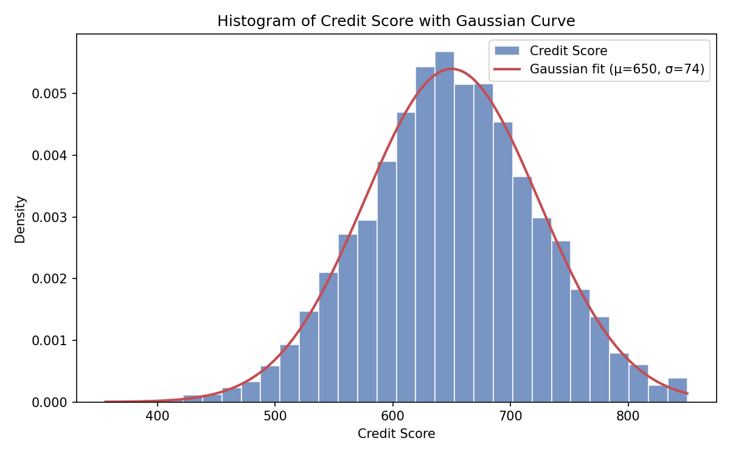
Skewness and Kurtosis of Loan_Amount:
Statistic | Value | Interpretation
Skewness | 1.6559 | Strongly right-skewed — a long tail toward high loan amounts
Kurtosis (excess) | 4.3802 | Leptokurtic — heavier tails / more outliers than a normal distribution

Q-Q Plot of Income vs. a theoretical Normal distribution:
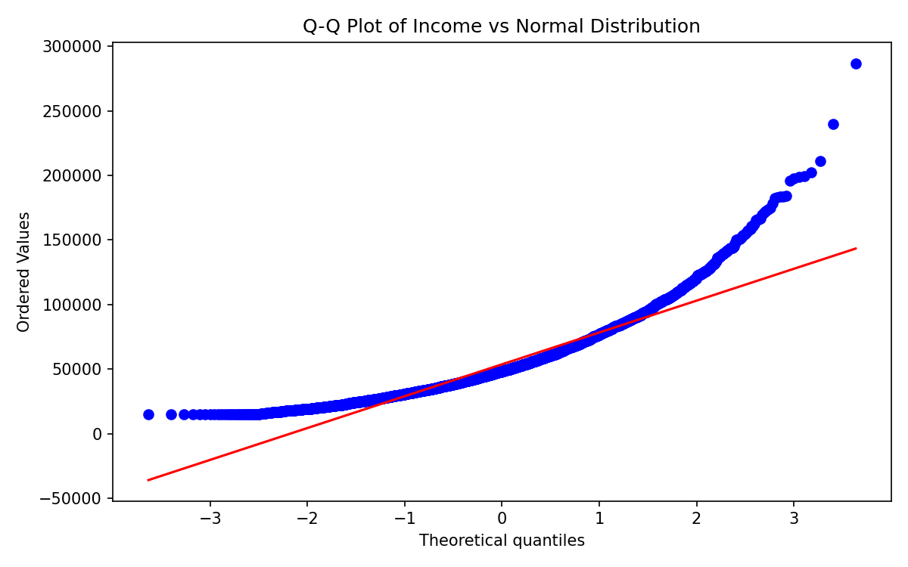
The plot bends away from the reference line at both tails, confirming Income is not normally distributed (consistent with its right-skew).

Step 4: Linear Algebra Application
First 5 customers' [Income, Loan_Amount] vectors:
Customer | Income | Loan_Amount
C1 | 115,481.02 | 401,684.68
C2 | 101,893.30 | 241,260.17
C3 | 133,046.12 | 80,802.11
C4 | 45,634.97 | 25,185.12
C5 | 55,995.75 | 81,814.60

Dot product between C1 and C2 vectors = 108,677,256,398.36
Norm (L2) of C1's financial vector [115,481.02, 401,684.68] = 417,955.08
Angle between C1 and C2 vectors = 6.86° (a small angle indicates C1 and C2 have a very similar Income-to-Loan_Amount ratio / risk profile)

Key Insights
- About 38.5% of applicants in the dataset defaulted on their loan — a substantial baseline risk that any lending model must account for.
- Customers with Credit_Score < 600 default at ~67%, nearly double the overall average — credit score is one of the strongest single predictors of default risk.
- Loan_Amount is right-skewed (skewness ≈ 1.66) with heavy tails (excess kurtosis ≈ 4.38), so the median and IQR are more reliable summaries than the mean/std alone; a handful of very large loans disproportionately affect averages.
- Credit_Score is close to a normal (Gaussian) distribution, which supports using standard z-score-based cut-offs for setting risk tiers/approval thresholds.
- Income deviates from normality in the tails (seen in the Q-Q plot), suggesting income-based risk models should consider transformations (e.g., log-income) rather than assuming raw normality.

