NextEvent AI — Sponsors Used

Anthropic Claude
All three agents (Network Intel, Retrospective, Planning), the chat intent router, and the suggestions feature run entirely on Claude (Sonnet 5) via the Anthropic API -- reasoning, ranking, drafting, and scoring.

Quirq / XO Space
Used for observability: XO Space independently tracks the actual agent development sessions that built this project, separate from the app's own action_log table.

The Code Registry
Post-hackathon static analysis of the public GitHub repository -- no additional integration required beyond keeping the repo public and up to date, which it is: github.com/prerna1001/Recommendation_System_Hack_Philly.

Below: the project mapped in XO Space's Data -> Graph view, and a real tracked session under Agents -> Overview showing prompts by turn.
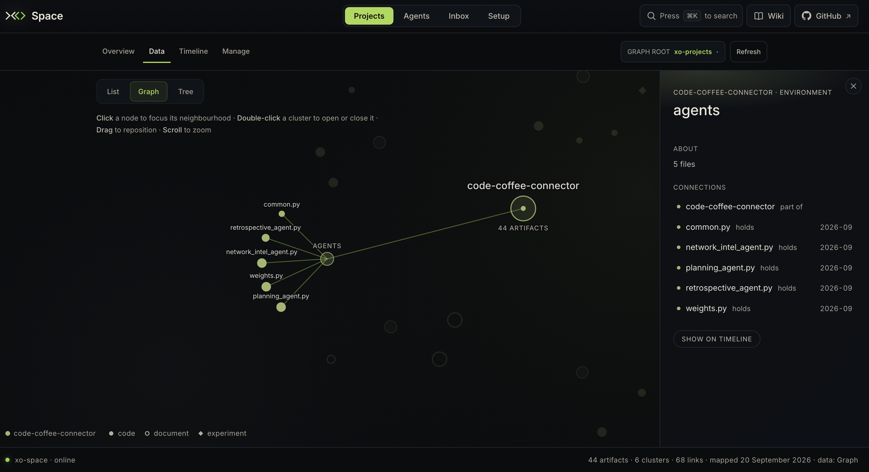
Figure 1: XO Space Data/Graph view of the agents/ folder (44 artifacts, 6 clusters).
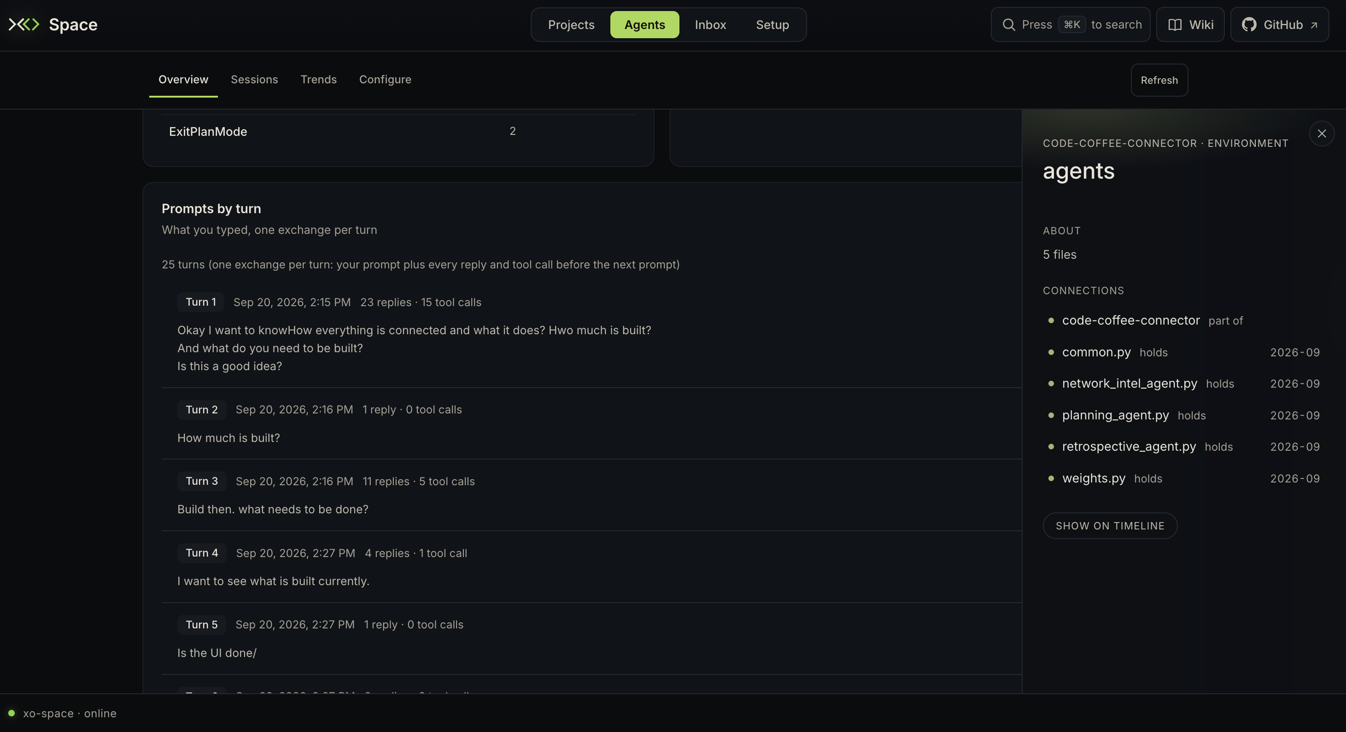
Figure 2: XO Space Agents -> Overview, real prompts-by-turn from the session that built this project.

