**EXPERIMENT-8**

**LCD**

**CIRCUIT DIAGRAM:**

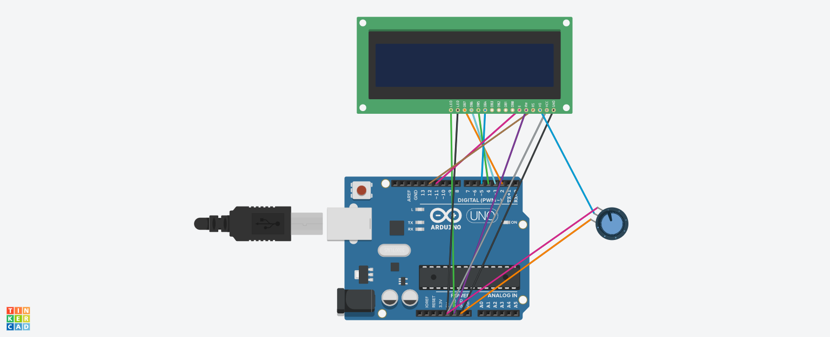

**THEORY:**

LCD (Liquid Crystal Display) is a type of flat panel display which uses liquid crystals in its primary form of operation. LCDs consume much less power than LED and gas-display displays because they work on the principle of blocking light rather than emitting it. Where an LED emits light, the liquid crystals in an LCD produces an image using a backlight.

It has 16 pins and the first one from left to right is the Ground pin. The second pin is the VCC which we connect the 5 volts pin on the Arduino Board. Next is the Vo pin. The RS pin or register select pin is used for selecting whether we will send commands or data to the LCD. R / W pin which selects the mode whether we will read or write to the LCD. the E pin which enables the writing to the registers, or the next 8 data pins from D0 to D7. last two pins A and K, or anode and cathode are for the LED back light.

***CONCEPT USED:***

VSS is connected to ground of arduino. VCC is connected to ground. Vo acts as rheostat. All three are part of potential divider. RS is connected to ground. R/W is connected to ground. Enable is connected to D11. Anode to 5V and cathode to ground. On completing the circuit we will get the desired result.

***LEARNING AND OBSERVATION:***

* Making circuits using Arduino and LCD
* Connecting LCD to arduino.
* Ground is connected to anode.
* Potentialdivider is connected to 5V and ground.

***Problems & Troubleshooting: –***

Error in coding and port selection.

***Precautions :–***

1. The circuit made can be wrong.
2. Any Element used may be defective.
3. The coding done can be incorrect due to which stimulation can be failed.

4.Port Selection for Arduino can be incorrect due to which it won’t upload on Arduino Board and resulting in failure of experiment.

***Learning Outcomes: –***

1. Setting up circuit on a Arduino.
2. Connecting LCD and Arduino.
3. Working and coding of Arduino.

***Result: –***

Working of Bluetooth and arduino is verified after uploading the program.