**CIRCUIT DIAGRAM:**

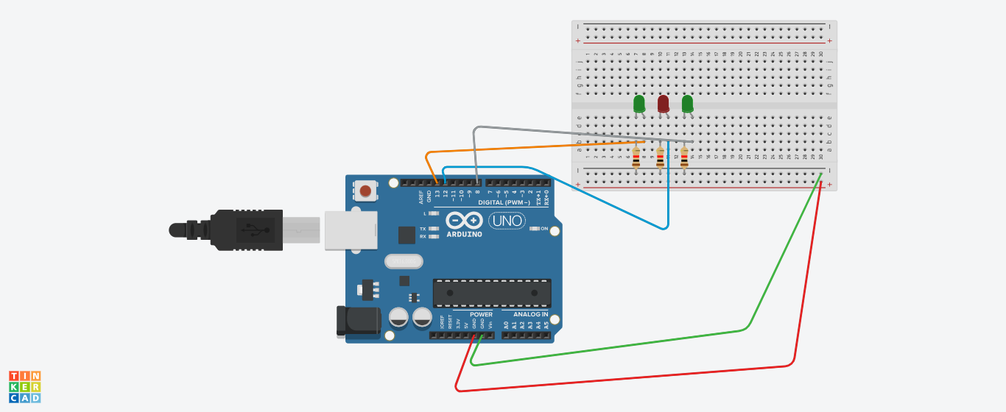

**THEORY:**

*Concept used:*

* The usage of Kirchhoff’s law:

1. Voltage

The total voltage in a loop is zero due to conservation of energy.

1. Current

The total current passing through a point across the junction is zero i.e., total current going is equal to total current coming.

* The LED is connected in series with the resistance so that current can be resisted.

Learning and observations:

* Connections in the breadboard are made in such a way that LED and resistor are in series.
* LEDs are connected with pin 13,12 and 8 of Arduino board.
* We have checked all components using a multimeter by putting it on the speaker mode with would make a sound when the component is working or not.

**OBSERVATIONS:**

* The LED is blinking is blinking in a pattern and is chasing form.

*PROGRAMMING:*

*void setup()*

*{*

*pinMode(13, OUTPUT);*

*pinMode(12, OUTPUT);*

*pinMode(8, OUTPUT);*

*}*

*void loop()*

*{*

*digitalWrite(13, HIGH);*

*digitalWrite(12, LOW);*

*digitalWrite(8, LOW);*

*delay(3000); // Wait for 3000 millisecond(s)*

*digitalWrite(12, HIGH);*

*digitalWrite(13, LOW);*

*digitalWrite(8, LOW);*

*delay(3000); // Wait for 3000 millisecond(s)*

*digitalWrite(8, HIGH);*

*digitalWrite(13, LOW);*

*digitalWrite(12, LOW);*

*digitalWrite(11, LOW);*

*delay(3000); // Wait for 3000 millisecond(s)*

*}*

**Problems and troubleshooting:**

* To select the right port and type of Arduino.
* To check the connection as it might be loose.
* Check the components’ continuity with the help of multimeter.
* To check the coding (syntax, pin number etc.)

**Precautions:**

* Handle the components carefully.
* Do not connect the Arduino till the circuit is completed which would cause Arduino voltage shock to individual.

**Outcome:**

* The LED glows in chasing manner.
* It can be used as for decorating purpose.