**CIRCUIT DIAGRAM:**

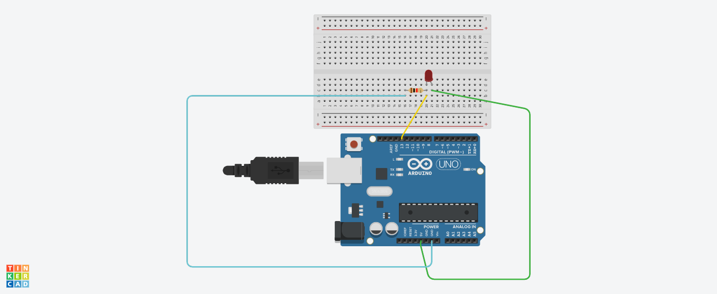

**THEORY:**

*Concept used:*

* The usage of Kirchhoff’s law:

1. Voltage

The total voltage in a loop is zero due to conservation of energy.

1. Current

The total current passing through a point across the junction is zero i.e., total current going is equal to total current coming.

* The LED is connected in series with the resistance so that current can be resisted.

Learning and observations:

* Connections in the breadboard are made in such a way that LED and resistor are in series.
* LED is connected with pin 13 of Arduino board.
* Voltage is maintained in the circuit 5ev.
* The n side of LED is connected to the ground and the resistance is connected to the positive terminal i.e., 5eV.
* In coding we have connected the LED with pin 13 of the board and in coding OUTPUT would be upon 13 only.
* We have checked all components using a multimeter by putting it on the speaker mode with would make a sound when the component is working or not.

**OBSERVATIONS:**

* The LED is blinking. Thus creation of a LED flasher.

*PROGRAMMING:*

*void setup()*

*{*

*pinMode(13, OUTPUT);*

*}*

*void loop()*

*{*

*digitalWrite(13, HIGH);*

*delay(3000); // Wait for 3000 millisecond(s)*

*digitalWrite(13, LOW);*

*delay(1000); // Wait for 1000 millisecond(s)*

*}*

**Problems and troubleshooting:**

* To select the right port and type of Arduino.
* To check the connection as it might be loose.
* Check the components’ continuity with the help of multimeter.
* To check the coding (syntax, pin number etc.)

**Precautions:**

* Handle the components carefully.
* Don not connect the Arduino till the circuit is completed which would cause Arduino voltage shock to individual.

**Outcome:**

* The LED is blinking.
* This can be used a LED flasher.