**DRINKS INN**

**A** **Project** **Work** **Report**

*Submitted* *in* *the* *partial* *fulfilment* *for* *the* *award* *of* *the* *degree* *of*

**BACHELOR** **OF** E**NGINEERING**

**IN**

**CSE-Big Data**

**Submitted** **by:**

**PRERNA VERMA**

**19BCS3777**

**Under** **the** **Supervision** **of:**

**Ms. JYOTI MEHRA**

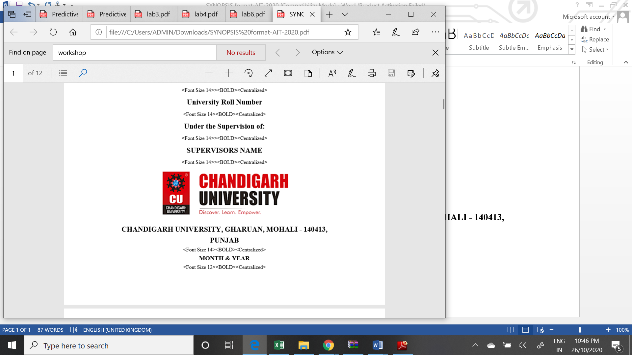

**CHANDIGARH** **UNIVERSITY,** **GHARUAN,** **MOHALI** **-** **140413,** **PUNJAB**

**December, 2020**

Prerna

Supervisor

# 

# PROJECT COMPLETION CERTIFICATE

## DRINKS INN

This is to certify that the PRERNA VERMA has successfully completed the project work titled “ DRINKS INN ” *Submitted* *in* *the* *partial* *fulfilment* *for* *the* *award* *of* *the* *degree of* **BACHELOR** **OF** E**NGINEERING** **IN CSE- Big Data.**

This project is the record of authentic work carried out during the academic year 2020-2021.

**JYOTI MEHRA**

Project Guide

**Date: 05/12/2020**

# DECLARATION

I the undersigned solemnly declare that the project report is based on my own work carried out during the course of our study under the supervision of Ms. Jyoti Mehra. I assert the statements made and conclusions drawn are an outcome of my work. I further certify that the work contained in the report is original and has been done by me under the general supervision of my supervisor.

II. The work has not been submitted to any other Institution for any other degree/diploma/certificate in this university or any other University of India or abroad.

III. We have followed the guidelines provided by the university in writing the report.

IV. Whenever we have used materials (data, theoretical analysis, and text) from other sources, we have given due credit to them in the text of the report and giving their details in the references.

PRERNA VERMA

19BCS3777

# ACKNOWLEDGEMENT

I have taken efforts in this project. However, it would not have been possible without the kind support and help of many individuals and organizations. I would like to extend my sincere thanks to all of them.

I am highly indebted to Jyoti Mehra for their guidance and constant supervision as well as for providing necessary information regarding the project & also for their support in completing the project.

I would like to express my gratitude towards my parents and my department for their kind co-operation and encouragement which help me in completion of this project.

THANKS AGAIN TO ALL WHO HELPED

**PROJECT PROFILES**

1. Project Partners:

* Strength: 1
* Name: Prerna Verma (19BCS3777)

1. Minimum system requirement:
   * + Modern Operating System:

1) Windows 7 or 10

2) Mac OS X 10.11 or higher, 64-bit

3) Linux: RHEL 6/7, 64-bit

* + - Samsung Driver (For Samsung Mobile)
    - x86 64-bit CPU (Intel / AMD architecture)
    - Graphic card NVIDIA
    - 4 GB RAM
    - 5 GB free disk spaces

1. Development Tools:

* Android Studio
* Samsung Driver.

1. Documentation & Presentation Tools:

* Microsoft Word.
* Mircosoft powerpoint.

**CHAPTER 1: INTRODUCTION TO PROJECT**

**Introduction:**

Drinks Inn is a beverage ordering which helps you order various beverages. There are various sections made in app (till now only 2- Hot and Cold). The user can think what to drink according to the season and then under each category there are various options with pictures and rate in INR.

A temporary price will be visible in the end where user can check whether it is fitting in budget and will not have to cancel order after ordering.

This app support 2 languages Hindi and English.

It support helpline where by clicking one button only the user can put up complaint through mail or text message.

Modifications Required:-

1. This has to support more languages other than English and Hindi.
2. This has have more detailed categories other than Hot and Cold.
3. Later this program will be modified to store previous information of person because of which they can modify their order without choosing items again and again.

Pros of the app:-

1. This app is secure, the details that are entered by user in this is not accessible by anyone.
2. It is a Fast and user friendly application.
3. Minimal system requirements.
4. It’s an offline application hence network connection is not required to use it.

**Purpose:**

During lockdown we were unable to go out and now also conditions are not so good that

This app helps you get rid of finding beverages. The user can order beverages with one click only. We have categorized beverages in our app in a very user-friendly way and enables you to choose the best one for you. Our app has a guide message for people who are not comfortable with the usage of the app.

This app is bilingual.The main goal for it is to provide beverages with only one click and with minimal cost by targeting customers and target to increase their reach and those who have negligible knowledge of technology and their usage. This can lead to a boom in their careers and increase their sales and improve their lifestyle. So, it focuses on less privileged and unexposed ones.

**Scope:**

The scope of the project can support API 16 also but will lack some color of buttons and no loss of the UI or services. This can work on android phones but later will be developed to work on Apple and other devices.

**PROJECT DEVELOPMENT APPROACH**

**App Development Model:**

The native app development model

Native app development is the creation of software programs that run on specific devices and platforms. You can build native apps for desktops, smart TVs, and all kinds of gadgets, the most popular target devices are smartphones.

**Model:**

* + - 1. **Strategy:**

The first phase of the mobile app development process is defining the strategy for evolving your idea into a successful app. You may include a more significant part of this in your overall enterprise mobility strategy. As one app’s objectives may differ from another, there is still an app-specific impact on the mobility strategy to address during the development process.

Mainly it deals with:

• Identifying the app users,

• Research the competition

• Establish the app’s goals and objectives

• Select a mobile platform for your app

**2. Examination and Planning**

At this stage, your application thought begins coming to fruition and transforms into a real undertaking. Examination and arranging start with characterizing use cases and catching natty gritty useful prerequisites.

Some portion of the arranging stage incorporates recognizing the abilities required for your application improvement activity. For instance, iOS and Android portable stages utilize distinctive advancement innovation stacks. On the off chance that you will likely form a versatile application for the two iOS and Android portable stages at that point, your versatile improvement group ought to incorporate iOS designers and Android engineers.

* + - 1. **UI/UX Design**

The motivation behind an application's plan is to convey consistent and easy client encounters with a cleaned look.

The achievement of a versatile application is resolved dependent on how well clients are receiving and profiting by the entirety of its highlights. The objective for versatile application UI/UX configuration is making fantastic client encounters making your application intelligent, natural, and easy to understand. While cleaned UI plans will help with early reception, your application must have instinctive client encounters to keep application clients' locked in.

* + - 1. **Application Development**

Arranging stays an essential piece of this stage in the versatile application improvement measure. Prior to genuine turn of events/programming endeavours start, you should:

* characterize the specialized engineering,
* pick an innovation stack, and
* Characterize the improvement achievements.

1. **Testing**

Performing thorough quality assurance (QA) testing during the mobile app development process makes applications stable, usable, and secure. To ensure comprehensive QA testing of your app, you first need to prepare test cases that address all aspects of app testing.

**Chapter 2: Project Requirements**

1. Hardware / Software Environment:

**Hardware:**

* Microsoft® Windows® 7/8/10 (64-bit)
* 4 GB RAM minimum, 8 GB RAM recommended
* 2 GB of available disk space minimum
* 4 GB Recommended (500 MB for IDE + 1.5 GB for Android SDK and emulator system image)
* 1280 x 800 minimum screen resolution

**Software:**

* Operating System: Windows 7 or above

Mac OS X or above

Linux

1. Development Tools:

* **Front End:** XML
* **Back End:** Java

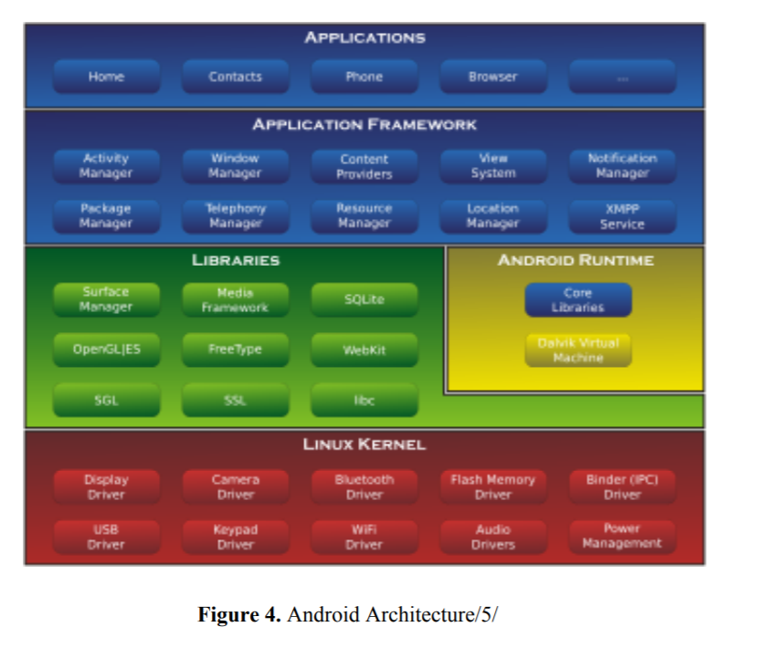

**Chapter 3: Implementation Details (Algorithm, code )**

**ALGORITHM:**

1. Start.
2. Front page will open with the image of the app.
3. Click anywhere on the screen to continue or click back button of mobile to close it.
4. Now the screen will appear.
5. Enter your name under Name section in front end in back end this will save as a variable n**ame_of_customer.**
6. Then check out the category you are interested in.
7. Under that check out the beverage which interest you.
8. Then to increase we click on + sign and to decrease we have to click on the – sign.
9. But if we try to decrease the quantity less than 0 then a pop up message will appear.
10. Then at bottom the price will be shown of the total items selected.
11. When all desired items are selected then click on place order.
12. When the place order is clicked then on the backend the table will be released that will consist of the columns with the name of the customer displaying.
13. The columns item names, quality, items rate per cup and total price.
14. Then there are 2 images under helpline which we can choose to compliant using email or using text message.
15. End.

**FRONT-END**

Starting Screen

*<?***xml version="1.0" encoding="utf-8"***?>*<**RelativeLayout xmlns:android="http://schemas.android.com/apk/res/android"  
 xmlns:app="http://schemas.android.com/apk/res-auto"  
 xmlns:tools="http://schemas.android.com/tools"  
 android:layout_width="match_parent"  
 android:layout_height="match_parent"  
 tools:context=".FlashAcitivity"  
 android:background="@color/white"**>  
  
 <**ImageView  
 android:id="@+id/logo"  
 android:layout_width="match_parent"  
 android:layout_height="match_parent"  
 android:scaleType="center"  
 android:src="@drawable/companylogo"  
 android:onClick="open"**/>  
  
  
</**RelativeLayout**>

Main Screen

*<?***xml version="1.0" encoding="utf-8"***?>*<**ScrollView  
 xmlns:android="http://schemas.android.com/apk/res/android"  
 xmlns:app="http://schemas.android.com/apk/res-auto"  
 xmlns:tools="http://schemas.android.com/tools"  
 android:layout_width="match_parent"  
 android:layout_height="match_parent"  
 android:fillViewport="true"  
 android:orientation="vertical"  
 android:background="#FFFFFF"**>  
 <**LinearLayout  
 android:layout_width="match_parent"  
 android:layout_height="wrap_content"  
 tools:context=".MainActivity"  
 android:orientation="vertical"**>  
 <**TextView  
 android:id="@+id/menu"  
 style="@style/TextStyle"  
 android:layout_width="wrap_content"  
 android:text="@string/beverage"  
 android:textSize="30sp"** />  
 <**EditText  
 android:id="@+id/name_edit_text"  
 android:layout_width="match_parent"  
 android:layout_height="wrap_content"  
 android:hint="@string/name"  
 android:inputType="textMultiLine"** />  
 <**TextView  
 style="@style/TextStyle"  
 android:text="@string/hot"** />  
  
 <**HorizontalScrollView  
 android:layout_width="fill_parent"  
 android:layout_height="wrap_content"  
 android:orientation="horizontal"**>  
  
 <**LinearLayout  
 android:layout_width="wrap_content"  
 android:layout_height="wrap_content"  
 android:orientation="horizontal"**>  
  
  
 *<!-- This is Coffe Section -->* <**LinearLayout  
 android:id="@+id/cofee"  
 style="@style/item_menu_layout_style"  
 tools:context=".MainActivity"**>  
  
 <**TextView  
 android:id="@+id/quantity"  
 style="@style/item_name_menu_text_style"  
 android:text="@string/coffee"** />  
 <**ImageView  
 style="@style/Image_style"  
 android:src="@drawable/coffe_cup"  
 android:id="@+id/pic_coffe"**/>  
  
 <**LinearLayout style="@style/item_layout_menu_style"**>  
  
 <**Button  
 android:id="@+id/increase_coffee"  
 style="@style/button_increase_quantity_menu_style"  
 android:onClick="increment_coffee"** />  
  
 <**TextView  
 android:id="@+id/quantity_coffee_text_view"  
 style="@style/item_quantity_menu_text_style"  
 android:text="0"**/>  
  
 <**Button  
 android:id="@+id/decrease_coffee"  
 style="@style/button_decrease_quantity_menu_style"  
 android:onClick="decrement_coffee"**/>  
 </**LinearLayout**>  
  
 *<!---<Button  
 android:layout_width="wrap_content"  
 android:layout_height="48dp"  
 android:onClick="clear"  
 android:text="@string/clear" />-->* </**LinearLayout**>  
  
  
 *<!-- This is Tea Section -->* <**LinearLayout  
 android:id="@+id/tea"  
 style="@style/item_menu_layout_style"  
 tools:context=".MainActivity"**>  
  
 <**TextView  
 android:id="@+id/quantity_tea"  
 style="@style/item_name_menu_text_style"  
 android:text="@string/tea"** />  
 <**ImageView  
 android:src="@drawable/tea_new"  
 style="@style/Image_style"**/>  
  
 <**LinearLayout style="@style/item_layout_menu_style"**>  
  
 <**Button  
 android:id="@+id/increase_tea"  
 style="@style/button_increase_quantity_menu_style"  
 android:onClick="increment_tea"** />  
  
 <**TextView  
 android:id="@+id/quantity_tea_text_view"  
 style="@style/item_quantity_menu_text_style"  
 android:text="0"** />  
  
 <**Button  
 android:id="@+id/decrease_tea"  
 style="@style/button_decrease_quantity_menu_style"  
 android:onClick="decrement_tea"** />  
 </**LinearLayout**>  
 </**LinearLayout**>  
*<!-- soup starts -->* <**LinearLayout  
 android:id="@+id/soup"  
 style="@style/item_menu_layout_style"  
 tools:context=".MainActivity"**>  
  
 <**TextView  
 android:id="@+id/quantity_soup"  
 style="@style/item_name_menu_text_style"  
 android:text="@string/Soup"** />  
 <**ImageView  
 android:src="@drawable/soup_new"  
 style="@style/Image_style"**/>  
  
 <**LinearLayout style="@style/item_layout_menu_style"**>  
  
 <**Button  
 android:id="@+id/increase_soup"  
 style="@style/button_increase_quantity_menu_style"  
 android:onClick="increment_soup"** />  
  
 <**TextView  
 android:id="@+id/quantity_soup_text_view"  
 style="@style/item_quantity_menu_text_style"  
 android:text="0"**/>  
  
 <**Button  
 android:id="@+id/decrease_soup"  
 style="@style/button_decrease_quantity_menu_style"  
 android:onClick="decrement_soup"** />  
 </**LinearLayout**>  
  
 *<!---<Button  
 android:layout_width="wrap_content"  
 android:layout_height="48dp"  
 android:onClick="clear"  
 android:text="@string/clear" />-->* </**LinearLayout**>  
  
  
  
 *<!-- This is Hot Chocolate Section -->* <**LinearLayout  
 android:id="@+id/hotChocolate"  
 style="@style/item_menu_layout_style"  
 tools:context=".MainActivity"**>  
  
 <**TextView  
 android:id="@+id/quantity_chocolate"  
 style="@style/item_name_menu_text_style"  
 android:text="@string/hotChocolate"** />  
 <**ImageView  
 android:src="@drawable/hotchocoltae_icon"  
 style="@style/Image_style"**/>  
  
 <**LinearLayout style="@style/item_layout_menu_style"**>  
  
 <**Button  
 android:id="@+id/increase_hotChocolate"  
 style="@style/button_increase_quantity_menu_style"  
 android:onClick="increment_hotChocolate"** />  
  
 <**TextView  
 android:id="@+id/quantity_hotChocolate_text_view"  
 style="@style/item_quantity_menu_text_style"  
 android:text="0"**/>  
  
 <**Button  
 android:id="@+id/decrease_hotChocolate"  
 style="@style/button_decrease_quantity_menu_style"  
 android:onClick="decrement_hotChocolate"** />  
 </**LinearLayout**>  
 </**LinearLayout**>  
  
  
  
 </**LinearLayout**>  
 </**HorizontalScrollView**>  
  
  
 *<!--start - - - here cold start- - - - - - - - - - - - - - - start -->* <**TextView  
 style="@style/TextStyle"  
 android:text="@string/cold"** />  
  
 <**HorizontalScrollView  
 android:layout_width="fill_parent"  
 android:layout_height="wrap_content"  
 android:orientation="horizontal"**>  
  
 <**LinearLayout  
 android:layout_width="wrap_content"  
 android:layout_height="wrap_content"  
 android:orientation="horizontal"**>  
  
  
 *<!-- This is Coffe Section -->* <**LinearLayout  
 android:id="@+id/coldCofee"  
 style="@style/item_menu_layout_style"  
 android:onClick="increment_coldcoffee"  
 tools:context=".MainActivity"**>  
  
 <**TextView  
 android:id="@+id/quantity_coldCoffee"  
 style="@style/item_name_menu_text_style"  
 android:text="@string/coldcoffee"** />  
 <**ImageView  
 android:src="@drawable/coldcooffe_icon"  
 style="@style/Image_style"**/>  
  
 <**LinearLayout style="@style/item_layout_menu_style"**>  
  
 <**Button  
 android:id="@+id/increase_coldCoffee"  
 style="@style/button_increase_quantity_menu_style"  
 android:onClick="increment_coldcoffee"** />  
  
 <**TextView  
 android:id="@+id/quantity_coldcoffee_text_view"  
 style="@style/item_quantity_menu_text_style"  
 android:text="0"**/>  
  
 <**Button  
 android:id="@+id/decrease_coldCoffee"  
 style="@style/button_decrease_quantity_menu_style"  
 android:onClick="decrement_coldcoffee"**/>  
 </**LinearLayout**>  
  
 *<!---<Button  
 android:layout_width="wrap_content"  
 android:layout_height="48dp"  
 android:onClick="clear"  
 android:text="@string/clear" />-->* </**LinearLayout**>  
  
  
 *<!-- This is jaljeera Section -->* <**LinearLayout  
 android:id="@+id/jaljeera"  
 style="@style/item_menu_layout_style"  
 tools:context=".MainActivity"**>  
  
 <**TextView  
 android:id="@+id/quantity_jaljeera"  
 style="@style/item_name_menu_text_style"  
 android:text="@string/jaljeera"** />  
 <**ImageView  
 android:src="@drawable/new_jaljeera"  
 style="@style/Image_style"**/>  
  
 <**LinearLayout style="@style/item_layout_menu_style"**>  
  
 <**Button  
 android:id="@+id/increase_jaljeera"  
 style="@style/button_increase_quantity_menu_style"  
 android:onClick="increment_jaljeera"** />  
  
 <**TextView  
 android:id="@+id/quantity_jaljeera_text_view"  
 style="@style/item_quantity_menu_text_style"  
 android:text="0"**/>  
  
 <**Button  
 android:id="@+id/decrease_jaljeera"  
 style="@style/button_decrease_quantity_menu_style"  
 android:onClick="decrement_jaljeera"** />  
 </**LinearLayout**>  
 </**LinearLayout**>  
  
  
 *<!-- This is nimbuPaani Section -->* <**LinearLayout  
 android:id="@+id/nimbuPaani"  
 style="@style/item_menu_layout_style"  
 tools:context=".MainActivity"**>  
  
 <**TextView  
 android:id="@+id/quantity_nimbuPaani"  
 style="@style/item_name_menu_text_style"  
 android:text="@string/lemonade"** />  
 <**ImageView  
 android:src="@drawable/lemonade_icon"  
 style="@style/Image_style"**/>  
  
 <**LinearLayout style="@style/item_layout_menu_style"**>  
  
 <**Button  
 android:id="@+id/increase_nimbuPaani"  
 style="@style/button_increase_quantity_menu_style"  
 android:onClick="increment_nimbuPaani"** />  
  
 <**TextView  
 android:id="@+id/quantity_nimbuPaani_text_view"  
 style="@style/item_quantity_menu_text_style"  
 android:text="0"**/>  
  
 <**Button  
 android:id="@+id/decrease_nimbuPaani"  
 style="@style/button_decrease_quantity_menu_style"  
 android:onClick="decrement_nimbuPaani"** />  
 </**LinearLayout**>  
  
 *<!---<Button  
 android:layout_width="wrap_content"  
 android:layout_height="48dp"  
 android:onClick="clear"  
 android:text="@string/clear" />-->* </**LinearLayout**>  
  
  
  
 *<!-- This is Krushers Section -->* <**LinearLayout  
 android:id="@+id/krushers"  
 style="@style/item_menu_layout_style"  
 tools:context=".MainActivity"**>  
  
 <**TextView  
 android:id="@+id/quantity_krushers"  
 style="@style/item_name_menu_text_style"  
 android:text="@string/krushers"** />  
 <**ImageView  
 android:src="@drawable/krushers_new"  
 style="@style/Image_style"**/>  
  
 <**LinearLayout style="@style/item_layout_menu_style"**>  
  
 <**Button  
 android:id="@+id/increase_krushers"  
 style="@style/button_increase_quantity_menu_style"  
 android:onClick="increment_krushers"** />  
  
 <**TextView  
 android:id="@+id/quantity_krushers_text_view"  
 style="@style/item_quantity_menu_text_style"  
 android:text="0"**/>  
  
 <**Button  
 android:id="@+id/decrease_krushers"  
 style="@style/button_decrease_quantity_menu_style"  
 android:onClick="decrement_krushers"** />  
 </**LinearLayout**>  
 </**LinearLayout**>  
  
  
  
 </**LinearLayout**>  
 </**HorizontalScrollView**>  
 <**LinearLayout  
 android:layout_width="wrap_content"  
 android:layout_height="wrap_content"  
 android:orientation="horizontal"**>  
 <**TextView  
 android:id="@+id/pricetext_text_view"  
 android:layout_width="wrap_content"  
 android:layout_height="wrap_content"  
 android:text="@string/price"  
 android:textColor="#000000"  
 android:textAllCaps="true"  
 android:textSize="15sp"  
 android:layout_marginRight="14dp"  
 android:layout_marginEnd="14dp"  
 android:layout_marginLeft="8dp"  
 android:layout_marginStart="8dp"  
 android:textStyle="bold"** />  
  
 <**TextView  
 android:id="@+id/price_text_view"  
 android:layout_width="wrap_content"  
 android:layout_height="wrap_content"  
 android:text=""  
 android:textSize="15sp"  
 android:textColor="#000000"** />  
 </**LinearLayout**>  
 <**HorizontalScrollView  
 android:layout_width="fill_parent"  
 android:layout_height="wrap_content"  
 android:orientation="horizontal"  
 android:paddingRight="8dp"  
 android:paddingEnd="8dp"**>  
 <**LinearLayout  
 android:layout_width="wrap_content"  
 android:layout_height="wrap_content"  
 android:orientation="horizontal"  
 android:layout_marginRight="8dp"  
 android:layout_marginEnd="8dp"**>  
 <**TextView  
 android:id="@+id/item_name"  
 android:layout_width="wrap_content"  
 android:text=""  
 android:textSize="15sp"  
 android:textColor="#000000"  
 android:textStyle="bold"  
 android:layout_height="wrap_content"  
 android:padding="8dp"**/>  
 <**TextView  
 android:id="@+id/item_quantity"  
 android:layout_width="wrap_content"  
 android:text=""  
 android:textSize="15sp"  
 android:textColor="#000000"  
 android:textStyle="bold"  
 android:layout_height="wrap_content"  
 android:padding="8dp"**/>  
 <**TextView  
 android:id="@+id/item_rateppc"  
 android:layout_width="wrap_content"  
 android:text=""  
 android:textSize="15sp"  
 android:textColor="#000000"  
 android:textStyle="bold"  
 android:layout_height="wrap_content"  
 android:padding="8dp"**/>  
 <**TextView  
 android:id="@+id/item_price"  
 android:layout_width="wrap_content"  
 android:layout_height="wrap_content"  
 android:text=""  
 android:textSize="15sp"  
 android:textColor="#000000"  
 android:textStyle="bold"  
 android:padding="8dp"**/>  
 </**LinearLayout**>  
 </**HorizontalScrollView**>  
 <**Button  
 android:id="@+id/button2_id"  
 style="@style/button_increase_quantity_menu_style"  
 android:layout_height="wrap_content"  
 android:layout_width="wrap_content"  
 android:text="@string/placeorder"  
 android:onClick="submitOrder"  
 android:textColor="@color/black"  
 android:background="#3e2723"  
 android:layout_margin="16dp"**/>  
 <**TextView  
 android:layout_width="wrap_content"  
 android:layout_height="wrap_content"  
 android:text="@string/helpline"  
 android:textSize="15sp"  
 android:textColor="#000000"  
 android:textStyle="bold"  
 android:paddingTop="8dp"  
 android:paddingLeft="8dp"  
 android:paddingStart="8dp"  
 android:paddingBottom="8dp"**/>  
 <**LinearLayout  
 android:layout_width="wrap_content"  
 android:layout_height="wrap_content"  
 android:orientation="horizontal"**>  
  
 <**Button  
 android:id="@+id/email"  
 android:layout_width="50dp"  
 android:layout_height="50dp"  
 android:background="@drawable/email"  
 android:onClick="composeEmail"  
 android:textColor="@color/black"** />  
 <**Button  
 android:id="@+id/call"  
 android:layout_width="50dp"  
 android:layout_height="50dp"  
 android:background="@drawable/message"  
 android:onClick="open_phone"  
 android:textColor="@color/black"** />  
 </**LinearLayout**>  
  
  
 </**LinearLayout**>  
</**ScrollView**>

**BACK-END**

Starting Screen

**package** com.example.weather;  
  
**import** androidx.appcompat.app.AppCompatActivity;  
  
**import** android.content.Intent;  
**import** android.os.Bundle;  
**import** android.util.Log;  
**import** android.view.View;  
**import** android.widget.Toast;  
  
**public class** FlashAcitivity **extends** AppCompatActivity {  
  
 @Override  
 **protected void** onCreate(Bundle savedInstanceState) {  
 **super**.onCreate(savedInstanceState);  
 setContentView(R.layout.***activity_flash_acitivity***);  
 Toast toast = Toast.*makeText*(getApplicationContext(),**"CLICK ANYWHERE ON SCREEN TO START ORDERING"**, Toast.***LENGTH_LONG***);  
 toast.show();  
 }  
 **public void** open(View view)  
 {  
 Intent intent = **new** Intent(FlashAcitivity.**this**, MainActivity.**class**);  
 startActivity(intent);  
 }  
}

Main Screen

**package** com.example.weather;  
  
**import** androidx.appcompat.app.AppCompatActivity;  
  
**import** android.content.Intent;  
**import** android.net.Uri;  
**import** android.os.Bundle;  
**import** android.util.Log;  
**import** android.view.View;  
**import** android.widget.EditText;  
**import** android.widget.TextView;  
**import** android.widget.Toast;  
  
**import** java.text.NumberFormat;  
**import** java.util.logging.Handler;  
  
  
**public class** MainActivity **extends** AppCompatActivity {  
 **public int coffee_quantity** = 0;  
 **public int tea_quantity** = 0;  
 **public int soup_quantity** = 0;  
 **public int hotChocolate_quantity** = 0;  
 **public int coldcoffee_quantity** = 0;  
 **public int jaljeera_quantity** = 0;  
 **public int nimbuPaani_quantity** = 0;  
 **public int krushers_quantity** = 0;  
  
  
 **public int**[] **tempPrice** = **new int**[100000];  
 **public int price_coffe_cup** = 20;  
 **public int price_tea_cup** = 10;  
 **public int price_soup** = 100;  
 **public int price_hotChocolate** = 70;  
 **public int price_coldcoffee** = 60;  
 **public int price_jaljeera** = 40;  
 **public int price_nimbupaani** = 30;  
 **public int price_krushers** = 140;  
 **int**[] **price_per_cup** = {**price_coffe_cup**, **price_tea_cup**, **price_soup**, **price_hotChocolate**, **price_coldcoffee**,  
 **price_jaljeera**, **price_nimbupaani**, **price_krushers**};  
 **public int**[] **quantity** = {**coffee_quantity**, **tea_quantity**, **soup_quantity**, **hotChocolate_quantity**,  
 **coldcoffee_quantity**, **jaljeera_quantity**, **nimbuPaani_quantity**, **krushers_quantity**};  
 String[] **beverage_name** = {**"COFFEE"**, **"TEA"**, **"SOUP"**, **"HOT CHOCOLATE"**, **"COLD COFFEE"**, **"JALJEERA"**,  
 **"NIMBUPAANI"**, **"KRUSHERS"**};  
 *// String[] addresses={"deepakverma34@yahoo.co.in"};* EditText **name_edit_text**;  
 String **name_of_customer**;  
  
 @Override  
 **protected void** onCreate(Bundle savedInstanceState) {  
  
 **super**.onCreate(savedInstanceState);  
 setContentView(R.layout.***activity_main***);  
  
 Log.*v*(**"IN MAIN"**, **"then"**);  
  
 **name_edit_text** = findViewById(R.id.***name_edit_text***);  
 }  
  
 */*  
 This funtions for coffee  
 */* **public void** increment_coffee(View view) {  
 **if** (**coffee_quantity** <= 99) {  
 **coffee_quantity** += 1;  
 displayQuantityCoffee(**coffee_quantity**);  
  
 } **else** {  
 **int** duration = Toast.***LENGTH_SHORT***;  
 Toast toast = Toast.*makeText*(getApplicationContext(), **"No. of coffee cannot be greater than 100"**, duration);  
 toast.show();  
 }  
 }  
  
 **public void** decrement_coffee(View view) {  
 **if** (**coffee_quantity** >= 1) {  
 **coffee_quantity** -= 1;  
 displayQuantityCoffee(**coffee_quantity**);  
  
 } **else** {  
 **int** duration = Toast.***LENGTH_SHORT***;  
 Toast toast = Toast.*makeText*(getApplicationContext(), **"No. of coffee cannot be lesser than 1"**, duration);  
 toast.show();  
 }  
 }  
  
 **private void** displayQuantityCoffee(**int** number) {  
 TextView quantityTextView = (TextView) findViewById(R.id.***quantity_coffee_text_view***);  
 quantityTextView.setText(**""** + number);  
 **int** index = 0;  
 **quantity**[index] = **coffee_quantity**;  
 **tempPrice**[index] = **coffee_quantity** * **price_coffe_cup**;  
 displaytempPrice(index);  
 }  
  
 */*  
 This funtions for tea  
 */* **public void** increment_tea(View view) {  
 **if** (**tea_quantity** <= 99) {  
 **tea_quantity** += 1;  
 displayQuantityTea(**tea_quantity**);  
 } **else** {  
 **int** duration = Toast.***LENGTH_SHORT***;  
 Toast toast = Toast.*makeText*(getApplicationContext(), **"No. of tea cannot be greater than 100"**, duration);  
 toast.show();  
 }  
 }  
  
 **public void** decrement_tea(View view) {  
 **if** (**tea_quantity** >= 1) {  
 **tea_quantity** -= 1;  
 displayQuantityTea(**tea_quantity**);  
 } **else** {  
 **int** duration = Toast.***LENGTH_SHORT***;  
 Toast toast = Toast.*makeText*(getApplicationContext(), **"No. of tea cannot be lesser than 1"**, duration);  
 toast.show();  
 }  
  
 }  
  
 **private void** displayQuantityTea(**int** number) {  
 TextView quantityTextView = (TextView) findViewById(R.id.***quantity_tea_text_view***);  
 quantityTextView.setText(**""** + number);  
 **int** index = 1;  
 **quantity**[index] = **tea_quantity**;  
 **tempPrice**[index] = **tea_quantity** * **price_tea_cup**;  
 displaytempPrice(index);  
 }  
  
 */*  
 This funtions for soup  
 */* **public void** increment_soup(View view) {  
 **if** (**soup_quantity** <= 99) {  
 **soup_quantity** += 1;  
 displayQuantitySoup(**soup_quantity**);  
 } **else** {  
 **int** duration = Toast.***LENGTH_SHORT***;  
 Toast toast = Toast.*makeText*(getApplicationContext(), **"No. of soup cannot be greater than 100"**, duration);  
 toast.show();  
 }  
 }  
  
 **public void** decrement_soup(View view) {  
 **if** (**soup_quantity** >= 1) {  
 **soup_quantity** -= 1;  
 displayQuantitySoup(**soup_quantity**);  
 } **else** {  
 **int** duration = Toast.***LENGTH_SHORT***;  
 Toast toast = Toast.*makeText*(getApplicationContext(), **"No. of soup cannot be lesser than 1"**, duration);  
 toast.show();  
 }  
  
 }  
  
 **private void** displayQuantitySoup(**int** number) {  
 TextView quantityTextView = (TextView) findViewById(R.id.***quantity_soup_text_view***);  
 quantityTextView.setText(**""** + number);  
 **int** index = 2;  
 **quantity**[index] = **soup_quantity**;  
 **tempPrice**[index] = **soup_quantity** * **price_soup**;  
 displaytempPrice(index);  
 }  
  
  
 */*  
 This funtions for hotChocolate  
 */* **public void** increment_hotChocolate(View view) {  
 **if** (**hotChocolate_quantity** <= 99) {  
 **hotChocolate_quantity** += 1;  
 displayQuantityhotChocolate(**hotChocolate_quantity**);  
 } **else** {  
 **int** duration = Toast.***LENGTH_SHORT***;  
 Toast toast = Toast.*makeText*(getApplicationContext(), **"No. of Hot Chocolate cannot be greater than 100"**, duration);  
 toast.show();  
 }  
 }  
  
 **public void** decrement_hotChocolate(View view) {  
 **if** (**hotChocolate_quantity** >= 1) {  
 **hotChocolate_quantity** -= 1;  
 displayQuantityhotChocolate(**hotChocolate_quantity**);  
 } **else** {  
 **int** duration = Toast.***LENGTH_SHORT***;  
 Toast toast = Toast.*makeText*(getApplicationContext(), **"No. of Hot Chocolate cannot be lesser than 1"**, duration);  
 toast.show();  
 }  
  
 }  
  
 **private void** displayQuantityhotChocolate(**int** number) {  
 TextView quantityTextView = (TextView) findViewById(R.id.***quantity_hotChocolate_text_view***);  
 quantityTextView.setText(**""** + number);  
 **int** index = 3;  
 **quantity**[index] = **hotChocolate_quantity**;  
 **tempPrice**[index] = **hotChocolate_quantity** * **price_hotChocolate**;  
 displaytempPrice(index);  
 }  
  
 *// start----------------------------------------------------------------------------------------------------------  
 /*  
 This funtions for coldcoffee  
 */* **public void** increment_coldcoffee(View view) {  
 **if** (**coldcoffee_quantity** <= 99) {  
 **coldcoffee_quantity** += 1;  
 displayQuantitycoldcoffee(**coldcoffee_quantity**);  
 } **else** {  
 **int** duration = Toast.***LENGTH_SHORT***;  
 Toast toast = Toast.*makeText*(getApplicationContext(), **"No. of coldcoffee cannot be greater than 100"**, duration);  
 toast.show();  
 }  
 }  
  
 **public void** decrement_coldcoffee(View view) {  
 **if** (**coldcoffee_quantity** >= 1) {  
 **coldcoffee_quantity** -= 1;  
 displayQuantitycoldcoffee(**coldcoffee_quantity**);  
 } **else** {  
 **int** duration = Toast.***LENGTH_SHORT***;  
 Toast toast = Toast.*makeText*(getApplicationContext(), **"No. of coldcoffee cannot be lesser than 1"**, duration);  
 toast.show();  
 }  
 }  
  
 **private void** displayQuantitycoldcoffee(**int** number) {  
 TextView quantityTextView = (TextView) findViewById(R.id.***quantity_coldcoffee_text_view***);  
 quantityTextView.setText(**""** + number);  
 **int** index = 4;  
 **quantity**[index] = **coldcoffee_quantity**;  
 **tempPrice**[index] = **coldcoffee_quantity** * **price_coldcoffee**;  
 displaytempPrice(index);  
 }  
  
 */*  
 This funtions for jaljeera  
 */* **public void** increment_jaljeera(View view) {  
 **if** (**jaljeera_quantity** <= 99) {  
 **jaljeera_quantity** += 1;  
 displayQuantityjaljeera(**jaljeera_quantity**);  
 } **else** {  
 **int** duration = Toast.***LENGTH_SHORT***;  
 Toast toast = Toast.*makeText*(getApplicationContext(), **"No. of jaljeera cannot be greater than 100"**, duration);  
 toast.show();  
 }  
 }  
  
 **public void** decrement_jaljeera(View view) {  
 **if** (**jaljeera_quantity** >= 1) {  
 **jaljeera_quantity** -= 1;  
 displayQuantityjaljeera(**jaljeera_quantity**);  
 } **else** {  
 **int** duration = Toast.***LENGTH_SHORT***;  
 Toast toast = Toast.*makeText*(getApplicationContext(), **"No. of jaljeera cannot be lesser than 1"**, duration);  
 toast.show();  
 }  
  
 }  
  
 **private void** displayQuantityjaljeera(**int** number) {  
 TextView quantityTextView = (TextView) findViewById(R.id.***quantity_jaljeera_text_view***);  
 quantityTextView.setText(**""** + number);  
 **int** index = 5;  
 **quantity**[index] = **jaljeera_quantity**;  
 **tempPrice**[index] = **jaljeera_quantity** * **price_jaljeera**;  
 displaytempPrice(index);  
  
 }  
  
 */*  
 This funtions for nimbuPaani  
 */* **public void** increment_nimbuPaani(View view) {  
 **if** (**nimbuPaani_quantity** <= 99) {  
 **nimbuPaani_quantity** += 1;  
 displayQuantitynimbuPaani(**nimbuPaani_quantity**);  
 } **else** {  
 **int** duration = Toast.***LENGTH_SHORT***;  
 Toast toast = Toast.*makeText*(getApplicationContext(), **"No. of nimbuPaani cannot be greater than 100"**, duration);  
 toast.show();  
 }  
 }  
  
 **public void** decrement_nimbuPaani(View view) {  
 **if** (**nimbuPaani_quantity** >= 1) {  
 **nimbuPaani_quantity** -= 1;  
 displayQuantitynimbuPaani(**nimbuPaani_quantity**);  
 } **else** {  
 **int** duration = Toast.***LENGTH_SHORT***;  
 Toast toast = Toast.*makeText*(getApplicationContext(), **"No. of nimbuPaani cannot be lesser than 1"**, duration);  
 toast.show();  
 }  
  
 }  
  
 **private void** displayQuantitynimbuPaani(**int** number) {  
 TextView quantityTextView = (TextView) findViewById(R.id.***quantity_nimbuPaani_text_view***);  
 quantityTextView.setText(**""** + number);  
 **int** index = 6;  
 **quantity**[index] = **nimbuPaani_quantity**;  
 **tempPrice**[index] = **nimbuPaani_quantity** * **price_nimbupaani**;  
 displaytempPrice(index);  
 }  
  
  
 */*  
 This funtions for krushers  
 */* **public void** increment_krushers(View view) {  
 **if** (**krushers_quantity** <= 99) {  
 **krushers_quantity** += 1;  
 displayQuantitykrushers(**krushers_quantity**);  
 } **else** {  
 **int** duration = Toast.***LENGTH_SHORT***;  
 Toast toast = Toast.*makeText*(getApplicationContext(), **"No. of Krushers cannot be greater than 100"**, duration);  
 toast.show();  
 }  
 }  
  
 **public void** decrement_krushers(View view) {  
 **if** (**krushers_quantity** >= 1) {  
 **krushers_quantity** -= 1;  
 displayQuantitykrushers(**krushers_quantity**);  
 } **else** {  
 **int** duration = Toast.***LENGTH_SHORT***;  
 Toast toast = Toast.*makeText*(getApplicationContext(), **"No. of Krushers cannot be lesser than 1"**, duration);  
 toast.show();  
 }  
  
 }  
  
 **private void** displayQuantitykrushers(**int** number) {  
 TextView quantityTextView = (TextView) findViewById(R.id.***quantity_krushers_text_view***);  
 quantityTextView.setText(**""** + number);  
 **int** index = 7;  
 **quantity**[index] = **krushers_quantity**;  
 **tempPrice**[index] = **krushers_quantity** * **price_krushers**;  
 displaytempPrice(index);  
 }  
  
  
 */*  
 This function will display the temporarry price of substances  
 */* **public void** displaytempPrice(**int** number) {  
 **int** price = 0;  
 **for** (**int** i = 0; i <= 7; i++) {  
 price += **tempPrice**[i];  
 }  
 TextView quantityTextView = (TextView) findViewById(R.id.***price_text_view***);  
 quantityTextView.setText(**"\u20B9 "** + price);  
 }  
  
  
  
 *//10+2* **public void** displayOrderSummary()  
 { **int** total_quantity=0;  
 **int** total_price=0;  
 StringBuilder order_item_name= **new** StringBuilder();  
 order_item_name.append(**"ITEM NAME\n"**);  
 StringBuilder order_item_quantity= **new** StringBuilder(**"QUANTITY\n"**);  
 StringBuilder order_item_ratepc= **new** StringBuilder(**"RATE PER CUP\n"**);  
 StringBuilder order_price= **new** StringBuilder(**"TOTAL RATE\n"**);  
 **for**(**int** i=0;i<(**beverage_name**.**length**);i++)  
 {  
 **if**(**quantity**[i]>0) {  
 order_item_name.append(**beverage_name**[i]).append(**"\n"**);  
 order_item_quantity.append(**quantity**[i]).append(**"\n"**);  
 order_item_ratepc.append(**"\u20B9"**).append(**price_per_cup**[i]).append(**"\n"**);  
 order_price.append(**"\u20B9"**).append(**tempPrice**[i]).append(**"\n"**);  
 total_quantity+=**quantity**[i];  
 total_price+=**tempPrice**[i];  
  
 }  
 }  
 order_item_name.append(getString(R.string.***total***)).append(**"\n"**).append(getString(R.string.***total***));  
 order_item_quantity.append(total_quantity);  
 order_price.append(**"\u20B9"**).append(total_price);  
  
 TextView nameTextView = (TextView) findViewById(R.id.***item_name***);  
 nameTextView.setText(**""** +order_item_name);  
 TextView quantityTextView = (TextView) findViewById(R.id.***item_quantity***);  
 quantityTextView.setText(**""** +order_item_quantity);  
 TextView pricepcTextView = (TextView) findViewById(R.id.***item_rateppc***);  
 pricepcTextView.setText(**""** +order_item_ratepc);  
 TextView priceTextView = (TextView) findViewById(R.id.***item_price***);  
 priceTextView.setText(**""** +order_price);  
 }  
  
 */*  
 this function is printing bill after ordering  
 */* **public void** submitOrder(View view)  
 { String order_details=**""**;  
 **name_of_customer** = **name_edit_text**.getText().toString().trim().toUpperCase();  
 order_details+=getString(R.string.***ordersumm***)+**"\n"**+getString(R.string.***name***)+**name_of_customer** + **"\n"**;  
 TextView quantityTextView = (TextView) findViewById(R.id.***pricetext_text_view***);  
 quantityTextView.setText(**""**+order_details);  
 TextView temppriceTextView = (TextView) findViewById(R.id.***price_text_view***);  
 temppriceTextView.setText(**""**);  
 displayOrderSummary();  
 }  
 **public void** composeEmail() {  
 Intent intent = **new** Intent(Intent.***ACTION_SENDTO***);  
 intent.setData(Uri.*parse*(**"mailto:"**)); *// only email apps should handle this* intent.putExtra(Intent.***EXTRA_EMAIL***, **new** String[]{**"prernaverma200214@gmail.com"**});  
 **if** (intent.resolveActivity(getPackageManager()) != **null**) {  
 startActivity(intent);  
 }  
 }  
 **public void** open_phone()  
 {  
 Intent intent1 = **new** Intent(Intent.***ACTION_SEND***);  
 intent1.setData(Uri.*parse*(**"smsto:"**)); *// This ensures only SMS apps respond* intent1.putExtra(**"address"**, **new** String(**"9876307580"**)); *//txtMobile.getText().toString())* **if** (intent1.resolveActivity(getPackageManager()) != **null**)  
 {  
 startActivity(intent1);  
 }  
 }  
  
  
  
  
  
  
}

**Study & Weaknesses of Current System**

**Current System**

**Strength:**

1. User-friendly have pop use message is user clicks wrong button.
2. We have used very clear pictures so that user is able to understand what he/she is drinking even if he/ she is not native to this place.

**Weakness:**

1. There is no proper database maintained in backend.
2. There is no variety support only few drinks.

**Feasibility Study**

**Feasibility Study:**

A key part of the preliminary investigation that reviews anticipated costs and benefits and recommends a course of action based on operational, technical, economic, and time factors. The purpose of the study is to determine if the systems request should proceed further.

**Economically Feasibility:**

It has nominal cost for drinks and no middle man charges and free to download.

**Technical feasibility:**

The technical requirement for the system is economic and it does not use any other additional Hardware and software. It can even support API 16.

**Behavioural Feasibility:**

The system working is quite easy to use and learn due to its simple but attractive interface. User requires no special training for using app.

**Chapter 4: SCREEN SHOTS**

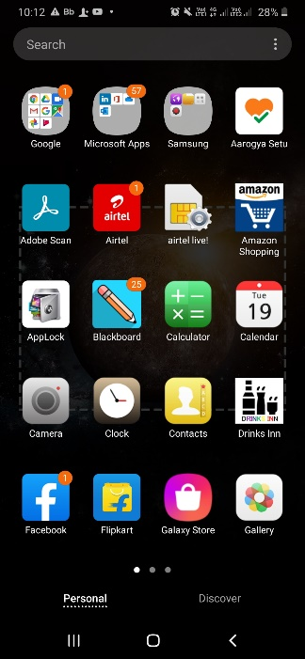

APP ICON.

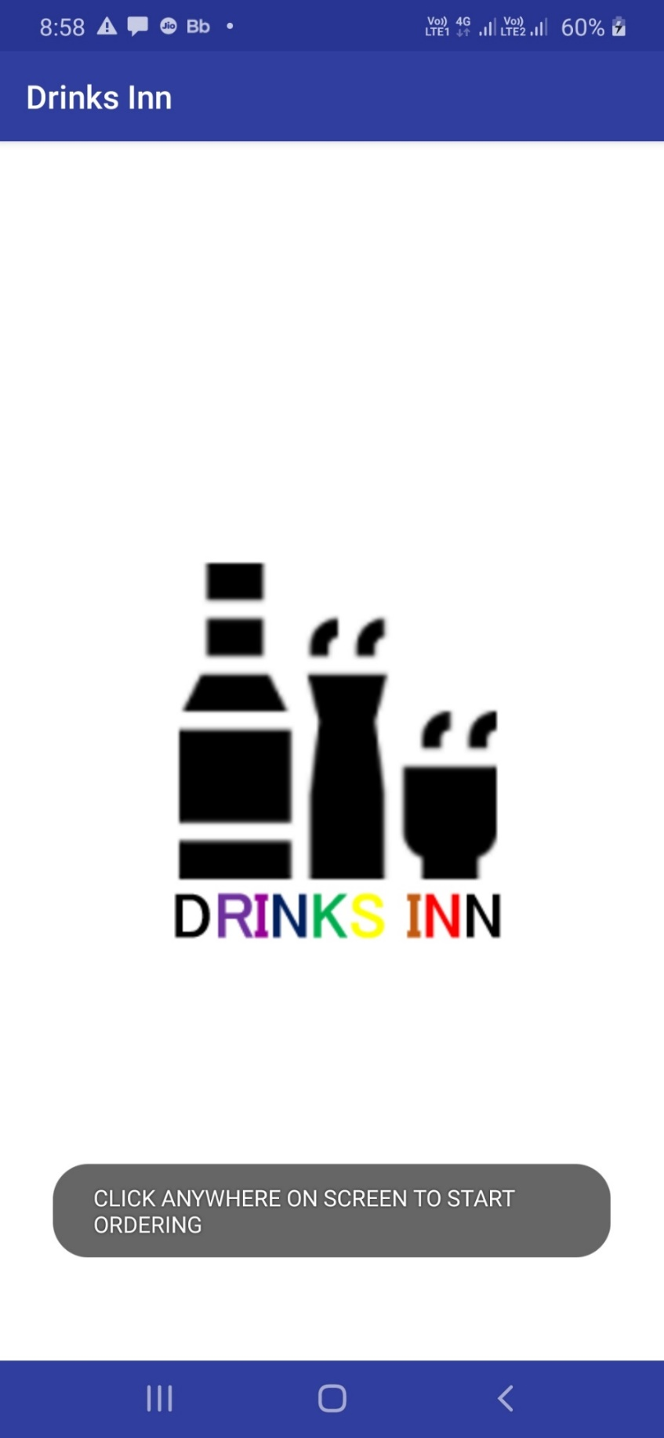

THE FRONT SCREEN AFTER OPENING APP.

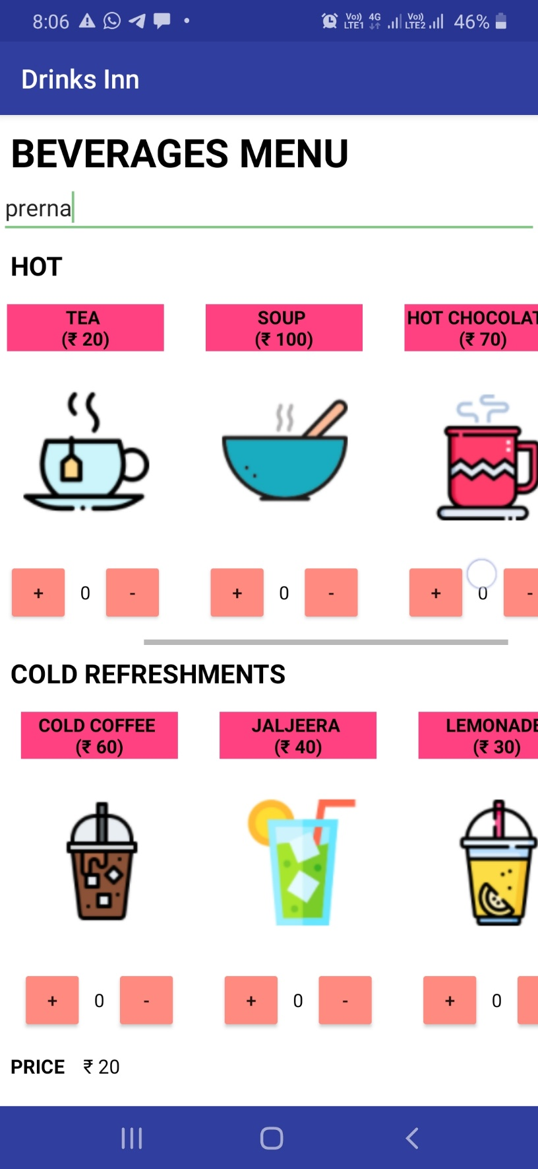

THE SCROLL VIEW UNDER EACH CATEGORY AS U CAN OBSERVE.

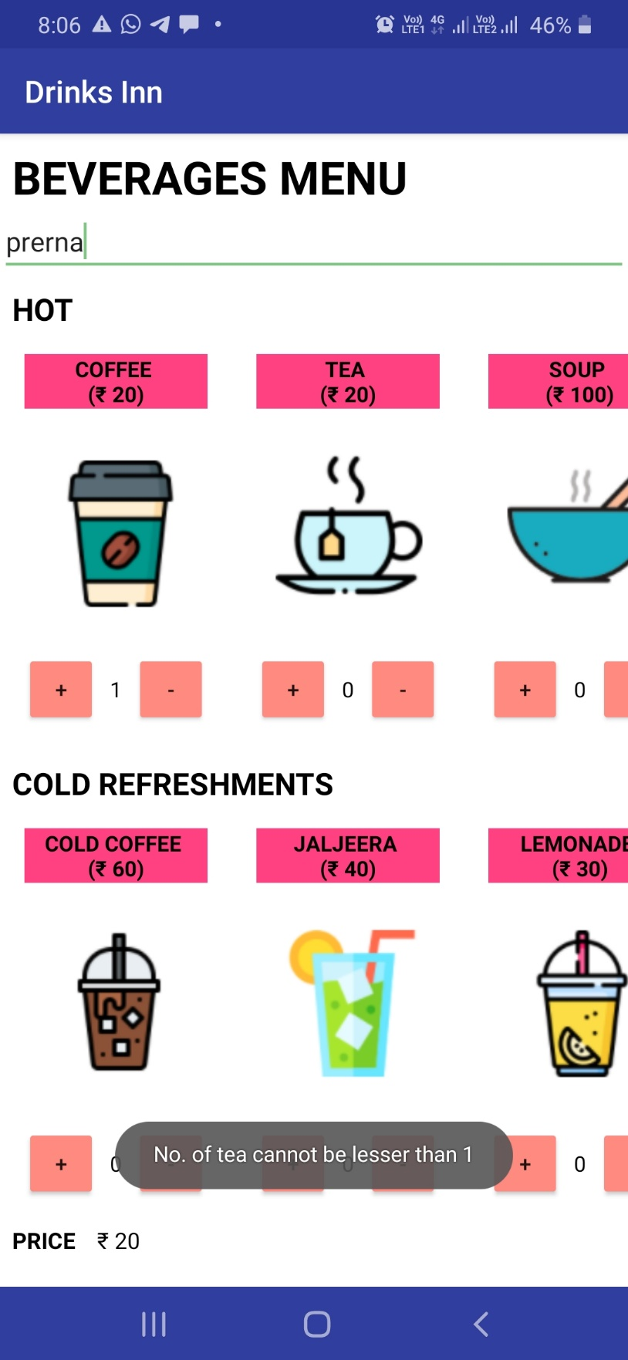

DISPLAYING ERROR WHEN WE ARE TRYING TO ORDER BEVERAGE LESS THAN 1.

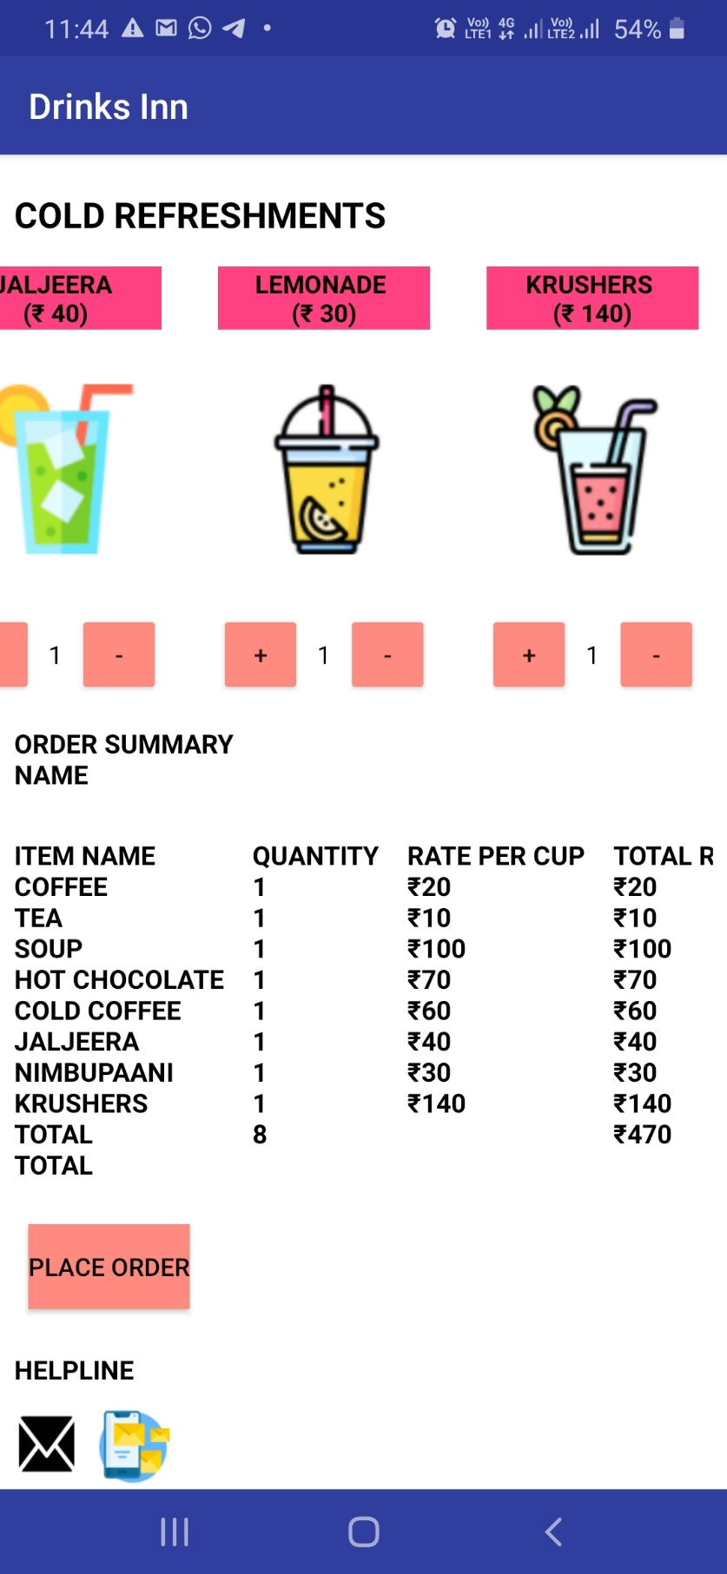

ORDER SUMMARY AND HELPINE.

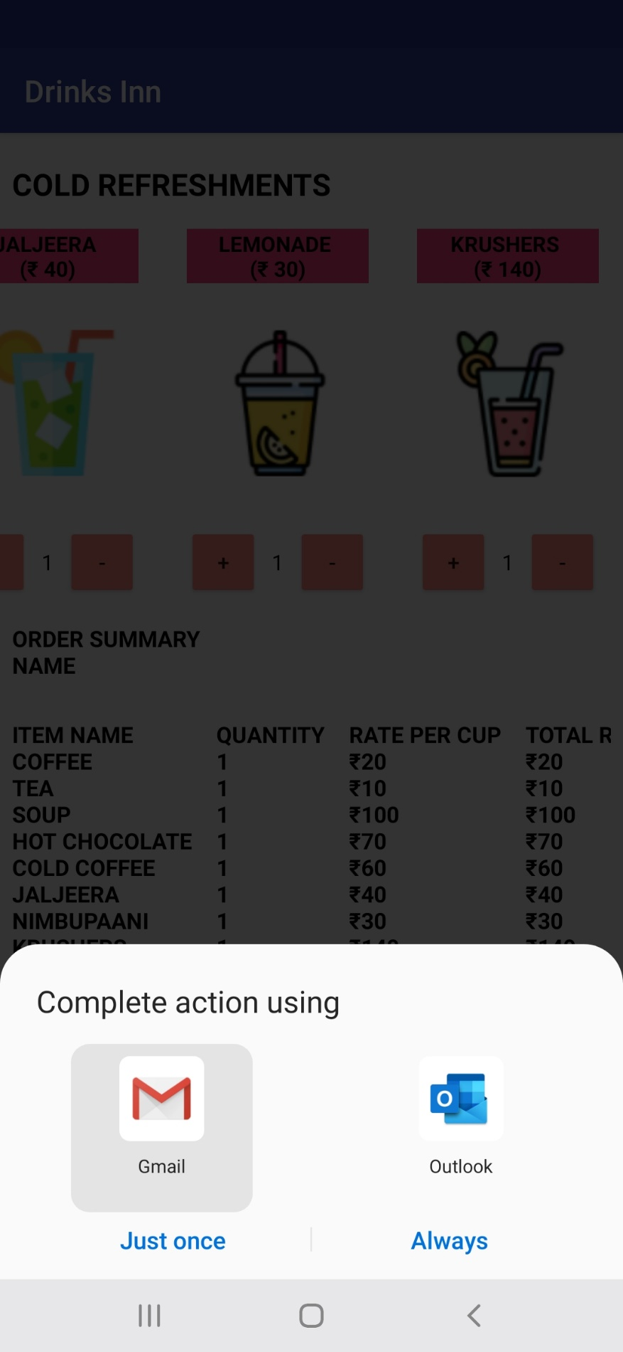

AFTER CLICKING MAIL BOX IN HELPINE

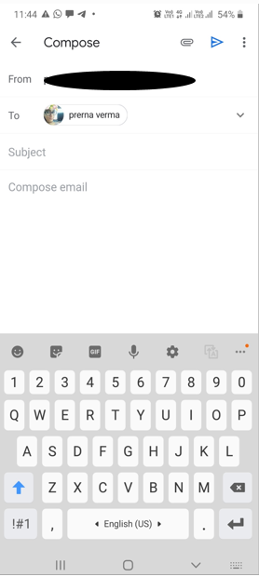

AFTER CLICKING E-MAIL BOX IN HELPINE

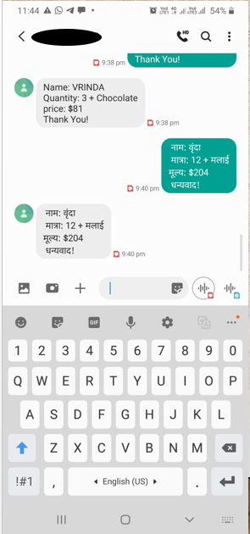

AFTER CLICKING TEXT BOX IN HELPINE

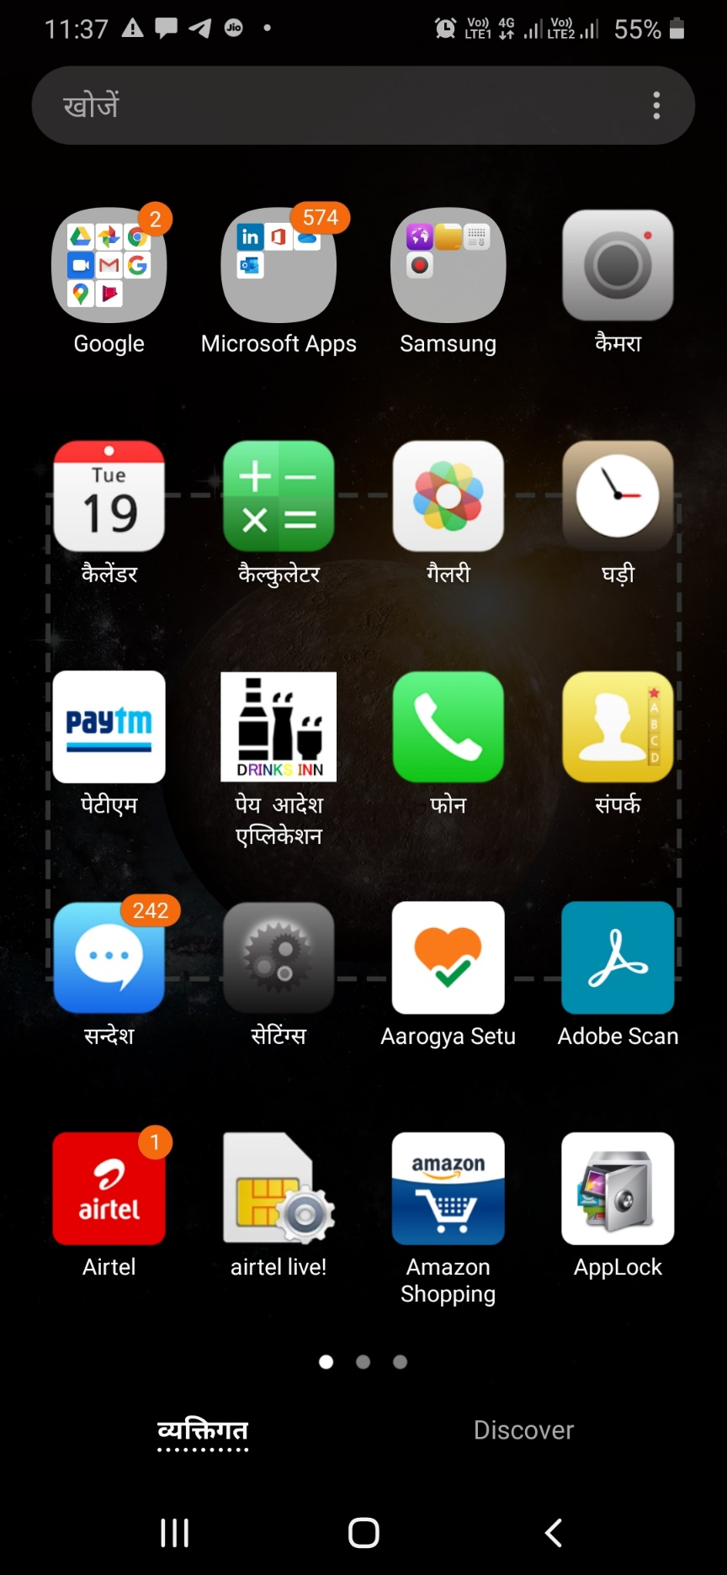

HINDI VERSION OF SAME APP

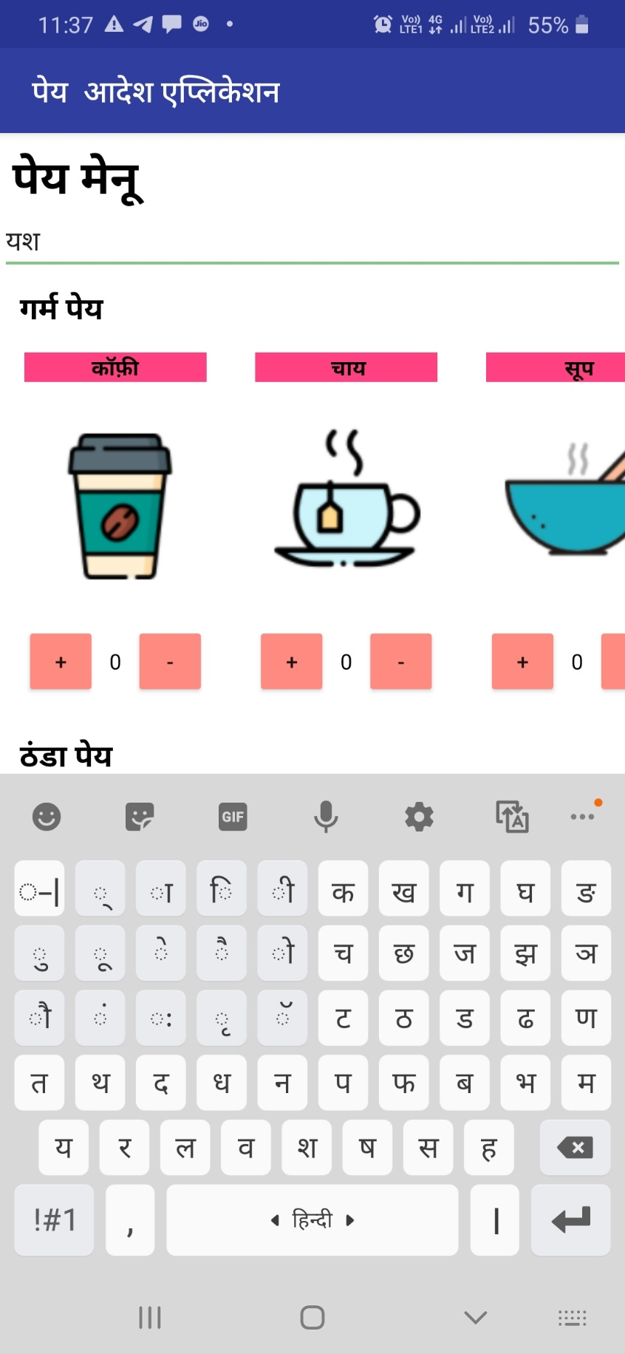

HINDI VERSION OF SAME APP

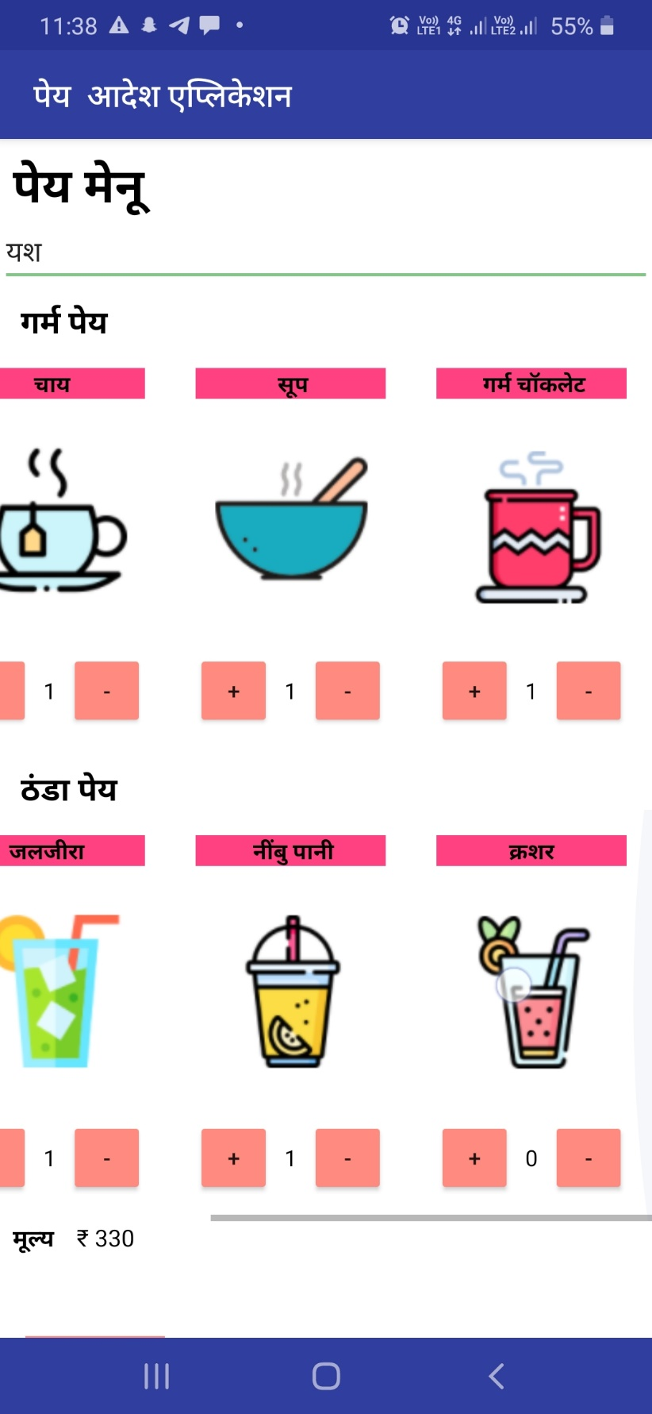

HINDI VERSION OF SAME APP

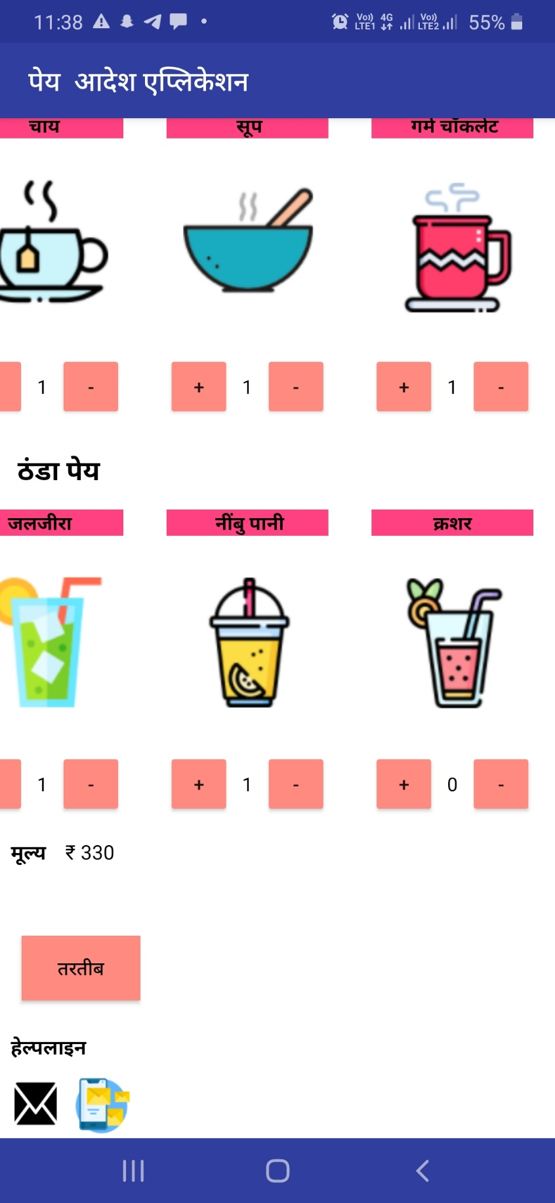

HINDI VERSION OF SAME APP

**Summary**

**Project Title:**

* Drinks Inn

**Software Used:**

* Android Studio
* Driver Samsung.

**Documentation Tools:**

* Microsoft Word
* Microsoft PowerPoint

**Project Guide:**

* Ms. Jyoti Mehra

**Submitted By:**

* Prerna Verma (19BCS3777)