***EXP.-1 LED CHASER***

**Circuit Diagram:**

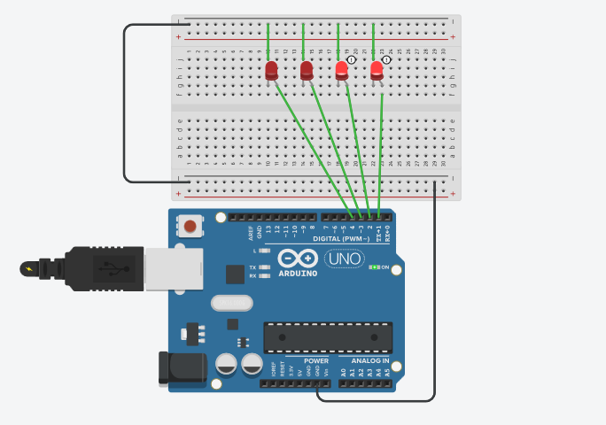

***Theory:***

**Concept Used:** In this experiment we have done coding to flash LED (Light Emitting Diode), which is held together on the Breadboard . LED flashers are semiconductor integrated circuits used to turn on and off groups of light emitting diodes either sequentially or according to a programmed pattern. Learning and Observations : Arduino is a single-board microcontroller meant to make the application more accessible which are interactive objects and its surroundings .This micro controller gives the valid instruction to the elements fitted on the breadboard according to coding done on software.

***Precautions:***

1--Postive and Negative terminals should be put in correct order. 2-All the wires and elements should be connected tightly and according to the coding done on the system. 3- The coding done on the software should be correct in every manner. All the errors should be avoided i.e. syntax,logical errors etc..

***Problems and Troubleshooting:***

1- Hardware should be correctly fitted on the Breadboard or they might get fuse or get permanently damaged . 2- The incorrect coding might cause problems in the working of hardware. This can be corrected by learning C++ and practicing it on the software. 3-Arduino wire must be checked if they are loose or not. And the ports should be properly cleaned before using ,they might cause problem in future.

***Learning Outcome:***

From this experiment we have learn how to code in the software . This project was the pillar for the upcoming project we are going to do in upcoming semester. In this project we learned how to flash a LED bulb and how to code it on the software.