Business Requirements Document (BRD)
Financial Reporting Module – Investment Company

1. Executive Summary
The Financial Reporting Module is designed to automate, standardize, and enhance financial reporting capabilities for an investment company. The system will generate accurate, real-time reports such as Profit & Loss statements, Balance Sheets, Cash Flow statements, and Portfolio Reports.
This solution will reduce manual effort, improve data accuracy, and ensure compliance with financial regulations such as IFRS and GAAP.

2. Business Objectives
- Automate financial report generation
- Reduce manual errors by at least 50%
- Provide real-time insights into portfolio performance
- Ensure compliance with financial regulations
- Improve decision-making for stakeholders

3. Stakeholders
Stakeholder | Role
Finance Team | Generate and analyze reports
Portfolio Manager | Monitor investment performance
Compliance Officer | Ensure regulatory compliance
IT Team | Maintain system
Senior Management | Strategic decision making

4. Scope
In Scope:
- P&L Reporting
- Balance Sheet Reporting
- Cash Flow Reporting
- Portfolio & Fund-Level Reports
- Export (PDF/Excel)
Out of Scope:
- Trading execution systems
- External audit tools
- Investment decision engines

5. Functional Requirements
FR1: Profit & Loss Report
- System shall generate P&L reports for selected date ranges
- Filters: Fund, Portfolio, Region
Example:
Revenue: ₹50,00,000
Expenses: ₹35,00,000
Net Profit: ₹15,00,000

FR2: Balance Sheet
- System shall display Assets, Liabilities, Equity
Example:
Assets: ₹1,20,00,000
Liabilities: ₹70,00,000
Equity: ₹50,00,000

FR3: Cash Flow Report
- System shall track inflow and outflow of cash
Example:
Cash Inflow: ₹20,00,000
Cash Outflow: ₹12,00,000
Net Cash Flow: ₹8,00,000

FR4: Portfolio Report
- System shall generate fund-level and portfolio-level reports
- Display NAV and AUM
Example:
NAV: ₹120 per unit
AUM: ₹10 Crore

FR5: Report Export
- Reports can be exported in PDF and Excel formats

FR6: User Authentication
- Secure login with role-based access

6. User Roles
Role | Access
Admin | Full access
Analyst | Generate and view reports
Compliance | Audit reports

7. Non-Functional Requirements
- Performance: Reports generated within 5 seconds
- Security: Role-based access control
- Availability: 99.9% uptime
- Compliance: IFRS / GAAP
- Scalability: Support 1000+ users

8. Data Requirements
- Portfolio Data
- Transaction Data
- Market Data
- User Data

9. Data Flow Diagram (DFD)
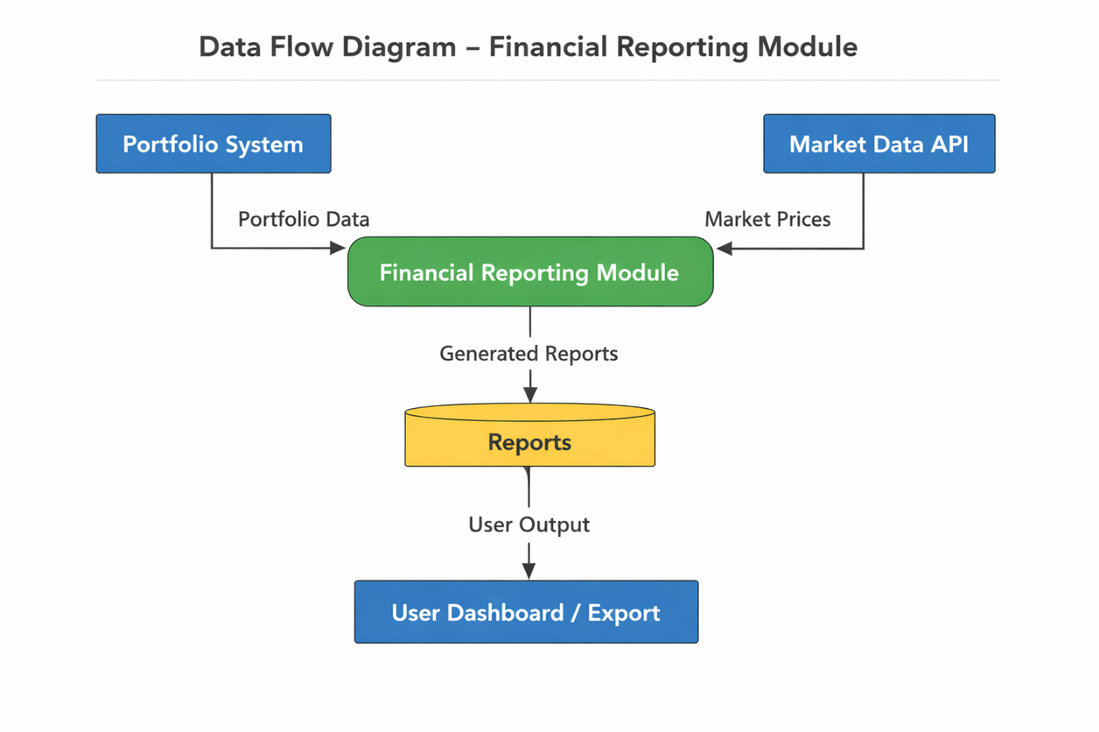

10. Integration Requirements
- Portfolio Management System
- ERP System
- Market Data APIs

11. Assumptions
- Source data is accurate
- Users have financial knowledge
- Systems are available

12. Constraints
- Budget limitations
- Dependency on external systems
- Data availability

13. Success Criteria
- Reports generated within 5 seconds
- 50% reduction in manual work
- High data accuracy
- Positive user feedback

14. Glossary
- P&L: Profit & Loss
- NAV: Net Asset Value
- AUM: Assets Under Management
- ERP: Enterprise Resource Planning

15.Use Case diagram
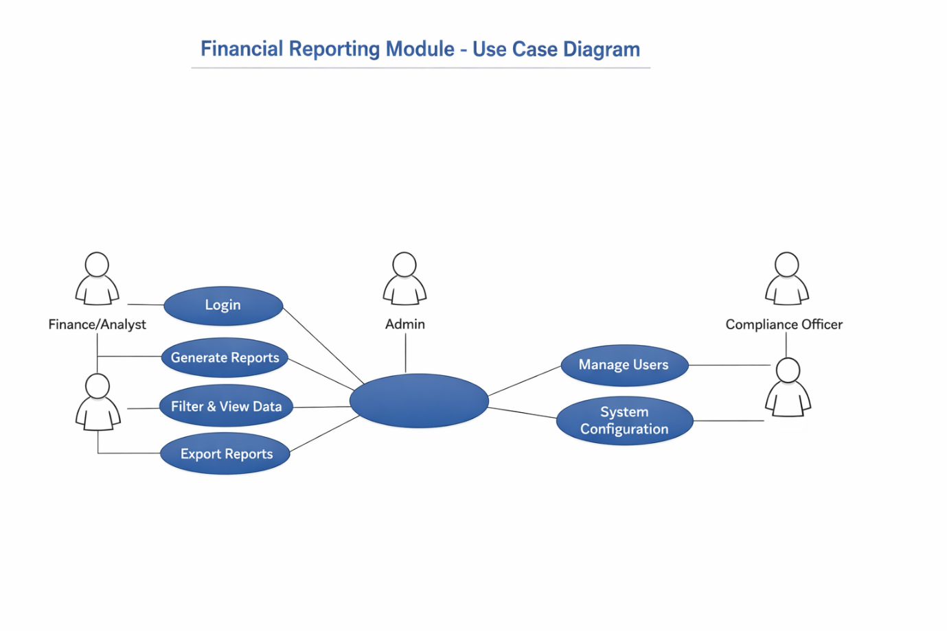
16.User Workflow (Step-by-Step Journey)
Workflow: Generate Financial Report
- User logs into the system using secure credentials
- System authenticates user and loads dashboard based on role
- User selects "Generate Report"
- User chooses report type (P&L / Balance Sheet / Cash Flow / Portfolio)
- User applies filters (date range, fund, portfolio, region)
- System fetches data from integrated sources (Portfolio System, ERP, Market Data)
- System processes and aggregates data
- Report is generated and displayed on screen
- User reviews report
- User exports report as PDF/Excel (optional)
- Compliance user can audit/view the report (if required)

15. Conclusion
This BRD provides a structured approach to building a Financial Reporting Module that meets business needs, ensures compliance, and improves operational efficiency.

