Introduction to Data Visualization
Data visualization is the graphical representation of data using plots, charts, and graphs. It helps in understanding patterns, trends, relationships, and insights from datasets. Visualization is essential in data analysis, machine learning, and business intelligence.
Python provides several powerful visualization libraries. This documentation focuses on:
- Matplotlib
- Seaborn

Matplotlib Library Overview
Matplotlib is a comprehensive Python library used for creating static, animated, and interactive visualizations. It was introduced by John Hunter in 2002 and is built on NumPy.
Key Features
- Full customization control
- Supports multiple plot types
- Works with NumPy and Pandas
- Suitable for publication-quality graphs
- Supports subplots and multiple axes

Import Libraries
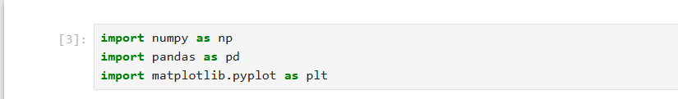

Matplotlib Graph Types with Examples
3.1 Line Plot
Use Case
Used to show growth over time, like temperature or sales.
Code Example
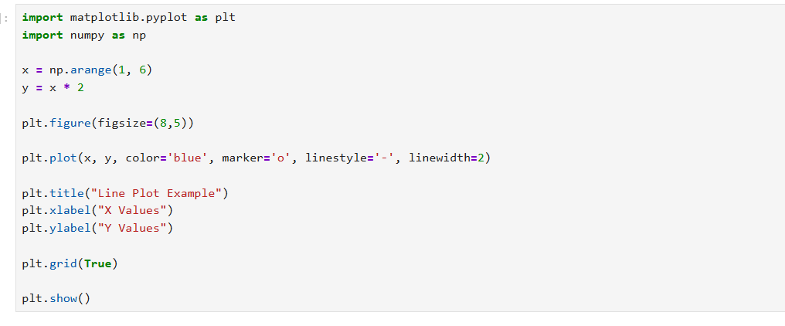
Output:
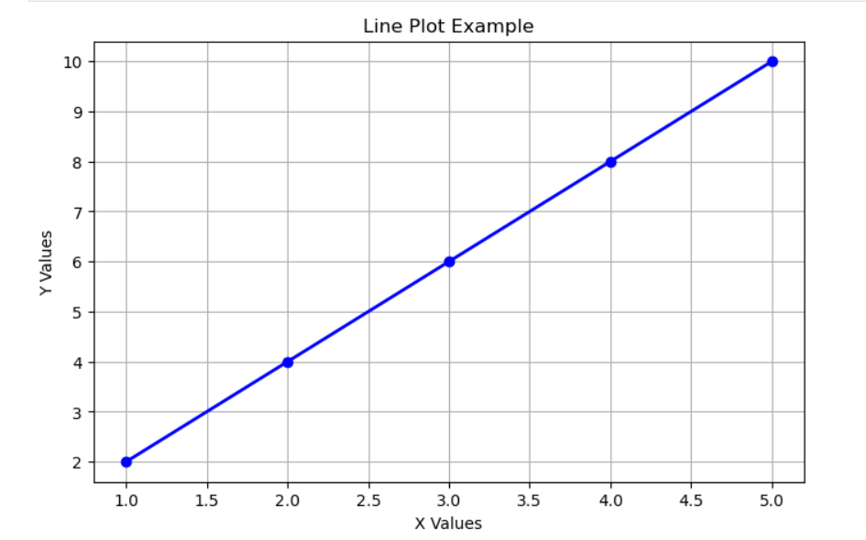
Description:
The line plot shows the relationship between X and Y values using a continuous line. It helps to visualize trends or changes over a sequence.
Here, x contains values from 1 to 5 and y contains double of x values.
plt.plot() is used to draw the line.
marker='o' shows points, linestyle='-' shows a solid line, and color='blue' sets the line color.
plt.grid(True) adds a grid for better readability.

3.2 Bar Chart
Use Case
Used to compare sales, marks, or counts.

Code Example
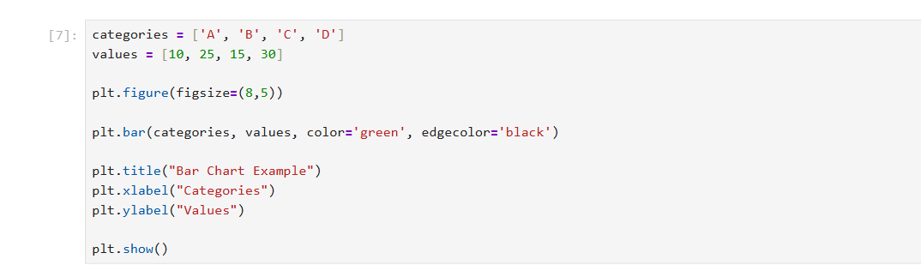

Output:
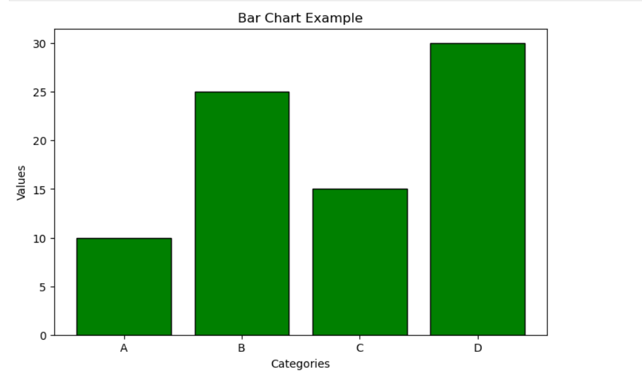
Description:
The bar chart is used to compare different categories using rectangular bars.
Here, categories contains labels A, B, C, and D, and values contains their corresponding numbers.
plt.bar() creates the bar chart.
color='green' sets the bar color and edgecolor='black' sets the border color.
This helps to visually compare values between categories.

3.3 Scatter Plot
Use Case
Used to find correlation.

Code Example
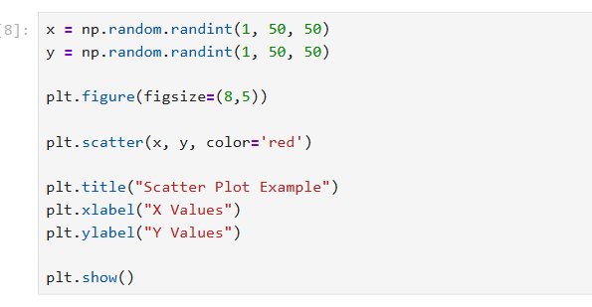
Output:
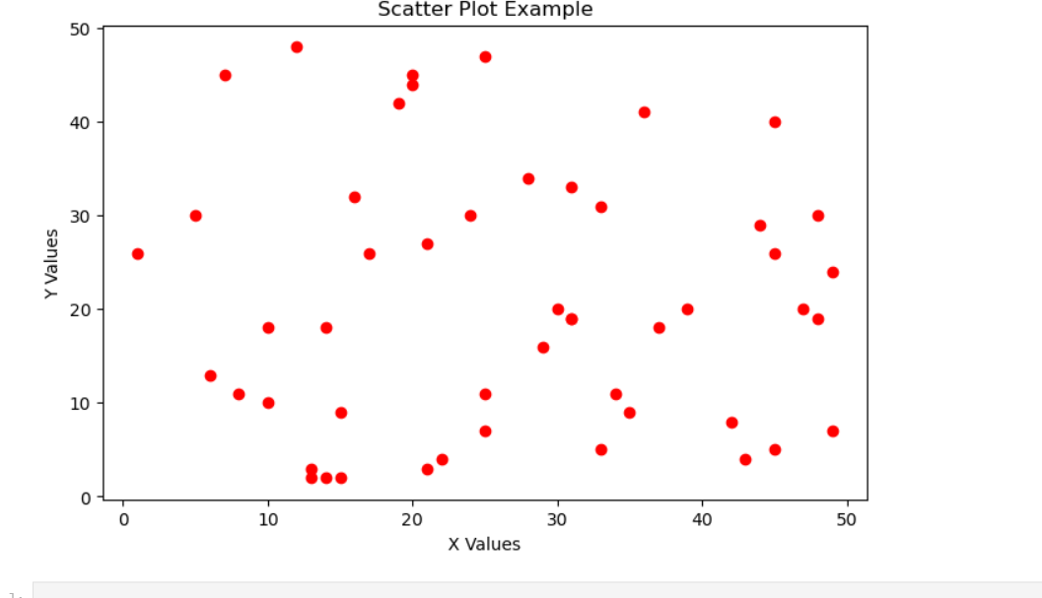
Description:
The scatter plot shows the relationship between two numerical variables using points.
Here, x and y contain random values.
plt.scatter() plots points on the graph.
Each dot represents one pair of values.
This plot helps to identify patterns, trends, or correlation between variables.

3.4 Histogram
Use Case
Used to see frequency distribution.

Code Example
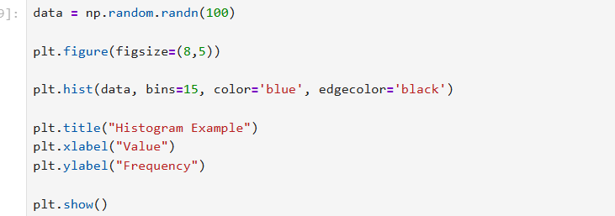

Output:
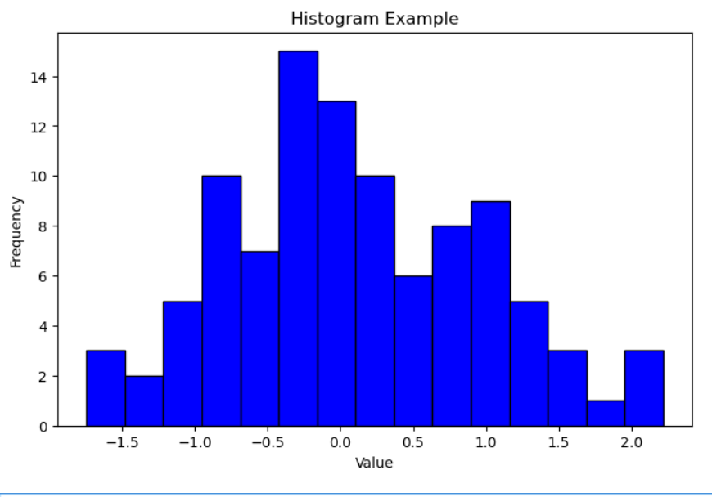
Description:
The histogram shows the distribution and frequency of data values.
Here, data contains 100 random values.
plt.hist() divides the data into bins and shows how many values fall into each bin.
bins=15 sets the number of groups and edgecolor='black' improves visibility.
It helps to understand how data is distributed.

3.5 Pie Chart
Use Case
Used to show market share.

Code Example
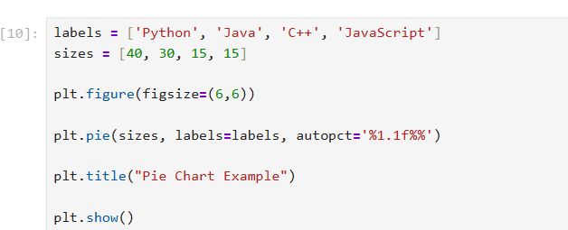

Output:
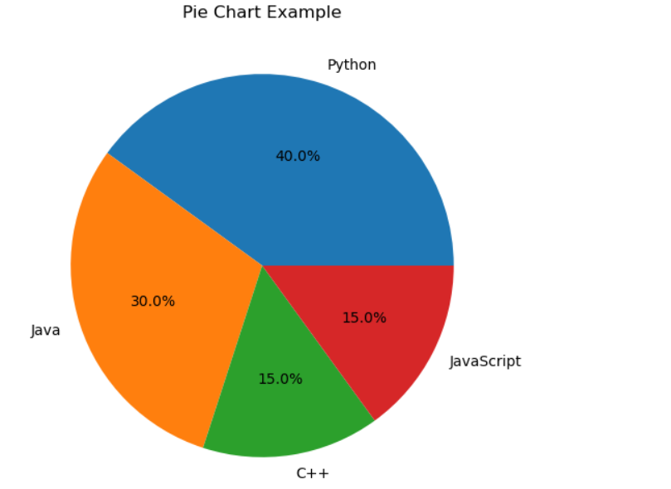
Description:
The pie chart shows the percentage distribution of different categories.
Here, labels contains programming language names and sizes contains their values.
plt.pie() creates the pie chart.
autopct='%1.1f%%' displays percentage values on the chart.
This helps to see the proportion of each category.

Seaborn Overview
Seaborn is a visualization library built on top of matplotlib. It provides more attractive and advanced statistical graphs.
Features
- Easy to use
- Beautiful default styles
- Works well with pandas data
- Provides statistical plots

Import Libraries
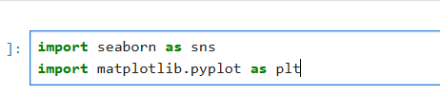

Graph Types in Seaborn
We will use built-in dataset called "tips".
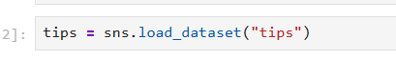

5.1 Scatter Plot
Code
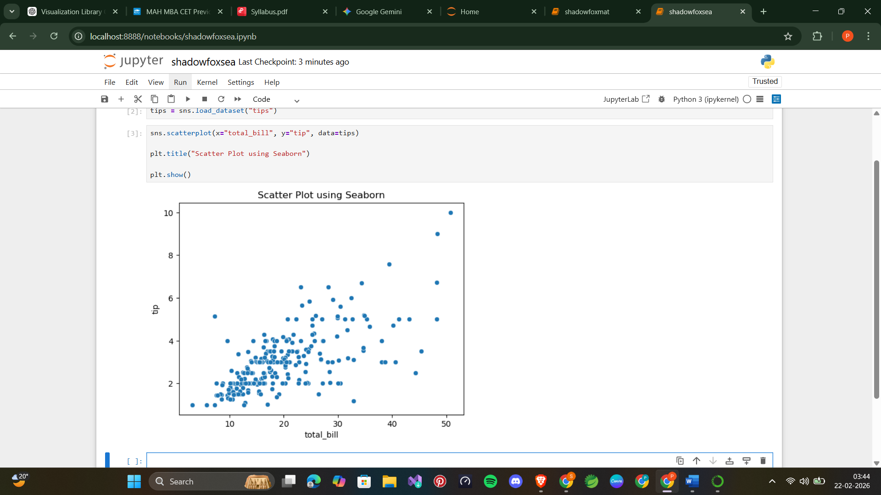

Output:
Description:
The scatter plot shows the relationship between total bill and tip amount.
Here, x="total_bill" and y="tip" represent the variables.
data=tips provides the dataset.
sns.scatterplot() creates the scatter plot.
It helps to see how tip changes with total bill.

5.2 Bar Plot
Code
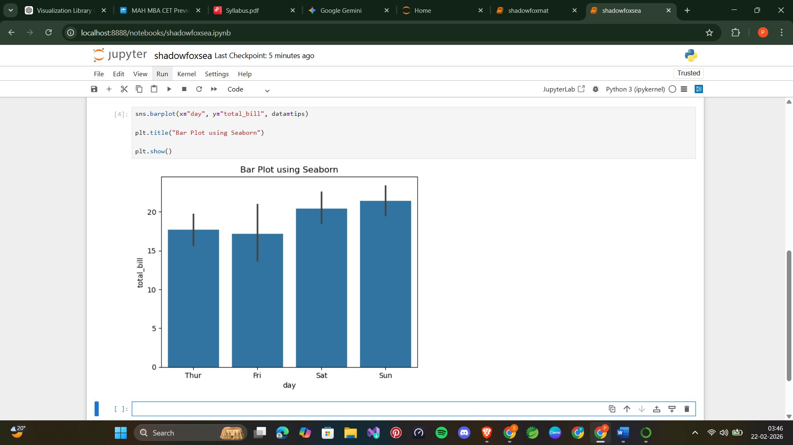

Output:
Description:
The bar plot shows the average total bill amount for each day.
Here, x="day" represents the days and y="total_bill" represents the values.
sns.barplot() calculates and displays the average automatically.
It helps to compare values between different categories.

5.3 Box Plot
Code
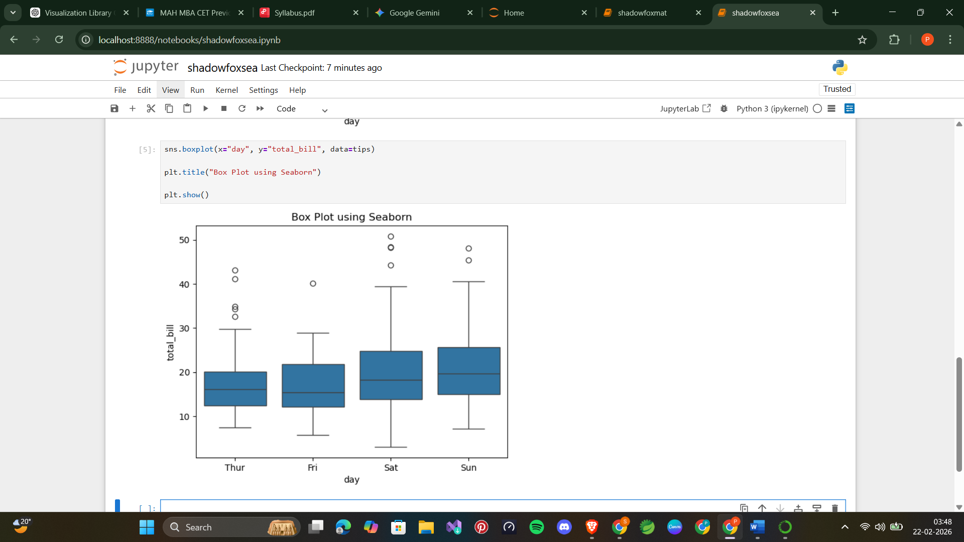

Output:
Description:
The box plot shows the distribution of total bill values and identifies outliers.
Here, x="day" represents categories and y="total_bill" represents numerical values.
sns.boxplot() creates the box plot.
The box shows quartiles and the lines show range and outliers.
It helps to understand data spread and variation.

5.4 Histogram
Code
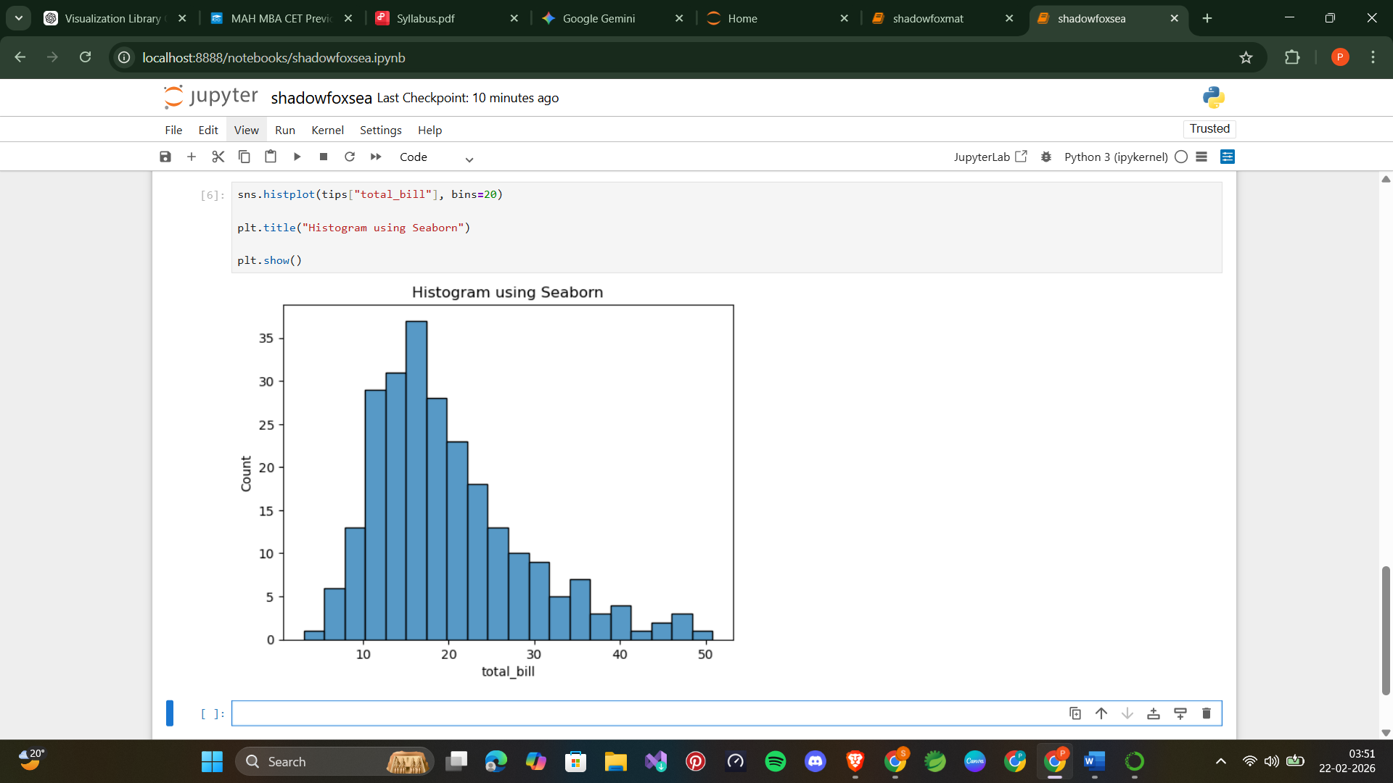

Output:
Description:
The histogram shows the distribution of total bill values.
Here, tips["total_bill"] provides the data.
sns.histplot() creates the histogram.
bins=20 divides the data into 20 groups.
It helps to see frequency and distribution of values.

5.5 Heatmap
Code
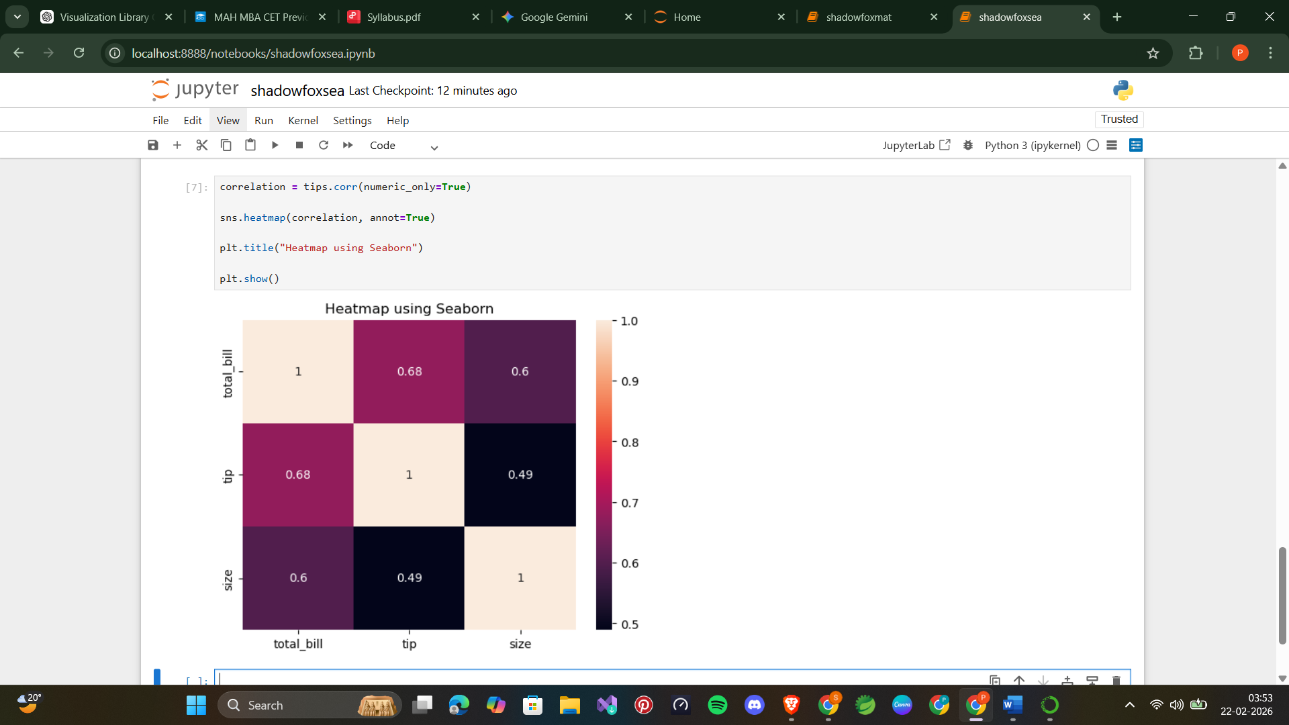

Output:
Description:
The heatmap shows the correlation between numerical variables.
Here, tips.corr() calculates correlation values.
sns.heatmap() displays them using colors.
annot=True shows the correlation numbers inside the boxes.
It helps to identify relationships between variables.

Comparison Between Matplotlib and Seaborn
Matplotlib and Seaborn are both widely used visualization libraries in Python, but they serve slightly different purposes and have different strengths.
Matplotlib is a low-level visualization library that provides full control over every part of the graph. It allows users to customize colors, labels, line styles, markers, grid, and other elements in detail. Because of this flexibility, Matplotlib is suitable for creating customized and complex visualizations. However, it requires more code and effort to make visually attractive graphs.
Seaborn, on the other hand, is built on top of Matplotlib and provides a high-level interface. It is easier to use and requires less code to create beautiful and informative graphs. Seaborn has built-in themes, color palettes, and statistical plotting functions. It is especially useful for statistical analysis, such as showing distributions, correlations, and relationships between variables.
Matplotlib is better when full control and customization are required, while Seaborn is better for quick, attractive, and statistical visualizations.
Comparison Table
Feature | Matplotlib | Seaborn
Ease of use | Medium – requires more code | Easy – requires less code
Customization | High – full control over graphs | Medium – limited compared to Matplotlib
Appearance | Basic by default | Attractive and modern by default
Statistical plots | Limited statistical support | Advanced statistical visualization
Built on | Independent library | Built on Matplotlib

7. Conclusion
Matplotlib and Seaborn are both important libraries for data visualization in Python. They help users understand data by representing it in graphical form.
Matplotlib provides complete control over the visualization. It allows users to customize every part of the graph, such as colors, labels, grid, size, and style. It is useful when detailed customization and flexibility are required. Matplotlib is commonly used in research, engineering, and data analysis.
Seaborn is built on top of Matplotlib and makes visualization easier and more attractive. It provides better default styles and built-in statistical plots such as box plots, heatmaps, and distribution plots. It is very useful for exploratory data analysis and understanding relationships between variables.
In real-world applications, both libraries are often used together. Matplotlib is used for customization, while Seaborn is used for statistical and attractive visualizations.
Therefore, both Matplotlib and Seaborn are essential tools for data visualization, and understanding them is important for data science, machine learning, and data analysis.

