TECHNOLOGY, MEDIA & TELECOMMUNICATIONS
Microsoft's Acquisition of Activision Blizzard, Inc.
Executive Summary — Illustrative M&A Deal Analysis
Prepared by Prerna Dudhmande
Acquirer | Microsoft Corporation (NASDAQ: MSFT)
Target | Activision Blizzard, Inc. (formerly NASDAQ: ATVI)
Consideration | $95.00 per share, all-cash
Equity Value / Final Consideration | $68.7bn announced / $75.4bn at closing
Announced / Closed | January 18, 2022 / October 13, 2023
Advisors | Goldman Sachs (Microsoft) • Allen & Company (Activision Blizzard)
Transaction Overview
On January 18, 2022, Microsoft Corporation announced a definitive agreement to acquire Activision Blizzard, Inc. for $95.00 per share in an all-cash transaction, implying an equity value of $68.7 billion — the largest transaction in the video game industry's history and the largest acquisition in Microsoft's corporate history. The deal closed on October 13, 2023, following an unprecedented, roughly 21-month multi-jurisdictional antitrust contest across the United States, United Kingdom, and European Union.
Strategic Rationale
- Subscription flywheel: owning (not licensing) Activision Blizzard's franchise catalogue accelerates Xbox Game Pass subscriber growth and retention.
- Mobile gaming at scale: King's Candy Crush franchise provides immediate, scaled entry into the largest platform segment in the global games market.
- Cloud gaming content moat: first-party ownership anchors Xbox Cloud Gaming's differentiation, leveraging Microsoft's Azure infrastructure.
- Competitive repositioning: moves Microsoft to the third-largest gaming company globally by revenue, behind Tencent and Sony.
Valuation
Microsoft's offer implied an EV/EBITDA multiple of approximately 16.5x–18.2x — above the peer trading median but below the ~20x average paid in comparable precedent gaming transactions, consistent with disciplined rather than promotional pricing for a scarce, category-leading asset.
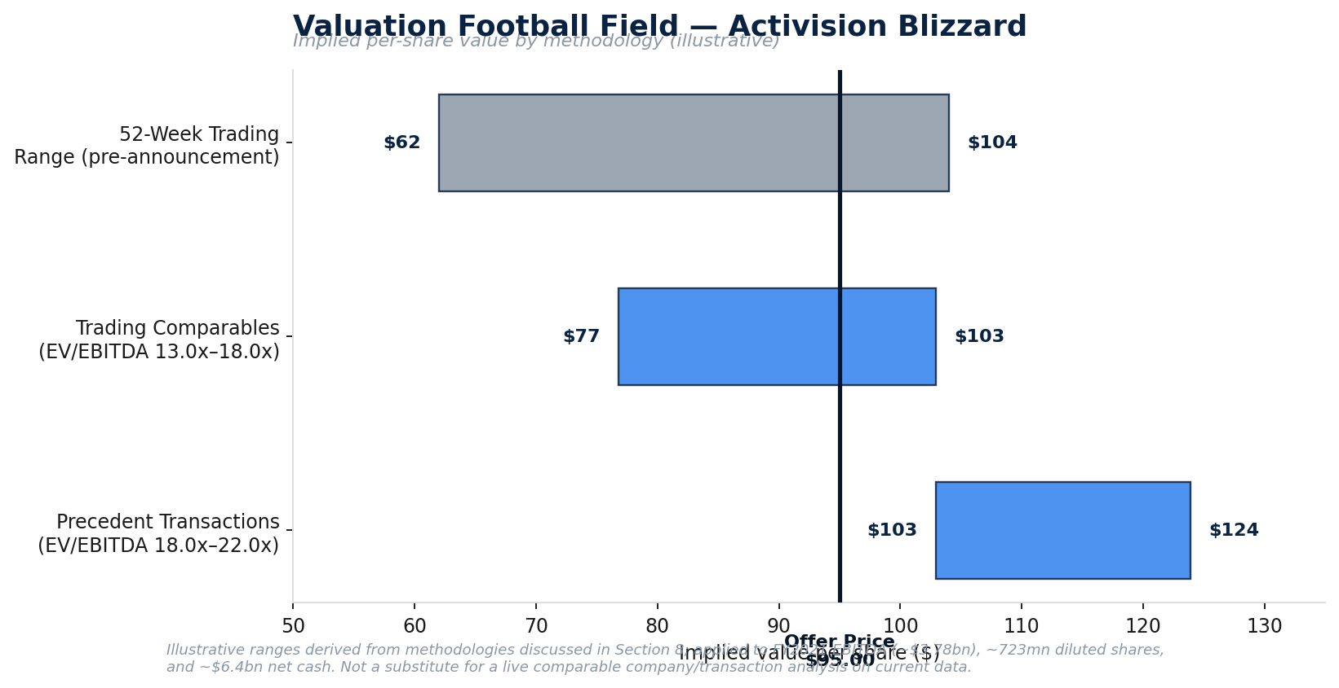
Exhibit. Valuation football field — implied per-share value by methodology (illustrative).
Regulatory Path
The transaction survived the most extensive regulatory contest in gaming M&A history: the U.S. FTC sued to block the deal and lost in federal court; the UK CMA issued an outright Phase 2 prohibition, later reversed following a structural divestiture of cloud-streaming rights to Ubisoft; and the European Commission cleared the deal subject to a behavioral licensing remedy. Approximately 40 other jurisdictions cleared the transaction unconditionally.
Financial Impact
Microsoft's FY2024 Form 10-K shows a near-neutral GAAP EPS impact through the first full fiscal year post-close ($11.80 actual vs. $11.82 pro forma diluted EPS) — a pattern consistent with purchase-accounting drag (intangible amortization, deferred revenue haircut, integration costs) temporarily offsetting the underlying revenue growth of the acquired business.
Post-Acquisition Performance & Conclusion
Call of Duty: Black Ops 6 (October 2024) delivered the largest console launch in franchise history and record Xbox Game Pass subscriber additions, validating the multi-platform strategy. Set against this, the integration has generated substantial organizational disruption — multiple rounds of layoffs, two shuttered studios, and a Game Pass pricing backlash. On balance, the transaction is best characterized as provisionally value-creating on strategic grounds, with financial value creation still being confirmed on a multi-year view.

