TECHNOLOGY, MEDIA & TELECOMMUNICATIONS
M&A DEAL ANALYSIS
Project Anchorage
Microsoft Corporation's Acquisition of Activision Blizzard, Inc.
An M&A Deal Analysis Prepared in the Format of a Sell-Side / Buy-Side Advisory Post-Mortem
Prepared by Prerna Dudhmande
Acquirer | Microsoft Corporation (NASDAQ: MSFT)
Target | Activision Blizzard, Inc. (formerly NASDAQ: ATVI)
Announcement Date | January 18, 2022
Closing Date | October 13, 2023
Transaction Value | $95.00 per share — $68.7bn equity value / $75.4bn final consideration
Classification | Illustrative Deal Analysis — Portfolio & Educational Purposes
Date of Analysis | July 2026
This document has been prepared as an independent, illustrative deal analysis modeled on the format of a sell-side/buy-side M&A post-mortem of the type circulated among deal teams and senior bankers. It is not an official publication of, and is not affiliated with, endorsed by, or produced on behalf of Microsoft Corporation, Activision Blizzard, Inc., or any of the financial institutions referenced herein. All financial figures are drawn from public filings, company disclosures, and reputable financial media, and are presented for analytical and educational purposes. Certain comparable company and precedent transaction multiples are presented as illustrative ranges consistent with market conditions at the relevant time and should be refreshed against live Bloomberg/Capital IQ data in a live deal context.

Table of Contents
1. Executive Summary3
2. Acquirer Overview — Microsoft Corporation5
3. Target Company Overview — Activision Blizzard, Inc.8
4. Gaming Industry Overview11
5. Transaction Overview15
6. Strategic Rationale18
7. Synergy Analysis20
8. Valuation Analysis23
9. Financial Impact27
10. Regulatory Review31
11. Integration Challenges35
12. Risk Analysis38
13. SWOT Analysis41
14. Market Reaction42
15. Post-Acquisition Performance44
16. Key Lessons for Investment Bankers46
17. Conclusion48
18. References49

1. EXECUTIVE SUMMARY

1.1 Transaction Overview
On January 18, 2022, Microsoft Corporation ("Microsoft," "MSFT," or the "Acquirer") announced a definitive agreement to acquire Activision Blizzard, Inc. ("Activision Blizzard," "ATVI," or the "Target") in an all-cash transaction. The deal represented the largest acquisition in Microsoft's corporate history and the largest transaction ever undertaken in the video game industry, surpassing the prior record held by Take-Two Interactive's contemporaneous $12.7 billion agreement to acquire Zynga (announced the same week) by a factor of more than five times.
Under the terms of the merger agreement, Microsoft agreed to acquire all outstanding shares of Activision Blizzard common stock for $95.00 per share in cash, implying a total equity purchase price of $68.7 billion, inclusive of Activision Blizzard's net cash position. The transaction was structured as a reverse triangular merger, whereby a wholly owned merger subsidiary of Microsoft merged with and into Activision Blizzard, with Activision Blizzard surviving as a wholly owned subsidiary of Microsoft.

1.2 Key Transaction Metrics
Metric | Value
Acquirer | Microsoft Corporation (NASDAQ: MSFT)
Target | Activision Blizzard, Inc. (formerly NASDAQ: ATVI)
Announcement Date | January 18, 2022
Closing Date | October 13, 2023 (approx. 21 months post-announcement)
Consideration | $95.00 per share, all-cash
Equity Purchase Price | $68.7 billion
Implied Enterprise Value (net of target cash) | ~$62.3 billion
Premium to Unaffected Share Price (Jan. 14, 2022 close of $65.39) | ~45%
Structure | Reverse triangular merger; all-cash; funded from balance sheet cash and short-term borrowings
Acquirer Financial Advisor | Goldman Sachs & Co. LLC
Target Financial Advisor | Allen & Company LLC
Acquirer Legal Counsel | Simpson Thacher & Bartlett LLP; Weil, Gotshal & Manges LLP (antitrust)
Target Legal Counsel | Skadden, Arps, Slate, Meagher & Flom LLP; Slaughter and May (UK)
Regulatory Approvals Required | United States (FTC), United Kingdom (CMA), European Union (European Commission), and ~40 additional jurisdictions

1.3 Strategic Significance
The transaction represented a decisive escalation in Microsoft's multi-year strategy of vertically integrating content ownership into its gaming platform economics, following smaller precedent acquisitions of ZeniMax Media/Bethesda Softworks ($7.5 billion, 2020) and a string of first-party studio acquisitions dating to 2018. The rationale, as publicly articulated by Microsoft, centered on four pillars: (i) accelerating growth of Xbox Game Pass, Microsoft's subscription gaming service, through the addition of Activision Blizzard's franchise portfolio (Call of Duty, World of Warcraft, Diablo, Overwatch, Candy Crush); (ii) establishing a leadership position in mobile gaming — the largest and fastest-growing segment of the games market — via King Digital Entertainment's Candy Crush franchise; (iii) building scale in cloud gaming ahead of an anticipated platform shift away from console-bound hardware; and (iv) securing content "building blocks" for Microsoft's broader ambitions in immersive and metaverse-adjacent computing, a framing that has since receded from Microsoft's public messaging as the industry's strategic center of gravity shifted toward generative artificial intelligence.
Upon signing, the transaction was expected to make Microsoft the third-largest gaming company in the world by revenue, behind Tencent and Sony. It was also, at signing, expected to close within Microsoft's fiscal year 2023 (ending June 30, 2023); in practice, an unprecedented cross-jurisdictional regulatory contest — culminating in litigation with the U.S. Federal Trade Commission and an outright prohibition decision by the UK Competition and Markets Authority — extended the closing timeline by approximately four months beyond the original outside date, with the transaction ultimately closing on October 13, 2023, following a substantial restructuring of Activision Blizzard's cloud-streaming rights.

1.4 Analytical Conclusion (Preview)
As detailed in Sections 8–17 below, the transaction is best characterized as a strategically coherent but full-value acquisition, priced at a substantial premium and elevated multiple of both revenue and EBITDA relative to Activision Blizzard's standalone trading history, financed conservatively (all-cash, minimal incremental leverage), and executed against an unusually adversarial global regulatory backdrop that materially increased execution risk and extended timeline, deal cost, and reputational exposure. Post-closing, the acquisition has delivered clear evidence of commercial validation — most visibly through the record-setting performance of Call of Duty: Black Ops 6 on Xbox Game Pass in October 2024 — while simultaneously generating substantial organizational disruption, including multiple rounds of layoffs, at least two shuttered studios, and consumer-facing price increases to Xbox Game Pass that have drawn continued regulatory and public scrutiny. Whether the transaction ultimately proves value-creating for Microsoft shareholders on a risk-adjusted, multi-year basis remains a matter of ongoing assessment, addressed in Section 17.

2. ACQUIRER OVERVIEW — MICROSOFT CORPORATION

2.1 Corporate Overview
Microsoft Corporation is a Redmond, Washington-headquartered multinational technology company, founded in 1975 by Bill Gates and Paul Allen, and listed on the NASDAQ Global Select Market (ticker: MSFT). Microsoft is one of the world's largest companies by market capitalization and a constituent of the Dow Jones Industrial Average, the S&P 500, and the NASDAQ-100. At the time of the Activision Blizzard announcement, Microsoft's market capitalization stood at approximately $2.3 trillion, making it, alongside Apple, one of only two U.S. public companies to have crossed the $2 trillion threshold at that point in time.
Microsoft's business is organized into three reportable segments, each reflecting a distinct customer orientation rather than a single product category:
- Productivity and Business Processes — Office 365 Commercial and Consumer, LinkedIn, Dynamics 365 and Dynamics ERP/CRM products.
- Intelligent Cloud — Azure and other cloud services, server products (SQL Server, Windows Server, GitHub), and enterprise services.
- More Personal Computing — Windows (OEM and Commercial), Devices (Surface), Search and news advertising (Bing, Microsoft Advertising), and Gaming (Xbox hardware, Xbox content and services, including Xbox Game Pass).
Gaming sits within the More Personal Computing segment, and prior to the Activision Blizzard acquisition it was consistently the smallest and most cyclical of Microsoft's major product lines — a structurally important detail, since it explains why Microsoft's board and management were willing to countenance the single largest acquisition in company history for a business that, standalone, remained a minority contributor to consolidated revenue.

2.2 Business Model and Revenue Streams
Microsoft's revenue model reflects one of the most successful enterprise transitions from perpetual-license software to recurring, cloud-delivered subscription revenue among large-capitalization technology companies. The principal revenue streams are:
Revenue Stream | Segment | Description
Commercial cloud (Azure, Office 365, Dynamics 365) | Intelligent Cloud / Productivity | Consumption- and seat-based subscription revenue; the primary driver of consolidated growth
Office / Microsoft 365 | Productivity and Business Processes | Seat-based subscription (commercial) and consumer subscription/perpetual licensing
LinkedIn | Productivity and Business Processes | Subscription (Talent Solutions, Premium), advertising, and marketing solutions
Windows OEM and Commercial | More Personal Computing | Licensing to OEM device manufacturers and enterprise volume licensing
Search and news advertising | More Personal Computing | Bing and Microsoft Advertising, monetized on a cost-per-click/impression basis
Devices (Surface) | More Personal Computing | Hardware sales
Gaming (Xbox) | More Personal Computing | Console hardware (typically low- or negative-margin, "razor" economics); Xbox content and services — digital game sales, third-party royalties, Xbox Game Pass subscriptions, and, following the ATVI close, Activision, Blizzard, and King content

The strategic logic of the Activision Blizzard acquisition is inseparable from Microsoft's broader "cloud-and-subscription-first" corporate strategy: Xbox Game Pass is, in effect, the gaming-industry analogue of Office 365 — a recurring-revenue subscription wrapper around a content library — and Microsoft's stated ambition has been to replicate, in interactive entertainment, the same subscription-economics transformation it achieved in productivity software.

2.3 Financial Performance
Table 2.1 — Microsoft Corporation Selected Consolidated Financial Data (Fiscal Years Ended June 30)
($ in billions, except per-share data) | FY2020 | FY2021 | FY2022
Revenue | $143.0 | $168.1 | $198.3
Revenue growth (YoY) | 14% | 18% | 18%
Operating income | $52.9 | $70.0 | $83.4
Net income | $44.3 | $61.3 | $72.7
Diluted EPS | $5.76 | $8.05 | $9.65
Cash & short-term investments (period-end) | ~$130bn+ | ~$130bn+ | ~$104bn

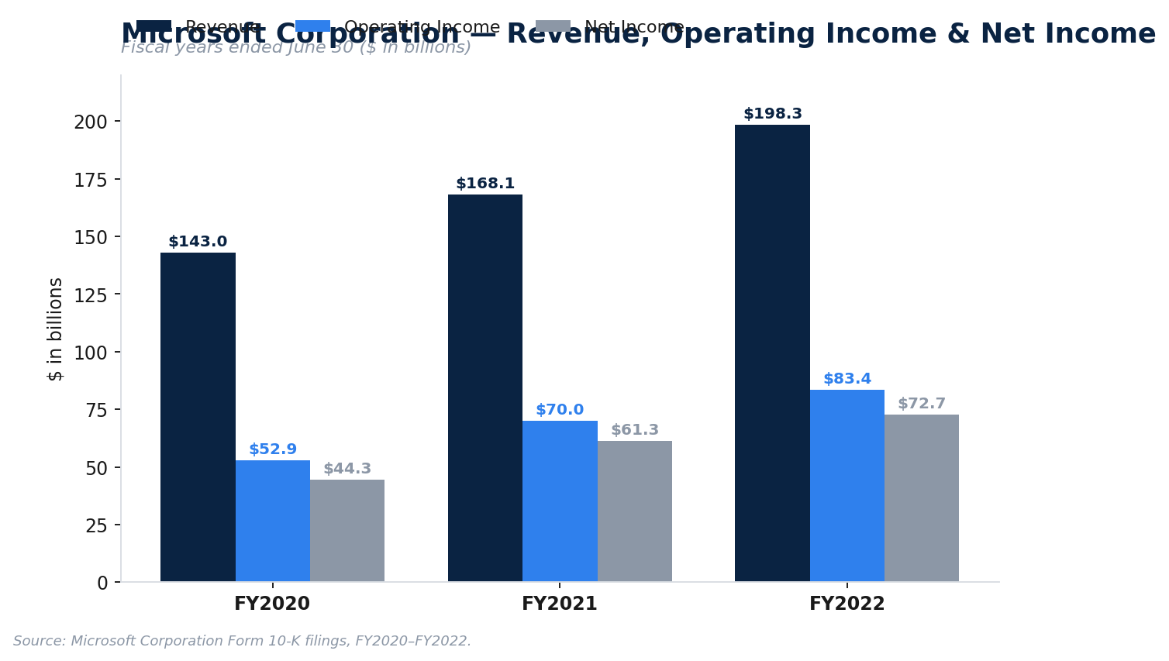
Exhibit 1. Microsoft Corporation Revenue, Operating Income & Net Income, FY2020–FY2022
Microsoft entered the transaction from a position of exceptional financial strength. At the December 31, 2021 balance sheet date immediately preceding signing, Microsoft held approximately $125–132 billion of cash and short-term investments, against total revenue of $168.1 billion and net income of $61.3 billion in the fiscal year just completed. This balance sheet strength was both the enabling condition for an all-cash offer of this scale and, as several buy-side commentators noted contemporaneously, itself a partial motivation for the deal: Microsoft's cash generation had, by 2021, begun to outpace the opportunity set for organic reinvestment and shareholder returns (buybacks and dividends), creating latent pressure to deploy capital into large, strategically differentiated acquisitions.

2.4 Competitive Advantages
Microsoft's principal competitive advantages relevant to the transaction thesis include:
- Balance sheet scale and cost of capital — an Aaa/AAA-adjacent credit profile (Microsoft is one of only two U.S. corporates to hold a top-tier credit rating from Moody's) enabled Microsoft to contemplate an all-cash, $68.7 billion transaction without meaningfully impairing its capital structure or credit profile.
- Cross-platform distribution — ownership of Windows (the dominant PC operating system), Xbox console hardware, and Azure cloud infrastructure gives Microsoft a distribution surface for game content that none of its direct gaming competitors (Sony, Nintendo) can replicate outside of their own hardware ecosystems.
- Cloud infrastructure for game streaming — Azure's hyperscale data center footprint is a structural advantage in cloud gaming economics (server-side game rendering and streaming), an area Microsoft has invested in since the 2019 launch of what became Xbox Cloud Gaming.
- Enterprise relationships and subscription go-to-market muscle — Microsoft's institutional experience monetizing Office 365 as a subscription product was explicitly cited by management as transferable know-how for scaling Xbox Game Pass.
- Existing first-party studio base — pre-deal, Microsoft already owned 23 internal game studios organized under the "Xbox Game Studios" umbrella (including Bethesda Softworks/ZeniMax, acquired 2020–2021), giving it in-house integration experience with large studio acquisitions prior to attempting one of Activision Blizzard's scale.

3. TARGET COMPANY OVERVIEW — ACTIVISION BLIZZARD, INC.

3.1 Corporate Overview
Activision Blizzard, Inc. was, prior to the transaction, a Santa Monica, California-headquartered interactive entertainment company listed on NASDAQ (ticker: ATVI) and a constituent of the S&P 500. The company was formed through the 2008 merger of Activision, Inc. and Vivendi Games (parent of Blizzard Entertainment), and subsequently expanded through the 2016 acquisition of King Digital Entertainment (developer of Candy Crush Saga) for approximately $5.9 billion. At the time of the Microsoft transaction, Activision Blizzard employed approximately 9,500–10,000 people worldwide and distributed content across roughly 190 countries, with reported audience reach of nearly 400 million monthly active users.

3.2 Business Segments
Activision Blizzard's operations were organized into three reportable segments:
Table 3.1 — Activision Blizzard Reportable Segments
Segment | Key Franchises | Business Model | FY2021 Net Revenue (approx.)
Activision | Call of Duty (premium + free-to-play mobile), Crash Bandicoot, Tony Hawk's Pro Skater | Premium console/PC game sales, in-game "Warzone"/battle-pass monetization, Call of Duty: Mobile | ~$4.4bn
Blizzard Entertainment | World of Warcraft, Diablo, Overwatch, StarCraft, Hearthstone | PC-centric premium sales, subscription (WoW), microtransactions, esports | ~$1.9bn
King | Candy Crush Saga, Candy Crush Soda Saga, Farm Heroes Saga | Free-to-play mobile, in-app purchases and advertising | ~$2.6bn
Total Net Revenue |  |  | ~$8.8bn

Note: segment figures are approximate and derived from company segment disclosures; a small non-reportable/corporate segment and intersegment eliminations account for the residual reconciliation to total net revenue.

3.3 Products and Franchise Portfolio
At announcement, Microsoft specifically cited Activision Blizzard's franchise depth as central to the deal rationale, noting three billion-dollar franchises (Call of Duty, World of Warcraft, and Candy Crush) within the portfolio — an unusually high concentration of "evergreen," multi-decade intellectual property within a single target, and one of the primary reasons the target commanded strategic (rather than purely financial) buyer interest.
- Call of Duty, the flagship Activision franchise, has historically ranked among the best-selling console/PC titles annually since 2007, with the two best-selling games of 2021 in the United States both being Call of Duty titles.
- World of Warcraft and Diablo, Blizzard's core PC franchises, have generated multi-decade subscription and premium revenue, though both franchises experienced delayed releases (Diablo IV, Overwatch 2) and declining engagement in the 2019–2021 period, contributing to a period of underperformance versus historical growth rates.
- Candy Crush Saga (King) remains one of the highest-grossing mobile games globally since its 2012 launch, providing Activision Blizzard with disproportionate exposure to mobile gaming — the largest sub-segment of the global games market by both revenue and player count.

3.4 Financial Performance
Table 3.2 — Activision Blizzard Selected Financial Data (Fiscal Years Ended December 31)
($ in billions) | FY2019 | FY2020 | FY2021 | FY2022
Net revenue (GAAP) | $6.49 | $8.09 | $8.80 | $7.53
EBITDA (approx., pre-deal basis) | n/a | n/a | ~$3.78 | n/a
Net income (approx.) | n/a | n/a | ~$2.70 | n/a
EBITDA margin (approx.) | n/a | n/a | ~43% | n/a

Activision Blizzard's FY2021 results — the last full fiscal year reported prior to the announcement — reflected net revenue of $8.80 billion, down modestly from a pandemic-elevated FY2020, alongside an approximate EBITDA margin in the low-to-mid 40s percent range, a materially higher-margin profile than Microsoft's own consolidated business at the time, and broadly consistent with the structural economics of scaled, franchise-driven interactive entertainment publishers (high fixed content-development costs amortized over very large digital-distribution volumes). Notably, FY2022 net revenue declined to $7.53 billion, reflecting content-delay-driven softness in the Activision and Blizzard segments during the period the deal was pending — a data point relevant to the standalone-value counterfactual discussed in Section 8.
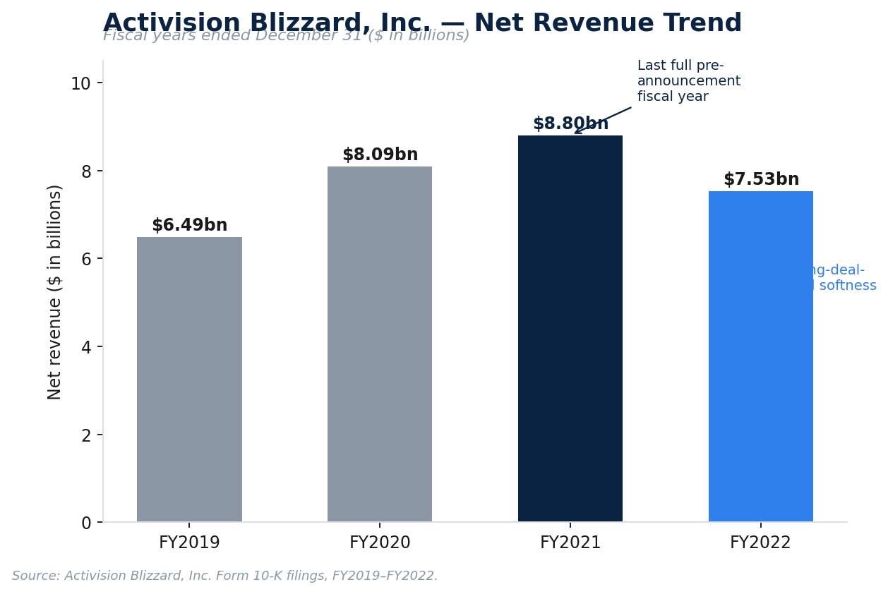
Exhibit 2. Activision Blizzard, Inc. Net Revenue Trend, FY2019–FY2022

3.5 Competitive Position (Pre-Deal)
Prior to the transaction, Activision Blizzard was among the three or four largest independent (i.e., non-hardware-platform-owned) video game publishers globally, alongside Electronic Arts, Take-Two Interactive, and Ubisoft Entertainment. Its competitive position, however, had weakened materially in the roughly 18 months preceding the Microsoft approach:
- A July 2021 lawsuit by the California Department of Fair Employment and Housing alleged a pervasive culture of sexual harassment and pay discrimination at the company, precipitating employee walkouts, a call from over 100 employees for CEO Bobby Kotick's resignation following Wall Street Journal reporting on the scope of his knowledge of the allegations, and sustained reputational damage.
- Content delays (Diablo IV, Overwatch 2) and a weaker-than-expected Call of Duty: Vanguard launch compounded the reputational overhang with fundamental underperformance.
- Activision Blizzard's share price fell approximately 28% in 2021 and continued declining into January 2022, trading near five-year lows in the days immediately preceding the Microsoft approach (closing at $65.39 on Friday, January 14, 2022, the last trading day before the announcement).
This combination of depressed valuation and heightened acquirability — a company with structurally attractive, high-margin franchise assets trading at a discounted multiple owing to governance and execution issues rather than a permanent impairment of its underlying intellectual property — is a classic setup for opportunistic strategic acquisition, and is addressed further in Section 6 (Strategic Rationale) and Section 8 (Valuation Analysis).

4. GAMING INDUSTRY OVERVIEW

4.1 Industry Size and Structure
The global video game industry generated approximately $198 billion in consumer spending in calendar year 2021, according to industry-tracking estimates widely cited at the time of the transaction (Newzoo and comparable trackers), representing the industry's continuation of a multi-year expansion that had accelerated further during pandemic-era lockdowns. By way of comparison, this made interactive entertainment larger, by consumer spending, than the global film box office and recorded music industries combined, and roughly comparable in scale to global pay-television revenue — a comparison Microsoft's own deal materials explicitly invoked ("gaming is now the largest and fastest-growing form of entertainment").
Table 4.1 — Global Games Market by Platform Segment (Illustrative, ~2021–2022)
Segment | Approx. Share of Global Market | Characteristics
Mobile | ~50–53% | Free-to-play dominant; in-app purchases and advertising; lowest barrier to player acquisition; China and U.S. largest markets
Console | ~26–28% | Premium and free-to-play hybrid; platform-owner (Sony, Microsoft, Nintendo) takes 30% storefront fee; highest average revenue per paying user
PC | ~19–21% | Digital storefronts (Steam, Battle.net, Epic Games Store); strong overlap with esports and subscription services

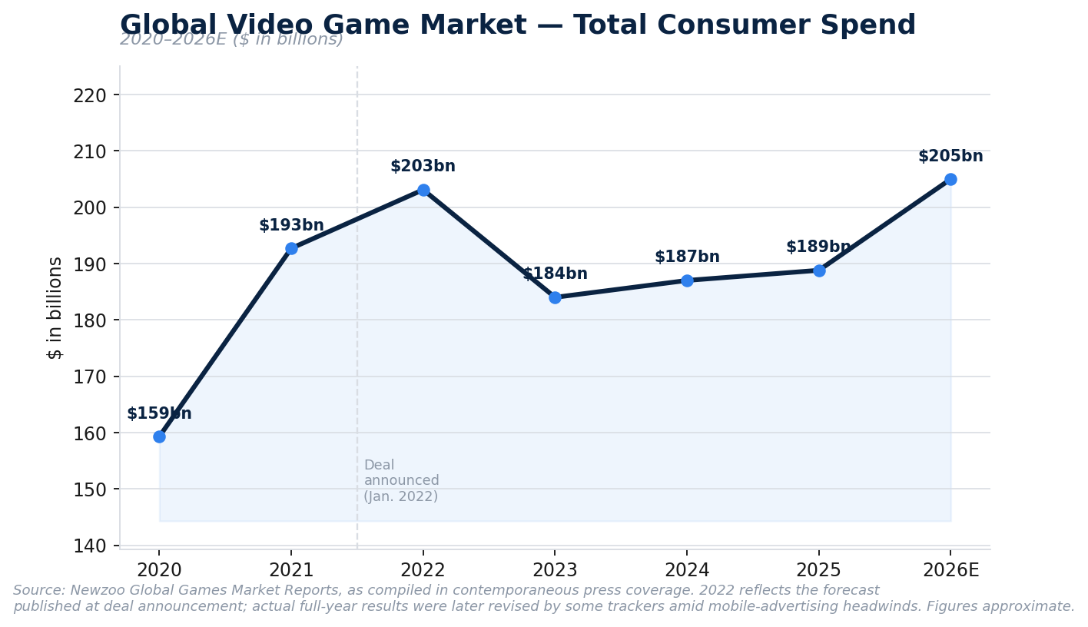
Exhibit 3. Global Video Game Market, Total Consumer Spend, 2020–2026E
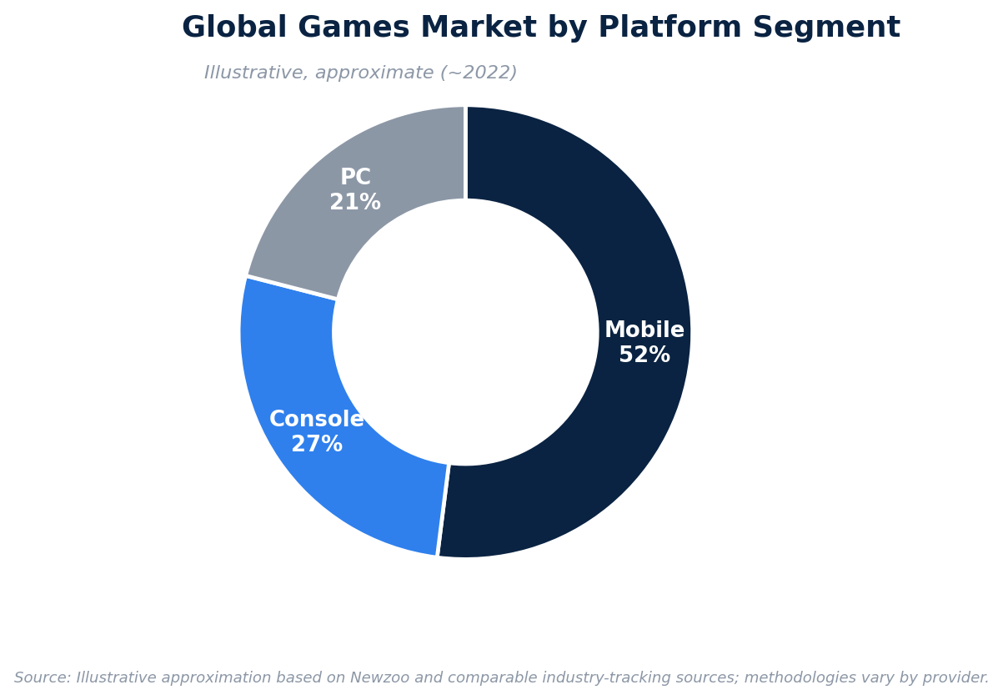
Exhibit 4. Global Games Market by Platform Segment

4.2 Growth Trends
Several structural trends were shaping industry economics at the time of the transaction and remain relevant to evaluating the deal's strategic logic in hindsight:
- Subscription/"games-as-a-service" transition — the industry's monetization model has increasingly shifted from one-time premium purchases toward recurring subscription access (Xbox Game Pass, PlayStation Plus, EA Play) and live-service monetization (battle passes, cosmetic microtransactions, seasonal content), mirroring the broader software industry's shift from license to subscription economics roughly a decade earlier.
- Cloud gaming — server-side game streaming (Xbox Cloud Gaming, NVIDIA GeForce Now, Amazon Luna) was, at the time of announcement, a nascent but strategically important segment, viewed by platform owners as a mechanism to decouple game access from console hardware ownership and expand addressable market into regions and demographics with limited console penetration. This segment proved central to the deal's regulatory contest, as detailed in Section 10.
- Mobile gaming maturation — mobile, the largest platform segment by revenue, experienced a period of deceleration in 2022–2023 driven by Apple's App Tracking Transparency (ATT) privacy changes, which materially impaired user-acquisition economics for free-to-play publishers dependent on targeted advertising, before resuming modest growth in 2024–2025.
- Console cycle maturity — both the Xbox Series X|S and PlayStation 5 launched in late 2020; by 2021–2022 the industry was mid-cycle, with hardware economics increasingly viewed by both Microsoft and Sony as secondary to services and content attach.
- Consolidation — the period 2020–2023 saw an unprecedented wave of gaming M&A activity, of which the Microsoft/Activision Blizzard transaction was the largest, but by no means the only, example (see Section 8.7, Precedent Transactions).

4.3 Key Competitors
Table 4.2 — Selected Gaming Industry Participants by Category
Category | Key Players
Platform owners (console/ecosystem) | Sony (PlayStation), Microsoft (Xbox), Nintendo (Switch)
Diversified publishers | Electronic Arts, Take-Two Interactive, Ubisoft Entertainment, Square Enix, Capcom, Bandai Namco
Mobile-first / free-to-play specialists | King (pre-deal, part of ATVI), Supercell (Tencent-controlled), Zynga (acquired by Take-Two, 2022), Scopely
Chinese/APAC giants | Tencent Games (also the largest shareholder-adjacent investor across the Western industry via minority stakes), NetEase
PC digital distribution | Valve (Steam), Epic Games (Epic Games Store, Unreal Engine)

By revenue, Tencent and Sony were, prior to the transaction, generally regarded as the two largest gaming companies globally; the Activision Blizzard acquisition was explicitly designed to elevate Microsoft into this tier — a point of significant relevance to the regulatory analysis in Section 10, since regulators scrutinized the transaction precisely because it consolidated a top-tier publisher's content into a vertically integrated platform owner also active in consoles, subscriptions, and cloud streaming.
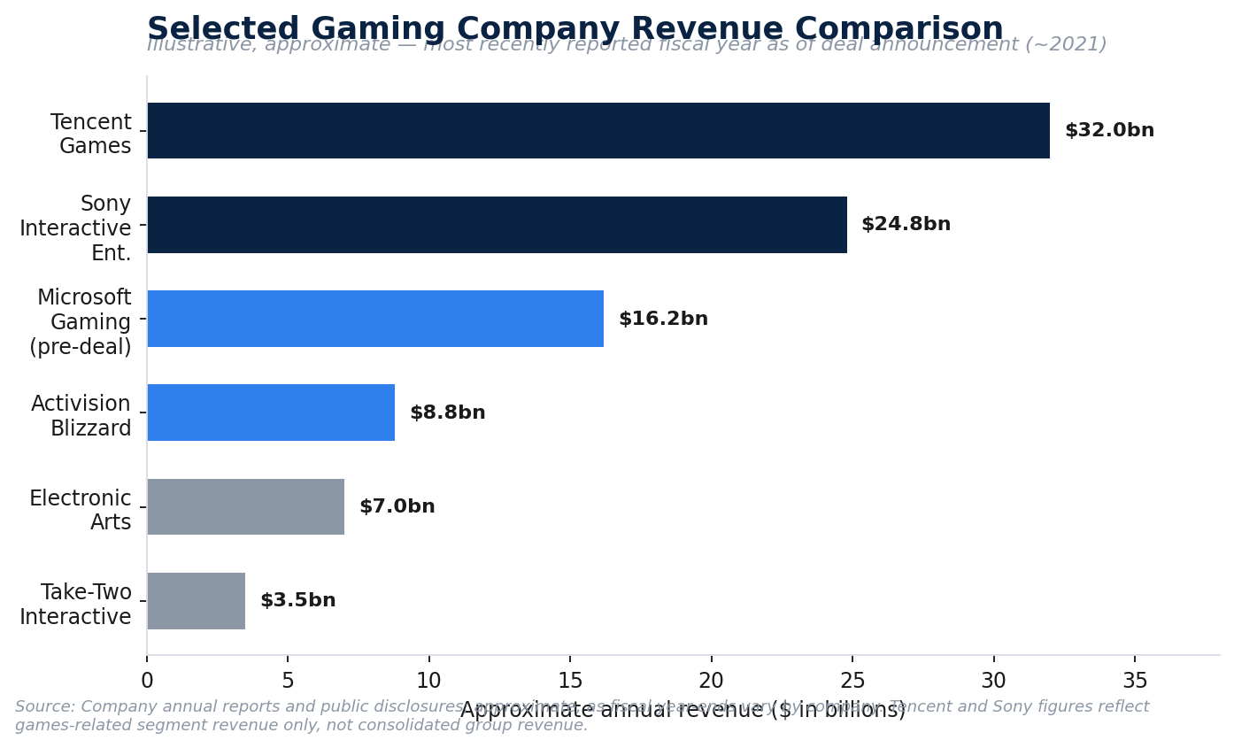
Exhibit 5. Selected Gaming Company Revenue Comparison

4.4 Market Opportunities
From Microsoft's perspective, the principal market opportunities the transaction was designed to capture were:
- Mobile gaming entry at scale — Microsoft's Xbox division had negligible standalone presence in mobile gaming prior to the deal; King's Candy Crush franchise provided immediate scale (hundreds of millions of monthly active users) in the largest platform segment.
- Subscription penetration — Game Pass subscriber growth was viewed as gated by content depth; Activision Blizzard's franchise catalogue was expected to accelerate subscriber acquisition and retention.
- Cloud gaming positioning — content ownership (rather than licensing) was viewed by Microsoft as a durable advantage in negotiating cloud-streaming rights and avoiding dependency on licensing renewals with third-party publishers.
- International and emerging-market expansion — mobile-led growth markets (Latin America, Middle East and North Africa, Southeast Asia) were disproportionately weighted toward the mobile segment where Microsoft's pre-deal position was weakest.
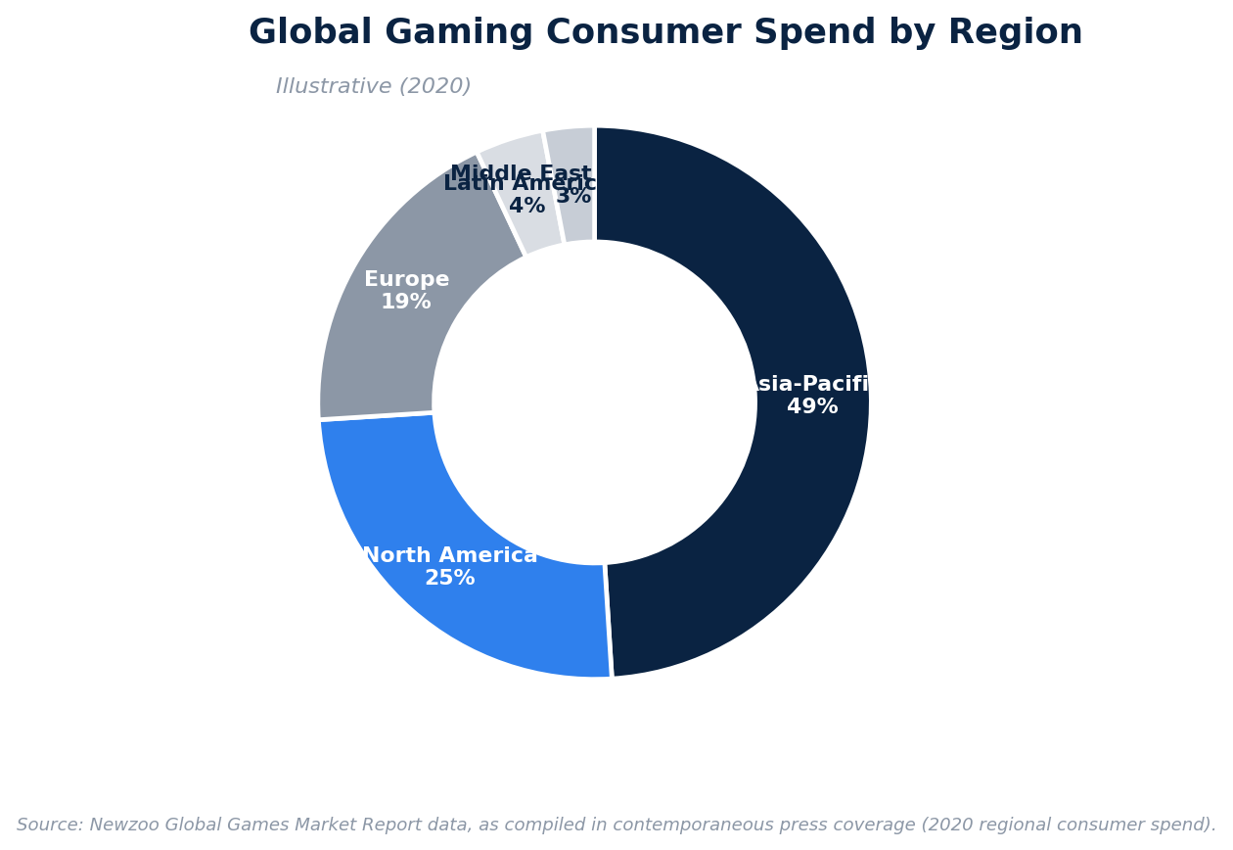
Exhibit 6. Global Gaming Consumer Spend by Region

4.5 Risks
Principal industry-level risks relevant to the transaction thesis include: (i) regulatory risk arising from the industry's rapid consolidation (addressed at length in Section 10); (ii) hit-driven revenue volatility inherent to content businesses, where a small number of franchises (Call of Duty, in Activision Blizzard's case) disproportionately drive segment economics; (iii) platform/store policy risk, particularly evolving mobile app-store rules (Apple App Tracking Transparency, EU Digital Markets Act third-party app store mandates) that directly affect monetization economics for the mobile segment; and (iv) input-cost inflation in AAA game development, where development budgets for top-tier titles have risen into the hundreds of millions of dollars, raising the fixed-cost base and franchise concentration risk across the industry.

5. TRANSACTION OVERVIEW

5.1 Purchase Price and Structure
Microsoft agreed to acquire Activision Blizzard for $95.00 per share in cash, implying an aggregate equity purchase price of $68.7 billion. The transaction was structured as a statutory reverse triangular merger under Delaware law: a wholly owned Microsoft merger subsidiary ("Anchorage Merger Sub Inc.") merged with and into Activision Blizzard, with Activision Blizzard surviving as a wholly owned indirect subsidiary of Microsoft. This structure is the standard vehicle for large public-company, all-cash acquisitions in the United States, as it allows the target's corporate existence (and, importantly, its contracts, licenses, and litigation history) to continue uninterrupted while automatically converting all outstanding shares into the right to receive cash merger consideration, subject to shareholder and regulatory approval.
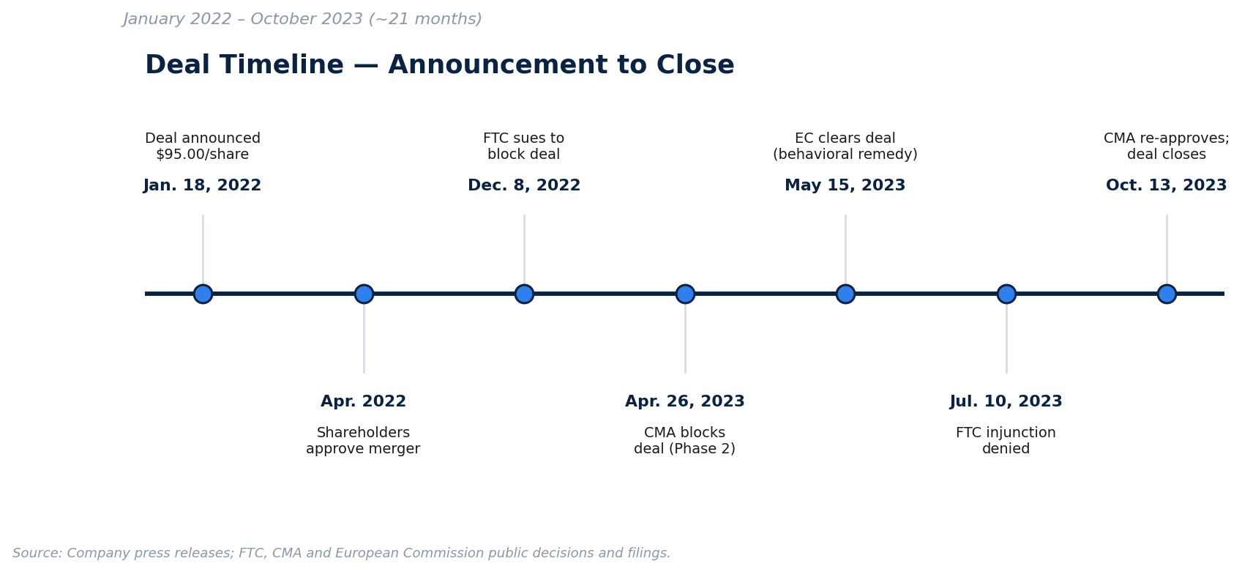
Exhibit 7. Deal Timeline: Announcement to Close

5.2 Enterprise Value Bridge
A rigorous distinction between equity value and enterprise value is essential to interpreting this transaction correctly, and is a common area of imprecision in secondary press coverage of the deal.
Table 5.1 — Illustrative Enterprise Value Bridge
($ in billions) | Amount
Fully diluted shares outstanding (approx.) | ~723 million
Offer price per share | $95.00
Equity Purchase Price | $68.7
Less: Activision Blizzard net cash (cash & equivalents + short-term investments, less debt, as of Dec. 31, 2021) | ~($6.4)
Implied Enterprise Value | ~$62.3

Microsoft's official communications described the $68.7 billion figure as "inclusive of Activision Blizzard's net cash" — standard language clarifying that the headline number is an equity value, and that because Activision Blizzard held a net cash (rather than net debt) balance sheet position, its enterprise value is lower than its equity value by the amount of that net cash. Much of the financial media at the time nonetheless referred to the $68.7 billion headline figure loosely as "the deal's enterprise value," a simplification that is directionally reasonable for headline purposes (the net cash adjustment is under 10% of the total) but imprecise in strict valuation terms. This report uses both conventions where relevant and flags which basis is being used in each case, consistent with the rigor expected in a live valuation work product.

5.3 Premium Analysis
Table 5.2 — Acquisition Premium Analysis
Reference Price | Value | Implied Premium
ATVI unaffected close, January 14, 2022 (last trading day pre-announcement) | $65.39 | 45%
Offer price | $95.00 | —
ATVI 52-week trading high (Feb. 2021) | ~$104.00 | Offer price below 52-week high

The 45% one-day premium is at the higher end of the typical range observed in large-cap, negotiated (non-hostile) U.S. public company transactions, which more commonly cluster in the 20–35% range. The elevated premium reflects two countervailing dynamics: (i) Activision Blizzard's share price was itself depressed at signing due to the governance scandal and content-delay overhang described in Section 3.5, meaning the premium overstates the uplift versus a "clean" trading history; and (ii) Microsoft's willingness to pay a full, and arguably rich, headline multiple to secure a scarce, category-leading content asset ahead of competing strategic or "arms race" bidders in a consolidating industry (see Section 6).

5.4 Financing Structure
The transaction was structured as an all-cash deal from inception, with Microsoft's January 2022 announcement stating the acquisition would be funded from existing cash resources; at the time, Microsoft held approximately $125–132 billion of cash and short-term investments, comfortably in excess of the deal's equity value, meaning Microsoft did not require committed acquisition financing (a bridge facility) at signing, a notable point of contrast with even sizable strategic transactions by less cash-generative acquirers.
However, the roughly 21-month gap between signing and closing materially altered the financing execution in practice. Over that period, Microsoft continued to deploy significant capital toward share buybacks, dividends, and — increasingly from 2023 onward — capital expenditure on AI and cloud infrastructure, drawing down its cash reserves. At the actual closing in October 2023, Microsoft supplemented its cash on hand with approximately $27 billion of new short-term borrowings (commercial paper), rather than funding the transaction entirely from balance sheet cash as originally telegraphed. This is an instructive real-world nuance for M&A analysts: financing plans described at signing are frequently revised in execution when there is a long gap to closing, and treasury teams optimize the actual funding mix (cash vs. short-term debt) based on prevailing cash balances, buyback commitments, and short-term interest rates at the time of closing, rather than rigidly following the announcement-day plan. Notwithstanding this, Microsoft's leverage profile remained conservative throughout, and the company retained its top-tier credit ratings.

5.5 Deal Protection Mechanisms
Table 5.3 — Termination Fee Structure
Fee | Payable By | Amount | Trigger
Company Termination Fee | Activision Blizzard → Microsoft | $2.27 billion | Target board changes recommendation, accepts superior proposal, or shareholders vote down the deal, among other customary triggers
Reverse Termination Fee (antitrust) | Microsoft → Activision Blizzard | Escalating: $2.0bn (pre-Jan. 18, 2023) → $2.5bn (through Apr. 18, 2023) → $3.0bn (through original July 18, 2023 outside date) → $3.5bn (after Aug. 29, 2023) → $4.5bn (after Sept. 15, 2023, per the extension agreement) | Deal fails to close due to a permanent antitrust injunction or failure to obtain required antitrust clearances by the outside date

This fee structure is a textbook illustration of how deal protection provisions price antitrust execution risk in large strategic transactions: the escalating reverse termination fee schedule directly reflects (i) the deal parties' shared expectation, priced into the merger agreement at signing, that antitrust review would be prolonged and contested, and (ii) an economic mechanism to keep Microsoft financially incentivized to pursue remedies and litigation rather than abandon the transaction as review dragged on, since the cost of walking away rose steadily over time. The eventual outside-date extension (from July 18 to October 18, 2023) and corresponding fee escalation (to $3.5bn/$4.5bn) is a directly observable data point of this dynamic in action, executed in real time as the UK CMA's Phase 2 prohibition decision required a full deal restructuring (see Section 10.3).

5.6 Advisors Involved
Table 5.4 — Transaction Advisors
Role | Microsoft (Acquirer) | Activision Blizzard (Target)
Financial Advisor | Goldman Sachs & Co. LLC | Allen & Company LLC
Legal Counsel (Corporate/M&A) | Simpson Thacher & Bartlett LLP | Skadden, Arps, Slate, Meagher & Flom LLP
Legal Counsel (Antitrust/Litigation) | Weil, Gotshal & Manges LLP | —
Legal Counsel (UK) | — | Slaughter and May

Allen & Company's engagement letter, as disclosed in Activision Blizzard's proxy statement, provided for an aggregate fee of $65 million, comprising $10 million payable upon delivery of its fairness opinion and $55 million contingent upon consummation of the merger — a fee structure (small opinion fee, large success fee) that is standard practice for sell-side fairness opinion providers in large public-company M&A, and is designed to align the advisor's economics with successful deal completion while preserving the independence of the fairness opinion itself (the opinion fee is not explicitly contingent on the opinion's conclusion, only on its delivery).

6. STRATEGIC RATIONALE

6.1 Why Microsoft Pursued the Acquisition
Microsoft's publicly stated rationale, articulated by Chairman and CEO Satya Nadella and Microsoft Gaming CEO Phil Spencer at announcement, centered on accelerating growth across "mobile, PC, console, and cloud" and providing "building blocks for the metaverse." Stripping away the metaverse framing — which has aged as a strategic narrative given the industry's subsequent pivot toward generative AI — the substantive strategic logic rests on four pillars, each addressed below.
Pillar 1: Subscription (Game Pass) flywheel acceleration. Xbox Game Pass, launched in 2017, is a Netflix-style subscription granting access to a rotating catalogue of games for a monthly fee. Subscription businesses exhibit a well-understood flywheel dynamic: more compelling content drives subscriber growth and retention, larger subscriber bases justify larger content investment, and the cycle compounds. Microsoft's central strategic bet was that owning, rather than merely licensing, Activision Blizzard's franchise catalogue would let it feed Game Pass with day-one access to marquee titles (chiefly Call of Duty) without the recurring licensing negotiation risk and cost that comes from depending on a third-party publisher's willingness to participate.
Pillar 2: Mobile gaming entry at scale. As detailed in Section 4, mobile is the largest platform segment in the global games market by both revenue and player count, and was, prior to this deal, a segment in which Microsoft had essentially no meaningful standalone position. Rather than build a mobile studio and publishing capability organically — a multi-year undertaking with uncertain payoff — Microsoft acquired King's Candy Crush franchise (hundreds of millions of monthly active users) as an immediate, scaled entry point, alongside Call of Duty: Mobile.
Pillar 3: Cloud gaming content moat. Cloud/streaming gaming was, at signing, viewed by Microsoft as a structurally advantaged distribution model given its ownership of Azure's hyperscale infrastructure, but a content-constrained one: Microsoft's cloud gaming service (Xbox Cloud Gaming) depended on licensing arrangements with third-party publishers for non-first-party content. Owning Activision Blizzard's catalogue outright removed a key licensing dependency and gave Microsoft first-party content to anchor its cloud gaming value proposition — though, as detailed in Section 10, this same logic became the central basis of the UK CMA's initial prohibition decision, since regulators viewed the acquisition as foreclosing rival cloud gaming services' access to Activision content.
Pillar 4: Competitive response to industry consolidation and Sony's scale advantage. Sony's PlayStation platform has historically maintained a larger installed base and stronger first-party exclusive content pipeline than Xbox in most recent console generations. Acquiring Activision Blizzard was, in part, a means of closing this competitive gap in aggregate content ownership and audience reach (moving Microsoft, by revenue, into the same tier as Sony and Tencent), rather than attempting to close it purely through console hardware competition, an arena in which Xbox has historically struggled to outsell PlayStation.

6.2 Strategic Fit
The strategic fit assessment can be summarized across several dimensions:
Table 6.1 — Strategic Fit Assessment
Dimension | Assessment
Content/IP complementarity | High — minimal franchise overlap between Xbox first-party studios (Halo, Forza, Minecraft, Elder Scrolls/Fallout post-ZeniMax) and Activision Blizzard (Call of Duty, Warcraft, Diablo, Candy Crush)
Platform distribution fit | High — Microsoft's Windows, Xbox, and Azure infrastructure provide multiple monetization surfaces for Activision Blizzard content that a financial buyer could not replicate
Business model fit | Moderate-to-high — Activision Blizzard's live-service and subscription-adjacent monetization (Call of Duty seasonal content, WoW subscriptions) aligns with Microsoft's recurring-revenue orientation, though King's mobile advertising-driven model is a less natural fit with Microsoft's enterprise-software culture
Cultural fit | Lower — Activision Blizzard's governance and workplace-culture issues (Section 3.5) represented a meaningfully different risk and cultural profile than Microsoft's own corporate culture, requiring active remediation post-close (Section 11)
Financial profile fit | High — Activision Blizzard's structurally higher EBITDA margin (~40%+) versus Microsoft's Gaming segment pre-deal was immediately accretive to Gaming segment profitability upon consolidation

6.3 Expansion Opportunities
Beyond the four core strategic pillars, the transaction opened several adjacent expansion opportunities that Microsoft has selectively pursued since closing:
- Multi-platform publishing strategy — rather than pursuing exclusivity (removing Activision Blizzard titles from PlayStation), Microsoft signed binding long-term agreements to keep Call of Duty on PlayStation (10 years) and bring it to Nintendo Switch (10 years), reflecting a strategic pivot toward maximizing content reach and Game Pass-adjacent revenue across all platforms rather than a traditional platform-exclusivity playbook — partly a function of regulatory necessity (Section 10) but also, as validated by the commercial success of Black Ops 6 (Section 15), a genuinely more profitable strategy at the current stage of the console cycle.
- Esports and live-service expansion — Activision Blizzard's Overwatch League and Call of Duty League esports properties, together with Blizzard's live-service infrastructure, provided an accelerant to Microsoft's broader live-service ambitions.
- International/localization expansion — King's mobile distribution footprint in emerging markets provided Microsoft with an accelerated path into geographies where console penetration is structurally low.

6.4 Competitive Positioning
Following the transaction, Microsoft's standing among global gaming companies shifted materially. Pre-deal, Microsoft's Gaming segment revenue trailed both Sony (PlayStation hardware, software, and network services) and Tencent (the world's largest games publisher by revenue, driven by domestic Chinese titles and international minority stakes) by a wide margin. The transaction was explicitly designed, and publicly described by Microsoft, to move Microsoft into the third-largest gaming company globally by revenue, a competitive repositioning of a scale rarely achievable through organic growth alone within a single transaction, and the central reason regulators globally treated the deal as warranting exceptional scrutiny rather than routine, non-problematic clearance.

7. SYNERGY ANALYSIS
Synergy analysis in strategic M&A is conventionally divided into revenue synergies (incremental revenue enabled by the combination that neither company could generate standalone) and cost synergies (efficiencies from eliminating duplicated cost structures or achieving scale economies). Because Microsoft did not publicly disclose a formal, quantified synergy target at signing — a deliberate choice common in cash-rich strategic acquisitions where the buyer does not need to justify the price to third-party lenders via a synergy bridge — the analysis below is constructed from management commentary, subsequent segment disclosures, and standard TMT M&A synergy frameworks, and should be read as an analytical estimate rather than a disclosed target.

7.1 Revenue Synergies
Table 7.1 — Revenue Synergy Framework
Synergy Category | Mechanism | Illustrative Basis for Estimate
Cross-selling / subscriber acquisition | Activision Blizzard franchises added to Game Pass catalogue drive incremental Game Pass subscriptions and reduce subscriber churn | Game Pass subscriber base was ~25 million at signing (per Microsoft's Jan. 2022 announcement); even modest incremental conversion (low single-digit % subscriber uplift) on a subscription priced at $10–$20/month represents a meaningful multi-hundred-million-dollar annual revenue opportunity at scale
Subscription (Game Pass) growth acceleration | Day-one access to major franchise releases (e.g., Call of Duty) has historically been the single largest driver of Game Pass subscriber adds in a given period | Evidenced post-close: Call of Duty: Black Ops 6 (Oct. 2024) delivered the largest single-day Game Pass subscriber addition on record (Section 15)
Cloud gaming catalogue expansion | Activision Blizzard content added to Xbox Cloud Gaming increases the service's competitive differentiation versus rival cloud platforms and supports monetization of Game Pass Ultimate (which bundles cloud streaming) | Directional, difficult to isolate quantitatively; primarily a retention/differentiation synergy rather than a standalone new revenue line
Mobile gaming expansion | Leveraging King's mobile publishing and live-ops expertise across Microsoft's broader first-party portfolio (e.g., adapting console/PC IP for mobile) | Optionality-based; no material disclosed progress as of this writing, representing a synergy that remains largely unrealized several years post-close
Advertising monetization | King's mobile advertising business (in-app ad inventory) combined with Microsoft's broader advertising technology stack (Xandr, acquired 2021/2022) | Modest; advertising remains a small proportion of combined Gaming segment revenue

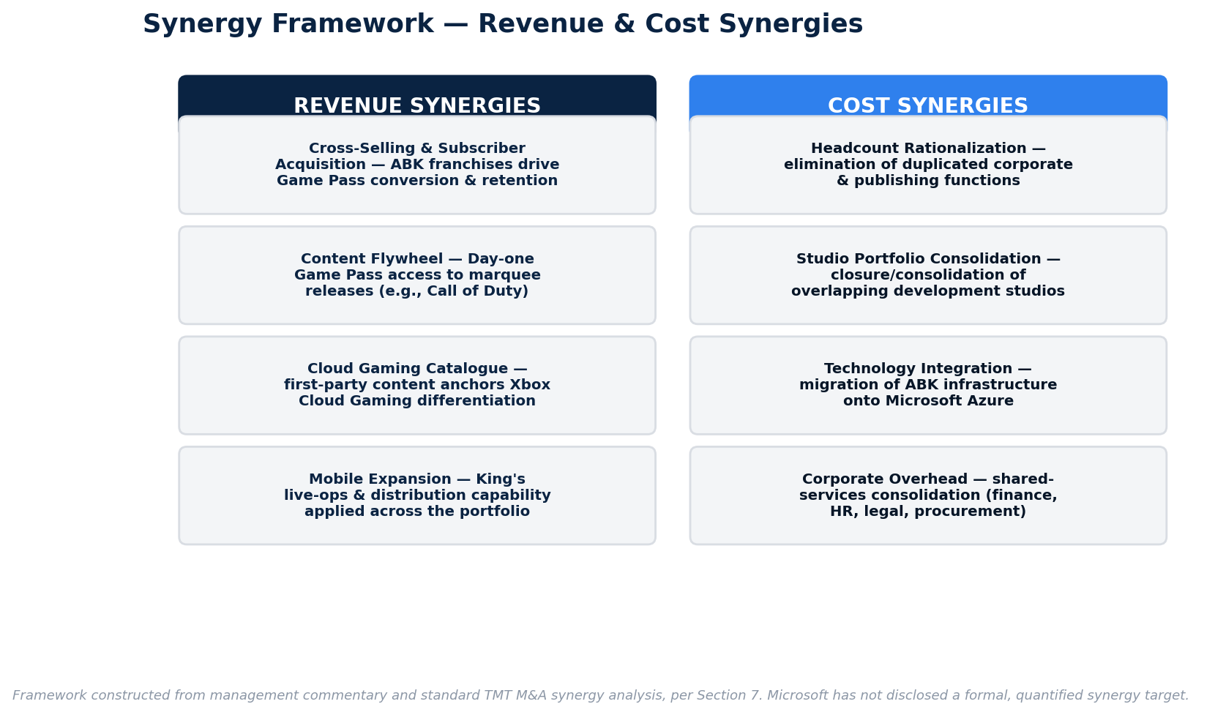
Exhibit 8. Synergy Framework: Revenue & Cost Synergies
The most economically significant and most clearly evidenced revenue synergy, in retrospect, has been the subscription/content-catalogue synergy: Microsoft's own segment commentary directly attributes a meaningful proportion of Xbox content and services revenue growth since the October 2023 close to "the impact of the Activision Blizzard acquisition," and the immediate jump in quarterly Gaming segment revenue from $3.9 billion (fiscal Q1 2024, pre-close) to $7.1 billion (fiscal Q2 2024, the first full quarter post-close) is the clearest available proof point of consolidation-driven revenue uplift, even though a significant portion of that jump reflects consolidation of Activision Blizzard's standalone revenue rather than synergy in the strict incremental sense.

7.2 Cost Synergies
Table 7.2 — Cost Synergy Framework
Synergy Category | Mechanism | Observed Post-Close Evidence
Operational efficiencies / headcount rationalization | Elimination of duplicated corporate, publishing, and administrative functions across Xbox and Activision Blizzard/King | January 2024: 1,900 layoffs (~9% of combined gaming division headcount); September 2024: ~650 further layoffs; cumulative gaming-specific cuts of roughly 2,500–2,900 within the first 12–18 months post-close
Studio portfolio rationalization | Closure or consolidation of overlapping or underperforming development studios | May 2024: closure of Arkane Austin (developer of Redfall) and Tango Gameworks (developer of Hi-Fi Rush, later divested to Krafton); cancellation of in-development titles including Blizzard's "Project Odyssey" survival MMO and an unannounced ZeniMax Online Studios MMORPG
Technology/platform integration | Migrating Activision Blizzard's infrastructure (data centers, back-office systems, anti-cheat and telemetry systems) onto Microsoft Azure | Directionally consistent with Microsoft's stated infrastructure strategy; specific cost savings not separately disclosed
Corporate/administrative overhead | Consolidation of finance, HR, legal, and other corporate functions into Microsoft's existing shared-services infrastructure | Reflected in the broader headcount reduction figures above; not separately quantified by management
Procurement and vendor consolidation | Combined purchasing scale across cloud infrastructure, marketing spend, and third-party licensing | Not separately disclosed

It is analytically important to distinguish, in this instance, between synergy realization and cost-cutting under margin pressure. The layoffs and studio closures observed since closing have been publicly attributed by Microsoft management primarily to "sustainable cost structure" objectives and "areas of overlap," which is consistent with a cost-synergy narrative; however, external commentators — including former FTC Chair Lina Khan — have characterized the same actions as evidence of the reduced competitive discipline that regulators warned the consolidation would produce (i.e., a large, dominant combined firm facing less competitive pressure to preserve headcount, studio diversity, or consumer-friendly pricing). Both readings are consistent with the same underlying facts; the distinction is a matter of framing and antitrust philosophy rather than dispute over the facts themselves, and is addressed further in Sections 11 and 15.

7.3 Synergy Realization Assessment
On balance, the evidence assembled in Section 15 (Post-Acquisition Performance) suggests that revenue synergies have materialized more clearly, and more quickly, than cost synergies have translated into durable margin improvement. The Gaming segment's revenue trajectory (Section 9) shows a clear step-change consistent with successful subscription and content-catalogue synergy capture, while the repeated, multi-year cadence of layoffs and studio closures suggests that cost-side integration has been a more protracted, and organizationally costly, process than a "clean" synergy capture story would imply — a pattern common in large content/media acquisitions, where revenue-side synergies (distribution, cross-sell) tend to be realized faster than cost-side synergies (headcount, real estate, systems), which typically require multiple budget cycles and are complicated by talent-retention considerations unique to creative organizations (see Section 11.3).

8. VALUATION ANALYSIS

8.1 Overview of Valuation Framework
This section applies the standard triad of M&A valuation methodologies — comparable company analysis ("trading comps"), precedent transaction analysis ("deal comps"), and a review of the implied multiples paid — to assess whether the $95.00 per share offer price represented fair, full, or excessive value for Activision Blizzard. As with any valuation exercise performed after the fact, the analysis benefits from hindsight regarding subsequent industry multiple compression (2022–2023 saw a broad de-rating of technology and media equities amid rising interest rates) that was not fully knowable at signing.

8.2 Enterprise Value and Equity Value Recap
As established in Section 5.2:
- Equity Purchase Price: $68.7 billion
- Implied Enterprise Value (net of target cash): ~$62.3 billion

8.3 Implied Transaction Multiples
Table 8.1 — Implied Transaction Multiples (based on FY2021 financials, the last full fiscal year prior to signing)
Metric | FY2021 Actual | Multiple on Equity Value ($68.7bn) | Multiple on Enterprise Value (~$62.3bn)
Net Revenue | $8.80bn | 7.8x | 7.1x
EBITDA | ~$3.78bn | 18.2x | 16.5x
Net Income (P/E basis) | ~$2.70bn | 25.4x | n/a (P/E is an equity-value multiple)

These multiples should be read against Activision Blizzard's own recent trading history: in the five years prior to the acquisition, the company had historically traded at an average of roughly 23x trailing earnings, a multiple that had compressed to approximately 17x immediately before the January 2022 announcement, reflecting the market's discounting of the company's governance and execution issues. Microsoft's offer, at approximately 25x trailing earnings, therefore represented not merely a premium to the depressed pre-announcement trading multiple, but effectively a restoration of, and modest premium to, Activision Blizzard's own historical "clean" trading multiple — a defensible framing for the price from Microsoft's perspective, and consistent with a disciplined strategic acquirer paying up for quality assets at a moment of temporary market mispricing rather than overpaying in absolute terms.

8.4 Comparable Company Analysis
Table 8.2 — Illustrative Comparable Company Trading Multiples (approximate, as of signing; for analytical illustration — refresh against live Bloomberg/CapIQ data in practice)
Company | Ticker | EV/Revenue | EV/EBITDA | P/E
Electronic Arts | EA | ~5–6x | ~15–17x | ~24–27x
Take-Two Interactive | TTWO | ~5–7x | ~17–20x | ~28–32x
Ubisoft Entertainment | UBI.PA | ~2–3x | ~9–12x | ~15–20x
Activision Blizzard (unaffected, pre-announcement) | ATVI | ~4x | ~13x | ~17x
Peer median (approx.) |  | ~4–5x | ~15x | ~24x
Implied by Microsoft's offer |  | 7.1–7.8x | 16.5–18.2x | ~25x

Note: comparable multiples presented above are illustrative approximations for analytical/educational purposes, constructed from general market conditions prevailing around the transaction date; a live comparable company analysis would source real-time multiples directly from Bloomberg, Capital IQ, or FactSet.
This comparison indicates that Microsoft's offer priced Activision Blizzard at a meaningful premium to the peer group median on an EV/Revenue basis, but closer to (and in the case of EV/EBITDA, only modestly above) the higher end of the peer trading range — consistent with the expectation that a strategic acquirer paying a control premium for a scarce, category-leading asset should price above the passive-minority trading multiples of its unowned peers. The revenue multiple premium is particularly notable and reflects the market's willingness, at signing, to pay up for Activision Blizzard's disproportionately high-margin business mix (heavy weighting toward King's mobile free-to-play economics and Blizzard's subscription/live-service revenue), which commands a structurally higher revenue multiple than more hit-driven, marketing-intensive publishers such as Ubisoft.

8.5 Comparable Transaction Analysis (Precedent Transactions)
Table 8.3 — Selected Precedent Gaming M&A Transactions
Date | Acquirer | Target | Deal Value | Notes
Sept. 2020 | Microsoft | ZeniMax Media (Bethesda Softworks) | $7.5bn | All-cash; Microsoft's prior-largest gaming acquisition; closed March 2021
Jan. 2022 | Take-Two Interactive | Zynga | $12.7bn | Cash-and-stock; announced the same week as the Microsoft/ATVI deal; closed May 2022
Jan. 2022 | Sony Interactive Entertainment | Bungie | $3.6bn | All-cash; Sony's largest studio acquisition to date, widely read as a direct competitive response to Microsoft's ATVI announcement
May 2022 | Embracer Group | Square Enix's Western studios (Crystal Dynamics, Eidos-Montréal, Square Enix Montréal) | ~$0.3bn | Illustrates the wide dispersion of gaming M&A deal sizes occurring concurrently
2023 | Savvy Games Group (Saudi Arabia's Public Investment Fund) | Scopely | ~$4.9bn | Reflects continued strategic and sovereign-wealth-backed consolidation in mobile gaming

The average EV/EBITDA multiple across recent, comparable gaming-industry M&A transactions in the period immediately preceding the Microsoft/Activision Blizzard announcement has been estimated at approximately 20x (median ~21x), meaning Microsoft's implied 16.5x–18.2x EV/EBITDA multiple was, on a precedent-transaction basis, arguably conservative rather than excessive — a materially different conclusion than the comparable-company analysis in isolation might suggest, and an important illustration of why analysts should always triangulate across both trading and transaction comps rather than relying on either in isolation. Precedent transaction multiples typically run above trading comps precisely because they embed a control premium and (often) a strategic scarcity premium; the fact that Microsoft's multiple sat below the precedent average, despite this being by far the largest transaction in the set, suggests disciplined, rather than promotional, pricing by Microsoft's deal team, notwithstanding the very large absolute price tag.

8.6 Acquisition Premium Analysis (Detailed)
As detailed in Section 5.3, the 45% one-day premium to Activision Blizzard's unaffected share price is elevated relative to typical large-cap strategic transaction premiums (which more commonly fall in a 20–35% range per long-run academic and practitioner studies of U.S. public M&A). Three factors explain this:
- Depressed starting point. Activision Blizzard's unaffected price already reflected a governance discount and content-delay discount; the premium is calculated off an artificially low base rather than a "clean" trading price.
- Competitive tension considerations. While the transaction was negotiated (not the product of a public auction), Microsoft's deal team would have needed to account for the possibility of a competing strategic bidder (Sony was widely discussed in commentary, though financially less capable of an all-cash offer at this scale) or a activist-driven push for a superior proposal, both of which argue for a decisive, premium-clearing bid rather than an opportunistic lowball offer that invites a bidding contest or protracted negotiation.
- Certainty and speed premium. An all-cash offer at a full price, from a AAA-rated acquirer with no financing contingency, is itself a value proposition to a target board evaluating fiduciary duty considerations — the premium partially compensates for the lower execution risk (from the target's perspective) inherent in an unconditioned cash offer versus a stock-for-stock alternative exposed to acquirer share price volatility.
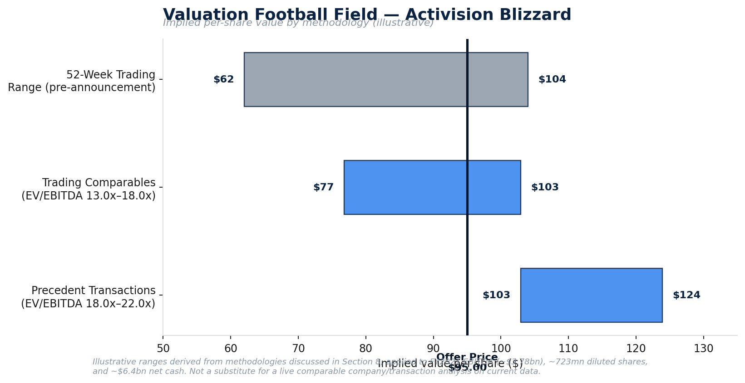
Exhibit 9. Valuation Football Field: Activision Blizzard

8.7 Fairness Opinion Considerations
Allen & Company's fairness opinion, delivered to the Activision Blizzard board on January 17, 2022 (the day before announcement), would have applied the same triad of methodologies presented above (comparable companies, precedent transactions, and a discounted cash flow analysis, the last of which is not separately reconstructed in this report given the absence of Activision Blizzard's non-public management projections). The fee structure attached to that opinion ($10 million upon delivery, $55 million contingent on closing) is worth noting from a valuation-governance perspective: while such contingent fee structures are standard market practice and were fully disclosed in the merger proxy, they are also a recurring subject of shareholder litigation (including, in this case, the subsequent Delaware Chancery litigation discussed in Section 16) on the theory that large contingent success fees may subtly bias a financial advisor's incentives toward recommending deal completion. This report does not take a position on that question but flags it as a standard area of scrutiny in comparable transactions.

8.8 Valuation Conclusion
Triangulating across the methodologies above, the $95.00 per share / $68.7 billion offer is best characterized as a full and complete valuation, at the upper end of a defensible range, but not demonstrably excessive relative to contemporaneous precedent transactions in the gaming sector. The price appropriately reflected a control premium and scarcity premium for a top-three global publisher with exceptional franchise depth, while remaining below the average EV/EBITDA multiple paid in comparable recent gaming M&A. The primary valuation risk embedded in the transaction was not that Microsoft structurally overpaid relative to sector norms, but rather that it paid a full multiple for assets (Blizzard in particular) that were, at signing, in a cyclical trough of content output — a risk that materialized, in part, through Activision Blizzard's FY2022 revenue decline to $7.53 billion during the pendency period, and one that has only been fully offset by the strong performance of Call of Duty since closing (Section 15).

9. FINANCIAL IMPACT

9.1 Actual Purchase Price and Purchase Price Allocation
An important — and frequently overlooked — nuance of this transaction is that the aggregate consideration actually paid by Microsoft at closing exceeded the headline figure announced at signing. Microsoft's FY2024 Form 10-K discloses a final purchase price allocation reconciling to total purchase consideration of $75.408 billion, versus the $68.7 billion equity value announced in January 2022. The approximately $6.7 billion increase is primarily attributable to the growth in Activision Blizzard's fully diluted share count over the ~21-month pendency period, as employee equity awards (RSUs and options) continued to vest and be issued while the deal remained pending — a mechanical, but real, illustration of how "cash-out" merger consideration on a per-share basis can produce a materially larger aggregate outlay than originally announced when closing is significantly delayed, a dynamic every M&A analyst modeling a long-dated regulatory-risk deal should build into their sources-and-uses.
Table 9.1 — Microsoft's Final Purchase Price Allocation for Activision Blizzard (per Microsoft FY2024 Form 10-K)
($ in millions) | Amount
Cash and cash equivalents acquired | $12,976
Goodwill | $50,969
Intangible assets acquired | $21,969
Other assets | $2,501
Less: Long-term debt assumed | $(2,799)
Less: Long-term income taxes | $(1,914)
Less: Deferred income taxes | $(4,677)
Less: Other liabilities | $(3,617)
Total Purchase Price | $75,408

Table 9.2 — Acquired Intangible Assets Detail
Intangible Asset Class | Fair Value ($mn) | Weighted Average Useful Life
Marketing-related (trademarks, franchise brands) | $11,619 | 24 years
Technology-based | $9,689 | 4 years
Customer-related | $661 | 4 years
Total | $21,969 | ~15 years (blended)

The allocation of roughly 68% of total consideration to goodwill ($51.0 billion) is high but not anomalous for a content/IP-driven entertainment acquisition, where the bulk of enduring economic value resides in assembled workforce, franchise ecosystems, and expected synergies that do not meet the accounting definition of a separately identifiable intangible asset, rather than in contractual or technology-based intangibles that can be discretely fair-valued. The concentration of value in the long-lived, 24-year "marketing-related" category (i.e., the Call of Duty, World of Warcraft, and Candy Crush brand franchises themselves) reflects appraisers' judgment that these franchises have multi-decade remaining economic lives — a defensible position given Call of Duty's uninterrupted annual release cadence since 2003 and World of Warcraft's 20-plus-year operating history at the time of the deal.

9.2 Revenue Impact
Table 9.3 — Microsoft Gaming Segment Revenue (Selected Fiscal Years, $ in billions)
Fiscal Year | Gaming Segment Revenue | YoY Growth | Commentary
FY2021 | ~$16.2 | +40%+ (pandemic-elevated) | Pre-deal
FY2023 | ~$15.5 | Modest decline | Last full pre-close fiscal year
FY2024 | $21.5 | +38% | First fiscal year including ~8.5 months of Activision Blizzard consolidation (deal closed Oct. 13, 2023)
FY2025 | $23.5 | +9% | First full fiscal year with Activision Blizzard fully consolidated

Microsoft's own segment commentary directly attributes the FY2024 Q4 (quarter ended June 30, 2024) year-over-year Gaming segment revenue increase of 61% predominantly to the Activision Blizzard consolidation. Perhaps the single clearest proof point of immediate revenue impact is the sequential jump in quarterly Gaming segment revenue from $3.9 billion in the quarter immediately preceding close (Jul–Sep 2023) to $7.1 billion in the first full quarter post-close (Oct–Dec 2023) — an increase of approximately 82% in a single quarter, driven almost entirely by consolidation of a business that had previously been reflected in Microsoft's results only via third-party royalty revenue on Activision Blizzard titles sold through the Xbox storefront.
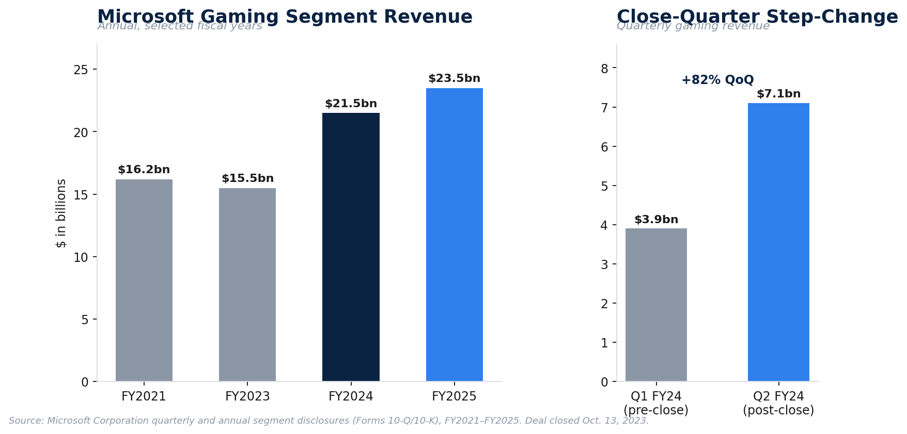
Exhibit 10. Microsoft Gaming Segment Revenue: Annual Trend & Close-Quarter Step-Change

9.3 EBITDA and Operating Income Impact
Counter-intuitively, and instructively for analysts studying purchase-accounting mechanics, Microsoft's own disclosure shows that Activision Blizzard's contribution to Microsoft's consolidated operating income was actually negative in the initial post-close stub period: for the period from the October 13, 2023 acquisition date through fiscal year-end June 30, 2024 (approximately 8.5 months), Microsoft disclosed that Activision Blizzard contributed $5.729 billion of incremental revenue but an operating loss of $1.362 billion.
This near-term operating loss does not indicate that the underlying Activision Blizzard business became unprofitable; rather, it is a textbook illustration of how purchase accounting can suppress reported profitability in the periods immediately following a large acquisition, through:
- Intangible amortization — approximately $22.0 billion of acquired intangible assets began amortizing on a blended ~15-year life (with the $9.7 billion technology-based component amortizing over just 4 years), creating a substantial new non-cash amortization expense that did not exist on Activision Blizzard's standalone income statement.
- Deferred revenue fair-value haircut — under purchase accounting, a target's deferred revenue balance (e.g., unearned revenue from in-game currency, season passes, or prepaid subscriptions) is generally written down to estimated fair value (essentially, the cost to fulfill the remaining obligation plus a normal margin) rather than carried at its full pre-acquisition book value. This mechanically suppresses revenue recognized on previously-deferred amounts in the periods following close relative to what Activision Blizzard would have recognized on a standalone basis — a near-universal, temporary drag on reported post-acquisition profitability in any subscription- or prepaid-revenue business, and one investors should not mistake for genuine business deterioration.
- Integration and restructuring costs — severance and restructuring charges associated with the layoffs and studio closures detailed in Sections 7 and 11 were recognized as expenses in the same period, further depressing reported operating income during the integration window.

9.4 EPS Accretion / Dilution
At announcement, Microsoft stated the transaction was expected to be accretive to non-GAAP earnings per share upon close; contemporaneous sell-side estimates suggested an initial annual accretion in the range of approximately $0.26 per share (versus Microsoft's then-current annual diluted EPS of $8.05), though this estimate necessarily predated both the extended regulatory timeline and the final purchase price step-up described in Section 9.1.
The clearest available "apples-to-apples" comparison of actual versus deal-model expectations comes from Microsoft's own supplemental pro forma disclosure in its FY2024 Form 10-K, which presents results as if the Activision Blizzard acquisition had closed on July 1, 2022 (i.e., simulating a full two-year combined operating history against Microsoft's actual, partial-year reported results):
Table 9.4 — Microsoft FY2024 Actual (GAAP, As Reported) vs. Pro Forma (Simulating Acquisition Effective July 1, 2022)
($ in millions, except EPS) | FY2024 Actual (Reported) | FY2024 Pro Forma (as if acquired July 1, 2022) | Delta
Revenue | $245,122 | $247,442 | +$2,320
Net income | $88,136 | $88,308 | +$172
Diluted EPS | $11.80 | $11.82 | +$0.02

The strikingly small delta between actual and pro forma results — a difference of just $0.02 in diluted EPS despite the pro forma scenario including several additional months of Activision Blizzard's standalone revenue — is itself a meaningful analytical finding: it indicates that, at least through FY2024, the incremental quarters of Activision Blizzard ownership contributed revenue at close to breakeven net income impact, consistent with the purchase-accounting drag described in Section 9.3 largely offsetting the underlying operating cash generation of the acquired business. In plain terms: as of the most recent full fiscal year analyzed here, the deal had not yet demonstrated clear, disclosed GAAP EPS accretion, though this is an expected and typical pattern for large acquisitions in their first 12–24 months, as amortization of the shorter-lived technology intangibles (4-year life) and one-time integration costs abate faster than the underlying revenue base continues to grow.

9.5 Cash Flow Implications
Activision Blizzard has historically been a strong free cash flow generator (a function of its high EBITDA margin and relatively modest capital intensity versus Microsoft's broader capital-expenditure-heavy cloud infrastructure business), and its consolidation is expected to be free-cash-flow accretive over the medium term once purchase-accounting and integration costs normalize. In the near term, however, cash flow was affected by: (i) the cash purchase consideration itself (part-funded by $27 billion of new short-term borrowings, per Section 5.4, rather than pure cash-on-hand); (ii) transaction costs (advisory, legal, and regulatory litigation costs across multiple jurisdictions, which — while never fully disclosed in aggregate — were almost certainly in the hundreds of millions of dollars given the scope and duration of the FTC litigation and CMA Phase 2 proceedings); and (iii) cash severance and restructuring payments associated with the multiple rounds of post-close layoffs.

9.6 Balance Sheet Effects
The transaction had material and lasting effects on Microsoft's consolidated balance sheet:
- Goodwill increased substantially, from approximately $67.9 billion pre-deal to more than $119 billion following the transaction — a greater-than-70% increase in a single line item, underscoring the scale of this acquisition relative to Microsoft's entire pre-existing M&A history combined.
- Total debt increased via the $27 billion of new short-term borrowings issued at closing (Section 5.4), modestly increasing consolidated leverage, though Microsoft's balance sheet remained conservatively levered on any reasonable metric (net debt/EBITDA remained well below 1.0x on a consolidated basis).
- Cash and short-term investments declined by the net cash consideration paid, net of cash acquired ($12.976 billion of Activision Blizzard's own cash came onto Microsoft's balance sheet as part of the acquisition, partially offsetting the cash outlay).
- No goodwill or intangible asset impairment related to the Activision Blizzard acquisition had been recognized as of Microsoft's most recent annual reporting reviewed for this analysis, indicating that, at the accounting-policy level, management's original valuation and cash flow assumptions had not (yet) been formally called into question by the impairment-testing process — a relevant, if necessarily backward-looking, data point for the accretion/dilution debate in Section 17.

10. REGULATORY REVIEW

10.1 Overview
The Microsoft/Activision Blizzard transaction triggered what is widely regarded as the most extensive, contested, and closely watched multi-jurisdictional merger review in the history of the technology and gaming industries. Ultimately, the deal required clearance (with or without conditions) in approximately 40 jurisdictions worldwide, including China, Japan, South Korea, Brazil, Saudi Arabia, Australia, and New Zealand, nearly all of which cleared the transaction without material remedies. The transaction's regulatory narrative, however, was dominated by three jurisdictions that reached starkly different conclusions on substantially the same underlying facts: the U.S. Federal Trade Commission (FTC), the UK Competition and Markets Authority (CMA), and the European Commission (EC).
Table 10.1 — Regulatory Timeline
Date | Event
Jan. 18, 2022 | Deal announced
Apr. 2022 | Activision Blizzard shareholders approve the merger by an overwhelming margin
Sept. 1, 2022 | European Commission opens Phase 2 (in-depth) investigation
Dec. 8, 2022 | FTC votes 3-1 to sue administratively to block the deal, alleging violation of Section 7 of the Clayton Act
Feb. 2023 | European Commission issues Statement of Objections
Mar. 2023 | UK CMA provisionally finds the deal would harm competition in cloud gaming
Apr. 26, 2023 | UK CMA formally blocks the deal (Phase 2 prohibition decision)
May 15, 2023 | European Commission conditionally clears the deal, subject to a 10-year free licensing remedy for cloud gaming providers
Jun. 12, 2023 | FTC seeks a federal preliminary injunction in the U.S. District Court for the Northern District of California to halt closing
Jul. 10, 2023 | Judge Jacqueline Scott Corley denies the FTC's motion for a preliminary injunction
Jul. 14, 2023 | Ninth Circuit Court of Appeals denies the FTC's emergency motion for an injunction pending appeal
Jul. 15, 2023 | Microsoft and Sony finalize a binding 10-year agreement to keep Call of Duty on PlayStation at parity
Jul. 18, 2023 | Original merger agreement outside date; extended to Oct. 18, 2023 amid continuing UK proceedings
Aug.–Sept. 2023 | Microsoft restructures the transaction, agreeing to divest Activision Blizzard's cloud-streaming rights (ex-EEA) to Ubisoft Entertainment SA for 15 years
Sept. 2023 | CMA opens a fresh, expedited review of the restructured deal
Oct. 13, 2023 | CMA gives final approval to the restructured transaction; deal closes the same day
May 7, 2025 | Ninth Circuit issues a published opinion on the FTC's appeal, addressing the merits notwithstanding the deal's completion

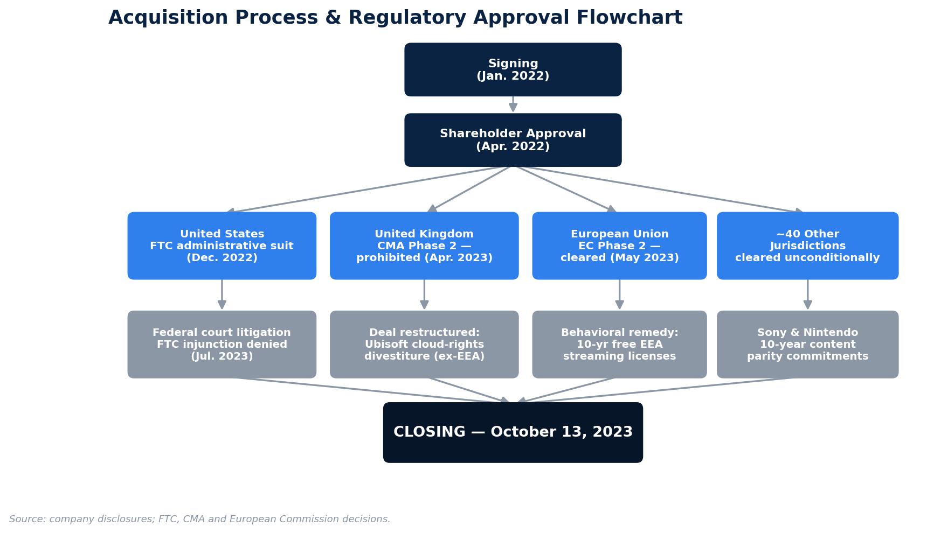
Exhibit 11. Acquisition Process & Regulatory Approval Flowchart

10.2 FTC Concerns and Litigation (United States)
The FTC's core theory of harm was one of vertical foreclosure: the agency alleged that a combined Microsoft-Activision Blizzard would have the incentive and ability to withhold or degrade access to Activision Blizzard content — chiefly Call of Duty — from rival gaming platforms and services, thereby substantially lessening competition in three claimed relevant markets: (i) high-performance video game consoles, (ii) video game content library subscription services (i.e., Xbox Game Pass versus PlayStation Plus), and (iii) cloud gaming services. Unlike a traditional horizontal merger theory (combining direct competitors selling the same product), a vertical foreclosure theory requires a more speculative showing of future incentive and conduct, which is generally harder for enforcers to prove to the traditional preliminary-injunction evidentiary standard, and is the central reason the FTC's case ultimately failed in court.
Following a five-day evidentiary hearing that included testimony from Xbox CEO Phil Spencer, Activision Blizzard CEO Bobby Kotick, and Sony executives, Judge Corley's July 10, 2023 opinion found that the FTC had not shown a likelihood of success on the merits, crediting Microsoft's written, public, and in-court commitments — including its agreements to keep Call of Duty on PlayStation and to bring it to Nintendo Switch — as credible evidence undermining the foreclosure theory. The court's reasoning turned significantly on the distinction between a firm having an increased incentive to foreclose rivals (which the court accepted as plausible) and the FTC's failure to show the merger would probably result in substantial lessening of competition (the actual legal standard), a nuanced but decisive distinction. The FTC's subsequent emergency appeal to the Ninth Circuit was denied within days, effectively clearing Microsoft's path to close in the United States, although the FTC's underlying administrative complaint (before its own in-house administrative law judge) remained technically pending for a further period before being withdrawn from adjudication and, ultimately, addressed via a published — but by then largely moot — Ninth Circuit opinion in May 2025.

10.3 CMA Review (United Kingdom)
The UK CMA's review followed a markedly different trajectory and is the single most consequential regulatory event in the transaction's history. Following a Phase 2 in-depth investigation, the CMA formally blocked the transaction outright on April 26, 2023 — a decision announced explicitly on the basis that the deal, as originally structured, would harm competition in the nascent but rapidly growing UK cloud gaming market, by giving Microsoft (already a leading cloud gaming infrastructure provider via Azure and Xbox Cloud Gaming) control over key content that could be withheld or degraded relative to rival cloud gaming services (NVIDIA GeForce Now, Amazon Luna, and others). This was, at the time, an unprecedented outcome for a UK regulator on a deal of this profile, and represented the most significant setback of the transaction's regulatory history.
Rather than abandon the deal, Microsoft pursued a structural remedy negotiated directly with the CMA: Microsoft agreed to divest Activision Blizzard's cloud-streaming rights for all current and future Activision Blizzard PC and console titles released over the next 15 years — excluding the European Economic Area, where the European Commission's own remedy already applied — to Ubisoft Entertainment SA, a direct competitor, for the life of that 15-year term. This divestiture directly addressed the CMA's foreclosure concern by ensuring a credible, independent, non-Microsoft-controlled licensor of Activision Blizzard's cloud-streaming rights would exist in the UK market regardless of Microsoft's own strategic incentives. Following a fresh, expedited review of this restructured transaction, the CMA granted final approval on October 13, 2023, the same day the deal closed.
The CMA episode is a rare and instructive real-world example of a structural remedy resolving an outright prohibition decision post-appeal, rather than the more common pattern of behavioral remedies negotiated during Phase 2 review before a prohibition decision is even issued. It is also a striking illustration of jurisdictional divergence in contemporary merger control: the same vertical foreclosure theory of harm that a U.S. federal court rejected as insufficiently substantiated was found sufficiently substantiated by the UK's competition authority to justify an outright block, reflecting differences in each jurisdiction's substantive legal standard, evidentiary thresholds, and institutional posture toward vertical mergers in digital and platform markets.

10.4 European Commission Review
The European Commission conducted its own Phase 2 in-depth investigation in parallel with the U.S. and UK proceedings, issuing a Statement of Objections in February 2023 that focused primarily on potential foreclosure effects in cloud game streaming. Unlike the CMA, the Commission opted for a behavioral remedy rather than a structural divestiture or block: on May 15, 2023, the Commission conditionally cleared the transaction, subject to Microsoft's commitment to grant free, automatic 10-year licenses to consumers in the European Economic Area, permitting them to stream, via any cloud gaming service of their choosing, all current and future Activision Blizzard PC and console games for which they own a license — effectively guaranteeing multi-homing rights for EEA consumers regardless of which cloud gaming platform they use.
The European Commission's clearance decision — reached roughly a month after the CMA's prohibition decision, on largely the same evidentiary record — is frequently cited in EU/UK competition law commentary as an example of two closely aligned regulatory regimes reaching opposite conclusions on remedy design (behavioral licensing versus structural divestiture) even while broadly agreeing on the underlying theory of harm, underscoring that merger remedy outcomes often turn as much on institutional risk tolerance and remedy philosophy as on the underlying competitive economics.

10.5 Remedies Implemented (Summary)
Table 10.2 — Summary of Remedies and Commitments
Remedy | Counterparty | Term | Jurisdiction Addressed
Call of Duty parity commitment (continued availability on PlayStation) | Sony Interactive Entertainment | 10 years | Global (cited across all three major reviews)
Call of Duty and other title availability on Nintendo platforms | Nintendo | 10 years | Global
Cloud-streaming rights divestiture (ex-EEA) for all current/future ABK PC & console titles | Ubisoft Entertainment SA | 15 years | United Kingdom (CMA structural remedy)
Free automatic 10-year cloud-streaming licenses to EEA consumers across any cloud gaming service | N/A (consumer-facing behavioral commitment) | 10 years | European Union (EC behavioral remedy)
Cloud gaming distribution agreements | NVIDIA (GeForce Now), Boosteroid, and others | Multi-year | Global; cited in U.S. litigation as evidence against foreclosure theory

10.6 Regulatory Analysis and Implications
Several conclusions of broader relevance to M&A practitioners emerge from this transaction's regulatory history:
- Vertical mergers are increasingly contestable, even absent horizontal overlap. All three major regulators accepted, to varying degrees, that a vertical foreclosure theory was plausible; the divergence was in whether the evidence met each jurisdiction's standard of proof, not in whether such theories are cognizable at all. Deal teams structuring content/platform combinations should now assume vertical foreclosure scrutiny as a base case, not an exceptional risk.
- Behavioral commitments made pre-emptively can meaningfully influence litigation outcomes, as demonstrated by Judge Corley's explicit reliance on Microsoft's Sony and Nintendo commitments in rejecting the FTC's case — suggesting that proactively negotiating supply commitments with the most vocal competitive objectors (here, Sony) before or during litigation can be a more effective legal strategy than resisting such commitments as a matter of negotiating leverage.
- Remedy design philosophy varies meaningfully by regulator even on similar facts, and deal teams should not assume that clearance (or remedy design) in one major jurisdiction is predictive of the approach in another, even among historically aligned regulators (EU and UK diverged sharply here despite a shared analytical starting point).
- Deal protection mechanics (Section 5.5) should explicitly price in the realistic possibility of an outright prohibition decision requiring a full deal restructuring, not merely a delay; the CMA's prohibition and subsequent restructuring is a rare, real-world instance of a "blocked" deal being revived through a negotiated structural remedy rather than abandoned, and is worth studying by any analyst modeling regulatory risk in future platform/content consolidation transactions.

11. INTEGRATION CHALLENGES

11.1 Cultural Integration
Cultural integration represented, by most external accounts, the single most difficult dimension of post-merger execution. Activision Blizzard entered the transaction amid an unresolved and highly public workplace-culture crisis (Section 3.5), including active litigation alleging systemic harassment and pay discrimination, and a leadership team (chiefly CEO Bobby Kotick) whose continued tenure through closing was itself a point of significant internal and external controversy. Microsoft, by contrast, operates under a substantially different corporate governance and HR compliance regime, shaped by its scale, public company tenure, and the reputational sensitivity inherent in being one of the world's most closely watched employers.
Microsoft's approach — allowing Kotick to remain CEO of the Activision Blizzard unit through a defined transition period (through December 31, 2023) before departing, while placing ultimate reporting authority with Xbox CEO Phil Spencer — reflected a common, if imperfect, large-acquirer playbook for managing this class of risk: preserve short-term operational continuity and institutional knowledge during the highest-risk integration window, while installing acquirer-side executive oversight and setting a firm, public departure date for legacy leadership most closely associated with the pre-deal controversy. This approach avoided the disruption of an abrupt leadership vacuum at close, but necessarily meant that full cultural remediation (updated reporting structures, HR policy harmonization, leadership changes below the CEO level) unfolded gradually over the twelve-plus months following closing rather than on day one.

11.2 Technology Integration
Technology integration challenges centered on migrating Activision Blizzard's game infrastructure, backend services, anti-cheat and telemetry systems, and internal enterprise systems (finance, HR, procurement) onto Microsoft's technology stack, principally Azure. This is a multi-year undertaking for an organization of Activision Blizzard's scale and technical complexity, particularly given that several Activision Blizzard studios (notably Blizzard, historically the most operationally independent of the three legacy segments) maintained bespoke, long-standing infrastructure supporting live-service titles with large concurrent user bases (World of Warcraft, Call of Duty: Warzone) where migration risk (service disruption, latency regression, data integrity) carries direct and immediate commercial consequences, unlike a typical back-office systems migration where user-facing risk is more contained.

11.3 Employee Retention
Talent retention is a first-order risk in any acquisition of a creative, studio-based organization, where the core asset is frequently the tacit knowledge and creative judgment of specific development teams rather than codified, transferable processes. The post-close track record on this dimension has been decidedly mixed:
- Multiple senior creative and executive departures occurred in the roughly two years following close, including reported departures at the Blizzard leadership level.
- The cancellation of in-development projects (Blizzard's "Project Odyssey" survival MMO; a ZeniMax Online Studios MMORPG reportedly codenamed "Blackbird") following the January 2024 layoffs represented a direct loss of multi-year creative investment and, in all likelihood, a contributing factor to subsequent departures of the teams associated with those projects.
- The May 2024 closures of Arkane Austin (developer of Redfall) and Tango Gameworks (developer of the critically acclaimed Hi-Fi Rush) resulted in the loss of entire, previously-intact creative teams; Tango Gameworks was subsequently divested to Krafton in what the industry broadly characterized as a rare, partial reversal of an initial closure decision, but one that came only after significant team attrition and reputational damage had already occurred.

11.4 Operational Execution
Table 11.1 — Post-Close Workforce Actions
Date | Action | Approx. Scale
Jan. 2024 | Layoffs across Xbox and Activision Blizzard gaming division | 1,900 roles (~9% of the combined ~22,000-person gaming division)
May 2024 | Studio closures: Arkane Austin, Tango Gameworks | Full studio headcounts affected; Tango later divested to Krafton
Sept. 2024 | Further layoffs, concentrated in corporate and support functions | ~650 roles
Jul. 2025 | Company-wide Microsoft layoffs (not gaming-specific, but affecting gaming division roles) | ~9,000 roles across Microsoft

Cumulatively, gaming-division-specific headcount reductions attributable to post-merger integration have been estimated at roughly 2,500–2,900 roles within the first 12–18 months following close, a substantial proportion of the combined division's pre-deal headcount, and a pace and scale of disruption that materially exceeded what Microsoft's public announcement-day messaging ("areas of overlap," a "sustainable cost structure") might have suggested to external observers at signing. Operationally, Xbox's first-party release cadence has also remained a point of ongoing scrutiny: despite the deal's promise of an expanded content pipeline, several commentators have noted that the combined studio slate has continued to experience the same delayed-release patterns that affected Activision Blizzard standalone (Diablo IV, Overwatch 2) prior to the deal, suggesting that scale alone does not resolve the structural challenges of AAA game development timelines.
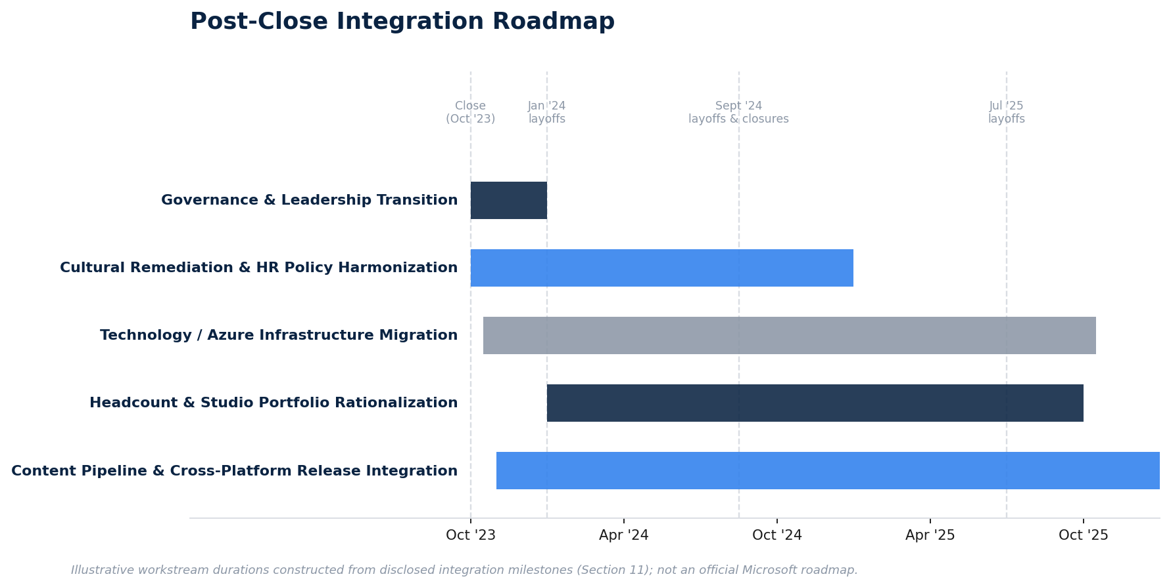
Exhibit 12. Post-Close Integration Roadmap

11.5 Integration Governance Structure
Following close, Activision Blizzard, Blizzard Entertainment, and King were absorbed into Microsoft Gaming under Phil Spencer's overall leadership, with day-to-day operational responsibility for the Activision Blizzard business reportedly transitioning to veteran Xbox executive Matt Booty following Bobby Kotick's scheduled departure. This governance structure — folding the acquired studios into Microsoft's existing "Xbox Game Studios" organizational umbrella rather than preserving Activision Blizzard as a standalone, arm's-length operating unit — reflects a "full integration" rather than "hold separate" post-merger integration philosophy, consistent with Microsoft's stated ambition to realize both revenue and cost synergies (Section 7) rather than simply operate Activision Blizzard as a financially consolidated but operationally independent subsidiary.

12. RISK ANALYSIS
Table 12.1 — Comprehensive Risk Matrix
Risk Category | Description | Likelihood (at signing) | Impact | Outcome / Mitigation Observed
Regulatory risk | Multi-jurisdictional antitrust review, including possibility of outright prohibition | High | Very High | Materialized in full (CMA prohibition); resolved via structural remedy (Ubisoft divestiture) and litigation victory (FTC); added ~4 months to timeline and materially increased deal cost
Market risk | Sensitivity of both MSFT and ATVI share prices to macro conditions (2022 tech sector de-rating, rising rates) during the 21-month pendency period | Moderate | Moderate | ATVI traded persistently below the $95 offer price throughout 2022–2023, reflecting market-priced deal-completion risk (merger arbitrage spread) rather than acquirer-specific market risk
Financial risk | Purchase price step-up from share dilution during extended pendency; financing mix shift from pure cash to partial short-term debt | Low-to-moderate | Moderate | Materialized: final consideration of $75.4bn versus $68.7bn announced; $27bn of new short-term borrowings required at close
Integration risk | Cultural, technology, and talent-retention risk given target's governance issues and creative-studio talent base | High | High | Materialized: multiple rounds of layoffs, studio closures, and reported executive/creative departures through 2024–2025
Execution risk | Risk that management fails to realize the articulated strategic and synergy rationale within a reasonable timeframe | Moderate | High | Mixed: clear evidence of revenue-side synergy realization (Game Pass, Black Ops 6 performance); GAAP profitability contribution has been near-neutral through the most recent fiscal year reported (Section 9.4)
Reputational risk | Ongoing association with pre-existing Activision Blizzard workplace-culture controversy, plus new post-close controversy (layoffs, price increases) | Moderate | Moderate | Materialized in the form of sustained media and political scrutiny (former FTC Chair Lina Khan's public commentary; consumer criticism of Game Pass price increases)
Litigation risk | Shareholder and other litigation arising from disclosure adequacy in the merger proxy | Low (at signing) | Moderate | Materialized: Delaware Court of Chancery declined to dismiss fiduciary-duty claims in Sjunde AP-Fonden v. Activision Blizzard (Oct. 2025), addressed further in Section 16

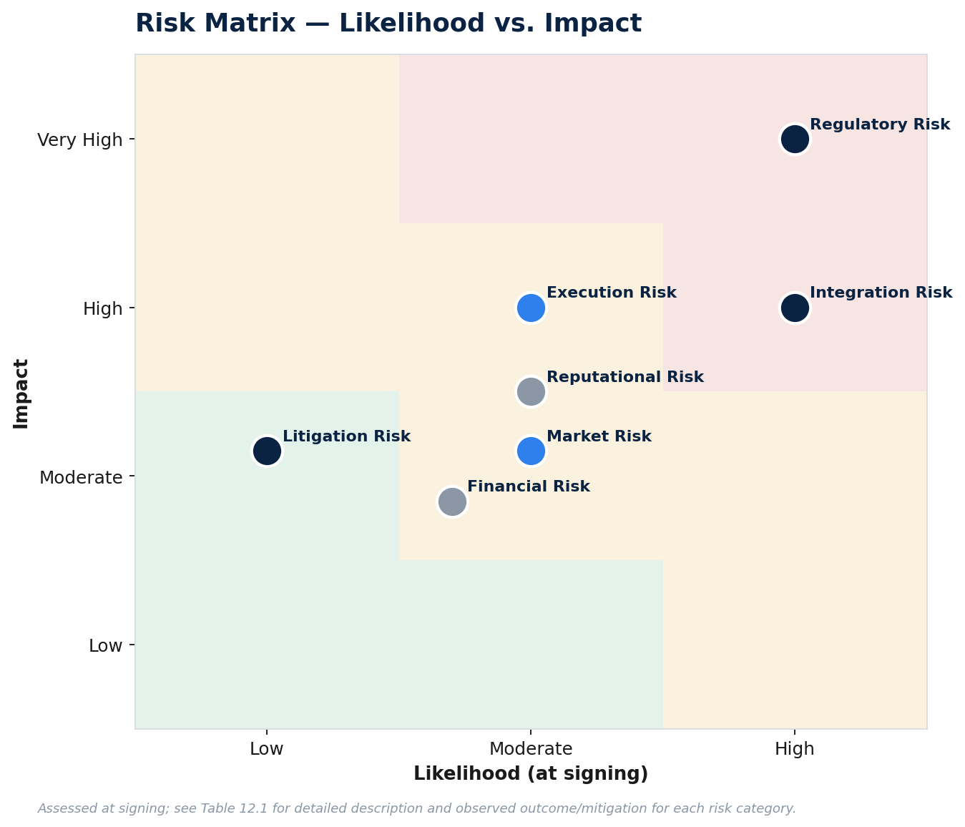
Exhibit 13. Risk Matrix: Likelihood vs. Impact

12.1 Regulatory Risk (Detailed)
As detailed extensively in Section 10, regulatory risk was both the most significant and most accurately anticipated risk in this transaction — reflected directly in the unusually large and steeply escalating reverse termination fee structure (Section 5.5), which shows that Microsoft's own deal team assigned meaningful probability, at signing, to a protracted and potentially unsuccessful antitrust process. What was less fully anticipated, based on the original fiscal-year-2023 closing target, was the specific form the risk would take: an outright prohibition decision by a G7 competition regulator (the CMA) is a materially more severe outcome than the negotiated Phase 2 remedies that are the more typical result of in-depth merger reviews, even in contested vertical mergers.

12.2 Market Risk (Detailed)
Because the transaction was structured as an all-cash offer, Activision Blizzard shareholders bore no direct exposure to Microsoft's share price between signing and closing; however, Activision Blizzard's own share price traded as a merger-arbitrage instrument throughout the pendency period, persistently below the $95.00 offer price by a spread reflecting the market's continuously updated assessment of deal-completion probability and timing. This spread widened notably around adverse regulatory news (the FTC's December 2022 lawsuit; the CMA's April 2023 prohibition) and narrowed following positive developments (the July 2023 FTC litigation victory), providing a real-time, market-based read on perceived deal risk throughout the review period — a dynamic of direct relevance to merger arbitrage desks and a useful teaching example of how public information flows translate into observable security pricing during a long-dated, contested regulatory review.

12.3 Financial Risk (Detailed)
See Section 9.1 and 9.4 above for the realized financial risks (purchase price step-up, near-neutral near-term GAAP EPS contribution).

12.4 Integration and Execution Risk (Detailed)
See Section 11 above.

13. SWOT ANALYSIS

13.1 SWOT — Combined Entity (Microsoft Gaming, Post-Acquisition)
Table 13.1 — SWOT Analysis
Strengths | Weaknesses
Unmatched breadth of first-party franchise portfolio (Halo, Forza, Minecraft, Elder Scrolls/Fallout, plus Call of Duty, Warcraft, Diablo, Overwatch, Candy Crush) | Persistent integration disruption (multiple layoff rounds, studio closures) creating morale and execution risk
Cross-platform distribution advantage via Windows, Xbox, and Azure that no pure-play publisher or console competitor can replicate | Console hardware business structurally sub-scale versus Sony's PlayStation installed base
Exceptional balance sheet strength enabling continued bolt-on M&A and sustained content investment | Reputational overhang from consumer-facing price increases (Game Pass) occurring in close proximity to the acquisition
Proven subscription go-to-market capability (Office 365 playbook) applied to Game Pass | Slower-than-hoped realization of mobile cross-portfolio synergies (King capabilities not yet visibly extended across the broader Microsoft first-party slate)
Demonstrated commercial validation of the multi-platform strategy (record Black Ops 6 performance across Xbox, PlayStation, and Steam) | Continued AAA development delays across both legacy Xbox and legacy Activision Blizzard studios

Opportunities | Threats
Further scaling of Xbox Cloud Gaming leveraging Azure infrastructure and now-owned content | Continued antitrust and political scrutiny of "Big Tech" gaming consolidation, particularly around pricing conduct post-close
Expansion of Game Pass internationally, leveraging King's emerging-market mobile distribution footprint | Subscriber attrition risk following Game Pass price increases (reported "millions" of subscriber losses after the October 2025 price increase)
Cross-IP opportunities (mobile adaptations of console/PC franchises; potential film/TV or transmedia extensions of Activision Blizzard IP) | Competitive response from Sony (Bungie acquisition) and Tencent/NetEase continuing to invest aggressively in content and studio acquisitions
AI-driven game development tools potentially reducing the cost and time of AAA development, addressing the industry-wide delay problem | Reallocation of Microsoft's overall capital expenditure priorities toward AI/cloud infrastructure, potentially crowding out gaming-specific investment over time

14. MARKET REACTION

14.1 Share Price Performance — Activision Blizzard
Activision Blizzard's share price reacted sharply and immediately to the announcement, rising from its unaffected close of $65.39 (January 14, 2022) to close at $82.31 on January 18, 2022 — an approximately 26% single-day gain, but notably still a roughly 13–14% discount to the $95.00 offer price. This immediate, persistent discount to the offer price (rather than the shares trading up to near-parity with the offer, as is typical in lower-risk negotiated cash mergers) reflected the market's real-time pricing of substantial deal-completion risk, driven primarily by the anticipated antitrust scrutiny that was itself flagged in contemporaneous press coverage on the very day of the deal's announcement.
Over the subsequent 21 months, Activision Blizzard's share price continued to trade as a merger-arbitrage security, generally in a band between the high-$60s and high-$80s, moving inversely to perceived regulatory risk: the shares fell sharply following the CMA's April 2023 prohibition decision, and recovered following Microsoft's July 2023 U.S. litigation victory, before converging toward the $95.00 offer price as closing certainty increased through September and October 2023.

14.2 Share Price Performance — Microsoft
By contrast, Microsoft's own share price showed minimal sensitivity to deal-related news throughout the pendency period — Microsoft shares declined only modestly (approximately 2%) on the announcement day itself, and showed similarly muted reactions to subsequent regulatory milestones (a roughly 0.2% move on the EC's May 2023 approval, for instance). This is consistent with basic financial-materiality logic: even at $68.7–75.4 billion, the transaction represented only approximately 3% of Microsoft's ~$2.3 trillion market capitalization at signing, meaning that even a binary deal-completion outcome (closing versus collapsing) was not, on its own, a market-moving event for Microsoft equity — a useful illustration for analysts of how absolute deal size must always be assessed relative to acquirer scale when forecasting market reaction, rather than in isolation.
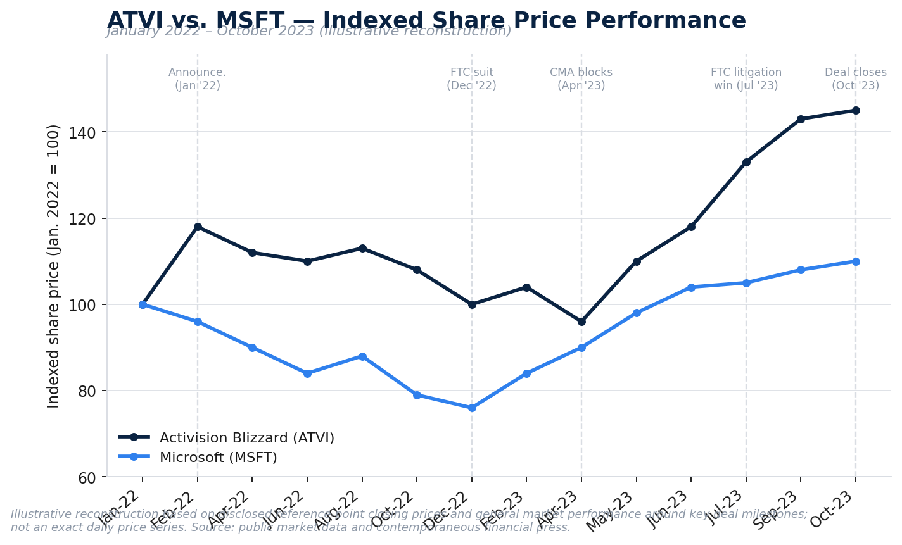
Exhibit 14. ATVI vs. MSFT Indexed Share Price Performance, Jan. 2022 – Oct. 2023

14.3 Analyst Opinions
Sell-side analyst reaction at signing was broadly constructive on strategic rationale but cautious on regulatory timing. Following the FTC's disclosed intent to challenge the deal in late 2022, multiple analysts (including at Wells Fargo and Morgan Stanley) issued price target commentary explicitly built around the $95.00 offer price as a reasonable estimate of standalone-plus-deal-probability fair value, with several analysts explicitly framing Activision Blizzard as an attractive holding on a risk-reward basis even in a deal-collapse scenario, citing the strength of the standalone franchise portfolio (particularly Call of Duty and World of Warcraft) independent of the Microsoft transaction. This dual framing — bullish on the underlying business, cautious on deal-completion timing — is a hallmark of well-calibrated merger-arbitrage-adjacent equity research and reflects appropriately disciplined analytical separation of business fundamentals from binary deal-completion risk.

14.4 Investor Sentiment
Broader investor sentiment diverged sharply along shareholder-base lines. Activision Blizzard's shareholder base, having overwhelmingly approved the merger in an April 2022 shareholder vote, was broadly supportive of the transaction throughout, given the substantial premium on offer relative to a depressed and scandal-affected standalone trading history. Microsoft's shareholder base, by contrast, showed limited engagement with the transaction as a standalone catalyst — consistent with the share price data in Section 14.2 — with buy-side commentary at the time (including from at least one disclosed institutional holder, Vontobel Asset Management) characterizing the deal size as manageable relative to Microsoft's overall balance sheet capacity, rather than as a transformative or high-conviction catalyst for the stock.

15. POST-ACQUISITION PERFORMANCE

15.1 Initial Outcomes (Close through FY2024)
The immediate post-close period (October 2023 – mid-2024) was characterized by a combination of clear financial consolidation success and significant organizational disruption, as detailed in Sections 9 and 11. Gaming segment revenue rose sharply on a reported basis, while the acquired business's contribution to consolidated operating income was, in the near term, actually negative on a GAAP basis due to purchase-accounting mechanics (Section 9.3). Organizationally, the January 2024 layoffs (1,900 roles) arrived within approximately three months of closing, an unusually rapid cadence for a target-side workforce reduction, that drew immediate media and regulatory-adjacent criticism given the deal's central public justification (accelerating investment in games and players) appeared, to critics, in tension with an immediate reduction in the development workforce.

15.2 Strategic Achievements
Notwithstanding the disruption described above, the transaction has, on the available evidence, delivered on several of its core strategic theses:
- Commercial validation of the multi-platform strategy. Call of Duty: Black Ops 6, released in October 2024 — the first Call of Duty title released under full Microsoft ownership and the first following the Sony parity commitment (Section 10.5) — delivered the largest console launch in the franchise's history and the largest single-day Xbox Game Pass subscriber addition on record. Notably, unit sales on PlayStation and Steam were reported up approximately 60% year-over-year versus the prior annual entry, directly validating Microsoft's decision to pursue maximal cross-platform reach (rather than Xbox exclusivity) as, in fact, the more commercially rational strategy at this stage of the console cycle — a strategy that was, in significant part, forced upon Microsoft by regulatory necessity, but which appears to have proven advantageous on the merits independent of that regulatory origin.
- Gaming segment scale. Microsoft Gaming segment revenue reached $23.5 billion in fiscal year 2025, up from $21.5 billion in fiscal year 2024 and roughly $15–16 billion in the last full pre-close fiscal year — a step-change in scale consistent with the deal's original strategic ambition of meaningfully repositioning Microsoft's standing among global gaming companies by revenue.
- No disclosed impairment. As of the most recent reporting reviewed, Microsoft had not recognized any goodwill or intangible asset impairment specifically associated with the Activision Blizzard acquisition, indicating management's original valuation case had not, at an accounting level, been formally revisited downward.

15.3 Remaining Challenges
Set against these achievements, several challenges remain unresolved as of this analysis:
- Xbox Game Pass subscriber trajectory and pricing backlash. The last officially disclosed Game Pass subscriber count was approximately 34 million, as of February 2024; Microsoft has not disclosed an updated total since. A roughly 18% price increase to Xbox Game Pass Ultimate (from $16.99 to $19.99 per month) took effect in 2024, followed by reports of a further, larger price increase in October 2025; media reporting has characterized subsequent subscriber losses as being "in the millions," though Microsoft has not confirmed precise figures. This pattern — reduced pricing transparency (discontinuing regular subscriber disclosures) coinciding with repeated price increases — has been the single most consistent source of continued public and regulatory-adjacent criticism of the transaction's aftermath, including renewed commentary from former FTC Chair Lina Khan directly linking the post-close price increases and layoffs to the competitive concerns the FTC originally raised in litigation.
- Continued workforce volatility. Beyond the January 2024 and September 2024 gaming-specific layoffs, Microsoft's July 2025 company-wide reduction of approximately 9,000 roles further affected the gaming division, extending the pattern of recurring workforce reductions well beyond what might be considered a "one-time" post-merger integration adjustment into a more sustained cost-discipline posture.
- Ongoing shareholder litigation. As detailed in Section 16, Delaware Chancery Court litigation concerning the adequacy of Activision Blizzard's merger-related disclosures remained active as of late 2025, more than two years after closing — illustrating that large public-company M&A transactions can generate multi-year "tail" litigation risk for the parties (and, by extension, for their advisors and insurers) well beyond the closing date itself.
- Studio pipeline and release cadence. Despite the combined entity's greatly expanded content portfolio, the pace of major first-party releases has continued to face delays across both legacy Xbox and legacy Activision Blizzard studios, suggesting the deal has not, on its own, resolved the structural execution challenges inherent in large-scale AAA game development.
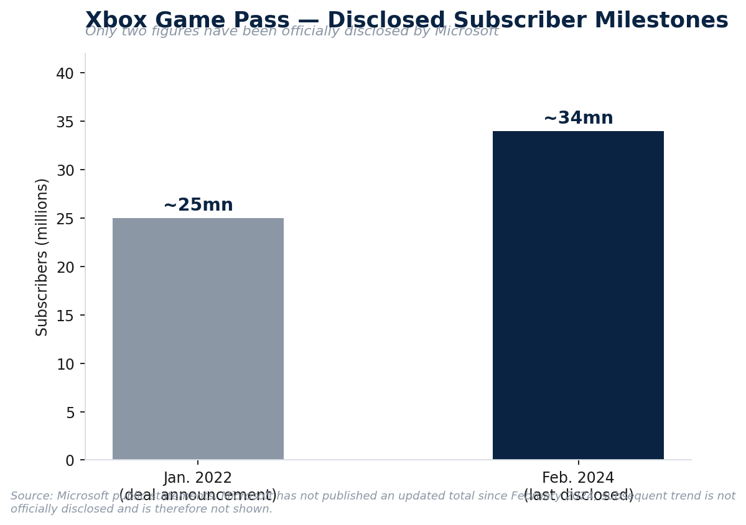
Exhibit 15. Xbox Game Pass: Disclosed Subscriber Milestones

16. KEY LESSONS FOR INVESTMENT BANKERS

16.1 What Made the Transaction Successful
Several deal-execution features distinguish this transaction as a well-constructed, professionally executed piece of M&A craft, independent of one's view on the ultimate strategic merits:
- Deal protection provisions correctly priced regulatory risk. The escalating reverse termination fee structure (Section 5.5) demonstrates sophisticated, forward-looking risk allocation between the parties, and the extension mechanics executed cleanly in real time when the CMA's Phase 2 review ran long — the mark of a well-drafted merger agreement is that its contingency provisions function smoothly under actual stress, not merely in theory.
- Proactive commitment strategy neutralized the most credible objector. Rather than treating Sony's public opposition purely as a public-relations problem, Microsoft's deal and regulatory-affairs teams converted that opposition into a concrete, litigable commitment (the 10-year Call of Duty parity agreement) that directly undercut the FTC's foreclosure theory in court — a clear illustration of how substantive commercial commitments, not just lobbying or messaging, are the most effective tool for managing merger-control risk in contested vertical deals.
- Willingness to restructure rather than abandon. Following the CMA's outright prohibition — an outcome many deal teams would have treated as fatal — Microsoft's team negotiated a genuine structural remedy (the Ubisoft divestiture) rather than either litigating the UK decision to a potentially adverse conclusion or walking away from a strategically important asset. This reflects disciplined problem-solving under an adverse ruling rather than reflexive escalation or abandonment.
- Conservative financing preserved optionality. By funding the deal predominantly from cash and only modest incremental short-term debt, Microsoft preserved its credit profile and financial flexibility throughout an unusually long and uncertain regulatory process — a markedly different risk profile than a heavily levered financial-sponsor-style acquisition would have carried through the same 21-month uncertainty window.

16.2 Major Negotiation Points
- Price and premium. The 45% premium, while elevated by conventional standards, was calibrated against a depressed, scandal-affected trading base rather than a "clean" share price, and was likely necessary to secure target board and shareholder support decisively (evidenced by the overwhelming April 2022 shareholder approval vote) and to preempt the risk of a competing bid or activist-driven demand for a higher price.
- Termination fee escalation and outside-date extension. The mid-2023 negotiation to extend the outside date (from July 18 to October 18, 2023) alongside an increased reverse termination fee schedule is itself a negotiation micro-event worth studying: it reflects real-time renegotiation of deal economics as new information (the CMA's prohibition, the pending FTC litigation outcome) became available, rather than a static agreement fixed at signing.
- CEO transition terms. The negotiated arrangement allowing Bobby Kotick to remain Activision Blizzard CEO through the transition period, reporting to Phil Spencer, represents a negotiated balance between preserving continuity through closing and managing the reputational and governance risk of extending a controversial executive's tenure — a recurring negotiation point in acquisitions of founder- or long-tenured-CEO-led targets with unresolved governance controversies.
- Remedy scope in the UK restructuring. The decision to carve the Ubisoft divestiture to "ex-EEA" rights specifically (rather than a global divestiture) reflects careful remedy-scoping to address the CMA's specific jurisdictional concern without unnecessarily conceding rights in markets (the EEA) where a different, less severe remedy (the EC's behavioral licensing commitment) was already in place — an efficient, jurisdiction-specific remedy design that avoided over-conceding value.

16.3 Key Takeaways
For investment banking analysts and associates studying this transaction as a template, the most durable, transferable lessons are:
- Model regulatory timeline risk explicitly, not just as a discount rate adjustment. A 21-month delay against an originally targeted ~17-month close materially changed the deal's actual economics (purchase price step-up from share count growth, financing mix shift, and substantial un-disclosed but real litigation and advisory cost) in ways a simple probability-weighted NPV framework may understate; sources-and-uses and financing plans should be stress-tested against realistic worst-case timelines, not just the base case.
- Distinguish "enterprise value" from "equity value" precisely, and be prepared for financial media to conflate them. As shown in Section 5.2, careful analysts should always reconstruct the EV bridge explicitly (net cash/debt adjustment) rather than relying on headline "deal value" figures, which frequently represent equity value dressed in enterprise-value language in secondary coverage.
- Purchase accounting can materially distort near-term reported results relative to underlying business economics (Section 9.3); analysts assessing whether an acquisition is "working" in the first 12–24 months post-close should look through GAAP operating income to underlying revenue growth, cash generation, and the specific composition of intangible amortization schedules, rather than concluding a deal has failed based on near-term GAAP dilution alone — and, conversely, should not uncritically accept management's "on track" framing without examining these same mechanics.
- Revenue synergies typically materialize faster, and cost synergies slower and more disruptively, than integration announcements suggest (Section 7.3) — a pattern directly observable in this transaction's clear, fast revenue consolidation set against its protracted, multi-year sequence of layoffs and studio closures, and a useful base-rate expectation to bring into any synergy-realization tracking exercise on a live deal.
- Disclosure adequacy in merger proxies remains a durable source of tail litigation risk, as demonstrated by the Delaware Court of Chancery's October 2025 decision declining to dismiss fiduciary-duty claims in Sjunde AP-Fonden v. Activision Blizzard, which centered on allegations that the merger proxy inadequately disclosed both the full scope of the pre-existing sexual-misconduct allegations' relevance to the transaction and a covenant obligating Activision Blizzard to purchase at least $0.7 billion of cloud services from Microsoft — a reminder that target-side boards and their advisors bear continuing disclosure obligations that can generate litigation years after a deal has closed and been widely regarded, commercially, as complete.
- Vertical merger control risk is now a mainstream, not a niche, consideration in technology and media M&A, and the divergent US/UK/EU outcomes on materially similar facts demonstrate that regulatory outcome prediction in this space requires jurisdiction-specific analysis grounded in each regulator's own precedent and institutional posture, not a single global assessment of "will this be approved."

17. CONCLUSION

17.1 Overall Assessment
Microsoft's acquisition of Activision Blizzard stands as a landmark transaction in the history of technology and media M&A: the largest deal in the video game industry's history, the largest acquisition in Microsoft's corporate history, and the subject of the most extensive and legally consequential multi-jurisdictional merger review yet undertaken in the sector. Judged purely as a piece of deal execution — valuation discipline, deal protection structuring, financing conservatism, and regulatory strategy — the transaction reflects a well-run, professionally executed process that successfully navigated an unprecedented and, at several points, genuinely uncertain path to closing, including recovering from an outright prohibition decision by a G7 competition regulator, a rare feat in large-cap M&A history.

17.2 Was the Acquisition Value-Creating?
A definitive answer to this question remains, appropriately, a matter of ongoing assessment rather than settled fact, for three reasons made evident throughout this report:
- The financial evidence is genuinely mixed on a near-term GAAP basis. As shown in Section 9.4, the acquisition's contribution to Microsoft's consolidated diluted EPS through the most recent full fiscal year analyzed here was effectively neutral (a $0.02 delta between pro forma and actual results), reflecting the offsetting effects of strong underlying revenue growth against substantial purchase-accounting amortization and integration costs — a pattern entirely typical of large acquisitions in their first 24 months, and not, on its own, evidence of value destruction, but equally not yet evidence of the clear accretion originally promised at announcement.
- The strategic evidence is more clearly positive. The commercial performance of Call of Duty: Black Ops 6 (Section 15.2), the step-change in Gaming segment revenue scale, and the absence of any disclosed impairment collectively suggest that the core strategic thesis — that owning, rather than licensing, top-tier content would strengthen Xbox Game Pass and Microsoft's overall competitive position in gaming — is being borne out in the data available to date.
- The organizational and reputational costs have been real and are not fully captured in the financial statements. Multiple rounds of layoffs, at least two shuttered studios, sustained Game Pass pricing controversy, and ongoing shareholder litigation collectively represent a meaningful, if difficult to precisely quantify, cost of the transaction that a purely financial accretion/dilution analysis will tend to understate.
On balance, this analysis concludes that the transaction should be characterized as provisionally value-creating on strategic grounds, with financial value creation still in the process of being realized and confirmed — an appropriately measured conclusion for a transaction whose full economic consequences, consistent with the general character of large strategic acquisitions in content-driven industries, will likely only be fully assessable on a five-to-seven-year view, well beyond the two years of post-close data available at the time of this analysis.

17.3 Long-Term Outlook
Looking forward, the trajectory of Microsoft's Activision Blizzard acquisition will likely be determined by three factors: (i) whether Xbox Game Pass subscriber and revenue growth can be sustained despite recent price increases, without triggering the kind of subscriber attrition that would undermine the subscription-flywheel thesis at the center of the deal's original rationale; (ii) whether Microsoft can stabilize its studio portfolio and release cadence sufficiently to convert its now-unmatched breadth of franchise ownership into a more consistent, rather than hit-driven, content pipeline; and (iii) how the broader technology industry's capital allocation priorities — increasingly dominated by generative AI infrastructure investment — affect the relative priority and investment intensity Microsoft applies to its gaming division over the coming years, a dynamic entirely exogenous to the original deal thesis but highly likely to shape its ultimate multi-year outcome.

18. REFERENCES

SEC Filings
- Microsoft Corporation, Form 10-Q, quarter ended December 31, 2021 (filed with the SEC).
- Microsoft Corporation, Form 10-K, fiscal year ended June 30, 2022.
- Microsoft Corporation, Form 10-K, fiscal year ended June 30, 2024 (purchase price allocation and supplemental pro forma disclosures for the Activision Blizzard acquisition).
- Activision Blizzard, Inc., Form 10-K, fiscal year ended December 31, 2021.
- Activision Blizzard, Inc., Preliminary Proxy Statement (PREM14A), filed in connection with the proposed merger with Microsoft Corporation.
- Microsoft Corporation, Form 8-K filings and earnings press releases, fiscal years 2021–2026 (quarterly and annual results).
- Microsoft Corporation, Form DEF 14A (Proxy Statement), fiscal year 2024.

Company Annual Reports and Investor Presentations
- Microsoft Corporation, 2021 Annual Report to Shareholders.
- Microsoft Corporation, 2024 Annual Report to Shareholders.
- Activision Blizzard, Inc., Fourth-Quarter and Full-Year 2021 Financial Results press release and supplemental materials.
- Activision Blizzard, Inc., Third-Quarter 2021 Financial Results press release.

Press Releases
- Microsoft News Center, "Microsoft to acquire Activision Blizzard to bring the joy and community of gaming to everyone, across every device," January 18, 2022.
- U.S. Court of Appeals for the Ninth Circuit, FTC v. Microsoft Corp., published opinion, May 7, 2025.

Reliable Financial News and Legal/Regulatory Sources
- Forbes, "Microsoft Finally Buys Activision For $69 Billion After Regulatory Approval," October 2023.
- Morningstar, "Activision Blizzard Bought by Microsoft for $69 Billion."
- Financier Worldwide, "Microsoft agrees $69bn Activision acquisition."
- CNBC, various reporting on Activision Blizzard share price performance and analyst commentary, 2022–2023.
- Davis Polk & Wardwell, "District court denies FTC's bid to halt Microsoft/Activision deal," client update, July 2023.
- CRA (Charles River Associates), "US review clears Microsoft's acquisition of Activision," engagement summary.
- Gustafson Gluek PLLC, "Court Rejects FTC Challenge to Microsoft Acquisition of Activision: A Setback to U.S. Antitrust Enforcement."
- MarketScreener, deal summary and advisor fee disclosures, Microsoft Corporation acquisition of Activision Blizzard, Inc.
- Harvard Law School Forum on Corporate Governance, "Activision II's New Lessons and Important Reminders for Boards When Selling the Company," November 2025 (discussing Sjunde AP-Fonden v. Activision Blizzard, Delaware Court of Chancery, October 2, 2025).
- PC Gamer, GameSpot, Yahoo Finance/Tech Insider, and Variety, reporting on post-acquisition layoffs, studio closures, Xbox Game Pass pricing, and Call of Duty: Black Ops 6 commercial performance, 2024–2026.
- Statista, Microsoft annual and quarterly gaming segment revenue data.
- Newzoo and industry-tracking sources (via secondary reporting), global games market size estimates, 2020–2025.
- CT Acquisitions / CLFI, analysis of Microsoft's final purchase price allocation for the Activision Blizzard acquisition, sourced from Microsoft's FY2024 and FY2025 Form 10-K disclosures.
End of report. All figures presented herein are drawn from the public sources cited above and are believed accurate as of the date of this analysis; certain comparable company multiples are presented as illustrative approximations for analytical purposes, as noted in Section 8. This document does not constitute investment advice, a fairness opinion, or an offer or solicitation with respect to any securities.

