SmartCare v0.3 - Domain Model Workbook
Week 6 student resource

Requirement-to-Concept Trace
Requirement | Concept | State/behaviour | Decision
FR-01 | Patient | patient_id, name / create record | Patient class
FR-02 | Patient | patient information / search | Patient responsibility
FR-03 | Patient | patient information / view | Patient responsibility
FR-04-FR-05 | Appointment | appointment time / create and change | Appointment class
FR-06-FR-07 | Appointment | appointment / cancel and manage | Appointment responsibility
FR-08 | Appointment | status | Keep as Appointment attribute
FR-09 | Practitioner | practitioner_id, name / view information | Practitioner class
FR-10 | Practitioner | availability / view schedule | Practitioner responsibility
FR-11 | Appointment | patient + practitioner + time / validation | Association/business rule
FR-01-FR-11 | Clinic | No distinct required state/behaviour identified | Do not add as core class

CRC Cards

Patient
Responsibilities | Collaborators
• Store patient information  • Provide patient information  • Be associated with appointments | • Appointment

Practitioner
Responsibilities | Collaborators
• Store practitioner information  • Provide practitioner information  • Maintain availability/schedule | • Appointment

Appointment
Responsibilities | Collaborators
• Store date/time and status  • Connect patient and practitioner  • Create/change/cancel appointment  • Prevent conflicting practitioner/time bookings | • Patient  • Practitioner

Optional class - Status
Responsibilities | Collaborators
• Represent appointment status if later expanded | • Appointment

UML Class Diagram
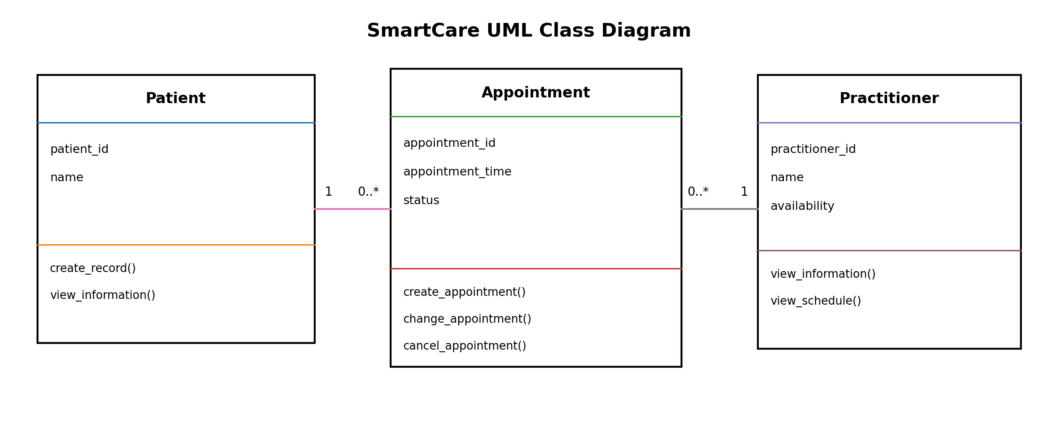

Design Rationale
Patient, Practitioner and Appointment were selected as the main domain classes because they represent the central SmartCare concepts identified from the confirmed requirements. Responsibilities are allocated to the class that owns the relevant information or behaviour. Appointment links one Patient with one Practitioner and stores the appointment time and status. A Patient may have zero or many Appointments, and a Practitioner may have zero or many Appointments. Appointment does not inherit from Patient because an appointment is not a type of patient. Status remains an Appointment attribute at this stage rather than a separate class, keeping the model simple.

AI Design Review Record
AI suggestion | Evidence | Decision | Reason | Model change
Patient class | FR-01-FR-03 | Accepted | Patient data and behaviour are required. | Keep Patient
Practitioner class | FR-09-FR-10 | Accepted | Practitioner information and schedule are required. | Keep Practitioner
Appointment class | FR-04-FR-08, FR-11 | Accepted | Appointment has its own state and behaviour. | Keep Appointment
Separate Status class | FR-08 | Modified | Status is required but is simple enough as an attribute. | Status stays attribute
NotificationManager / ScheduleEngine | No confirmed requirement / FR-10 only partially related | Rejected | Would add unsupported or unnecessary complexity. | No extra class

