SmartCare v0.5 - Architecture and Refactoring Workbook
Week 8 student resource

Current Architecture Problems
Problem | Evidence | Impact | Refactoring
Mixed presentation and domain logic | input()/printing mixed with validation and rules | Harder to test and change UI | Move input/output to Presentation
SQL mixed with workflow logic | SQLite statements in application code | Tight coupling to SQLite | Move SQL to Persistence
Workflow coordination mixed with entities | Booking steps handled in one place with domain rules | Low cohesion and harder maintenance | Introduce focused AppointmentService
Direct data access dependency | Service/application code would call SQLite directly | Difficult to substitute storage | Depend on AppointmentRepository abstraction
Too many responsibilities in one file | UI, validation, rules, persistence and coordination together | Changes can break unrelated behaviour | Separate into layers/packages

Layer Responsibilities
Layer | Responsibilities | Must not contain
Presentation | Read menu/user input; display and format results | SQL, domain rules, repository implementation
Service | Coordinate booking/cancellation use cases; call domain and repository | UI formatting, SQLite-specific SQL
Domain | Patient, Practitioner, Appointment state; validation and status-transition rules | input()/printing, SQL, persistence details
Repository | Define small contracts such as find/save appointment | SQLite implementation details, UI logic
Persistence | Implement repository using SQLite; execute INSERT/SELECT/UPDATE | Business rules, presentation workflow

Architecture Diagram
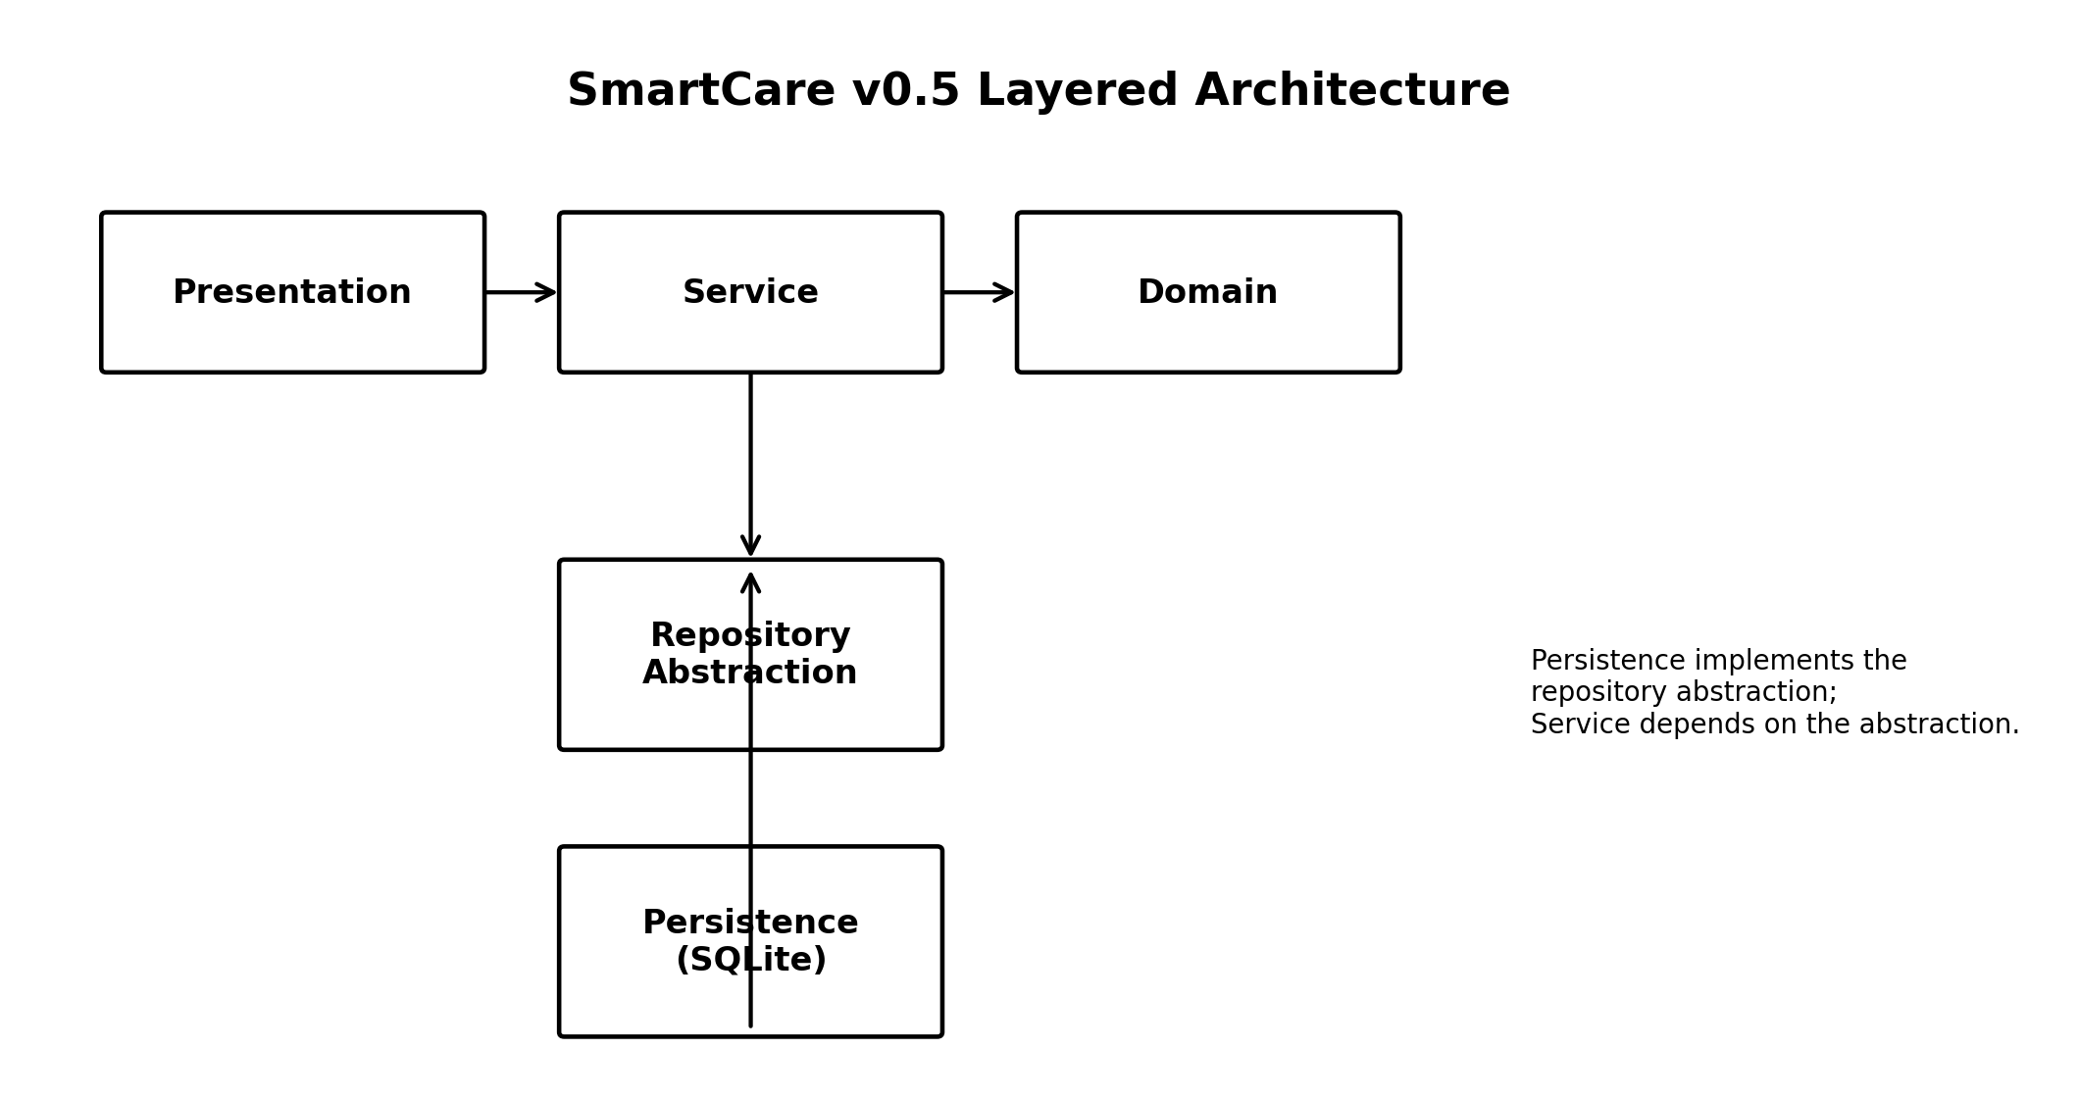

SOLID Review
Principle | Relevant? | Evidence | Decision
SRP | Yes | A single file/ClinicManager handling UI, workflow, rules and data access has multiple responsibilities. | Separate responsibilities by layer and use a focused AppointmentService.
OCP | Partly | Storage changes should not require rewriting service workflow. | Use repository abstraction so persistence can change behind it.
LSP | Not a current issue | No justified inheritance hierarchy is required by the current architecture. | Do not introduce inheritance without a real substitutable subtype.
ISP | Yes | A large repository interface with many unused methods would burden clients. | Keep AppointmentRepository small and limited to current use-case needs.
DIP | Yes | AppointmentService should not import sqlite3 or depend on SQLite directly. | Service depends on repository abstraction; persistence implements it.

AI Architecture Review
AI suggestion | Observed problem? | Decision | Reason | Verification
Layered architecture | Yes - responsibilities are mixed | Accept | Directly addresses separation of concerns with limited complexity. | Check dependency direction and unchanged behaviour
Small AppointmentRepository abstraction | Yes - service should not depend on SQLite | Accept | Supports current appointment use cases and DIP without overengineering. | Service uses abstraction; persistence implements it
Six interfaces | No | Reject | Most are not justified by current requirements. | Keep only the repository abstraction that solves an observed dependency
Microservices and event bus | No | Reject/defer | System is small and current requirements do not justify distributed architecture. | Retain simple in-process layered design
Dependency-injection framework | No | Reject/defer | Adds framework complexity without a current need. | Use simple constructor/manual dependency passing if needed

