LAB 6: SWITCH AND ROUTERS
NAME: PRERNA MITTAL
SECTION: D
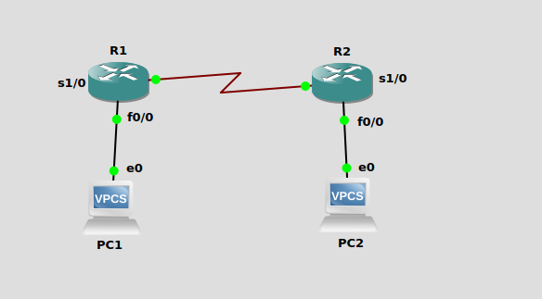

Interface Fastethernet0/0 in global configuration mode
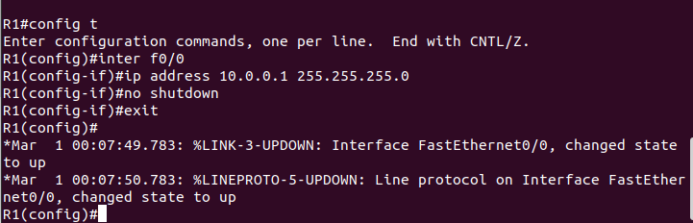
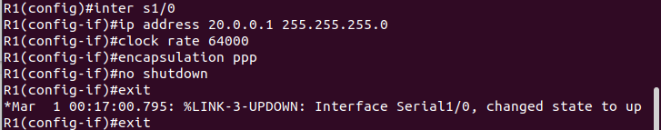
Interface Serial 1/0

Interface Fastethernet 0/0
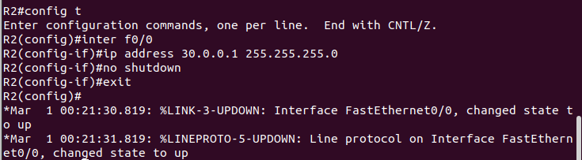

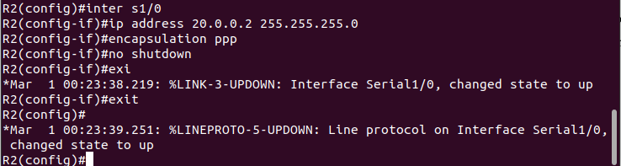
Interface Serial 1/0

R1# show interfaces
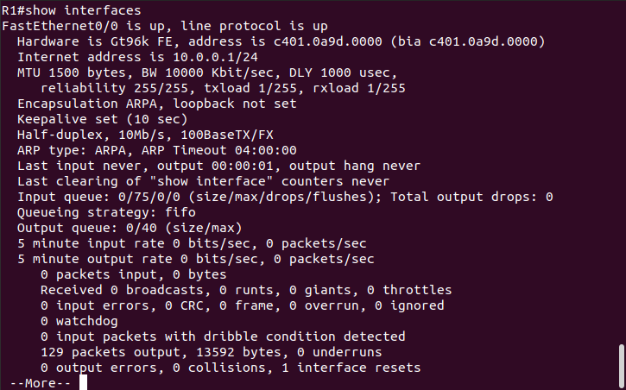
R1#show running-config
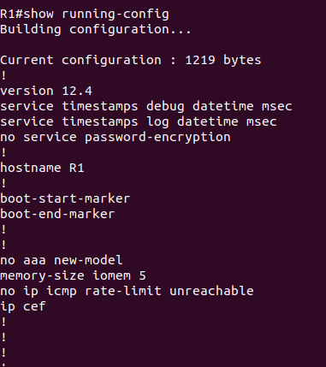

Assign ip addresses for both PC's
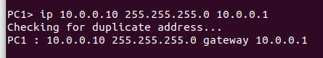

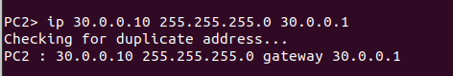

Setting static routing table entries on a Cisco router
PRIVILIGED EXECUTION
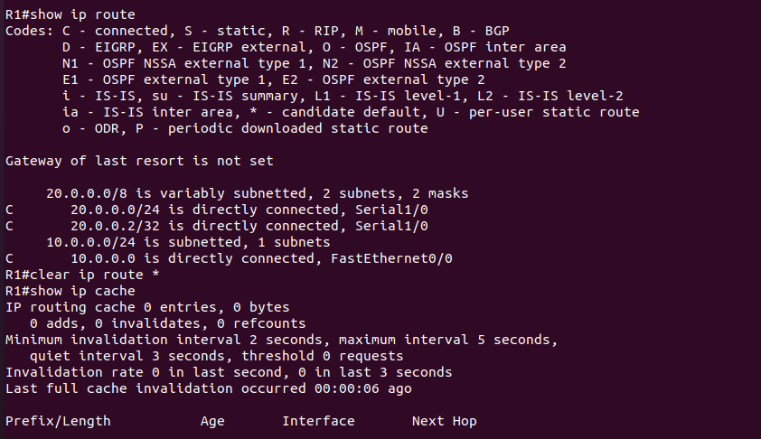
R1(config)#ip route 30.0.0.0 255.0.0.0 20.0.0.2
R2(config)#ip route 10.0.0.0 255.0.0.0 20.0.0.1
ping command from PC1 to PC2 (wireshark observation)
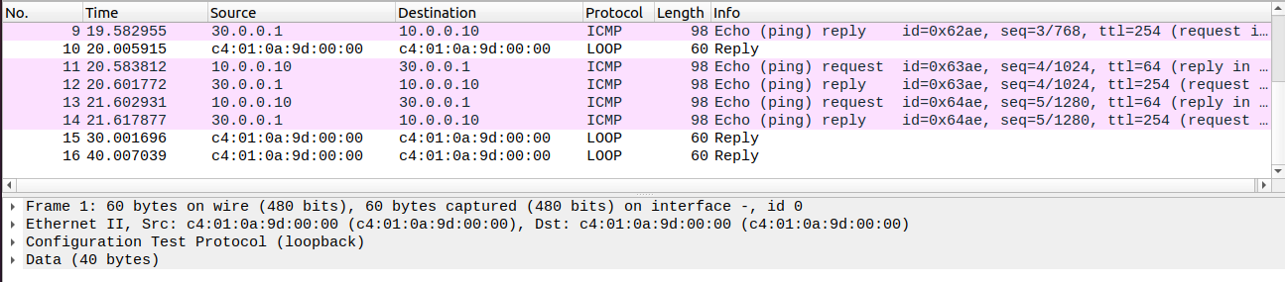
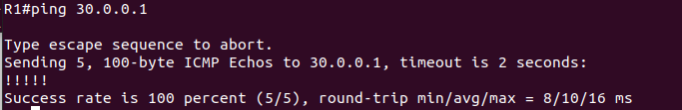
ping command from R1 to PC2 (terminal observation)

