NAME: PRERNA MITTAL
SECTION: CSE-D

QUESTION-1
GNS3 DIAGRAM
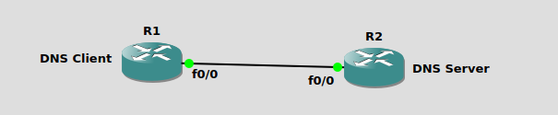
R1 IP configurations:
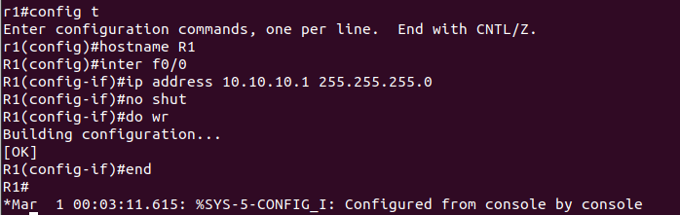
R2 IP and Hostname Configurations and Setting up R2 as DNS Server:
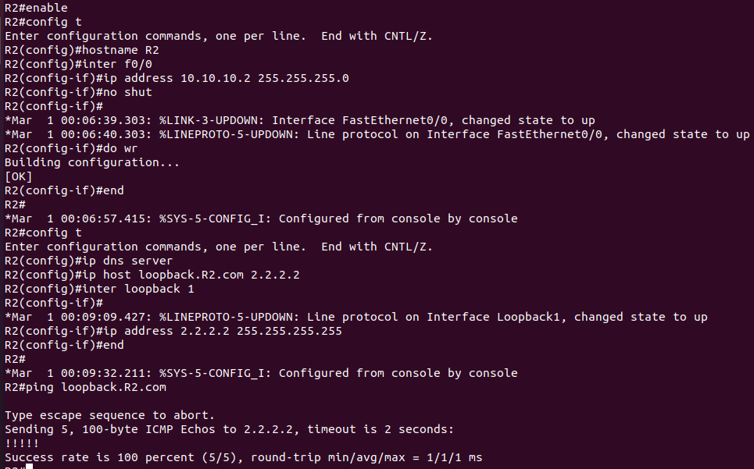
setup R1 to resolve hostnames using R2.
ip domain lookup
ip name-server 10.10.10.2
ip route 0.0.0.0 0.0.0.0 10.10.10.2
end
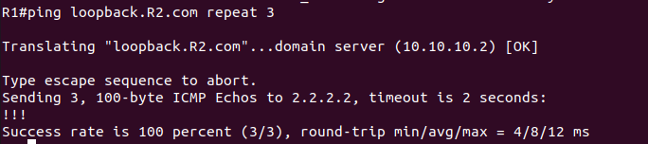
WIRESHARK OBSERVATION
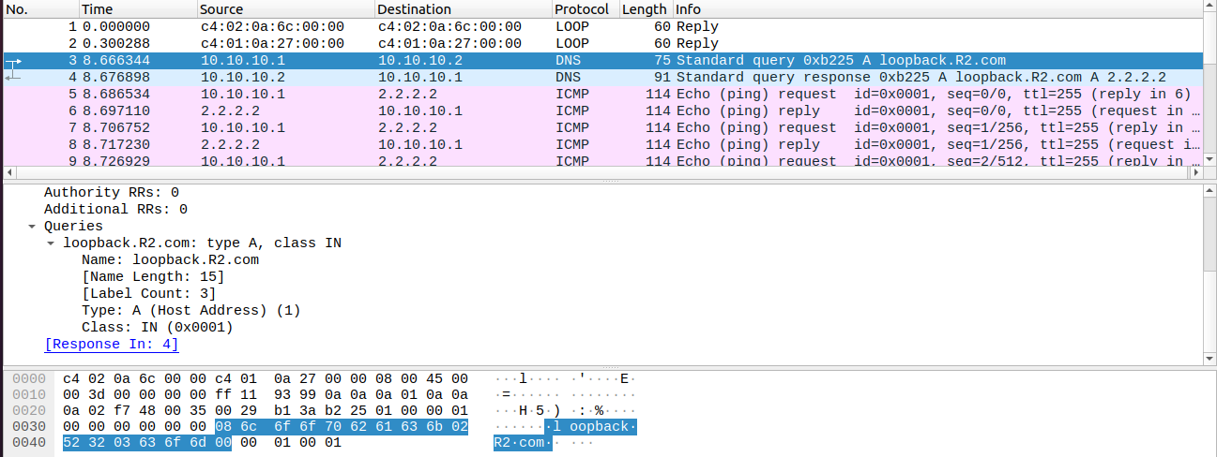

QUESTION-2
GNS3 DIAGRAM

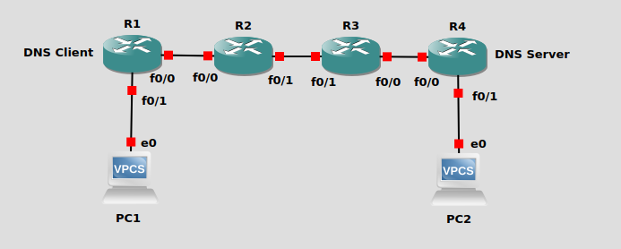

R1 CONFIG (CLIENT)
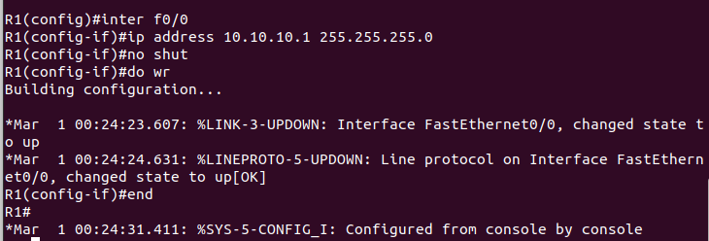
R4 CONFIG (SERVER)
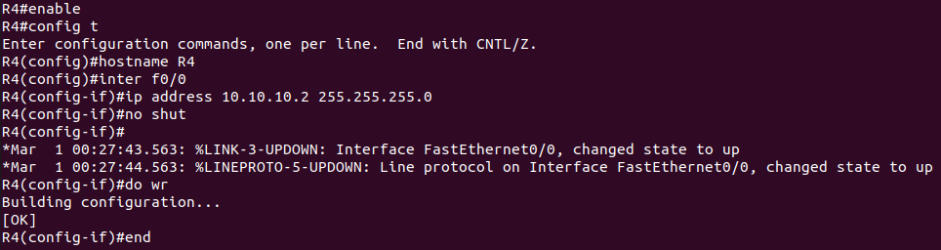
R2 CONFIG
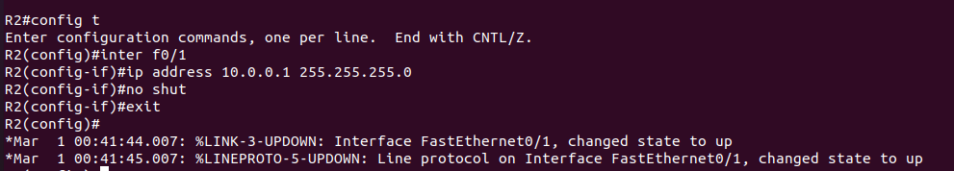
R3 CONFIG
