NAME: PRERNA MITTAL
SECTION: CSE-D

SAMPLE
GNS3 DIAGRAM
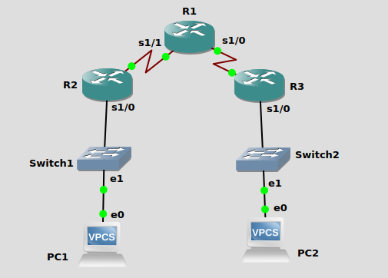

R1 CONFIG
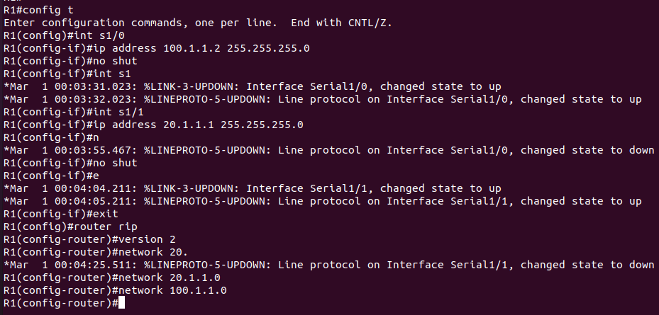
R2 CONFIG
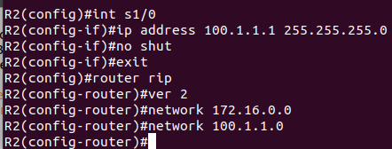

R3 CONFIG
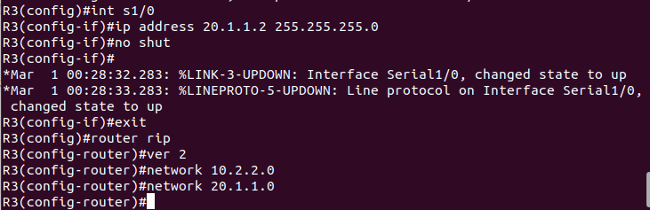
QUESTION-1
GNS DIAGRAM
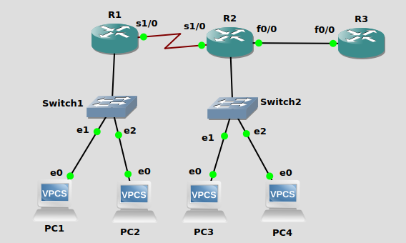
R1 CONFIG
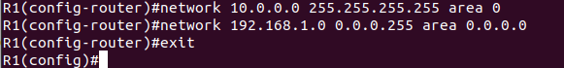
R2 CONFIG
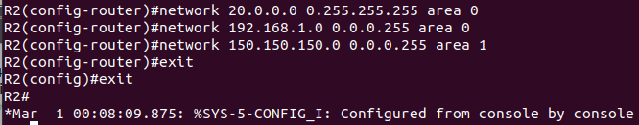

R3 CONFIG
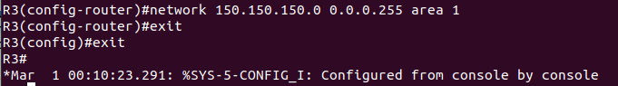
QUESTION-2
GNS DIAGRAM

