NAME: PRERNA MITTAL
SECTION: CSE-D

QUESTION-1
GNS3 DIAGRAM
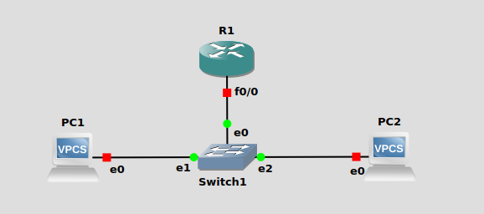
R1 CONFIG
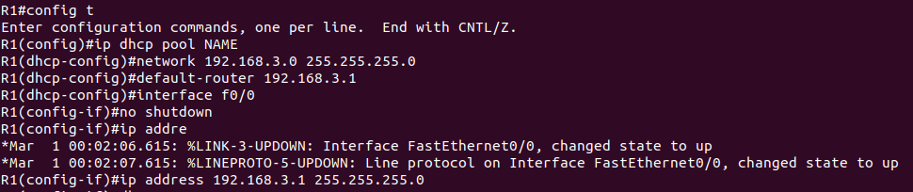
PC1 PC2 DHCP
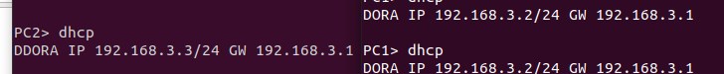

QUESTION-2
GNS3 DIAGRAM
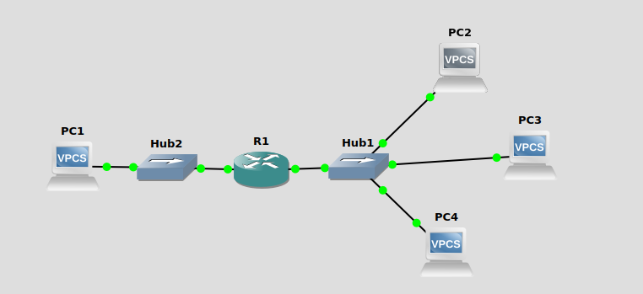
PC CONFIGS
