NAME: PRERNA MITTAL
SECTION: CSE-D

QUESTION-1
GNS3 DIAGRAM
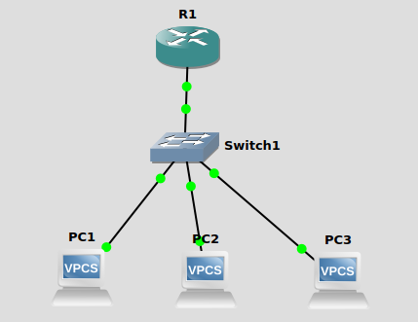

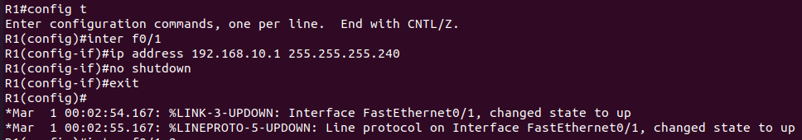
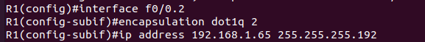
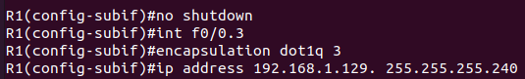

PC1:
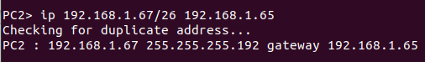

PC2:

PC3:
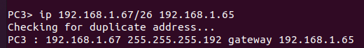

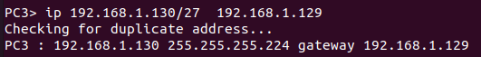

WIRESHARK OBSERVATION
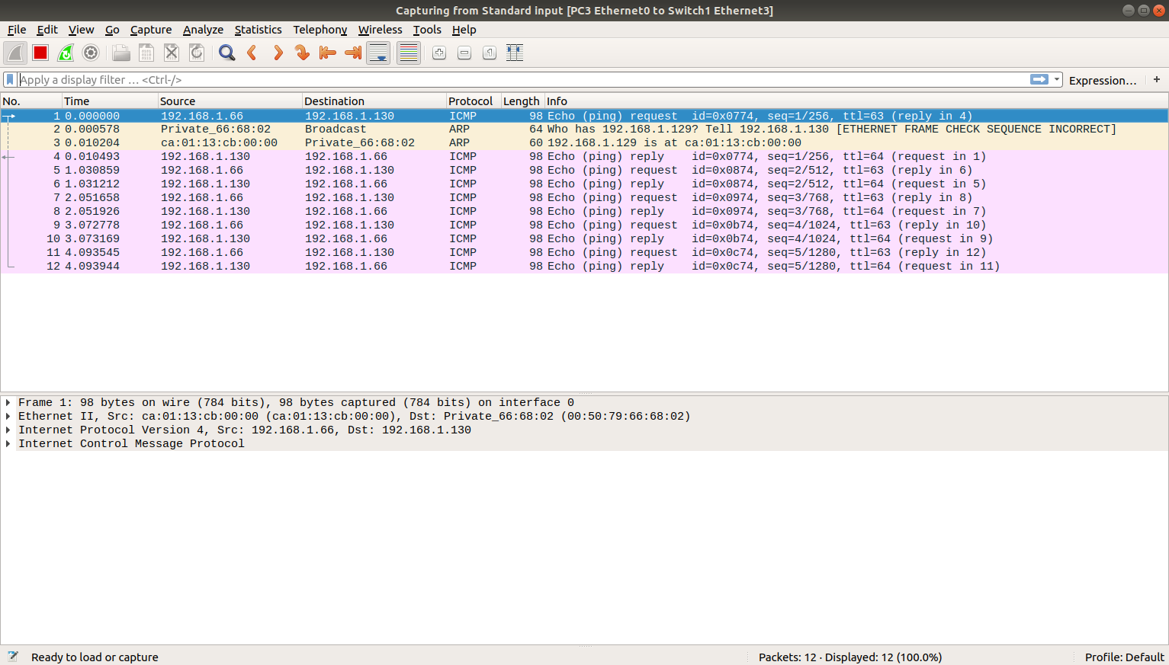

QUESTION-2
GNS3 DIAGRAM
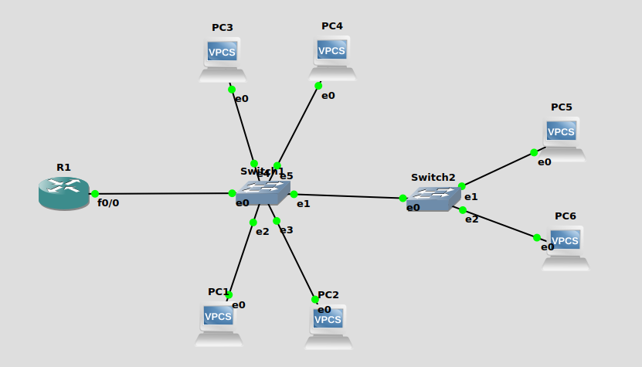
SWITCHES CONFIG
Switch 1:

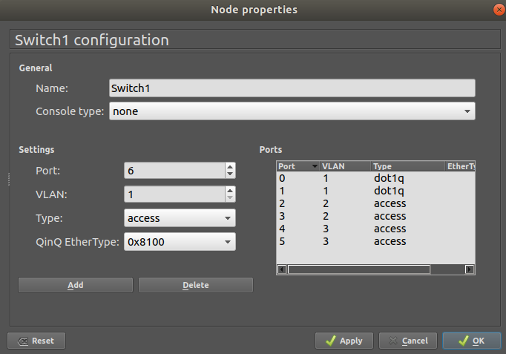

Switch 2:

