Name: Prerana.M.S Class: 3 E

SRN: PES2UG19CS296 Date: 14.08.2020

Automata Formal Languages and Logic

ASSIGNMENT 1

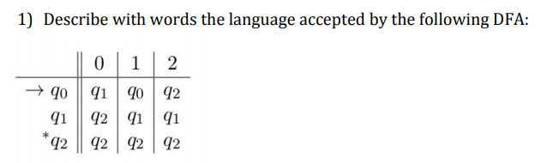

Answer. The language is the set of strings over the alphabet {0,1,2} such that, the strings starting with 0 **must have another 0** with any number of 0,1,2 ; the strings starting with 1 **must have a successive 2 or at least two 0’s** with any number of 0,1,2 ; the strings starting with 2 can have any number of 0,1,2 .

2) Let L be the language that contains a set of strings over the alphabet {0, 1, 2} that do not have two consecutive identical symbols. That is, strings of L are any string in {0,1,2}* such that there is no occurrence of 00, no occurrence of 11, and no occurrence of 22. Design a DFA (transition table or transition diagram -- your choice) that accepts L.

Answer.

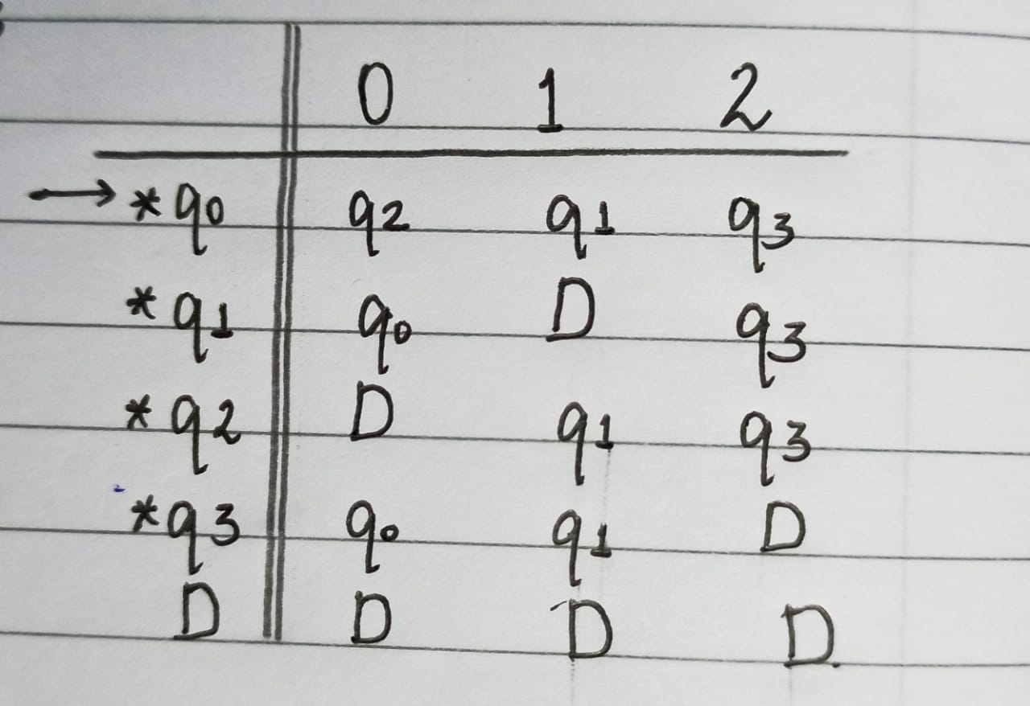

3) Construct a DFA that accepts L = {x01y : x ,y ∈ {0,1}∗}

Answer.

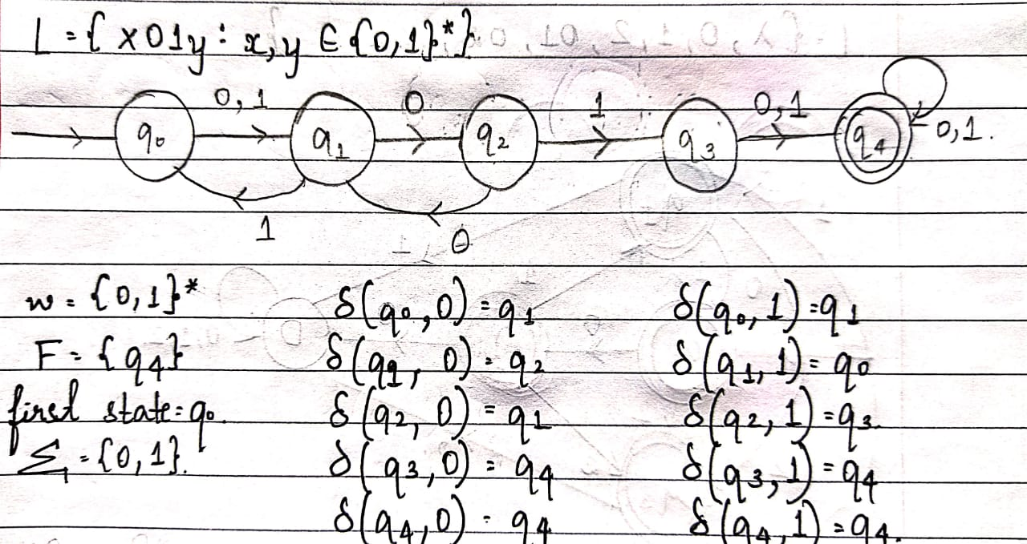

4) Let L be the language consisting of all strings of zero or more 0’s followed by one or more 1’s, followed by two or more 2’s For example 001122, 122 and 0111122 are in L; 012 ( too few 2’s) and 0112122 (a 2 precedes a a are not). Draw the transition diagram of a DFA whose language is L.

Answer.

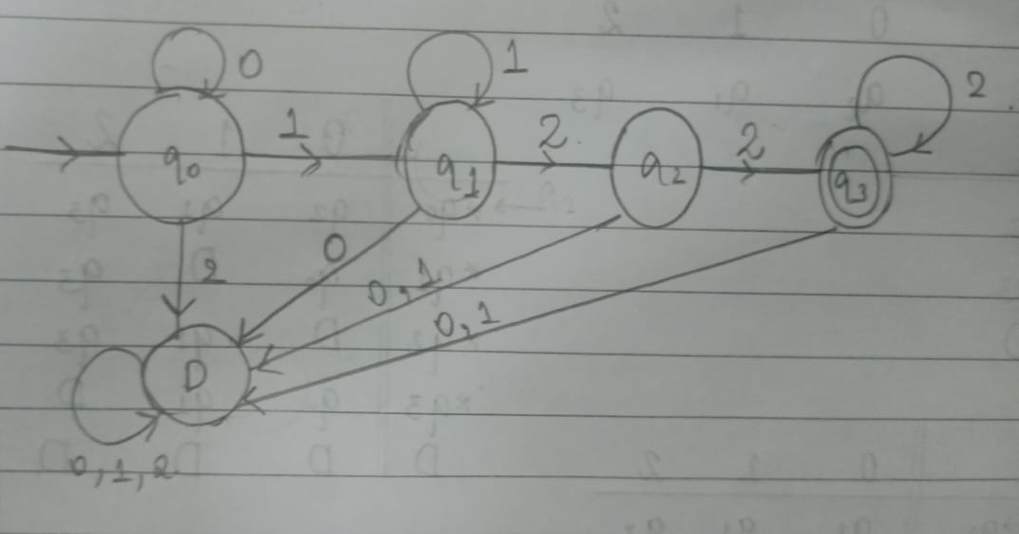

5) Define a DFA that accepts the language over the alphabet {0, 1} where words start and end with a 1, have even length and where any 0 in the word is immediately followed by at least a 1.

Example of accepted words: 1011, 101101, 1111

Example of non accepted words: 101, 1001, 010

Answer.

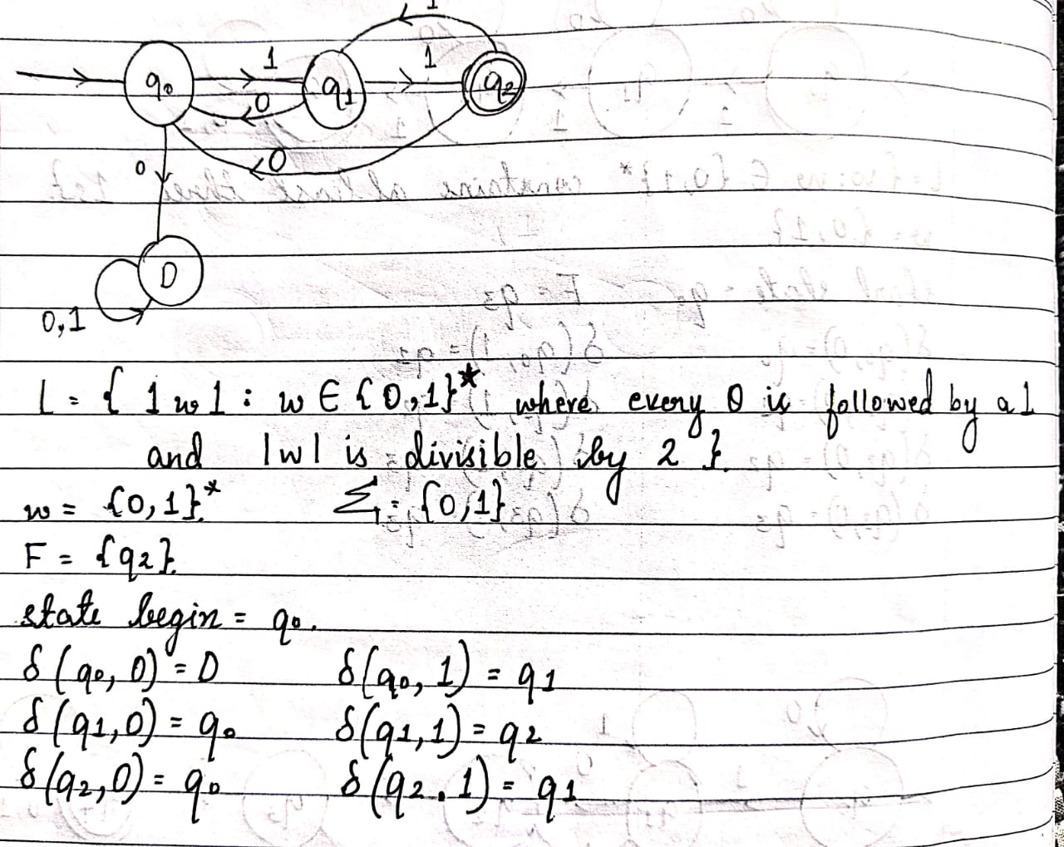

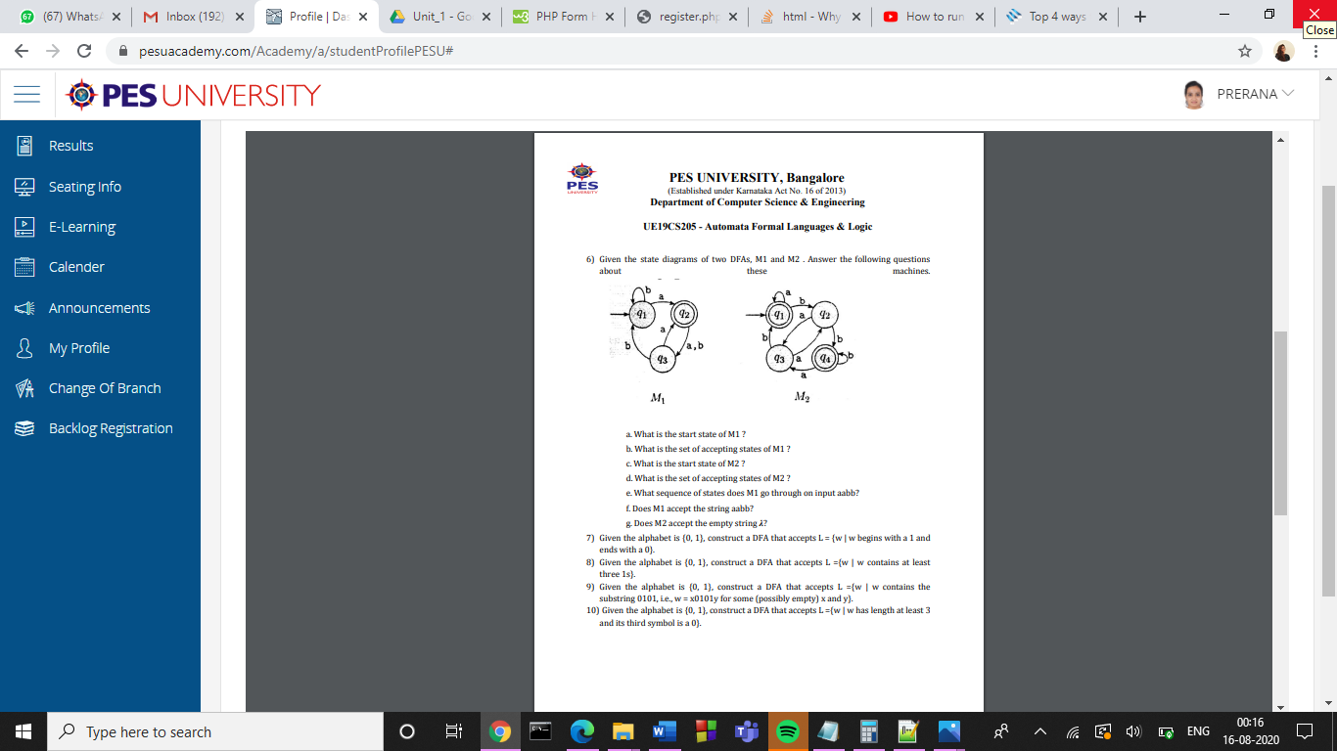

Answer.

a. q1 is the start state of M1.

b. The accepting states of M1 are {q2}.

c. q1 is the start state of M2.

d. The accepting states of M2 are {q1 , q4}.

e. The sequence of states M1 goes through on input aabb are: q1 , q2 , q3 , q1 , q1.

f. No, M1 does not accept the string aabb.

g. Yes, M2 accepts the empty string λ .

7) Given the alphabet is {0, 1}, construct a DFA that accepts L = {w | w begins with a 1 and ends with a 0}.

Answer.

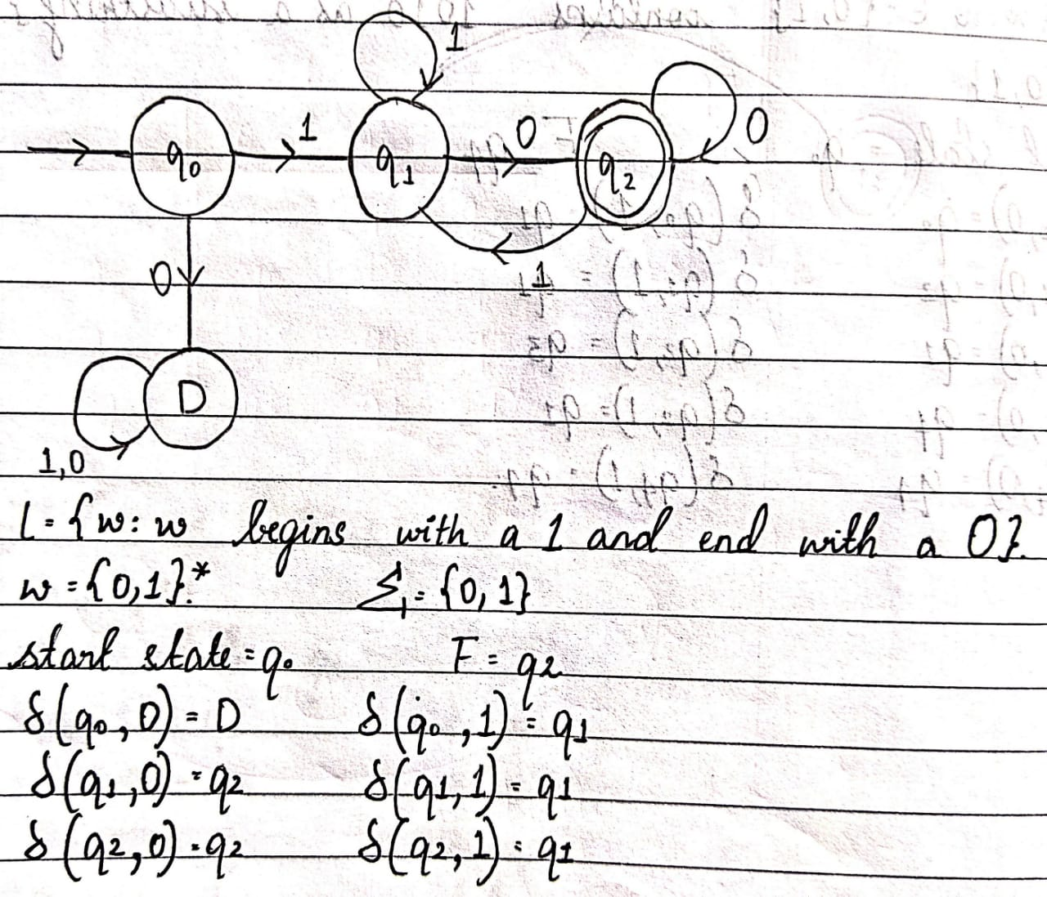

8) Given the alphabet is {0, 1}, construct a DFA that accepts L ={w | w contains at least three 1s}.

Answer.

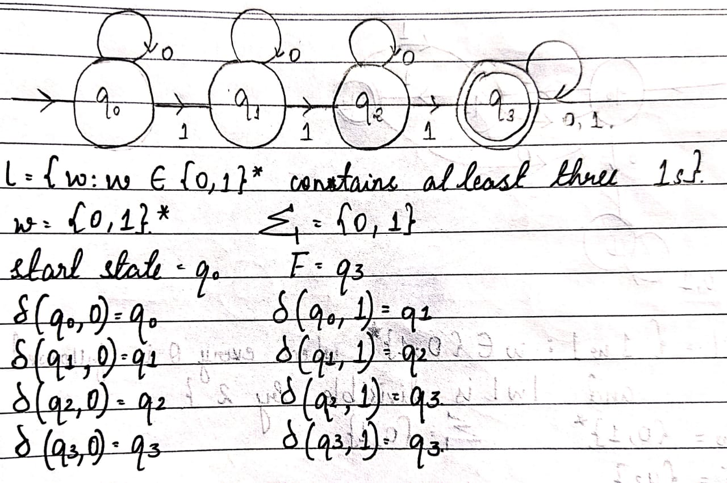

9) Given the alphabet is {0, 1}, construct a DFA that accepts L ={w | w contains the substring 0101, i.e., w = x0101y for some (possibly empty) x and y}.

Answer.

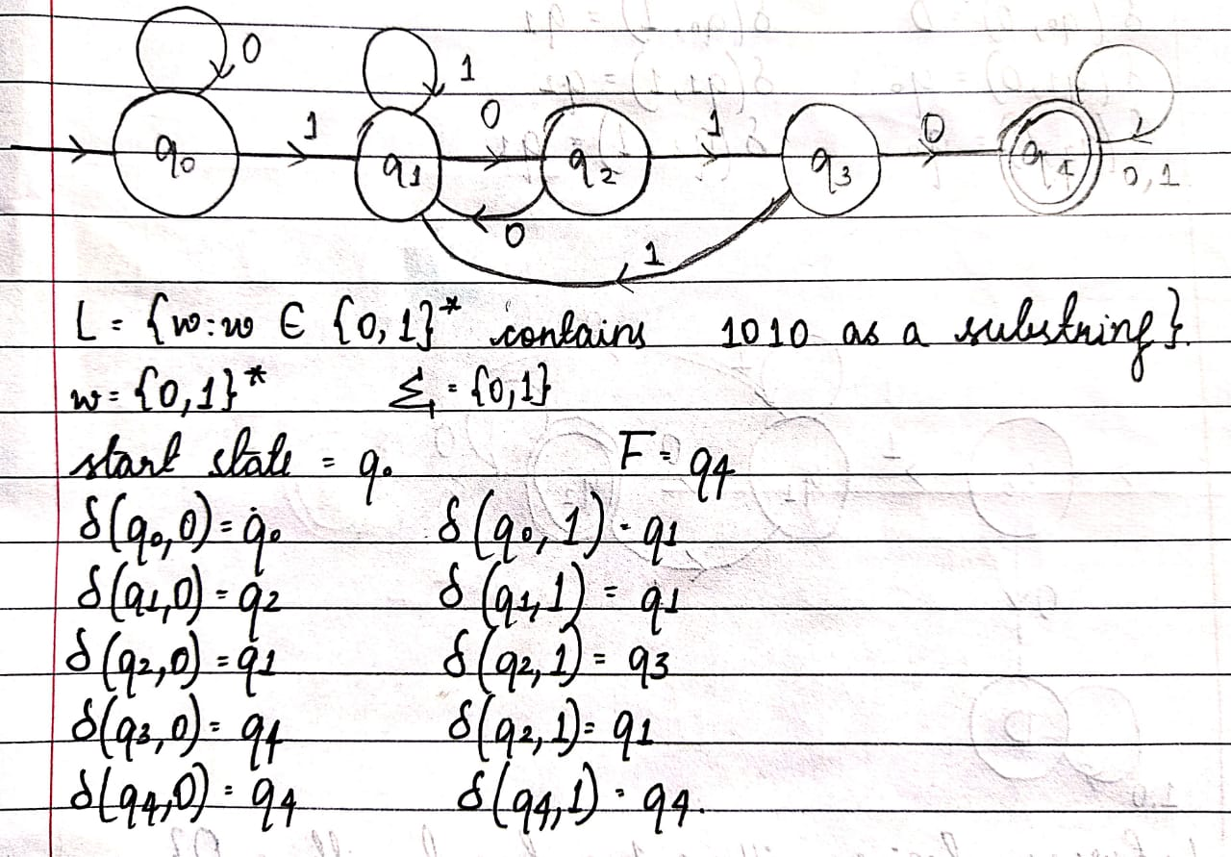

10) Given the alphabet is {0, 1}, construct a DFA that accepts L ={w | w has length at least 3 and its third symbol is a 0}.

Answer.

