Name: Prerana.M.S Class: 3 E

SRN: PES2UG19CS296 Date: 21.08.2020

Automata Formal Languages and Logic

ASSIGNMENT 2

1. Given the alphabet is {0, 1}, construct a NFA with three states, that accepts L = {w | w ends with 00}.

Answer.

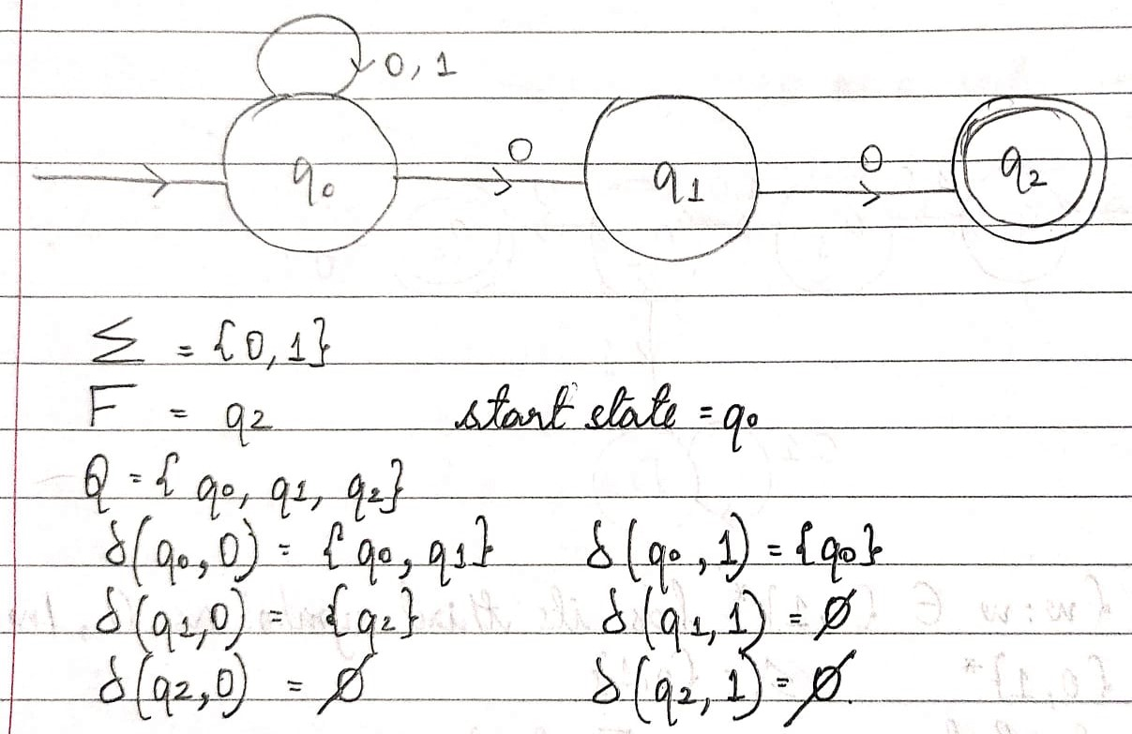

1. Given the alphabet is {0, 1}, construct a NFA where the sum of the last 4 digits is even.

Answer.

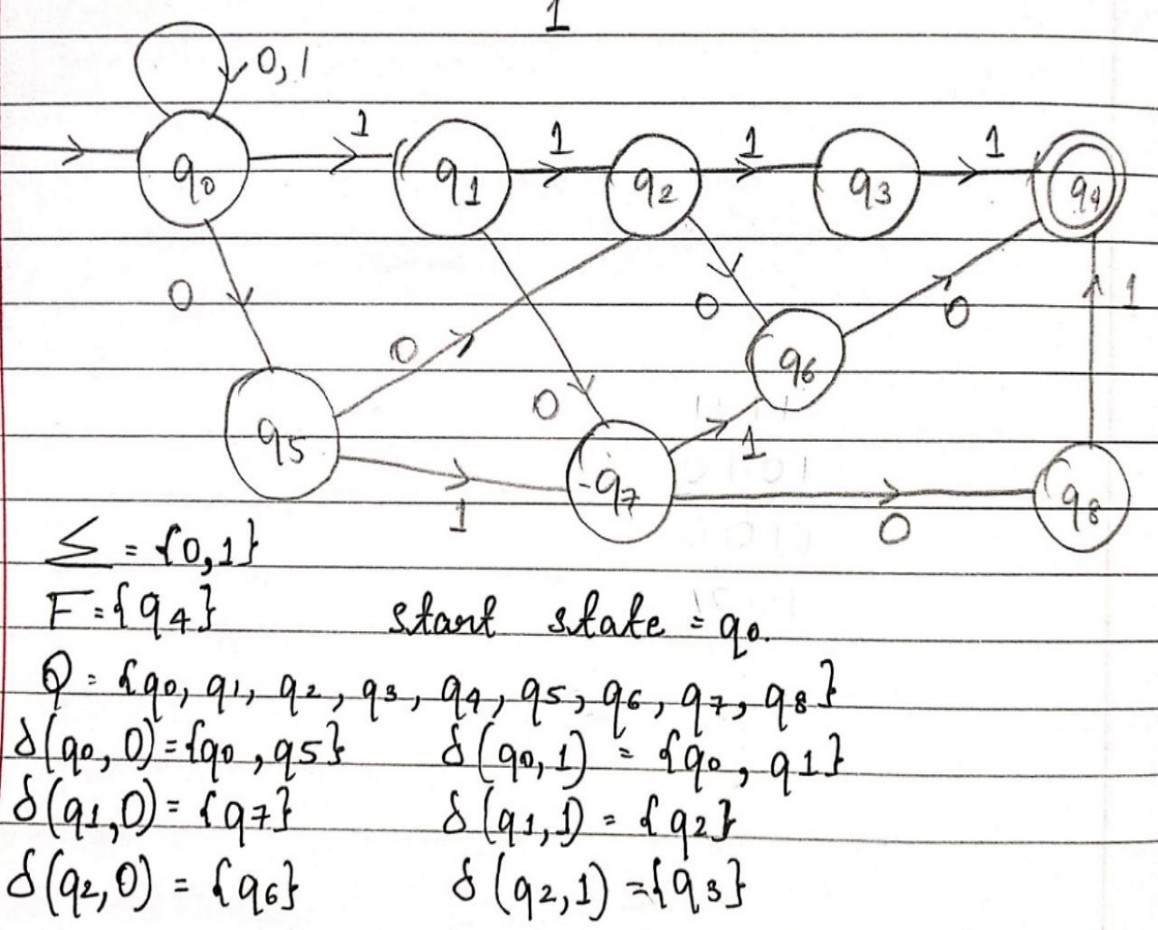

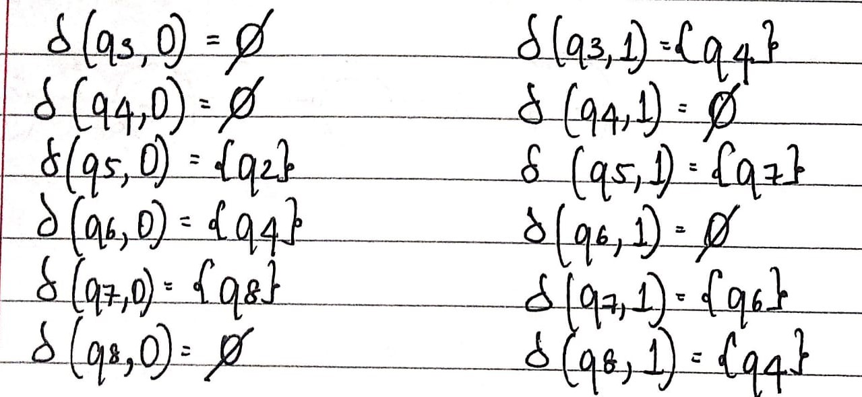

1. Construct an NFA for the language of all strings over {a, b, c} for which one of the number of occurrences of a or b or c is a multiple of 3.

Answer.

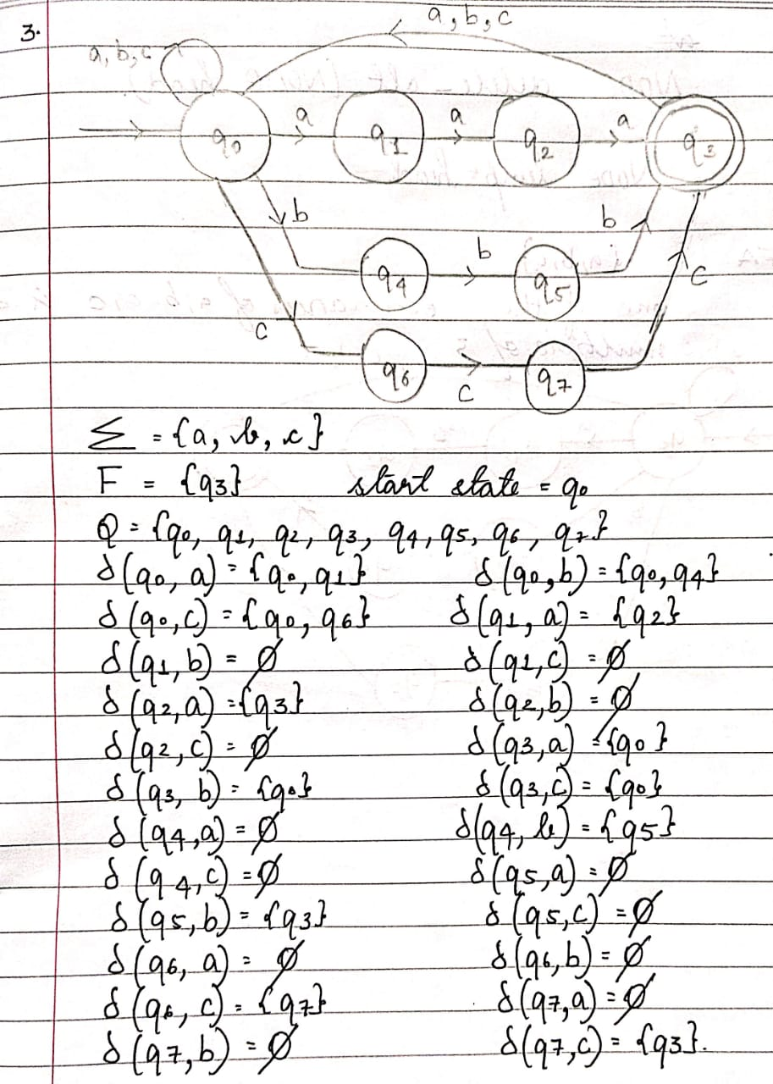

1. Construct an NFA that will accept strings over alphabet {1, 2, 3} such that the last symbol appears at least twice, but without any intervening higher symbol, in between: e.g., 11, 2112, 123113, 3212113, etc.

Answer.

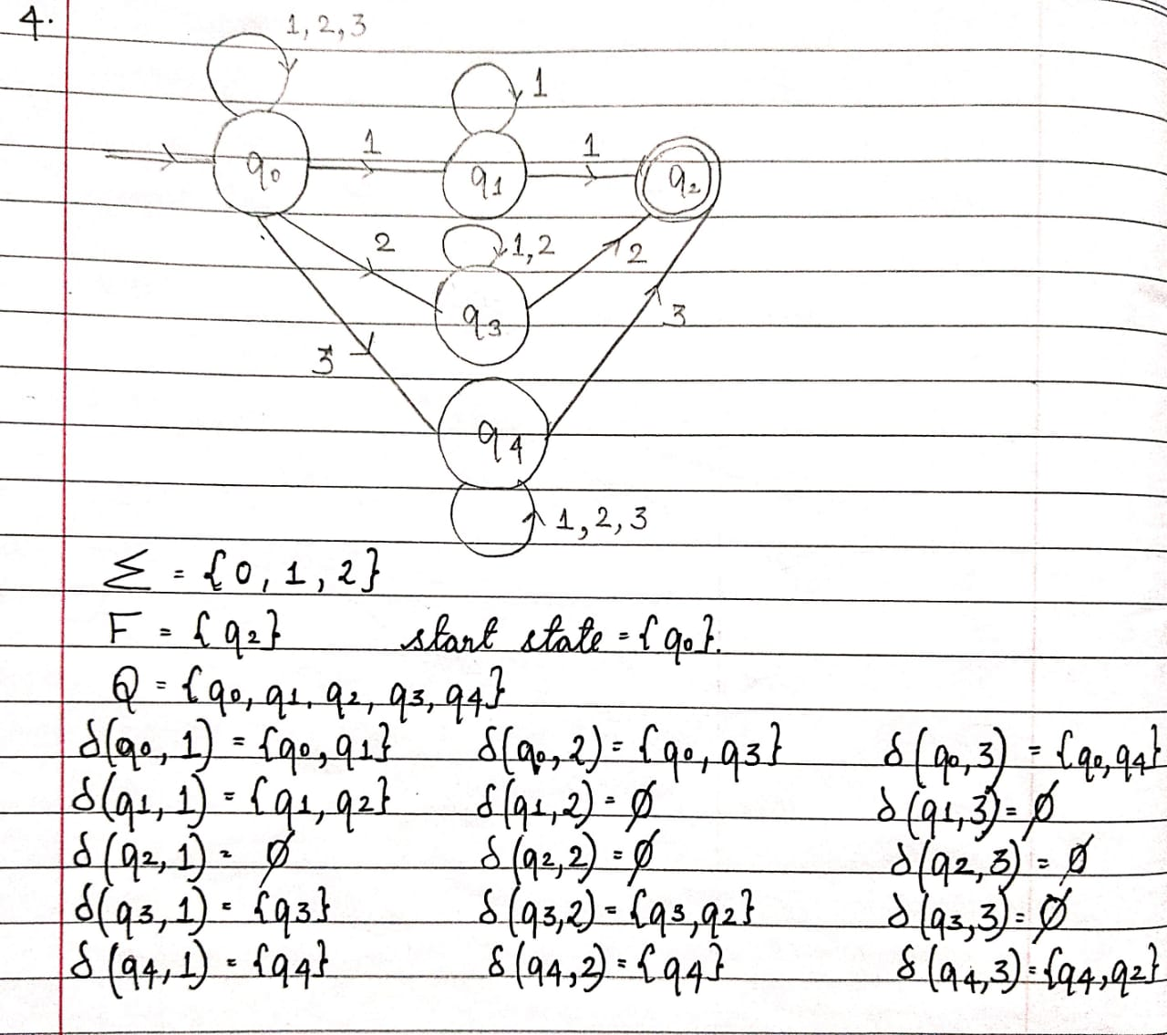

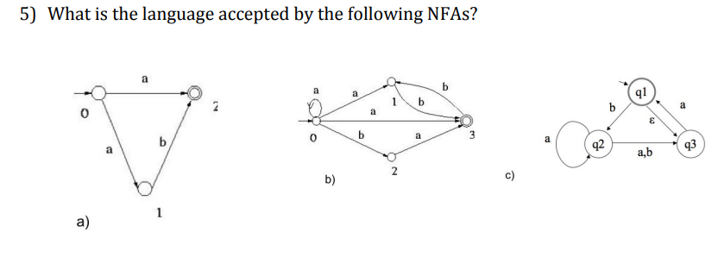

Answer.

1. Language is the set of all non-empty strings with w={a,b}* **starting with a** and **|w|<=2.**
2. Language is the set of strings with w={a,b}* having at **least one a** and have either **zero or odd number of b’s**
3. Language is the set of all strings with w={a,b}* where every string that **contains b must have at least one a** in it.