Name: Prerana.M.S Class: 3 E

SRN: PES2UG19CS296 Date: 28.08.2020

STATISTICS FOR DATA SCIENCE

ASSIGNMENT 11

**Scatter Plot**

1. Explore the Gender-Height-Weight Dataset.

<https://www.kaggle.com/yersever/500-person-gender-height-weight-bodymassindex>

    Plot the Scatter plot and find the dependent and independent variables and specify the relationship between them.

**Heat Map**

1. Explore Avacado prices (Kaggle Dataset) using Heat Map.       <https://www.kaggle.com/neuromusic/avocado-prices>

Answer.

SCATTER PLOT

Independent variables: Gender, Weight, Height

Dependent variables: Index

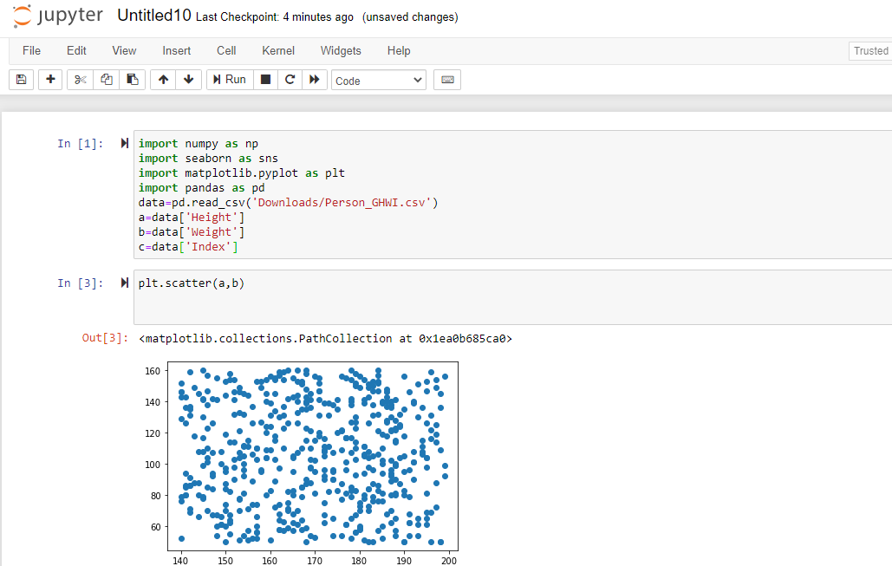

This plot shows us that Height and Weight independent of each other with no correlation at all

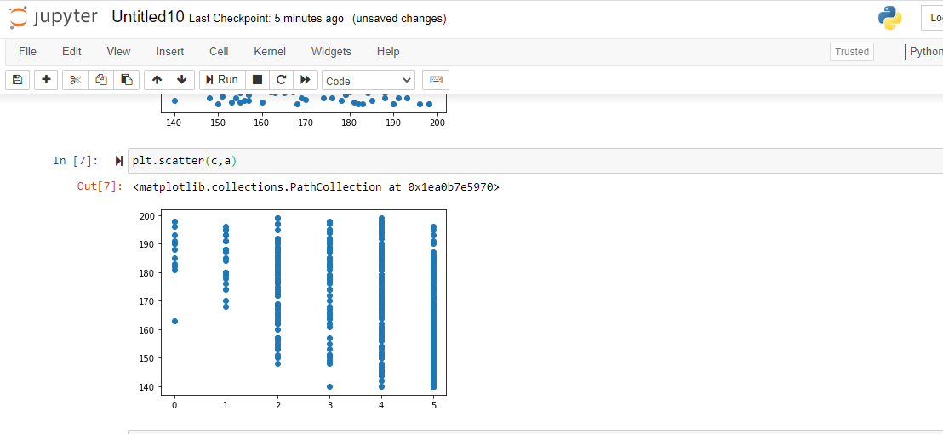

This plot shows negative correlation which tells us that Height and Index are inversely proportional to each other.

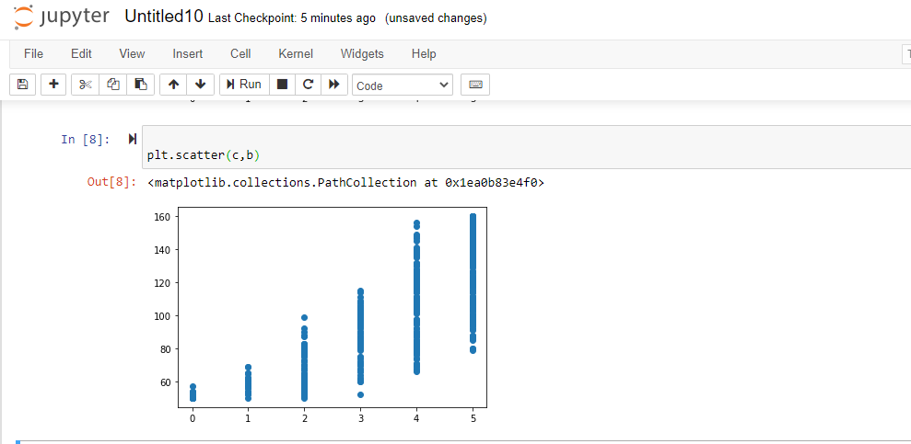

This plot shows positive correlation which tells us that Weight and Index are directly proportional to each other.

HEAD PLOT

