Name: Prerana.M.S Class: 3 E

SRN: PES2UG19CS296 Date: 25.08.2020

STATISTICS FOR DATA SCIENCE

ASSIGNMENT 8

1. The heights of the players (in centimeters) from a basketball team are represented by the table:

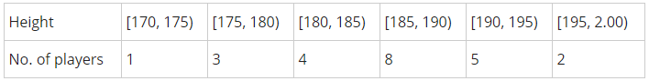Calculate standard deviation.

2. For the following data sets, calculate the quartiles and find the interquartile range.The following numbers represent the time in minutes that twelve employees took to get to work on a particular day.

34          68      22        10        92        46        52        38        29        45        37

Answer.

1.

|  |  |  |  |  |  |  |
| --- | --- | --- | --- | --- | --- | --- |
| Height | No.of players(f) | x | f.x | x-x’ | (x-x’)2 | f(x-x’)2 |
| [170,175) | 1 | 172.5 | 172.5 | -14.13 | 199.66 | 199.66 |
| [175,180) | 3 | 177.5 | 532.5 | -9.13 | 83.36 | 250.08 |
| [180,185) | 4 | 182.5 | 730 | -4.13 | 17.06 | 68.24 |
| [185,190) | 8 | 187.5 | 1500 | 0.87 | 0.76 | 6.08 |
| [190,195) | 5 | 192.5 | 962.5 | 5.87 | 34.46 | 172.3 |
| [195,200) | 2 | 197.5 | 395 | 10.87 | 118.16 | 236.32 |
|  | Σ=23 |  | Σ=4292.5 |  |  | Σ=932.68 |

x’=Σf.m / Σf = 4292.5 / 23 = 186.63

**s= [Σf.(x-x’)2/ (n-1)]0.5**

=[932.68 / 22]0.5 = ***6.51***

2.

Data= 10 ,22 ,29 ,34 ,37 ,38 ,45 ,46 ,52 ,68 ,92.

N=11

1st quartile=Q1= 0.25(n+1)

= 0.25(12) = 3

=*29*

2nd quartile=Q2= 0.5(n+1)

=0.5(12)=6

=*38*

3rd quartile=Q3= 0.75(n+1)

= 0.75(12) = 9

=*52*

Interquartile Range= Q3-Q1

= 52-29

= **23**