Name: Prerana.M.S Class: 3 E

SRN: PES2UG19CS296 Date: 13.08.2020

WEB TECHNOLOGIES 1

ASSIGNMENT 3

Write a HTML page with a summer course registration form containing the following:

1. Student Name
2. SRN
3. Dropdown list to select department of student
4. Checkboxes with course list (at least 8 courses – 2 in a line)
5. Radio button (Online or Offline mode)
6. Text area for Expectations from the courses
7. Submit and reset buttons

The form should send the details to “register.php” as a “post” http request and display the response from register.php on a new tab.

Answer.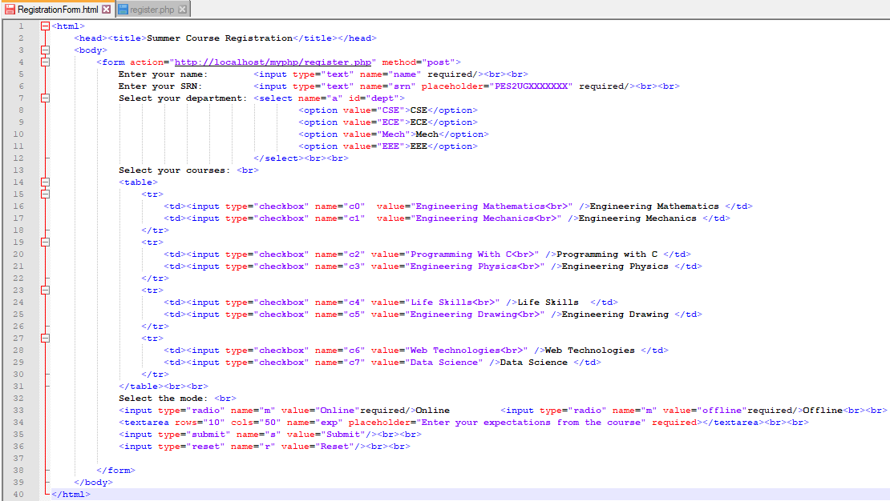

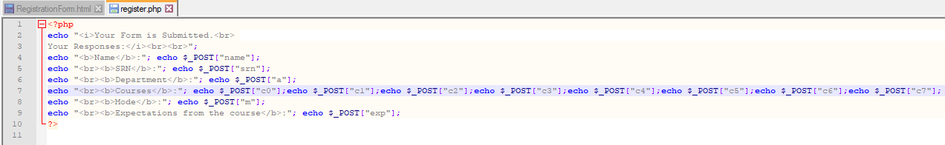

OUTPUT

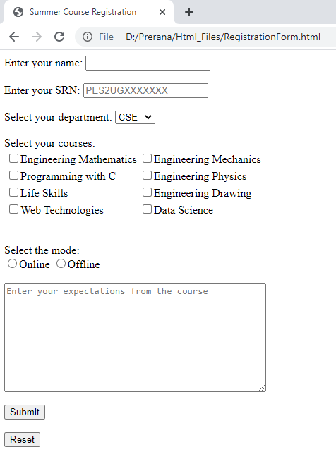

After filling

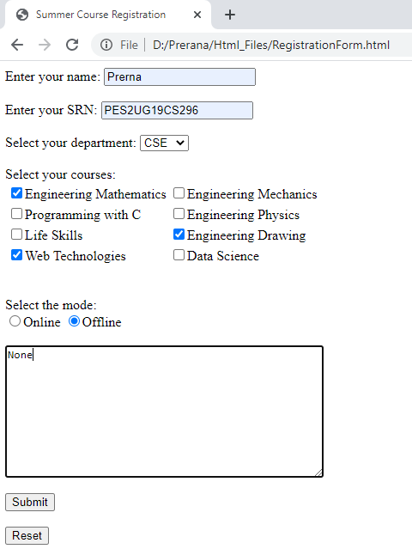

After Submitting the Form

