Name: Prerana.M.S Class: 3 E

SRN: PES2UG19CS296 Date: 18.08.2020

WEB TECHNOLOGIES 1

ASSIGNMENT 4

Add style to your profile created as part of Lesson 2 assignment.

Include styles at element level, document level and using external style sheets.

Demonstrate how conflicts are resolved by adding style for the same element at two different levels

Answer.

Resume.html

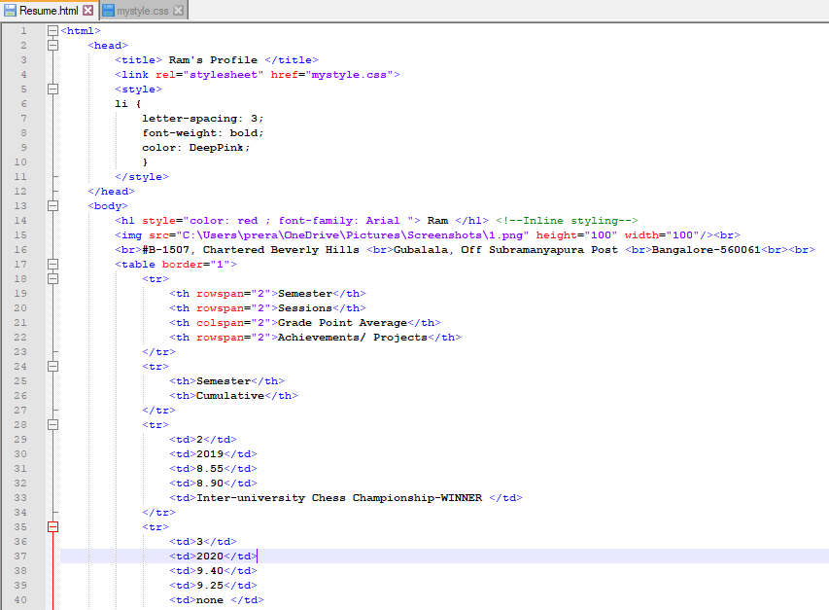

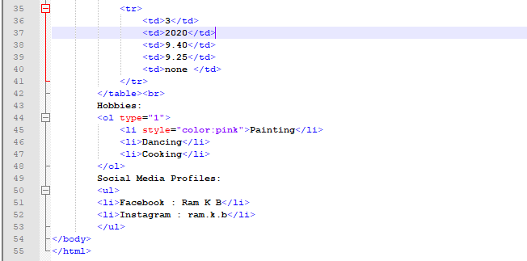

Mystyle.css

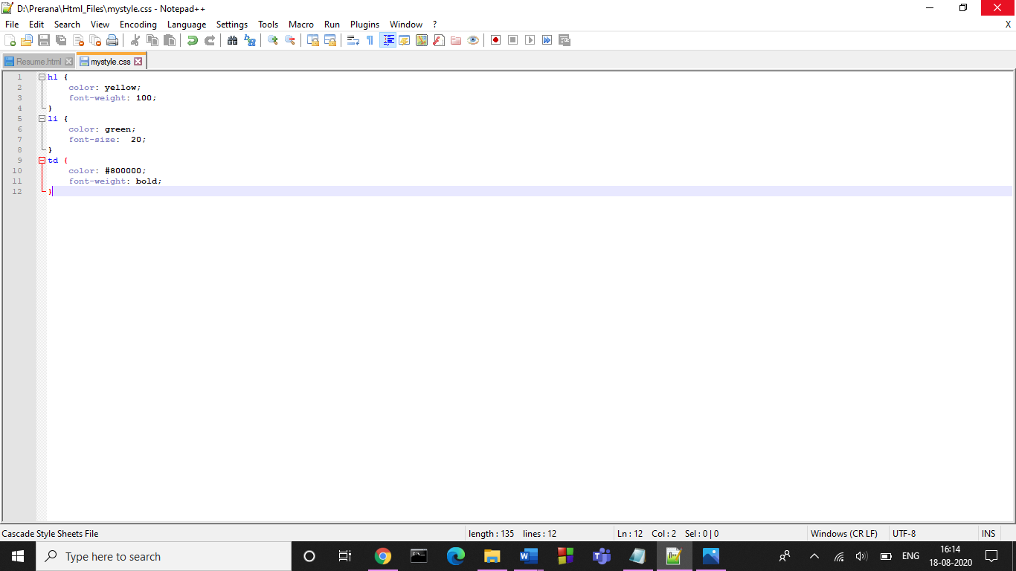

Output:

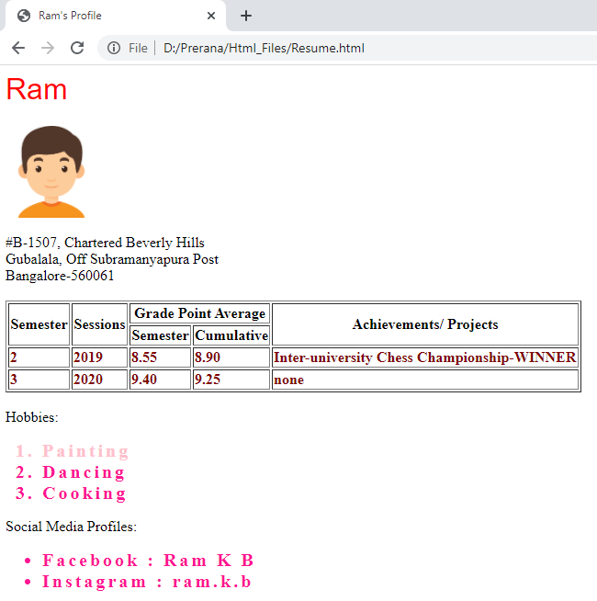

Therefore, when a selector is given the same property with different values in different levels, it gives more priority to element level , followed by document level and the external level.

**Priority: Element level > Document level > External level**