Name: Prerana.M.S Class: 3 E

SRN: PES2UG19CS296 Date: 19.08.2020

WEB TECHNOLOGIES 1

ASSIGNMENT 5

Further beautify the profile created by using box properties like border/margin/padding to improve the spacing between elements (like list elements/table cells). Also, position the interests and online profiles next to each other as follows using <div> tags

|  |  |
| --- | --- |
| Interests:   1. A 2. B 3. C | Online Profiles:   * A * B * C |
|  |  |

Answer.

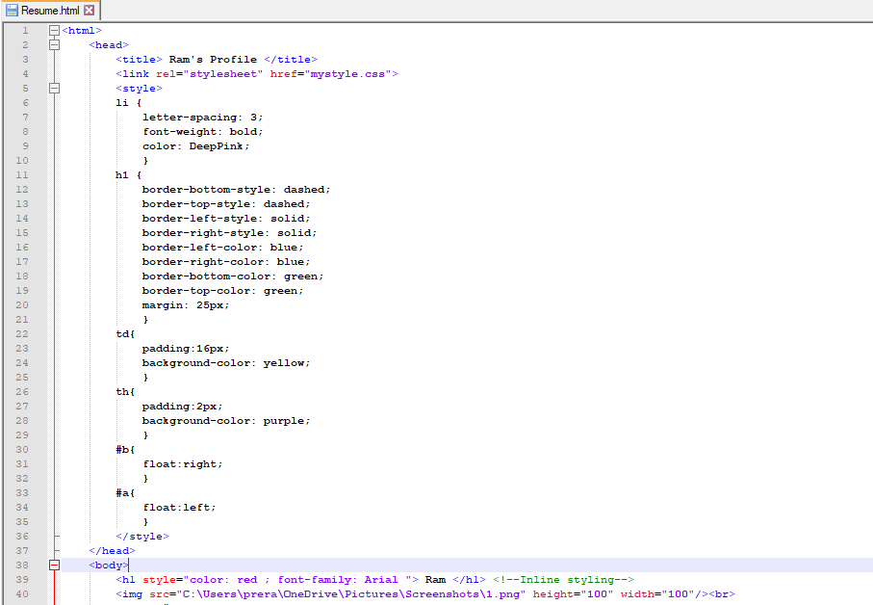

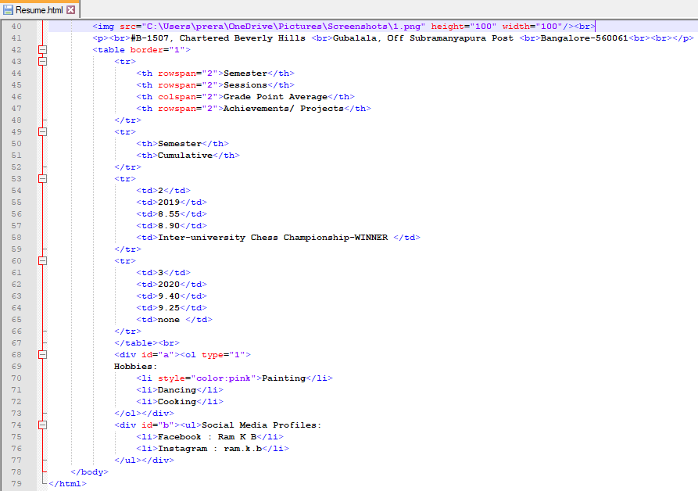

Output:

