Name: Prerana.M.S Class: 3 E

SRN: PES2UG19CS296 Date: 24.08.2020

WEB TECHNOLOGIES 1

ASSIGNMENT 7

Write a JavaScript function calc () that takes the first parameter as the operation to be performed and one or more operands as the other parameters. The first argument should be treated as a function reference that appropriately calls the function to perform the actual operation. That is, there should be multiple functions for each operation (like add, increment etc.).

Answer.

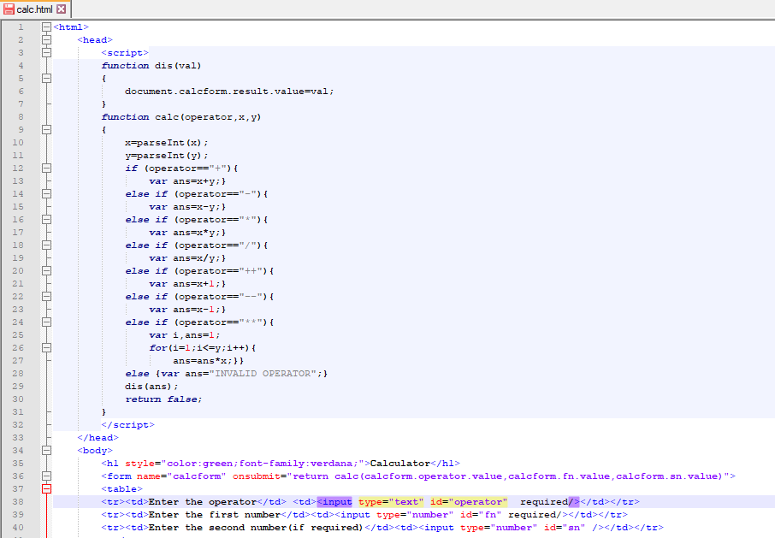

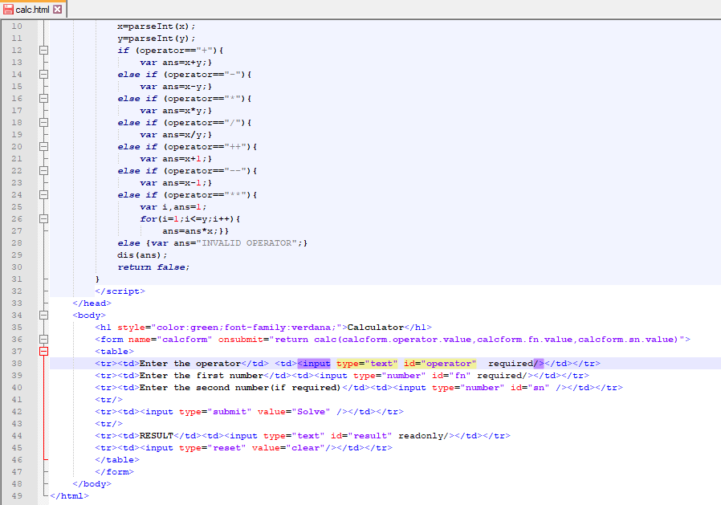

OUTPUT:

