Name: Prerana.M.S Class: 3 E

SRN: PES2UG19CS296 Date: 25.08.2020

WEB TECHNOLOGIES 1

ASSIGNMENT 8

Write a function convert which would convert an array into string or string into an array. The function checks the number of arguments that are passed. (use ...args for variable arguments). If only one argument is passed, it converts the string into an array (using the split method) and returns the array. If more than one argument is passed, it appends each argument to a string and returns the string. (use array.join method).

Answer.

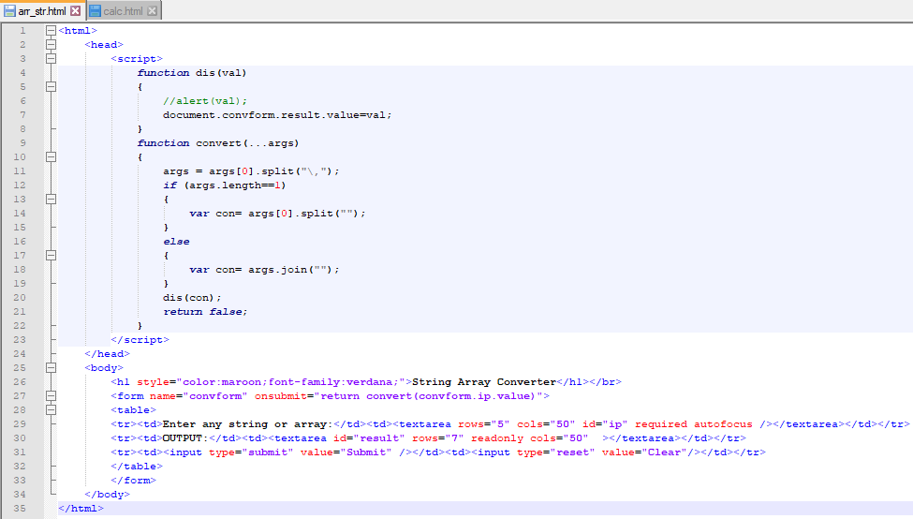

OUTPUT:

