Basic questions :
1. What is semantic search
-> Search based on meaning/context, not exact words.
Semantic search = meaning search
2. What is a vector embedding?
-> A numerical representation of text that captures meaning.
3. What is the difference between embedding and vector?
-> Embedding: Process/output representing meaning numerically
Vector: The actual list of numbers
Embedding creates vectors
4. What is similarity search?
-> Finding vectors closest to another vector
5. What is a retriever?
-> Component that searches and returns relevant chunks
Retriever = search engine of your RAG
6. What is chunking?
-> Breaking large text into smaller pieces
7. What is chunk overlap?
-> Repeating some text between chunks to keep context
8. What is a vector database?
-> Database optimized for storing embeddings and searching similar vectors
9. What is retrieval?
-> Getting relevant chunks from stored documents
10. What is RAG?
-> Retrieval + LLM generation (search + answer)

- Install the required libraries.
create a requirements.txt file add all the needed libs then in vs terminal
pip install -r requirements.txt
- Create Project structure properly
- Add Sample PDFs in a folder named data
- Create ingest.py
  - from langchain_community.document_loaders import PyPDFLoader
-> loads and reads text from pdf files
  - from langchain_text_splitters import RecursiveCharacterTextSplitter
-> Breaks large text into smaller pieces (chunks)
Why?
LLMs cannot handle huge text at once, Smaller chunks improves accuracy
  - from langchain_huggingface import HuggingFaceEmbeddings
-> Turns text into numerical vectors (embeddings)
Why?
Computers compare no.s easier than text, used for similarity search
  - from langchain_community.vectorstores import Chroma
-> stores embeddings and helps retrieve similar chunks later
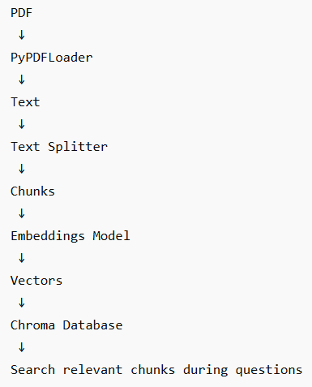
# This code creates the knowledge base for your RAG chatbot. It takes PDF files from a folder, extracts text, breaks the text into smaller chunks, converts those chunks into embeddings (vectors), and stores them in a vector database so the chatbot can search them later.
  - documents = []
-> creates an empty list which will store all pages from all pdfs
DATA_FOLDER = "data"
-> stores folder name in a variable, assumes all pdfs are inside
  - for file in os.listdir(DATA_FOLDER):
-> os.listdir() gives list of all files inside the folder
if file.endswith(".pdf"):
-> checks if file is a pdf
  - path = os.path.join(
DATA_FOLDER,
File
)
-> os.path.join() safely creates paths for different operating systems
  - loader = PyPDFLoader(path)
docs = loader.load()
-> Creates loader
-> Loads PDF pages
-> Each page becomes a LangChain document object
  - documents.extend(docs)
-> extend() adds multiple items, So all PDF pages combine together
  - try:
-> try running this
  - except Exception as e:
-> If something breaks, don't crash, This prevents one bad PDF from stopping everything
  - print(
f"\nPages loaded: {len(documents)}"
)
-> len(documents) – counts pages
  - splitter = RecursiveCharacterTextSplitter(
chunk_size=500,
chunk_overlap=50
)
-> splits with max each chunk max 500 characters, This prevents losing context
  - chunks = splitter.split_documents(
documents
)
-> turns 100 pages into 2000 chunks – breaking down into smaller pieces
  - print(
f"Chunks created: {len(chunks)}")
-> shows total chunks
  - embeddings = HuggingFaceEmbeddings(
model_name="sentence-transformers/paraphrase-multilingual-MiniLM-L12-v2")
-> This model converts text into vectors
  - db = Chroma.from_documents(
documents=chunks,
embedding=embeddings,
persist_directory="vector_store")
-> takes chunks – creates embeddings – stores them in database
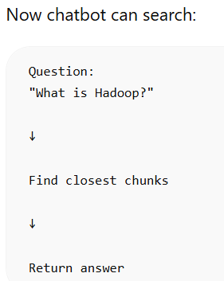
persist_directory="vector_store" means Save database permanently
This entire script is usually called the ingestion pipeline or indexing pipeline in a RAG system because it prepares documents before users ask questions.
- Create app.py
  - from langchain_huggingface import HuggingFaceEmbeddings
-> HuggingFaceEmbeddings – Loads embedding model, Converts queries into vectors
from langchain_community.vectorstores import Chroma
-> Chroma – Loads vector database, Searches stored embeddings
  - embeddings = HuggingFaceEmbeddings(...)
-> Load embeddings again cuz question also needs vector conversion
  - db = Chroma(...)
-> load vector_store/ , no recomputation
  - retriever = db.as_retriever(
search_kwargs={"k":3}
)
-> Return top 3 closest chunks
  - infinite question loop
while True:
  - results = retriever.invoke(
query
)
-> retrieves relevant chunks
  - for i, doc in enumerate(results):
-> loops through retrieved chunks
  - print(
doc.page_content[:700]
)
-> shows only first 700 characters of the chunk cuz chunks may be very large
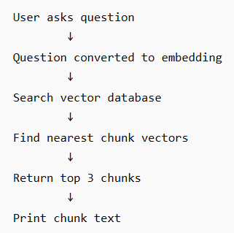
This code is the retrieval part of your RAG pipeline. Earlier code created and stored embeddings in a vector database; this code loads that database back, accepts user questions, searches for similar chunks, and shows the most relevant text pieces.
- Adding open source LLM
-> we’ll use google/flan-t5-base, cuz smaller than Llama models, easier locally, works on CPU, beginner friendly
- Updating app.py
  - from transformers import pipeline
-> Imports Hugging Face pipeline utility cuz it lets you load and run model easily
  - generator = pipeline(
"text2text-generation",
model="google/flan-t5-base")
-> This creates your LLM "text2text-generation"
model="google/flan-t5-base"
-> loads the model
  - docs = retriever.invoke(
query
)
-> retrieves top chunks
  - Create context from retrieved chunks
context = "\n".join(
[doc.page_content for doc in docs]
)
-> takes chunks and combines them together
[doc.page_content for doc in docs]
-> creates a list
"\n".join(...)
-> joins with new line
  - Prompt Creation :
prompt = f"""
Use the context below to answer.
Context:
{context}
Question:
{query}
Answer:
"""
you create instructions for the LLM (this is called prompt engineering)
  - Generate answer
response = generator(
prompt,
max_new_tokens=150 )
-> model receives prompt and produces output
max_new_tokens=150
-> Prevents extremely long responses
  - Extract generated text
response[0]["generated_text"]
response[0] -> gets the first result
["generated_text"] -> gets the actual answer
Old pipeline :
Questions Retrieve chunks Show chunks
New pipeline :
Questions Retrieve chunks Build context Send context + question to LLM Generate final answer
- retrieval improvement + source visibility
  - Improve Retrieval + Add Sources
print("\nRetrieved Sources:\n")
for i, doc in enumerate(docs):
print(f"\nSource {i+1}:")
print(doc.page_content[:250])
print("\nAnswer:\n")
print(answer)
-> question which chunk got retrieved did retrieval make sense then answer generated
  - Improve retrieval quality
retriever = db.as_retriever(
search_type="similarity",
search_kwargs={"k": 5}
)
-> k=5 adds more context improving answer
  - Add score visibility
docs = db.similarity_search(
query,
k=5
)
->

