Crime analysis

### Introduction

This project is made for purpose of Data mining course - Mathematics and Computer science department Original data from Kaggle: <https://www.kaggle.com/adamschroeder/crimes-new-york-city/version/1> Data : New York crime data Objective : extraction of knowledge related to crimes from dataset General purpose of this project is not classic classification of regression problems, but finding out important features of crime nature in New York.

### R Libraries

library(dplyr)

##   
## Attaching package: 'dplyr'

## The following objects are masked from 'package:stats':  
##   
## filter, lag

## The following objects are masked from 'package:base':  
##   
## intersect, setdiff, setequal, union

library(ggplot2)  
library(DT)  
library(arules)

## Loading required package: Matrix

##   
## Attaching package: 'arules'

## The following object is masked from 'package:dplyr':  
##   
## recode

## The following objects are masked from 'package:base':  
##   
## abbreviate, write

library(viridis)

## Loading required package: viridisLite

library(viridisLite)

### Data

crimeData = read.table("CrimeData.csv",header = TRUE,sep = ',')  
crimeData[sample(x = 1:1048575,size = 15),] # a brief look at the data

## day month year time Borough dayPart Latitude Longitude  
## 1042778 5 11 2013 20.50 BROOKLYN 17-22 40.64105 -73.98092  
## 250842 30 6 2015 18.83 BRONX 17-22 40.82637 -73.89884  
## 789269 19 5 2014 10.00 BROOKLYN 06-12 40.62291 -73.93608  
## 890864 5 3 2014 13.75 BROOKLYN 12-17 40.59234 -73.98149  
## 695785 23 7 2014 20.62 BROOKLYN 17-22 40.66060 -73.91134  
## 55346 17 11 2015 17.83 BROOKLYN 17-22 40.65170 -73.86845  
## 890911 5 3 2014 12.75 BROOKLYN 12-17 40.66970 -73.92251  
## 820925 26 4 2014 18.00 STATEN_ISLAND 17-22 40.63669 -74.16972  
## 297295 27 5 2015 22.00 QUEENS 17-22 40.78086 -73.84599  
## 595015 1 10 2014 10.00 BRONX 06-12 40.83594 -73.89032  
## 190682 11 8 2015 17.00 BRONX 12-17 40.82841 -73.88858  
## 675841 6 8 2014 9.83 BROOKLYN 06-12 40.66081 -73.98502  
## 806495 7 5 2014 8.33 MANHATTAN 06-12 40.75627 -73.99050  
## 275388 12 6 2015 22.67 BROOKLYN 22-06 40.64669 -74.00689  
## 396802 3 3 2015 0.02 STATEN_ISLAND 22-06 40.63247 -74.13344  
## offenseDescription pdDescription  
## 1042778 CRIMINAL_MISCHIEF_AND_RELATED_OF MISCHIEF_CRIMINAL___OF_MOTOR  
## 250842 ROBBERY ROBBERY_OPEN_AREA_UNCLASSIFIED  
## 789269 BURGLARY BURGLARY_RESIDENCE_DAY  
## 890864 FRAUDS IMPERSONATION_PUBLIC_SERVAN  
## 695785 ASSAULT_AND_RELATED_OFFENSES ASSAULT  
## 55346 PETIT_LARCENY LARCENY_PETIT_FROM_STORE_SHOPL  
## 890911 OFFENSES_AGAINST_PUBLIC_ADMINI CONTEMPT_CRIMINAL  
## 820925 HARRASSMENT_ HARASSMENT_SUBD___5  
## 297295 PETIT_LARCENY LARCENY_PETIT_FROM_AUTO  
## 595015 ASSAULT_AND_RELATED_OFFENSES ASSAULT  
## 190682 HARRASSMENT_ HARASSMENT_SUBD_CIVILIAN  
## 675841 CRIMINAL_MISCHIEF_AND_RELATED_OF CRIMINAL_MISCHIEF_UNCLASSIFIED  
## 806495 PETIT_LARCENY LARCENY_PETIT_FROM_STORE_SHOPL  
## 275388 DANGEROUS_WEAPONS WEAPONS_POSSESSION_  
## 396802 CRIMINAL_MISCHIEF_AND_RELATED_OF CRIMINAL_MISCHIEF__TH_GRAFFIT  
## crimeCompleted offenseLevel occurenceLocation premiseDescription  
## 1042778 COMPLETED MISDEMEANOR FRONT_OF STREET  
## 250842 COMPLETED FELONY MISSING_VALUE STREET  
## 789269 COMPLETED FELONY INSIDE RESIDENCE_APT_HOUSE  
## 890864 COMPLETED MISDEMEANOR INSIDE RESIDENCE_PUBLIC_HOUSING  
## 695785 COMPLETED MISDEMEANOR MISSING_VALUE STREET  
## 55346 COMPLETED MISDEMEANOR INSIDE COMMERCIAL_BUILDING  
## 890911 COMPLETED MISDEMEANOR INSIDE RESIDENCE_APT_HOUSE  
## 820925 COMPLETED VIOLATION FRONT_OF RESIDENCE_HOUSE  
## 297295 COMPLETED MISDEMEANOR MISSING_VALUE STREET  
## 595015 COMPLETED MISDEMEANOR INSIDE PUBLIC_SCHOOL  
## 190682 COMPLETED VIOLATION FRONT_OF STREET  
## 675841 COMPLETED MISDEMEANOR INSIDE STREET  
## 806495 COMPLETED MISDEMEANOR INSIDE DRUG_STORE  
## 275388 COMPLETED FELONY FRONT_OF STREET  
## 396802 COMPLETED MISDEMEANOR FRONT_OF STREET

There is a difference beetwen this data and original from Kaggle. Simple preprocessing is made and some variables(date event was reported,police jurisdiction…) are ejected, some are changed(date variable to month, day and year, hours and minutes to time…) and some are added(dayPart) due to simplicity. Variables “hours” and “minutes” are joined into 1 continuous variable time - for instance: 15h 30min is now 15.5 (15 + 30/60). Variable “time” is divided into categorical variable “dayPart” with 4 classes(parts of the day). All NA’s are replaced with “MISSING_VALUE”

summary(crimeData)

## day month year time   
## Min. : 1.00 Min. : 1.000 Min. :1015 Min. : 0.00   
## 1st Qu.: 8.00 1st Qu.: 4.000 1st Qu.:2014 1st Qu.: 9.00   
## Median :15.00 Median : 7.000 Median :2014 Median :14.67   
## Mean :15.52 Mean : 6.947 Mean :2014 Mean :13.51   
## 3rd Qu.:23.00 3rd Qu.:10.000 3rd Qu.:2015 3rd Qu.:19.00   
## Max. :31.00 Max. :12.000 Max. :2015 Max. :23.98   
## NA's :65 NA's :65 NA's :65   
## Borough dayPart Latitude Longitude   
## Length:1048575 Length:1048575 Min. :40.50 Min. :-74.26   
## Class :character Class :character 1st Qu.:40.67 1st Qu.:-73.97   
## Mode :character Mode :character Median :40.73 Median :-73.93   
## Mean :40.73 Mean :-73.93   
## 3rd Qu.:40.81 3rd Qu.:-73.88   
## Max. :40.91 Max. :-73.70   
## NA's :32417 NA's :32417   
## offenseDescription pdDescription crimeCompleted offenseLevel   
## Length:1048575 Length:1048575 Length:1048575 Length:1048575   
## Class :character Class :character Class :character Class :character   
## Mode :character Mode :character Mode :character Mode :character   
##   
##   
##   
##   
## occurenceLocation premiseDescription  
## Length:1048575 Length:1048575   
## Class :character Class :character   
## Mode :character Mode :character   
##   
##   
##   
##

### Data visualization

The most crimes generally occur in Brooklyn while least number of crimes occur in Staten Island

ggplot(data = crimeData) +  
 geom_bar(mapping = aes(x = Borough, fill = Borough)) +   
 xlab("New York Boroughs") + ylab("Number of Crimes") +  
 theme_minimal() +   
 theme(axis.text.x = element_text(angle = 45, hjust = 1))

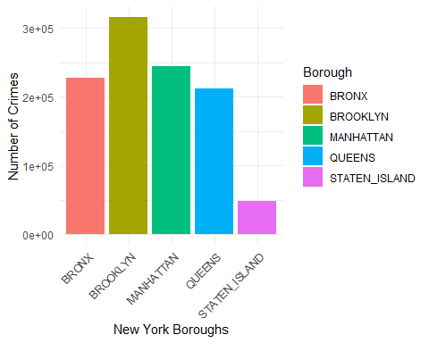

Distribution of “offense level” variable Misdemeanor offense dominate over felony and violation.

ggplot(data = crimeData) +  
 geom_bar(mapping = aes(x = offenseLevel)) +  
 xlab("Offense Level")

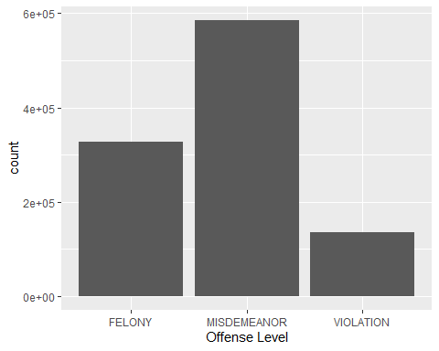

subset(crimeData, year >= 2012) %>%  
 count(Borough, offenseLevel) %>%  
 ggplot(mapping = aes(x = Borough, y = offenseLevel, fill = n)) +  
 geom_tile() +  
 labs(x = "New York Boroughs", y = "Offense Level", fill = "Number of Crimes") +  
 scale_fill_viridis(option = "A", direction = -1) +   
 theme_minimal() +   
 theme(axis.text.x = element_text(angle = 45, hjust = 1)) +   
 theme(legend.position = "right")

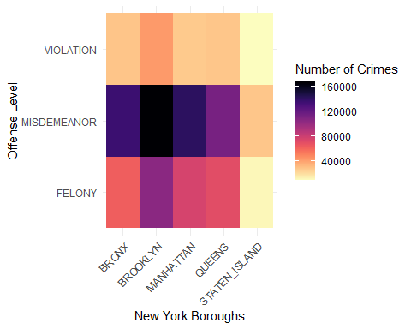

Distribution of each offense level through the day. It is clear that second part of the day (17-21) is the time when most crimes of each level occur and the morning is the part of the day with less crime appearances.

options(repr.plot.width = 12, repr.plot.height = 5)  
ggplot(crimeData, mapping = aes(x = time, colour = offenseLevel)) +  
 geom_freqpoly(binwidth = 0.9, lwd = 1) +  
 xlab("Time of the Day") +  
 ylab("Distribution") +  
 theme_minimal() +   
 scale_color_brewer(palette = "Set1") +   
 theme(legend.position = "top",   
 legend.title = element_blank(),   
 axis.text.x = element_text(angle = 45, hjust = 1))

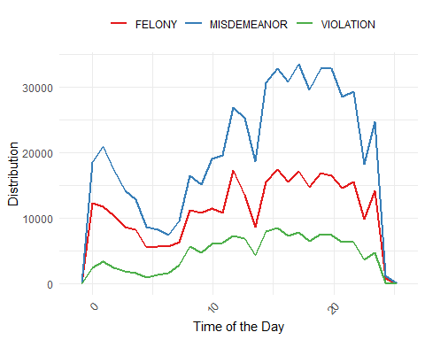

This trend don’t change over time. The similar pattern occur if one smaller subset(44% of data) of data is taken (only crimes from last year - 2015)

options(repr.plot.width=9, repr.plot.height=5)  
subset(crimeData, year == 2015) %>%  
 ggplot(mapping = aes(x = time, colour = offenseLevel)) +  
 geom_freqpoly(binwidth = 0.85, lwd = 1) +  
 xlab("Time of the Day") + ylab("Distribution") +  
 theme_minimal() +   
 theme(legend.position = "top", legend.title = element_blank()) +   
 scale_color_brewer(palette = "Set1")

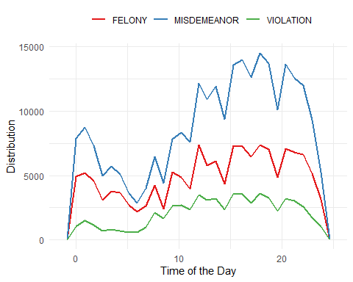

2014 year

options(repr.plot.width=9, repr.plot.height=5)  
subset(crimeData, year == 2014) %>%  
 ggplot(mapping = aes(x = time, colour = offenseLevel)) +  
 geom_freqpoly(binwidth = 0.85, lwd = 1) +  
 xlab("Time of the Day") + ylab("Distribution") +  
 theme_minimal() +   
 theme(legend.position = "top") +   
 scale_color_brewer(palette = "Set1")

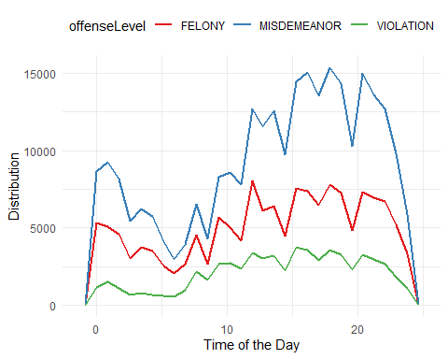

Relation beetwen New York boroughs, offense level and time. Crime offense levels mostly don’t depend on borough but on time od the day.

options(repr.plot.width=10, repr.plot.height=7)  
ggplot(data = subset(crimeData, year >= 2012), aes(x = time)) +  
 geom_histogram(binwidth = 0.1, color = "black", fill = "blue", alpha = 0.6) +  
 facet_grid(Borough ~ offenseLevel) +  
 labs(x = "Time", y = "Distribution through time") +  
 theme_minimal() +  
 theme(legend.position = "bottom")

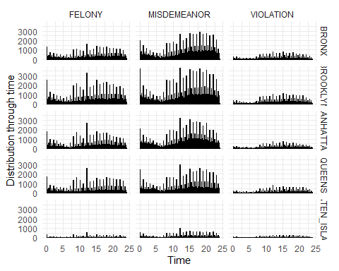

Offense level vs. crime location Inside crimes are dominant independently of crime level.

ggplot(data = subset(crimeData, year >= 2013), aes(x = occurenceLocation)) +  
 geom_bar(aes(fill = offenseLevel), position = "dodge") +  
 labs(x = "Location of Crime", y = "Count of Crimes") +  
 facet_wrap(~offenseLevel, ncol = 1, scales = "free_y") +  
 coord_flip() +  
 theme_minimal() +  
 scale_fill_brewer(palette = "Set1")

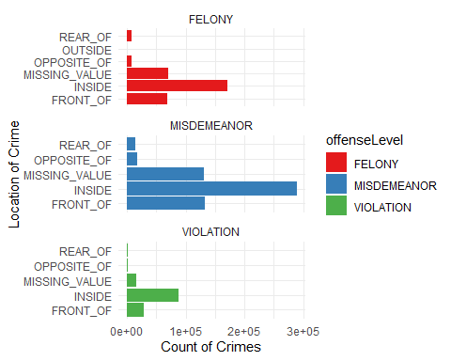

### How to get some new information - simple example

One of the main tasks of data mining is extraction new data and information from the old one. Here is a very simple example of getting day of the week from a given date.

crimeData[15] <- crimeData[, c(3, 2, 1)] %>%  
 apply(MARGIN = 1, FUN = function(vec) {paste(vec, collapse = '-')}) %>%  
 as.Date() %>%  
 weekdays()  
  
names(crimeData)[15] <- 'weekDay'  
options(repr.plot.width = 7, repr.plot.height = 5)  
ggplot(data = crimeData, aes(x = weekDay)) +  
 geom_bar(fill = "purple") +   
 xlab("Weekday") + ylab("Count of Crimes") +  
 theme_minimal() +   
 theme(axis.text.x = element_text(angle = 45, hjust = 1))

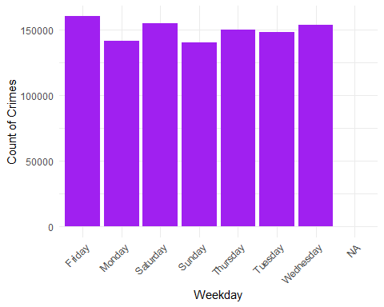

### Day of the week vs. time (year 2014 and 2015)

As it can be seen, the most dangerous time of the week is weekend night(saturday and sunday 22-06) and middle of the week through the day, while the less dangerous is the middle of the week at night and weekend mornings. For this and similar analysis, the idea is to track new trends that might happen and for that reason newer data should be taken for analysis(in this case last 2 years).

subset(crimeData, !is.na(weekDay) & year >= 2014) %>%  
 count(weekDay, dayPart) %>%  
 ggplot(mapping = aes(x = weekDay, y = dayPart)) +  
 geom_tile(mapping = aes(fill = n)) +  
 xlab("Day of the week") + ylab("Part of the day") +  
 theme_minimal() +   
 scale_fill_gradient(low = "orange", high = "red")

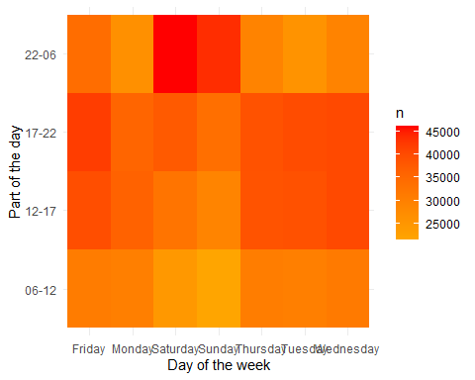

### Some things happen more often than the others - interactive data tables

For this kind of analysis DT(data-table) library is used - simple review of particular desired events. From this data-tables it is easy to observe what events are more frequent than the others.

subset(crimeData, year >= 2014 & occurenceLocation != "MISSING_VALUE") %>%  
 group_by(offenseDescription, Borough, dayPart, premiseDescription) %>%  
 summarize(count = n()) %>%  
 arrange(desc(count)) %>%  
 head(20) %>%  
 ggplot(mapping = aes(x = reorder(premiseDescription, -count), y = count)) +  
 geom_bar(stat = "identity", fill = "skyblue") + # Change the fill color  
 xlab("Premise Description") + ylab("Count") +  
 ggtitle("Top 20 Premise Descriptions by Count") +  
 theme_minimal() +   
 theme(axis.text.x = element_text(angle = 45, hjust = 1)) +   
 coord_flip()

## `summarise()` has grouped output by 'offenseDescription', 'Borough', 'dayPart'.  
## You can override using the `.groups` argument.

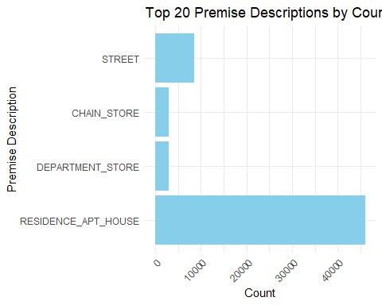

summary_data <- subset(crimeData, year >= 2014 & occurenceLocation != "MISSING_VALUE") %>%  
 group_by(occurenceLocation, Borough, dayPart, pdDescription) %>%  
 summarize(count = n()) %>%  
 arrange(desc(count)) %>%  
 head(20)

## `summarise()` has grouped output by 'occurenceLocation', 'Borough', 'dayPart'.  
## You can override using the `.groups` argument.

ggplot(summary_data, aes(x = reorder(pdDescription, -count), y = count, fill = occurenceLocation)) +  
 geom_bar(stat = "identity", position = "dodge") +  
 facet_wrap(~dayPart) +  
 labs(x = "PD Description", y = "Count") +  
 theme_minimal() +  
 theme(axis.text.x = element_text(angle = 45, hjust = 1)) +  
 scale_fill_brewer(palette = "Set1")

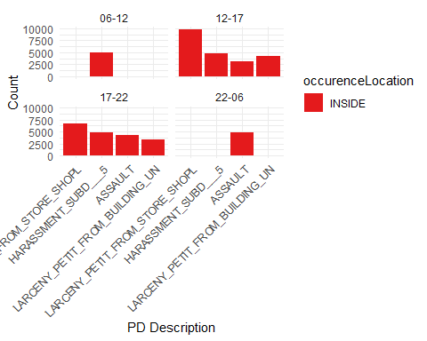

### Felony

2015 felony related crimes - small pattern emerges. The most dangerous place for this specific category is Brooklyn - 12 h, at beginning of the week. The same pattern come up for 2014 year.

subset(crimeData,year == 2015 & offenseLevel == "FELONY") %>% group_by(Borough,time,weekDay) %>% summarise(count = n()) %>%   
arrange(desc(count)) %>% head(30) %>% datatable(options = list(pageLength = 10,scrollX='400px'))

## `summarise()` has grouped output by 'Borough', 'time'. You can override using  
## the `.groups` argument.

## Association rules

Association rules are rule-based data mining method for discovering certain relations between variables in data-sets. The main purpose of association rules is to discover strong rules in data-sets using measures of interestingness. Let $I=\{i_{1},...,i_{n}\}$ be the set of variables in the dataset. Observations of data-set (rows of data frame) are usually called **transactions**. A rule is defined like implication $A⟹B$ where $A,B⊂I$. $A$ is usually called antecedent or left-hand-side (LHS) and $Y$ consequent or right-hand-side (RHS). In some implementations rule is defined like $A⟹i_{j}$ where $i_{j}∈I$.

### Significant measures

Let $X,Y$ be itemsets, $X⟹Y$ an association rule and $T$ a set of transactions of a given data-set.

### Support

Support is an indication of how frequently the itemset appears in the dataset. It is proportion of transactions(rows in data frame) that contain specific itemset, with respect to number of transactions. $supp\left(X\right)=\frac{\left|t∈T;X⊂t\right|}{\left|T\right|}$

### Confidence

Confidence is an indication of how often the rule has been found to be true. $conf\left(X∪Y\right)=\frac{supp\left(X∪Y\right)}{supp\left(X\right)}$ Confidence can be interpreted as an estimate of the conditional probability $P\left(Y|X\right)$, the probability of finding the $Y$ in transactions under the condition that these transactions also contain the $X$ in the left side of the rule.

### The lift

The lift of a rule is defined as $lift\left(X⟹Y\right)=\frac{supp\left(X∪Y\right)}{supp\left(X\right)*supp\left(Y\right)}$ It is the ratio of the observed support to that expected if X and Y were independent events. If $X$ and $Y$ are truly independent events, we can expect that about $supp\left(X\right)*supp\left(Y\right)$ number of transactions will contain both of them. If the rule had a **lift of 1**, it would imply that the probability of occurrence of the antecedent and that of the consequent are independent of each other. When two events are independent of each other, no rule can be drawn involving those two events. If the **lift is > 1**, that lets us know the degree to which those two occurrences are dependent on one another, and makes those rules potentially useful for predicting the consequent in future data sets. If the **lift is < 1**, that lets us know the items are substitute to each other. This means that presence of one item has negative effect on presence of other item and vice versa. Definitons taken from : <https://en.wikipedia.org/wiki/Association_rule_learning> R implementation: library arules , apriori algorithm.

### Example - wrong way of using association rules

One of the obvious wrong ways of using of association rules is to apply it to variables that are obviously correlated in some way. In this dataset for instance we could get rule like: offenseDescription = ASSAULT_AND_RELATED_OFFENSES $⟹$ pdDescription = ASSAULT. It is clear and natural that these 2 variables are in close relationship, so although this rule might have large lift, is not very helpfull. For this reason in examples below algorithm will take only some subset of variables, excluding others that are obviously correlated with them.

### Apriori algorithm

Apriori algorithm is classic algorithm for generating association rules from datasets or databases. The key idea of the algorithm is to begin by generating frequent itemsets with just one item (1-itemsets) and to recursively generate frequent itemsets with 2 items, then frequent 3-itemsets and so on till some stopping condition is satisfied. This is where computational complexity comes into the game. Apriori algorithm is based on very simple observation: **subsets of frequent itemsets are also frequent itemsets**. In other words , if some itemset is proven to be non-frequent , then it will not be considered by algorithm any more for forming new frequent itemsets. To identify the k-itemsets that are not frequent algorithm need to examine all subsets of size (k-1) of each candidate k-itemset. It generates candidate itemsets of length k from item sets of length k-1. Then it prunes the candidates which have an infrequent sub-pattern.

rules <- apriori(data = subset(crimeData,year >= 2013)[,-c(1,2,3,6,7,8,9,10,11,14)] ,   
parameter = list(support = 0.03 , confidence = 0.6,maxlen = 5,target = 'rules'))

## Warning: Column(s) 1, 2, 3, 4, 5 not logical or factor. Applying default  
## discretization (see '? discretizeDF').

## Apriori  
##   
## Parameter specification:  
## confidence minval smax arem aval originalSupport maxtime support minlen  
## 0.6 0.1 1 none FALSE TRUE 5 0.03 1  
## maxlen target ext  
## 5 rules TRUE  
##   
## Algorithmic control:  
## filter tree heap memopt load sort verbose  
## 0.1 TRUE TRUE FALSE TRUE 2 TRUE  
##   
## Absolute minimum support count: 31353   
##   
## set item appearances ...[0 item(s)] done [0.00s].  
## set transactions ...[24 item(s), 1045101 transaction(s)] done [0.22s].  
## sorting and recoding items ... [21 item(s)] done [0.03s].  
## creating transaction tree ... done [0.93s].  
## checking subsets of size 1 2 3 4 done [0.00s].  
## writing ... [7 rule(s)] done [0.00s].  
## creating S4 object ... done [0.10s].

inspect(sort(rules,by='lift'))

## lhs rhs support confidence coverage lift count  
## [1] {offenseLevel=VIOLATION} => {occurenceLocation=INSIDE} 0.08360436 0.6466426 0.12928990 1.236093 87375  
## [2] {time=[11.3,17.5),   
## Borough=MANHATTAN} => {occurenceLocation=INSIDE} 0.05160458 0.6279414 0.08218057 1.200345 53932  
## [3] {Borough=MANHATTAN,   
## offenseLevel=FELONY} => {occurenceLocation=INSIDE} 0.04407995 0.6062536 0.07270876 1.158888 46068  
## [4] {Borough=BRONX,   
## occurenceLocation=MISSING_VALUE} => {offenseLevel=MISDEMEANOR} 0.03050040 0.6278635 0.04857808 1.122953 31876  
## [5] {time=[17.5,24],   
## Borough=BRONX} => {offenseLevel=MISDEMEANOR} 0.04869864 0.6273884 0.07762121 1.122103 50895  
## [6] {time=[0,11.3),   
## occurenceLocation=MISSING_VALUE} => {offenseLevel=MISDEMEANOR} 0.04490858 0.6237491 0.07199783 1.115594 46934  
## [7] {occurenceLocation=MISSING_VALUE} => {offenseLevel=MISDEMEANOR} 0.12501663 0.6005801 0.20815979 1.074156 130655

In the example above, the first couple of rules have the lift that is slightly greater than 1 which means there might be light correlation between these itemsets. On the other hand, this might be because value “INSIDE” (1st rule) for occurenceLocation is dominating over the other values of occurenceLocation. Intuitive way of interpreting this rule is something like “when crime belongs to the level VIOLATION, it is slightly more likely that it happened INSIDE than then somewhere else”. However, confidence of this rule could be somewhat better so we can’t accept that this is strong connection between these 2 variables although lift implies some dependence.

### Trying to detect what is the cause of rare events

From summary table it is clear that most crimes have value COMPLETED for category crimeCompleted, much less number of crimes are registered as just ATTEMPTED. Association rules could allow us to find some specific moments that imply this rare events. Although lift is really high for these events, their count is small(2-3) and these are not indicators of any kind of correlation with ATTEMPTED value.

rules <- apriori(data = subset(crimeData,year >= 2011)[,c(4,5,9,11,14)] ,   
parameter = list(support = 0.000001 , confidence = 0.85,maxlen = 5),  
appearance = list(rhs = c('crimeCompleted=ATTEMPTED')))

## Warning: Column(s) 1, 2, 3, 4, 5 not logical or factor. Applying default  
## discretization (see '? discretizeDF').

## Apriori  
##   
## Parameter specification:  
## confidence minval smax arem aval originalSupport maxtime support minlen  
## 0.85 0.1 1 none FALSE TRUE 5 1e-06 1  
## maxlen target ext  
## 5 rules TRUE  
##   
## Algorithmic control:  
## filter tree heap memopt load sort verbose  
## 0.1 TRUE TRUE FALSE TRUE 2 TRUE  
##   
## Absolute minimum support count: 1   
##   
## set item appearances ...[1 item(s)] done [0.00s].  
## set transactions ...[150 item(s), 1046908 transaction(s)] done [0.23s].  
## sorting and recoding items ... [146 item(s)] done [0.03s].  
## creating transaction tree ... done [1.02s].  
## checking subsets of size 1 2 3 4 5 done [0.01s].  
## writing ... [10 rule(s)] done [0.00s].  
## creating S4 object ... done [0.13s].

inspect(head(sort(rules,by='lift'),10))

## lhs rhs support confidence coverage lift count  
## [1] {offenseDescription=FRAUDULENT_ACCOSTING,   
## premiseDescription=PARKING_LOT_GARAGE_(PUBLIC)} => {crimeCompleted=ATTEMPTED} 1.910388e-06 1 1.910388e-06 55.93055 2  
## [2] {offenseDescription=RAPE,   
## premiseDescription=BEAUTY_&_NAIL_SALON} => {crimeCompleted=ATTEMPTED} 1.910388e-06 1 1.910388e-06 55.93055 2  
## [3] {time=[11.3,17.5),   
## offenseDescription=RAPE,   
## premiseDescription=TRANSIT_NYC_SUBWAY} => {crimeCompleted=ATTEMPTED} 2.865581e-06 1 2.865581e-06 55.93055 3  
## [4] {Borough=STATEN_ISLAND,   
## offenseDescription=BURGLARY,   
## premiseDescription=BANK} => {crimeCompleted=ATTEMPTED} 1.910388e-06 1 1.910388e-06 55.93055 2  
## [5] {time=[11.3,17.5),   
## Borough=MANHATTAN,   
## offenseDescription=KIDNAPPING_AND_RELATED_OFFENSES,   
## premiseDescription=STREET} => {crimeCompleted=ATTEMPTED} 1.910388e-06 1 1.910388e-06 55.93055 2  
## [6] {time=[0,11.3),   
## Borough=MANHATTAN,   
## offenseDescription=ROBBERY,   
## premiseDescription=BUS_STOP} => {crimeCompleted=ATTEMPTED} 1.910388e-06 1 1.910388e-06 55.93055 2  
## [7] {time=[17.5,24],   
## Borough=MANHATTAN,   
## offenseDescription=ROBBERY,   
## premiseDescription=BUS_STOP} => {crimeCompleted=ATTEMPTED} 2.865581e-06 1 2.865581e-06 55.93055 3  
## [8] {time=[11.3,17.5),   
## Borough=MANHATTAN,   
## offenseDescription=RAPE,   
## premiseDescription=TRANSIT_NYC_SUBWAY} => {crimeCompleted=ATTEMPTED} 1.910388e-06 1 1.910388e-06 55.93055 2  
## [9] {time=[0,11.3),   
## Borough=STATEN_ISLAND,   
## offenseDescription=BURGLARY,   
## premiseDescription=BANK} => {crimeCompleted=ATTEMPTED} 1.910388e-06 1 1.910388e-06 55.93055 2  
## [10] {time=[11.3,17.5),   
## Borough=STATEN_ISLAND,   
## offenseDescription=BURGLARY,   
## premiseDescription=SMALL_MERCHANT} => {crimeCompleted=ATTEMPTED} 1.910388e-06 1 1.910388e-06 55.93055 2

Greater count implies that we need to sacrifice confidence. Left-hand side of these rules with great lift value, contains some specific events like explicit part of the day when “KIDNAPPING_AND_RELATED_OFFENSES” crimes happend on the street.

rules <- apriori(data = subset(crimeData,year >= 2013)[,c(4,5,9,11,14)] ,   
parameter = list(support = 0.00001 , confidence = 0.55,maxlen = 5),  
appearance = list(rhs = c('crimeCompleted=ATTEMPTED')))

## Warning: Column(s) 1, 2, 3, 4, 5 not logical or factor. Applying default  
## discretization (see '? discretizeDF').

## Apriori  
##   
## Parameter specification:  
## confidence minval smax arem aval originalSupport maxtime support minlen  
## 0.55 0.1 1 none FALSE TRUE 5 1e-05 1  
## maxlen target ext  
## 5 rules TRUE  
##   
## Algorithmic control:  
## filter tree heap memopt load sort verbose  
## 0.1 TRUE TRUE FALSE TRUE 2 TRUE  
##   
## Absolute minimum support count: 10   
##   
## set item appearances ...[1 item(s)] done [0.00s].  
## set transactions ...[150 item(s), 1045101 transaction(s)] done [0.23s].  
## sorting and recoding items ... [135 item(s)] done [0.03s].  
## creating transaction tree ... done [0.98s].  
## checking subsets of size 1 2 3 4 5 done [0.01s].  
## writing ... [3 rule(s)] done [0.00s].  
## creating S4 object ... done [0.12s].

inspect(head(sort(rules,by='lift'),10))

## lhs rhs support confidence coverage lift count  
## [1] {time=[11.3,17.5),   
## offenseDescription=KIDNAPPING_AND_RELATED_OFFENSES,   
## premiseDescription=STREET} => {crimeCompleted=ATTEMPTED} 1.435268e-05 0.6521739 2.200744e-05 36.47975 15  
## [2] {Borough=BRONX,   
## offenseDescription=ROBBERY,   
## premiseDescription=CHECK_CASHING_BUSINESS} => {crimeCompleted=ATTEMPTED} 1.339583e-05 0.5833333 2.296429e-05 32.62911 14  
## [3] {time=[0,11.3),   
## offenseDescription=ROBBERY,   
## premiseDescription=CHECK_CASHING_BUSINESS} => {crimeCompleted=ATTEMPTED} 1.913691e-05 0.5555556 3.444643e-05 31.07534 20

Association rules allow us to discover nature of serious crimes, like burglary and larceny (for 2015 year). Rules with higher lift and confidence are good candidates for better research because they imply that there might be some connection between certain variables in this subset of data.

rules <- apriori(data = subset(crimeData,year == 2015)[,c(4,5,9,11,14,15)] ,   
parameter = list(support = 0.00001 , confidence = 0.7,maxlen = 5,target='rules'),  
appearance = list(rhs = c('offenseDescription=BURGLARY')))

## Warning: Column(s) 1, 2, 3, 4, 5, 6 not logical or factor. Applying default  
## discretization (see '? discretizeDF').

## Apriori  
##   
## Parameter specification:  
## confidence minval smax arem aval originalSupport maxtime support minlen  
## 0.7 0.1 1 none FALSE TRUE 5 1e-05 1  
## maxlen target ext  
## 5 rules TRUE  
##   
## Algorithmic control:  
## filter tree heap memopt load sort verbose  
## 0.1 TRUE TRUE FALSE TRUE 2 TRUE  
##   
## Absolute minimum support count: 4   
##   
## set item appearances ...[1 item(s)] done [0.00s].  
## set transactions ...[154 item(s), 468576 transaction(s)] done [0.12s].  
## sorting and recoding items ... [143 item(s)] done [0.02s].  
## creating transaction tree ... done [0.36s].  
## checking subsets of size 1 2 3 4 5

## Warning in apriori(data = subset(crimeData, year == 2015)[, c(4, 5, 9, 11, :  
## Mining stopped (maxlen reached). Only patterns up to a length of 5 returned!

## done [0.04s].  
## writing ... [12 rule(s)] done [0.00s].  
## creating S4 object ... done [0.06s].

inspect(head(sort(rules,by='count'),10))

## lhs rhs support confidence coverage lift count  
## [1] {time=[11.3,17.5),   
## Borough=BRONX,   
## premiseDescription=CONSTRUCTION_SITE,   
## weekDay=Friday} => {offenseDescription=BURGLARY} 2.987776e-05 0.8235294 3.628013e-05 25.72574 14  
## [2] {time=[0,11.3),   
## Borough=QUEENS,   
## crimeCompleted=ATTEMPTED,   
## premiseDescription=RESTAURANT_DINER} => {offenseDescription=BURGLARY} 2.560951e-05 0.7500000 3.414601e-05 23.42880 12  
## [3] {time=[17.5,24],   
## Borough=BROOKLYN,   
## premiseDescription=CONSTRUCTION_SITE,   
## weekDay=Thursday} => {offenseDescription=BURGLARY} 1.920713e-05 0.7500000 2.560951e-05 23.42880 9  
## [4] {time=[0,11.3),   
## Borough=BROOKLYN,   
## crimeCompleted=ATTEMPTED,   
## premiseDescription=RESTAURANT_DINER} => {offenseDescription=BURGLARY} 1.920713e-05 0.7500000 2.560951e-05 23.42880 9  
## [5] {time=[11.3,17.5),   
## Borough=BRONX,   
## premiseDescription=CONSTRUCTION_SITE,   
## weekDay=Saturday} => {offenseDescription=BURGLARY} 1.707300e-05 0.8000000 2.134126e-05 24.99072 8  
## [6] {time=[11.3,17.5),   
## Borough=BROOKLYN,   
## premiseDescription=CONSTRUCTION_SITE,   
## weekDay=Sunday} => {offenseDescription=BURGLARY} 1.280475e-05 0.7500000 1.707300e-05 23.42880 6  
## [7] {time=[0,11.3),   
## crimeCompleted=ATTEMPTED,   
## premiseDescription=RESTAURANT_DINER,   
## weekDay=Monday} => {offenseDescription=BURGLARY} 1.280475e-05 0.8571429 1.493888e-05 26.77577 6  
## [8] {time=[0,11.3),   
## crimeCompleted=ATTEMPTED,   
## premiseDescription=RESTAURANT_DINER,   
## weekDay=Saturday} => {offenseDescription=BURGLARY} 1.280475e-05 0.7500000 1.707300e-05 23.42880 6  
## [9] {crimeCompleted=ATTEMPTED,   
## premiseDescription=CHURCH,   
## weekDay=Saturday} => {offenseDescription=BURGLARY} 1.067063e-05 0.8333333 1.280475e-05 26.03200 5  
## [10] {Borough=QUEENS,   
## crimeCompleted=ATTEMPTED,   
## premiseDescription=CHURCH} => {offenseDescription=BURGLARY} 1.067063e-05 1.0000000 1.067063e-05 31.23840 5

rules <- apriori(data = subset(crimeData,year == 2015)[,c(4,5,9,11,14,15)] ,   
parameter = list(support = 0.00001 , confidence = 0.75,maxlen = 5,target='rules'),  
appearance = list(rhs = c('offenseDescription=GRAND_LARCENY')))

## Warning: Column(s) 1, 2, 3, 4, 5, 6 not logical or factor. Applying default  
## discretization (see '? discretizeDF').

## Apriori  
##   
## Parameter specification:  
## confidence minval smax arem aval originalSupport maxtime support minlen  
## 0.75 0.1 1 none FALSE TRUE 5 1e-05 1  
## maxlen target ext  
## 5 rules TRUE  
##   
## Algorithmic control:  
## filter tree heap memopt load sort verbose  
## 0.1 TRUE TRUE FALSE TRUE 2 TRUE  
##   
## Absolute minimum support count: 4   
##   
## set item appearances ...[1 item(s)] done [0.00s].  
## set transactions ...[154 item(s), 468576 transaction(s)] done [0.13s].  
## sorting and recoding items ... [143 item(s)] done [0.02s].  
## creating transaction tree ... done [0.36s].  
## checking subsets of size 1 2 3 4 5

## Warning in apriori(data = subset(crimeData, year == 2015)[, c(4, 5, 9, 11, :  
## Mining stopped (maxlen reached). Only patterns up to a length of 5 returned!

## done [0.05s].  
## writing ... [26 rule(s)] done [0.00s].  
## creating S4 object ... done [0.06s].

inspect(head(sort(rules,by='count'),10))

## lhs rhs support confidence coverage lift count  
## [1] {time=[0,11.3),   
## Borough=QUEENS,   
## premiseDescription=ATM} => {offenseDescription=GRAND_LARCENY} 4.695076e-05 0.8461538 5.548726e-05 9.425140 22  
## [2] {time=[0,11.3),   
## Borough=QUEENS,   
## crimeCompleted=COMPLETED,   
## premiseDescription=ATM} => {offenseDescription=GRAND_LARCENY} 4.268251e-05 0.8333333 5.121901e-05 9.282335 20  
## [3] {time=[0,11.3),   
## premiseDescription=ATM,   
## weekDay=Thursday} => {offenseDescription=GRAND_LARCENY} 3.628013e-05 0.7727273 4.695076e-05 8.607256 17  
## [4] {time=[0,11.3),   
## crimeCompleted=COMPLETED,   
## premiseDescription=ATM,   
## weekDay=Thursday} => {offenseDescription=GRAND_LARCENY} 3.414601e-05 0.7619048 4.481664e-05 8.486707 16  
## [5] {time=[0,11.3),   
## premiseDescription=ATM,   
## weekDay=Wednesday} => {offenseDescription=GRAND_LARCENY} 3.201188e-05 0.7500000 4.268251e-05 8.354102 15  
## [6] {crimeCompleted=ATTEMPTED,   
## premiseDescription=ATM} => {offenseDescription=GRAND_LARCENY} 2.774363e-05 0.7647059 3.628013e-05 8.517908 13  
## [7] {time=[0,11.3),   
## crimeCompleted=ATTEMPTED,   
## premiseDescription=ATM} => {offenseDescription=GRAND_LARCENY} 1.920713e-05 1.0000000 1.920713e-05 11.138802 9  
## [8] {Borough=QUEENS,   
## premiseDescription=ATM,   
## weekDay=Friday} => {offenseDescription=GRAND_LARCENY} 1.920713e-05 0.7500000 2.560951e-05 8.354102 9  
## [9] {Borough=QUEENS,   
## crimeCompleted=COMPLETED,   
## premiseDescription=ATM,   
## weekDay=Friday} => {offenseDescription=GRAND_LARCENY} 1.920713e-05 0.7500000 2.560951e-05 8.354102 9  
## [10] {Borough=QUEENS,   
## premiseDescription=ATM,   
## weekDay=Thursday} => {offenseDescription=GRAND_LARCENY} 1.707300e-05 0.8888889 1.920713e-05 9.901158 8

## Hotspots detection

Crime hotspots are areas within the city that experience a high concentration of criminal activity.

The primary motivation behind analyzing crime hotspots is to enable law enforcement to allocate resources effectively, focusing on potential hubs of criminal activity.

The analysis of crime locations and their associated data is a fundamental aspect of crime analysis.

This kind of analysis holds significant importance because it highlights that the risk of becoming a victim of a particular type of crime is not uniformly distributed geographically.

According to crime pattern theory, crimes do not occur randomly. The initial definition implies that identifying crime clusters based on density is a crucial approach.”

This revised text maintains the original content while improving the flow and readability of the information.

library(dbscan)

##   
## Attaching package: 'dbscan'

## The following object is masked from 'package:stats':  
##   
## as.dendrogram

library(ggmap)

## The legacy packages maptools, rgdal, and rgeos, underpinning the sp package,  
## which was just loaded, will retire in October 2023.  
## Please refer to R-spatial evolution reports for details, especially  
## https://r-spatial.org/r/2023/05/15/evolution4.html.  
## It may be desirable to make the sf package available;  
## package maintainers should consider adding sf to Suggests:.  
## The sp package is now running under evolution status 2  
## (status 2 uses the sf package in place of rgdal)

## ℹ Google's Terms of Service: <https://mapsplatform.google.com>  
## ℹ Please cite ggmap if you use it! Use `citation("ggmap")` for details.

library(leaflet)  
# Citation:  
citation("ggmap")

## To cite package 'ggmap' in publications use:  
##   
## D. Kahle and H. Wickham. ggmap: Spatial Visualization with ggplot2.  
## The R Journal, 5(1), 144-161. URL  
## http://journal.r-project.org/archive/2013-1/kahle-wickham.pdf  
##   
## A BibTeX entry for LaTeX users is  
##   
## @Article{,  
## author = {David Kahle and Hadley Wickham},  
## title = {ggmap: Spatial Visualization with ggplot2},  
## journal = {The R Journal},  
## year = {2013},  
## volume = {5},  
## number = {1},  
## pages = {144--161},  
## url = {https://journal.r-project.org/archive/2013-1/kahle-wickham.pdf},  
## }

## DBSCAN algorithm

For purpose of detecting crime hotspots it is appropriate to use DBSCAN(density-based spatial clustering of applications with noise) clustering algorithm. For a given a set of points in space, it groups together points that are closely packed together(nearby neigbors). Source: <https://en.Wikipedia.org/wiki/DBSCAN>

### Simple example

data <- subset(crimeData, year >= 2014 & Borough == "BRONX" &  
 offenseDescription == "MURDER_AND_NON_NEGL_MANSLAUGHTER" &  
 !is.na(Longitude) & !is.na(Latitude))[, c(7, 8)]  
options(repr.plot.width = 9, repr.plot.height = 7)  
leaflet() %>%  
 addTiles() %>%  
 addCircleMarkers(  
 lng = data$Longitude,  
 lat = data$Latitude,  
 radius = 7,   
 color = "orange",   
 fill = TRUE,  
 fillOpacity = 0.6,  
 fillColor = "brown"   
 )

Murders in Bronx in period 2014 and 2015

data <- subset(crimeData, year >= 2014 & Borough == "BRONX" &   
 offenseDescription == "MURDER_AND_NON_NEGL_MANSLAUGHTER" &   
 !is.na(Longitude) & !is.na(Latitude))[, c(7, 8)]  
options(repr.plot.width = 9, repr.plot.height = 7)  
leaflet() %>%  
 addTiles() %>%  
 addCircleMarkers(  
 data = data,  
 lng = ~Longitude,  
 lat = ~Latitude,  
 radius = 5,   
 color = "blue",   
 fill = TRUE,   
 fillOpacity = 0.7,   
 stroke = TRUE,   
 weight = 1,   
 popup = ~paste("Latitude: ", Latitude, "<br>Longitude: ", Longitude)  
 ) %>%  
 addProviderTiles("CartoDB.PositronNoLabels")

options(repr.plot.width = 8, repr.plot.height = 7)  
clust = dbscan(x = data, eps = 0.01, minPts = 20, borderPoints = FALSE)  
leaflet() %>%  
 addTiles() %>%  
 addCircleMarkers(  
 lng = data$Longitude[which(clust$cluster == 1)],  
 lat = data$Latitude[which(clust$cluster == 1)],  
 radius = 5,   
 fillColor = "purple",   
 color = "black",   
 fillOpacity = 0.5,   
 stroke = TRUE,   
 weight = 2   
 )

### Robberies in Queens (2015)

Although crime hotspots can be found relatively easy with DBSCAN, they might be very natural because of greater density of population in that places(not visible from this data). Great density of population might imply greater density of some specific crime level.

options(repr.plot.width = 8, repr.plot.height = 8)  
data <- subset(crimeData, year >= 2015 & month >= 10 & Borough == "QUEENS" &  
 offenseDescription == "ROBBERY" & !is.na(Longitude) & !is.na(Latitude))[, c(7, 8)]  
marker_color <- "coral2"   
leaflet() %>%  
 addProviderTiles("CartoDB.Positron") %>%   
 addCircleMarkers(lng = data$Longitude, lat = data$Latitude,  
 color = marker_color,   
 radius = 5)

clust = dbscan(x = data, eps = 0.0095, minPts = 35, borderPoints = FALSE)  
leaflet() %>%  
 addTiles() %>%  
 addCircleMarkers(  
 lng = data$Longitude[which(clust$cluster >= 1)],  
 lat = data$Latitude[which(clust$cluster >= 1)],  
 color = "deeppink4", # Change marker color  
 radius = 7, # Change marker size  
 fillOpacity = 0.7, # Adjust fill opacity  
 stroke = FALSE # Remove marker border  
 )

In example above DBSCAN algorithm found few clusters that could represent possible hotspots for certain level of crime. However, there are other methods for searching hotspots, like test for clustering. Testing for clustering is the first step in revealing whether data has crime hotspots.

In the example above, the DBSCAN algorithm identified several clusters that could potentially represent hotspots for specific levels of crime.

However, there are alternative methods for identifying hotspots, such as testing for clustering. Testing for clustering is the initial step in determining the presence of crime hotspots.

##Nearest Neighbor Index (NNI) NNI is a simple and quick method for assessing clustering. This test compares the actual distribution of crime data to a dataset of the same size but with a random distribution.

The NNI test involves the following steps:

Calculate the observed average nearest neighbor distance. For each point, find its closest neighbor, calculate the distance, and then average these distances. Repeat the same process for a random distribution of the same size to compute the average random nearest neighbor distance. Calculate the NNI as the ratio of the observed average nearest neighbor distance to the average random nearest neighbor distance. If the NNI result is 1, it suggests that the crime data are randomly distributed. If the NNI is less than 1, it indicates evidence of clustering. An NNI greater than 1 suggests a uniform pattern in the crime data.

##Z-Score Test Statistics To gain confidence in the NNI result, you can apply a z-score test statistic. This statistical test measures how different the actual average nearest neighbor distance is from the average random nearest neighbor distance.

The general principle is that a more negative z-score provides greater confidence in the NNI result.

##Example In the example above, the NNI is approximately 0.62, indicating that there is evidence of clustering, and it is unlikely to be a random occurrence.”

library(spatstat)

## Loading required package: spatstat.data

## Loading required package: spatstat.geom

## spatstat.geom 3.2-5

##   
## Attaching package: 'spatstat.geom'

## The following object is masked from 'package:arules':  
##   
## compatible

## Loading required package: spatstat.random

## spatstat.random 3.1-6

## Loading required package: spatstat.explore

## Loading required package: nlme

##   
## Attaching package: 'nlme'

## The following object is masked from 'package:dplyr':  
##   
## collapse

## spatstat.explore 3.2-3

## Loading required package: spatstat.model

## Loading required package: rpart

## spatstat.model 3.2-6

## Loading required package: spatstat.linnet

## spatstat.linnet 3.1-1

##   
## spatstat 3.0-6   
## For an introduction to spatstat, type 'beginner'

library(sp)

## Crime oportunity - vehicle crimes

Some places have great oportunity for vehicle crimes

options(repr.plot.width = 8, repr.plot.height = 5)  
data <- subset(crimeData, year >= 2014 & Borough == "STATEN_ISLAND" & offenseDescription == "VEHICLE_AND_TRAFFIC_LAWS" & !is.na(Longitude) & !is.na(Latitude))[, c(7, 8)]  
leaflet() %>%  
 addProviderTiles("CartoDB.Positron") %>%   
 addCircleMarkers(data = data, radius = 5, fillOpacity = 0.7, color = "grey", stroke = FALSE)

## Conclusion

Crime remains an integral facet of modern society, particularly in urban and metropolitan areas. Over the past few decades, advancements in technology and extensive statistical research have provided scientists and researchers with sophisticated tools for crime analysis and prevention.

These analytical approaches have consistently demonstrated that crime is not a random occurrence; rather, it is often driven by identifiable factors that can be understood and, to some extent, predicted. Even basic statistical analyses and tests can uncover hidden correlations within the data that may not be immediately apparent.

However, a fundamental question arises in the wake of crime analysis and prevention efforts: Do these initiatives effectively reduce crime in specific locations, or do they merely displace criminal activities to other areas? For instance, hotspot analysis may identify and allow authorities to combat crimes associated with drugs in certain areas. Yet, over time, these efforts may inadvertently lead to the emergence of new hotspots for drug-related crimes in previously unaffected regions. This dynamic underscores the complex and evolving nature of crime patterns and the need for a continuous and adaptive approach to crime prevention.