Read carefully, reproduce and practice the scenarios!

**1. Supposing that you already have a local repo with some versions in the history and a remote one on GitHub platform (from the Git session 1):**

a. You need to add some more changes in a file from your local repository and then to pass these changes to remote repo. What steps should you follow (reproduce this actions)?

Add the required changes into the files

git add . - adding the changed files to the staging area

git commit -m “Commit 5” - adding commit to the local repository

git push origin master - passing the changes to the remote repo

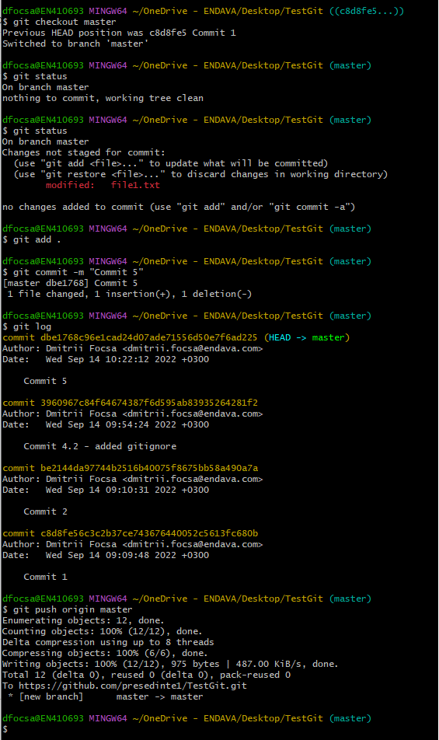

b. You have made a small mistake in the commit message or in a file within the previous commit which was pushed to remote and now you must make those minor corrections without “registering” a new commit. How can you achieve that?

Make the required changes

git add <file_name>

git commit -m ”Commin 5.1” –amend

git push origin master -f

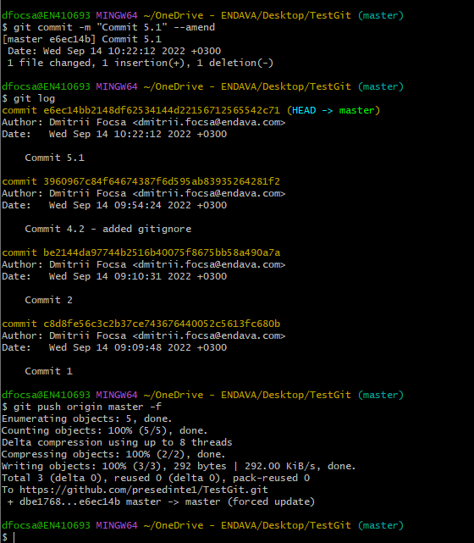

c. You need a new folder in your project on local repository where you will keep some local configurations, secrets which should not be promoted in further commits or on remote. How

will you achieve that?

Create a file .gitignore

Add a filename of the files which should be ignored

git add .gitignore

git commit -m “Added files into gitignore”

d. You have performed some changes in a version and have made a commit (without to push it), and then immediately you realized that there is a mistake, and an additional fix is necessary. How will you undo the commit?

git reset --soft hash_commit or git reset --soft HEAD~

git add .

git commit –m “Commit 7.3”

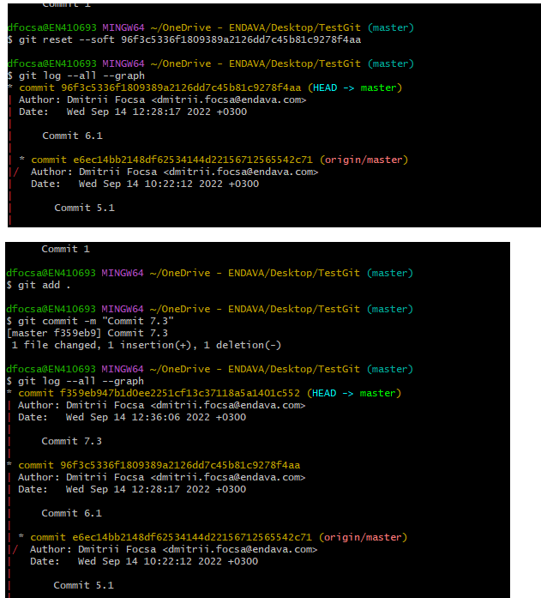

**2. You are a new joiner in a developing team, and in order to start working you need to recreate the project’s remote repository to your working station. What will be your actions?**

git clone URL_to_the_remote_repo

**3. As a new joiner, you just started to work on a project which is using Git and follows a classic branching strategy. You have cloned the remote repo to a local one and need to start to work on a task. What will be your first actions?**

git checkout -b feature_task1665

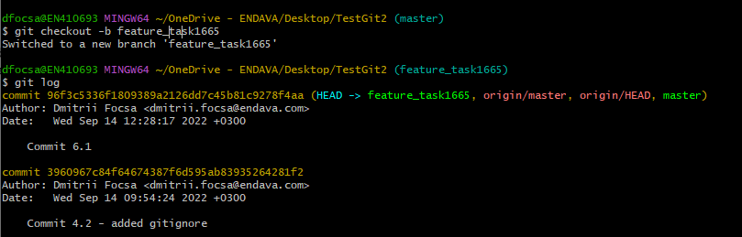

**4. You are actively working on a new implementation on a branch called feature1. You are asked to perform a bug fix and deliver it as soon as possible. Your actions?**

git stash

git checkout master

git checkout -b hotfix_task16625

<changing the code, fixing the bug>

git add .

git commit -m “Fixed bug task16625 ”