**Econ Chapter 4-6 Graphs Questions and Answers**

**Multiple Choice**

*Identify the letter of the choice that best completes the statement or answers the question.*

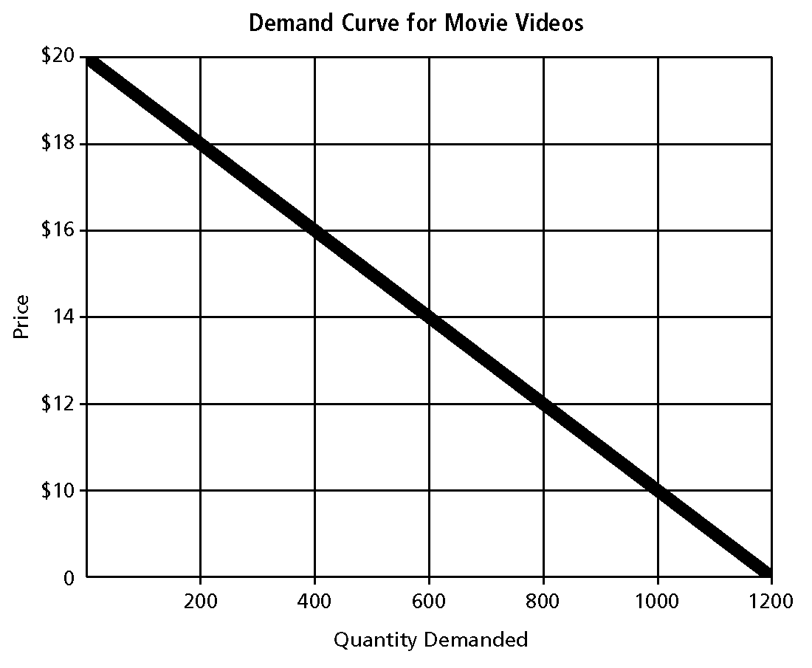

____ 1.  According to this demand curve, how many movie videos will be demanded at a price of $10?

|  |  |  |  |
| --- | --- | --- | --- |
| a. | 400 | c. | 800 |
| b. | 600 | d. | 1000 |

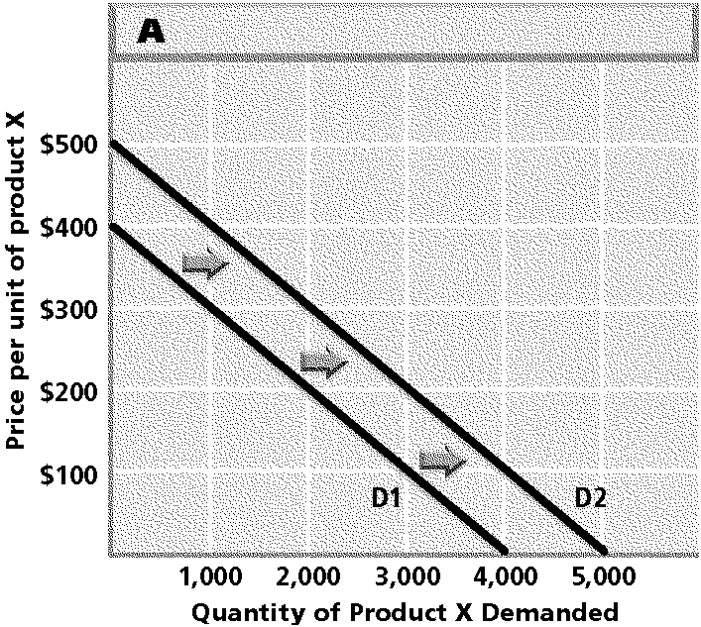

____ 2.  The movement shown in this graph represents a change in what?

|  |  |  |  |
| --- | --- | --- | --- |
| a. | quantity demanded | c. | demand |
| b. | marginal utility | d. | demand elasticity |

____ 3. 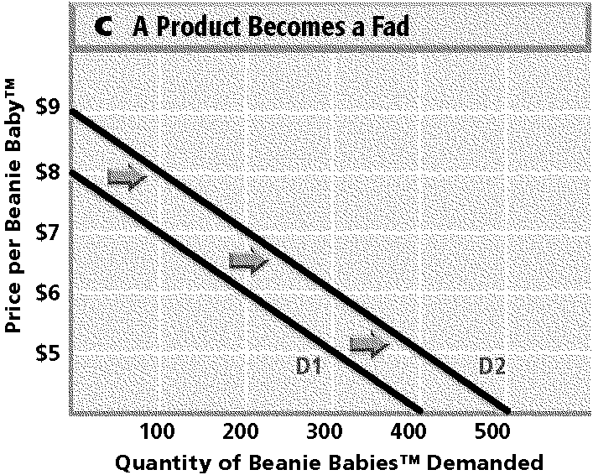

 Based on this graph, how many Beanie Babies™ were demanded at a price of $6 before they became a fad?

|  |  |  |  |
| --- | --- | --- | --- |
| a. | 100 | c. | 300 |
| b. | 200 | d. | 400 |

____ 4. 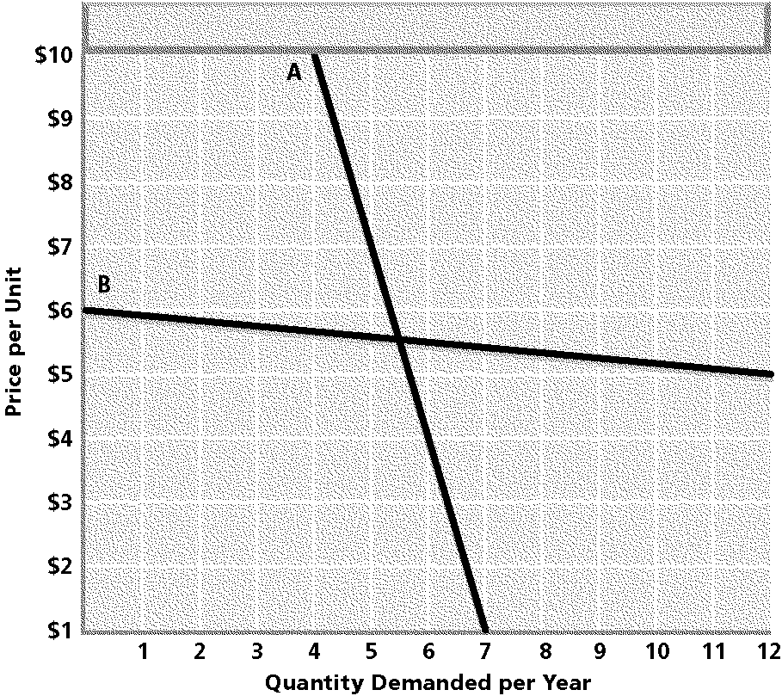

 On Curve A in the graph, suppose the price dropped from $10 to $7. Would quantity demanded increase or decrease and by how much?

|  |  |
| --- | --- |
| a. | Quantity demanded would decrease by 1 unit. |
| b. | Quantity demanded would increase by 1 unit. |
| c. | Quantity demanded would decrease by 5 units. |
| d. | Quantity demanded would increase by 5 units. |

____ 5. 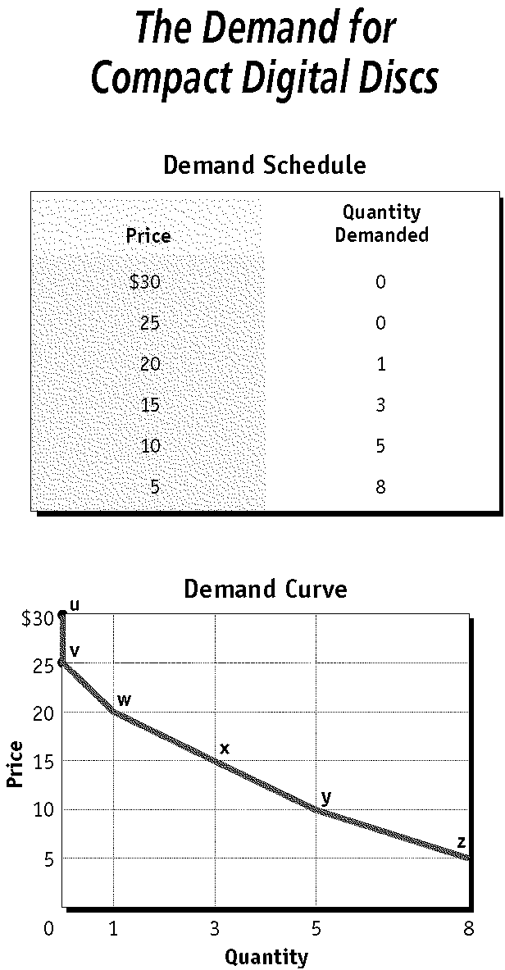

 Find the price of $15 on the demand schedule. What point does this price and quantity correspond to in the graph?

|  |  |  |  |
| --- | --- | --- | --- |
| a. | v | c. | x |
| b. | w | d. | y |

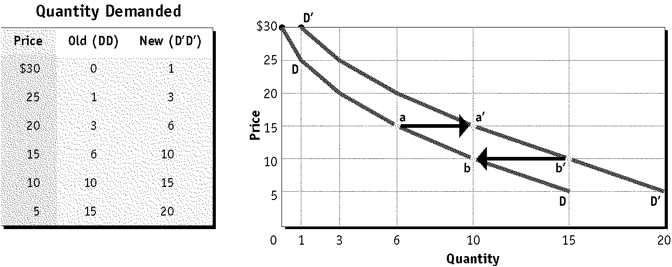

____ 6.  What does the movement from b' to b on the graph represent?

|  |  |
| --- | --- |
| a. | an increase in demand |
| b. | an increase in quantity demanded |
| c. | a decrease in demand |
| d. | a decrease in quantity demanded |

____ 7.  Study the illustration. At a price of $25, how much more of the product is demanded on curve D'D' than on curve DD?

|  |  |  |  |
| --- | --- | --- | --- |
| a. | 2 units | c. | 1 unit |
| b. | 3 units | d. | 4 units |

|  |  |  |  |  |  |
| --- | --- | --- | --- | --- | --- |
|  | **Products** | | | | |
| **Fresh tomatoes** | **Gasoline from a particular station** | **Gasoline in general** | **Services of medical doctors** | **Butter** |
| Can purchase be delayed? | yes | yes | no | no | yes |
| Are adequate substitutes available? | yes | yes | no | no | yes |
| Does purchase use a large portion of income? | no | yes | yes | yes | no |

____ 8.  Which products shown in the table are likely to have elastic demand?

|  |  |
| --- | --- |
| a. | gasoline in general, services of medical doctors |
| b. | fresh tomatoes, gasoline from a particular station, butter |
| c. | fresh tomatoes, gasoline in general, butter |
| d. | gasoline from a particular station, gasoline in general, butter |

____ 9.  Which products shown in the table are likely to have inelastic demand?

|  |  |
| --- | --- |
| a. | gasoline in general, services of medical doctors |
| b. | fresh tomatoes, gasoline from a particular station, butter |
| c. | fresh tomatoes, gasoline in general, butter |
| d. | gasoline from a particular station, gasoline in general, butter |

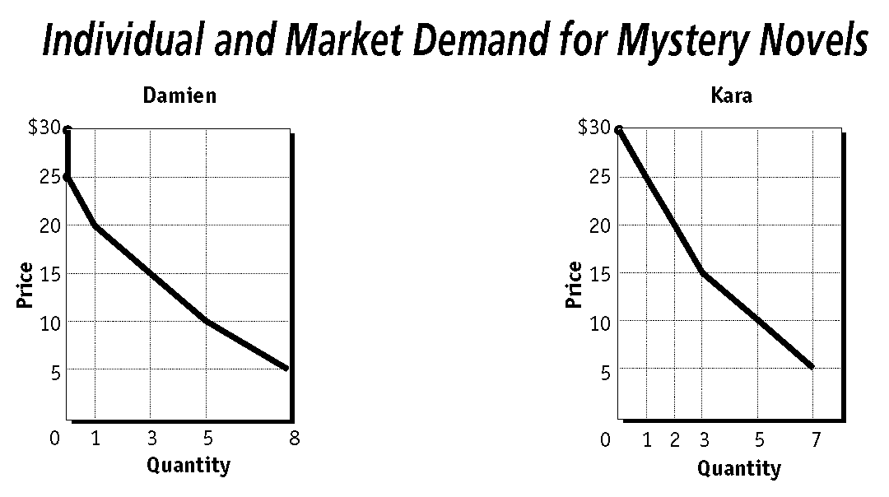

____ 10.  According to the demand curves, at a price of $20, how many more mystery novels would Kara demand than would Damien?

|  |  |  |  |
| --- | --- | --- | --- |
| a. | 0 more | c. | 2 more |
| b. | 1 more | d. | 3 more |

____ 11.  Assume that Damien and Kara are the only two people in the market for mystery novels. Based on the graphs, what would be the market quantity demanded for mystery novels at a price of $5?

|  |  |  |  |
| --- | --- | --- | --- |
| a. | 5 | c. | 15 |
| b. | 10 | d. | 20 |

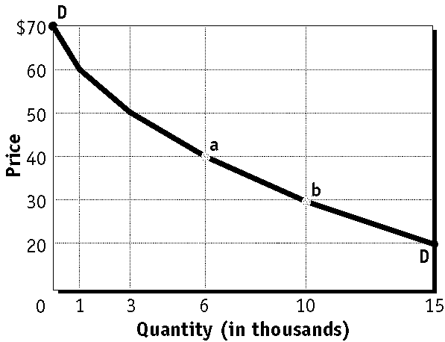

____ 12.  Based on the graph, how does the market demand for concert tickets change if the price increases from $30 to $40?

|  |  |
| --- | --- |
| a. | the demand curve shifts to the right |
| b. | the demand curve shifts to the left |
| c. | quantity demanded decreases by 4,000 |
| d. | quantity demanded increases by 4,000 |

|  |  |  |  |
| --- | --- | --- | --- |
| **Quantity of Burritos Demanded by**  **All Consumers in the Market** | | | |
| **Price** | **Consumer P** | **Consumer Q** | **Consumer R** |
| $7 | 0 | 0 | 0 |
| $6 | 1 | 2 | 1 |
| $5 | 2 | 3 | 3 |
| $4 | 4 | 5 | 5 |
| $3 | 6 | 6 | 8 |
| $2 | 8 | 10 | 10 |

____ 13.  Based on the table, what is the market demand for burritos at a price of $5?

|  |  |  |  |
| --- | --- | --- | --- |
| a. | 2 | c. | 6 |
| b. | 3 | d. | 8 |

____ 14.  Based on the table, at what price would the market demand for burritos be 14?

|  |  |  |  |
| --- | --- | --- | --- |
| a. | $3 | c. | $5 |
| b. | $4 | d. | $6 |

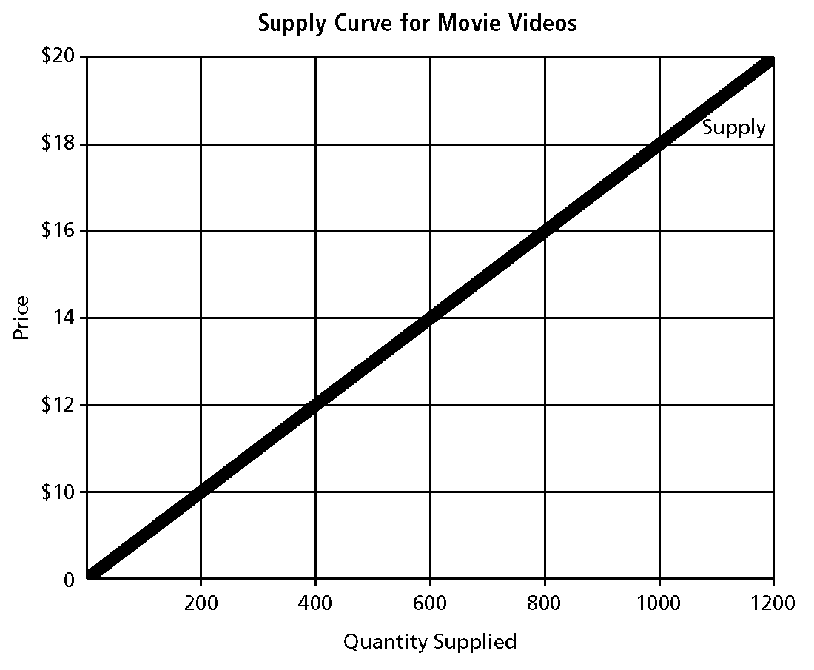

____ 15.  According to this supply curve, 400 movie videos will be supplied at what price?

|  |  |  |  |
| --- | --- | --- | --- |
| a. | $10 | c. | $14 |
| b. | $12 | d. | $16 |

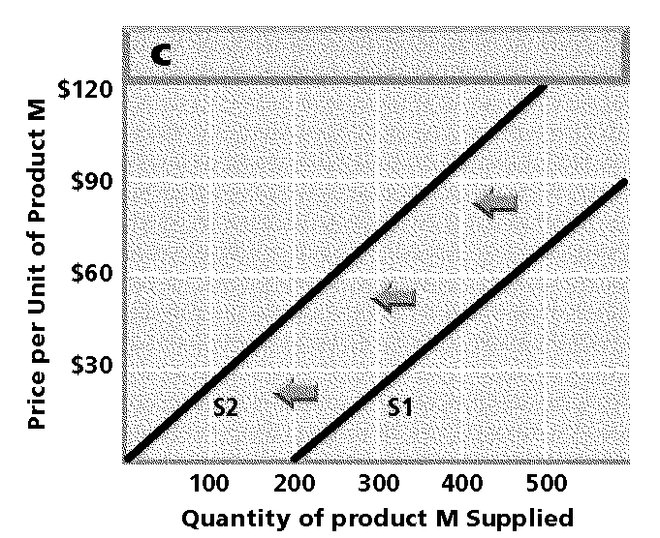

____ 16.  The movement shown in this graph represents a change in what?

|  |  |  |  |
| --- | --- | --- | --- |
| a. | supply | c. | supply elasticity |
| b. | quantity supplied | d. | production function |

____ 17. 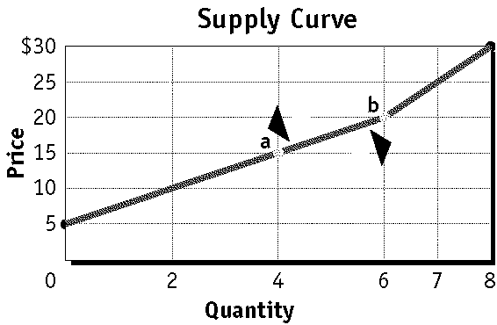

 What does the movement shown on this graph represent?

|  |  |
| --- | --- |
| a. | a change in supply |
| b. | a change in quantity supplied |
| c. | the law of diminishing returns |
| d. | a shift in the market supply curve |

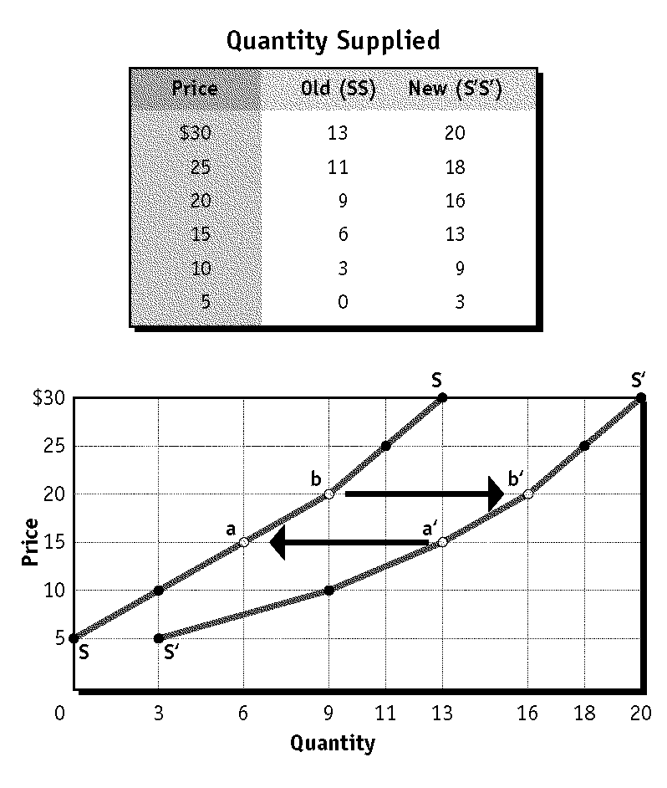

____ 18.  What does the movement from b to b' on the graph represent?

|  |  |  |  |
| --- | --- | --- | --- |
| a. | an increase in quantity supplied | c. | a decrease in supply |
| b. | a decrease in quantity supplied | d. | an increase in supply |

____ 19.  Study the illustration. At a price of $10, how many more units of the product are supplied on curve S'S' than on curve SS?

|  |  |  |  |
| --- | --- | --- | --- |
| a. | 9 | c. | 3 |
| b. | 6 | d. | 12 |

____ 20. 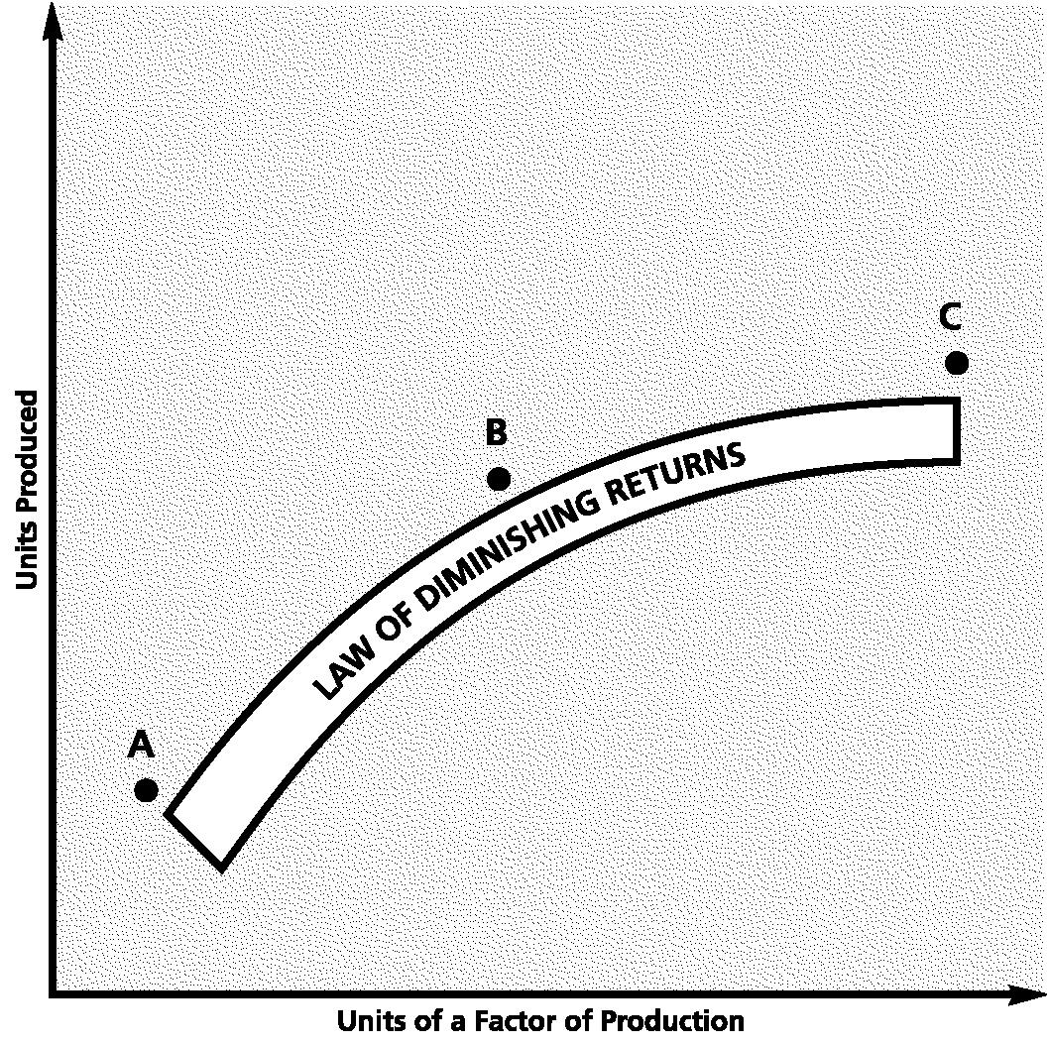

 What economic principle does the graph illustrate?

|  |  |
| --- | --- |
| a. | law of supply |
| b. | law of diminishing marginal utility |
| c. | law of diminishing returns |
| d. | law of demand |

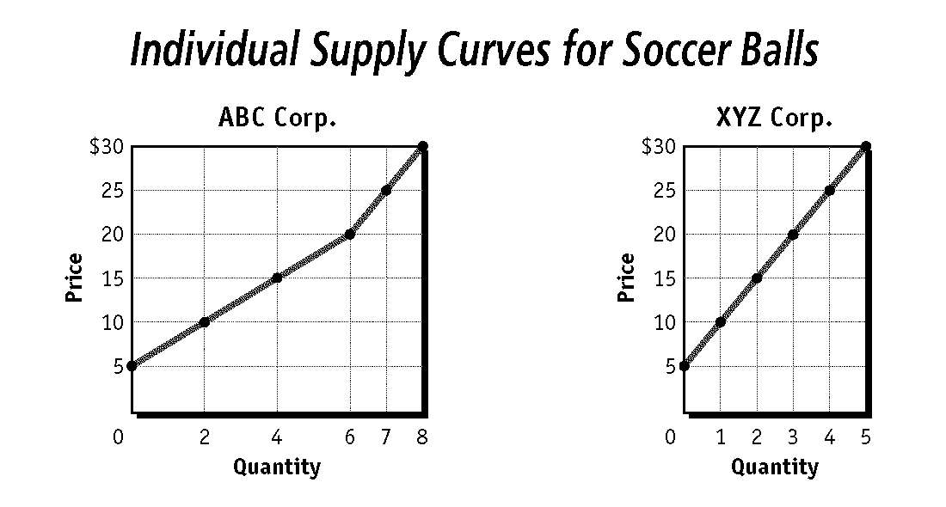

____ 21.  According to the supply curves, at a price of $25, how many more soccer balls would ABC Corp. supply than would XYZ Corp.?

|  |  |  |  |
| --- | --- | --- | --- |
| a. | 2 more | c. | 7 more |
| b. | 3 more | d. | 11 more |

____ 22.  Assume that ABC Corp. and XYZ Corp. are the only two firms that supply soccer balls. Based on the graphs, what would be the market quantity of soccer balls supplied at a price of $20?

|  |  |  |  |
| --- | --- | --- | --- |
| a. | 3 | c. | 9 |
| b. | 6 | d. | 10 |

____ 23. 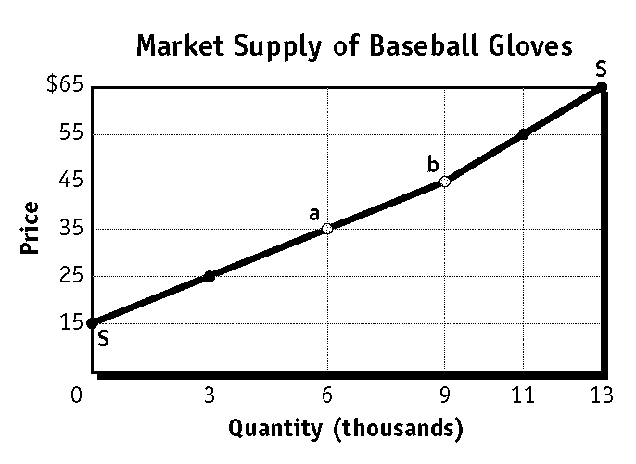

 Based on the graph, how does the market supply of baseball gloves change if the price increases from $25 to $35?

|  |  |
| --- | --- |
| a. | quantity supplied decreases by 9,000 |
| b. | quantity supplied increases by 9,000 |
| c. | quantity supplied decreases by 3,000 |
| d. | quantity supplied increases by 3,000 |

|  |  |  |  |
| --- | --- | --- | --- |
| **Quantity of Softballs Supplied by**  **All Firms in the Market** | | | |
| **Price** | **Firm X** | **Firm Y** | **Firm Z** |
| $11 | 400 | 500 | 1,000 |
| $9 | 300 | 400 | 800 |
| $7 | 200 | 200 | 600 |
| $5 | 100 | 50 | 300 |
| $3 | 50 | 0 | 100 |
| $1 | 0 | 0 | 0 |

____ 24.  Based on the table, what is the market supply of softballs at a price of $7?

|  |  |  |  |
| --- | --- | --- | --- |
| a. | 1,000 | c. | 600 |
| b. | 200 | d. | 800 |

____ 25.  Based on the table, at what price would the market supply of softballs be 1,500?

|  |  |  |  |
| --- | --- | --- | --- |
| a. | $5 | c. | $9 |
| b. | $3 | d. | $11 |

____ 26.

|  |  |  |
| --- | --- | --- |
| **Production Schedule** | | |
| **Number of**  **Workers** | **Total**  **Product** | **Marginal**  **Product\*** |
| 0 | 0 | 0 |
| 1 | 7 | 7 |
| 2 | 20 | 13 |
| 3 | 38 | 18 |
| 4 | 62 | 24 |
| 5 | 90 | 28 |
| 6 | 110 | 20 |
| 7 | 129 | 19 |
| 8 | 138 | 9 |
| 9 | 144 | 6 |
| 10 | 148 | 4 |
| 11 | 145 | –3 |
| 12 | 135 | –10 |

*All figures in terms of output per day.

 In this production schedule, production Stage III begins with the addition of which numbered worker?

|  |  |  |  |
| --- | --- | --- | --- |
| a. | 10 | c. | 8 |
| b. | 6 | d. | 11 |

|  |  |  |  |  |  |  |
| --- | --- | --- | --- | --- | --- | --- |
| **Production Schedule** | | | **Costs** | | | |
| **Number of Workers** | **Total Product** | **Marginal Product\*** | **Total**  **Fixed**  **Costs** | **Total**  **Variable**  **Costs** | **Total Costs** | **Marginal**  **Costs** |
| 0 | 0 | 0 | $50 | $0 | $50 | -- |
| 1 | 7 | 7 | 50 | 90 | 140 | $12.86 |
| 2 | 20 | 13 | 50 | 180 | 230 | 6.92 |
| 3 | 38 | 18 | 50 | 270 | 320 | 5.00 |
| 4 | 62 | 24 | 50 | 360 | 410 | 3.75 |
| 5 | 90 | 28 | 50 | 450 | 500 | 3.21 |
| 6 | 110 | 20 | 50 | 540 | 590 | 4.50 |
| 7 | 129 | 19 | 50 | 630 | 680 | 4.74 |
| 8 | 138 | 9 | 50 | 720 | 770 | 10.00 |
| 9 | 144 | 6 | 50 | 810 | 860 | 15.00 |
| 10 | 148 | 4 | 50 | 900 | 950 | 22.50 |
| 11 | 145 | –3 | 50 | 990 | 1,040 | -- |
| 12 | 135 | –10 | 50 | 1,080 | 1,130 | -- |

*All figures in terms of output per day.

____ 27.  Based on the table, what is the variable cost of the third worker?

|  |  |  |  |
| --- | --- | --- | --- |
| a. | $270 | c. | $90 |
| b. | $5.00 | d. | $320 |

____ 28.  What is the variable input in this production and cost table?

|  |  |  |  |
| --- | --- | --- | --- |
| a. | units of product | c. | capital |
| b. | units of cost | d. | labor |

|  |  |  |  |  |  |  |  |  |  |
| --- | --- | --- | --- | --- | --- | --- | --- | --- | --- |
| **Production Schedule** | | | **Costs** | | | | **Revenues** | | **Profit** |
| **Number**  **of**  **Workers** | **Total**  **Product** | **Marginal**  **Product\*** | **Total**  **Fixed**  **Costs** | **Total**  **Variable**  **Costs** | **Total**  **Costs** | **Marginal**  **Costs** | **Total**  **Revenue** | **Marginal**  **Revenue** | **Total**  **Profit** |
| 0 | 0 | 0 | $50 | $0 | $50 | -- | $0 | -- | –$50 |
| 1 | 7 | 7 | 50 | 90 | 140 | $12.86 | 105 | $15 | –35 |
| 2 | 20 | 13 | 50 | 180 | 230 | 6.92 | 300 | 15 | 70 |
| 3 | 38 | 18 | 50 | 270 | 320 | 5.00 | 570 | 15 | 250 |
| 4 | 62 | 24 | 50 | 360 | 410 | 3.75 | 930 | 15 | 520 |
| 5 | 90 | 28 | 50 | 450 | 500 | 3.21 | 1,350 | 15 | 850 |
| 6 | 110 | 20 | 50 | 540 | 590 | 4.50 | 1,650 | 15 | 1,060 |
| 7 | 129 | 19 | 50 | 630 | 680 | 4.74 | 1,935 | 15 | 1,210 |
| 8 | 138 | 9 | 50 | 720 | 770 | 10.00 | 2,070 | 15 | 1,300 |
| 9 | 144 | 6 | 50 | 810 | 860 | 15.00 | 2,160 | 15 | 1,300 |
| 10 | 148 | 4 | 50 | 900 | 950 | 22.50 | 2,220 | 15 | 1,270 |
| 11 | 145 | –3 | 50 | 990 | 1,040 | -- | 2,175 | 15 | 1,135 |
| 12 | 135 | –10 | 50 | 1,080 | 1,130 | -- | 2,025 | 15 | 895 |

*All figures in terms of output per day.

____ 29.  According to the table, the company must hire at least how many workers to earn a profit?

|  |  |  |  |
| --- | --- | --- | --- |
| a. | 1 | c. | 3 |
| b. | 2 | d. | 4 |

____ 30.  In the table, how much extra revenue does the company generate by producing and selling one additional unit of output?

|  |  |  |  |
| --- | --- | --- | --- |
| a. | $90 | c. | $15 |
| b. | $13 | d. | $50 |

____ 31. 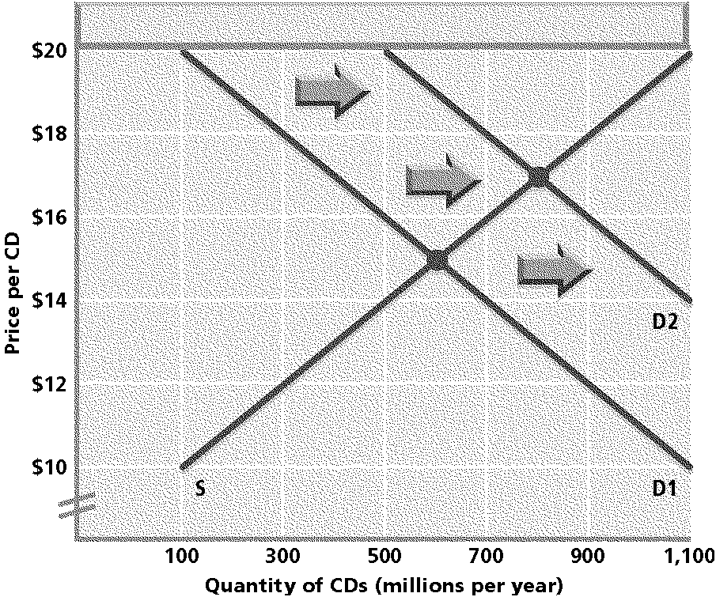

 Suppose the demand curve shifts from D1 to D2, as shown on the graph. How do the quantity supplied and quantity demanded change at the new equilibrium price?

|  |  |
| --- | --- |
| a. | Quantity supplied increases and quantity demanded decreases. |
| b. | Quantity supplied decreases and quantity demanded increases. |
| c. | Both quantity supplied and quantity demanded increase. |
| d. | Both quantity supplied and quantity demanded decrease. |

____ 32.

|  |  |  |  |
| --- | --- | --- | --- |
| **Market Demand and Supply Schedules** | | | |
| **Price** | **Quantity**  **Demanded** | **Quantity**  **Supplied** | **Surplus/**  **Shortage** |
| $20 | 0 | 20 | 20 |
| 18 | 2 | 16 | 14 |
| 16 | 4 | 10 | 6 |
| 14 | 7 | 7 | 0 |
| 12 | 11 | 5 | **?** |
| 10 | 13 | 0 | –13 |

 In the table, market equilibrium will occur at what price?

|  |  |  |  |
| --- | --- | --- | --- |
| a. | $20 | c. | $14 |
| b. | $16 | d. | $10 |

____ 33. 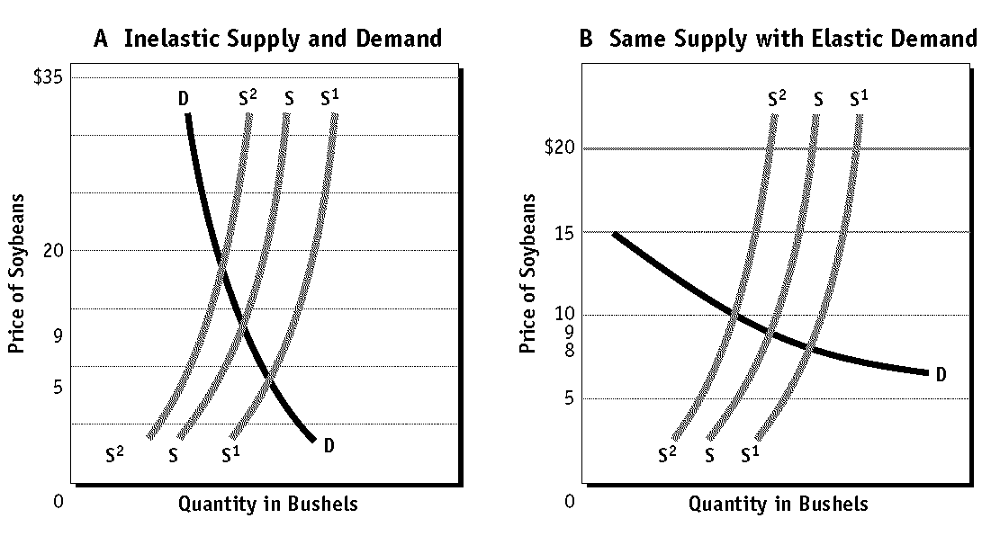

 In the graphs, which curve represents the “worst case” yield for soybean farmers?

|  |  |  |  |
| --- | --- | --- | --- |
| a. | DD | c. | S1S1 |
| b. | SS | d. | S2S2 |

____ 34. 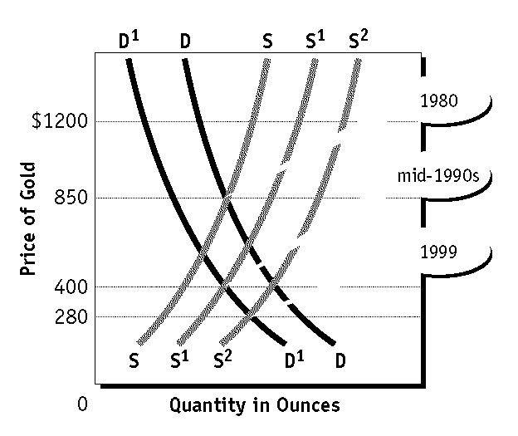

 On the graph, suppose that demand for gold stands at D1D1. Then the opening of a new gold mine shifts the supply curve from S1S1 to S2S2. How does this shift affect price?

|  |  |  |  |
| --- | --- | --- | --- |
| a. | price rises from 280 to 400 | c. | price rises from 400 to 850 |
| b. | price declines from 400 to 280 | d. | price declines from 850 to 400 |

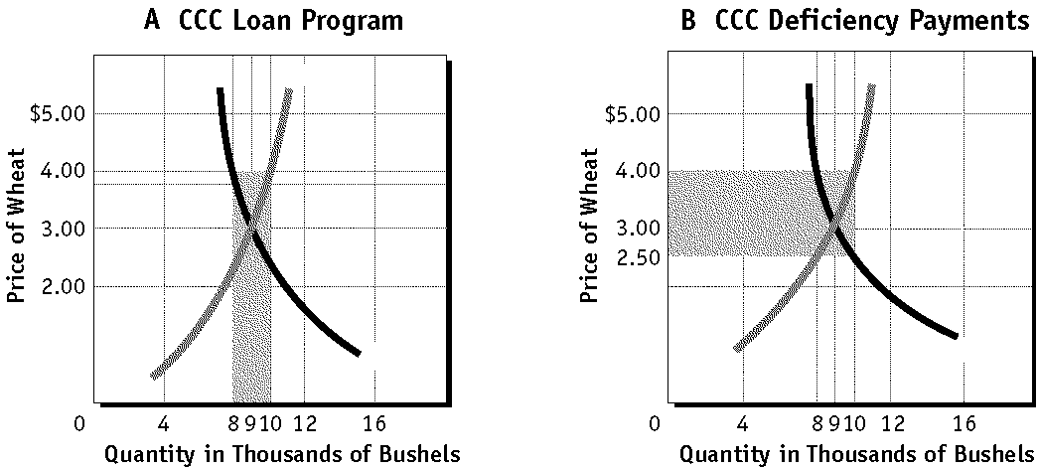

____ 35.  In Panel A of the graph, the farmer produced 10,000 bushels of wheat under the loan program. At the target price, how many bushels did the farmer sell on the open market?

|  |  |  |  |
| --- | --- | --- | --- |
| a. | 8,000 bushels | c. | 10,000 bushels |
| b. | 9,000 bushels | d. | 2,000 bushels |

____ 36.  In Panel A of the graph, the farmer produced 10,000 bushels of wheat under the loan program. If the program did not exist, how many bushels would the farmer have produced and sold?

|  |  |  |  |
| --- | --- | --- | --- |
| a. | 8,000 bushels | c. | 10,000 bushels |
| b. | 9,000 bushels | d. | 2,000 bushels |

**Short Answer**

**APPLYING SKILLS**

***Using Graphs:*** *Study the graph and answer the questions below.*

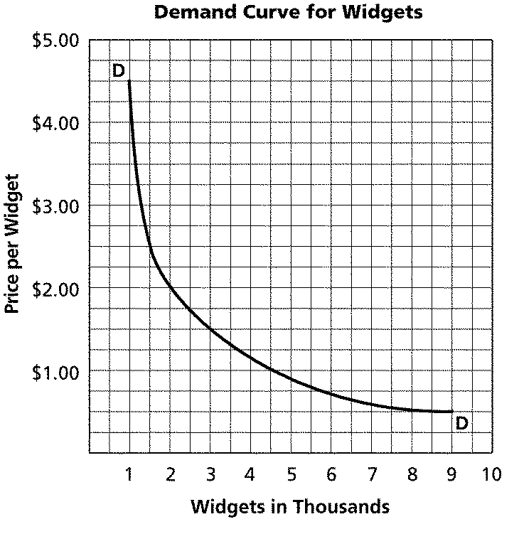

37.

|  |  |
| --- | --- |
|  | How many widgets were in demand when the price was $4.50? |

38.

|  |  |
| --- | --- |
|  | If the demand for widgets at $4.50 was met, what would be the resulting total revenue? |

39.

|  |  |
| --- | --- |
|  | Does this graph demonstrate the Law of Demand? Explain. |

40.

|  |  |
| --- | --- |
|  | How many widgets were in demand when the price was $1.50? |

41.

|  |  |
| --- | --- |
|  | If the demand for widgets at $1.50 were met, what would be the resulting total revenue? |

42.

|  |  |
| --- | --- |
|  | What would be the quantity demanded if the price were then lowered from $1.50 to $1? Is demand elastic, unit elastic, or inelastic between these two prices? Explain. |

43.

|  |  |  |
| --- | --- | --- |
| **Quantity Demanded** | | |
| **Price** | **Old Demand Curve** | **New Demand Curve** |
| $80 | 0 | 1 |
| 70 | 2 | 5 |
| 60 | 4 | 8 |
| 50 | 7 | 10 |
| 40 | 12 | 15 |
| 30 | 15 | 22 |

|  |  |
| --- | --- |
|  | In the table, does the movement in the demand curve from the old to the new represent a change in demand or a change in quantity demanded? Explain. |

44. 

|  |  |
| --- | --- |
|  | What conclusion can you draw from the slope of the demand curve in this illustration? |

45. 

|  |  |
| --- | --- |
|  | Summarize what Point a on the graph represents. |

**APPLYING SKILLS**

***Using Graphs:*** *Study the graph and answer the questions below.*

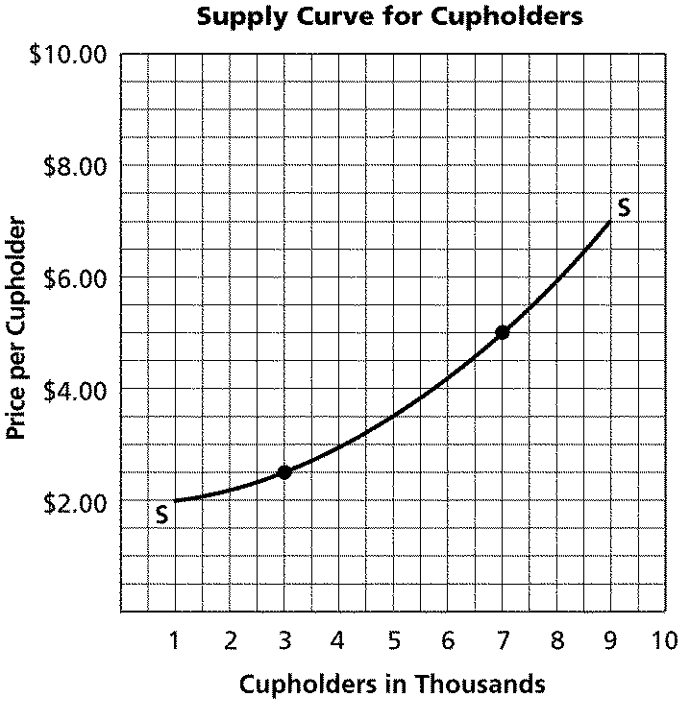

46.

|  |  |
| --- | --- |
|  | How many cupholders are producers willing to supply at a price of $2.50? |

47.

|  |  |
| --- | --- |
|  | What would be the quantity supplied if the price increased from $2.50 to $5.00? |

48.

|  |  |
| --- | --- |
|  | How many cupholders are producers willing to supply at a price of $3.00? |

49.

|  |  |
| --- | --- |
|  | Does this graph demonstrate the Law of Supply? Explain. |

50.

|  |  |
| --- | --- |
|  | Is supply elastic, unit elastic, or inelastic between the prices of $2.50 and $5.00? Explain. |

51.

|  |  |
| --- | --- |
|  | At what price were the fewest cupholders produced? |

52. 

|  |  |
| --- | --- |
|  | Summarize what Point b on the graph represents. |

53.

|  |  |  |
| --- | --- | --- |
| **Production Schedule** | | |
| **Number of Workers** | **Total Product** | **Marginal Product\*** |
| 0 | 0 | 0 |
| 1 | 7 | 7 |
| 2 | 20 | 13 |
| 3 | 38 | 18 |
| 4 | 62 | 24 |
| 5 | 90 | 28 |
| 6 | 110 | 20 |
| 7 | 129 | 19 |
| 8 | 138 | 9 |
| 9 | 144 | 6 |
| 10 | 148 | 4 |
| 11 | 145 | –3 |
| 12 | 135 | –10 |

*All figures in terms of output per day.

|  |  |
| --- | --- |
|  | In this production schedule, production Stage II begins with the addition of which numbered worker? Explain how you know. |

**APPLYING SKILLS**

***Using Tables:*** *Study the table and answer the questions below.*

|  |  |  |
| --- | --- | --- |
| **Annual Supply and Demand for**  **portable CD players**  **(in Thousands)** | | |
| **Price** | **Quantity Demanded** | **Quantity Supplied** |
| $40.00 | 14 | 0 |
| $42.50 | 12 | 1 |
| $45.00 | 11 | 2 |
| $47.50 | 9 | 3 |
| $50.00 | 7 | 4 |
| $52.50 | 5 | 5 |
| $55.00 | 4 | 7 |
| $57.50 | 3 | 9 |
| $60.00 | 2 | 10 |
| $62.50 | 1 | 12 |

54.

|  |  |
| --- | --- |
|  | What is the equilibrium price for portable CD players? |

55.

|  |  |
| --- | --- |
|  | What would be the result of a $45.00 price ceiling on portable CD players? |

56.

|  |  |
| --- | --- |
|  | If only one firm supplied all CD players and that firm decided to produce 8,000 CD players priced at $57.50, what would be the result? |

**APPLYING SKILLS**

***Using Tables:*** *Study the table and answer the questions below.*

|  |  |  |
| --- | --- | --- |
| **Annual Supply and Demand for VCRs**  **(in Thousands)** | | |
| **Price** | **Quantity Demanded** | **Quantity Supplied** |
| $100 | 23 | 3 |
| $110 | 22 | 4 |
| $120 | 20 | 5 |
| $130 | 18 | 10 |
| $140 | 16 | 12 |
| $150 | 14 | 14 |
| $160 | 10 | 18 |
| $170 | 6 | 26 |
| $180 | 3 | 30 |
| $190 | 2 | 34 |

57.

|  |  |
| --- | --- |
|  | What is the equilibrium price for VCRs? |

58.

|  |  |
| --- | --- |
|  | If only one firm supplied all VCRs and that firm decided to produce 16,000 of them at $160, what would be the result? |

59.

|  |  |
| --- | --- |
|  | What would be the result of a $110 price ceiling on VCRs? |

60. 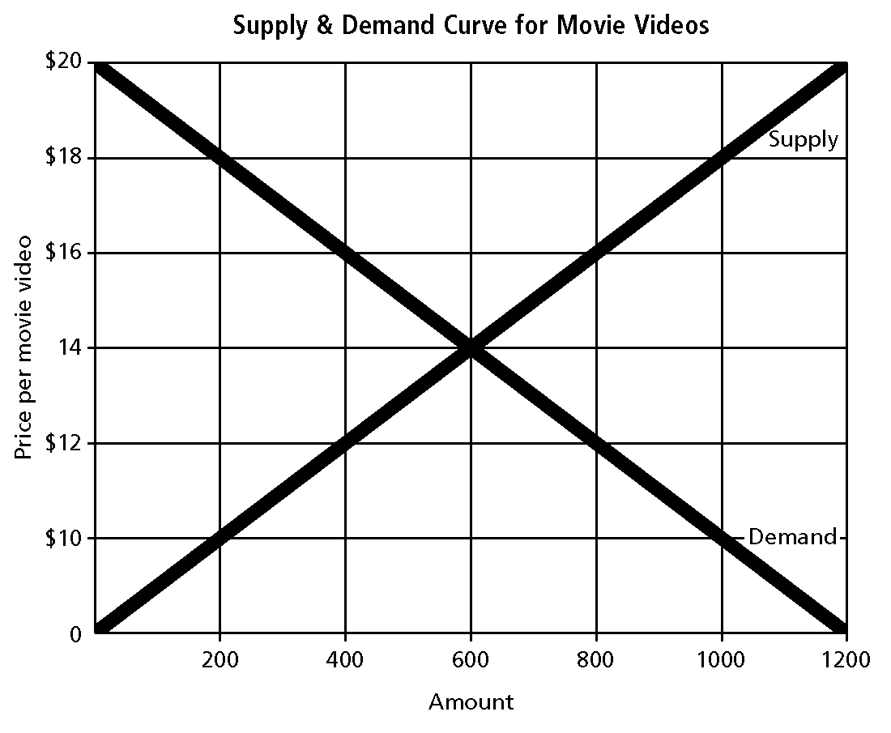

|  |  |
| --- | --- |
|  | What is the equilibrium price on this graph? Explain what that means. |

61.

|  |  |  |  |
| --- | --- | --- | --- |
| **Market Demand and Supply Schedules** | | | |
| **Price** | **Quantity**  **Demanded** | **Quantity**  **Supplied** | **Surplus/**  **Shortage** |
| $20 | 0 | 20 | 20 |
| 18 | 2 | 16 | 14 |
| 16 | 4 | 10 | 6 |
| 14 | 7 | 7 | 0 |
| 12 | 11 | 5 | **?** |
| 10 | 13 | 0 | –13 |

|  |  |
| --- | --- |
|  | At a price of $12 in the table, does the market have a surplus or shortage? of how many units? Explain how you know. |

**Essay**

62.

|  |  |
| --- | --- |
| **Demand Schedule for CDs** | |
| **Price per CD** | **Quantity Demanded**  **(in millions)** |
| $10 | 1,100 |
| $12 | 900 |
| $14 | 700 |
| $16 | 500 |
| $18 | 300 |
| $20 | 100 |

|  |  |
| --- | --- |
|  | Use the information in the demand schedule to explain the law of demand. |

63. 

|  |  |
| --- | --- |
|  | Which demand curve on the graph is more elastic, Curve A or Curve B? Explain. |

64. 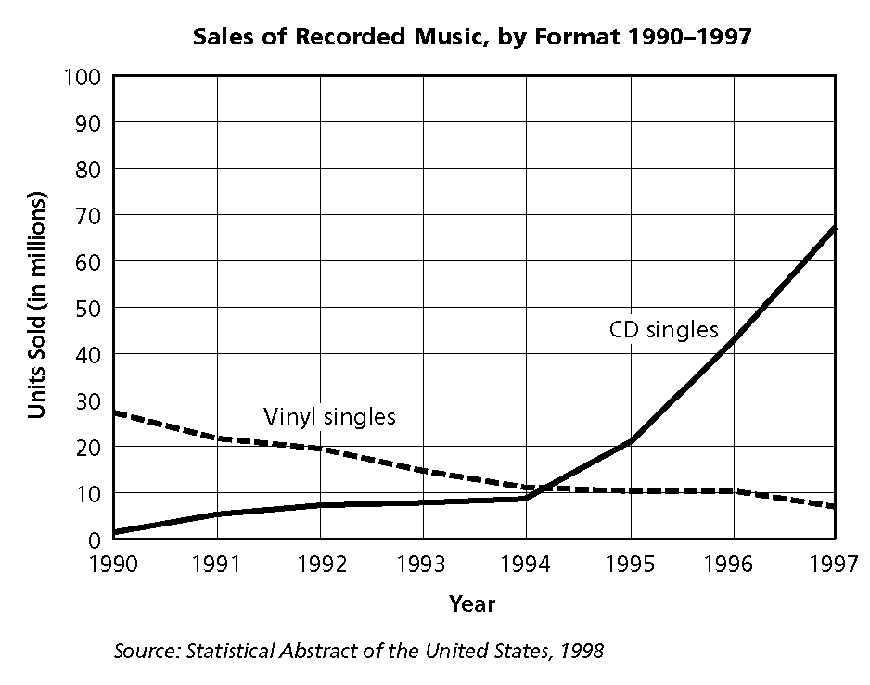

|  |  |
| --- | --- |
|  | This graph shows two formats in which people can buy music—on vinyl records or on CDs. Describe the trend in sales shown for both formats. Do you think sales of one format affect the sales of the other? Explain. |

65. 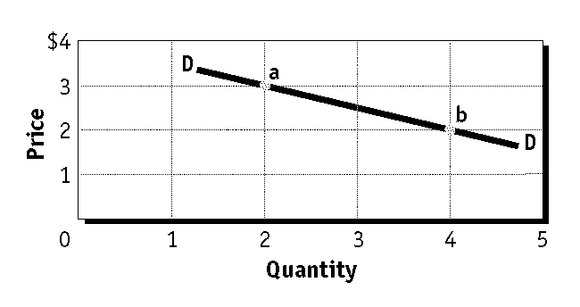

|  |  |
| --- | --- |
|  | On demand curve DD shown on the graph, how do expenditures change when the price increases from $2 to $3? What does this tell you about the elasticity of the demand curve? Explain. |

66. 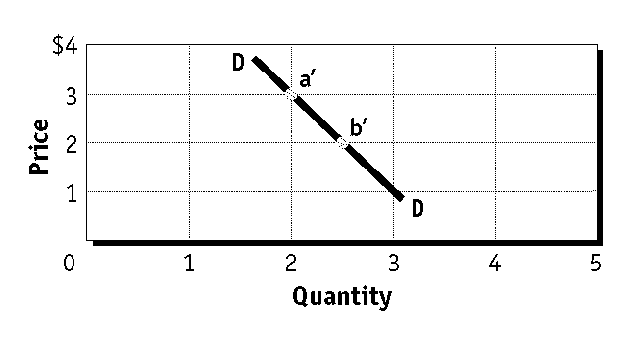

|  |  |
| --- | --- |
|  | Is demand curve DD on the graph elastic, inelastic, or unit elastic? Use numbers from the graph to explain how you know. |

67. 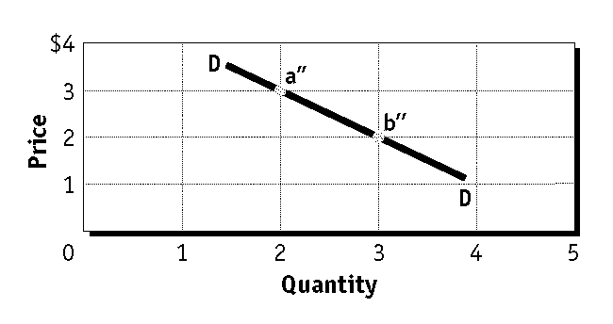

|  |  |
| --- | --- |
|  | Is demand curve DD on the graph elastic, inelastic, or unit elastic? Use the expenditures test to explain how you know. |

68.

|  |  |
| --- | --- |
| **Supply Schedule for CDs** | |
| **Price per CD** | **Quantity supplied**  **(in millions)** |
| $10 | 100 |
| $12 | 300 |
| $14 | 500 |
| $16 | 700 |
| $18 | 900 |
| $20 | 1,100 |

|  |  |
| --- | --- |
|  | Use the information on this supply schedule to explain the law of supply. |

69. 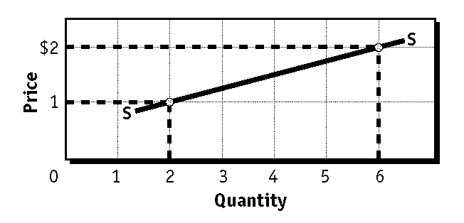

|  |  |
| --- | --- |
|  | On supply curve SS shown on the graph, how does the quantity supplied change when the price increases from $1 to $2? What does this tell you about the elasticity of the supply curve? Explain. |

70. 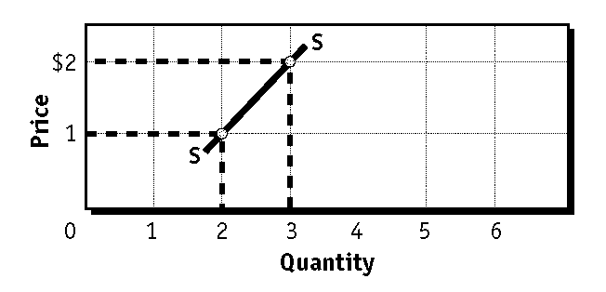

|  |  |
| --- | --- |
|  | Is supply curve SS on the graph elastic, inelastic, or unit elastic? Use numbers from the graph to explain how you know. |

71. 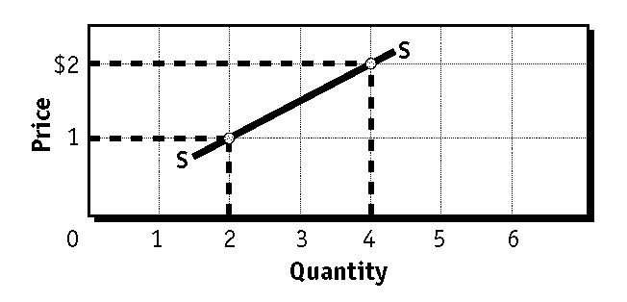

|  |  |
| --- | --- |
|  | Is supply curve SS on the graph elastic, inelastic, or unit elastic? Compare proportional changes to explain how you know. |

|  |  |  |
| --- | --- | --- |
| **Production Schedule** | | |
| **Number of Workers** | **Total Product** | **Marginal Product\*** |
| 0 | 0 | 0 |
| 1 | 7 | 7 |
| 2 | 20 | 13 |
| 3 | 38 | 18 |
| 4 | 62 | 24 |
| 5 | 90 | 28 |
| 6 | 110 | 20 |
| 7 | 129 | 19 |
| 8 | 138 | 9 |
| 9 | 144 | 6 |
| 10 | 148 | 4 |
| 11 | 145 | –3 |
| 12 | 135 | –10 |

*All figures in terms of output per day.

72.

|  |  |
| --- | --- |
|  | In this production schedule, what does the number 24 in the Marginal Product column mean and how was it computed? |

73.

|  |  |  |  |  |  |  |
| --- | --- | --- | --- | --- | --- | --- |
| **Production Schedule** | | | **Costs** | | | |
| **Number of Workers** | **Total Product** | **Marginal**  **Product\*** | **Total**  **Fixed**  **Costs** | **Total**  **Variable**  **Costs** | **Total Costs** | **Marginal**  **Costs** |
| 0 | 0 | 0 | $50 | $0 | $50 | -- |
| 1 | 7 | 7 | 50 | 90 | 140 | $12.86 |
| 2 | 20 | 13 | 50 | 180 | 230 | 6.92 |
| 3 | 38 | 18 | 50 | 270 | 320 | 5.00 |
| 4 | 62 | 24 | 50 | 360 | 410 | 3.75 |
| 5 | 90 | 28 | 50 | 450 | 500 | 3.21 |
| 6 | 110 | 20 | 50 | 540 | 590 | 4.50 |
| 7 | 129 | 19 | 50 | 630 | 680 | 4.74 |
| 8 | 138 | 9 | 50 | 720 | 770 | 10.00 |
| 9 | 144 | 6 | 50 | 810 | 860 | 15.00 |
| 10 | 148 | 4 | 50 | 900 | 950 | 22.50 |
| 11 | 145 | –3 | 50 | 990 | 1,040 | -- |
| 12 | 135 | –10 | 50 | 1,080 | 1,130 | -- |

*All figures in terms of output per day.

|  |  |
| --- | --- |
|  | In the table, what does the number 3.75 in the Marginal Cost column mean? Explain how it was computed. |

|  |  |  |  |  |  |  |  |  |  |
| --- | --- | --- | --- | --- | --- | --- | --- | --- | --- |
| **Production Schedule** | | | **Costs** | | | | **Revenues** | | **Profit** |
| **Number**  **of**  **Workers** | **Total**  **Product** | **Marginal**  **Product\*** | **Total**  **Fixed**  **Costs** | **Total**  **Variable**  **Costs** | **Total**  **Costs** | **Marginal**  **Costs** | **Total**  **Revenue** | **Marginal**  **Revenue** | **Total**  **Profit** |
| 0 | 0 | 0 | $50 | $0 | $50 | -- | $0 | -- | –$50 |
| 1 | 7 | 7 | 50 | 90 | 140 | $12.86 | 105 | $15 | –35 |
| 2 | 20 | 13 | 50 | 180 | 230 | 6.92 | 300 | 15 | 70 |
| 3 | 38 | 18 | 50 | 270 | 320 | 5.00 | 570 | 15 | 250 |
| 4 | 62 | 24 | 50 | 360 | 410 | 3.75 | 930 | 15 | 520 |
| 5 | 90 | 28 | 50 | 450 | 500 | 3.21 | 1,350 | 15 | 850 |
| 6 | 110 | 20 | 50 | 540 | 590 | 4.50 | 1,650 | 15 | 1,060 |
| 7 | 129 | 19 | 50 | 630 | 680 | 4.74 | 1,935 | 15 | 1,210 |
| 8 | 138 | 9 | 50 | 720 | 770 | 10.00 | 2,070 | 15 | 1,300 |
| 9 | 144 | 6 | 50 | 810 | 860 | 15.00 | 2,160 | 15 | 1,300 |
| 10 | 148 | 4 | 50 | 900 | 950 | 22.50 | 2,220 | 15 | 1,270 |
| 11 | 145 | –3 | 50 | 990 | 1,040 | -- | 2,175 | 15 | 1,135 |
| 12 | 135 | –10 | 50 | 1,080 | 1,130 | -- | 2,025 | 15 | 895 |

*All figures in terms of output per day.

74.

|  |  |
| --- | --- |
|  | In the table, the break-even point is between what units of total product? Explain how you know. |

75.

|  |  |
| --- | --- |
|  | In the table, the company will reach its profit-maximizing quantity of output when it hires which numbered worker? Explain how you know. |

76. 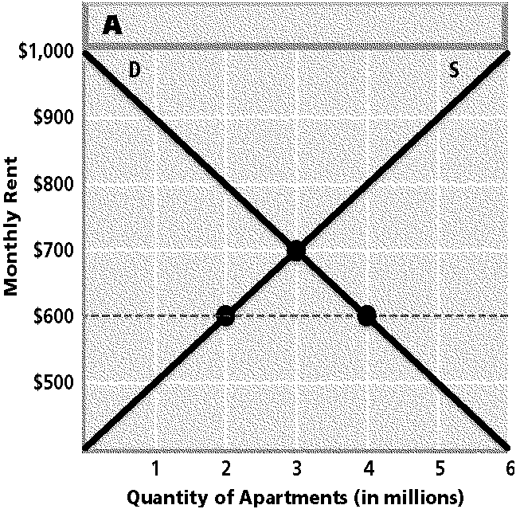

|  |  |
| --- | --- |
|  | Suppose the government sets a maximum rent on government-controlled apartments, as shown by the dotted line in the graph. Use the information on the graph to explain the result. |

77. 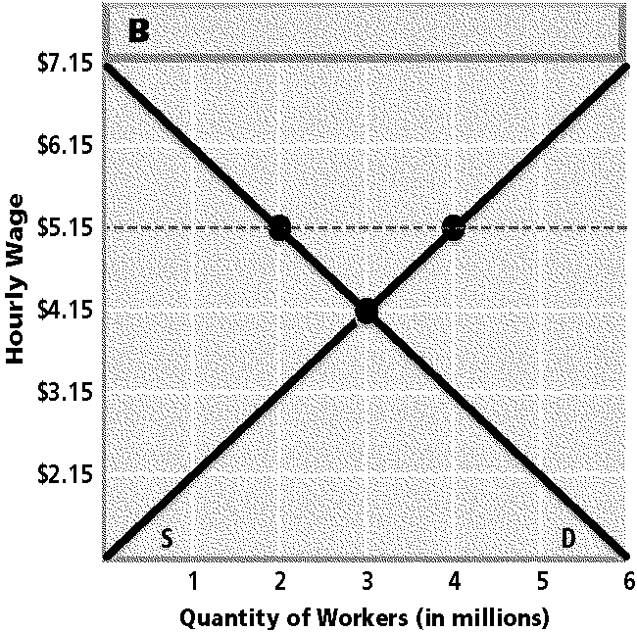

|  |  |
| --- | --- |
|  | Suppose the government sets a minimum wage at $5.15 per hour, as shown by the dotted line in the graph. Use the information on the graph to explain the result. |

78.

|  |  |  |  |
| --- | --- | --- | --- |
| **Market Demand and Supply Schedules** | | | |
| **Price** | **Quantity**  **Demanded** | **Quantity**  **Supplied** | **Surplus/**  **Shortage** |
| $20 | 0 | 20 | 20 |
| 18 | 2 | 16 | 14 |
| 16 | 4 | 10 | 6 |
| 14 | 7 | 7 | 0 |
| 12 | 11 | 5 | **?** |
| 10 | 13 | 0 | –13 |

|  |  |
| --- | --- |
|  | Suppose sellers of the product described in the table set their price at $18. What evidence will they see that tells them that this price is too high? Use supply and demand concepts to explain how the sellers in this example will likely adjust their price. |

79. 

|  |  |
| --- | --- |
|  | The two graphs have identical supply curves representing different possible soybean yields. Based on the graphs, what can you conclude about the relationship between demand elasticity and the degree of price fluctuation across possible yields? Explain. |

80. 

|  |  |
| --- | --- |
|  | In Panel B of the graph, the farmer produced 10,000 bushels of wheat under the deficiency payments program. How much money did the farmer receive from selling wheat on the open market? How much money did the farmer receive from the government as a deficiency payment? Explain and show your work. |

**Econ Chapter 4-6 Graphs**

**Answer Section**

**MULTIPLE CHOICE**

1. ANS: D DIF: Easy REF: Page 91 STO: EPS3

MSC: Document Based Question

2. ANS: C DIF: Easy REF: Page 96 STO: EPS3

MSC: Document Based Question

3. ANS: B DIF: Easy REF: Page 96 STO: EPS3

MSC: Document Based Question

4. ANS: B DIF: Average REF: Page 95 STO: EPS3

MSC: Document Based Question

5. ANS: C DIF: Easy REF: Page 90 STO: EPS3

MSC: Document Based Question

6. ANS: C DIF: Average REF: Page 96 STO: EPS3

MSC: Document Based Question

7. ANS: A DIF: Average REF: Page 96 STO: EPS3.a

MSC: Document Based Question

8. ANS: B DIF: Average REF: Page 102 STO: EPS3.a

MSC: Document Based Question

9. ANS: A DIF: Average REF: Page 102 STO: EPS3.a

MSC: Document Based Question

10. ANS: B DIF: Average REF: Page 91 STO: EPS3

MSC: Document Based Question

11. ANS: C DIF: Average REF: Page 91 STO: EPS3

MSC: Document Based Question

12. ANS: C DIF: Average REF: Page 91 STO: EPS3

MSC: Document Based Question

13. ANS: D DIF: Average REF: Page 91 STO: EPS3.a

MSC: Document Based Question

14. ANS: B DIF: Average REF: Page 92 STO: EPS3.a

MSC: Document Based Question

15. ANS: B DIF: Easy REF: Pages 114-115

STO: EPS3 MSC: Document Based Question

16. ANS: A DIF: Easy REF: Page 113 STO: EPS3

MSC: Document Based Question

17. ANS: B DIF: Easy REF: Page 115 STO: EPS3

MSC: Document Based Question

18. ANS: D DIF: Average REF: Page 115 STO: EPS3

MSC: Document Based Question

19. ANS: B DIF: Average REF: Page 114 STO: EPS3

MSC: Document Based Question

20. ANS: C DIF: Average REF: Page 125 STO: EPS3

MSC: Document Based Question

21. ANS: B DIF: Average REF: Pages 114-115

STO: EPS3 MSC: Document Based Question

22. ANS: C DIF: Average REF: Page 115 STO: EPS3

MSC: Document Based Question

23. ANS: D DIF: Average REF: Page 114 STO: EPS3

MSC: Document Based Question

24. ANS: A DIF: Average REF: Page 114 STO: EPS3.a

MSC: Document Based Question

25. ANS: C DIF: Average REF: Page 114 STO: EPS3.a

MSC: Document Based Question

26. ANS: D DIF: Average REF: Page 125 STO: EPS3.a, EG4

MSC: Document Based Question

27. ANS: C DIF: Average REF: Page 129 STO: EPS3.a, EG4

MSC: Document Based Question

28. ANS: D DIF: Average REF: Page 128 STO: EPS3.a

MSC: Document Based Question

29. ANS: B DIF: Easy REF: Page 125 STO: EPS3.a, EG4

MSC: Document Based Question

30. ANS: C DIF: Average REF: Page 129 STO: EPS3.a

MSC: Document Based Question

31. ANS: C DIF: Average REF: Page 145 STO: EPS3

MSC: Document Based Question

32. ANS: C DIF: Average REF: Page 143 STO: EPS3

MSC: Document Based Question

33. ANS: D DIF: Average REF: Page 146 STO: EPS3

MSC: Document Based Question

34. ANS: B DIF: Average REF: Page 147 STO: EPS3

MSC: Document Based Question

35. ANS: A DIF: Challenging REF: Page 154 STO: EPS3, EHPS6.a

MSC: Document Based Question

36. ANS: B DIF: Challenging REF: Page 154 STO: EPS3, EHPS6.a

MSC: Document Based Question

**SHORT ANSWER**

37. ANS:

1,000 widgets

DIF: Average REF: Page 90 STO: EPS3 MSC: Document Based Question

NOT: Widgets

38. ANS:

$4,500

DIF: Challenging REF: Page 90 STO: EPS3 MSC: Document Based Question

NOT: Widgets

39. ANS:

Yes, because there is an inverse relationship between the price of the widget and the quantity demanded.

DIF: Average REF: Page 91 STO: EPS3 MSC: Document Based Question

NOT: Widgets

40. ANS:

3,000 widgets

DIF: Average REF: Page 90 STO: EPS3 MSC: Document Based Question

NOT: Widgets

41. ANS:

$4,500

DIF: Average REF: Page 90 STO: EPS3 MSC: Document Based Question

NOT: Widgets

42. ANS:

At $1.00 (a 30% reduction in price) the quantity demanded is 4,500 (a 30% increase). Demand is, therefore, unit elastic because the change in price led to a proportional change in the quantity demanded.

DIF: Challenging REF: Page 90 STO: EPS3 MSC: Document Based Question

NOT: Widgets

43. ANS:

The shift from the old to the new demand curve represents a change in demand, because a different quantity is demanded at every price.

DIF: Average REF: Page 89 STO: EPS3.a MSC: Document Based Question

44. ANS:

The demand curve slopes downward, which means that more will be demanded at lower prices, and fewer at higher prices.

DIF: Average REF: Page 91 STO: EPS3 MSC: Document Based Question

45. ANS:

Point a represents the total quantity of concert tickets demanded (6,000) by everyone who is willing and able to buy concert tickets at a price of $40.

DIF: Average REF: Page 91 STO: EPS3 MSC: Document Based Question

46. ANS:

3,000 cupholders

DIF: Average REF: Page 114 STO: EPS3 MSC: Document Based Question

NOT: Cupholders

47. ANS:

7,000 cupholders

DIF: Average REF: Page 114 STO: EPS3 MSC: Document Based Question

NOT: Cupholders

48. ANS:

4,000 cupholders

DIF: Average REF: Page 114 STO: EPS3 MSC: Document Based Question

NOT: Cupholders

49. ANS:

Yes, because more cupholders are produced as the price for cupholders increases.

DIF: Challenging REF: Page 113 STO: EPS3 MSC: Document Based Question

NOT: Cupholders

50. ANS:

Supply is elastic between $2.50 and $5.00 because a 100% price increase resulted in a change in quantity supplied of more than 100%.

DIF: Challenging REF: Page 119 STO: EPS3 MSC: Document Based Question

NOT: Cupholders

51. ANS:

$2.00

DIF: Average REF: Page 116 STO: EPS3 MSC: Document Based Question

NOT: Cupholders

52. ANS:

Point b represents the total quantity of baseball gloves supplied (9,000) by all suppliers of baseball gloves at a price of $45.

DIF: Average REF: Page 115 STO: EPS3 MSC: Document Based Question

53. ANS:

In this production schedule, Stage II starts with the addition of the sixth worker, because with the addition of this unit of variable input, output begins to increase at a diminishing rate.

DIF: Challenging REF: Page 125 STO: EPS3.a, EG4

MSC: Document Based Question

54. ANS:

$52.50

DIF: Average REF: Page 144 STO: EPS3 MSC: Document Based Question

NOT: CDS

55. ANS:

a shortage of 9,000 portable CD players

DIF: Challenging REF: Page 144 STO: EPS3, EPS3.b

MSC: Document Based Question NOT: CDS

56. ANS:

a surplus of 5,000 portable CD players

DIF: Average REF: Page 144 STO: EPS3 MSC: Document Based Question

NOT: CDS

57. ANS:

$150

DIF: Average REF: Page 144 STO: EPS3 MSC: Document Based Question

NOT: VCRS

58. ANS:

a surplus of 6,000 portable VCRs

DIF: Challenging REF: Page 144 STO: EPS3 MSC: Document Based Question

NOT: VCRS

59. ANS:

a shortage of 18,000 VCRs

DIF: Average REF: Page 144 STO: EPS3 MSC: Document Based Question

NOT: VCRS

60. ANS:

The equilibrium price is $14. This is the price at which the amount producers are willing to supply is equal to the amount consumers are willing and able to buy.

DIF: Easy REF: Page 144 STO: EPS3 MSC: Document Based Question

61. ANS:

A shortage of 6 units occurs at a price of $12, because at this price, quantity demanded exceeds quantity supplied by 6 units.

DIF: Average REF: Page 144 STO: EPS3.a MSC: Document Based Question

**ESSAY**

62. ANS:

At $20 per CD, 100 million CDs will be demanded. At $18, the quantity demanded rises to 300 million. In fact, at each lower price in the demand schedule, the quantity demanded increases. This is the law of demand: As price falls, quantity demanded increases.

DIF: Average REF: Page 91 STO: EPS3.a MSC: Document Based Question

63. ANS:

Curve B is more elastic than Curve A. Elasticity refers to consumers’ responsiveness to an increase or decrease in price of a product. The larger the consumer response to a change in price, the more elastic the curve. On Curve B, when the price drops by only $1, the quantity demanded increases dramatically. On Curve A, a $1 price drop would not change the quantity demanded very much.

DIF: Challenging REF: Pages 101-102 STO: EPS3

MSC: Document Based Question

64. ANS:

Sales of vinyl singles are trending down, as sales of CD singles are trending up. Sales of one format affect the other because they are substitutes.

DIF: Challenging REF: Page 98 STO: EPS3 MSC: Document Based Question

65. ANS:

When the price increases from $2 to $3, expenditures decrease from $8 to $6. When price and total expenditures change in opposite directions, the demand curve is elastic.

DIF: Challenging REF: Page 102 STO: EPS3 MSC: Document Based Question

66. ANS:

Demand curve DD is inelastic, because a decrease in price from $3 to $2 results in a decrease in expenditures from $6 to $5. When price and expenditures change in the same direction, the curve is inelastic.

DIF: Challenging REF: Pages 102-104 STO: EPS3

MSC: Document Based Question

67. ANS:

Demand curve DD is unit elastic. When the price decreases from $3 to $2, total expenditures remain $6. When a price change results in no change in expenditures, the curve is unit elastic.

DIF: Challenging REF: Pages 103-104 STO: EPS3

MSC: Document Based Question

68. ANS:

At $10 per CD, 100 million CDs will be supplied. At $12, the quantity supplied rises to 300 million. In fact, at each higher price in the supply schedule, the quantity supplied rises. This is the law of supply: price and quantity supplied move in the same direction. As the price rises, the quantity supplied generally rises. As the price falls, the quantity supplied also falls.

DIF: Average REF: Page 113 STO: EPS3.a MSC: Document Based Question

69. ANS:

Doubling the price from $1 to $2 causes the quantity supplied to triple, from 2 to 6. Because a change in price results in a more-than-proportional change in quantity supplied, the supply curve is elastic.

DIF: Challenging REF: Pages 119-120 STO: EPS3

MSC: Document Based Question

70. ANS:

Doubling the price from $1 to $2 causes the quantity supplied to rise by only 50%, from 2 to 3. Because a change in price results in a less-than-proportional change in quantity supplied, the supply curve is inelastic.

DIF: Challenging REF: Page 119 STO: EPS3 MSC: Document Based Question

71. ANS:

Doubling the price from $1 to $2 causes the quantity supplied double as well, from 2 to 4. Because a change in price results in a proportional change in quantity supplied, the supply curve is unit elastic.

DIF: Challenging REF: Page 119 STO: EPS3 MSC: Document Based Question

72. ANS:

The number 24 is the extra output or change in total product caused by the addition of the fourth worker. It was computed by subtracting 38, the total product produced by 3 workers, from 62, the total product produced by 4 workers.

DIF: Average REF: Page 124 STO: EPS3.a MSC: Document Based Question

73. ANS:

The 3.75 is the extra cost incurred when the business produced one additional unit of the product. Because fixed costs do not change from one level of production to another, marginal cost is the per-unit increase in variable costs that stems from using additional factors of production. In this example, the variable cost of adding the fourth worker (and every other worker) is $90. The addition of the fourth worker adds 24 units to production. Thus, the marginal cost is computed as $90/24 units = $3.75 cost per additional unit.

DIF: Challenging REF: Pages 127-129 STO: EPS3.a

MSC: Document Based Question

74. ANS:

The break-even point is between 7 and 20 units of total product. This is the total product the business needs to sell in order to cover its total costs. At 7 units, total revenue of $105 does not cover total costs of $140. However, at 20 units, total revenue of $300 does cover total costs of $230. Therefore, the break-even point falls somewhere between these two levels of output.

DIF: Challenging REF: Page 131 STO: EPS3.a MSC: Document Based Question

75. ANS:

The company will reach its profit-maximizing quantity of output when marginal cost and marginal revenue are equal. In this case, that quantity of output occurs when the ninth worker is hired. At that point, marginal cost and marginal revenue are both $15.

DIF: Challenging REF: Page 131 STO: EPS3.a MSC: Document Based Question

76. ANS:

A shortage of 2 million apartments will result. At a rent of $600, 4 million people will want to rent apartments, but apartment owners will be willing to supply only 2 million apartments.

DIF: Challenging REF: Page 152 STO: EPS3, EHPS6

MSC: Document Based Question

77. ANS:

A surplus of 2 million workers will result. At the minimum wage of $5.15 per hour, 4 million people will want jobs, but employers will be willing to offer only 2 million jobs.

DIF: Challenging REF: Page 152 STO: EPS3, EPS3.b, EGPS8.f

MSC: Document Based Question

78. ANS:

If sellers set a price that is too high, they will see a surplus of unsold products build up on their shelves and in their warehouses. This surplus tells them that the price is too high, and they must lower their price to attract more buyers and dispose of the surplus. In this example, the $18 price will result in a surplus of 14 units. These sellers will likely reduce their price and examine the results on their inventories until they reach the equilibrium price of $14, where the quantity supplied just equals the quantity demanded.

DIF: Challenging REF: Page 144 STO: EGHPS2.e, EPS3.a

MSC: Document Based Question

79. ANS:

With the inelastic demand curve in Graph A, different yields result in a relatively wide fluctuation in price, from $5 to $20 per bushel. The elastic demand curve in Graph B results in a smaller price fluctuation, ranging from $8 to $10 per bushel for the different possible yields. We can conclude that, for different possible yields, price fluctuates more widely if demand is inelastic than if it is elastic.

DIF: Challenging REF: Page 146 STO: EPS3 MSC: Document Based Question

80. ANS:

Based on the graph, the farmer made $25,000 by selling 10,000 bushels at $2.50 each on the open market. Because this was $1.50 below the target price of $4.00 a bushel, the farmer received a deficiency payment of $1.50 X 10,000 bushels = $15,000.

DIF: Challenging REF: Page 153 STO: EPS3, EHPS6

MSC: Document Based Question