**See Detached Chart for Questions 1-5**

22. This chart best demonstrates which of the following?

1. Successful outposts and settlements for fishing and fur trading spurred continued European exploration of North Atlantic.
2. Spanish sponsorship of the Colombian voyages across the Atlantic dramatically increased European interest in transoceanic travel and trade.
3. Europeans role in Asian trade was characterized mostly by transporting goods from one Asian market to another.
4. Portuguese development of maritime technology led to increased travel to and trade with West Africa.

23. The increased demand for American foods and cash crops during the Columbian Exchange directly led to the development of which of the following?

1. Plantation systems supported by coerced labor in Latin America..
2. Industrialism and increased production of manufactured goods.
3. Colonial economies dependent upon a labor force made up primarily of free European immigrants.
4. Independence movements across Central and Latin America as native populations sought control of their own economies.

24. Which of the following best explains the impact of the arrival of Europeans on the Native American populations?

(A) Europeans .brought Catholicism to the Americas and attempted to peacefully spread the faith among native populations, but tolerated the natives religious traditions, as well   
(B)The native populations slowly disappeared as there was little to no racial mixing between the natives and Europeans   
(C)The native populations were decimated by warfare, coerced labor, and the spread of foreign diseases   
(D) European settlers assisted the natives in establishing their own government systems independent of the European rulers

25. The Columbian Exchange led to the development of mercantilism, an economic system that is best described by which of the following?

1. Trade, industry, and means of production are largely or entirely privately owned.
2. A system of common or collective ownership, in which the economy and means of production are controlled and regulated by the government.
3. Transactions between private parties are free from government involvement, regulation, and taxation.
4. The regulated use of joint stock companies by European rulers to control their domestic and colonial economies.

26. In what ways did European agriculture and the arrival of European crops affect human interaction with the environment of the Americas?

1. European agriculture had little to no impact on the environment in the Americas, as most of the plants and animals brought from Eurasia and Africa were unable to survive in the new climate.
2. European crops and animals were able to adapt and flourish in the Americas, but had little impact overall, as the natives had already been engaging in large scale agriculture, mining, and harvesting of raw materials.
3. European agriculture often affected the physical environment negatively through deforestation, soil depletion, and a disruption of native ecosystems.
4. The crops and animals from Eurasia and Africa had a positive impact on the environment of the New World, because the natives had few food crops or domesticated animals available to support their populations.

Thomas Phillips, English Slave Trader, 1694

*After we come to an agreement for the prices of our slaves,…we are oblig’d to pay our customs to the king and his cappasheirs [attendents] for leave of trade, protection and justice….Having bought my compliment of 700 slaves, viz. 480 men and 220 women, and finish’d all my business at Whidaw, I took my leave of the old king, and his cappasheirs, and parted, with many affectionate expressions on both sides, being forced to promise him that I would return again the next year, with several things he desired me to bring him from England; and having sign’d bills of lading…for the negroes aboard, I set sail the 27th of July in the morning….I deliver’d alive at Barbados to the company’s factors 372 [slaves], which being sold, came at about nineteen pounds per head.*

10. The primary source above would be most useful to a historian researching:

1. the effects of Christianity on the attitudes of slave traders.
2. the most common goods used by English slave traders for the purchasing of slaves.
3. whether royal monopoly companies were as profitable as private joint-stock companies in the Atlantic slave trade
4. the mortality rate of African slaves during transport from Africa to the West Indies.

11. The letter also demonstrates which historical fact about the Atlantic slave trade?

1. It operated as a secret agreement between a select group of traders and suppliers.
2. It operated as a tacit trade agreement between European traders and African peoples.
3. It developed as an attempt to provide a sustainable labor force for colonies in Southeast Asia.
4. It shows the unfair advantages that European traders held over the African suppliers of slaves.

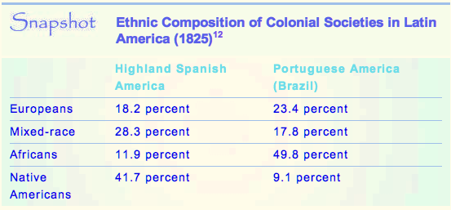

**Highland Spanish Portuguese America**

**America (Brazil)**

12. Which interpretation of the chart above would reflect the growing demand for sugar production in the Americas after 1450CE?

(A) The slightly larger percentage of Europeans in Brazil

(B) The larger percentage of Mixed-race people in Spanish colonies

(C) The larger percentage of Africans in Brazil

(D) The larger percentage of Native Americans in Spanish colonies

KC 4.1.V.B; T: Creation, Expansion, and Interaction of Economic Systems; S: Appropriate Use of Relevant Information

13. Which factor **BEST** explains the decrease in population of Native Americans?

(A) Many Native Americas migrated from the path of both Spanish and Portuguese settlements.

(B) Successful deportation of these groups by the Spanish and Portuguese to new lands.

(C) The impact of war, disease, and forced labor resulted in a severe decrease of life among the Native Americans.

(D) The plague that hit Native American groups prior to the coming of the Iberians decimated their population.

6. Which of the following **BEST** explains the large increase in Africans to Brazil?

(A) The sugar plantations of Brazil required rapid replacement of workers due to the brutal conditions which led to average life-span of 23 years for slaves.

(B) The silver mines of Brazil required rapid replacement of workers due to the brutal conditions which led to average life-span of 23 years for slaves.

(C) The fruit plantations in Brazil required rapid replacement of workers due to the brutal conditions which led to average life-span of 23 years for slaves.

(D) The timber camps of Brazil required rapid replacement of workers due to the brutal conditions which led to average life-span of 23 years for slaves.

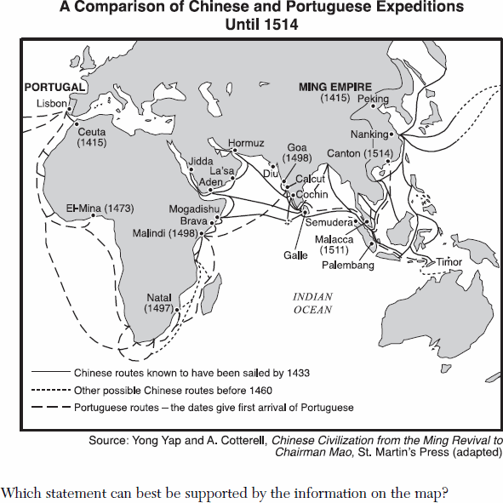

7. The map at left BEST explains which of the following about global interaction in the transition from the fifteenth to the sixteenth centuries?

(A) The importance of the silk routes as an engine of global trade declined as Eurasian civilizations sponsored transoceanic voyages.

(B) Connections between the Eastern and Western hemispheres were established for the first time resulting in the transfer of foods and crops known as the Columbian exchange.

(C) Eurasian interest in African trading posts as a source of slave laborers for cash crop plantations emerged and accelerated global migrations.

(D) Previously established regional trading networks in the Indian Ocean were connected in new ways to emerging Eurasian markets.

Key Concept 4.1.I Theme 4: Economy Skill: Historical argument

8. The map above shows what significant fifteenth century development in exploration?

(A) The opening of new routes for the Hajj pilgrimage to Arabia by Muslim merchants.

(B) Chinese naval voyages undertaken to enhance the prestige of the Ming Dynasty.

(C) The failure of trading posts developed by European explorers along the coasts Africa.

(D) Disruption of existing patterns of Indian Ocean trade.

9. What eventually happened to the trading aspirations of the two countries depicted in the map?

(A) The Ming continued to build trade and served as a check on Portuguese aspirations in the region.

(B) The Portuguese used military force to push the Ming Dynasty back to China and became the top traders in the region.

(C) The Ming Dynasty removed themselves from the world seeking isolation, while the Portuguese advanced trade and exploration throughout the world.

(D) Both nations entered into the Treaty of Tordesillas which divided the world of trade and colonies between China and Portugal.

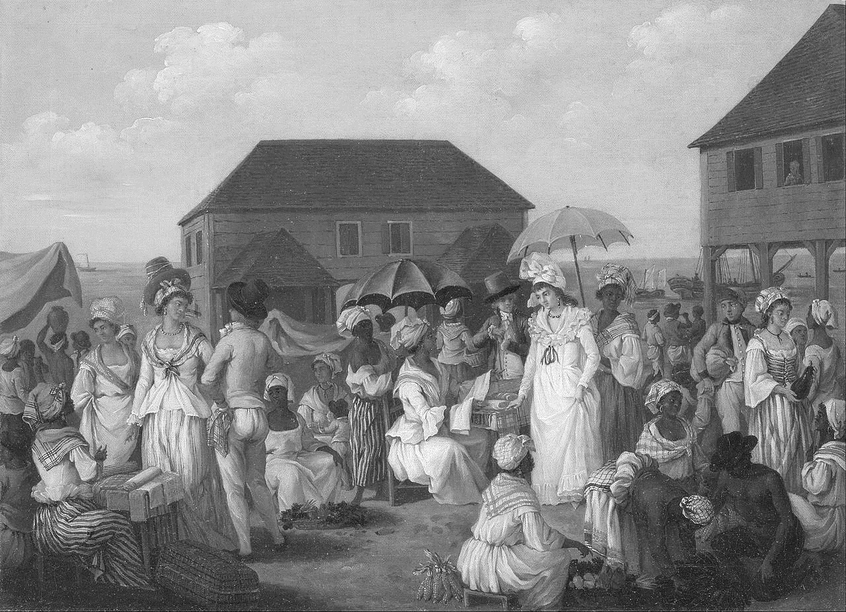

18. The painting above, by the Italian artist Agostino Brunias, of the “Linen Market” on the island of Dominca Caribbean in the mid-eighteenth century supports which of the following conclusions about the new connections between the Eastern and Western hemispheres?

1. European elites remained isolated from their subjects in new maritime empires.
2. Mercantilism was successful in the creation of a tightly controlled trade in luxury goods.
3. Gender roles were enforced that excluded women from participating in public life.
4. African, American, and European peoples mixed in the emerging Atlantic cultural system.

Key Concept 4.1.IV.D Theme 2: Culture Skills: Interpretation

19. Which of the following describes the demographic implications of three centuries of Spanish rule in Peru and Mexico?

* 1. A mestizo population emerged.
  2. The majority of the population was Spanish.
  3. Spanish women outnumbered indigenous women.
  4. Racial identity was defined as either Spanish or indigenous

**Passage: Excerpt from Ottoman Sultan Suleiman’s reply to French King Francis’ request for assistance, 1528 C.E.**

“I, sultan of sultans, king of kings, the shadow of God who bestows the crown to the monarchs on earth, the supreme ruler of the Mediterranean and Black Seas, the Balkans and Anatolia, Azerbaijan, Damascus and Halep, Egypt, Mecca and Medina, Jerusalem, and all of the Arab dominions, and Yemen, and the sultan and the supreme king of many nations, I am the son of Sultan Selim Khan and grandson of Sultan Bayezid Khan, and you, King Francis, are the governor of the French province. May God the Most High advance righteousness! May His will, whatsoever it portends, be accomplished. For the rest, ask it from your envoy and be informed. Know that it will be as said.”

Source: http://defence.pk/threads/reminding-of-sultan-suleiman-letter-to-france.184952/#ixzz4EnIDuZKT

1. Based on the reading of titles of the passage, what can you infer about the attitude of Sultan Suleiman towards his French counterpart King Francis and Europe as a whole?
2. The belief that he and Francis I are equals.
3. The belief that God is the only sovereign of their realms.
4. An assumption that Francis is of significantly lower rank and prestige.
5. A recognition that he reveres the position of King Francis.
6. Based on your knowledge of 16th-18th century European affairs, as well as inferring from the two sources above, which of the following best supports the rationale behind French overtures to the Ottoman Sultan?
7. The French shared similar economic interests in developing joint trade routes to the Far East via the Near East and Central Asia.
8. The French were threatening Central Europe and sought the neutrality of the Ottomans before undertaking further conquests in Europe and abroad.
9. The French and Ottomans shared a common enemy in the Habsburg Empire and believed an alliance would be mutually beneficial to both parties.
10. The French wished to establish a commercial foothold in Ottoman-administered North Africa to eventually extract natural resources within the interior of Africa.

**Excerpts from the Way of the Samurai (Shido), By Yamaga Soko; Tokugawa Japan, ca 1650.**

”The business of the samurai is to reflect on his own station in life, to give loyal service to his master if he has one…to devote himself to duty above all…. Although these are also the fundamental moral obligations of everyone in the land, the farmers, artisans, and merchants have no leisure from their occupations, and so they cannot constantly act in accordance with them and fully exemplify the Way. Because the samurai has dispensed with the business of the farmer, artisan, and merchant and confined himself to practising this Way, if there is someone in the three classes of the common people who violates these moral principles, the samurai should punish him summarily and thus uphold the proper moral principles in the land. It would not do for the samurai to know martial and civil virtues without manifesting them. Since this is the case, outwardly he stands in physical readiness for any call to service… Within his heart he keeps to the ways of peace, but without, he keeps his weapons ready for use. The three classes of the common people make him their teacher and respect him. By following his teachings, they are able to understand what is fundamental and what is secondary.”

1. Why was the unification of Japan under the Tokugawa shogun significant in the history of Asia?
2. Ending the civil wars allowed Japan to significantly increase the power of the Emperor.
3. Japan became more influenced by outside cultures during the Tokugawa shogunate.
4. Japan developed a less rigid social hierarchy as the samurai brought order to the countryside.
5. The Tokugawa shogunate ruled over a more centralized Japan, eventually almost ending all foreign influence.

17. What eventually happened to the status of the samurai under the Tokugawa shogunate?

1. The increase in chaos under Tokugawa led to an increased need for military force which led the samurai to greater militarism.
   1. The decrease in their status resulted in mass migration to areas of the world where their martial skills could be put to use.
   2. The decrease in their military status resulted in a shift to a new role as bureaucrats while some lost their status completely.
   3. The resulting attempts to pacify the samurai led to wide-spread rebellions throughout Japan increasing chaos under the regime.

**Christopher Columbus’ Letter to King Ferdinand of Spain, describing the results of the first voyage, 1493.**

*On August 3, 1492, Columbus set sail from Spain to find an all-water route to Asia. On October 12, more than two months later, Columbus landed on an island in the Bahamas. He proceeded to explore the Caribbean and discovered several islands.*

“…I found very many islands, filled with innumerable people, and I have taken possession of them all for their Highnesses, done by proclamation and with the royal standard unfurled, and no opposition was offered to me. … The island, Espanola … is a land to be desired and, when seen, never to be left. I have taken possession of all for their Highnesses, and all are more richly endowed than I know how or am able to say, and I hold all for their Highnesses, so that they may dispose of them as they do of the kingdoms of Castile and as absolutely. But especially, in this Espanola, in the situation most convenient and in the best position for the mines of gold and for all trade as well with the mainland here as with that there, belonging to the Grand Khan, where will be great trade and profit … In conclusion, to speak only of what has been accomplished on this voyage, which was so hasty, their Highnesses can see that I will give them as much gold as they may need, if their Highnesses will render me very slight assistance; presently, I will give them spices and cotton, as much as their Highnesses shall command; and mastic, as much as they shall order to be shipped and which, up to now, has been found only in Greece, in the island of Chios, and the Seignory sells it for what it pleases; and aloe, as much as they shall order to be shipped; and slaves, as many as they shall order, and who will be from the idolaters. I believe also that I have found rhubarb and cinnamon, and I shall find a thousand other things of value, which the people whom I have left there will have discovered, for I have not delayed at any point, so far as the wind allowed me to sail …”

Source: http://xroads.virginia.edu/~hyper/hns/garden/columbus.html

1. What enabled Columbus, and other European explorers to successfully sail across the Atlantic?
2. The invention of the Steamship (or steamboat) drastically improved transoceanic travel for Columbus and other European explorers
3. American crops including potatoes, maize and manioc were vital to ensure survival of early European settlements.
4. Smallpox and other diseases that were decimating Europe at the time did not affect Columbus’ naval crew.
5. The development of maritime technology led to remarkable new transoceanic maritime reconnaissance during this period.
6. Based on the excerpt above, which of the following statements best summarizes the motives of Columbus to sail for Spain?
   1. Columbus was determined to establish Spanish colonies in the Caribbean.
   2. Columbus wanted to find a Northwest Passage to China through North America.
   3. Columbus wanted to ensure a source of sustainable labor for the Spanish court.
   4. Columbus wanted to find a route to China for trade, and to obtain gold, spices, and slaves.

***Nzinga Memba, King of Kongo, to the King of Portugal, 1526 (Note: King Affonso was his Christian name)***

“Sir, Your Highness (King of Portugal) should know how our Kingdom is being lost in so many ways that it is convenient to provide for the necessary remedy, since this is caused by the excessive freedom given by your agents and officials to the men and merchants who are allowed to come to this Kingdom to set up shops with goods and many things which have been prohibited by us, and which they spread throughout our kingdoms and Domains, in such an abundance that many of our vassals, whom we had in obedience, do not comply because they have the things in greater abundance than we ourselves… and it was with these things that we had them content and subjected under our vassalage and jurisdiction, so it is doing a great harm not only to the service of God, but the security and peace of our kings and State as well…”

“And we cannot reckon how great the damage is, since the mentioned merchants are taking every day our natives, sons of the land and sons of our noblemen and vassals and our relatives, because the thieves and men of bad conscience grab them, wishing to have the things and wares of this Kingdom which they are ambitious of; they grab them and get them to be sold; and so great, Sir, is the corruption and licentiousness that our country is being completely depopulated, and Your Highness should not agree with this nor accept it as in your service.  And to avoid it we need from those (your) Kingdoms no more than some priests and a few people to teach in schools, and no other goods except wine and flour for the holy sacrament.  That is why we beg of Your Highness to help and assist us in this matter, commanding your factors that they should not send here either merchants or wares, because it is our will that in these Kingdoms there should not be any trade of slaves nor outlet for them…”

Source:  Wiesner, Wheeler, Doeringer, Curtis, ed. *Discovering the Global Past, A Look at the Evidence, Volume 1: to 1650*, 4th edition. 2012.

1.  Which of the following was an important direct cause of the processes described in the passage?

1. The importation of sugar to the Americas from the Mediterranean.
2. Spanish and Portuguese colonization of the Americas.
3. Portuguese exploration of the Western coast of Africa.
4. The transition of Western Europe into a global power.

2.   A historian researching the religious history of this era would most likely find this letter as a useful source of information about which of the following?

1. The preservation of traditional religious rituals and beliefs in the Kongo.
2. The conversion of the people of the Kongo to Catholic Christianity.
3. The advancement of divine right of kings, both in the Kongo and in Portugal.
4. The Kongo king’s rejection of Christianity due to differences between the kingdoms.

3.  Which of the following conclusions about the western coast of Africa during the period 1450-1750 is best supported by this letter?

1. The Trans-Atlantic slave trade reduced the population of West African societies.
2. The Trans-Saharan slave trade continued between West Africa and the Muslim Empires in the east.
3. Europeans sought to export more male slaves to the Americas than female.
4. West African leaders were successful in negotiating with European leaders.

4.   Which of the following best expresses King Affonso’s point of view in this passage?

1. As a Christian, Nzinga Memba believed slavery was a human rights violation and hoped to prevent Europeans from trading his people into slavery because it caused such disruption to his society.
2. As a Christian king writing to another Christian king he believed he should be able to persuade the Portuguese king to do as he has asked because they shared similar beliefs about morality.
3. As the leader of his people, Nzinga Memba wanted to ensure economic opportunities and prevent the Europeans from commercially swindling them because the Kongolese suffered more of a technological disadvantage.
4. As a powerful king, Nzinga Memba had always been suspicious of the Portuguese early on and had only traded with them as a way to enhance his own power.

5.   In this passage, there were two major changes Nzinga Memba described.  One was the damage caused by the introduction of the slave trade to his kingdom.  What was the other major change?

1. The merchants had become more corrupt in their practices than when they had first arrived.
2. The selling of wares, often forbidden to the Kongolese people had threatened King Affonso’s own power.
3. There were now many foreigners in the Kongo, colonizing it and marrying local women.
4. The king passed a law which forbid the trading activities of any Europeans within the Kongo.

**Excerpts from the Qing Dynasty “Sacred Edict”**

1. Esteem most highly filial piety and brotherly submission, in order to give due importance to human moral relations.

2. Behave with generosity toward your kindred, in order to illustrate harmony and benignity.

3. Cultivate peace and concord in your neighborhoods, in order to prevent quarrels and litigations.

4. Give importance to agriculture and sericulture, in order to ensure a sufficiency of clothing and food.

5. Show that you prize moderation and economy, in order to prevent the lavish waste of your means.

6. Foster colleges and schools, in order to give the training of scholars a proper start. -17th Century China

27. Items 1 and 6 above **BEST** reflect which aspect of the Qing Dynasty’s rule over China?

1. The promotion of Daoist philosophies formerly suppressed under Mongol rule.
2. The use of Buddhism to promote the Chinese emperor as the successor to Buddha
3. The reinforcement of Confucian ideals for government and society.
4. The rejection of Christianity of a threat to traditional Chinese culture and values.
5. Item 4 is **MOST LIKELY** a response to what occurrence during the rule of the Qing Dynasty?
6. An outbreak of bubonic plague due to increased trade over the Silk Road.
7. An increase in China’s population due to crops from the Americas.
8. A loss of manufacturing and agricultural jobs due to cheaper labor costs in Indonesia.
9. A protracted war with Mughal India over natural resources in Himalayas.

Answer Questions 29 and 31 based on the following quote and your knowledge of history:

**Antonio Vasquez de Espinosa, Spanish priest, *Compendium and Description of the West Indies,* 1620’s**

*So huge is the wealth that has been taken out of [Potosi silver mine] since 1545, when it was discovered, up to the present year of 1628, that . . . 326,000,000 silver coins have been taken out.*

*This does not count the great amount of silver taken secretly from these mines to Spain, paying no 20 per cent tax or registry fee, and to other countries outside Spain, including the Philippines and China.*

29. The document above provides evidence that:

(A) Spain’s empire was wealthier and more productive than those of its rivals.

(B) Silver was likely important to Spain’s economy during this period.

(C) Silver was more important than gold in the commerce of this era.

(D) Spain prevented silver from reaching other countries.

30. What problem does the document refer to?

(A) Abuse of Native American labor

(B) Silver was causing inflation

(C) Spanish clergy profited significantly from the silver trade

(D) Theft and smuggling of silver

31. The Trans-Atlantic slave trade had all of these effects **EXCEPT**:

1. The European conquest of Africa.
2. The settlement and development of vast areas of the Americas by Africans
3. The increased violence in Africa as slavers raided and warred for slaves.
4. Contributing to the growth of capitalism.

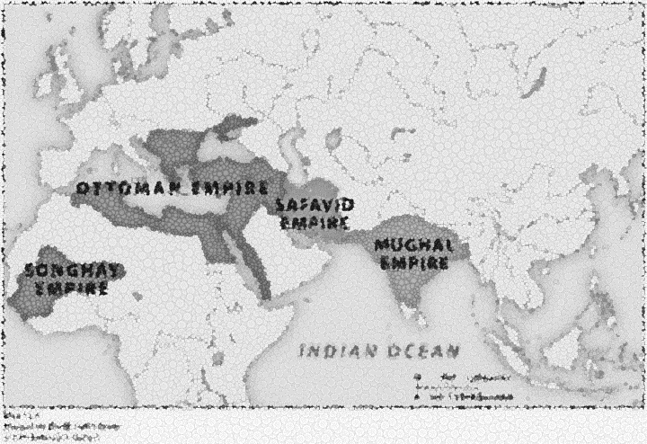Questions 32 to 33 refer to the map and passage below.

*“Animated by the spirit of this fatwa, conforming to the Quran, the code of divine laws, and wishing on one side to strengthen Islam, on the other to liberate the lands and peoples who writhe under your yoke, we have resolved to lay aside our imperial robes in order to put on the shield and coat of mail [armor]...*

-Letter written by Sunni Ottoman Sultan Selim I to the Shia Safavid Shah Ismail

32. The letter above written by the Sunni Ottoman Sultan Selim I to the Shia Safavid Shah Ismail highlights:

1. the intensification of the split between Sunni and Shia sects of Islam.
2. a strong desire to use the Quran to resolve differences nonviolently.
3. an increasing tension between Muslims and Jews in the Ottoman Empire.
4. a growing united front among Muslims against the spread of Christianity.

33. Which of the following contributed the most to the Ottoman Empire’s successful expansion in Europe and the Middle East and Mughal expansion into India in the period from 1450 to 1600?

* + - * 1. The use of revenues from transoceanic trade to build a powerful army.
        2. The use of nomadic tribes as cavalry troops.
        3. The adoption of the latest gunpowder and artillery technology.
        4. The exploitation of Muslim desire to avenge the Crusades.

**Source:  Vow of Endorsement, written by several Japanese gentlemen during the Tokugawa Shogunate, 1645.**

“We have been Kirishitans [Christians] for many years.  But the more we learn of the Kirishitan doctrines the greater becomes our conviction that they are evil.

We hereby present a statement in writing to you, worshipful Magistrate, as a testimony.  Hereafter we shall not harbor any thought of the Kirishitan in our heart. […] If any falsehood be noted in our declaration now or in the future, we shall be subject to divine punishment by Bonten, Taishaku, the four deva kings, the great or little gods in all the sixty or more provinces of Japan, especially our own family gods.”

34. The authors likely reference the “four deva kings” and “family gods” because:

1. They fear they will burn in hell for what they have done.
2. They know that the Magistrate will punish them if the gods do not.
3. The gods will identify the Christians in the various provinces of Japan.
4. They wish to emphasize that they have returned to more acceptable forms of worship.

35. In the above passage, the authors most likely are giving testimony because:

1. They have family members in court that they are defending.
2. The Japanese government has cracked down on foreign influences in Japan.
3. Christian priests have been convicted of crimes against Japanese citizens.
4. They wish to prove to the Buddha that they are ready to receive enlightenment.

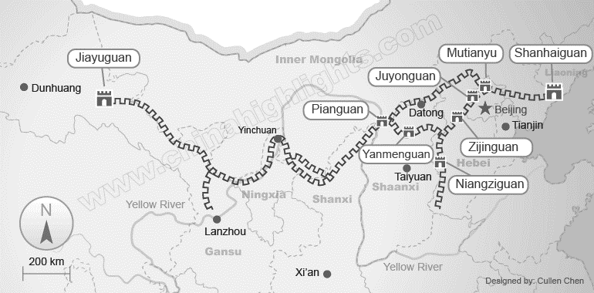

1. Which of the following is the BEST explanation for the Ming Dynasty’s expansion of the great wall, as shown above?
   1. The Great Wall was improved to reinforce Ming China’s ending of the tribute system with its neighbors.
   2. The Great Wall was revitalized as a public works project to employ poor, urban workers.
   3. The Great Wall was rebuilt to prevent another foreign dynasty like the Yuan from gaining power over China.
   4. The Great Wall was renovated to encourage China’s merchants to seek maritime routes for trade and commerce.
2. The Ming Dynasty’s expansion of the Great Wall was ultimately a failure because:
   * 1. Japanese samurai attacked China by crossing the East China Sea.
     2. Vietnamese and Khmer forces were able to invade Ming China from the southwest.
     3. Islamic forces from the Safavid Empire were able to conquer most of western China.
     4. Manchus from the north east invaded and overthrew the Ming Dynasty in the late 17th century.

**World Economic Theory, 1500-1800**

*The world economic system that developed after 1500 featured unequal relationships between western Europe and dependent economies in other regions. Strong governments and large armies fed European dominance of world trade. Dependent economies used slave or serf labor to produce cheap foods and minerals for Europe, and they imported more expensive European items in turn. Dependent regions had weak governments, which made European conquest and slave systems possible.*

1. Which of the following best supports the contentions of the world economic theory in the passage?

(A) China was not massively affected by world patterns in the period.

(B) The rise of Protestantism and the Scientific Revolution transformed European cultures.

(C) Latin America exported sugar and silver and imported manufactured items.

(D) Britain had relatively weak central control compared to France.

39. Which of the following statements would challenge the arguments made in the passage?

(A) Strong governments in the slave-exporting regions of West Africa.

(B) The role of Dutch trading companies in Southeast Asia.

(C) The use of slaves and the plantation system in the Americas.

(D) European imports of sugar and tobacco.

40. Which of the following statements describes a social change in western Europe between 1500 and 1750 C.E.?

(A) the feudal system came to an end

(B) rural women gained significant rights

(C) urban families had a lower fertility rate

(D) There was a mass rural to urban migration for work

**World Silver Trade 1600-1750**

**WORLD SILVER FLOWS, 1600-1650 C.E., METRIC TONS PER YEAR (average)**

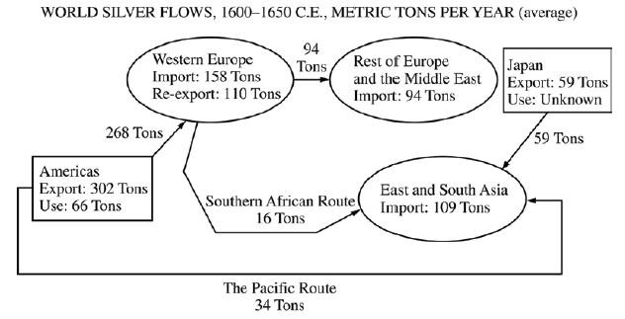

**WORLD SILVER FLOWS, 1725-1750 C.E., METRIC TONS PER YEAR (average)**

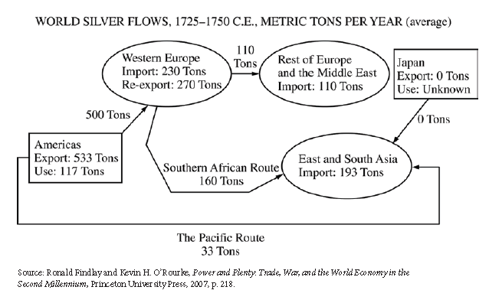

Source: Ronald Findlay and Kevin H. O’Rourke, Power and Plenty: Trade, War, and the World Economy in the Second Millennium, Princeton University Press, 2007, p. 218.

1. Which of the following economic conditions was most important in creating the global trade network illustrated by the two diagrams?
2. American demand for labor and African supply of slaves.
3. Japanese supply of silver and Middle Eastern demand for spices.
4. Western European demand for industrial raw materials and American and South Asian supply of cash crops.
5. Chinese and Indian demand for precious metals and European demand for Asian textiles and luxury goods.
6. Which of the following was an important continuity underlying the trade interactions illustrated by the two diagrams?
7. The resilience of the Chinese economy, despite the dynastic change from Ming to Qing.
8. The industrial and commercial supremacy of Great Britain in western Europe.
9. The widespread acceptance of the principles of free trade by most European and Asian governments.
10. The ongoing expansion of Middle Eastern Muslim empires, such as the Ottoman and the Safavid.

*“In countries where there is a great scarcity of money, all other saleable goods, and even the labor of men, are given for less money than [in countries] where money is abundant. Thus we see by experience that in France (where money is scarcer than in Spain) bread, wine, cloth, and labor, are worth much less. And even in Spain, in [recent] times when money was scarcer than it is now, saleable goods and labor were given for much less.”*

Martín de Azpilcueta Navarro, Spanish scholar, treatise, 1556

43. Navarro’s economic observations expressed in the passage above are best understood in the context of which of the following?

1. The Spanish-Portuguese colonial rivalry in the Atlantic.
2. The influx of silver from the Americas into the Spanish economy.
3. The practice of governments devaluing their currencies by reducing the proportion of precious metals in their coins.
4. The beginning of large-scale importation of silver by China from Spanish mines in the Americas.

**Charter of the Dutch West India Company, 1621**

“We know that the prosperity of the Netherlands and the welfare of their inhabitants depends principally on navigation and trade, and we find by experience that without the common help, assistance, and interposition of a General Company, Dutch merchants cannot be profitably protected and maintained in their great risk from pirates, extortion, and otherwise, which will happen in so very long a voyage. We have found it good that navigation, trade, and commerce in the West Indies and Africa should not henceforth be carried on any otherwise than by the common united strength of the merchants and inhabitants of the Netherlands. And for that end there shall be erected one General Company.

Moreover, we furnish the General Company with a proper charter and with the following privileges and exemptions, namely that for 24 years none of the natives or inhabitants of the Netherlands who are not affiliated with the General Company shall be permitted to sail to the Americas or the West Indies.”

1. The risks mentioned in the first paragraph are best understood in the context of which of the following historical developments?
2. Competition with African states for the profits from the slave trade.
3. Competition with Catholic European states to convert Amerindian peoples.
4. Competition with European states for the profits of global trade.
5. Competition with Asian empires for the profits of the spice trade.
6. The privileges and exemptions mentioned in the second paragraph of the passage are best seen as an example of which of the following?
7. Social Darwinism
8. Feudalism
9. Laissez-faire economics
10. Mercantilism

46. The economic system which developed in **opposition** to the ideas of charters and government involvement was called?

1. Socialism
2. Capitalism
3. Feudalism
4. Mercantilism

47. This drawing, at right, by Jose Mariano of Portugal entitled “Farming in Brazil” best illustrates which of the following changes caused by new patterns of global interaction during the late eighteenth century?

1. The introduction of European agricultural practices that affected the environment through soil depletion.
2. 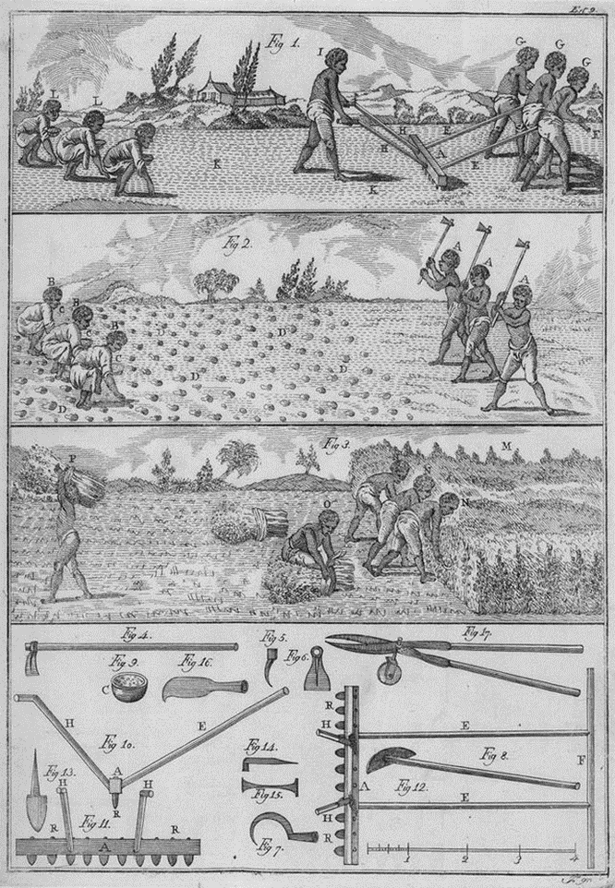Innovations in visual arts made possible by the increased profits obtained from new colonial plantations.
3. An exchange of food crops between continents led to a gradual increase of human population in Afro-Eurasia.
4. Intensification of coerced labor from the export of African slaves to the Mediterranean and Indian Ocean markets.

Key Concept 4.1.V.E Theme 1: Interaction Skills: Interpretation

48. One effect of the encomienda system was that it:

(A) eliminated the use of guilds.

(B) promoted isolationism.

(C) exploited indigenous peoples.

(D) reduced Spanish influence.

**A History of the World in 6 Glasses**

...Shortly before his death in 1605, Pope Clement VIII was asked to state the Catholic Church’s position on coffee. At the time, the drink was a novelty little known in Europe except among botanists and medical men, including those at the University of Padua, a leading center for medical research. Coffee’s religious opponents argued that coffee was evil: They contended that since Muslims were unable to drink wine, the holy drink of Christians, the devil had punished them with coffee instead. A Venetian merchant provided a small sample for inspection, and Clement decided to taste the new drink before making his decision. The story goes that he was so enchanted by its taste and aroma that he approved its consumption by Christians.

Within half a century, this exotic novelty was fast becoming commonplace in parts of Western Europe. Coffeehouses opened in Britain in the 1650s and in Amsterdam and The Hague during the 1660s. As coffee moved west, it took the Arab notion of the coffeehouse as a more respectable, intellectual, and above all nonalcoholic alternative to the tavern along with it... Source: Tom Standage’s A History of the World in 6 Glasses, 2005

1. Which of the following conclusions is best supported by the data in the document?
   1. Muslim countries’ dominance in world trade, especially in the Indian Ocean World, was waning just as some Europeans were becoming more dominant.
   2. The influence of the pope reached beyond church matters and beyond Catholic populations.
   3. The westward movement of coffee and coffeehouses was accompanied by the spread of Islam into the west.
   4. Opponents of the introduction of coffee into the Christian world had both religious as well as economic objections to the new beverage.
2. The views in this document are best seen as evidence of which of the following:
   1. Syncretism of Muslim practices into Western Christian beliefs associated with holy beverages.
   2. Spread of both cultural ideas and trade goods between the Muslim World and Western Christendom.
   3. The Western church’s reliance of the scientific method of trial and error, and the sharing of findings internationally.
   4. The infallibility of the Roman Catholic Pope in all areas, including political, economic, social and religious.

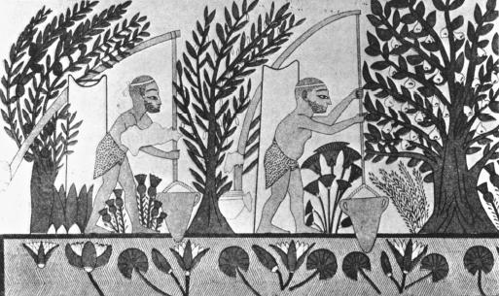

**BLAST FROM THE PAST**

51) The image at left **best** illustrates which of the following?

* + 1. Ancient Egyptian societies lived in small groups that structured social, economic, and political activity.
    2. Pastoralism and agriculture led to more abundant food supplies in ancient Egyptian societies.
    3. Humans developed increasingly diverse and sophisticated tools as they adapted to new environments.
    4. As a response to climate change, permanent agricultural villages emerged first in the lands of Mesopotamia.  
       KC: 1.1.A, T/LO: ENV-2; S: Causation

52) A historian researching Egyptian irrigation systems around 2000 B.C.E. would most likely find the document useful as a source of information for which of the following?

1. Technological innovations led to major improvements in agricultural production
2. Trade routes between Egypt and Mesopotamia
3. The role of military in early civilizations
4. New religious beliefs that developed including Hebrew monotheism

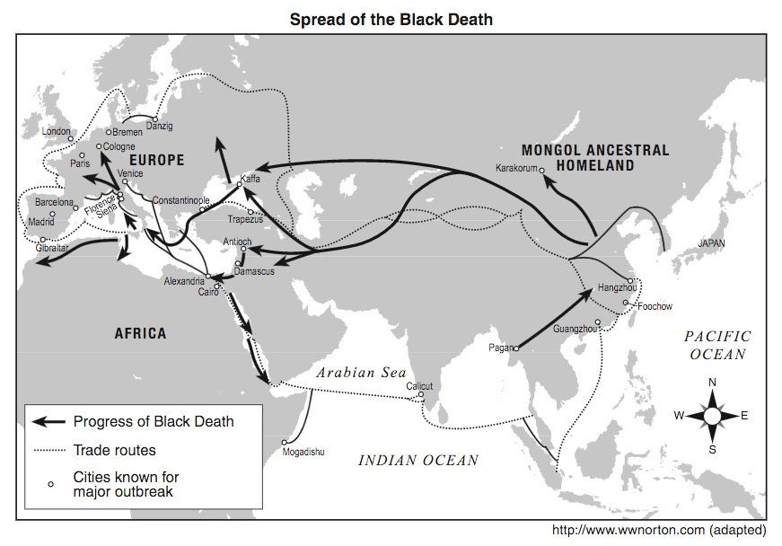

1. This map is best understood in the context of which of the following period 3 key concepts?
2. The growth of urban areas that was caused by the expansion of trade routes.
3. The decline of urban areas following invasions and falling agricultural productivity
4. Technological and cultural transfers that were caused by the expansion of trade routes.
5. The diffusion of crops and epidemic diseases caused by the expansion of trade routes.
6. The “progress of the Black Death” shown on this map could be used as evidence to support which of the following claims?
7. The Middle East was the site of the first outbreak of the disease because of the Crusades
8. Eastern Europe had the first outbreak and the disease spread to Western Europe
9. Starting in East Asia, the Black Death spread via the silk routes to the west.
10. African deaths were not as numerous as those in Eurasia
11. Which is the BEST description of the effects of the Black Death on Europe?
12. One-third of the population died, creating economic and social problems for feudal kingdoms.
13. Physicians rapidly developed a cure for the disease, launching a medical revolution.
14. Seeking help, Europeans voluntarily joined the Mongol Empire which became stronger
15. Fearful of the outside world, Europe lost interest in all trade and exploration opportunities.