Not All Restaking Risk Is Independent:
Measuring Correlated Slashing Exposure Through
Shared Operator Structure in Ethereum Restaking

Abstract: Ethereum restaking allows a single pool of staked capital to secure many independent services at once, with each service holding the power to slash that capital under its own rules. Restakers, liquid restaking protocols, and institutional allocators currently assess this exposure one service at a time and add the resulting risks together. That practice is valid only if service failures are statistically independent. They are not. Almost no restaker runs infrastructure directly; capital is delegated to a small set of professional node operators, and the same operators run many services at once, so one misconfiguration, key compromise, or bad upgrade triggers simultaneous penalties across every service that operator supports. We model the restaking ecosystem as a stake-weighted bipartite graph between operators and services, and we prove that under a uniform operator failure hazard the correlation between two services’ slashing losses reduces exactly to the cosine similarity of their operator stake vectors, normalised by their Herfindahl concentration. This quantity is free of the operator failure probability, which matters because no large slashing event has yet occurred and that probability cannot be estimated from history. We define a correlated exposure ratio $Λ$ and an effective number of independent services $k_{\text{eff}}$, and evaluate both on a synthetic operator network calibrated to published ecosystem statistics for twenty live services. There, mean pairwise stake-weighted correlation is $0.84$ while mean unweighted set overlap is only $0.15$, so the dependency is invisible to membership counting. A five-service allocation across the largest services carries $Λ=2.03$, understating loss dispersion by $103$ percent, and delivers $k_{\text{eff}}=1.21$ rather than the five independent bets it appears to be. No choice among all 15,504 five-service allocations exceeds $k_{\text{eff}}=1.42$, and conditional value at risk at $99$ percent is understated by a factor of $2.25$. We give a data pipeline for computing these quantities from public chain state, a deployable risk score, and an explicit account of what the model cannot yet establish.
Index Terms: restaking, EigenLayer, slashing, correlated risk, systemic risk, blockchain, proof of stake, operator concentration, shared security

I. Introduction
Proof of stake secures a blockchain by requiring participants to post capital that can be destroyed if they misbehave. Ethereum has run on this basis since 2022, and over 30 million ETH is currently staked [21]. Restaking, introduced by EigenLayer [1], extends the idea: capital already staked on Ethereum can be committed a second time to secure additional services, referred to as actively validated services (AVSs). Each AVS defines its own conditions under which it may slash that capital. The restaker earns additional yield, and the AVS obtains economic security without having to bootstrap a validator set of its own. Reported total value locked in EigenLayer has ranged between roughly $5 billion and $9 billion during 2026, with a peak above $15 billion earlier in the year [17], [18], [21], and more than twenty AVSs are live.
The question a restaker faces is which combination of services to back. The method used in practice is to look up each service’s slashing conditions, form a view on how likely each is to fire, and add the resulting expected losses. Industry risk guides and protocol documentation are organised around this per-service framing [16], [22], [23]. The framing carries an assumption that is rarely made explicit: that a slashing event at one service tells you nothing about the probability of a slashing event at another. If that assumption fails, then adding risks together is not conservative, it is wrong in the direction of understatement, and the error compounds with the number of services chosen.
The assumption fails for a structural reason. Restakers do not run validator infrastructure. They delegate to professional node operators, and an operator registers to many operator sets at once, running the client software for each AVS it serves. Two AVSs that appear to be unrelated businesses, a data availability layer and a cross-chain oracle, may be executed by substantially the same machines under the same operational team. A compromised signing key, a failed upgrade, or a cloud region outage at that operator produces simultaneous faults at every AVS it serves. The AVSs then slash the same underlying capital in the same block interval. The events are not independent; they share a cause.
An analogy clarifies the error. Holding shares in five airlines looks like diversification, but a single move in the fuel price damages all five together; holding one airline and one pharmaceutical company is diversification in the sense that matters. Shared operators play the role the fuel price plays for the airlines. The difference is that in restaking the common cause is not hidden inside private balance sheets: operator registrations and stake allocations are recorded on a public ledger. The dependency is measurable today, and to our knowledge nobody has measured it.

A. Contributions
This paper makes five contributions.
- A formal model of the failure channel. We represent the ecosystem as a stake-weighted bipartite graph between operators and AVSs, and we write the restaker’s loss as a function of operator-level rather than service-level events (Section IV).
- An identity for the loss correlation. We prove that when operator failures are independent and share a common hazard rate, the correlation between two AVSs’ slashing losses equals the cosine similarity of their operator stake weight vectors divided by the geometric mean of their Herfindahl indices (Proposition 2). It does not depend on the hazard rate, so no historical slashing data is needed.
- Two portfolio-level measures. The correlated exposure ratio $Λ$, the factor by which the additive method understates the standard deviation of loss, and the effective number of independent services $k_{\text{eff}}=k/Λ^{2}$ (Section V).
- A measurement pipeline and evaluation. We specify how to recover the required state from public sources and evaluate the estimators on a synthetic operator network calibrated to published statistics for twenty named live services (Sections VI and VII).
- A deployable score and a limitations account. We map $k_{\text{eff}}$ to a bounded score for use by liquid restaking protocols and institutional allocators, and state plainly which claims the model can and cannot support (Sections VIII and X).

B. Scope and honesty about status
This is a measurement and modelling paper, not an empirical study of realised losses. No large slashing event has occurred across restaking protocols to date, so there is no loss history against which to validate a calibrated hazard model, and we do not claim one. The network used in Section VII is synthetic and calibrated to published aggregate statistics. It demonstrates the behaviour of the estimators and the size of the error the additive method makes under realistic structure, and it is not a report of measured values for the live system.

II. Background

A. Staking, slashing, and restaking
An Ethereum validator posts 32 ETH and earns issuance for attesting to blocks. Provable misbehaviour, such as signing two conflicting blocks, causes part of that deposit to be burned. This penalty, called slashing, converts a cryptographic claim into an economic one. New services needing Byzantine fault tolerant guarantees face a bootstrapping problem, since assembling an independent validator set with enough capital at risk is slow and expensive. Restaking resolves it by letting capital already at risk on Ethereum serve as collateral for additional services: the restaker opts in, accepts the new service’s slashing conditions, and receives additional reward, while the service receives economic security on day one.

B. The three roles
Three roles matter for what follows.
Restakers supply capital. They may hold native staked ETH or a liquid staking token. On EigenLayer a restaker delegates to exactly one operator at a time, which is an important constraint: the individual restaker does not choose a portfolio of AVSs directly. The operator does, on their behalf.
Operators run the software. An operator accepts delegated stake, registers to operator sets belonging to one or more AVSs, and allocates a magnitude of the delegated stake to each set. Under the allocation model introduced with slashing, an AVS may slash only the unique stake allocated to its own operator set, up to that allocation [2]. A slash burns the affected shares to a designated address, or, for redistributable operator sets holding ERC-20 collateral, transfers them to a recipient nominated by the AVS [3]. A resolution delay of seven days applies before slashed shares clear.
Liquid restaking protocols (LRTs) sit above both. They accept deposits from ordinary users, issue a receipt token, and spread the pooled capital across many operators. Ether.fi (eETH), Renzo (ezETH), Puffer (pufETH), and Kelp (rsETH) are the largest [21]. It is at this layer that the portfolio question is posed most sharply, because an LRT genuinely does choose a multi-service, multi-operator allocation on behalf of depositors who never see it. Ether.fi alone has been reported at 65.4 percent of the liquid restaking token market [9] and at one point held over half of all restaked ETH [15].

C. Ecosystem participants
Table I lists the protocols and services the model describes, with the figures we were able to source. Two points deserve emphasis. First, reported values disagree across sources by wide margins, which is itself a finding about the state of measurement in this sector: EigenLayer TVL is given as roughly $5.0 billion by one 2026 survey [18] and roughly $8.9 billion by another [17], so we report the range. Second, the operator and service counts are the inputs a shared-operator analysis needs, and they are not published in a form permitting the pairwise analysis this paper requires. That gap motivates Section VI.
TABLE I. Restaking protocols and named services. Figures are as reported by the cited sources during 2026 and disagree between sources where a range is shown. Operator-set sizes are drawn from a published uptime leaderboard and are used as calibration targets in Section VII.
Layer | Participant | Scale | Operators | Status and notes
Restaking protocol | EigenLayer / EigenCloud | $5.0B to $8.9B TVL | 1,247 to 1,900+ | Slashing live Apr. 2025; redistribution live Jul. 2025 [3], [17]–[19]
 | Symbiotic | $0.33B to $1.6B TVL | 78 | Slashing live at launch Jan. 2025; 50+ integrated networks [17], [18]
 | Babylon | $3.3B to $4B in BTC | 250+ | Finality-provider slashing, Bitcoin enforced [17], [18]
 | Karak | $6.6M to $740M TVL | not disclosed | Declined sharply from its 2024 peak; effectively exited restaking [17], [18]
Actively validated service | EigenDA | data availability | 300 | Largest operator set; 99.999% reported uptime [19]
 | Espresso Sequencer | shared sequencing | 285 | Second largest operator set [19]
 | Lagrange | zero-knowledge proving | 270 | [19], [20]
 | Witness Chain | light client verification | 255 | [19], [20]
 | eOracle | oracle network | 240 | [19], [20]
 | AltLayer MACH, Brevis, | rollup, proving, | 195, 150, | Remaining named services used in the calibration of
 | Automata, Infura DIN | attestation, RPC | 140, 130 | Section VII; over 20 AVSs live as of mid-2026 [19]–[21]
Liquid restaking | Ether.fi (eETH) | 65.4% of LRT market | 20 nodes | Largest allocator; held over 50% of restaked ETH at one point [9], [15]
 | Renzo (ezETH) | multi-chain | pooled | About 30% of supply bridged; econometric study in [9]
 | Puffer (pufETH) | anti-slashing design | pooled | Third largest issuer by reported supply [21]
 | Kelp (rsETH) | multi-asset | pooled | $292M bridge exploit reported Apr. 2026 [18]
Node operator | P2P.org, Figment, | professional | serve many | Among the operators reported fully enrolled across the
 | Luganodes, Stakin | staking providers | AVSs each | available AVS set [15], [19]

D. Why the additive method persists
The additive method is not the product of carelessness. It requires only per-service information, which is what protocol documentation publishes; it composes trivially, so a new service can be assessed without revisiting existing positions; and it never nets exposures against each other. What it does not do is account for a common cause. Adding independent risks is a valid operation; the failure is in the independence premise, not the addition.

III. Related Work

A. Theory of restaking security
A theoretical literature on restaking security has developed since 2024. Durvasula and Roughgarden [4] study cascading failure, defining robustness through the relationship between attack cost and profit, and show that when attack costs exceed profits by 10 percent a 0.1 percent stake loss cannot cascade beyond 1.1 percent. Chitra and Pai [5] add incentives and strategic operators, finding that submodular attacker profit with incentive-responsive operators avoids those large cascades. Chitra, Penna, and Schneider [6] prove that no slashing mechanism prevents both of the Sybil attack classes they identify, and show that topology governs the outcome: Erdős-Rényi graphs remain Sybil-proof while slight heterogeneity in a two-block stochastic block model makes Sybil attacks profitable. Nag et al. [7] compare architectures for a service secured by several providers at once, and Mamageishvili and Sudakov [8] bound the capital saving of restaking against separate proof of stake protocols.
This body of work is adversarial: it asks what a rational attacker can extract and what stake conditions prevent it. The present paper asks a different question. We are concerned with non-adversarial correlated failure, the case where an operator has no strategy at all but simply breaks, and with the consequences for an allocator sizing a position today. Topology drives both questions, which is why the finding of [6] that heterogeneity changes the security conclusion supports the argument here that stake-weighted structure, and not membership counting, is the object to measure.

B. Empirical work on restaking
Empirical study is thinner. Sevim and Torres [9] give the closest work, an econometric analysis of Renzo revenue together with an assessment of interconnected risk from bridging liquid restaking tokens across chains. They report that a 1 percent rise in EigenLayer TVL is associated with a 0.98 percent rise in Renzo revenue, and they identify concentration in the LRT layer as a single point of failure, with Ether.fi at 65.4 percent of the market. Their risk channel is bridge and liquidity contagion. Ours is the operator registration graph beneath the AVSs, which their analysis does not address. Symbiotic has published a modelling note on cascading slashing across restaked networks [14], which shares our concern but is protocol specific and not framed as an estimator.

C. Correlated risk outside blockchain
Treating correlation as the object of measurement rather than a nuisance is standard in portfolio theory following Markowitz [10], whose central point is that portfolio variance depends on the covariance matrix rather than on individual variances alone. The quantities in Section V are the restaking analogues. We take conditional value at risk from Rockafellar and Uryasev [11], since expected loss alone does not capture what an allocator cares about in a shared-operator failure, and the concentration index from Hirschman [12]. The setting differs from finance in one respect that favours the analyst: the dependency structure is read directly from chain state rather than inferred from a return history, so the covariance matrix is observed rather than estimated.

D. Position of this work
Table II places the contribution. Prior work either models adversarial cascades without a measurement instrument, or measures ecosystem quantities without pairwise structure. Neither line produces a number an allocator can put on a specific combination of services.
TABLE II. Position of this work relative to prior literature.
Work | Pairwise | Stake | Failure
 | structure | weighted | model
Durvasula & Roughgarden [4] | yes | yes | adversarial
Chitra & Pai [5] | yes | yes | adversarial
Chitra et al. [6] | yes | yes | adversarial
Nag et al. [7] | partial | yes | adversarial
Mamageishvili & Sudakov [8] | yes | yes | adversarial
Sevim & Torres [9] | no | yes | empirical, bridge
Industry guides [16], [22], [23] | no | no | qualitative
This work | yes | yes | non-adversarial

IV. Model

A. The registration graph
Let $O=\{o_{1},…,o_{n}\}$ be the set of operators and $A=\{a_{1},…,a_{m}\}$ the set of AVSs. Define the allocation matrix $S∈R_{≥0}^{n×m}$, where $S_{oa}$ is the unique stake operator $o$ has allocated to the operator set of AVS $a$, in units of ETH. An entry is zero when the operator is not registered to that AVS, so $S$ is the weighted biadjacency matrix of a bipartite graph. Figure 1 shows the structure on a three-service example.
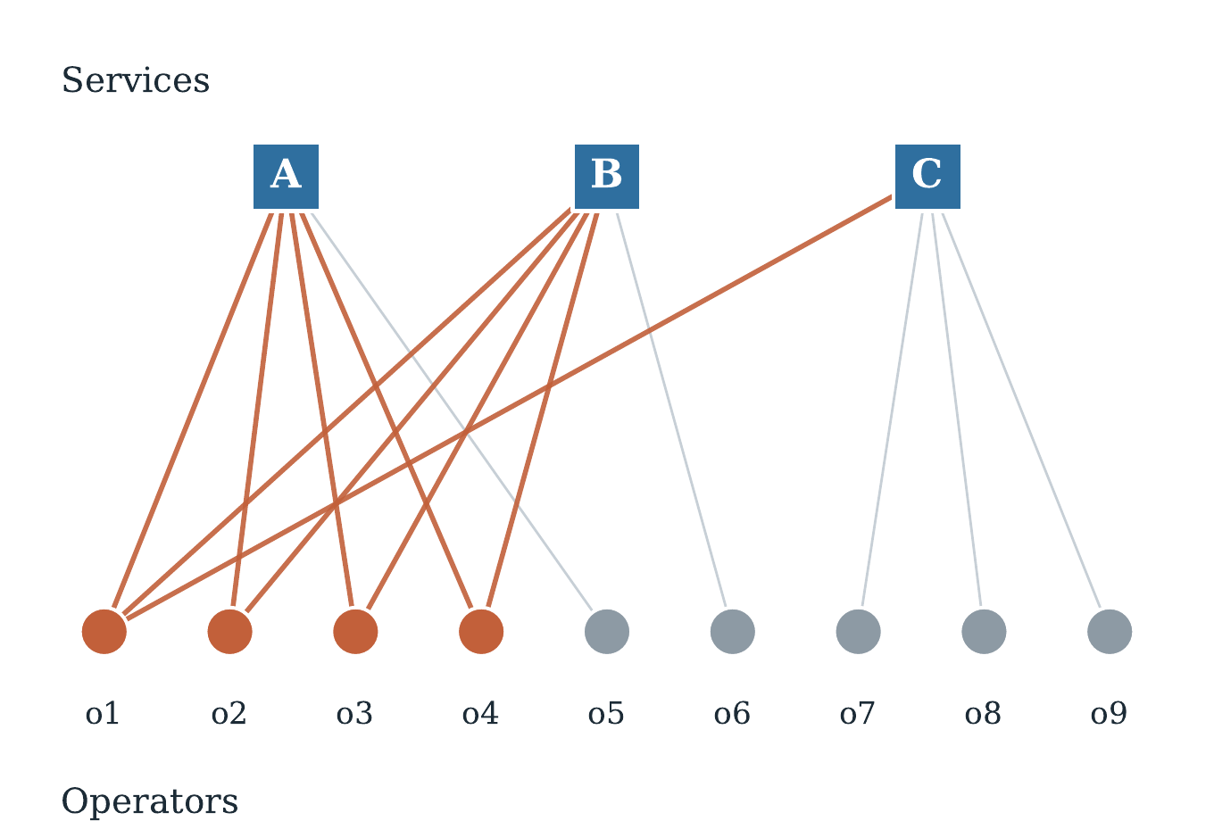
Fig. 1. The registration graph. Services $A$ and $B$ share four of five operators, so they fail together. Service $C$ shares only one. Under the additive method the pair $\{A,B\}$ and the pair $\{A,C\}$ carry the same risk. They do not.
Write Sa=o​Soa for the total stake backing AVS $a$, and define the operator weight
woa=SoaSa, o∈O​woa=1.
The concentration of AVS $a$ is its Herfindahl index
Ha=o∈O​woa2,
with $1/H_{a}$ interpretable as the effective number of operators backing $a$. A service with 300 registered operators but $H_{a}=0.076$ is backed, for risk purposes, by about 13 of them.

B. The failure process
The additive method treats the AVS as the unit of failure. We treat the operator as the unit of failure, which is where faults actually originate.
Let operator $o$ suffer a fault in a given period with probability $q_{o}$, independently across operators. A fault is any event causing the operator’s nodes to produce slashable behaviour: a compromised signing key, an unsafely upgraded client, a double-signing bug, an infrastructure outage triggering liveness penalties, or an operational error. We do not decompose $q_{o}$ further, and Corollary 1 shows the central quantity does not require it.
When operator $o$ faults, every AVS to which $o$ is registered observes the fault and slashes $o$’s allocation to its own operator set. Let $β_{a}∈(0,1]$ be the slashable fraction that AVS $a$ applies. Consider an allocator holding capital $x_{a}$ against AVS $a$, distributed across operators in proportion to that AVS’s weights, so that the allocator has $x_{a}w_{oa}$ sitting with operator $o$ within AVS $a$. The realised loss is
L=o∈O​1{o faults}a∈A​βa xa woa.
Note the order of summation. The indicator sits outside the sum over services, which is precisely the dependency the additive method drops.

C. The additive counterfactual
The additive method computes instead
L=a∈A​βa xao∈O​1{o faults for a} woa,
where the fault indicators are drawn independently for each pair $\left(o,a\right)$. Equations (3) and (4) have the same expectation. They differ in every higher moment, and it is the higher moments that determine capital adequacy.
Proposition 1 (Means agree, variances do not).
$E\left[L\right]=E\left[\tilde{L}\right]$, and $Var\left(L\right)≥Var\left(\tilde{L}\right)$, with equality if and only if no operator is registered to more than one AVS carrying positive allocator capital.
Proof. Linearity of expectation gives the first claim immediately, since both expressions reduce to a​βaxao​qowoa. For the second, write L=o​Zouo with $Z_{o}=1\{o\text{ faults}\}$ and uo=a​βaxawoa. Independence across operators gives VarL=o​qo1-qouo2, whereas the additive construction yields VarL=o​qo1-qoa​βaxawoa2. Since uo2=a​βaxawoa2≥a​βaxawoa2 for non-negative terms, with equality exactly when at most one term in the inner sum is non-zero, the claim follows. □
Proposition 1 states the failure in its sharpest form. The additive method is not merely imprecise. It is biased in a known direction, and the bias is zero only in the case that never occurs in practice, namely that every operator serves at most one of the services held.

V. Correlated Exposure Metrics

A. Shared-operator correlation
Proposition 2 (Loss correlation identity).
Suppose $q_{o}=q$ for all operators. Then for any two AVSs $a≠b$ the correlation between their slashing losses is
ρab=o∈O​woawobHaHb,
independent of $q$, of the slashable fractions $β_{a},β_{b}$, and of the capital amounts $x_{a},x_{b}$.
Proof. Let La=βaxao​Zowoa be the loss attributable to AVS $a$ under (3). With $Z_{o}$ independent Bernoulli($q$),
CovLa,Lb=βaβbxaxb q1-qo​woawob,VarLa=βa2xa2 q1-qo​woa2=βa2xa2 q1-qHa.
Forming the correlation, every factor of $β$, $x$, and $q\left(1-q\right)$ cancels, leaving (5). □
Equation (5) is the cosine similarity of the two operator weight vectors. It is worth stating what it is not. It is not the Jaccard index of the two operator sets, which counts membership and treats a 0.1 percent operator the same as a 30 percent one. Section VII shows the two diverge severely.
Corollary 1 (Structural robustness).
$ρ_{ab}$ is computable from chain state alone. It requires no estimate of operator failure probability and no slashing history.
This corollary is the reason the approach is viable now. The obvious objection to any restaking risk model is that no large slashing event has occurred, so the hazard rate is unknown. Corollary 1 shows the correlation structure is separable from the hazard: the unknown quantity scales the whole loss distribution, but the shape of the dependency is fixed by observable allocations. Section VII confirms numerically that $Λ$ is flat in $q$ across two orders of magnitude.
Proposition 3 (Bounds and the concentration floor).
$0≤ρ_{ab}≤1$, with $ρ_{ab}=1$ if and only if $w_{⋅a}$ and $w_{⋅b}$ are proportional. Further, if a single operator $o^{*}$ holds weight $w_{o^{*}a}$ in $a$ and $w_{o^{*}b}$ in $b$, then
$$ρ_{ab} ≥ \frac{w_{o^{*}a} w_{o^{*}b}}{\sqrt{H_{a}H_{b}}}.$$
Proof. The upper bound and its equality condition are Cauchy-Schwarz applied to $⟨w_{⋅a},w_{⋅b}⟩≤∥w_{⋅a}∥∥w_{⋅b}∥=\sqrt{H_{a}H_{b}}$. Non-negativity holds because all weights are non-negative. The floor follows by dropping all other non-negative terms from the numerator. □
Proposition 3 explains why concentration and correlation cannot be treated as separate concerns. One operator large in two services forces the correlation up on its own, regardless of how many small operators are added alongside. Recruiting a long tail of minor operators improves the membership count without improving $ρ$.

B. Correlated exposure ratio
Definition 1 (Correlated exposure ratio). For an allocation $x$ over a set $P⊆A$ of $k$ services, let $σ_{a}=β_{a}x_{a}\sqrt{H_{a}}$ and let $R$ be the matrix with entries $ρ_{ab}$. The correlated exposure ratio is
ΛP,x=σ⊤R σa∈P​σa2 ≥ 1.
$Λ$ is the factor by which the additive method understates the standard deviation of loss. It equals 1 exactly when the services share no operators and grows without bound as the allocation concentrates on a common operator base. For the equally weighted case with equal $β$ and mean pairwise correlation $\overset{‾}{ρ}$, (9) collapses to the familiar form
$$Λ=\sqrt{1+\left(k-1\right)\overset{‾}{ρ}},$$
which is convenient for reasoning about magnitudes: at $\overset{‾}{ρ}=0.8$, five services give $Λ≈2.05$, so the additive method reports about half the true dispersion.

C. Effective number of independent services
Definition 2 (Effective independence).
keffP,x=kΛP,x2 = ka​σa2σ⊤Rσ.
$k_{\text{eff}}$ answers the allocator’s question in the allocator’s units. An allocation across $k$ services with $k_{\text{eff}}=1.2$ carries the risk profile of roughly 1.2 independent bets, not $k$ of them, and it is bounded between 1 and $k$. The gap between $k$ and $k_{\text{eff}}$ is the diversification the allocator believes they have but does not.

D. Tail risk
Variance is not the whole story, since the loss distribution under (3) is a mixture dominated by rare events in which one large shared operator faults. We therefore also report value at risk and conditional value at risk [11],
$${\text{CVaR}}_{α}\left(L\right)=E​\left[L | L≥{\text{VaR}}_{α}\left(L\right)\right],$$
estimated by Monte Carlo over the operator fault vector. The ratio of ${\text{CVaR}}_{α}$ under (3) to ${\text{CVaR}}_{α}$ under (4) is the tail analogue of $Λ$ and, as Section VII shows, is larger.

E. Operator attribution
Because VarL=o​qo1-qouo2 with uo=a​βaxawoa, the variance decomposes exactly across operators. Under a common $q$ the share attributable to operator $o$ is
ϕo=uo2o'​uo'2.
This gives an allocator a ranked list of the specific counterparties driving their exposure, which is directly actionable in a way that a single risk number is not. The quadratic form means an operator’s share of risk grows as the square of its share of capital, so a counterparty holding 19 percent of an allocation can account for more than half of its variance.

VI. Measurement Methodology
The estimators require only $S$, the allocation matrix. This section specifies how to recover it.

A. Data sources
Table III lists the required state and where it is published. Registration and allocation are contract state on Ethereum mainnet and are retrievable in full. All sources are free.
TABLE III. State required to construct the allocation matrix $S$.
Quantity | Source | Method
Operator set membership | AllocationManager events | Log replay from deployment block
Allocated magnitude per set | AllocationManager state | Direct contract read at block height
Delegated shares per operator | DelegationManager | Direct contract read
Strategy to asset mapping | StrategyManager | Direct contract read
Max magnitude after prior slashes | AllocationManager | Needed to convert magnitude to ETH
AVS identity and metadata | AVS registry, off-chain labels | Manual labelling of contract addresses
LRT operator allocations | LRT protocol contracts | Per protocol, for the LRT-level analysis

B. Pipeline
The pipeline has four stages.
Stage 1: reconstruct the graph. Replay allocation and deregistration events from the slashing release block to a chosen height, and read current state to resolve magnitudes into ETH-denominated allocations. Because magnitude is expressed relative to a maximum that itself falls after a slash, this conversion must use the max magnitude prevailing at that height and cannot be approximated by delegated shares alone.
Stage 2: compute structure. Form $w_{oa}$, $H_{a}$, and $R$ by (2) and (5). This is one normalisation and one Gram product, costing $O\left(nm+m^{2}n\right)$ and running in under a second at present ecosystem size. Report $R$ alongside the unweighted Jaccard matrix so the difference between membership overlap and stake overlap is visible.
Stage 3: simulate. Draw operator fault vectors and evaluate (3) and (4). Report $Λ$, $k_{\text{eff}}$, ${\text{VaR}}_{α}$, ${\text{CVaR}}_{α}$, and the attribution (13). Sweep $q$ widely and confirm $Λ$ is flat, which checks that Corollary 1 holds in the implementation.
Stage 4: score and serve. Map $k_{\text{eff}}$ to the bounded score of Section VIII and expose it through an interface described there.

C. Repeating over time
The graph moves as operators register, deregister, and reallocate, so a single snapshot is a point estimate of a moving object. The pipeline should be run at a series of block heights, weekly for instance, so the trend in $\overset{‾}{ρ}$ and $k_{\text{eff}}$ can be reported. A trend is more useful than a level: an ecosystem whose $k_{\text{eff}}$ falls as it grows is concentrating even while it appears to be diversifying.

VII. Evaluation

A. Calibrated network
We evaluate the estimators on a synthetic network built to match published ecosystem statistics. It has $n=1,247$ operators, matching the reported operator count [19], and $m=20$ AVSs, matching the reported count of live services [21]. Operator-set sizes for the ten largest services are taken directly from the published uptime leaderboard [19], running from 300 for EigenDA down to 165 for Hyperlane, with the remaining ten services scaled down to 60. Operator delegated stake follows a Zipf distribution with exponent 1.05, which reproduces the reported pattern of heavy concentration in a small number of large providers [9], [15]: the largest operator holds 15.2 percent of stake, the top ten hold 42.6 percent, and the top fifty hold 63.0 percent.
Recruitment is preferential attachment with exponent 0.75 on operator stake, sampled without replacement, encoding the mechanism that generates overlap in reality: AVSs want operators with capital and operational maturity, and the same firms satisfy both criteria for every AVS. Allocation magnitudes are drawn Beta(2,3) and capped at the protocol maximum. This network is a calibrated construction, not a measurement of the live system; its purpose is to show how the estimators behave and how large the additive error is under structure of the kind the sources describe.

B. Overlap is invisible to membership counting
Figure 2 gives the headline structural result. The mean pairwise stake-weighted correlation across the 190 service pairs is $\overset{‾}{ρ}=0.844$, ranging from 0.496 to 0.987. The mean unweighted Jaccard index over the same pairs is 0.148. The two distributions do not overlap at all. An analyst counting shared operator addresses would conclude that services share about 15 percent of their operator base and are largely distinct. Weighting by stake shows the same services are 84 percent correlated, because the operators that matter are shared even when most of the operators are not. This is the practical case for Proposition 2 over any set-based overlap measure.
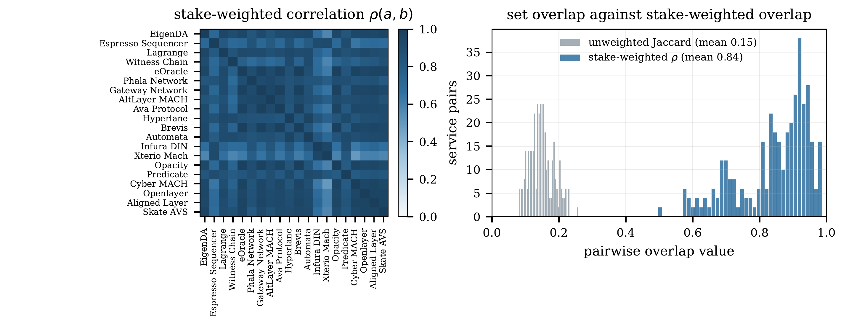
Fig. 2. Left: the stake-weighted correlation matrix $ρ_{ab}$ over 20 calibrated services. Right: the same 190 pairs measured two ways. Unweighted set overlap (grey) puts every pair below 0.25; stake-weighted correlation (blue) puts almost every pair above 0.6.
Figure 3 shows why. The left panel contrasts registered operator count against the effective count $1/H_{a}$. EigenDA has 300 registered operators and an effective count of 13.2; the smallest calibrated services have effective counts near 5. The median ratio of registered to effective operators exceeds 15, so more than 90 percent of the operators registered to a typical service contribute negligibly to its risk. The right panel shows the stake curve that produces this.
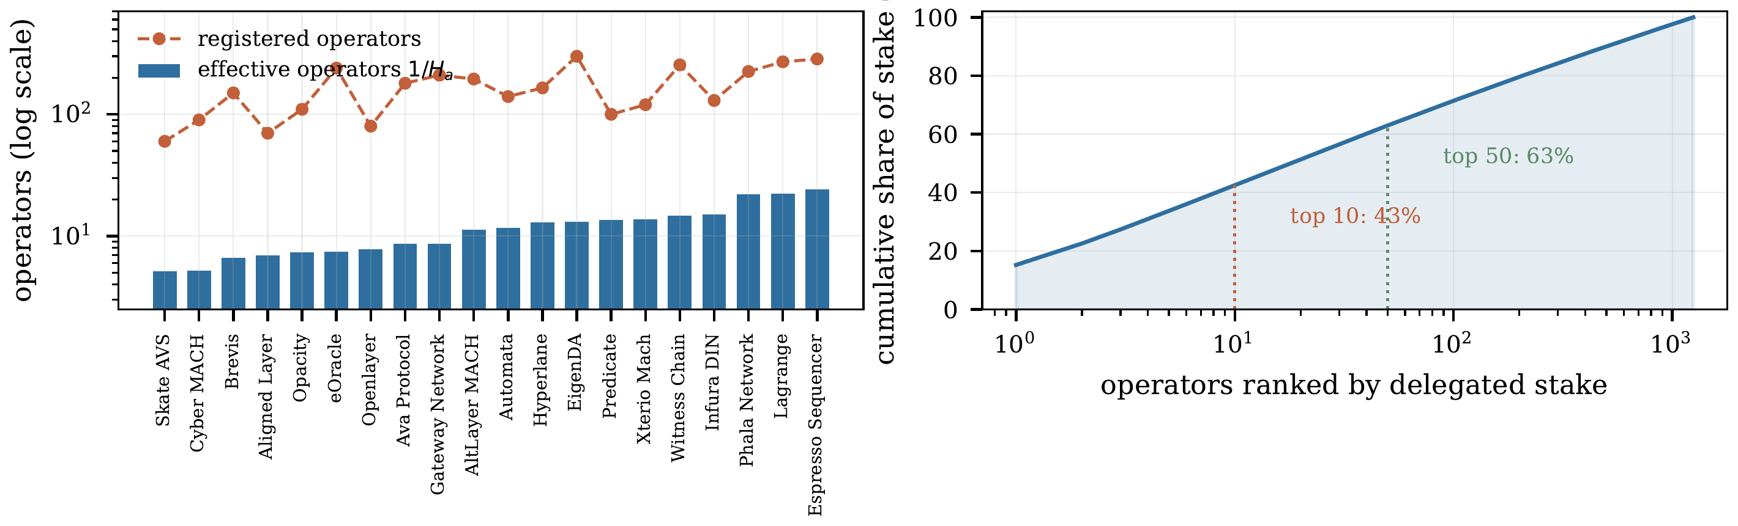
Fig. 3. Left: registered operators against the effective number $1/H_{a}$ per service, log scale. Right: cumulative share of delegated stake by operator rank.

C. The size of the error
Table IV reports the two allocations we examine. Allocation A places equal capital across the five largest services by operator-set size, which is the natural choice for an LRT seeking established services. Allocation B is the result of an exhaustive search over all $\left({20 \atop 5}\right)=15,504$ five-service combinations for the minimum $Λ$, which selects Espresso Sequencer, Witness Chain, Phala Network, Xterio Mach and Cyber MACH.
TABLE IV. Five-service allocations, equally weighted. Allocation B is the minimum-$Λ$ combination found by exhaustive search over all 15,504 possibilities.
Quantity | A: largest five | B: best of 15,504
Mean pairwise $ρ$ | 0.825 | 0.727
$$Λ$$ | 2.033 | 1.877
$$k_{\text{eff}}$$ | 1.210 | 1.419
Dispersion understated by | 103% | 88%
${\text{VaR}}_{99}$ ratio | 2.378 | 1.801
${\text{CVaR}}_{99}$ ratio | 2.249 | 1.794
Allocation A gives $Λ=2.033$. The additive method understates the standard deviation of annual loss by 103 percent. In the allocator’s units, $k_{\text{eff}}=1.21$: spreading capital across the five largest services buys the equivalent of 1.21 independent positions, not five. The distribution of $Λ$ over all 15,504 combinations has mean 2.058 and range $\left[1.877,2.214\right]$, so the choice of services moves the answer by less than 18 percent from worst to best. The best achievable $k_{\text{eff}}$ is 1.419 and the worst is 1.020. There is no five-service allocation on this network that buys meaningful diversification, which is the more uncomfortable finding: the problem cannot be solved by choosing services more carefully, because the dependency lives one layer below the service choice.
Figure 4 shows how the error scales with the number of services. The measured $Λ$ curve tracks the closed form (10) at $\overset{‾}{ρ}≈0.8$ closely, which is a consistency check on the implementation. The right panel is the same information in the allocator’s units: $k_{\text{eff}}$ is essentially flat near 1.2 as $k$ rises from 2 to 12, while the additive model believes diversification is growing linearly. Adding services to this allocation adds exposure without adding independence.
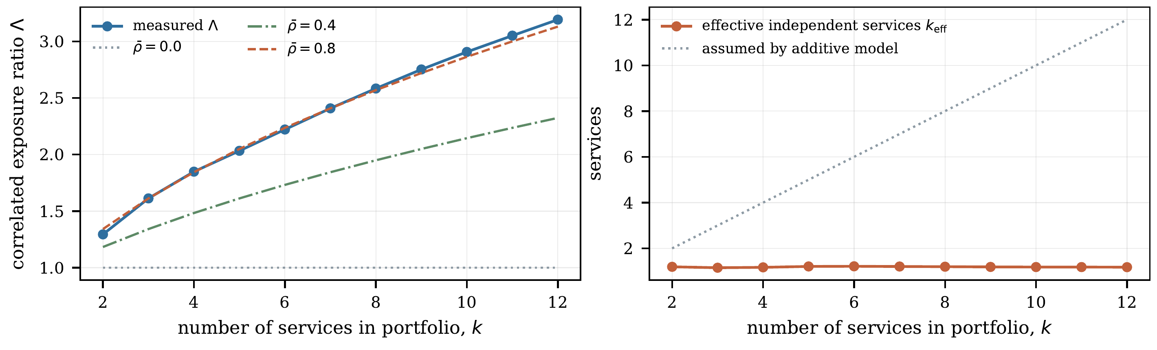
Fig. 4. Left: correlated exposure ratio against portfolio size, with the closed form $\sqrt{1+\left(k-1\right)\overset{‾}{ρ}}$ at three values of $\overset{‾}{ρ}$. Right: effective number of independent services. The additive model assumes the dotted line; the measured value is flat near 1.2.

D. Tail behaviour
Figure 5 shows the simulated annual loss distribution for allocation A over 200,000 draws, with $β=0.10$ and $q=0.02$. The additive distribution is unimodal and thin tailed. The operator-conditioned distribution has a distinct secondary mode near 1.9 percent of stake at risk, which is the event in which the single largest shared operator faults and all five services slash at once. This mode has no counterpart under the additive model at any confidence level, and it is the scenario an allocator most needs to size for.
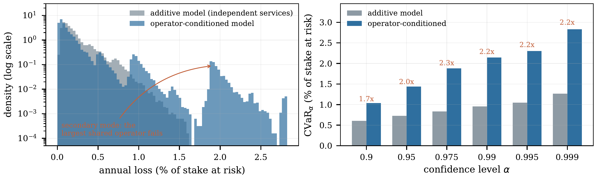
Fig. 5. Left: simulated annual loss for allocation A, 200,000 draws, log density. The secondary mode is the simultaneous slash caused by one operator. Right: conditional value at risk at six levels, with model ratios annotated.
Table V gives conditional value at risk at six levels. The understatement is 1.72 times at the 90 percent level and rises to 2.25 times at 99 percent, then holds near that level further into the tail. The tail understatement exceeds the variance understatement, which is the expected consequence of a mixture with a rare high-severity component.
TABLE V. Conditional value at risk for allocation A, as a percentage of stake at risk, over 200,000 Monte Carlo draws.
$$α$$ | Additive | Operator-conditioned | Ratio
0.90 | 0.605 | 1.038 | 1.72
0.95 | 0.726 | 1.440 | 1.98
0.975 | 0.832 | 1.880 | 2.26
0.99 | 0.954 | 2.145 | 2.25
0.995 | 1.050 | 2.305 | 2.20
0.999 | 1.265 | 2.830 | 2.24

E. Where the risk sits
The operator attribution (13) localises the exposure sharply. Allocation A touches 758 distinct operators, but the effective number of operators bearing its risk is 16.8. The single largest counterparty holds 18.6 percent of the allocation’s capital and accounts for 58.1 percent of its loss variance, a consequence of the quadratic form. The top three account for 84.7 percent and the top ten for 96.4 percent. That operator is registered to all twenty services in the calibration.
This reframes the problem usefully. An allocator reading a single score can only accept or reject; one reading the attribution can negotiate a stake cap with a named counterparty and see the score respond. Governance attention is best spent on a handful of firms rather than on the service list.

F. Insensitivity to the unknown hazard rate
Corollary 1 predicts $Λ$ does not depend on $q$. Table VI confirms it numerically. Across a twentyfold range of assumed operator failure probability the ratio of standard deviations varies between 2.031 and 2.064, a spread of 1.6 percent that is within Monte Carlo noise. The CVaR ratio does move, falling from 2.43 at $q=0.005$ to 1.67 at $q=0.10$, because at high hazard rates multiple simultaneous operator faults become common under both models and the distributions converge. The practical reading is that the variance-based conclusion holds without any view on $q$, while tail statements need one, and the direction of the dependence is favourable: lower assumed hazard makes the additive method’s tail understatement worse, not better.
TABLE VI. Sensitivity of the understatement to the assumed per-operator annual failure probability $q$, allocation A, 60,000 draws per cell.
$$q$$ | Std. dev. ratio | ${\text{CVaR}}_{99}$ ratio
0.005 | 2.055 | 2.433
0.010 | 2.064 | 2.631
0.020 | 2.062 | 2.243
0.050 | 2.031 | 1.896
0.100 | 2.031 | 1.673

VIII. A Deployable Risk Score

A. Definition
Research output that stops at a covariance matrix does not change allocation decisions. We therefore define a bounded score from $k_{\text{eff}}$:
$$Σ\left(P,x\right)=100⋅\left(1-\frac{k_{\text{eff}}\left(P,x\right)-1}{k-1}\right), Σ∈\left[0,100\right].$$
$Σ=0$ means the chosen services share no operators and the additive method is exactly right. $Σ=100$ means the allocation is equivalent to a single position, however many services it nominally contains. Allocation A scores $Σ=94.7$; the best allocation found by exhaustive search still scores $Σ=89.5$.
The score is monotone in $\overset{‾}{ρ}$, so improving the underlying structure always improves it; scale free, so a large allocator and a small one holding the same proportions receive the same number; and decomposable by (13), so it always comes with an explanation naming the counterparties responsible.

B. Interface
A dashboard takes a proposed set of services and weights and returns $Σ$, $k_{\text{eff}}$, the attribution table, and the marginal effect of adding or dropping each candidate. A read interface returns the same quantities to other contracts and automated allocators, which is what an LRT rebalancer or vault curator would consume. The graph changes slowly, so a periodic refresh with a published timestamp is the sensible design.

C. Marginal analysis
The useful operation for an allocator is not scoring a fixed set but scoring a change. Because $Λ^{2}$ is a ratio of quadratic forms, the marginal effect of adding service $c$ to an existing set $P$ is available in closed form and costs $O\left(\left|P\right|\right)$ to evaluate. This supports a greedy construction that adds services in order of marginal $k_{\text{eff}}$ gain per unit of expected yield, which is the restaking analogue of a mean-variance frontier [10].

IX. Discussion

A. Who needs this number
Liquid restaking protocols are the most direct users. They allocate pooled depositor capital across operators and services, and depositors do not see those choices. If the allocation is made on an additive basis, risk is mispriced across billions of dollars of retail deposits and the depositor cannot detect it. With one issuer at 65.4 percent of the LRT market [9], the mispricing is not diversified away at the sector level either.
Institutional allocators are the second group. Published guidance identifies correlated slashing as a reason large holders stay in plain staking rather than restaking [16], a decision made without a number. Supplying one is valuable whichever way it resolves: if correlation is as high as the calibration suggests, the caution was justified and can now be sized, and if live data shows it is lower, capital currently sitting out has a basis for entering.
Protocol governance is the third. EigenLayer has proposed an operator safety score and an AVS risk rating, and as of mid-2026 these remain under development rather than deployed. A published, reproducible measure computed from public state is useful in the interim and remains useful afterwards as an independent check, in the way that third-party risk analytics coexist with issuer ratings in conventional markets. A fourth group does not exist yet: insurance against slashing has no developed market, and any such product would need exactly this measurement to price a policy covering more than one service.

B. Interpretation and intent
If measurement on live data reproduces $k_{\text{eff}}$ near 1.2 for typical allocations, the implication is not that restaking is unsafe. It is that restaking yield should be understood as compensation for roughly one concentrated position rather than for several diversified ones, and that capital buffers sized on the additive method are about half the size they should be. Neither conclusion requires anyone to stop restaking. The purpose of this work is to make a currently invisible exposure visible so that it can be priced, using quantities that are already public, which removes an information asymmetry between allocators who can reconstruct the graph and depositors who cannot.

X. Limitations
We state the weaknesses of this work directly.
No empirical validation. No large slashing event has occurred across restaking protocols, so there is no realised loss series against which to test the model. The model is structural: it is built from the observable graph and the published slashing rules, and it predicts a dependency rather than reproducing an observed one. This is the principal weakness. Corollary 1 limits the damage, because the correlation structure does not depend on the unvalidated hazard rate, but statements about absolute loss levels do depend on it and should be read as conditional.
The evaluation network is synthetic. Section VII uses a calibrated construction, not measured chain state. The targets are real and cited, but the recruitment and allocation mechanisms are modelling choices, so the reported numbers are properties of that construction. They demonstrate the estimators and indicate the magnitude of error to expect. Producing the measured version through the pipeline of Section VI is the necessary next step and could move the numbers in either direction.
Uniform hazard is a simplification. Proposition 2 assumes $q_{o}=q$. Operators differ in maturity, key management, and cloud footprint, so this is certainly false. Relaxing it breaks the clean identity, since $ρ_{ab}$ then depends on the $q_{o}$ weights, and it requires per-operator reliability data that is incomplete at best. We expect relaxation to raise the measured correlation rather than lower it, because larger operators are more heavily shared, but we have not shown this.
Operator faults are treated as independent of each other. Common cloud providers, client implementations, and upgrade schedules create dependence at that level too. Ignoring it makes our estimate conservative in the direction of understatement, so the true figure is likely worse than reported, but a full treatment needs a second graph layer over infrastructure and client software.
Snapshot rather than trend. The graph changes as operators register and reallocate. Results at one block height are a point estimate. Section VI specifies repetition over time, which has not been done here.
Slashing conditions are not fully comparable. We compress each AVS’s rules into a single slashable fraction $β_{a}$. Real conditions differ in what triggers them, whether they are objective or committee determined, and whether proceeds burn or redistribute [3].
Source quality is uneven. Much of the ecosystem data in Table I comes from company documentation and industry commentary rather than peer-reviewed work, and those sources disagree by factors approaching two on headline figures. We report ranges and attribute each figure. The theoretical literature in Section III is peer reviewed or preprinted and is the stronger part of the foundation.
The negative result is a real possibility. Measurement on live data may show that stake-weighted overlap is modest and that the additive method is adequate for practical position sizing. That would be a useful and publishable finding, and this paper is written so that it can be reported as one rather than argued away.

XI. Work Plan
Table VII gives the schedule for the empirical instantiation.
TABLE VII. Work plan for the empirical instantiation.
Weeks | Activity
1 to 2 | Study allocation and slashing mechanics in the deployed contracts; confirm every quantity in Table III is retrievable and identify gaps.
3 to 5 | Build the extraction pipeline; reconstruct $S$ at a series of block heights; label AVS contract addresses.
6 to 8 | Compute $R$, $H_{a}$, $Λ$, $k_{\text{eff}}$ on measured data; run Monte Carlo; produce operator attribution; compare against the calibrated results reported here.
9 to 10 | Implement the score of (14) and the two interfaces of Section VIII; validate against held-out block heights.
11 to 12 | Write up, including the trend analysis and an explicit treatment of every limitation in Section X.

XII. Conclusion
Restaking risk is currently assessed by adding service-level risks together, an operation that is valid only if service failures are independent. They are not, because the same small group of node operators runs many services at once, and a fault at one operator slashes every service it touches in the same interval.
We formalised the dependency and proved that under a uniform operator hazard the correlation between two services’ losses is exactly the cosine similarity of their operator stake vectors normalised by their Herfindahl concentration, a quantity computable from public chain state with no slashing history. On a calibrated network, mean stake-weighted correlation is 0.84 against mean membership overlap of 0.15, a five-service allocation understates loss dispersion by 103 percent and delivers the equivalent of 1.21 independent positions, 99 percent conditional value at risk is understated by a factor of 2.25, and none of the 15,504 possible five-service allocations achieves more than 1.42 effective independent positions. One counterparty holding 18.6 percent of capital carries 58.1 percent of the variance.
What remains is to run the measurement against live chain state, which Section VI specifies and Section XI schedules. If the result holds, allocators are sizing positions with roughly half the dispersion they should be using. If it does not, current practice is vindicated and that is worth knowing too.
[1] EigenLayer Team, “EigenLayer: The restaking collective,” whitepaper, 2023. Protocol documentation, not peer reviewed.
[2] EigenCloud, “Slashing,” EigenLayer documentation, 2026. [Online]. Available: https://docs.eigencloud.xyz
[3] EigenCloud, “Redistribution is live on mainnet,” 2025. [Online]. Available: https://blog.eigencloud.xyz
[4] N. Durvasula and T. Roughgarden, “Robust restaking networks,” in Proc. 16th Innovations in Theoretical Computer Science Conf. (ITCS), LIPIcs vol. 325, 2025, pp. 48:1–48:21, doi: 10.4230/LIPIcs.ITCS.2025.48.
[5] T. Chitra and M. Pai, “How much should you pay for restaking security?” arXiv:2408.00928, Aug. 2024.
[6] T. Chitra, P. Penna, and M. Schneider, “On Sybil-proofness in restaking networks,” arXiv:2509.18338, Sep. 2025.
[7] A. Nag, D. Bodani, and A. Kumar, “Economic security of multiple shared security protocols,” in Mathematical Research for Blockchain Economy (MARBLE 2025), Springer, 2026, pp. 166–186, doi: 10.1007/978-3-032-13377-9_8.
[8] A. Mamageishvili and B. Sudakov, “The cost of secure restaking vs. proof-of-stake,” arXiv:2505.24440, 2025, rev. Mar. 2026.
[9] H. O. Sevim and C. Ferreira Torres, “Financial dynamics and interconnected risk of liquid restaking,” arXiv:2604.03274, 2026.
[10] H. Markowitz, “Portfolio selection,” J. Finance, vol. 7, no. 1, pp. 77–91, 1952.
[11] R. T. Rockafellar and S. Uryasev, “Optimization of conditional value-at-risk,” J. Risk, vol. 2, no. 3, pp. 21–41, 2000.
[12] A. O. Hirschman, “The paternity of an index,” American Economic Review, vol. 54, no. 5, p. 761, 1964.
[13] V. Buterin, “Don’t overload Ethereum’s consensus,” May 2023. Cited for the position that extending consensus to additional services carries systemic risk.
[14] Symbiotic, “Collateral contagion: modeling cascading slashing across restaked networks,” 2025. Protocol research note, not peer reviewed.
[15] Crypto.com Research, “Expanding Ethereum’s frontier: restaking and EigenLayer’s ecosystem,” Apr. 2024. Industry analysis; operator concentration and LRT dominance figures.
[16] P2P.org, “Restaking for institutions,” 2026. Industry analysis; institutional hesitancy regarding correlated slashing.
[17] Spark, “Restaking protocols compared,” 2026. Industry source for TVL and operator counts; disagrees with [18].
[18] Protofire, “EigenLayer vs Symbiotic vs Babylon,” 2026. Industry source for TVL, slashing dates, and protocol status.
[19] AVS Leaderboard, “2026 EigenLayer AVS uptime leaderboard,” Feb. 2026. Source for operator-set sizes and operator count.
[20] StakingRewards, “EigenLayer’s actively validated services,” 2024. Industry source for the named AVS list.
[21] The Currency Analytics, “EigenLayer passes $15 billion peak as restaked ETH powers 20-plus live protocols,” Aug. 2026. Source for the live service count and LRT issuer list.
[22] Coin Bureau, “EigenLayer review: restaking, AVSs and operator risk,” 2026. Qualitative description of operator concentration risk.
[23] VaaSBlock, “Ethereum restaking and shared security explained,” 2026. Describes compounding exposure across multiple services.
[24] “Execution welfare across solver-based DEXes,” arXiv:2503.00738, 2025. Methodological precedent for empirical analysis on public chain data.

