Reliability-Guided Temporal Modelling for Explainable Detection of Learner Disengagement From Webcam Video

Ilakkiya S, Adhvaith N A *, Don George, Deepika J
School of Computer Science and Engineering, Vellore Institute of Technology, Vellore (India)

Abstract
Webcam-based engagement recognition pipelines usually discard poorly observed frames, breaking the regular temporal sampling that sequence models rely on. We evaluate an alternative in which a five-component Motion Reliability Score (MRS) with learned mixture weights acts as a soft, length-preserving weight on the frame embeddings of a Vision Transformer (ViT) and on the temporal pooling of a Mamba state-space encoder, fused with a facial landmark branch. On the full, subject-disjoint Dataset for Affective States in E-Environments (DAiSEE), the system detects disengagement with an area under the receiver operating characteristic curve (ROC-AUC) of 0.794 against a 0.5 baseline. A controlled ablation places the contribution of reliability weighting at 0.0002 ROC-AUC, and SHapley Additive exPlanations (SHAP) attribute the signal mainly to eye and gaze geometry. We also show that softmax-parameterised mixture weights collapse unless weight decay is applied.
Keywords
Affective Computing, Engagement Recognition, Explainable Artificial Intelligence, State-Space Models, Vision Transformer.

Introduction
E
NGAGEMENT is among the strongest predictors of learning outcome, and measuring it has become more pressing as instruction has moved online. In a physical classroom an instructor reads the room continuously and adapts; in a video-conferencing lecture presented as a grid of thumbnails, that feedback channel is largely absent. Automatic engagement recognition from webcam video aims to restore part of it [1].
The Dataset for Affective States in E-Environments (DAiSEE) [2] is the standard public benchmark for this task. It contains 9,068 ten-second clips from 112 participants recorded in unconstrained settings, each annotated for boredom, confusion, engagement and frustration at four ordered intensity levels. The benchmark is difficult for two reasons: the engagement classes are heavily imbalanced, with the two upper levels covering about 95% of the test partition, and adjacent levels are visually similar even to the annotators. Accuracy alone is therefore an inadequate measure on this corpus [1], [3].
* Corresponding author:
E-mail address: ashokadhvaith@gmail.com (Adhvaith N A).
Engagement differs from facial expression in that it is a temporal construct. It is not visible in a single frame in the way a smile is; it is inferred from how attention is sustained, how gaze drifts and how posture settles over seconds. Recognition therefore requires a model that reads a sequence. Recurrent networks over per-frame descriptors [4], three-dimensional convolution [5] and space-time attention [6] have all been applied to video understanding, and selective state-space models such as Mamba [7] now offer sequence modelling at a cost linear in sequence length. Vision Mamba [8] applies the same idea spatially, over image patches; the present work uses a state-space encoder on the temporal axis only, with a Vision Transformer (ViT) [9] as the spatial encoder.
A second and less studied difficulty is observation quality. In unconstrained webcam video a participant turns to speak to someone off-camera, the autofocus hunts, or a hand passes across the face. Variance of the Laplacian [10] remains the standard no-reference sharpness estimator, face image quality assessment has been shown to predict recognition error [11], uncertainty-aware weighting is established in deep learning [12], and neural aggregation networks learn per-frame weights for video face recognition [13]. In engagement pipelines, however, quality is usually handled by a gate: frames below a threshold are discarded. For a temporal model this is the wrong remedy. Dropping frames changes the number and spacing of temporal positions, so the encoder receives an irregularly sampled sequence whose gaps carry no marker, and it cannot distinguish a pause in behaviour from a gap in observation.
Three gaps follow from this literature. First, reliability is used as a gate rather than as a weight, and no widely reported DAiSEE pipeline preserves the full sequence while attenuating unreliable frames in place. Second, where several quality factors are combined, their relative importance is fixed by hand, usually uniformly, rather than learned. Third, reliability and behaviour are often conflated: head rotation and eye closure are treated as evidence of disengagement, although a turned head only means that the frontal appearance evidence is weaker. This work addresses all three. Every sampled frame is retained and contributes in proportion to how well it was observed, the reliability score is computed from observation-quality evidence alone, and its component weights are learned. The contributions of this paper are the following:
- A length-preserving formulation of observation reliability, applied both to frame embeddings and to temporal pooling, with the component weights learned rather than asserted.
- A controlled ablation on the full DAiSEE release that measures the contribution of that mechanism, together with a power analysis of an earlier development-scale comparison that could not resolve it.
- The identification and remedy of a silent collapse in softmax-parameterised mixture weights, with simulation evidence that weight decay, and not learning rate, bounds them.
- An explainability analysis over 512 test clips that localises the discriminative signal to specific, interpretable facial features.
The remainder of the paper is organised as follows. Section II describes the materials, participants and methods. Section III reports the results, Section IV discusses them together with the limitations of the study, and Section V concludes.

Methods
This section describes the data and tools used, the participants represented in the data, and the processing, modelling and evaluation steps in enough detail for the experiments to be repeated.

Materials
All experiments use the full DAiSEE release with its official partition unchanged. Video files were joined to the official label files, and 497 videos without a label row were excluded, leaving 8,570 labelled clips. The engagement label is the sole prediction target. Table I reports the clip and subject counts obtained by indexing the release, together with the class distribution. Subject disjointness between the three partitions was verified programmatically and holds exactly, so no participant appears in more than one partition.
TABLE I. DAiSEE Partition as Indexed, With Engagement Class Counts
Partition | Clips | Subjects | L0 | L1 | L2 | L3
Train | 5,357 | 69 | 34 | 213 | 2,617 | 2,494
Validation | 1,429 | 19 | 23 | 143 | 813 | 450
Test | 1,784 | 21 | 4 | 84 | 882 | 814
ª L0 to L3 denote the engagement levels Very Low, Low, High and Very High. Subject overlap between any two partitions is zero.
Levels 0 and 1 carry 34 and 213 training clips and 4 and 84 test clips respectively. Four test clips make a per-class F1 estimate dominated by sampling noise, so two reduced formulations are evaluated: a three-class formulation that merges levels 0 and 1 into a Low class of 247 training and 88 test clips, and a binary formulation that separates engaged (levels 2 and 3) from not engaged (levels 0 and 1). Merging does not lower the accuracy bar, because majority-class accuracy on the test partition is 882/1,784 = 0.4944 under both the four-class and the three-class labelling.
The tools are publicly available pretrained models and open-source libraries. Faces are detected with the MediaPipe [14] BlazeFace short-range detector [15], and the MediaPipe Face Landmarker [16], [17] returns 478 three-dimensional landmarks including ten iris points, 52 blendshape activations and a 4 × 4 facial transformation matrix per frame. Aligned crops are encoded by a ViT-B/16 backbone [9], [18] pretrained on ImageNet and loaded through the PyTorch Image Models library. The temporal encoder uses the reference (non-fused) implementation of Mamba [7], which computes the same function as the fused CUDA kernel without requiring a compiler toolchain. Experiments ran on a laptop with an NVIDIA GeForce RTX 3060 graphics processing unit (GPU) with 6 GB of memory, 16 GB of system memory and an eight-thread x86-64 processor, under Python 3.13 and PyTorch 2.11; the full software stack is listed in the Appendix.

Participants
No new recordings were made for this study. The participants are those of the DAiSEE corpus [2]: 112 students aged 18 to 30 who were recorded with a webcam while watching e-learning content, in dormitories, laboratories, libraries and offices. The dataset is distributed by its creators for research use under a registration agreement, and this study relied on the consent obtained by them. Because the clips show identifiable faces, the raw video, the derived face crops and the extracted landmark data were kept on the processing machine, were excluded from version control and are not redistributed with this work. DAiSEE engagement labels are third-party judgements of observable behaviour and are treated as such, not as measurements of a learner's internal state.

Tasks and Methods

Frame Sampling and Face Processing
Each clip (640 × 480 pixels, 30 frames per second, about 300 frames) is reduced to T = 16 frames by deterministic uniform sampling, as in (1), where N is the number of decoded frames. The sampler always returns exactly T indices, so every clip yields a sequence of the same length.
$i_{k}=\operatorname{round}\left(\frac{k\left(N−1\right)}{T−1}\right), k=0,…,T−1$ (1)
In each sampled frame the face is detected, the crop is roll-aligned using the two eye keypoints, padded by 25% and resized to the input resolution of the backbone, and the detector confidence is recorded. Where no face is detected, the pipeline falls back through an explicit, recorded chain instead of dropping the frame, and the frame is marked as unreliable. Crops and the raw quality signals are cached under a key derived from every setting that affects them, so a stale cache cannot be reused silently.

Motion Reliability Score
For each frame t, five components s_{t,c} ∈ [0, 1] are computed from observation-quality evidence alone: blur from the variance of the Laplacian; face visibility from the detected box area and the detector confidence; head pose from the yaw and pitch deviation from frontal; eye visibility from the landmark mesh; and motion consistency from frame-to-frame landmark displacement. Blur and face area are calibrated against percentiles measured on the training partition only. No engagement label takes part in the computation. The components are combined as in (2) and (3).
$r_{t}=\sum_{c=1}^{5}{w_{c}s_{t,c}}$ (2)
$w=\operatorname{softmax}\left(θ\right), θ∈ℝ^{5}$ (3)
The weight vector w is the softmax of five free parameters θ learned by gradient descent with the rest of the network. A parameter vector of zero yields exactly the uniform weighting of 0.2 per component, which gives the parameterisation a natural initialisation and, as Section III.D shows, a natural regulariser.

Reliability-Weighted Temporal Encoder
Fig. 1 shows the pipeline. Reliability enters the network at two points. Each ViT embedding f_{t} ∈ ℝ⁷⁶⁸ is scaled by its own reliability, as in (4), and the temporal pooling that follows the state-space encoder is a reliability-weighted average, as in (5), where h_{t} is the encoder output at position t.
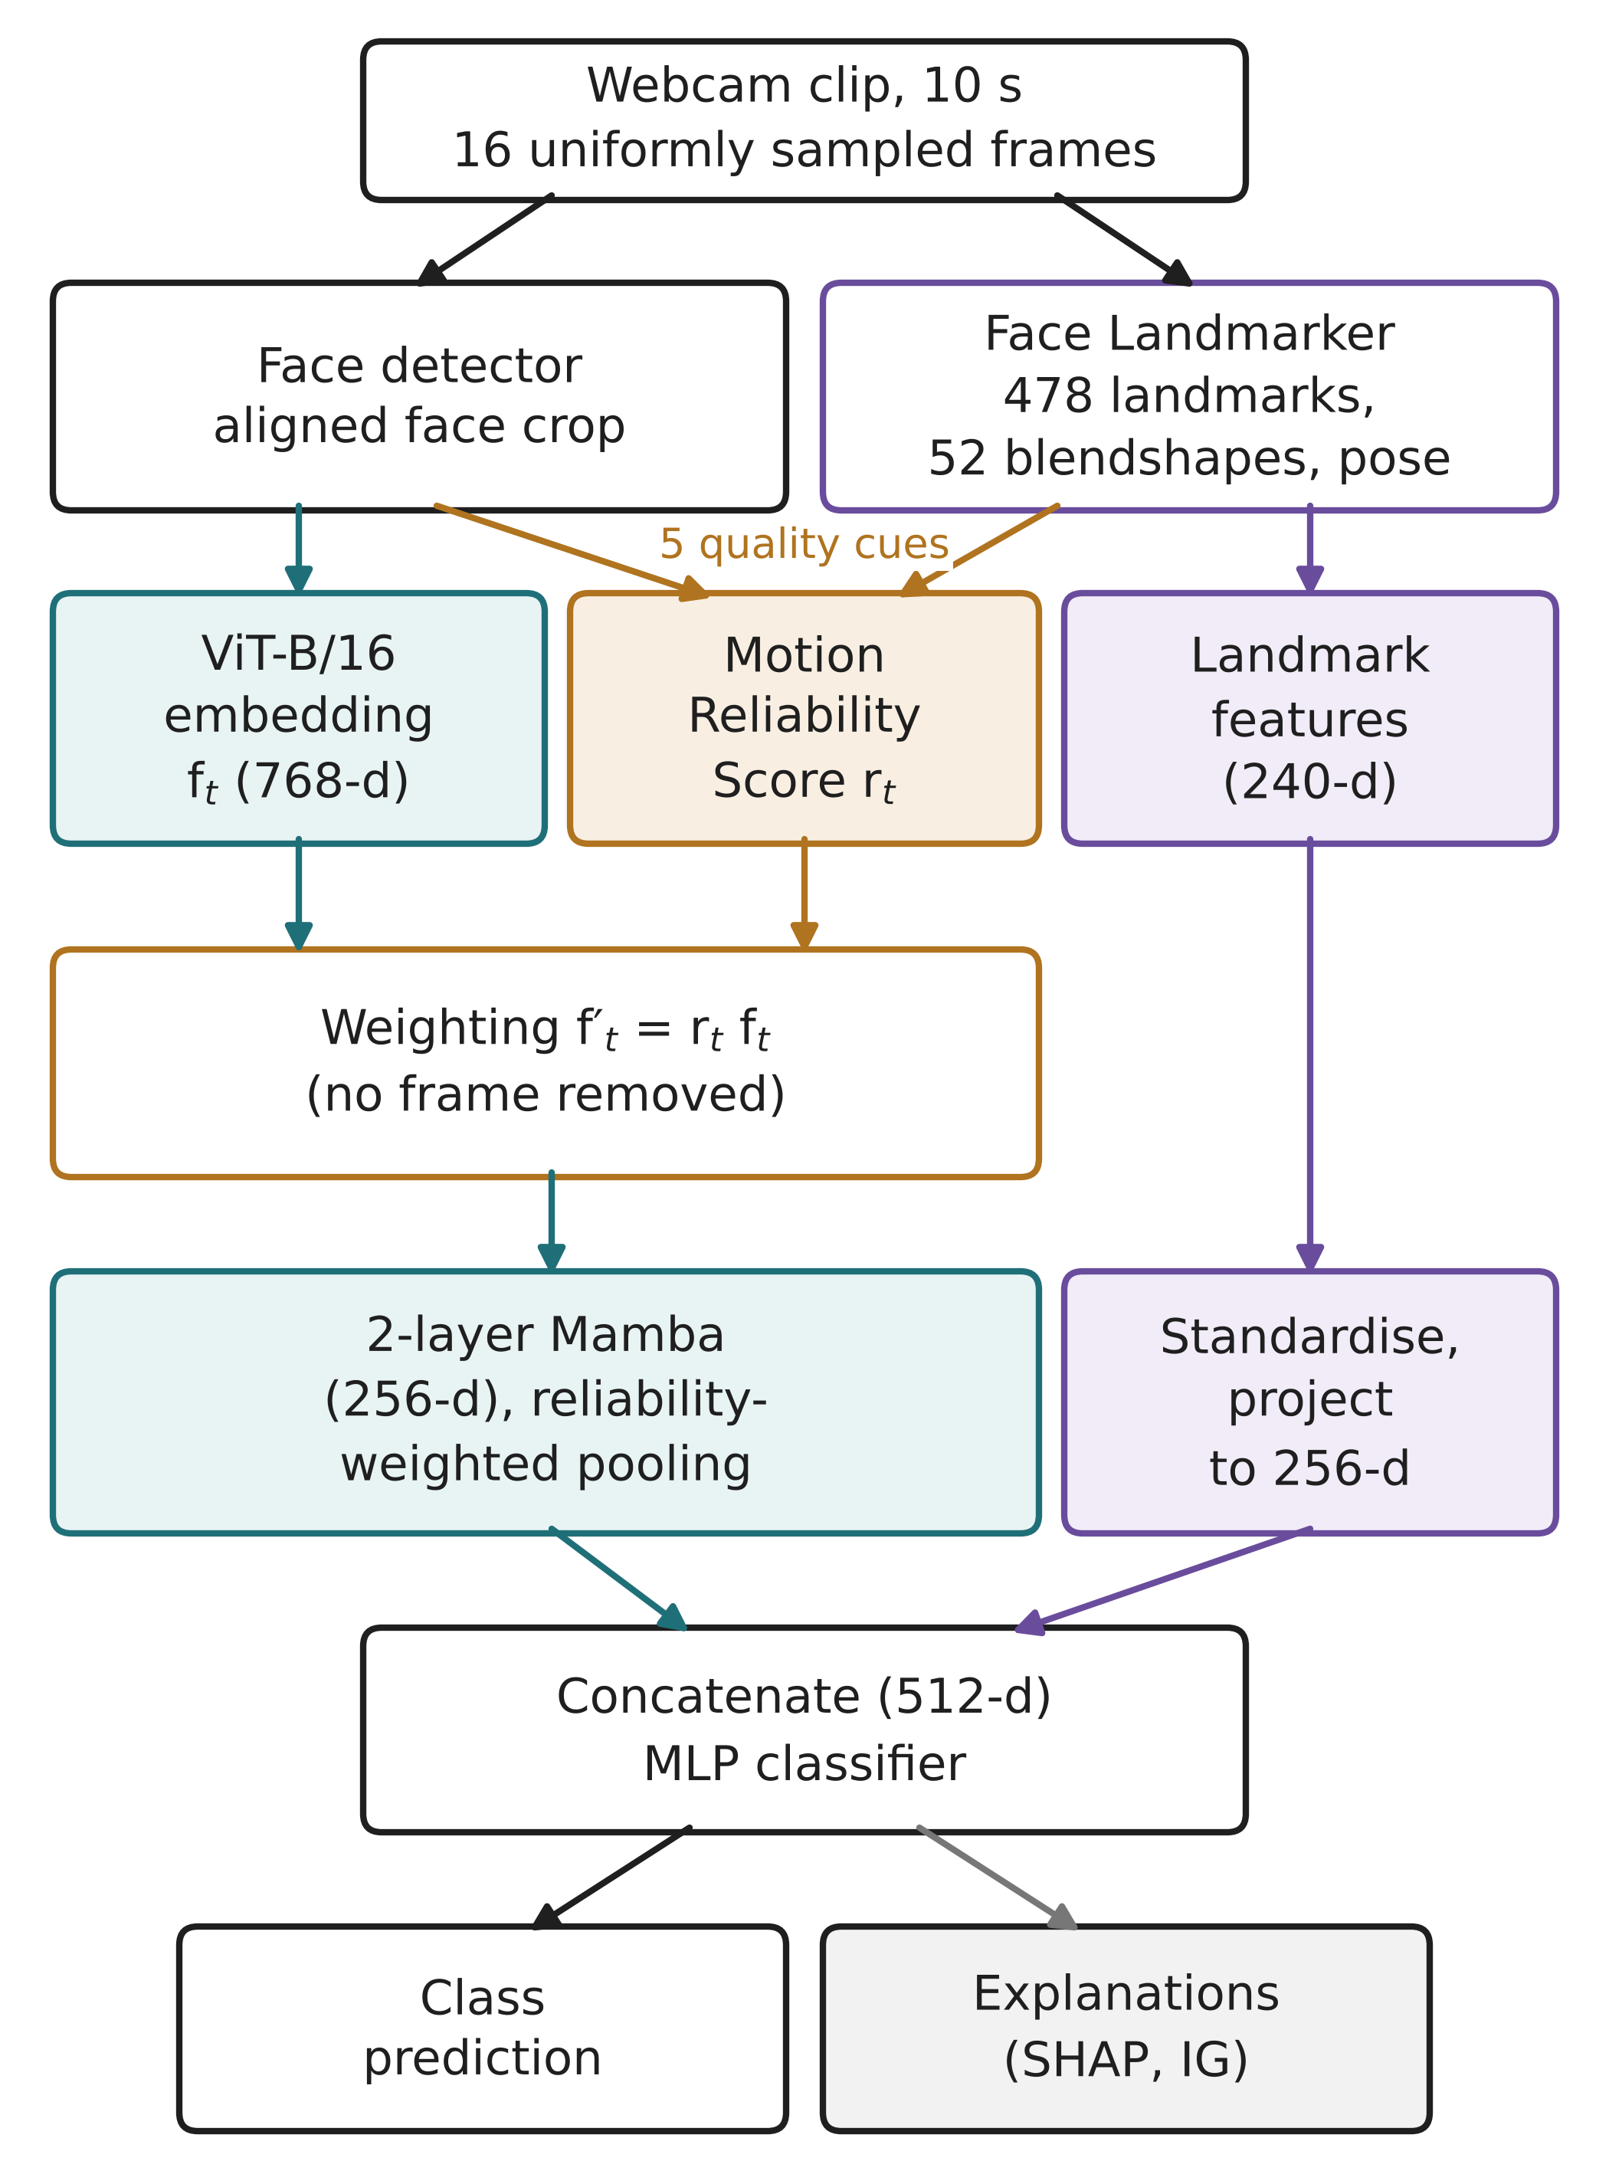
Fig. 1. Pipeline of the proposed system. Reliability is applied as a weight at two points and never removes a temporal position.
${f′}_{t}=r_{t}f_{t}$ (4)
$z=\frac{\sum_{t=1}^{T}{r_{t}h_{t}}}{\sum_{t=1}^{T}{r_{t}}}$ (5)
Neither operation removes a frame: the number and ordering of temporal positions is preserved, so the encoder still receives a regularly sampled sequence. The weighted sequence is projected from 768 to 256 dimensions and passed through two Mamba blocks, each applying RMS normalisation, an input projection, a causal depthwise convolution, a SiLU gate and the selective scan with a residual connection (state dimension 16, inner dimension 512). In the final configuration the last four of the twelve ViT blocks and the final normalisation layer are trainable, which is 28.4 million of the 85.8 million backbone parameters.

Landmark Branch and Fusion
A parallel branch converts the landmark mesh into 28 scale-normalised geometric measurements, such as eye aspect ratio [19], which together with the 52 blendshape activations give an 80-dimensional descriptor per frame. The blendshapes are semantic descriptors related to facial action units [20]. The per-frame descriptors are aggregated over time by the mean, the standard deviation and the mean absolute temporal difference of each named feature, which gives a 240-dimensional clip vector. Its standardiser is fitted on the training partition alone. Both branches are projected to 256 dimensions and concatenated, and a multilayer perceptron (MLP) of 512, 256 and 128 units with GELU activations and dropout produces the class logits. The assembled model has 87.2 million parameters; the parts specific to this work total 1.27 million.

Training and Evaluation Design
Class imbalance is handled at two independent points: how often each class is drawn, through a weighted sampler, and how much each error costs, through a class-weighted cross-entropy loss. The two are not combined, because their effects multiply. On the binary task the sampler alone raises the minority class from 4.6% to 27.8% of draws, and adding effective-number loss weights [21] on top would place the effective prior near 81% when the true rate is 4.6%. Optimisation uses decoupled weight decay [22], and all randomness is seeded.
The checkpoint is selected on validation balanced accuracy. Selecting on raw accuracy is unsound on this distribution: in a preliminary run the highest validation accuracy, 0.579, occurred at the first epoch against a validation majority baseline of 0.569, on a model that had barely departed from the prior. For the binary task the operating threshold is chosen on the validation partition and applied unchanged to the test partition. The test partition is read once per run, after selection, with three-view test-time augmentation, and never informs selection.
The reported metrics are accuracy, balanced accuracy, macro and weighted F1, per-class precision, recall and F1 and the confusion matrix, each next to the baseline that applies to it. For the binary task, ROC-AUC and average precision (AP) are reported because both are independent of the decision threshold. The pipeline is covered by 169 automated tests that check temporal integrity, leakage prevention, class merging, weight stability and metric correctness.

Explainability
SHAP [23] attribution is computed over the fused representation, where the landmark half keeps named dimensions and can be grouped into facial feature families, for 512 test clips against 512 background clips. Integrated gradients from an all-zero baseline separate the contributions of the deep and landmark branches on individual clips, and Grad-CAM over the ViT shows where on the face the model attends.

Results

Three-Class Engagement Recognition
Table II reports the three-class results on the 1,784 test clips. The system exceeds the majority baseline on balanced accuracy and macro F1 and falls below it on raw accuracy. A constant majority predictor attains 0.4944 accuracy while scoring 0.3333 balanced accuracy and 0.2206 macro F1. Table III gives the per-class figures.
TABLE II. Three-Class Results on the Full DAiSEE Test Partition
Metric | Model | Majority baseline
Accuracy | 0.4596 | 0.4944
Balanced accuracy | 0.4185 | 0.3333
Macro F1 | 0.3833 | 0.2206
Weighted F1 | 0.4661 | -

TABLE III. Three-Class Per-Class Performance on the Test Partition
Class | Precision | Recall | F1 | Support
Low (levels 0-1) | 0.137 | 0.330 | 0.193 | 88
High (level 2) | 0.511 | 0.546 | 0.528 | 882
Very High (level 3) | 0.491 | 0.380 | 0.428 | 814

The confusion structure locates the limitation. Of 1,696 clips labelled High or Very High, 308 true High clips were predicted Very High and 414 true Very High clips were predicted High. Restricted to a forced choice between those two classes, the model reached 0.5153 accuracy against 0.5200 for always answering High, with a ROC-AUC of 0.5235. Re-deciding the stored test probabilities gave the same picture: correcting for the class-weighted loss raised accuracy to 0.4849, and suppressing the rare class entirely raised it to 0.4899, both below the 0.4944 baseline.

Binary Disengagement Detection
Table IV reports the binary formulation. The test partition contains 1,696 engaged and 88 not-engaged clips, so a constant engaged prediction scores 0.9507 accuracy while detecting nothing, and ROC-AUC is the primary metric. The detector recovered 54 of the 88 disengaged clips at the cost of 255 false alarms among the engaged clips (Fig. 2). Training on the full release rather than a 1,500-clip subset raised ROC-AUC from 0.7324 to 0.7943; the subset contained 69 not-engaged training clips against 247 in the full partition.
TABLE IV. Binary Disengagement Detection on the Full Test Partition
Metric | Model | Baseline
ROC-AUC | 0.7943 | 0.5000
Average precision | 0.2628 | 0.0493
Balanced accuracy | 0.7316 | 0.5000
Accuracy | 0.8380 | 0.9507
Recall (not engaged) | 0.614 | 0.000
Precision (not engaged) | 0.175 | -

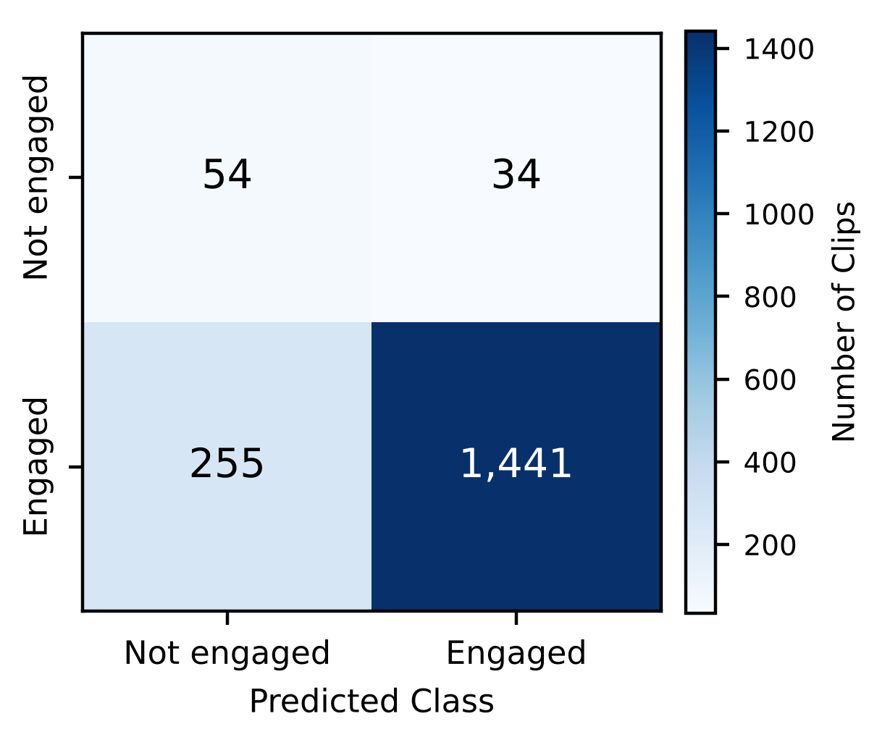
Fig. 2. Confusion matrix for binary disengagement detection on the full DAiSEE test partition (1,784 clips).

Ablation of Reliability Weighting
The hypothesis requires a control: the same model with the mechanism removed, trained on the same clips with the same seed. Two configurations were compared that differ in exactly two of 117 settings, namely whether reliability scales the frame embeddings and whether temporal pooling is reliability-weighted or a plain mean. Table V reports the outcome.
TABLE V. Controlled Ablation on the Full Test Partition
Configuration | ROC-AUC | AP | Balanced accuracy
Reliability weighting on | 0.7943 | 0.2628 | 0.7316
Reliability weighting removed | 0.7941 | 0.2627 | 0.7313
Difference | +0.0002 | +0.0001 | +0.0003

The difference was 0.0002 ROC-AUC, and on the validation partition the control was marginally ahead. An earlier ablation over seven architectural variants with five seeds each, run on a 120-clip development subset, could not resolve this question. There the full model scored 0.214 ± 0.024 test macro F1 against 0.205 ± 0.029 for the variant without reliability: a difference of 0.0090 against a pooled standard deviation of 0.0266. The smallest difference five seeds could declare significant at the 5% level was 0.0388, more than four times the observed effect, and detecting a 0.0090 effect at 80% power would have required about 137 seeds per arm.

Collapse of Learned Mixture Weights
Trained without regularisation, the five reliability weights collapsed: a fifteen-epoch run ended with motion consistency at 0.990 and the other four components near 0.001, so the five-component score had become a one-component score with no error raised. Simulation over the same number of optimiser steps showed that the learning rate does not control this behaviour, whereas weight decay does (Table VI). Because a parameter vector of zero is exactly the uniform weighting, decay acts as a prior toward it.
TABLE VI. Simulated Maximum Component Weight After a Full Run
Learning rate | Weight decay | Maximum weight
0.04 | 0.0 | 1.000 (observed failure)
0.002 | 0.0 | 0.999
0.002 | 0.5 | 0.902
0.01 | 1.0 | 0.649 (bounded)

The prior does not freeze the weights. Under a weak noisy signal one component still separated to about 0.30 against 0.17 for the others, and under pure noise all five remained at 0.20. With the prior in place, three subsequent full runs ended with all five components between 0.182 and 0.218.

Explainability
Table VII reports SHAP attribution by feature group for the binary model. Group totals are sums over groups of different size, so the per-dimension column is the comparable one. Per dimension, eye-openness and iris or gaze features carried about twice the attribution of the deep temporal block. The five highest-ranked individual features were all eye-related (Fig. 3): brow lowering, eye aspect ratio and eye openness for both eyes, followed by gaze direction and blink features.
TABLE VII. SHAP Attribution by Feature Group, 512 Test Clips
Feature group | Dim. | Share | Per dim.
Deep temporal (ViT-Mamba) | 256 | 42.77% | 0.00257
Iris and gaze | 45 | 15.28% | 0.00523
Mouth and jaw | 90 | 15.10% | 0.00258
Eye openness | 36 | 12.56% | 0.00537
Brow | 27 | 6.62% | 0.00378
Head pose | 15 | 2.89% | 0.00297
Face scale | 9 | 2.74% | 0.00469
Cheek and nose | 15 | 1.83% | 0.00188

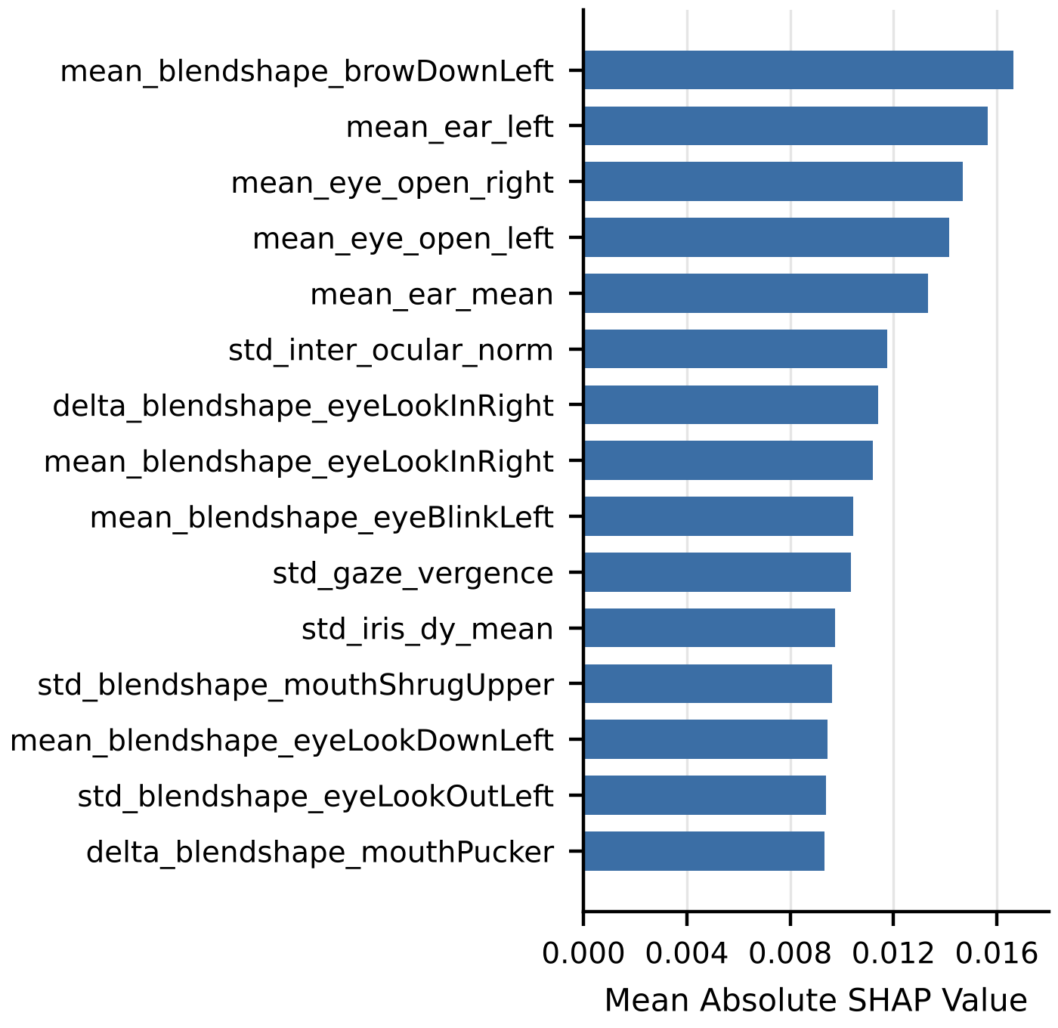
Fig. 3. The fifteen named landmark features with the highest mean absolute SHAP value on the test partition (mean, std and delta denote the temporal mean, standard deviation and mean absolute difference).
Integrated gradients on three worked examples from three participants gave landmark-branch contributions of +2.14, +1.51 and +1.56 to the predicted-class score, against deep-branch contributions of -0.35, -0.14 and +0.12.

Discussion
Three findings follow from the results, and they are not all favourable to the hypothesis this work set out to test.
First, the architecture yields a usable disengagement detector. A ROC-AUC of 0.7943 against a 0.5 no-signal baseline, with average precision 5.3 times its own baseline, is a real capability on a corpus where 95% of the clips belong to one class. The gain obtained by moving from a 1,500-clip subset to the full release indicates that the number of minority-class clips, rather than model capacity, was the binding constraint.
Second, the reliability mechanism does not account for that capability. The controlled ablation places its contribution at 0.0002 ROC-AUC, and attribution assigns the discriminative signal to MediaPipe eye and gaze geometry rather than to the reliability-weighted deep representation. The integrated-gradients results are consistent with this: the deep block carries attribution magnitude comparable to its size, but it does not push consistently toward the correct class, whereas the landmark geometry does.
Third, the fine-grained formulation is bounded by annotation ambiguity rather than by model capacity. With a ROC-AUC of 0.5235 separating High from Very High, and those classes forming 95% of the test partition, no decision rule raised accuracy above the 0.4944 prior. The distinction between high and very high engagement is a subjective judgement on which annotators themselves disagree [1], and accuracy on the four-level or three-level task should be read against this ceiling.
The weight-collapse finding generalises beyond this application. Any system that learns a convex combination of components through a softmax over free parameters can lose all but one component without any error being raised. Weight decay on the logits is a direct remedy, because their zero point is the uniform mixture, and the decay strength sets how far the data must push before a component dominates.
The study has limitations. Both ablation arms selected their best checkpoint at the first epoch, and across the epochs trained the learned weights moved only between 0.182 and 0.218 from their uniform initialisation. The comparison therefore contrasts reliability weighting with a near-uniform mixture against no weighting at all; the learned component remains untested rather than refuted, because the model overfits before the weights travel far. All full-scale comparisons report a single seed per configuration, while the development-scale ablation showed a seed-to-seed standard deviation of 0.0266 in macro F1, so differences below about 0.04 cannot be distinguished without repetition. No external published system was re-run on this protocol; published DAiSEE figures differ in partition, granularity and class formulation and are not directly comparable. Finally, DAiSEE participants are young adults in e-learning sessions, and the results do not transfer to other age groups, such as children, or to other recording conditions without re-validation.

Conclusion
This work tested whether treating observation reliability as a length-preserving, learned weight improves engagement recognition from webcam video. On the full, subject-disjoint DAiSEE release, a controlled ablation that differs in two of 117 settings measured the contribution of the mechanism at 0.0002 ROC-AUC. The hypothesis was therefore not supported, and this result was established by a controlled comparison with the effect size and the statistical power stated, rather than inferred from a single score.
The other outcomes are of direct practical use. As a disengagement detector the system reaches a ROC-AUC of 0.7943 and recovers 54 of 88 disengaged test clips. Attribution localises the signal to eye-openness and gaze geometry, which suggests that a landmark-only model of a few hundred thousand parameters may match the present 87-million-parameter system. The collapse of softmax-parameterised mixture weights, and the finding that weight decay rather than learning rate bounds it, applies to any model that learns such a mixture.
Future work should give the learned weights a fair test by freezing the backbone and training on cached features for hundreds of epochs across several seeds, exploit the three unused DAiSEE affect labels through multi-task training, model the intensity levels as ordinal rather than categorical to target the adjacent-class boundary where the present model is at chance, normalise features within each participant, and compare the full system against a landmark-only model.

Appendix
Table VIII lists the hardware and software used for all reported runs. The exact package versions, device and configuration were recorded alongside every result artifact.
TABLE VIII. Hardware and Software Used in the Experiments
Item | Specification
Processor | x86-64, 8 logical cores
Memory | 16 GB
GPU | NVIDIA GeForce RTX 3060 Laptop, 6 GB
Operating system | Windows 11 Home (64-bit)
Language | Python 3.13.3
Deep learning | PyTorch 2.11.0, torchvision 0.26.0, CUDA 12.8
Vision backbone | timm 1.0.29
Facial analysis | MediaPipe Tasks 1.0.1, OpenCV 5.0.0
Sequence model | Mamba reference implementation
Metrics and attribution | scikit-learn 1.9.0, SHAP 0.52.0
Testing | pytest 9.1.1 (169 tests)

CRediT Authorship Contribution Statement
Ilakkiya S: Data curation, Investigation, Validation, Visualization, Writing – original draft. Adhvaith N A: Conceptualization, Methodology, Software, Formal analysis, Writing – original draft, Writing – review and editing. Don George: Software, Investigation, Validation, Visualization, Writing – review and editing. Deepika J: Supervision, Project administration, Resources, Writing – review and editing.

Data Statement
This study uses the DAiSEE dataset, which is publicly available for research from its creators under a registration agreement at https://people.iith.ac.in/vineethnb/resources/daisee/. No new data were collected. In keeping with the licence conditions, the dataset video, the derived face crops and the extracted landmark data are not redistributed. The source code, configuration files and result artifacts supporting the findings are available from the corresponding author on reasonable request.

Declaration of Conflicts of Interest
We have no conflict of interest to declare.

Acknowledgment
The authors thank the School of Computer Science and Engineering, Vellore Institute of Technology, Vellore, for supporting this work, the creators of DAiSEE for making the dataset available for research, and the maintainers of the open-source libraries used in this study.
Funding: This research did not receive funding.

References
- J. Whitehill, Z. Serpell, Y.-C. Lin, A. Foster, and J. R. Movellan, "The faces of engagement: automatic recognition of student engagement from facial expressions," IEEE Transactions on Affective Computing, vol. 5, no. 1, pp. 86-98, 2014, doi: https://doi.org/10.1109/TAFFC.2014.2316163.
- A. Gupta, A. D'Cunha, K. Awasthi, and V. Balasubramanian, "DAiSEE: towards user engagement recognition in the wild," arXiv preprint arXiv:1609.01885, 2016, doi: https://doi.org/10.48550/arXiv.1609.01885.
- Ö. Sümer, P. Goldberg, S. D'Mello, P. Gerjets, U. Trautwein, and E. Kasneci, "Multimodal engagement analysis from facial videos in the classroom," IEEE Transactions on Affective Computing, vol. 14, no. 2, pp. 1012-1027, 2023.
- J. Donahue et al., "Long-term recurrent convolutional networks for visual recognition and description," in Proceedings of the IEEE Conference on Computer Vision and Pattern Recognition, Boston, MA, USA, 2015, pp. 2625-2634, doi: https://doi.org/10.1109/CVPR.2015.7298878.
- D. Tran, L. Bourdev, R. Fergus, L. Torresani, and M. Paluri, "Learning spatiotemporal features with 3D convolutional networks," in Proceedings of the IEEE International Conference on Computer Vision, Santiago, Chile, 2015, pp. 4489-4497, doi: https://doi.org/10.1109/ICCV.2015.510.
- G. Bertasius, H. Wang, and L. Torresani, "Is space-time attention all you need for video understanding?," in Proceedings of the 38th International Conference on Machine Learning, 2021, pp. 813-824.
- A. Gu and T. Dao, "Mamba: linear-time sequence modeling with selective state spaces," arXiv preprint arXiv:2312.00752, 2023, doi: https://doi.org/10.48550/arXiv.2312.00752.
- L. Zhu, B. Liao, Q. Zhang, X. Wang, W. Liu, and X. Wang, "Vision Mamba: efficient visual representation learning with bidirectional state space model," in Proceedings of the 41st International Conference on Machine Learning, Vienna, Austria, 2024.
- A. Dosovitskiy et al., "An image is worth 16x16 words: transformers for image recognition at scale," in Proceedings of the International Conference on Learning Representations, 2021.
- J. L. Pech-Pacheco, G. Cristóbal, J. Chamorro-Martínez, and J. Fernández-Valdivia, "Diatom autofocusing in brightfield microscopy: a comparative study," in Proceedings of the 15th International Conference on Pattern Recognition, Barcelona, Spain, 2000, pp. 314-317, doi: https://doi.org/10.1109/ICPR.2000.903548.
- P. Terhörst, J. N. Kolf, N. Damer, F. Kirchbuchner, and A. Kuijper, "SER-FIQ: unsupervised estimation of face image quality based on stochastic embedding robustness," in Proceedings of the IEEE/CVF Conference on Computer Vision and Pattern Recognition, Seattle, WA, USA, 2020, pp. 5651-5660.
- A. Kendall and Y. Gal, "What uncertainties do we need in Bayesian deep learning for computer vision?," in Advances in Neural Information Processing Systems, Long Beach, CA, USA, 2017, pp. 5574-5584.
- J. Yang et al., "Neural aggregation network for video face recognition," in Proceedings of the IEEE Conference on Computer Vision and Pattern Recognition, Honolulu, HI, USA, 2017, pp. 4362-4371, doi: https://doi.org/10.1109/CVPR.2017.554.
- C. Lugaresi et al., "MediaPipe: a framework for building perception pipelines," arXiv preprint arXiv:1906.08172, 2019, doi: https://doi.org/10.48550/arXiv.1906.08172.
- V. Bazarevsky, Y. Kartynnik, A. Vakunov, K. Raveendran, and M. Grundmann, "BlazeFace: sub-millisecond neural face detection on mobile GPUs," arXiv preprint arXiv:1907.05047, 2019, doi: https://doi.org/10.48550/arXiv.1907.05047.
- Y. Kartynnik, A. Ablavatski, I. Grishchenko, and M. Grundmann, "Real-time facial surface geometry from monocular video on mobile GPUs," in Proceedings of the IEEE Conference on Computer Vision and Pattern Recognition Workshops, Long Beach, CA, USA, 2019.
- A. Ablavatski, A. Vakunov, I. Grishchenko, K. Raveendran, and M. Zhdanovich, "Real-time pupil tracking from monocular video for digital puppetry," arXiv preprint arXiv:2006.11341, 2020, doi: https://doi.org/10.48550/arXiv.2006.11341.
- A. Steiner, A. Kolesnikov, X. Zhai, R. Wightman, J. Uszkoreit, and L. Beyer, "How to train your ViT? Data, augmentation, and regularization in vision transformers," Transactions on Machine Learning Research, 2022.
- T. Soukupová and J. Čech, "Real-time eye blink detection using facial landmarks," in Proceedings of the 21st Computer Vision Winter Workshop, Rimske Toplice, Slovenia, 2016.
- P. Ekman and W. V. Friesen, Facial Action Coding System: a technique for the measurement of facial movement, Palo Alto, CA, USA: Consulting Psychologists Press, 1978.
- Y. Cui, M. Jia, T.-Y. Lin, Y. Song, and S. Belongie, "Class-balanced loss based on effective number of samples," in Proceedings of the IEEE/CVF Conference on Computer Vision and Pattern Recognition, Long Beach, CA, USA, 2019, pp. 9268-9277, doi: https://doi.org/10.1109/CVPR.2019.00949.
- I. Loshchilov and F. Hutter, "Decoupled weight decay regularization," in Proceedings of the International Conference on Learning Representations, New Orleans, LA, USA, 2019.
- S. M. Lundberg and S.-I. Lee, "A unified approach to interpreting model predictions," in Advances in Neural Information Processing Systems, Long Beach, CA, USA, 2017, pp. 4765-4774.


Ilakkiya S
Ilakkiya S is pursuing a B.Tech. degree in Computer Science and Engineering at the School of Computer Science and Engineering, Vellore Institute of Technology (VIT), Vellore, India (2023-2027). Within this work, the contributions covered dataset curation, the experimental runs and the visual presentation of results. Research interests include computer vision, affective computing and machine learning for education.

Adhvaith N A
Adhvaith N A is pursuing a B.Tech. degree in Computer Science and Engineering at the School of Computer Science and Engineering, Vellore Institute of Technology (VIT), Vellore, India (2023-2027). Alongside his studies he works as a freelance software developer and consultant in software architecture and full-stack development, and builds workflow automation systems. Research interests include multimodal machine learning, video understanding, explainable artificial intelligence and applied AI agents.

Don George
Don George is pursuing a B.Tech. degree in Computer Science and Engineering with specialization in Data Science at the School of Computer Science and Engineering, Vellore Institute of Technology (VIT), Vellore, India (2023-2027). Within this work, the contributions covered software implementation, testing and analysis of results. Research interests include data science, deep learning and computer vision.

Deepika J
Deepika J is an Assistant Professor Senior Grade 1 at the School of Computer Science and Engineering, Vellore Institute of Technology (VIT), Vellore, India, and supervises undergraduate research projects in the school. Research interests include machine learning and its applications.

