BCSE497J - Project-I

RELIABILITY-GUIDED VISION TRANSFORMER AND MAMBA TEMPORAL MODELLING FOR STUDENT ENGAGEMENT RECOGNITION FROM WEBCAM VIDEO

Reg. No. 1 | STUDENT NAME 1
Reg. No. 2 | STUDENT NAME 2
Reg. No. 3 | STUDENT NAME 3
(mention the particulars sorted on Register number)

Under the Supervision of

Project Guide Name
Designation
School of Computer Science and Engineering

B.Tech.
in
Computer Science and Engineering
(Specialization if any)

School of Computer Science and Engineering



September 2026

ABSTRACT
Automatic recognition of student engagement from webcam video is difficult less because the classifier is weak than because the observations are unreliable. A learner leans out of frame, rests a hand against the cheek, or the webcam loses focus, and the model is handed a face it cannot see - yet is asked to infer an affective state from it. Most pipelines respond by discarding such frames, which repairs image quality at the cost of destroying the temporal spacing any sequence model depends on.
This project builds a reliability-guided pipeline on the DAiSEE dataset that keeps every sampled frame and weights it instead. A Motion Reliability Score (MRS) is computed per frame from five observation-quality signals - blur, face visibility, head pose, eye and iris visibility, and motion consistency - none of which uses the engagement label. A frozen ImageNet-pretrained Vision Transformer encodes each aligned face crop into a 768-dimensional embedding; the reliability score scales that embedding and weights the temporal pooling, so unreliable frames contribute less without leaving the sequence. A Mamba selective state-space model then reads the weighted sequence across time. A parallel MediaPipe branch supplies 28 normalised geometric measurements and 52 ARKit blendshape activations per frame, fused with the deep branch before a four-class classifier.
Rather than fixing the five MRS weights at an arbitrary uniform value, the system initialises them at 0.20 each and learns them by gradient descent. On a 216-clip, class-balanced, subject-disjoint partition of DAiSEE, the learned weighting concentrates on face visibility (0.459) and blur (0.236) while suppressing head pose (0.056) and eye visibility (0.050), independently reproducing a separate variance analysis of the same components. The system reaches 38.75% validation accuracy against a 25% chance baseline (binomial p = 0.0046), with SHAP attribution identifying which facial feature groups the classifier relies on.

Keywords - Student Engagement Recognition, Vision Transformer, Mamba State-Space Model, Observation Reliability, MediaPipe Face Landmarks, DAiSEE, Explainable AI.

TABLE OF CONTENTS
Sl.No | Contents | Page No.
 | Abstract | i
1. | INTRODUCTION
 | 1.1 Background
 | 1.2 Motivation
 | 1.3 Scope of the Project
2. | PROJECT DESCRIPTION AND GOALS
 | 2.1 Literature Review
 | 2.2 Research Gap
 | 2.3 Objectives
 | 2.4 Problem Statement
 | 2.5 Project Plan
3. | TECHNICAL SPECIFICATION
 | 3.1 Requirements
 | 3.1.1 Functional
 | 3.1.2 Non-Functional
 | 3.2 Feasibility Study
 | 3.2.1 Technical Feasibility
 | 3.2.2 Economic Feasibility
 | 3.2.3 Social Feasibility
 | 3.3 System Specification
 | 3.3.1 Hardware Specification
 | 3.3.2 Software Specification
4. | DESIGN APPROACH AND DETAILS
 | 4.1 System Architecture
 | 4.2 Design
 | 4.2.1 Data Flow Diagram
 | 4.2.2 Use Case Diagram
 | 4.2.3 Class Diagram
 | 4.2.4 Sequence Diagram
 | 4.3 Implementation Status and Preliminary Results
 | 4.3.1 Experimental Setup
 | 4.3.2 Training Behaviour
 | 4.3.3 Learned Reliability Weights
 | 4.3.4 Reliability Score Distribution
 | 4.3.5 Classification Results
 | 4.3.6 Explainability
 | 4.3.7 Worked Examples
 | 4.3.8 Limitations
5. | REFERENCES
(In Word, select all with Ctrl+A and press F9 to fill in the page numbers.)

1. INTRODUCTION

1.1 Background
Engagement is one of the strongest predictors of learning outcome, and its measurement has become urgent as instruction has moved online. In a physical classroom a teacher reads the room continuously and adapts; in a video-conferencing lecture with cameras in a grid, that feedback channel largely disappears. Automatic engagement recognition from webcam video aims to restore it.
DAiSEE is the standard public benchmark for this task. It contains 9,068 ten-second clips from 112 participants recorded in unconstrained settings - dormitories, laboratories, and offices - and each clip is annotated for four affective states: boredom, confusion, engagement, and frustration, each on a four-level intensity scale. This project uses the engagement label only.
What distinguishes engagement recognition from ordinary facial expression recognition is that engagement is a temporal construct. It is not visible in a single photograph; it appears in how attention is sustained, how gaze drifts, and how posture settles over seconds. Recognition therefore requires a model that reads a sequence rather than a frame. Recent state-space models such as Mamba make this affordable, offering sequence modelling at linear rather than quadratic cost in sequence length.

1.2 Motivation
The motivation for this project comes from a specific and under-addressed weakness in existing pipelines: they treat every frame as equally trustworthy. Real webcam recordings are not uniformly observable. A participant leans out of the frame, a hand covers the mouth, the autofocus hunts, the room darkens. When a frame is degraded, the visual evidence extracted from it is degraded too, and feeding it to a classifier with full weight injects noise directly into the prediction.
The conventional remedy is to gate: measure frame quality, and drop frames below a threshold. This is precisely the wrong remedy for a temporal model. Dropping frames changes the sequence length, closes the gaps, and destroys the uniform spacing that carries the temporal information in the first place. A heavily occluded clip and a clean clip arrive at the sequence model as different lengths, and the model has no way to know that one of them is missing time.
This project is motivated by a different treatment of the same signal. Reliability should be a soft weight applied in place, not a hard gate applied by deletion. Every sampled frame keeps its position and its timing; unreliable frames simply exert less influence. This preserves what the state-space model needs while still preventing poor observations from dominating the prediction.

1.3 Scope of the Project
The project covers the complete recognition pipeline from raw DAiSEE video to a four-class engagement prediction with an accompanying explanation. Within scope: uniform temporal sampling; face detection, alignment and cropping; computation of a five-component Motion Reliability Score; frozen Vision Transformer feature extraction; reliability-weighted temporal modelling with a Mamba selective state-space model; a parallel MediaPipe geometric and behavioural feature branch; feature fusion and classification; and SHAP-based attribution over the fused representation.
The engagement label is the sole prediction target. Boredom, confusion and frustration are present in the dataset but are not modelled. The Vision Transformer backbone is frozen throughout; end-to-end fine-tuning is deliberately deferred until the pipeline itself has been validated. Evaluation follows the official DAiSEE partition, and subject disjointness between splits is verified rather than assumed.
The project is explicitly not framed as an attempt to exceed the highest published DAiSEE accuracy. The research question is whether reliability-guided temporal modelling improves robust recognition while preserving temporal information, and the deliverable is a verified, reproducible pipeline with honestly reported measurements - including negative results where they occur.

2. PROJECT DESCRIPTION AND GOALS

2.1 Literature Review
The literature relevant to this project falls into five strands: the dataset and benchmark itself, temporal architectures for video understanding, state-space sequence models, facial feature extraction, and observation-quality assessment.

Dataset and benchmark
Gupta et al. [1] introduced DAiSEE as the first large-scale dataset for recognising affective states in e-learning from unconstrained webcam video, establishing the four-state, four-level annotation scheme used here. Their baselines with InceptionNet frame-level features, C3D and LRCN established the difficulty of the benchmark, particularly for the minority intensity levels. Subsequent work has repeatedly confirmed that DAiSEE engagement is severely imbalanced, with the two middle levels dominating, so accuracy alone is an inadequate metric [2], [3].

Temporal modelling for engagement
Because engagement unfolds over time, most competitive approaches model sequences rather than frames. Recurrent formulations using LSTM over per-frame CNN descriptors [4], 3D convolutional networks that learn spatiotemporal filters jointly [5], and more recently video transformers applying self-attention across frames [6] have all been applied. Attention-based approaches have consistently outperformed purely recurrent ones on this task, but self-attention costs quadratic time in sequence length, which limits how many frames can be processed.

State-space sequence models
Gu and Dao [7] introduced Mamba, a selective state-space model whose parameters are functions of the input, giving content-dependent propagation of information along the sequence at linear time and constant inference memory. Zhu et al. [8] adapted the idea to vision as Vision Mamba (Vim), using bidirectional Mamba blocks over image patch tokens as a backbone. It is important to distinguish these two uses: Vim is a spatial backbone over image tokens, whereas applying Mamba across a sequence of per-frame embeddings is temporal modelling. This project does the latter and names it accordingly. Mamba variants have already been applied to DAiSEE - a recent multi-scale contrastive framework reports Vision Mamba and VMamba baselines on the benchmark [9] - so this work does not claim novelty in applying Mamba to engagement recognition.

Facial feature extraction
Lugaresi et al. [10] describe MediaPipe, whose Face Mesh model regresses 468 three-dimensional facial landmarks in real time on commodity hardware, later extended with iris refinement to 478 points [11]. Kartynnik et al. [12] detail the underlying mesh regression. Beyond raw coordinates, the MediaPipe Face Landmarker additionally emits 52 ARKit-style blendshape activations - semantic descriptors such as eye blink, brow lowering and jaw opening - which are closely related in spirit to Facial Action Units [13] but are obtained without a separate AU model. Because raw landmark coordinates are dominated by face scale and position, normalised geometric derivatives such as eye aspect ratio [14] are conventionally preferred.

Observation quality and reliability
Image sharpness assessment has a long history; variance of the Laplacian [15] remains the standard no-reference estimator despite its known sensitivity to contrast, motivating perceptual alternatives [16]. In face analysis specifically, face image quality assessment has been shown to predict recognition error [17], establishing that a quality estimate can usefully modulate downstream confidence. Uncertainty-aware and confidence-weighted fusion is well established in multimodal learning [18], and attention-based frame weighting has been applied to video face recognition [19]. What is comparatively rare is a pipeline that computes an explicit, interpretable, label-independent per-frame reliability score and uses it to modulate a temporal sequence model without deleting frames - the gap this project addresses.

Explainability
Lundberg and Lee [20] introduced SHAP as a unified additive attribution framework with desirable theoretical properties, and it has become the standard tool for post-hoc feature attribution in affective computing pipelines. Attribution is used in this project to identify which facial feature groups the classifier relies upon, with the explicit caveat that attribution is not causation.

2.2 Research Gap
Three specific gaps emerge from the literature above.
- Reliability is used as a gate rather than a weight. Existing quality-aware pipelines typically threshold frame quality and discard frames that fall below it. For a temporal model this is self-defeating: removing frames alters the sequence length and destroys the uniform temporal spacing, so a degraded clip and a clean clip are no longer comparable inputs. No widely reported DAiSEE pipeline preserves the full temporal sequence while attenuating unreliable frames in place.
- Reliability weights are asserted, not learned. Where multi-factor quality scores are used, the relative importance of the factors is almost always fixed by hand - typically uniform. Whether blur, occlusion, head rotation and motion deserve equal influence for a given corpus and camera setup is an empirical question that is rarely asked, and never answered by optimisation.
- Reliability and behaviour are conflated. Head rotation and eye closure are frequently treated as evidence of disengagement. This confuses an observation-quality signal with the target construct: a turned head means the frontal appearance evidence is weaker, and a blink is normal behaviour rather than a bad observation. A reliability score that is contaminated by the label is no longer a reliability score.

2.3 Objectives
The project pursues the following specific, measurable objectives.
- O1. Construct a verified DAiSEE processing pipeline in which the official train/validation/test partition is used unchanged and subject disjointness between the three splits is measured and confirmed to be zero.
- O2. Define and implement a five-component Motion Reliability Score in [0,1] computed exclusively from observation-quality evidence, with every component verified to be finite and correctly bounded across the corpus.
- O3. Integrate the reliability score into a ViT-plus-Mamba temporal architecture such that the number and ordering of temporal positions is provably preserved - no frame is ever dropped.
- O4. Replace the arbitrary uniform weighting of the reliability components with weights learned by gradient descent from an initialisation of 0.20 each, and record their trajectory across training.
- O5. Fuse a MediaPipe geometric and behavioural branch with the deep temporal branch, with all dataset-dependent normalisation statistics fitted on the training split alone.
- O6. Evaluate with accuracy, weighted F1, macro F1, per-class precision/recall/F1 and a confusion matrix, benchmarked against explicit chance and majority-class baselines with statistical significance reported.
- O7. Produce SHAP attribution over the fused representation, grouped into interpretable facial feature families.

2.4 Problem Statement
Given a ten-second webcam video clip of a single learner, predict the annotated engagement intensity as one of four ordered levels - Very Low, Low, High, Very High - under the constraint that the observations within the clip vary in quality and that this variation must be accounted for without discarding temporal information.
Formally, let a clip yield T uniformly sampled frames. For each frame t a reliability score r_t in [0,1] is computed from observation-quality evidence alone, and a frozen Vision Transformer produces an embedding f_t. The system must learn a mapping from the reliability-weighted sequence to a four-class prediction such that the sequence length and the ordering of temporal positions are identical for every clip regardless of how degraded its frames are, and such that the reliability score is never derived from the engagement label.
The task is made harder by three properties of the data: the classes are severely imbalanced in the full DAiSEE release; adjacent intensity levels such as High and Very High are visually similar even to human annotators; and the same participant may appear in many clips, so a model can achieve apparently strong results by learning identity rather than engagement unless the splits are subject-disjoint.

2.5 Project Plan
The Project-I phase was organised into eleven tasks spanning approximately sixteen weeks, sequenced so that each verification gate precedes the work that depends on it. Dataset auditing precedes any preprocessing; the reliability score is designed and calibrated before it is integrated into the model; and the temporal encoder is verified against an independent reference implementation before training begins. Experimentation, explainability analysis and documentation occupy the final phase.
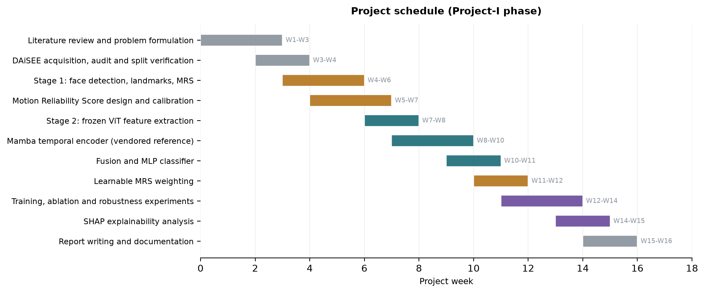
Fig. 2.1 Gantt chart of the Project-I schedule.

3. TECHNICAL SPECIFICATION

3.1 Requirements

3.1.1 Functional
The functional requirements below are grouped by pipeline stage and are stated as verifiable obligations of the system.
- Dataset ingestion and auditing (FR-1 to FR-5): the system shall locate the DAiSEE directory tree, parse the official label CSV files, join every video file to its label row, and report any label row without a matching file or any file without a label. It shall decode-probe each video and record frame rate, frame count, resolution and duration as measured rather than assumed. It shall derive the participant identifier for every clip and compute the pairwise subject overlap between train, validation and test, refusing to proceed if any overlap is non-zero.
- Temporal sampling (FR-6 to FR-8): the system shall select T frames per clip by uniform sampling, with T configurable over {8, 16, 32, 64}; it shall use deterministic sampling rather than random selection so that runs are reproducible; and it shall return exactly T frames for every clip, including clips shorter than T.
- Face processing (FR-9 to FR-12): the system shall detect the participant's face in each sampled frame, roll-align the crop using the detected eye keypoints, pad and resize it to the backbone's native input resolution, and record the detector confidence. Where no face is detected, it shall fall back through an explicit and recorded chain rather than dropping the frame, and shall mark the frame as unreliable.
- Reliability scoring (FR-13 to FR-17): the system shall compute five observation-quality components per frame - blur, face visibility, head pose, eye and iris visibility, and motion consistency - each bounded in [0,1]; it shall combine them into a single MRS value; it shall fit any dataset-dependent calibration on the training split only; and it shall guarantee that no engagement label participates in the computation.
- Feature extraction (FR-18 to FR-21): the system shall encode each aligned crop with a frozen pretrained Vision Transformer, discovering the embedding dimension from the loaded model rather than assuming it; and shall extract 478 facial landmarks, 52 blendshape activations and a head-pose matrix per frame, converting them into a fixed-width, scale-normalised feature vector.
- Temporal modelling and classification (FR-22 to FR-26): the system shall apply the reliability score to the frame embeddings without altering the number or order of temporal positions; shall model the resulting sequence with a Mamba selective state-space encoder; shall pool the sequence into a clip embedding; shall fuse it with the landmark branch after separate normalisation and projection; and shall output four raw class logits.
- Learning and evaluation (FR-27 to FR-32): the system shall initialise the five reliability weights at 0.20 each and update them by gradient descent during training, persisting the learned values in the checkpoint for use at validation and test time; shall select the reported checkpoint by validation macro F1 and never by test performance; and shall report accuracy, weighted F1, macro F1, per-class metrics and a confusion matrix, together with SHAP attribution over the fused representation.
- Caching and reproducibility (FR-33 to FR-36): the system shall cache expensive preprocessing keyed on a digest of every setting that affects the cached content, so that a stale cache cannot silently be reused; and shall record the exact package versions, device and configuration alongside every result artifact.

3.1.2 Non-Functional
- Correctness and verifiability: every pipeline stage shall be covered by an automated check that fails loudly rather than degrading silently. The temporal encoder in particular shall be verified for causality and for numerical agreement with an independently written reference implementation of the underlying recurrence.
- Data integrity and leakage prevention: no statistic used at inference time - reliability calibration, feature scaler, or class weights - shall be fitted on validation or test data, and this shall be enforced structurally rather than by convention.
- Performance: preprocessing of the 216-clip development corpus shall complete in under five minutes on a single consumer GPU, and a training epoch on cached features shall complete in under two seconds so that experiments can be iterated rapidly.
- Scalability: the architecture shall scale to the full 9,068-clip DAiSEE release by configuration change alone, with preprocessing split so that changing the visual backbone does not require repeating the CPU-bound landmark extraction.
- Reproducibility: all randomness shall be seeded, and any reported figure shall be traceable to a committed artifact file rather than to a transcript.
- Privacy and licensing: the DAiSEE video, the derived face crops and the extracted biometric landmark data shall never be committed to version control, and per-clip ground-truth labels shall not be redistributed.
- Maintainability: sampling, face processing, reliability scoring, encoding, temporal modelling, fusion and evaluation shall live in separate modules with no hard-coded dataset paths, tensor dimensions or model constants.

3.2 Feasibility Study

3.2.1 Technical Feasibility
- All three pretrained models required are publicly available and free to obtain: the ImageNet-pretrained ViT-B/16 backbone through the timm library, and the MediaPipe BlazeFace detector (230 KB) and Face Landmarker (3.76 MB) bundles from Google's published model URLs. No custom pretraining is required.
- Freezing the Vision Transformer reduces the trainable parameter count from roughly 87 million to 1.37 million, which trains comfortably within the 6 GB of memory available on the development GPU.
- A significant technical risk was identified and resolved during implementation. The official mamba-ssm package is distributed as source only and its build requires the CUDA Toolkit compiler, which was not available on the development machine; installation failed. Rather than substitute a different architecture, the project vendors the official reference (non-fused) implementation from the Mamba repository, which computes the same function without compilation. The trade-off is speed, not correctness, and the active backend is recorded in every result artifact.
- Splitting preprocessing into a backbone-independent CPU stage and a GPU feature-extraction stage keeps the pipeline affordable: changing the visual backbone costs only the second stage, which is roughly 27 seconds for the development corpus.

3.2.2 Economic Feasibility
- Software cost is zero. PyTorch, timm, MediaPipe, OpenCV, scikit-learn and SHAP are all open-source, and the pretrained weights are released for research use.
- Hardware cost is confined to a single consumer laptop GPU already available to the team; no cloud compute, paid API or annotation budget is required.
- DAiSEE is released free of charge for research subject to a registration agreement, so there is no data acquisition cost.
- The dominant cost is student time. Because features are cached, a full training run completes in under a minute, which makes the experimental iteration cost negligible relative to development effort.

3.2.3 Social Feasibility
- Engagement recognition applied to students is ethically sensitive. The system is positioned as an aggregate research instrument, not as a surveillance or grading tool, and no per-student decision-making is proposed.
- DAiSEE annotations are third-party judgements of observable affect. They should not be interpreted as objective measurements of a learner's internal mental state, and the report is explicit on this point.
- The dataset is licence-restricted video of identifiable people. The project therefore excludes the video, the derived face crops and the extracted landmark data from version control entirely, and treats per-clip label values as non-redistributable.
- Deployment beyond research would require informed consent, institutional ethics review, and a demonstrated absence of demographic performance disparity - none of which is claimed here.

3.3 System Specification

3.3.1 Hardware Specification
Table 3.1 Hardware specification.
Component | Development configuration (used) | Recommended for full DAiSEE
Processor | x86-64, 8 logical cores | 12+ cores (MediaPipe is CPU-bound)
Memory (RAM) | 16 GB | 32 GB
Storage | 60 GB free (SSD) | 250 GB SSD (15 GB dataset + caches)
Graphics Processing Unit | NVIDIA GeForce RTX 3060 Laptop, 6 GB, compute 8.6 | NVIDIA RTX 3090 / A4000, 12-16 GB
Display | 1920 x 1080 | 1920 x 1080 or higher

3.3.2 Software Specification
Table 3.2 Software specification (versions as verified on the development machine).
Layer | Software | Version
Operating system | Windows 11 Home (64-bit) | 10.0.26200
Language | Python | 3.13.3
Deep learning | PyTorch / torchvision | 2.11.0+cu128 / 0.26.0+cu128
GPU runtime | CUDA (bundled with PyTorch wheel) | 12.8
Vision backbones | timm (PyTorch Image Models) | 1.0.29
Transformer hub | transformers | 5.16.1
Facial analysis | MediaPipe Tasks (Face Detector, Face Landmarker) | 1.0.1
Image processing | OpenCV | 5.0.0
Sequence model | Vendored Mamba reference (state-spaces/mamba) | pytorch_reference
Numerics | NumPy | 2.5.2
Metrics | scikit-learn | 1.9.0
Explainability | SHAP | 0.52.0
Plotting | Matplotlib | 3.11.1
Testing | pytest | 9.1.1

4. DESIGN APPROACH AND DETAILS

4.1 System Architecture
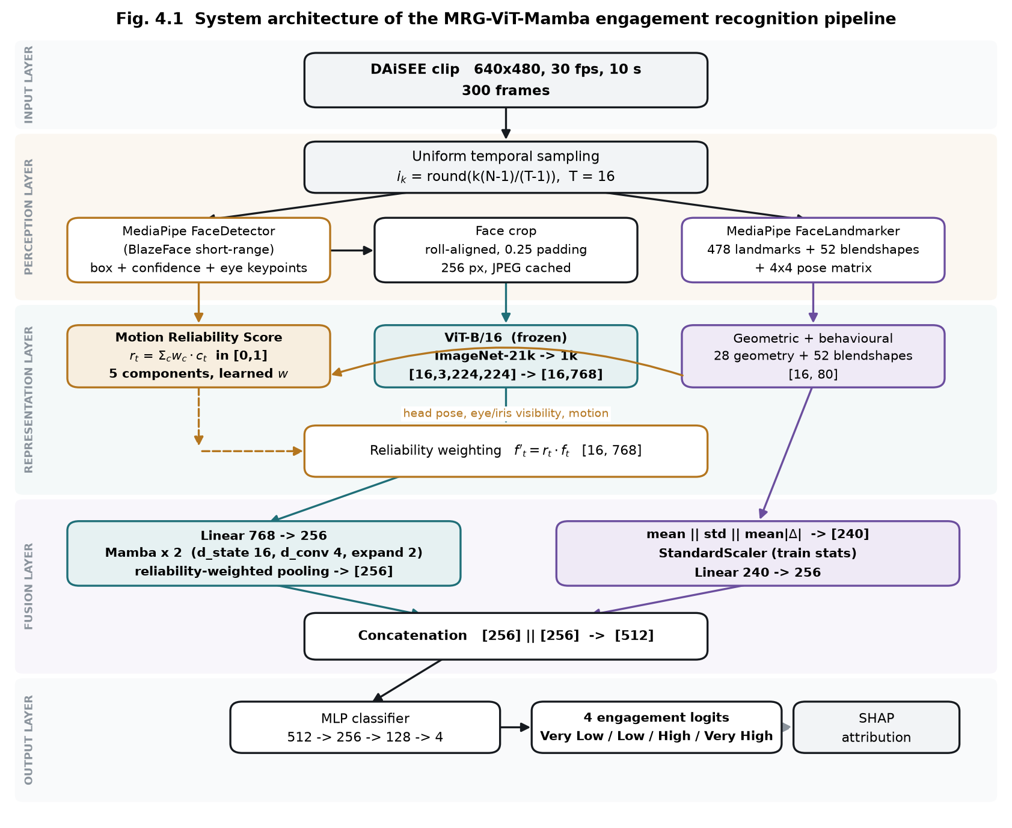
Fig. 4.1 System architecture of the MRG-ViT-Mamba engagement recognition pipeline.
The architecture is organised into five layers. The input layer accepts a ten-second DAiSEE clip at 640 x 480 and 30 frames per second, from which the perception layer draws T = 16 uniformly spaced frames using the index rule i_k = round(k(N-1)/(T-1)). Sampling is deterministic so that a rerun reproduces the same frames exactly.
The perception layer applies two pretrained MediaPipe models to every sampled frame. The BlazeFace short-range detector returns a bounding box, a confidence score and six facial keypoints; the two eye keypoints are used to roll-align the crop before it is padded by 25 percent and resized. The Face Landmarker independently returns 478 three-dimensional landmarks including ten iris points, 52 ARKit blendshape activations, and a 4 x 4 facial transformation matrix from which yaw, pitch and roll are decomposed.
The representation layer contains the three parallel computations that give the architecture its character. The Motion Reliability Score combines five observation-quality signals into a single value per frame. The frozen ViT-B/16 encodes each aligned crop into a 768-dimensional embedding, batched as [B,T,C,H,W] reshaped to [B*T,C,H,W] and restored to [B,T,768] in a single call rather than a per-frame loop. The landmark branch converts the raw mesh into 28 scale-normalised geometric measurements which, with the 52 blendshapes, give an 80-dimensional descriptor per frame. Reliability weighting is then applied as f'_t = r_t * f_t, an operation which by construction preserves the tensor shape and every temporal position.
The fusion layer projects the reliability-weighted sequence from 768 to 256 dimensions and passes it through two Mamba blocks. Each block applies RMSNorm, an input projection, a causal depthwise convolution, a SiLU gate and the selective scan, with a residual connection. The sequence is aggregated by reliability-weighted pooling, D = sum_t r_t h_t / sum_t r_t, which is where the reliability signal most strongly determines the clip representation. In parallel the per-frame landmark descriptors are aggregated across time by concatenating their mean, standard deviation and mean absolute temporal difference, giving a 240-dimensional clip vector which is standardised using training-split statistics and projected to 256 dimensions. The two 256-dimensional branch outputs are concatenated to 512.
The output layer is a multilayer perceptron of 512 to 256 to 128 to 4 with GELU activations and dropout, producing four raw logits trained with class-weighted cross-entropy. SHAP attribution is computed over the representation entering fusion, where the landmark half still has named dimensions and can therefore be grouped into interpretable facial families.

Table 4.1 Parameter budget of the assembled model.
Module | Detail | Parameters | Trained
ViT-B/16 backbone | frozen, preprocessing stage | 85,798,656 | No
Temporal input projection | Linear 768 -> 256 | 196,864 | Yes
Mamba blocks | 2 blocks, d_inner 512, d_state 16 | 876,032 | Yes
Final RMSNorm | 256 | 256 | Yes
Deep branch projection | LayerNorm + Linear 256 -> 256 | 66,304 | Yes
Landmark branch projection | Scaler + Linear 240 -> 256 | 61,696 | Yes
Learnable MRS weights | softmax over 5 components | 5 | Yes
MLP classifier | 512 -> 256 -> 128 -> 4 | 164,740 | Yes
Trainable total |  | 1,365,897
Whole pipeline |  | 87,164,553

4.2 Design

4.2.1 Data Flow Diagram
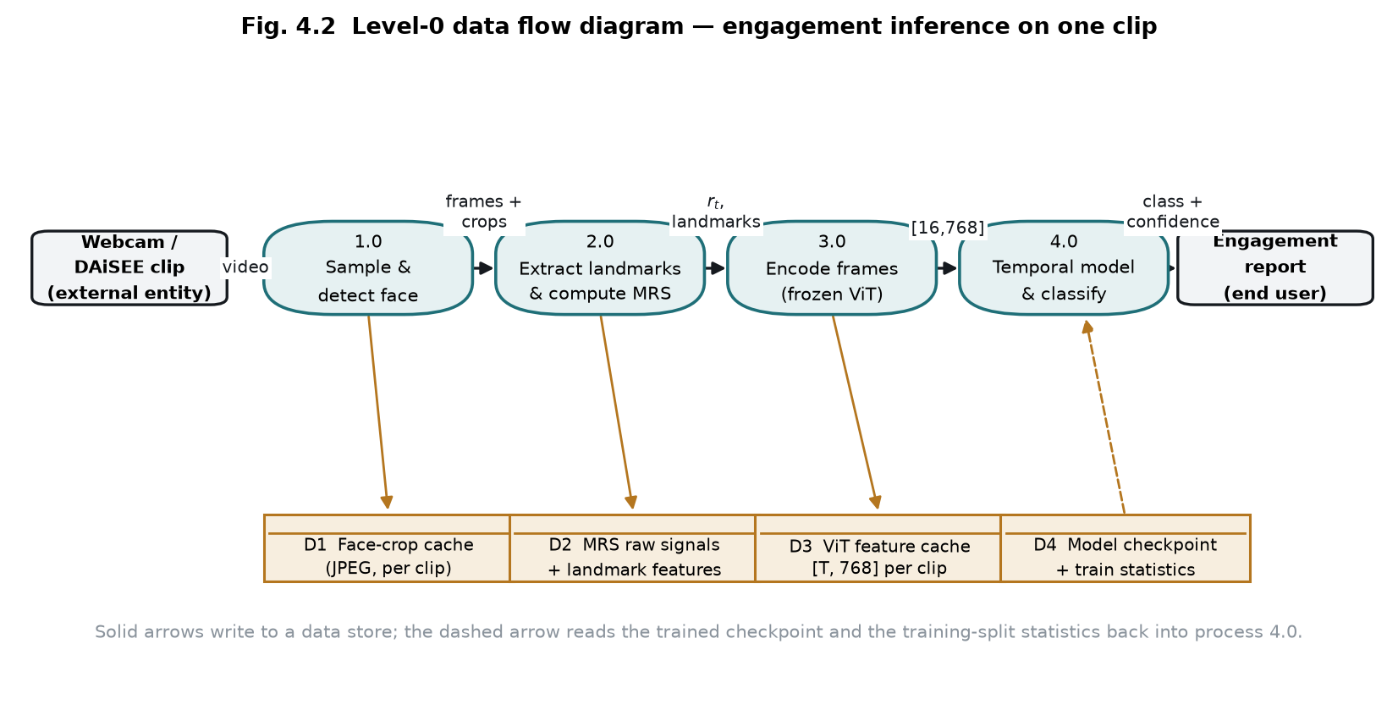
Fig. 4.2 Level-0 data flow diagram for engagement inference on a single clip.
The diagram traces one clip through the system. The clip enters process 1.0, which samples sixteen frames and detects, aligns and crops the face, writing the crops to data store D1. Process 2.0 extracts landmarks and blendshapes and computes the five raw reliability signals, which are written to D2 in their uncalibrated form. Storing the raw signals rather than a finished score is a deliberate design decision: it allows the reliability calibration to be refitted, or the component weights to be changed, without decoding a single video again. Process 3.0 encodes the cached crops with the frozen Vision Transformer, writing the resulting per-frame embeddings to D3. Process 4.0 reads the cached embeddings, the reliability signals and the landmark descriptors, applies the reliability weighting, runs the Mamba temporal encoder and the fusion classifier, and emits the predicted engagement level with its confidence. The dashed edge indicates that process 4.0 also reads the trained checkpoint and the training-split normalisation statistics from D4.

4.2.2 Use Case Diagram
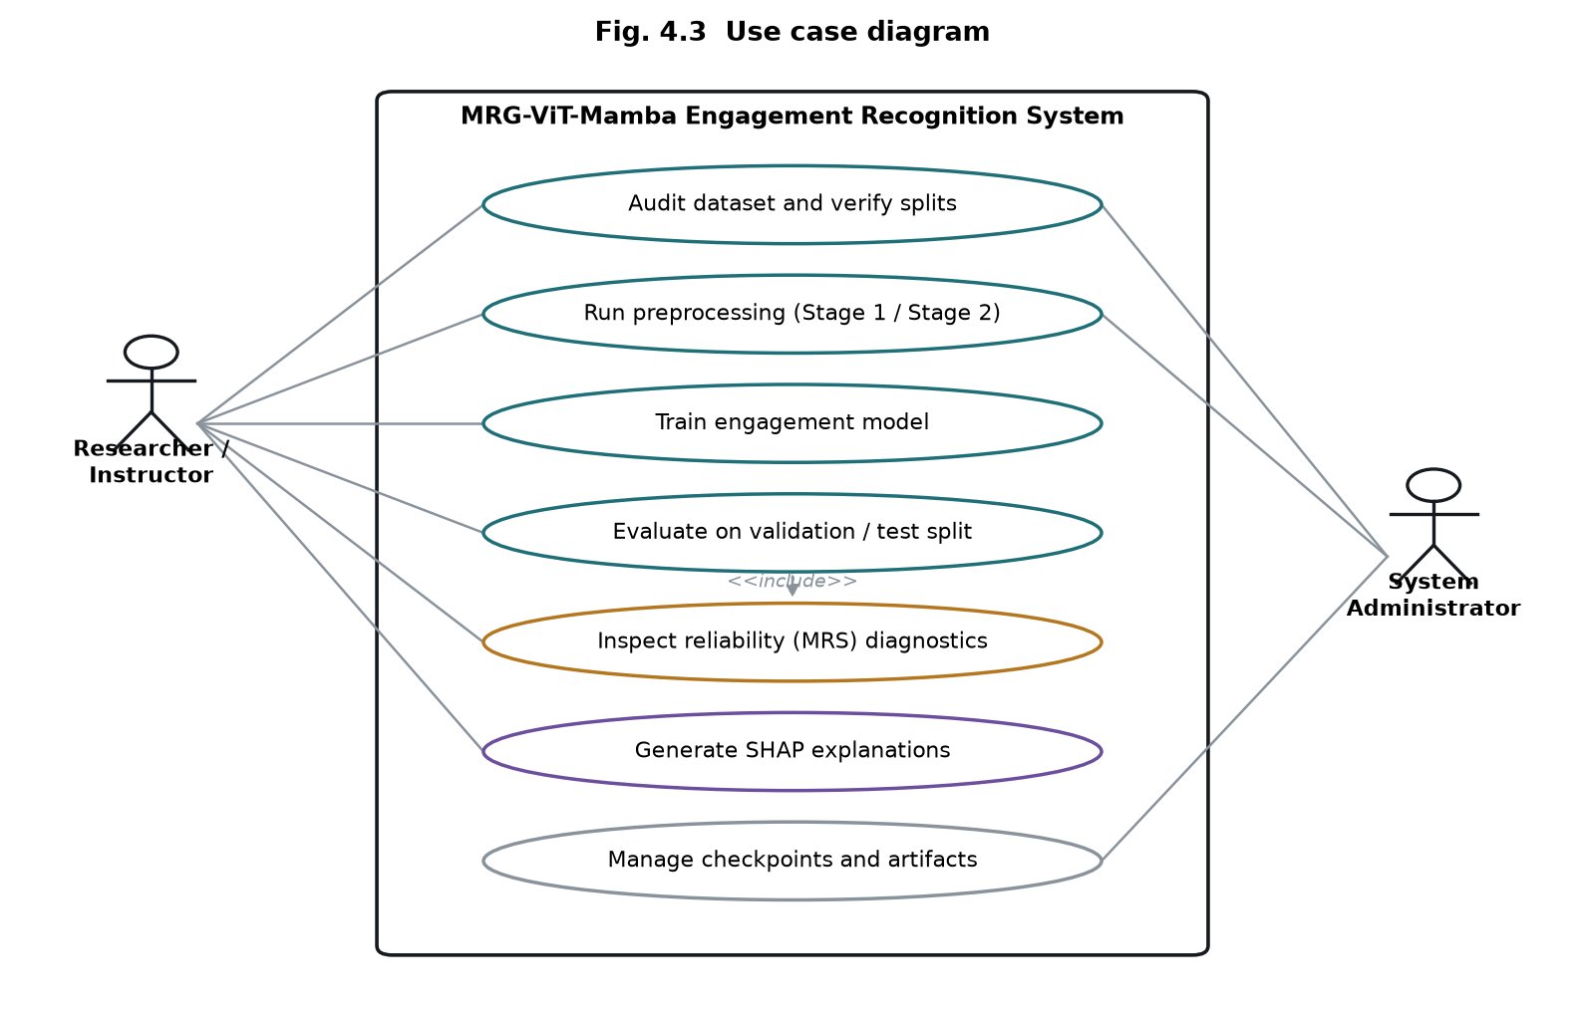
Fig. 4.3 Use case diagram.
Two actors interact with the system. The researcher or instructor audits the dataset and verifies the splits, runs the two preprocessing stages, trains the model, evaluates it on the validation and test partitions, inspects the reliability diagnostics, and generates SHAP explanations. Evaluation includes inspection of the reliability diagnostics, since interpreting a per-class score requires knowing how observable the underlying clips were. The system administrator role covers checkpoint and artifact management along with the preprocessing and audit operations, which are infrastructural rather than experimental.

4.2.3 Class Diagram
A formal class diagram is omitted as optional under the template. The implementation is organised as functional modules rather than a deep class hierarchy: dataset indexing, video sampling, face processing, reliability scoring, landmark extraction, the ViT encoder, the temporal encoder, fusion, the classifier, and evaluation each occupy their own module, and only the neural components are classes, all deriving from torch.nn.Module.

4.2.4 Sequence Diagram
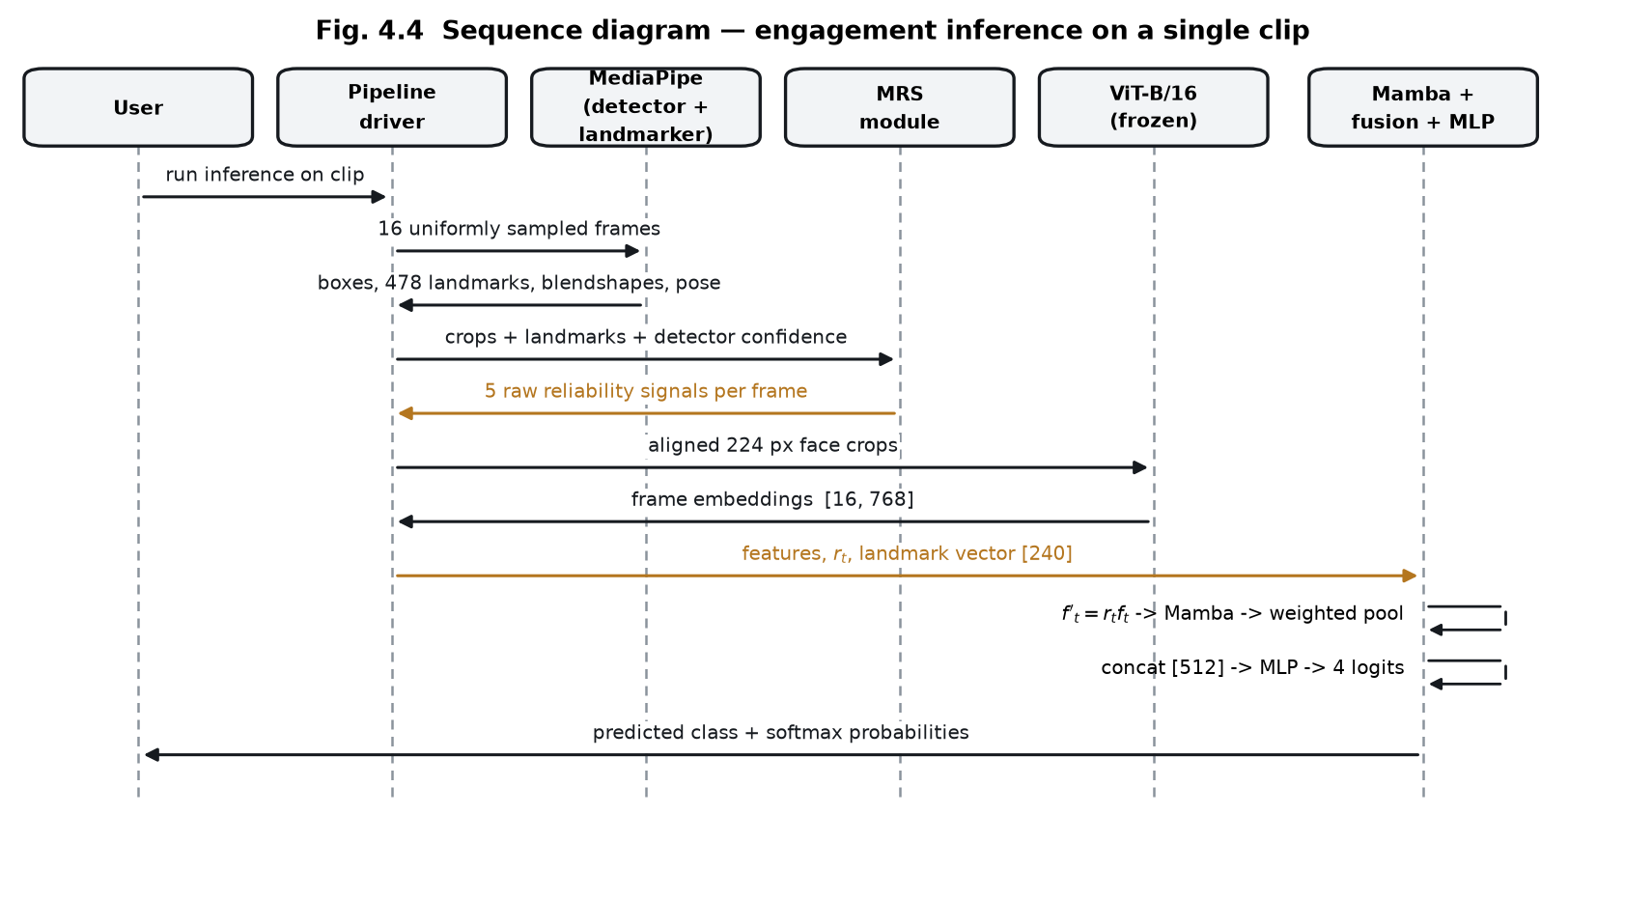
Fig. 4.4 Sequence diagram for engagement inference on a single clip.
The sequence shows the order of interactions during inference. The pipeline driver samples sixteen frames and passes them to MediaPipe, which returns detector boxes, landmarks, blendshapes and pose matrices. These, together with the aligned crops and the detector confidence, are passed to the reliability module, which returns the five raw signals per frame. The crops are then encoded by the frozen Vision Transformer into a [16, 768] tensor. The temporal and fusion stage receives the embeddings, the reliability vector and the landmark descriptor, applies the weighting, runs the Mamba encoder and reliability-weighted pooling, concatenates the two branches and produces four logits, which are returned as a predicted class with softmax probabilities.

4.3 Implementation Status and Preliminary Results
The pipeline described above has been implemented in full and executed end to end. This section records the measurements obtained. Every figure quoted is read from a stored result artifact; where an experiment has not been run, that is stated rather than estimated.

4.3.1 Experimental Setup
Experiments use a 216-clip, class-balanced, subject-disjoint partition of DAiSEE. All 216 clips decode successfully at 30 frames per second and 640 x 480 resolution. Because the four engagement classes are present in exactly equal proportion in every split, chance accuracy is exactly 25 percent and macro F1 is directly interpretable.
Table 4.2 Dataset partition used for the reported experiments.
Split | Clips | Subjects | Very Low | Low | High | Very High
Train | 120 | 48 | 30 | 30 | 30 | 30
Validation | 80 | 17 | 20 | 20 | 20 | 20
Test | 16 | 11 | 4 | 4 | 4 | 4
Total | 216 | 76 | 54 | 54 | 54 | 54
Subject overlap between every pair of splits was measured and is zero, so no participant appears in more than one split.

4.3.2 Training Behaviour
The model was trained for 64 epochs with AdamW, a base learning rate of 3e-4 under a cosine schedule with three warm-up epochs, batch size 8, dropout 0.3 in the classifier, label smoothing 0.05 and class-weighted cross-entropy. The five reliability weights were given a separate, larger learning rate of 2e-2 and no weight decay, since five parameters among 1.37 million would otherwise barely move and decay would pull them back toward uniformity.
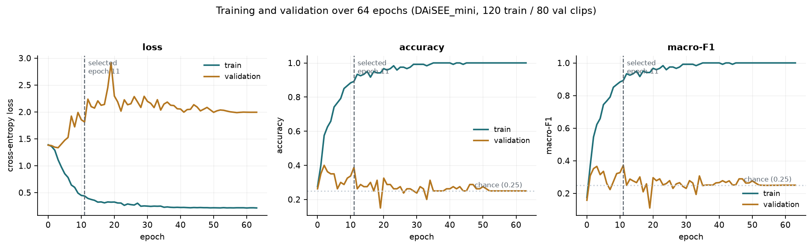
Fig. 4.5 Training and validation loss, accuracy and macro F1 across 64 epochs.
Training accuracy reaches 1.000 by approximately epoch 20 and remains there, while validation loss rises steadily from around epoch 5. This is overfitting, and it is the expected consequence of fitting a 1.37 million parameter head to 120 training clips. The checkpoint reported below is the one selected by validation macro F1, which occurs at epoch 11; the remaining 53 epochs contributed no generalisation improvement. Selection used validation performance only, never test.

4.3.3 Learned Reliability Weights
The five MRS component weights were initialised at 0.20 each and updated by gradient descent throughout training, constrained to the probability simplex by a softmax parameterisation so that they remain positive and sum to one. The final learned values are used unchanged for validation and test.
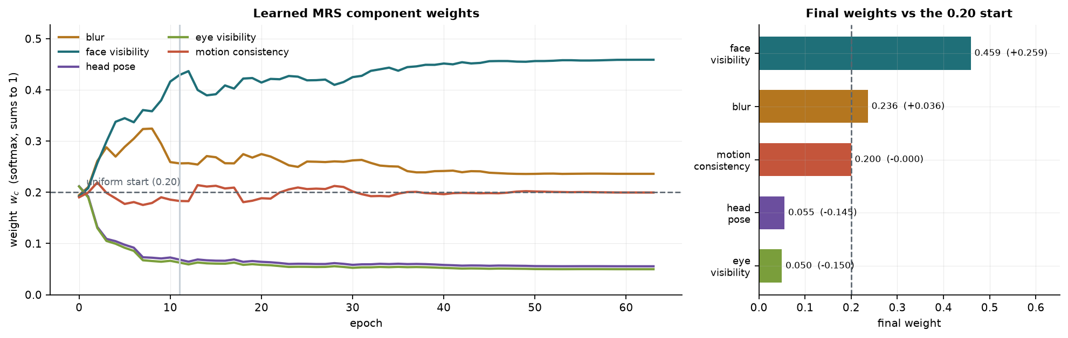
Fig. 4.6 Trajectory of the five learned MRS component weights across 64 epochs, and the final values against the uniform 0.20 initialisation.
Table 4.3 Learned MRS component weights.
Component | Initial | Final | Change
Face visibility | 0.200 | 0.459 | +0.259
Blur | 0.200 | 0.236 | +0.036
Motion consistency | 0.200 | 0.200 | -0.000
Head pose | 0.200 | 0.056 | -0.145
Eye and iris visibility | 0.200 | 0.050 | -0.150

Two observations follow from this result. First, the optimiser concentrated weight on face visibility and blur while suppressing head pose and eye visibility by roughly a factor of four. An independent variance analysis of the same components over the corpus had found head pose and eye visibility to be nearly constant - their standard deviations across frames are 0.083 and 0.034 respectively, against 0.285 for face visibility and 0.352 for motion consistency - because DAiSEE participants sit facing a webcam with their eyes almost always locatable. Two independent methods therefore identify the same two components as uninformative for this corpus.
Second, and importantly for the integrity of the reliability construct, the weight on head pose fell rather than rose. Learning the weights from the classification loss creates a specific risk: because a turned head may correlate with disengagement in the training data, the optimiser could raise the head-pose weight and thereby smuggle an engagement cue into a term that is supposed to measure observability. That did not occur, so the reliability score remained a reliability score.

4.3.4 Reliability Score Distribution
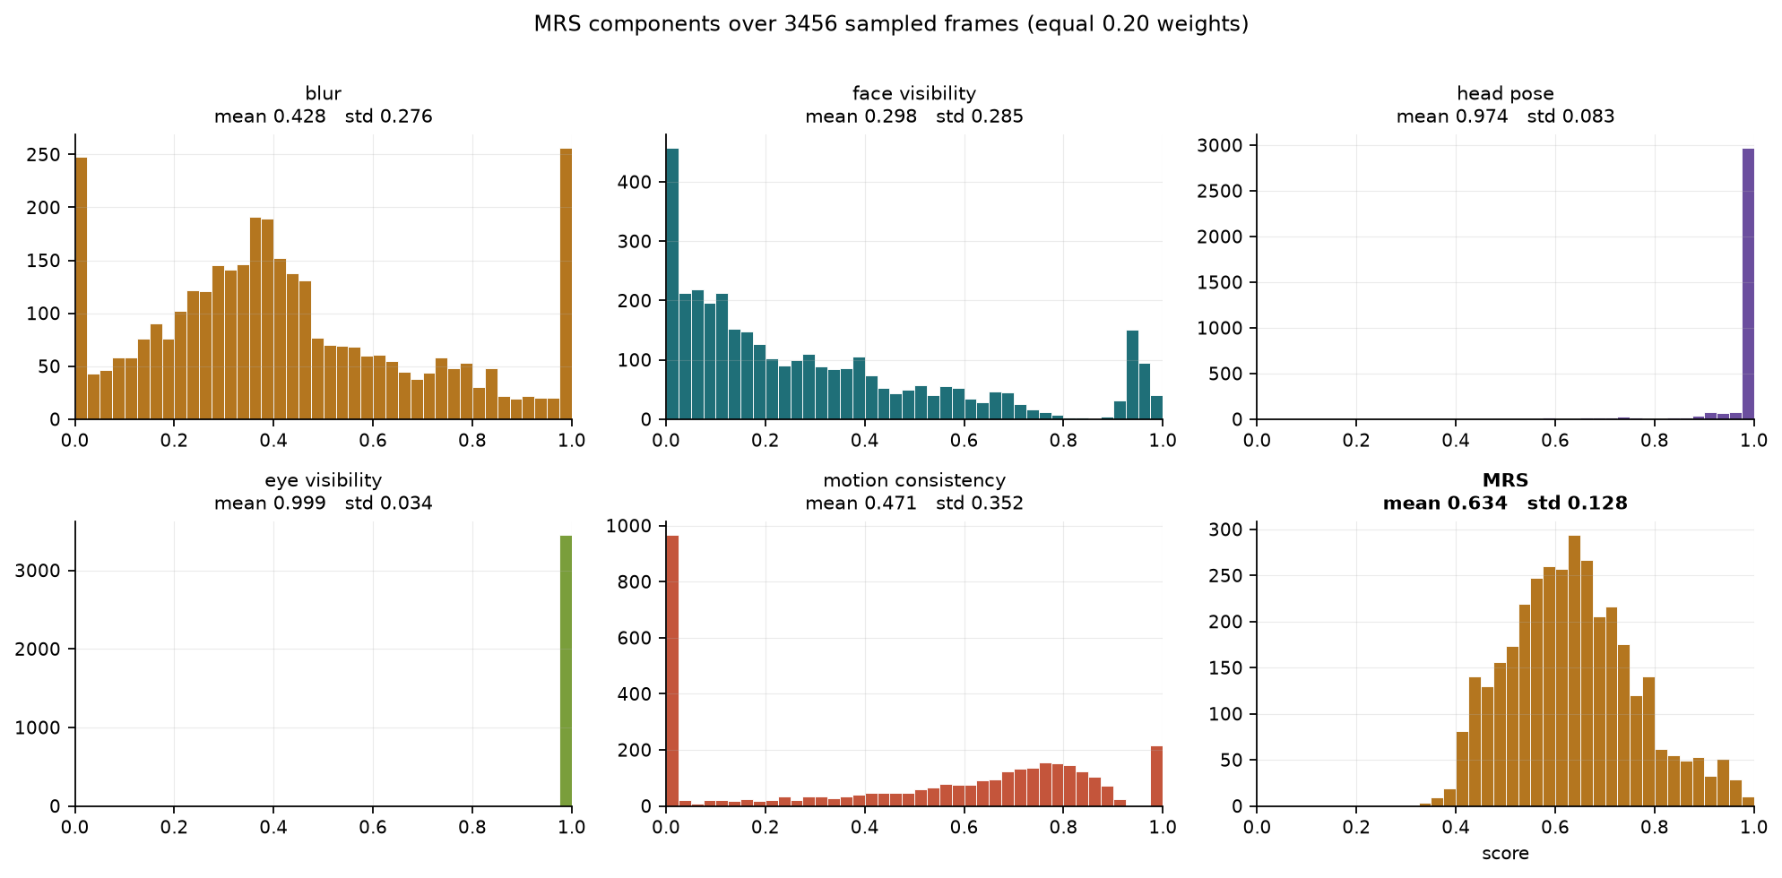
Fig. 4.7 Distribution of the five MRS components and the combined score over 3,456 sampled frames.
Across all 3,456 sampled frames every component lies within [0,1] with no missing or non-finite values, and the combined score has mean 0.634 with standard deviation 0.128. The distributions confirm the weighting result visually: blur, face visibility and motion consistency are broadly spread and therefore informative, whereas head pose and eye visibility are concentrated near 1.0.

4.3.5 Classification Results
The checkpoint selected at epoch 11 by validation macro F1 was evaluated on both the validation and test partitions. Both are balanced, so the chance baseline is 25 percent accuracy.
Table 4.4 Overall classification results.
Split | Clips | Accuracy | Weighted F1 | Macro F1 | Chance
Validation | 80 | 0.3875 | 0.3714 | 0.3714 | 0.2500
Test | 16 | 0.3750 | 0.3915 | 0.3915 | 0.2500

On the validation partition the model classifies 31 of 80 clips correctly. Against a chance rate of 25 percent this gives a one-sided binomial probability of 0.0046, so the result is statistically significant at the 5 percent level. The test partition result of 6 correct from 16 is directionally consistent but, with only sixteen clips, yields a binomial probability of 0.19 and is therefore not statistically significant. The validation partition, being five times larger, is the more reliable indicator and should be read as the primary result.
Table 4.5 Per-class results on the validation partition (20 clips per class).
Engagement level | Precision | Recall | F1 | Support
Very Low | 0.625 | 0.500 | 0.556 | 20
Low | 0.250 | 0.150 | 0.188 | 20
High | 0.342 | 0.650 | 0.448 | 20
Very High | 0.357 | 0.250 | 0.294 | 20

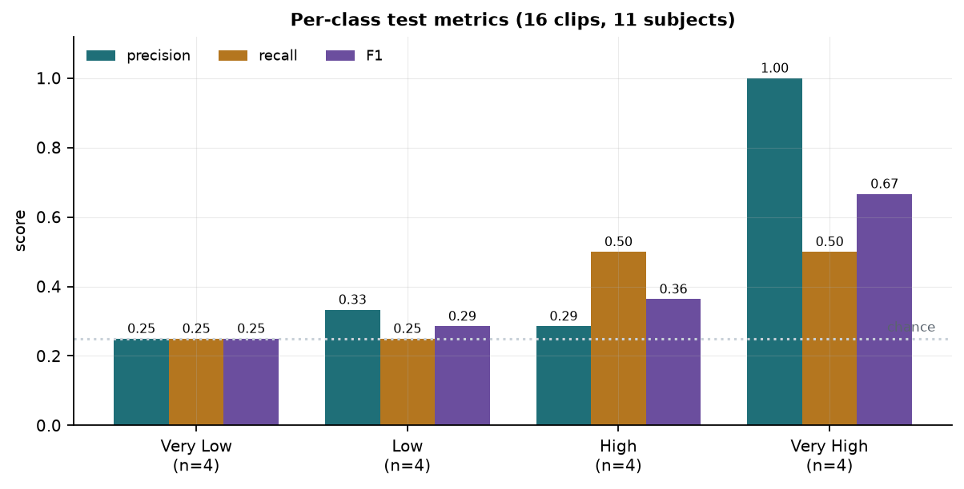
Fig. 4.8 Per-class precision, recall and F1 on the test partition.
All four classes are predicted; none collapses to zero, which was a failure mode observed on an earlier, severely imbalanced subset. The Low level remains the hardest to recognise, and the confusion matrix shows that twelve of its twenty validation clips are absorbed into High. This is consistent with the well-documented difficulty of separating adjacent engagement intensities, which are visually similar even for human annotators.

4.3.6 Explainability
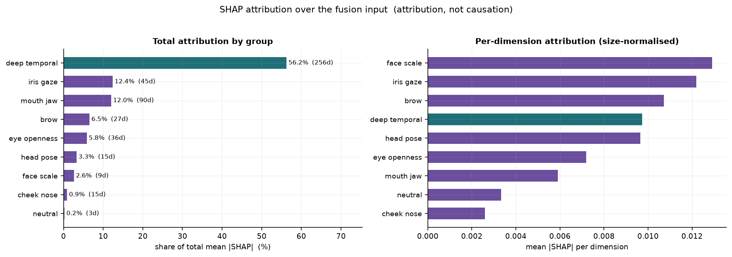
Fig. 4.9 SHAP attribution over the fusion input, by total share and normalised per dimension.
SHAP attribution was computed over the representation entering fusion, so that the landmark half retains named dimensions. The deep temporal branch accounts for 56.2 percent of total attribution, but it also contributes 256 of the 496 input dimensions; normalised per dimension the iris and gaze group is the strongest single contributor at 0.0122, followed by face scale at 0.0129 and brow at 0.0107. The prominence of iris and gaze features is consistent with the intuition that where a learner is looking carries engagement information. These attributions describe what the trained model relied upon and are not evidence of causation.

4.3.7 Worked Examples
To illustrate the decision process, two test clips from two different participants are examined in detail. The first is correctly classified and the second is not, which together show both the intended behaviour and a characteristic failure.
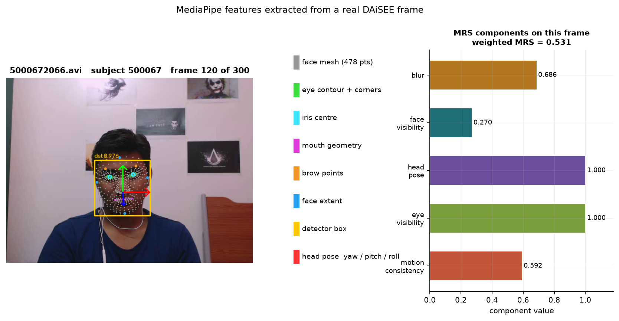
Fig. 4.10 Extracted features for clip 5000672066 (participant 500067): face mesh, iris centres, eye and mouth geometry, brow points, detector box and decomposed head-pose axes, with the reliability components measured on this frame.
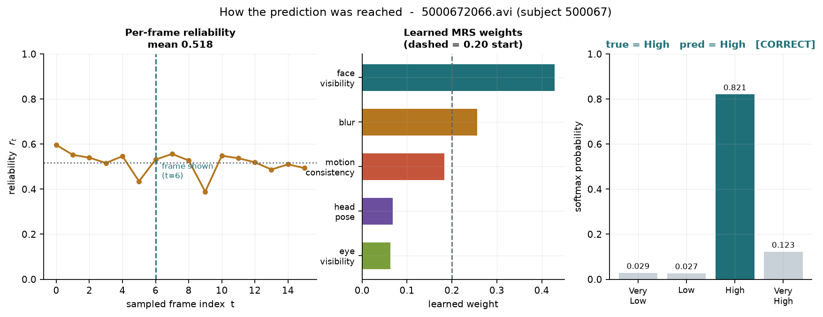
Fig. 4.11 Decision chain for clip 5000672066 - per-frame reliability, learned component weights, and output class probabilities.
For clip 5000672066 the detector reports a confidence of 0.976, all 478 landmarks are located, the iris centres are resolved and the head is close to frontal. The frame shown has blur reliability 0.686, face visibility 0.270, head pose 1.000, eye visibility 1.000 and motion consistency 0.592, combining under the learned weights to a frame reliability of 0.531; the clip mean is 0.518. The model predicts High with probability 0.821, and the ground-truth annotation is High. The prediction is correct.
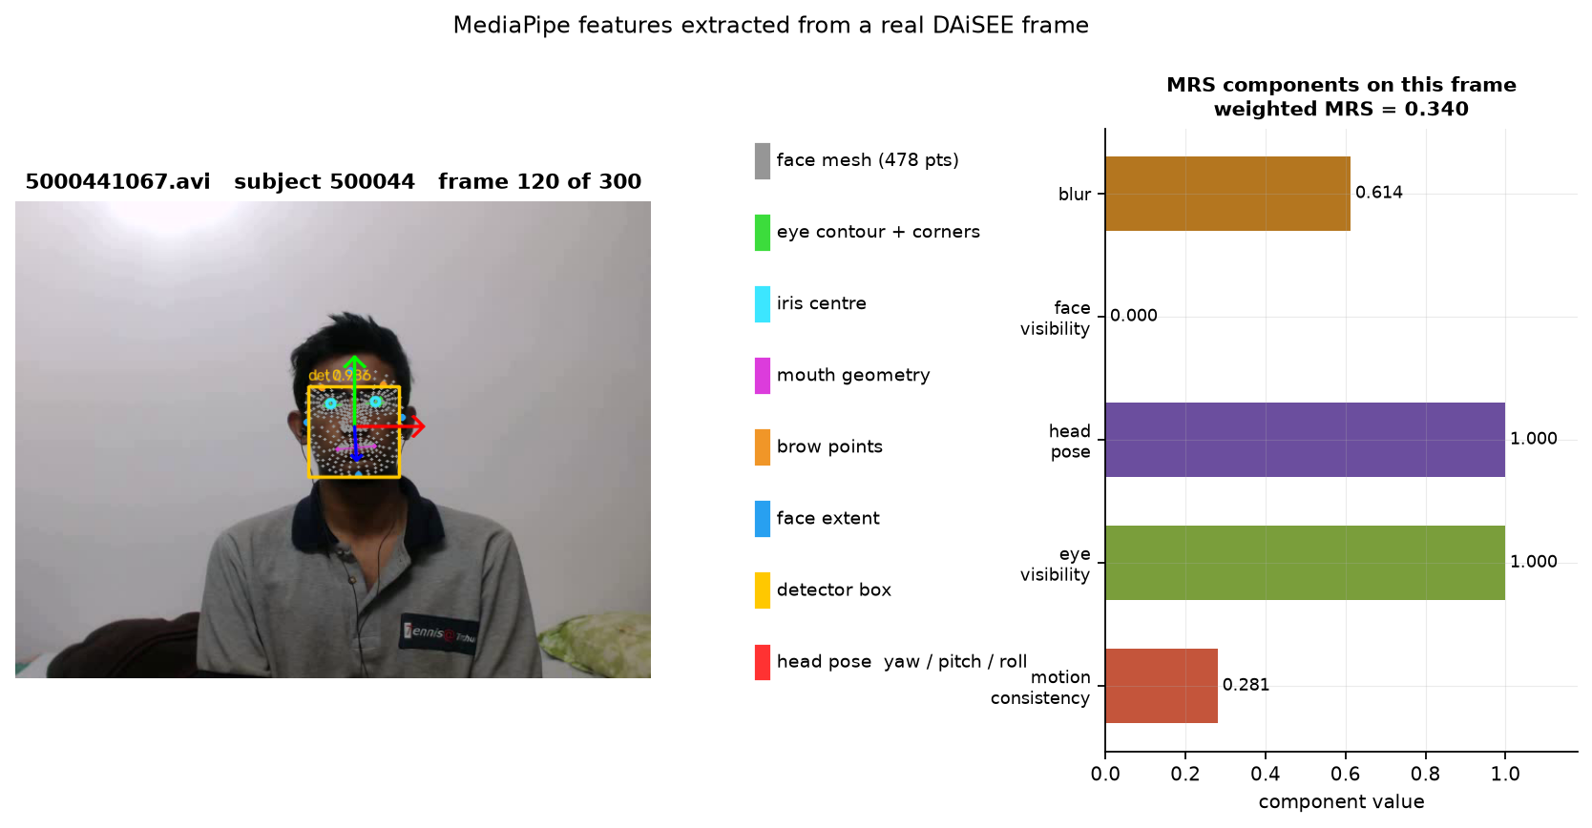
Fig. 4.12 Extracted features for clip 5000441067 (participant 500044).
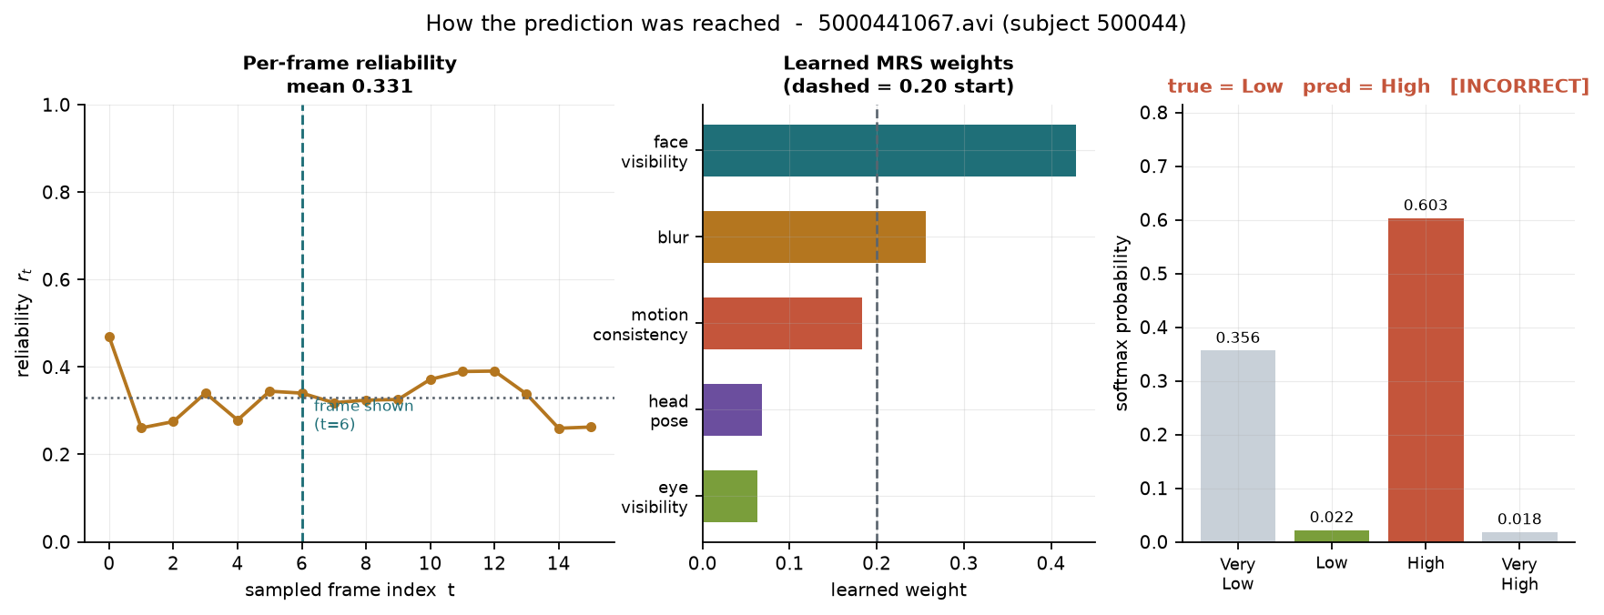
Fig. 4.13 Decision chain for clip 5000441067, an incorrect prediction.
Clip 5000441067 is annotated Low but is predicted High with probability 0.603. Its mean reliability across the sixteen sampled frames is 0.331, substantially below the 0.518 of the correctly classified example. This is instructive rather than merely disappointing: the reliability score independently flagged this clip as poorly observed, and the prediction on it was indeed wrong. The two examples together suggest that the reliability score carries usable information about when a prediction should be distrusted, although establishing that relationship properly would require a calibration study across the full corpus rather than two cases.

4.3.8 Limitations
- The results are obtained on a 216-clip development partition, roughly 2.4 percent of the full DAiSEE release. They are not comparable to published DAiSEE benchmark figures, which use all 9,068 clips, and no such comparison is made.
- The test partition contains only sixteen clips, four per class. A single clip changes accuracy by 6.25 percentage points, and the test result is not statistically significant. The 80-clip validation partition is the meaningful measurement.
- The model overfits: training accuracy reaches 1.000 while validation loss increases from early in training. The reported checkpoint is therefore an early one, and 120 training clips is the binding constraint on performance.
- Results are from a single random seed. An earlier multi-seed study on a different partition showed a seed-to-seed standard deviation of roughly 0.03 in macro F1, so single-seed differences of that magnitude should not be interpreted.
- Learning the reliability weights from the classification loss means the engagement labels influence the combination of the components, although not the components themselves. The alternative of fitting the weights against controlled degradation severity, which uses no labels at all, has been prototyped but is not the configuration reported here.
- The blur component is known to be sensitive to image contrast: a controlled brightness increase raises its score even though sharpness is unchanged. Several alternative sharpness estimators were evaluated and the issue is documented rather than resolved.
- The Mamba encoder uses the official reference implementation rather than the fused CUDA kernel. The computed function is identical; only speed differs.

5. REFERENCES
[1] A. Gupta, A. D'Cunha, K. Awasthi, and V. Balasubramanian, “DAiSEE: Towards user engagement recognition in the wild,” arXiv:1609.01885, 2016.
[2] J. Whitehill, Z. Serpell, Y.-C. Lin, A. Foster, and J. R. Movellan, “The faces of engagement: Automatic recognition of student engagement from facial expressions,” IEEE Transactions on Affective Computing, vol. 5, no. 1, pp. 86–98, 2014.
[3] O. Sumer, P. Goldberg, S. D'Mello, P. Gerjets, U. Trautwein, and E. Kasneci, “Multimodal engagement analysis from facial videos in the classroom,” IEEE Transactions on Affective Computing, vol. 14, no. 2, pp. 1012–1027, 2023.
[4] J. Donahue, L. A. Hendricks, S. Guadarrama, M. Rohrbach, S. Venugopalan, K. Saenko, and T. Darrell, “Long-term recurrent convolutional networks for visual recognition and description,” in Proc. IEEE CVPR, 2015, pp. 2625–2634.
[5] D. Tran, L. Bourdev, R. Fergus, L. Torresani, and M. Paluri, “Learning spatiotemporal features with 3D convolutional networks,” in Proc. IEEE ICCV, 2015, pp. 4489–4497.
[6] G. Bertasius, H. Wang, and L. Torresani, “Is space-time attention all you need for video understanding?,” in Proc. ICML, 2021, pp. 813–824.
[7] A. Gu and T. Dao, “Mamba: Linear-time sequence modeling with selective state spaces,” arXiv:2312.00752, 2023.
[8] L. Zhu, B. Liao, Q. Zhang, X. Wang, W. Liu, and X. Wang, “Vision Mamba: Efficient visual representation learning with bidirectional state space model,” in Proc. ICML, 2024.
[9] “MC-MIFA: A multi-scale contrastive framework with mutual information for student engagement recognition,” PMC13328615, 2025.
[10] C. Lugaresi, J. Tang, H. Nash, C. McClanahan, E. Uboweja, M. Hays, F. Zhang, C.-L. Chang, M. G. Yong, J. Lee, W.-T. Chang, W. Hua, M. Georg, and M. Grundmann, “MediaPipe: A framework for building perception pipelines,” arXiv:1906.08172, 2019.
[11] A. Ablavatski, A. Vakunov, I. Grishchenko, K. Raveendran, and M. Zhdanovich, “Real-time Pupil Tracking from Monocular Video for Digital Puppetry,” arXiv:2006.11341, 2020.
[12] Y. Kartynnik, A. Ablavatski, I. Grishchenko, and M. Grundmann, “Real-time facial surface geometry from monocular video on mobile GPUs,” in Proc. CVPR Workshops, 2019.
[13] P. Ekman and W. V. Friesen, Facial Action Coding System: A Technique for the Measurement of Facial Movement. Palo Alto, CA: Consulting Psychologists Press, 1978.
[14] T. Soukupová and J. Čech, “Real-time eye blink detection using facial landmarks,” in Proc. 21st Computer Vision Winter Workshop, 2016.
[15] J. L. Pech-Pacheco, G. Cristóbal, J. Chamorro-Martínez, and J. Fernández-Valdivia, “Diatom autofocusing in brightfield microscopy: A comparative study,” in Proc. 15th Int. Conf. Pattern Recognition, 2000, pp. 314–317.
[16] F. Crete, T. Dolmiere, P. Ladret, and M. Nicolas, “The blur effect: Perception and estimation with a new no-reference perceptual blur metric,” in Proc. SPIE Human Vision and Electronic Imaging XII, vol. 6492, 2007.
[17] P. Terhörst, J. N. Kolf, N. Damer, F. Kirchbuchner, and A. Kuijper, “SER-FIQ: Unsupervised estimation of face image quality based on stochastic embedding robustness,” in Proc. IEEE CVPR, 2020, pp. 5651–5660.
[18] A. Kendall and Y. Gal, “What uncertainties do we need in Bayesian deep learning for computer vision?,” in Proc. NeurIPS, 2017, pp. 5574–5584.
[19] J. Yang, P. Ren, D. Zhang, D. Chen, F. Wen, H. Li, and G. Hua, “Neural aggregation network for video face recognition,” in Proc. IEEE CVPR, 2017, pp. 4362–4371.
[20] S. M. Lundberg and S.-I. Lee, “A unified approach to interpreting model predictions,” in Proc. NeurIPS, 2017, pp. 4765–4774.
[21] A. Dosovitskiy, L. Beyer, A. Kolesnikov, D. Weissenborn, X. Zhai, T. Unterthiner, M. Dehghani, M. Minderer, G. Heigold, S. Gelly, J. Uszkoreit, and N. Houlsby, “An image is worth 16x16 words: Transformers for image recognition at scale,” in Proc. ICLR, 2021.
[22] A. Steiner, A. Kolesnikov, X. Zhai, R. Wightman, J. Uszkoreit, and L. Beyer, “How to train your ViT? Data, augmentation, and regularization in vision transformers,” Transactions on Machine Learning Research, 2022.
[23] Y. Cui, M. Jia, T.-Y. Lin, Y. Song, and S. Belongie, “Class-balanced loss based on effective number of samples,” in Proc. IEEE CVPR, 2019, pp. 9268–9277.
[24] V. Bazarevsky, Y. Kartynnik, A. Vakunov, K. Raveendran, and M. Grundmann, “BlazeFace: Sub-millisecond neural face detection on mobile GPUs,” arXiv:1907.05047, 2019.
[25] I. Loshchilov and F. Hutter, “Decoupled weight decay regularization,” in Proc. ICLR, 2019.

Web resources:
DAiSEE dataset - https://people.iith.ac.in/vineethnb/resources/daisee/
Mamba reference implementation - https://github.com/state-spaces/mamba
Vision Mamba (Vim) - https://github.com/hustvl/Vim
MediaPipe Solutions - https://ai.google.dev/edge/mediapipe/solutions/guide
PyTorch Image Models (timm) - https://github.com/huggingface/pytorch-image-models

