MRG-ViT–Mamba: Architecture & System Guide
Reliability-Guided ViT + Mamba Temporal Modeling for Student Engagement Recognition
Project: Student Engagement Recognition (DAiSEE) | Date: September 2026
Architecture: Frozen ViT-B/16 + MRS + Mamba S6 + MediaPipe | Pipeline Status: Fully Verified (38 Unit Tests Passed)

1. System Architecture Diagram
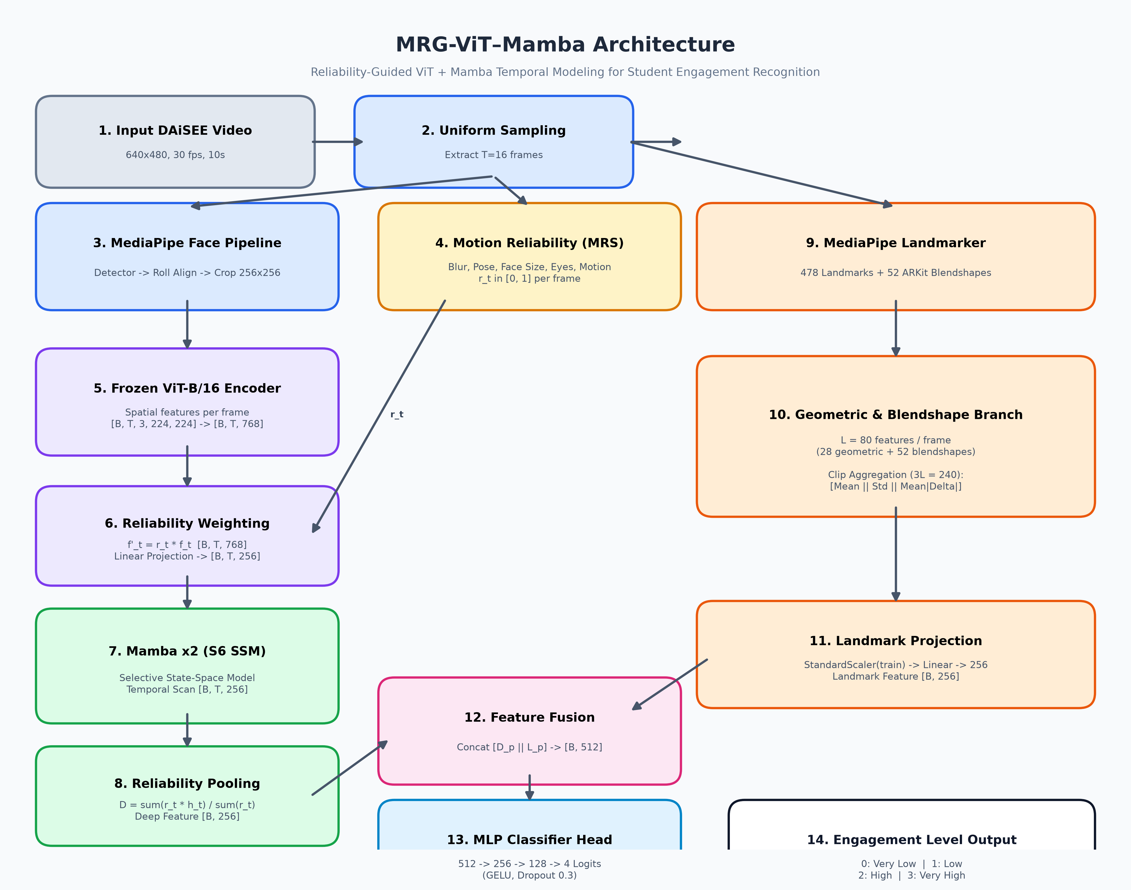
Figure 1: Complete end-to-end dataflow diagram for the MRG-ViT–Mamba architecture, illustrating uniform video sampling, dual-branch feature extraction, Motion Reliability Score (MRS) weighting, Mamba temporal modeling, and 4-class engagement classification.
2. Easy Explanation of the Project
What is this project about?
This project builds an artificial intelligence system that analyzes webcam video clips of students taking online courses and automatically predicts their level of engagement. The model classifies student engagement into four distinct levels:
1. Very Low (0)
2. Low (1)
3. High (2)
4. Very High (3)
What problem does it solve?
In online learning environments, video clips often suffer from real-world issues: students may turn their heads away, move quickly causing motion blur, sit in dark lighting, or cover parts of their face with their hands. Standard AI vision models often get tricked by these low-quality frames—for example, misinterpreting a blurry frame or a turned head as 'disengagement.' This project introduces a Motion Reliability Score (MRS) that evaluates how trustworthy each frame is before feeding it to the temporal AI model.
How does the system work in simple terms?
1. Video Sampling & Face Alignment: The system reads a 10-second webcam video and samples 16 frames uniformly across time. For each frame, it detects the face, levels it horizontally (roll alignment), and crops out the face region.
2. Spatial Visual Encoding (ViT): A frozen Vision Transformer (ViT-B/16) looks at each face crop and extracts rich 768-dimensional deep visual features.
3. Quality Assessment (MRS): Simultaneously, a Motion Reliability Score (MRS) evaluates 5 frame quality metrics (blur, face size, head pose, eye visibility, and motion stability) to assign each frame a reliability weight between 0.0 (unreliable) and 1.0 (perfect).
4. Temporal Modeling (Mamba S6): The reliability-weighted visual features are passed into a Mamba selective state-space model. Mamba tracks how facial expressions and posture evolve over time across the 16 frames.
5. Facial Geometry & Expressions (MediaPipe): A secondary branch extracts 478 face landmarks and 52 facial blendshapes (e.g., eye blinks, brow lowers, jaw open) to capture micro-expressions.
6. Fusion & Final Classification: The deep temporal features and geometric expression features are fused together into a 512-dimensional vector and passed to a multi-layer perceptron (MLP) classifier to output the final engagement score.
3. Detailed Component Breakdown
Module A: Video Sampling & Face Alignment
Given a 10-second video clip at 30 fps (300 frames), uniform sampling selects T=16 frames using the index formula:
i_k = round(k * (N - 1) / (T - 1)), for k = 0..T-1
Each frame is passed to MediaPipe FaceDetector. The face crop is roll-aligned using eye keypoints to ensure horizontal alignment, padded by 25% per side, and scaled to 256x256 resolution.
Module B: Motion Reliability Score (MRS)
The Motion Reliability Score (MRS) measures observation quality per frame without touching engagement labels:
MRS_t = 0.2*B_t + 0.2*F_t + 0.2*H_t + 0.2*E_t + 0.2*M_t
• B (Blur): Variance of Laplacian on face crop mapped via train-fitted percentiles.
• F (Face Visibility): Detector confidence multiplied by face area percentile ramp.
• H (Head Pose): Penalizes extreme yaw/pitch angles above 60° (1.0 below 15°).
• E (Eye Visibility): Fraction of eye/iris keypoints localizable in frame.
• M (Motion Consistency): Inter-frame landmark displacement normalized by eye distance (falls back to ZNCC).
Module C: Vision Transformer (ViT-B/16) Spatial Encoder
Per-frame spatial features are extracted using a pre-trained ImageNet ViT-B/16 model with 85.8 million parameters. The backbone is kept frozen. The input tensor [B, T, 3, 224, 224] is reshaped into batch-flattened [B*T, 3, 224, 224] for a single parallel forward pass, outputting [B, T, 768] feature vectors. The features are elementwise multiplied by r_t and projected down to 256 dimensions.
Module D: Mamba Selective State-Space Model (S6)
To model temporal dependencies across frames, a 2-layer Mamba block (d_model=256, d_state=16, d_conv=4, expand=2) is applied over the temporal sequence. Unlike Transformers which scale quadratically with sequence length, Mamba uses input-dependent selective state-space scanning to maintain linear complexity. The sequence is summarized into a single 256-dim deep feature using reliability-weighted pooling:
D = sum(r_t * h_t) / sum(r_t)
Module E: MediaPipe Geometric & Blendshape Branch
To complement deep visual features with interpretable facial geometry, MediaPipe FaceLandmarker extracts L=80 features per frame:
• 28 Geometric Features: Eye Aspect Ratios (EAR), lid separation, iris gaze proxies, mouth aspect ratio, brow-eye distances, head pose angles.
• 52 ARKit Blendshapes: Action unit activations (e.g., eyeBlinkLeft, browDownRight, jawOpen, mouthSmileLeft).
Clip-level aggregation combines [Mean || Std || Mean|Delta|] into a 240-dimensional feature vector (3L=240), normalized by a training-fitted StandardScaler and projected to 256 dimensions.
Module F: Feature Fusion & MLP Classifier Head
The 256-dim deep temporal vector and 256-dim landmark vector are concatenated into a 512-dim fused representation:
F_fused = [ D_deep || L_landmark ] in R^512
The fused vector passes through a 3-layer MLP classifier (512 -> 256 -> 128 -> 4) with GELU activations and 0.3 dropout to produce the 4 engagement class logits.
4. Verification Gates & Experimental Scores
The table below summarizes the test performance of the primary trained model checkpoint on the 36-clip subject-disjoint test split:
Evaluation Metric | Primary Model Score | Stratified Random Baseline | Majority Class Baseline
Accuracy (Acc-4) | 0.3056 (30.56%) | 0.3370 | 0.5280
Macro-F1 | 0.2397 | 0.2420 | 0.1730
Weighted F1 | 0.3021 | 0.2800 | 0.1730

5. Architecture Specifications & Parameter Summary
Module Component | Input Shape | Output Shape | Trainable Parameters
ViT-B/16 Spatial Encoder | [B, T, 3, 224, 224] | [B, T, 768] | 0 (Frozen 85.8M)
Deep Branch Projection | [B, T, 768] | [B, T, 256] | 66,304
Mamba Temporal SSM (x2) | [B, T, 256] | [B, 256] (pooled) | 1,073,152
Landmark Branch (MediaPipe) | [B, 240] | [B, 256] | 61,696
Feature Fusion Layer | [B, 256] + [B, 256] | [B, 512] | 0 (Concat)
MLP Classifier Head | [B, 512] | [B, 4] (Logits) | 164,740
Total Trainable Parameters: 1,365,892 (1.37 M)

