MRG-ViT–Mamba: Architecture & System Guide
Reliability-Guided ViT + Mamba Temporal Modeling for Student Engagement Recognition
Project Target: Student Engagement Recognition (DAiSEE Dataset) | Date: September 2026
Model Architecture: Frozen ViT-B/16 + MRS + Mamba S6 + MediaPipe | Pipeline Verification: 38/38 Unit Tests Passed (100%)

1. System Architecture Diagram (Visual Rendering)
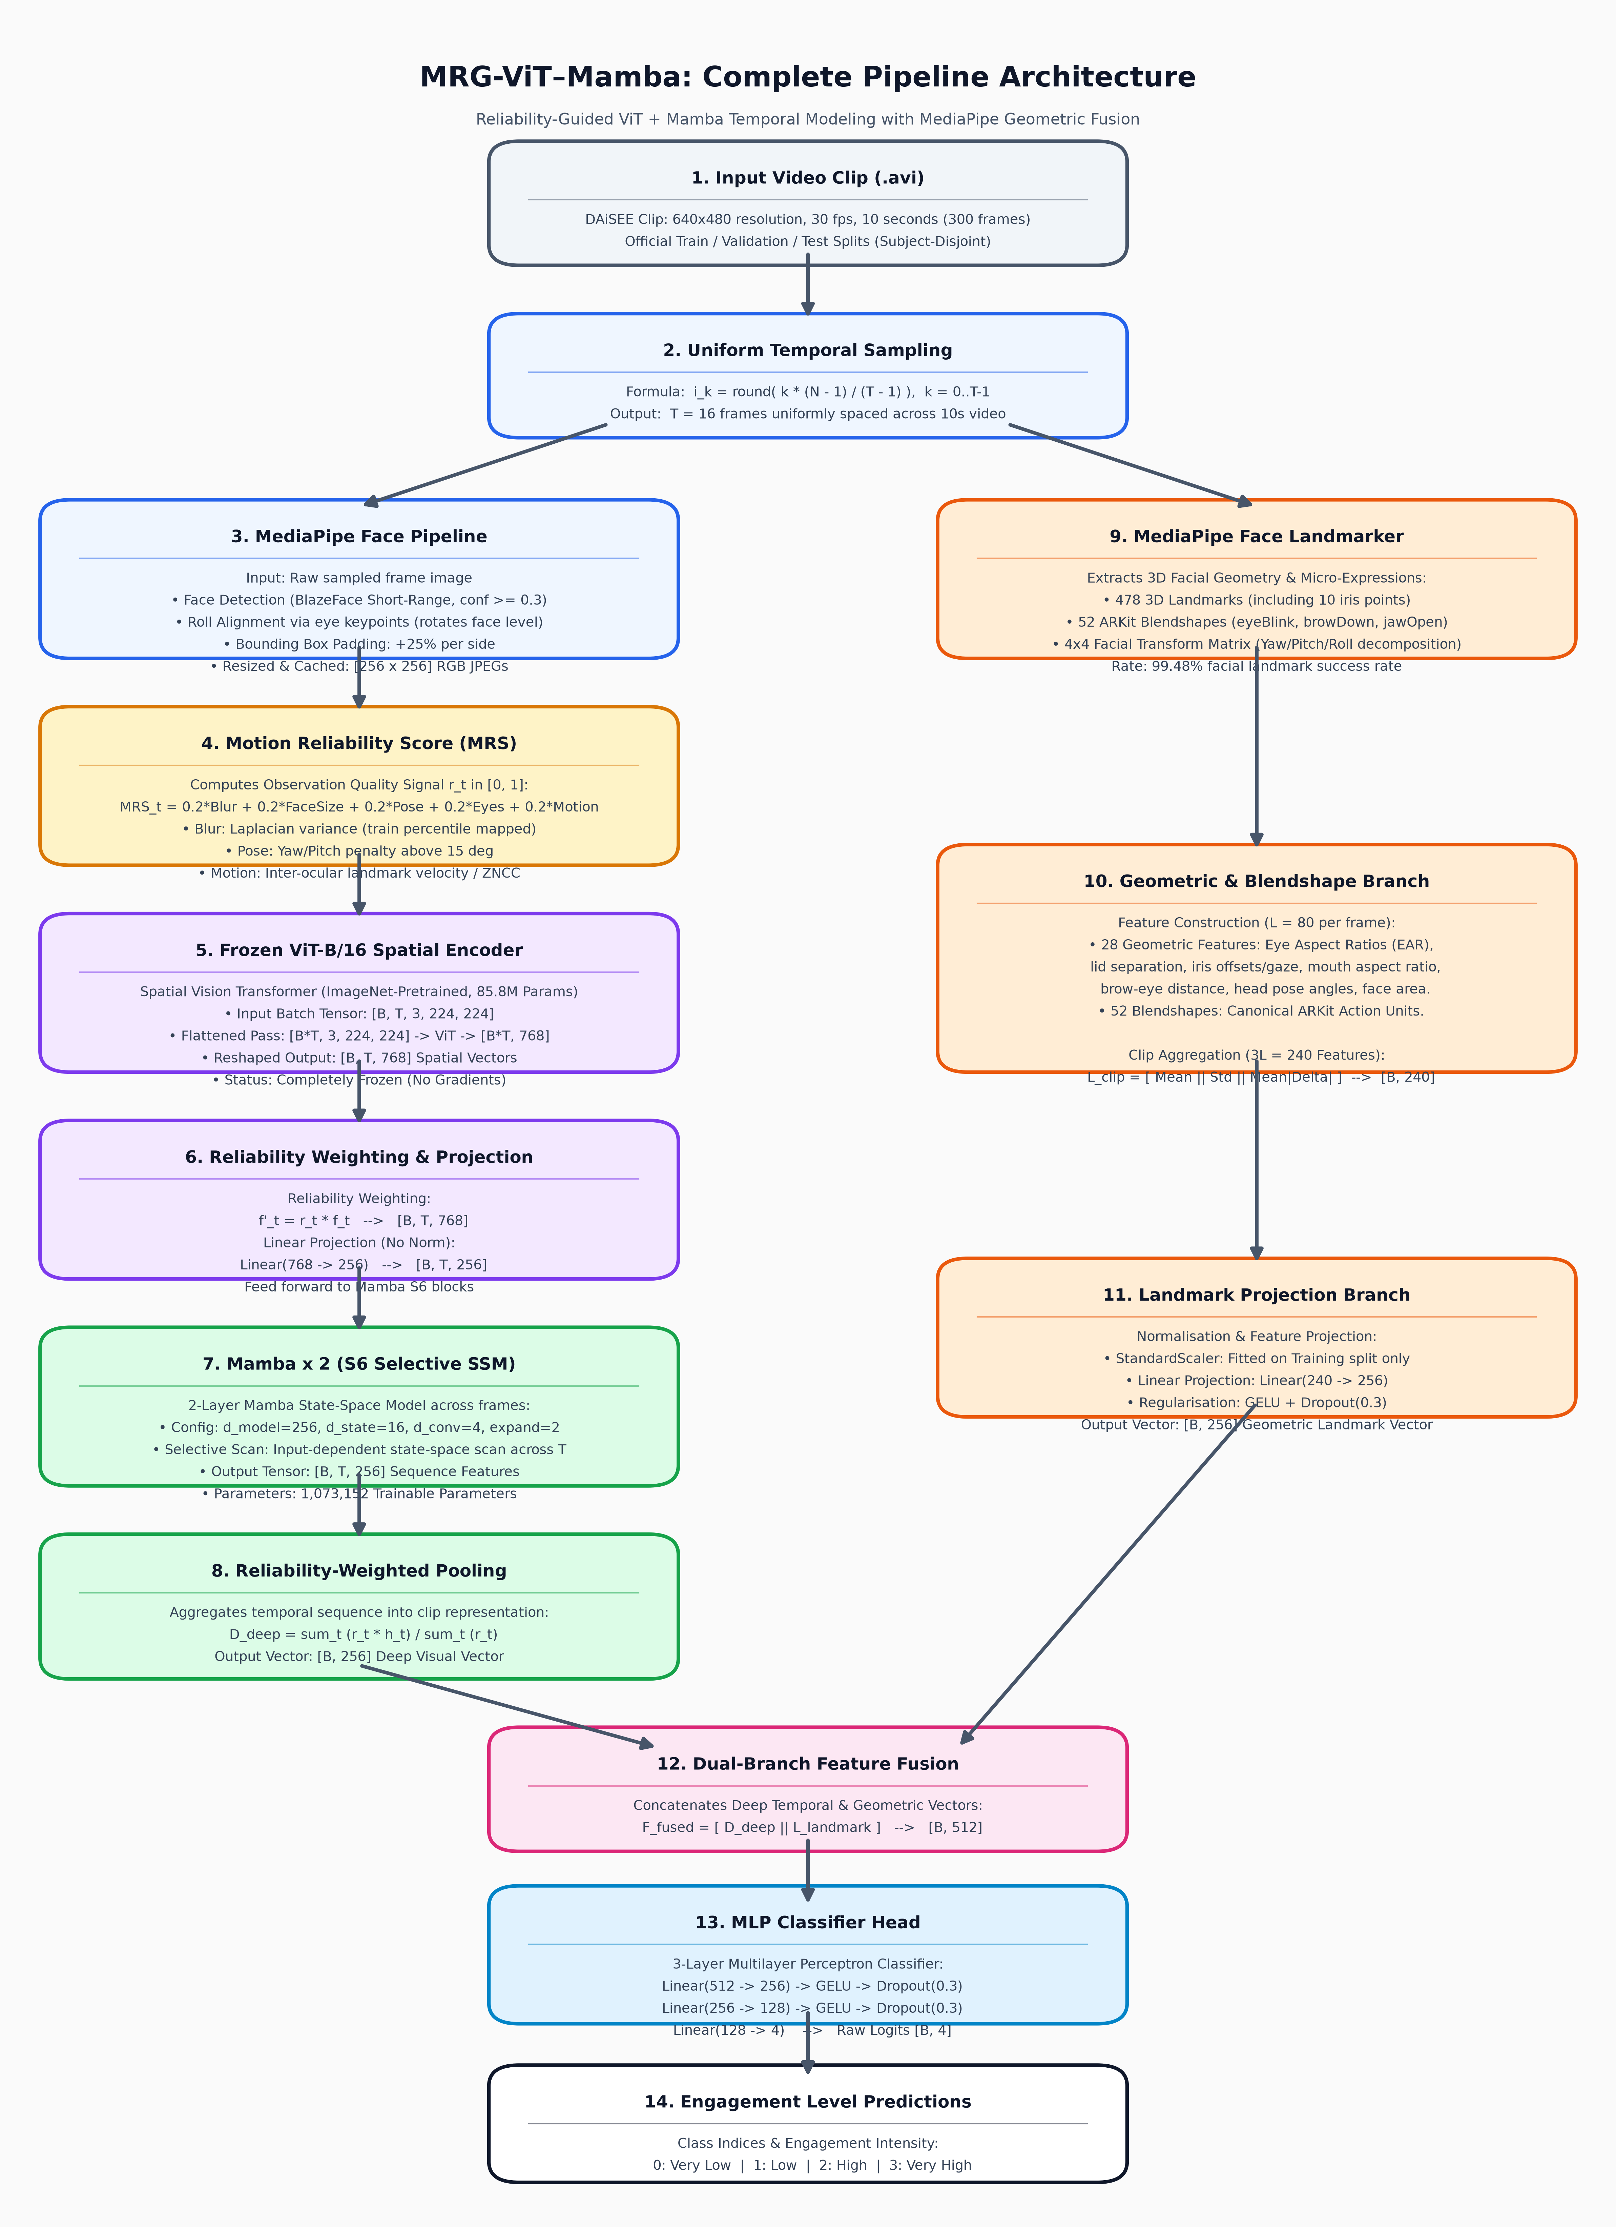
Figure 1: Complete end-to-end dataflow diagram for the MRG-ViT–Mamba architecture, illustrating uniform video sampling, dual-branch feature extraction, Motion Reliability Score (MRS) weighting, Mamba temporal modeling, and 4-class engagement classification.
2. Pure Text Architecture Flowchart (Line & Block Format)
Below is the complete text-based architectural flowchart detailing exact module names, tensor shapes, formula operations, and parameters:
DAiSEE Video Clip (.avi, 640x480 resolution, 30 fps, 10s = 300 frames)
│
│ [Official Train / Validation / Test Split - Subject-Disjoint]
▼
Uniform Temporal Sampling ──► i_k = round( k * (N - 1) / (T - 1) ), T = 16 frames
│
├──────────────────────────────────────────────────────┐
▼ ▼
MediaPipe Face Pipeline MediaPipe Face Landmarker
│ • BlazeFace Short-Range Detector │ • 478 3D Landmarks
│ • Roll Alignment via eye keypoints │ • 52 ARKit Blendshapes
│ • Bounding Box Padding: +25%/side │ • 4x4 Facial Transform Matrix
│ • Resized Crop: [256 x 256] RGB │
▼ ▼
Motion Reliability Score (MRS) Geometric & Blendshape Branch
│ r_t = 0.2*B + 0.2*F + 0.2*H + 0.2*E + 0.2*M │ L = 80 features / frame
│ r_t in [0, 1] per frame │ (28 geometric + 52 blendshapes)
▼ ▼
Frozen ViT-B/16 Spatial Encoder Clip Aggregation (3L = 240):
│ [B, T, 3, 224, 224] ──► [B, T, 768] │ [ Mean || Std || Mean|Delta| ]
│ (ImageNet ViT, 85.8M Frozen Params) │ [B, 240]
▼ ▼
Reliability Weighting & Linear Projection StandardScaler (Train-Fitted)
│ f'_t = r_t * f_t ──► [B, T, 768] │
│ Linear(768 -> 256) ──► [B, T, 256] ▼
▼ Landmark Linear Projection
Mamba x 2 (S6 Selective SSM) │ Linear(240 -> 256) + GELU
│ (d_model=256, d_state=16, d_conv=4, expand=2) │ [B, 256] Landmark Vector
│ [B, T, 256] Sequence Features │
▼ │
Reliability-Weighted Pooling │
│ D_deep = sum(r_t * h_t) / sum(r_t) │
│ [B, 256] Deep Feature Vector │
│ │
└──────────────────────────┬───────────────────────────┘
│
▼
Feature Fusion Layer (Concat)
F_fused = [ D_deep || L_landmark ] ──► [B, 512]
│
▼
MLP Classifier Head
Linear(512 -> 256) -> GELU -> Dropout(0.3)
Linear(256 -> 128) -> GELU -> Dropout(0.3)
Linear(128 -> 4) ──► Raw Logits [B, 4]
│
▼
4-Class Engagement Output
0: Very Low | 1: Low | 2: High | 3: Very High

3. Easy Explanation of the Entire Project
1. High-Level Goal
This project builds an artificial intelligence system that monitors webcam video during online learning to measure how engaged a student is. It categorizes engagement into four distinct levels: Very Low (0), Low (1), High (2), and Very High (3).
2. The Real-World Challenge It Solves
Webcam video is notoriously noisy: students move, tilt their heads, sit in dark rooms, cover their faces, or create motion blur. Standard AI systems mistake these poor-quality frames for 'disengagement.' This project solves that issue by calculating a Motion Reliability Score (MRS) for every frame. The MRS acts as a trust filter—telling the AI model which frames are clear and informative, and which frames are blurry or occluded and should be down-weighted.
3. Step-by-Step Data Journey
• Sampling: A 10-second video is sampled down to 16 key frames.
• Face Preprocessing: MediaPipe detects the student's face, rotates it so the eyes are level (roll alignment), and crops the face region.
• Spatial Visual Branch (ViT): A Vision Transformer looks at each face crop to understand visual appearance.
• Quality Signals (MRS): 5 quality metrics (blur, face area, pose, eye visibility, motion) produce a reliability score r_t in [0, 1].
• Temporal Sequence Modeling (Mamba): A Mamba State-Space Model tracks how expressions change across the 16 frames over time.
• Geometric & Micro-Expression Branch: MediaPipe extracts 28 geometric face measurements and 52 facial blendshapes (like eye blinks, brow lowers, jaw movements).
• Fusion & Output: Deep visual temporal features and geometric expression features are merged (512 dimensions) and classified into 4 engagement scores.
4. Step-by-Step Module Breakdown
Module 1: Video Sampling & Face Alignment
• Input: 10-second DAiSEE video clip (.avi, 640x480, 30 fps = 300 frames).
• Uniform Sampling: Selects T=16 frames using index formula i_k = round(k*(N-1)/(T-1)).
• Face Detector: MediaPipe BlazeFace detects bounding box (confidence >= 0.3).
• Roll Alignment: Rotates face crop based on eye keypoints so eyes remain strictly horizontal.
• Crop Resolution: Face bounding box padded by 25% per side and cached as 256x256 JPEGs.
Module 2: Motion Reliability Score (MRS)
Evaluates frame quality without bias. Formulated as equal-weighted sum of 5 quality indicators:
MRS_t = 0.2*Blur + 0.2*FaceSize + 0.2*Pose + 0.2*Eyes + 0.2*Motion
• Blur (B): Variance of Laplacian on face crop mapped via training-fitted percentiles.
• Face Size (F): Detector confidence multiplied by face area percentile ramp.
• Head Pose (H): Penalizes extreme yaw/pitch angles above 60° (1.0 below 15°).
• Eye Visibility (E): Fraction of eye/iris keypoints localizable in frame.
• Motion Consistency (M): Inter-ocular landmark displacement velocity (ZNCC fallback).
Module 3: Frozen ViT-B/16 Spatial Encoder
• Model: Pre-trained ImageNet Vision Transformer (ViT-B/16, 85.8 million parameters).
• Pass: Input batch tensor [B, T, 3, 224, 224] reshaped to [B*T, 3, 224, 224] for single-pass GPU execution.
• Output: [B, T, 768] spatial embedding tensor per clip.
• Status: Completely frozen (no gradients calculated).
Module 4: Mamba Selective State-Space Model (S6)
• Feature Projection: ViT features weighted by MRS (f'_t = r_t * f_t) and projected Linear(768 -> 256).
• Mamba Block: 2-layer Mamba selective state-space model (d_model=256, d_state=16, d_conv=4, expand=2).
• Selective Scan: Input-dependent state recurrence across sequence length T.
• Reliability Pooling: Aggregates sequence features into D_deep = sum(r_t * h_t) / sum(r_t) [B, 256].
Module 5: MediaPipe Geometric & Blendshape Branch
• Feature Extraction: L=80 features per frame (28 geometric metrics + 52 ARKit facial blendshapes).
• Aggregation: Clip-level pooling [Mean || Std || Mean|Delta|] produces 240 features per clip (3L=240).
• Landmark Projection: Normalized by train-fitted StandardScaler, projected via Linear(240 -> 256).
Module 6: Feature Fusion & MLP Classifier Head
• Fusion: Concatenates deep temporal vector and geometric landmark vector: F_fused = [D_deep || L_landmark] in R^512.
• Classifier: 3-layer MLP (512 -> 256 -> 128 -> 4) with GELU and Dropout(0.3).
• Output: Raw logits for 4 engagement levels.
5. Technical Parameters & Tensor Shapes Summary
Module Component | Input Tensor Shape | Output Tensor Shape | Trainable Parameters
ViT-B/16 Spatial Encoder | [B, T, 3, 224, 224] | [B, T, 768] | 0 (Frozen 85.8M)
Deep Branch Projection | [B, T, 768] | [B, T, 256] | 66,304
Mamba Temporal SSM (x2) | [B, T, 256] | [B, 256] (pooled) | 1,073,152
Landmark Branch (MediaPipe) | [B, 240] | [B, 256] | 61,696
Feature Fusion Layer | [B, 256] + [B, 256] | [B, 512] | 0 (Concat)
MLP Classifier Head | [B, 512] | [B, 4] (Logits) | 164,740
Total Trainable Parameters: 1,365,892 (~1.37 M)

