Explainable multimodal AI for early detection of learning engagement and emotional states in children using eye movement

Adhvaith N A, Deepika J (0000-0002-1246-4609), Don George, Ilakkiya S
School of Computer Science and Engineering, Vellore Institute of Technology, Vellore (India)

Abstract
Webcam pipelines for engagement recognition usually throw away badly observed frames, which breaks the even temporal sampling that sequence models depend on. We test a different treatment. A five-part Motion Reliability Score (MRS) with learned mixing weights scales each Vision Transformer (ViT) frame embedding and the temporal pooling of a Mamba state-space encoder, and a facial landmark branch is fused before classification. On the full, subject-disjoint Dataset for Affective States in E-Environments (DAiSEE), disengagement detection reaches an area under the receiver operating characteristic curve (ROC-AUC) of 0.794, level with the best published result on the same split. A controlled ablation puts the gain from reliability weighting at 0.0002 ROC-AUC, and SHapley Additive exPlanations (SHAP) trace most of the signal to eye and gaze geometry. Comparisons across training-set size, backbones, frame counts and image degradations are also reported.
Keywords
Affective Computing, Engagement Recognition, Explainable Artificial Intelligence, State-Space Models, Vision Transformer.

Introduction
E
NGAGEMENT predicts learning outcome better than most things a teacher can observe, and it has become harder to watch since teaching moved online. In a classroom the instructor reads the room and adjusts. In a video call, where students appear as a grid of thumbnails, that feedback mostly disappears. Automatic engagement recognition from webcam video is an attempt to recover some of it [1].
The Dataset for Affective States in E-Environments (DAiSEE) [2] is the usual public benchmark for the task. It holds 9,068 ten-second clips of 112 participants filmed in uncontrolled settings, and every clip is rated for boredom, confusion, engagement and frustration on four ordered levels. Two properties make it hard. The engagement labels are badly imbalanced: the two upper levels cover about 95% of the test partition. Adjacent levels also look alike, even to the people who labelled them. On this corpus, accuracy on its own says little about a model [1], [3].
* Corresponding author: Deepika J
E-mail address: deepika.j@vit.ac.in, ashokadhvaith@gmail.com ,
dongeomac04@gmail.com, ilakkiyamax@gmail.com

Engagement is also a temporal construct, which sets it apart from facial expression. A smile can be seen in one frame; engagement has to be inferred from how attention holds, how the gaze wanders and how posture settles over several seconds. Recognition therefore calls for a model that reads sequences. Recurrent networks over per-frame descriptors [4], three-dimensional convolution [5] and space-time attention [6] have all been used for video, and selective state-space models such as Mamba [7] now model sequences at a cost that grows linearly with their length. Vision Mamba [8] applies the same idea across image patches. Here the state-space encoder runs along the time axis only, and a Vision Transformer (ViT) [9] handles each frame.
Observation quality is a second problem, and it has received less attention. In webcam footage a participant turns to talk to someone off-camera, the autofocus hunts, or a hand covers the face. Variance of the Laplacian [10] is still the standard sharpness measure when no reference image exists. Face image quality scores predict recognition error [11], uncertainty estimates can down-weight unreliable inputs [12], and neural aggregation networks learn a weight for each frame in video face recognition [13]. Engagement pipelines, by contrast, usually treat quality as a gate and drop frames that fall below a threshold. That choice hurts a temporal model. Once frames are removed, the encoder sees an unevenly spaced sequence with no marker where the gaps are, so a pause in behaviour and a gap in observation look the same.
Three gaps follow from that literature. Reliability is used to gate frames, and we are not aware of a DAiSEE pipeline that keeps the full sequence while damping the unreliable frames. Where several quality factors are combined, their weights are set by hand, usually equally. Reliability is also mixed up with behaviour: a turned head or closed eyes is often taken as a sign of disengagement, when a turned head only means that less of the face is visible. In this work every sampled frame stays in the sequence and counts in proportion to how well it was seen. The reliability score uses observation-quality evidence alone, and its component weights are learned. The paper makes four contributions:
- A formulation of observation reliability that keeps sequence length fixed. It is applied to the frame embeddings and to temporal pooling, and its component weights are learned from data.
- A controlled ablation on the full DAiSEE release that measures what the mechanism adds, with a power analysis that explains why an earlier small-scale comparison could not settle the question.
- An account of how softmax-parameterised mixing weights can collapse onto one component without warning, and simulation evidence that weight decay prevents it while a lower learning rate does not.
- A comparative analysis against published DAiSEE systems and across training-set size, backbones, frame counts and synthetic image degradation, together with an attribution analysis that locates the useful signal in specific facial features.
Section II covers the data, participants and methods. Section III reports the results and the comparisons, Section IV interprets them and states the limitations, and Section V concludes.

Methods

Materials
All main experiments use the full DAiSEE release and its official partition. We joined the video files to the official label files and dropped 497 videos that had no label row, which left 8,570 labelled clips. Engagement is the only prediction target. Table I gives the clip and subject counts we obtained, with the class distribution. A script checked that no participant appears in more than one partition, and none does.
TABLE I. DAiSEE Partition as Indexed, With Engagement Class Counts
Partition | Clips | Subjects | L0 | L1 | L2 | L3
Train | 5,357 | 69 | 34 | 213 | 2,617 | 2,494
Validation | 1,429 | 19 | 23 | 143 | 813 | 450
Test | 1,784 | 21 | 4 | 84 | 882 | 814
ª L0 to L3 are the engagement levels Very Low, Low, High and Very High. No subject appears in two partitions.
Levels 0 and 1 have 34 and 213 training clips and only 4 and 84 test clips. With four test clips, a per-class F1 for level 0 is mostly noise, so we evaluate two reduced formulations. The three-class version merges levels 0 and 1 into a Low class. The binary version separates engaged clips (levels 2 and 3) from not-engaged clips (levels 0 and 1). Merging leaves the accuracy bar where it was: a majority-class predictor scores 882/1,784 = 0.4944 on the test partition under both the four-class and the three-class labels.
Two smaller sets were used alongside the full release. A 1,500-clip training subset (69 not-engaged and 1,431 engaged clips) was used to train the three-class model and an earlier binary model; both were scored on the full validation and test partitions. A development corpus of 108 clips, with 36 clips in each partition and the test clips drawn from eight subjects, was used for the seven-arm ablation, the robustness tests, the backbone probe and the frame-count sweep in Sections III.E to III.G. These development experiments use the four engagement levels.
All tools are public pretrained models and open-source libraries. Faces are found with the MediaPipe [14] BlazeFace short-range detector [15]. The MediaPipe Face Landmarker [16], [17] returns, for each frame, 478 three-dimensional landmarks (ten of them on the irises), 52 blendshape activations and a 4 × 4 facial transformation matrix. Aligned face crops go through a ViT-B/16 backbone [9], [18] pretrained on ImageNet and loaded from the PyTorch Image Models library. For the temporal encoder we used the reference (non-fused) Mamba implementation [7], which computes the same function as the fused CUDA kernel but needs no compiler toolchain. Experiments ran on a laptop with an NVIDIA GeForce RTX 3060 graphics processing unit (GPU) with 6 GB of memory, 16 GB of system memory and an x86-64 processor with eight logical cores, under Python 3.13 and PyTorch 2.11. The Appendix lists the full software stack.

Participants
We made no new recordings. The participants are those of the DAiSEE corpus [2]: 112 students aged 18 to 30, filmed by webcam while they watched e-learning material in dormitories, laboratories, libraries and offices. The dataset's authors release it for research under a registration agreement, and this study relies on the consent they obtained. Because the clips show identifiable faces, the raw video, the face crops and the landmark data stayed on the processing machine, were kept out of version control and are not shared with this paper. We also treat the DAiSEE engagement labels as third-party judgements of visible behaviour. They are not measurements of what a learner was thinking.

Tasks and Methods

Frame Sampling and Face Processing
Each clip (640 × 480 pixels at 30 frames per second, about 300 frames) is cut down to T = 16 frames by deterministic uniform sampling, as in (1), where N is the number of decoded frames. The sampler always returns T indices, so every clip gives a sequence of the same length.
$i_{k}=\operatorname{round}\left(\frac{k\left(N−1\right)}{T−1}\right), k=0,…,T−1$ (1)
In each sampled frame we detect the face, roll-align the crop on the two eye keypoints, pad it by 25%, resize it to the backbone's input size and record the detector confidence. If no face is found, the pipeline steps through a fixed, logged fallback chain and marks the frame as unreliable; it does not drop the frame. Crops and raw quality signals are cached under a key built from every setting that affects them, so an out-of-date cache cannot be reused by accident.

Motion Reliability Score
For frame t we compute five components s_{t,c} ∈ [0, 1] from observation quality alone. Blur comes from the variance of the Laplacian and face visibility from the box area and detector confidence. Head pose is the yaw and pitch distance from frontal, eye visibility comes from the landmark mesh, and motion consistency from frame-to-frame landmark displacement. Blur and face area are calibrated against percentiles of the training partition only, and no engagement label enters the calculation. The components are combined as in (2) and (3).
$r_{t}=\sum_{c=1}^{5}{w_{c}s_{t,c}}$ (2)
$w=\operatorname{softmax}\left(θ\right), θ∈ℝ^{5}$ (3)
The weight vector w is the softmax of five free parameters θ, trained by gradient descent along with the rest of the network. Setting θ to zero gives exactly 0.2 per component. Zero is therefore a natural starting point and, as Section III.H shows, a useful target for regularisation.

Reliability-Weighted Temporal Encoder
Fig. 1 shows the pipeline. Reliability enters the network twice. Each ViT embedding f_{t} ∈ ℝ⁷⁶⁸ is multiplied by its own reliability, as in (4). After the state-space encoder, the sequence is pooled with a reliability-weighted average, as in (5), where h_{t} is the encoder output at position t.
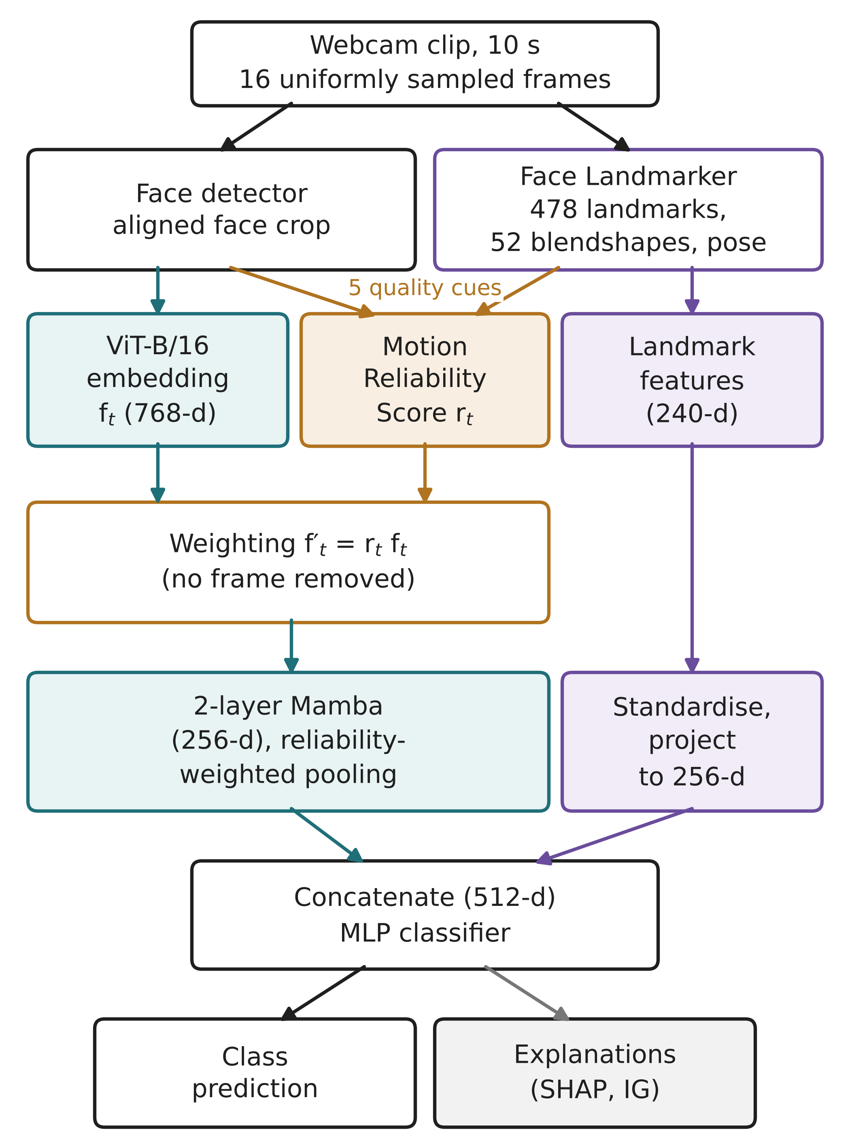
Fig. 1. Pipeline of the proposed system. Reliability is applied as a weight at two points and never removes a temporal position.
${f′}_{t}=r_{t}f_{t}$ (4)
$z=\frac{\sum_{t=1}^{T}{r_{t}h_{t}}}{\sum_{t=1}^{T}{r_{t}}}$ (5)
Neither step deletes a frame. The number and order of positions stay the same, so the encoder still receives an evenly sampled sequence. The weighted sequence is projected from 768 to 256 dimensions and passed through two Mamba blocks. Each block applies RMS normalisation, an input projection, a causal depthwise convolution, a SiLU gate and the selective scan, with a residual connection (state dimension 16, inner dimension 512). In the final configuration the last four of the twelve ViT blocks and the final normalisation layer are trained; that is 28.4 million of the backbone's 85.8 million parameters.

Landmark Branch and Fusion
A second branch turns the landmark mesh into 28 scale-normalised geometric measurements, such as the eye aspect ratio [19]. With the 52 blendshape activations, which are close in meaning to facial action units [20], this gives an 80-dimensional descriptor per frame. Over time we take the mean, the standard deviation and the mean absolute frame-to-frame difference of each named feature, which yields a 240-dimensional clip vector. Its standardiser is fitted on the training partition only. Both branches are projected to 256 dimensions and concatenated. A multilayer perceptron (MLP) with layers of 512, 256 and 128 units, GELU activations and dropout then produces the class logits. The full model has 87.2 million parameters, of which 1.27 million belong to the parts introduced in this work.

Training and Evaluation Design
Class imbalance can be handled by changing how often each class is drawn, through a weighted sampler, or by changing how much each mistake costs, through a class-weighted cross-entropy loss. We use one or the other and never both, because the two effects multiply. On the binary task the sampler alone lifts the minority class from 4.6% to 27.8% of draws. Stacking effective-number loss weights [21] on top would push the effective prior to about 81% when the true rate is 4.6%. Training uses decoupled weight decay [22], and every source of randomness is seeded.
Full-scale checkpoints are chosen on validation balanced accuracy. Raw accuracy is a poor choice here. In a preliminary run the best validation accuracy, 0.579, came at the first epoch against a validation majority baseline of 0.569, from a model that had hardly moved away from the class prior. Development-scale runs are chosen on validation macro F1. For the binary task we also fix an operating threshold on the validation partition and apply it unchanged to the test partition. The test partition is read once per run, after selection, with three-view test-time augmentation, and it never feeds back into model choice.
We report accuracy, balanced accuracy, macro and weighted F1, per-class precision, recall and F1 and the confusion matrix, each beside the baseline it should be judged against. For the binary task we add ROC-AUC and average precision (AP), since neither depends on a decision threshold. A suite of 169 automated tests checks temporal integrity, leakage between splits, class merging, weight stability and the metric code.

Comparative Protocols
Four further comparisons were run at development scale. In the seven-arm ablation each arm changes one design choice and is trained with five seeds (42 to 46). In the backbone probe, five frozen image encoders are compared with a balanced multinomial logistic regression on reliability-weighted, mean-pooled features, fitted on the training partition and scored on validation. The frame-count sweep repeats training at T = 8, 16, 32 and 64 with three seeds and times the cached-feature head on the GPU at batch size 1. For robustness, nine degradations are applied in memory to the decoded frames, and two models trained on clean data (with and without reliability weighting, seed 42) are evaluated unchanged.

Explainability
SHAP [23] values are computed with an expected-gradients explainer over the fused representation, for 512 test clips against 512 background clips. The landmark half of that representation keeps named dimensions, so it can be grouped into facial feature families. Integrated gradients [24] from an all-zero baseline split the contribution of the deep and landmark branches on single clips, and Grad-CAM [25] on the ViT shows which parts of the face the model looks at.

Results

Three-Class Engagement Recognition
For the model trained on the 1,500-clip subset, three-class results over all 1,784 test clips appear in Table II. The model beats the majority baseline on balanced accuracy and macro F1, and falls short of it on raw accuracy. A constant majority predictor reaches 0.4944 accuracy with only 0.3333 balanced accuracy and 0.2206 macro F1. Table III breaks the result down by class.
TABLE II. Three-Class Results on the Full DAiSEE Test Partition
Metric | Model | Majority baseline
Accuracy | 0.4596 | 0.4944
Balanced accuracy | 0.4185 | 0.3333
Macro F1 | 0.3833 | 0.2206
Weighted F1 | 0.4661 | -

TABLE III. Three-Class Per-Class Performance on the Test Partition
Class | Precision | Recall | F1 | Support
Low (levels 0-1) | 0.137 | 0.330 | 0.193 | 88
High (level 2) | 0.511 | 0.546 | 0.528 | 882
Very High (level 3) | 0.491 | 0.380 | 0.428 | 814

Most errors fall between High and Very High. Of the 1,696 clips in those two classes, 308 High clips were labelled Very High and 414 Very High clips were labelled High. Forced to choose between just those two classes, the model scored 0.5153 accuracy, against 0.5200 for always answering High, with a ROC-AUC of 0.5235. Table IV compares decision rules applied to the same stored test probabilities. None of them gets past the majority baseline.
TABLE IV. Accuracy of Alternative Decision Rules on the Three-Class Test Partition
Decision rule | Accuracy
Arg-max of model output | 0.4596
Prior correction for the class-weighted loss | 0.4849
Rare (Low) class suppressed | 0.4899
Constant High (majority baseline) | 0.4944

Binary Disengagement Detection
Trained on all 5,357 training clips, the binary model behaves as reported in Table V. The test partition holds 1,696 engaged and 88 not-engaged clips, so always answering "engaged" gives 0.9507 accuracy and detects nothing. We therefore treat ROC-AUC as the main measure. At the default threshold the detector found 54 of the 88 disengaged clips and raised 255 false alarms among engaged clips (Fig. 2). Moving to the threshold chosen on validation (0.435) raised recall to 0.705 (62 clips found) at the cost of 90 more false alarms. Training ROC-AUC was 0.858, against 0.739 on validation and 0.794 on test.
TABLE V. Binary Detection Across Partitions and Operating Points
Setting | ROC-AUC | Bal. acc. | Recall | Precision
Validation, default threshold | 0.739 | 0.666 | 0.566 | 0.241
Test, default threshold | 0.794 | 0.732 | 0.614 | 0.175
Test, tuned thresholdª | 0.794 | 0.751 | 0.705 | 0.152
Test, constant "engaged" | 0.500 | 0.500 | 0.000 | -
ª Threshold of 0.435, chosen to maximise balanced accuracy on the validation partition. Recall and precision refer to the not-engaged class. Test accuracy is 0.838 at the default threshold, 0.792 at the tuned threshold and 0.951 for the constant predictor.
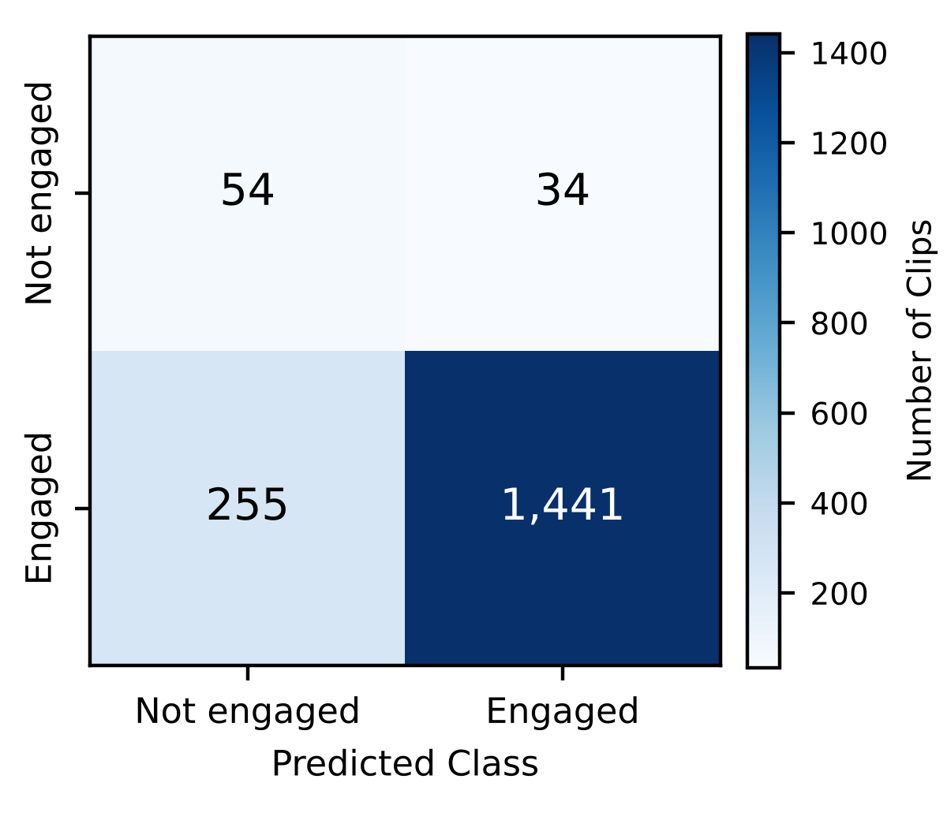
Fig. 2. Confusion matrix for binary disengagement detection on the full DAiSEE test partition (1,784 clips), default threshold.

Effect of Training-Set Size
The same binary architecture was trained twice, once on the 1,500-clip subset and once on the full training partition, with validation and test data held identical (Table VI). With the full data, test ROC-AUC rose from 0.7324 to 0.7943 and validation ROC-AUC from 0.6497 to 0.7385. Recall on the not-engaged class climbed from 0.432 to 0.614. The subset model looks better on accuracy, precision and macro F1, but only because it flagged fewer clips; it found 38 disengaged clips against 54.
TABLE VI. Binary Model Trained on a 1,500-Clip Subset and on the Full Training Partition
Metric (test unless noted) | 1,500 clips | 5,357 clips
Not-engaged training clips | 69 | 247
Validation ROC-AUC | 0.6497 | 0.7385
ROC-AUC | 0.7324 | 0.7943
Average precision | 0.2077 | 0.2628
Balanced accuracy | 0.6832 | 0.7316
Recall (not engaged) | 0.432 | 0.614
Precision (not engaged) | 0.255 | 0.175
Macro F1 | 0.6362 | 0.5905
Accuracy | 0.9098 | 0.8380

Comparison With Published Methods
Abedi and Khan [26] evaluated disengagement detection on the same binary split, with levels 0 and 1 as not engaged and the same 88 and 1,696 test clips. That makes their numbers directly comparable to ours, and Table VII lists them. Our system reaches 0.7943 ROC-AUC and 0.2628 AP. Their best system, a temporal convolutional autoencoder that treats disengagement as an anomaly, reaches 0.7974 and 0.2632. Their supervised temporal convolutional network (TCN) with a weighted loss reaches 0.7516, and their end-to-end video models stay between 0.59 and 0.63.
TABLE VII. Binary Disengagement Detection on the DAiSEE Test Partition Compared With Published Results
Method | Input | ROC-AUC | AP
C3D + LSTM [26] | Video | 0.5931 | 0.1058
ResNet + TCN [26] | Video | 0.6084 | 0.1409
ResNet + LSTM [26] | Video | 0.6243 | 0.1460
TCN, behaviour + affect [26] | Features | 0.7160 | 0.2182
TCN, weighted loss [26] | Features | 0.7516 | 0.2007
TCN autoencoder [26] | Features | 0.7974 | 0.2632
Ours, 1,500-clip training subset | Both | 0.7324 | 0.2077
Ours, without reliability weighting | Both | 0.7941 | 0.2627
Ours, full model | Both | 0.7943 | 0.2628
ª Published values as reported in [26]. Video denotes models that learn from the frames, Features denotes precomputed behavioural and affect features, and Both denotes our frame encoder combined with landmark features.
Most published DAiSEE work reports four-class accuracy, which Table VIII collects. These figures come from different preprocessing and training choices, and they are not on the same footing as our formulations. They still show how close some systems sit to the class prior. Under four-class labels a constant majority predictor already scores 0.4944; one listed system falls below that, and another is less than three points above it. Our three-class accuracy of 0.4596 is below every published four-class figure. We report it because the class-balanced metrics in Table II are, in our view, the fairer measure on this corpus.
TABLE VIII. Published Four-Class Engagement Accuracy on the DAiSEE Test Partition
Method | Source | Accuracy (%)
Video-level InceptionNet | [27] | 46.40
I3D, weighted loss | [28] | 52.35
C3D | [27] | 56.10
LRCN | [27] | 57.90
DFSTN | [27] | 58.84
DERN | [27] | 60.00
ResNet + TCN | [27] | 63.90
EfficientNetB7 + LSTM | [28] | 67.48
ViBED-Net | [28] | 73.43
Majority class (four-class) | This work | 49.44
Ours, three-class | This work | 45.96
ª Values as compiled in the cited sources. Our three-class result merges levels 0 and 1 and is shown for reference only.

Ablation of Reliability Weighting
Testing the main hypothesis needs a control: the same model without the mechanism, trained on the same clips with the same seed. The two configurations in Table IX differ in two of 117 settings, namely whether reliability scales the frame embeddings and whether temporal pooling is reliability-weighted or a plain mean. Every threshold-free metric moved by less than 0.0005. At the default threshold the control was slightly ahead on accuracy, precision and macro F1, because it flagged 290 clips instead of 309. It was also marginally ahead on validation ROC-AUC (0.7398 against 0.7385).
TABLE IX. Full-Scale Ablation on the Binary Test Partition
Metric | With MRS | Without MRS
ROC-AUC | 0.7943 | 0.7941
Average precision | 0.2628 | 0.2627
Balanced accuracy | 0.7316 | 0.7313
Macro F1 | 0.5905 | 0.5976
Recall (not engaged) | 0.614 | 0.602
Precision (not engaged) | 0.175 | 0.183
Accuracy | 0.8380 | 0.8475
Clips flagged | 309 | 290

The earlier seven-arm ablation on the development corpus is collected in Table X. The full model scored 0.214 ± 0.024 test macro F1 and the variant without reliability 0.205 ± 0.029, a paired difference of 0.0085 over five seeds (paired t-test, p = 0.40). With a pooled standard deviation of 0.027, the smallest difference five seeds per arm could detect at the 5% level is about 0.039, more than four times the observed gap. Detecting a gap of 0.0085 with 80% power would take around 158 seeds per arm. No arm separated from the others, and on the development test set every arm stayed below the stratified random baseline of 0.242 macro F1. The landmark branch made the clearest difference: without it, test macro F1 fell to 0.170 and its spread across seeds almost doubled.
TABLE X. Development-Scale Ablation, Five Seeds per Arm (Mean±SD)
Arm | Val. macro F1 | Test macro F1 | Test acc.
Full model | 0.302±0.075 | 0.214±0.024 | 0.278±0.035
No MRS | 0.289±0.068 | 0.205±0.029 | 0.272±0.044
Scaling only | 0.298±0.074 | 0.217±0.029 | 0.289±0.045
Pooling only | 0.284±0.071 | 0.216±0.029 | 0.283±0.032
Residual MRS | 0.313±0.073 | 0.189±0.016 | 0.250±0.030
No landmarks | 0.289±0.065 | 0.170±0.046 | 0.278±0.086
Bidirectional | 0.280±0.018 | 0.219±0.030 | 0.306±0.105
Majority class | 0.160 | 0.173 | 0.528
Stratified random | 0.246 | 0.242 | 0.337
ª Four engagement levels; 36 validation and 36 test clips. Standard deviations are over seeds.

Robustness to Image Degradation
Degrading the development test clips, with both models left unchanged, gives Table XI. The reliability score responded as intended. Its mean fell from 0.657 on clean frames to between 0.48 and 0.54 under blur, downscaling, darkening and heavy occlusion, and it changed little under mild occlusion, brightening or JPEG compression. Under 25% occlusion the detector found a face in only 32% of frames, yet every frame stayed in the sequence. Macro F1 favoured the reliability-weighted model in four conditions and the baseline in three, with two ties. On 36 clips from eight subjects these differences sit within noise, apart from 4× downscaling, where the gap reached 0.069.
TABLE XI. Mean Reliability and Test Macro F1 Under Synthetic Degradation (Development Corpus)
Condition | Mean MRS | Face det. | F1 without MRS | F1 with MRS
Clean | 0.657 | 1.00 | 0.179 | 0.179
Gaussian blur, σ = 2 | 0.537 | 1.00 | 0.201 | 0.185
Gaussian blur, σ = 4 | 0.522 | 1.00 | 0.111 | 0.159
Downscale 4× | 0.536 | 1.00 | 0.228 | 0.297
Downscale 8× | 0.515 | 1.00 | 0.121 | 0.138
Occlusion 10% | 0.634 | 0.98 | 0.251 | 0.246
Occlusion 25% | 0.484 | 0.32 | 0.231 | 0.230
Dark, low contrast | 0.492 | 1.00 | 0.176 | 0.208
Bright, high contrast | 0.691 | 1.00 | 0.195 | 0.195
JPEG, quality 15 | 0.634 | 1.00 | 0.180 | 0.180
ª Both models trained on clean data with seed 42; 36 test clips from eight subjects. Face det. is the share of frames with a detected face.

Backbone and Temporal Resolution
Five frozen image encoders were put through the linear probe (Table XII). The ImageNet ViT-B/16 came first on validation macro F1 (0.279). The CLIP image encoder [29] and a ViT-B/16 fine-tuned for facial expression scored about 0.23. A second expression model and the self-supervised DINOv2 ViT-S/14 [30] scored lower. Expression training did not transfer to engagement in this probe, which is why the ImageNet backbone was kept.
TABLE XII. Linear-Probe Comparison of Frozen Backbones on the Development Validation Set
Backbone | Dim. | Val. accuracy | Val. macro F1
ViT-B/16, ImageNet-21k to 1k | 768 | 0.361 | 0.279
ViT-B/16, facial expression Aª | 768 | 0.333 | 0.232
CLIP ViT-B/16 | 768 | 0.333 | 0.228
ViT-B/16, facial expression Bª | 768 | 0.250 | 0.157
DINOv2 ViT-S/14 | 384 | 0.222 | 0.136
ª Public checkpoints trpakov/vit-face-expression (A) and dima806/facial_emotions_image_detection (B) from the Hugging Face hub. The probe reached 1.00 training accuracy for every backbone.
The frame-count sweep is reported in Table XIII. Test macro F1 did not follow any trend between 8 and 64 frames, and the spread across seeds was as large as the differences between settings. Cost did follow a trend. Latency of the cached-feature head rose from 8.8 ms to 78.6 ms per clip, and throughput fell from 114 to 13 clips per second, while peak GPU memory stayed near 380 MB. Sixteen frames was kept as a compromise between temporal coverage and preprocessing time.
TABLE XIII. Effect of Frame Count on Accuracy and Cost (Development Corpus, Three Seeds)
T | Val. macro F1 | Test macro F1 | Latency (ms) | Clips/s
8 | 0.296±0.023 | 0.184±0.003 | 8.8 | 113.6
16 | 0.268±0.038 | 0.202±0.023 | 15.2 | 66.0
32 | 0.280±0.045 | 0.164±0.006 | 21.7 | 46.0
64 | 0.326±0.091 | 0.213±0.065 | 78.6 | 12.7
ª Latency covers reliability weighting, Mamba, fusion and the MLP on cached features at batch size 1; it excludes video decoding, MediaPipe and the ViT.

Behaviour of the Learned Mixture Weights
Without regularisation the five reliability weights collapsed. A fifteen-epoch run ended with motion consistency at 0.990 and the other four components near 0.001, so the score had become a single-component score, and nothing in training flagged it. To find out what controls this we simulated the same number of optimiser steps (Table XIV). A lower learning rate made no difference; weight decay did, because a parameter vector of zero is the uniform mixture, so decay pulls the parameters back towards it.
TABLE XIV. Simulated Maximum Component Weight After a Full Run
Learning rate | Weight decay | Maximum weight
0.04 | 0.0 | 1.000 (observed failure)
0.002 | 0.0 | 0.999
0.002 | 0.5 | 0.902
0.01 | 1.0 | 0.649 (bounded)

Decay does not freeze the weights. In simulation, a weak noisy signal still pushed one component to about 0.30 against 0.17 for the rest, and pure noise left all five at 0.20. Table XV shows where the weights ended in real runs. The full-scale runs stopped early and stayed between 0.18 and 0.23. The 64-epoch development runs travelled much further: head pose and eye visibility dropped to between 0.06 and 0.08, while face visibility and motion consistency rose to between 0.33 and 0.38.
TABLE XV. Learned Reliability Weights at the End of Training
Run | Blur | Face | Pose | Eyes | Motion
Initial | 0.200 | 0.200 | 0.200 | 0.200 | 0.200
Binary, full (7 ep.) | 0.206 | 0.201 | 0.193 | 0.193 | 0.207
Three-class (32 ep.) | 0.197 | 0.211 | 0.202 | 0.202 | 0.189
Dev. A (64 ep.) | 0.125 | 0.348 | 0.081 | 0.072 | 0.373
Dev. B (64 ep.) | 0.151 | 0.384 | 0.071 | 0.060 | 0.334
ª ep. = epochs. Development runs A and B used 120 training clips at T = 32; B added augmentation, layer-wise learning-rate decay and drop-path.

Explainability
SHAP attribution for the binary model, grouped by feature family, is listed in Table XVI. Groups differ in size, so the per-dimension column is the one to compare. Per dimension, eye openness and iris or gaze features carried about twice the attribution of the deep temporal block. Taken together, the 240 landmark dimensions held 57.2% of the attribution against 42.8% for the 256 deep dimensions, about 1.4 times as much per dimension. The five top-ranked single features all concern the eyes and brows (Fig. 3): brow lowering, eye aspect ratio and eye openness for both eyes.
TABLE XVI. SHAP Attribution by Feature Group, 512 Test Clips
Feature group | Dim. | Share | Per dim.
Deep temporal (ViT-Mamba) | 256 | 42.77% | 0.00257
Iris and gaze | 45 | 15.28% | 0.00523
Mouth and jaw | 90 | 15.10% | 0.00258
Eye openness | 36 | 12.56% | 0.00537
Brow | 27 | 6.62% | 0.00378
Head pose | 15 | 2.89% | 0.00297
Face scale | 9 | 2.74% | 0.00469
Cheek and nose | 15 | 1.83% | 0.00188

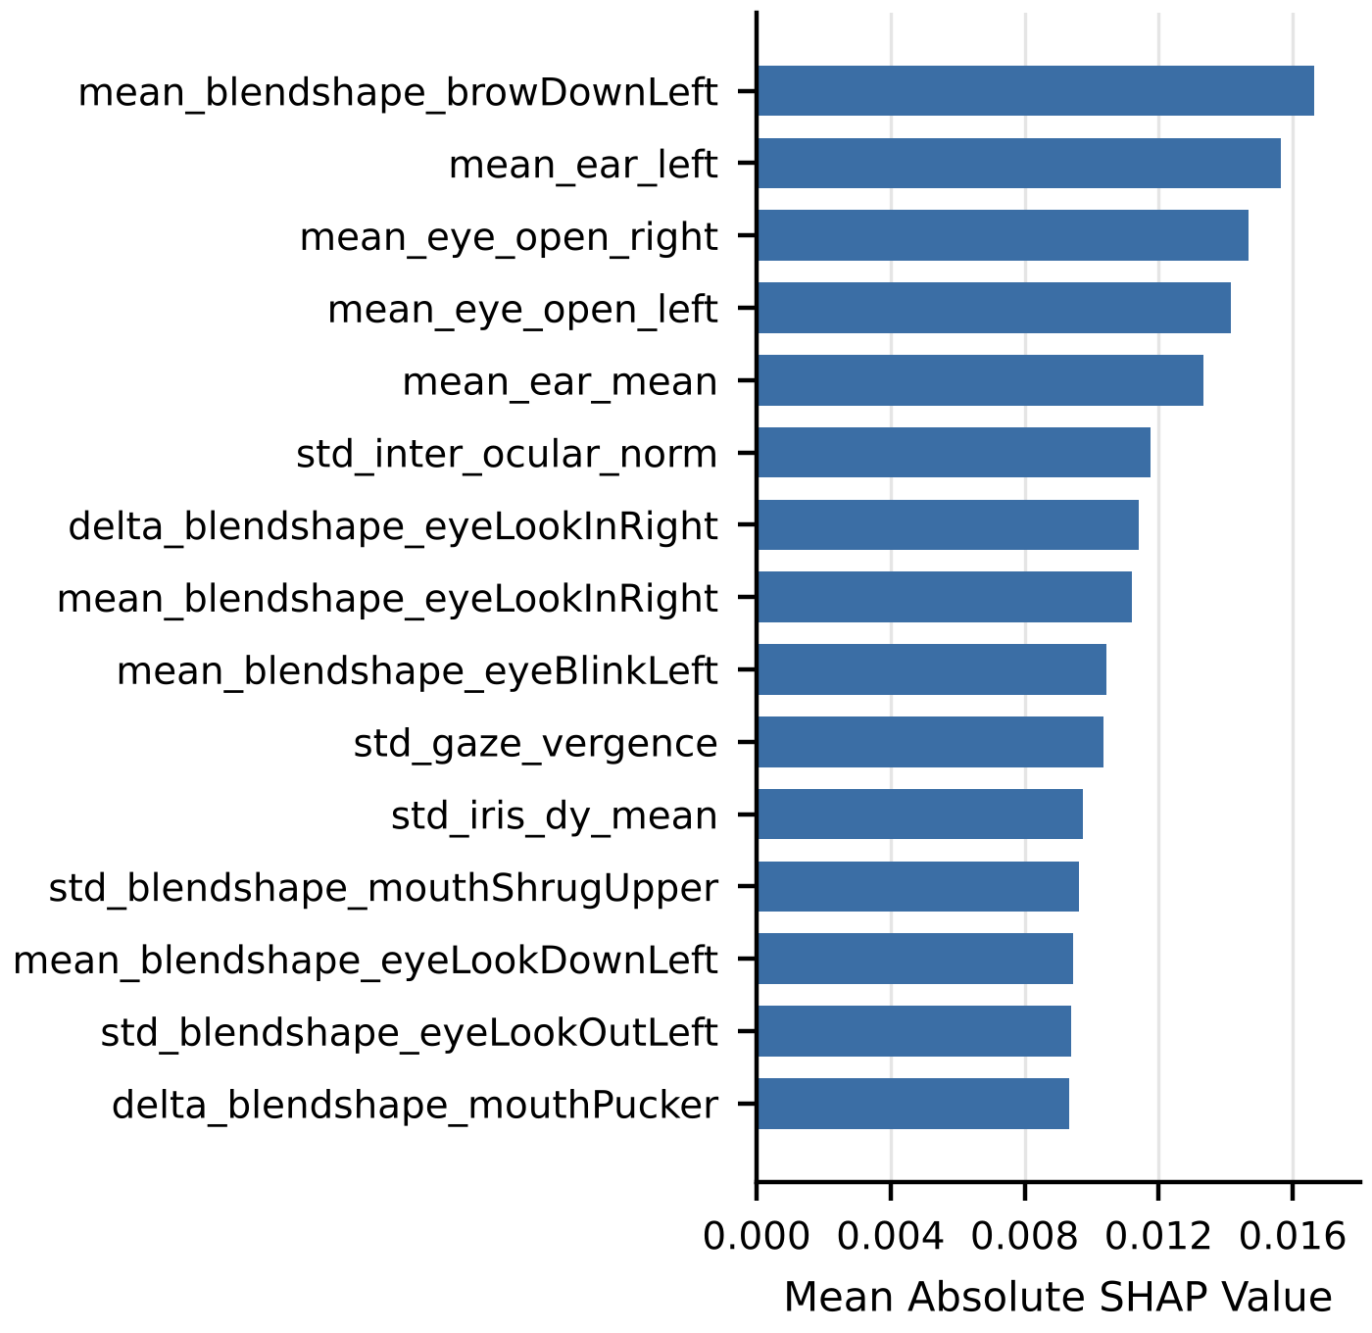
Fig. 3. The fifteen named landmark features with the highest mean absolute SHAP value on the test partition (mean, std and delta denote the temporal mean, standard deviation and mean absolute difference).
Integrated gradients on three worked examples, each from a different participant, gave the landmark branch contributions of +2.14, +1.51 and +1.56 to the predicted-class score. The deep branch contributed -0.35, -0.14 and +0.12.

Discussion
The results support a working disengagement detector, but they do not support the mechanism we set out to test.
On the binary task the system reached 0.7943 ROC-AUC, with average precision 5.3 times its baseline, on a corpus where 95% of clips belong to one class. That is within 0.004 ROC-AUC of the best published result on the identical split [26]. The two systems get there differently: ours fine-tunes an image encoder and adds landmark geometry, while the published one models precomputed behavioural and affect features. Our model also beats the end-to-end video models in that study by 0.17 to 0.20. Table VI points to the main reason for the improvement over our own earlier model: more minority-class clips. Going from 69 to 247 not-engaged training clips added 0.062 ROC-AUC, far more than any change in our ablations.
Reliability weighting does not explain that performance. The full-scale ablation puts its contribution at 0.0002 ROC-AUC, the seven-arm study could not tell any reliability variant apart, and attribution places the useful signal in MediaPipe eye and gaze geometry. Integrated gradients agree: the deep branch carries attribution in proportion to its size, but its sign varies from clip to clip, while the landmark branch pushes consistently towards the correct class. The development ablation tells the same story from the other side. Removing the landmark branch hurt more than removing reliability weighting.
The robustness test adds a partial counterpoint. The score fell under the degradations it was built to notice, and the reliability-weighted model was ahead under blur at σ = 4, both downscaling levels and darkening. With 36 test clips, those gains cannot be separated from chance, but they suggest that the mechanism may matter more on poor footage than on DAiSEE, where most frames are reasonably clean.
The finer-grained task is limited by the labels more than by the model. High and Very High were separated at 0.5235 ROC-AUC, and since those classes make up 95% of the test partition, no decision rule in Table IV lifted accuracy above the 0.4944 prior. Annotators disagree on exactly this boundary [1]. The published four-class accuracies in Table VIII should be read with that ceiling in mind, since one of them sits below a constant predictor.
The weight collapse is not specific to engagement. Any model that learns a convex mixture through a softmax over free logits can lose all but one component and give no sign of it. Weight decay on the logits is a cheap fix, since their zero point is the uniform mixture, and the decay strength sets how hard the data must push before one component takes over. The long development runs in Table XV hint at what the data would choose if training ran longer: less trust in head pose and eye visibility, more in face visibility and motion.
Several limits bound what these results can show. Both full-scale ablation arms peaked at the first epoch, when the learned weights had moved only to between 0.182 and 0.218. The ablation therefore compares a near-uniform mixture against no weighting. Whether learned weights help is still open, because the model overfits before they move far. Each full-scale configuration was run with one seed, and the development ablation showed a seed-to-seed spread of 0.027 in macro F1, so smaller differences need repeated runs. The development comparisons (Tables X to XIII) rest on 36 test clips and are best read as trends. Published four-class figures use differing preprocessing and are not strictly comparable. Finally, DAiSEE participants are young adults in e-learning sessions, and the results do not carry over to children or to other recording conditions without new validation.

Conclusion
We tested whether treating observation reliability as a learned, length-preserving weight improves engagement recognition from webcam video. On the full, subject-disjoint DAiSEE release, a controlled ablation that changed two of 117 settings measured the effect at 0.0002 ROC-AUC. The hypothesis was not supported, and we reached that conclusion through a controlled comparison with the effect size and the statistical power stated.
The system still works as a disengagement detector. It reaches 0.7943 ROC-AUC and finds 54 of 88 disengaged test clips, which equals the best published result on the same split and exceeds published end-to-end video models by a wide margin. Training-set size mattered more than any design choice we compared. Attribution points to eye openness and gaze geometry, so a landmark-only model of a few hundred thousand parameters may come close to the present 87-million-parameter system. We also showed that softmax-parameterised mixing weights can collapse silently, and that weight decay, not a smaller learning rate, prevents it.
Several next steps follow from these results. The learned weights deserve a fair test with a frozen backbone, cached features and hundreds of epochs over several seeds. The three unused DAiSEE affect labels could be added through multi-task training, and treating engagement as ordinal would target the High and Very High boundary where the model is at chance. Per-participant feature normalisation, a landmark-only baseline and a robustness test at full scale would complete the picture.

Appendix
Table XVII lists the hardware and software used for every reported run. Exact package versions, device details and configuration were saved with each result file.
TABLE XVII. Hardware and Software Used in the Experiments
Item | Specification
Processor | x86-64, 8 logical cores
Memory | 16 GB
GPU | NVIDIA GeForce RTX 3060 Laptop, 6 GB
Operating system | Windows 11 Home (64-bit)
Language | Python 3.13.3
Deep learning | PyTorch 2.11.0, torchvision 0.26.0, CUDA 12.8
Vision backbone | timm 1.0.29
Facial analysis | MediaPipe Tasks 1.0.1, OpenCV 5.0.0
Sequence model | Mamba reference implementation
Metrics and attribution | scikit-learn 1.9.0, SHAP 0.52.0
Testing | pytest 9.1.1 (169 tests)

CRediT Authorship Contribution Statement
Adhvaith N A: Conceptualization, Methodology, Software, Formal analysis, Writing – original draft, Writing – review and editing. Deepika J: Conceptualization, Methodology, Supervision, Project administration, Validation, Writing – review and editing. Don George: Software, Investigation, Validation, Visualization, Writing – review and editing. Ilakkiya S: Data curation, Investigation, Validation, Visualization, Writing – original draft.

Data Statement
This study uses the DAiSEE dataset, which its creators make available for research under a registration agreement at https://people.iith.ac.in/vineethnb/resources/daisee/. No new data were collected. Under the licence terms, we do not redistribute the video, the derived face crops or the extracted landmark data. The source code, configuration files and result files behind the findings are available from the corresponding author on reasonable request.

Declaration of Conflicts of Interest
We have no conflict of interest to declare.

Acknowledgment
We thank the School of Computer Science and Engineering, Vellore Institute of Technology, Vellore, for the computing facilities that supported this work, the creators of DAiSEE for making the dataset available for research, and the maintainers of the open-source libraries on which the pipeline depends.
Funding: This research did not receive funding.

References
- J. Whitehill, Z. Serpell, Y.-C. Lin, A. Foster, and J. R. Movellan, "The faces of engagement: automatic recognition of student engagement from facial expressions," IEEE Transactions on Affective Computing, vol. 5, no. 1, pp. 86-98, 2014, doi: https://doi.org/10.1109/TAFFC.2014.2316163.
- A. Gupta, A. D'Cunha, K. Awasthi, and V. Balasubramanian, "DAiSEE: towards user engagement recognition in the wild," arXiv preprint arXiv:1609.01885, 2016, doi: https://doi.org/10.48550/arXiv.1609.01885.
- Ö. Sümer, P. Goldberg, S. D'Mello, P. Gerjets, U. Trautwein, and E. Kasneci, "Multimodal engagement analysis from facial videos in the classroom," IEEE Transactions on Affective Computing, vol. 14, no. 2, pp. 1012-1027, 2023.
- J. Donahue et al., "Long-term recurrent convolutional networks for visual recognition and description," in Proceedings of the IEEE Conference on Computer Vision and Pattern Recognition, Boston, MA, USA, 2015, pp. 2625-2634, doi: https://doi.org/10.1109/CVPR.2015.7298878.
- D. Tran, L. Bourdev, R. Fergus, L. Torresani, and M. Paluri, "Learning spatiotemporal features with 3D convolutional networks," in Proceedings of the IEEE International Conference on Computer Vision, Santiago, Chile, 2015, pp. 4489-4497, doi: https://doi.org/10.1109/ICCV.2015.510.
- G. Bertasius, H. Wang, and L. Torresani, "Is space-time attention all you need for video understanding?," in Proceedings of the 38th International Conference on Machine Learning, 2021, pp. 813-824.
- A. Gu and T. Dao, "Mamba: linear-time sequence modeling with selective state spaces," arXiv preprint arXiv:2312.00752, 2023, doi: https://doi.org/10.48550/arXiv.2312.00752.
- L. Zhu, B. Liao, Q. Zhang, X. Wang, W. Liu, and X. Wang, "Vision Mamba: efficient visual representation learning with bidirectional state space model," in Proceedings of the 41st International Conference on Machine Learning, Vienna, Austria, 2024.
- A. Dosovitskiy et al., "An image is worth 16x16 words: transformers for image recognition at scale," in Proceedings of the International Conference on Learning Representations, 2021.
- J. L. Pech-Pacheco, G. Cristóbal, J. Chamorro-Martínez, and J. Fernández-Valdivia, "Diatom autofocusing in brightfield microscopy: a comparative study," in Proceedings of the 15th International Conference on Pattern Recognition, Barcelona, Spain, 2000, pp. 314-317, doi: https://doi.org/10.1109/ICPR.2000.903548.
- P. Terhörst, J. N. Kolf, N. Damer, F. Kirchbuchner, and A. Kuijper, "SER-FIQ: unsupervised estimation of face image quality based on stochastic embedding robustness," in Proceedings of the IEEE/CVF Conference on Computer Vision and Pattern Recognition, Seattle, WA, USA, 2020, pp. 5651-5660.
- A. Kendall and Y. Gal, "What uncertainties do we need in Bayesian deep learning for computer vision?," in Advances in Neural Information Processing Systems, Long Beach, CA, USA, 2017, pp. 5574-5584.
- J. Yang et al., "Neural aggregation network for video face recognition," in Proceedings of the IEEE Conference on Computer Vision and Pattern Recognition, Honolulu, HI, USA, 2017, pp. 4362-4371, doi: https://doi.org/10.1109/CVPR.2017.554.
- C. Lugaresi et al., "MediaPipe: a framework for building perception pipelines," arXiv preprint arXiv:1906.08172, 2019, doi: https://doi.org/10.48550/arXiv.1906.08172.
- V. Bazarevsky, Y. Kartynnik, A. Vakunov, K. Raveendran, and M. Grundmann, "BlazeFace: sub-millisecond neural face detection on mobile GPUs," arXiv preprint arXiv:1907.05047, 2019, doi: https://doi.org/10.48550/arXiv.1907.05047.
- Y. Kartynnik, A. Ablavatski, I. Grishchenko, and M. Grundmann, "Real-time facial surface geometry from monocular video on mobile GPUs," in Proceedings of the IEEE Conference on Computer Vision and Pattern Recognition Workshops, Long Beach, CA, USA, 2019.
- A. Ablavatski, A. Vakunov, I. Grishchenko, K. Raveendran, and M. Zhdanovich, "Real-time pupil tracking from monocular video for digital puppetry," arXiv preprint arXiv:2006.11341, 2020, doi: https://doi.org/10.48550/arXiv.2006.11341.
- A. Steiner, A. Kolesnikov, X. Zhai, R. Wightman, J. Uszkoreit, and L. Beyer, "How to train your ViT? Data, augmentation, and regularization in vision transformers," Transactions on Machine Learning Research, 2022.
- T. Soukupová and J. Čech, "Real-time eye blink detection using facial landmarks," in Proceedings of the 21st Computer Vision Winter Workshop, Rimske Toplice, Slovenia, 2016.
- P. Ekman and W. V. Friesen, Facial Action Coding System: a technique for the measurement of facial movement, Palo Alto, CA, USA: Consulting Psychologists Press, 1978.
- Y. Cui, M. Jia, T.-Y. Lin, Y. Song, and S. Belongie, "Class-balanced loss based on effective number of samples," in Proceedings of the IEEE/CVF Conference on Computer Vision and Pattern Recognition, Long Beach, CA, USA, 2019, pp. 9268-9277, doi: https://doi.org/10.1109/CVPR.2019.00949.
- I. Loshchilov and F. Hutter, "Decoupled weight decay regularization," in Proceedings of the International Conference on Learning Representations, New Orleans, LA, USA, 2019.
- S. M. Lundberg and S.-I. Lee, "A unified approach to interpreting model predictions," in Advances in Neural Information Processing Systems, Long Beach, CA, USA, 2017, pp. 4765-4774.
- M. Sundararajan, A. Taly, and Q. Yan, "Axiomatic attribution for deep networks," in Proceedings of the 34th International Conference on Machine Learning, Sydney, Australia, 2017, pp. 3319-3328.
- R. R. Selvaraju, M. Cogswell, A. Das, R. Vedantam, D. Parikh, and D. Batra, "Grad-CAM: visual explanations from deep networks via gradient-based localization," in Proceedings of the IEEE International Conference on Computer Vision, Venice, Italy, 2017, pp. 618-626, doi: https://doi.org/10.1109/ICCV.2017.74.
- A. Abedi and S. S. Khan, "Detecting disengagement in virtual learning as an anomaly using temporal convolutional network autoencoder," arXiv preprint arXiv:2211.06870, 2022, doi: https://doi.org/10.48550/arXiv.2211.06870.
- A. Abedi and S. S. Khan, "Improving state-of-the-art in detecting student engagement with ResNet and TCN hybrid network," arXiv preprint arXiv:2104.10122, 2021, doi: https://doi.org/10.48550/arXiv.2104.10122.
- P. Gothwal, D. Banaerjee, and A. K. Biswas, "ViBED-Net: video based engagement detection network using face-aware and scene-aware spatiotemporal cues," arXiv preprint arXiv:2510.18016, 2025, doi: https://doi.org/10.48550/arXiv.2510.18016.
- A. Radford et al., "Learning transferable visual models from natural language supervision," in Proceedings of the 38th International Conference on Machine Learning, 2021, pp. 8748-8763.
- M. Oquab et al., "DINOv2: learning robust visual features without supervision," Transactions on Machine Learning Research, 2024.

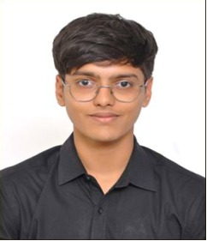
Adhvaith N A
Adhvaith N A is pursuing a B.Tech. degree in Computer Science and Engineering at the School of Computer Science and Engineering, Vellore Institute of Technology (VIT), Vellore, India (2023-2027). Alongside his studies he works as a freelance software developer and consultant in software architecture and full-stack development, and builds workflow automation systems. Research interests include multimodal machine learning, video understanding, explainable artificial intelligence and applied AI agents.


Deepika J
Deepika J received the B.E. degree in Computer Science from Bannari Amman Institute of Technology, India, in 2009, the M.E. degree in Software Engineering (First Rank Holder) from College of Engineering Guindy, India, in 2011, and the Ph.D. degree from Anna University in 2022. She is currently an Assistant Professor at Vellore Institute of Technology, Vellore. Her research interests include machine learning, deep learning, and data privacy. She has published in reputed journals, holds an h-index of 6 (Scopus), and has received the Anna University Researcher Award (2022). Within this work, the contributions covered supervision of the experimental design and review of the manuscript.

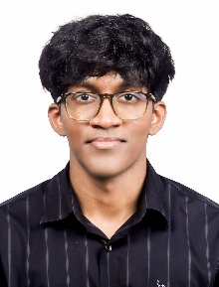
Don George
Don George is pursuing a B.Tech. degree in Computer Science and Engineering with specialization in Data Science at the School of Computer Science and Engineering, Vellore Institute of Technology (VIT), Vellore, India (2023-2027). Within this work, the contributions covered software implementation, testing and analysis of results. Research interests include data science, deep learning and computer vision.

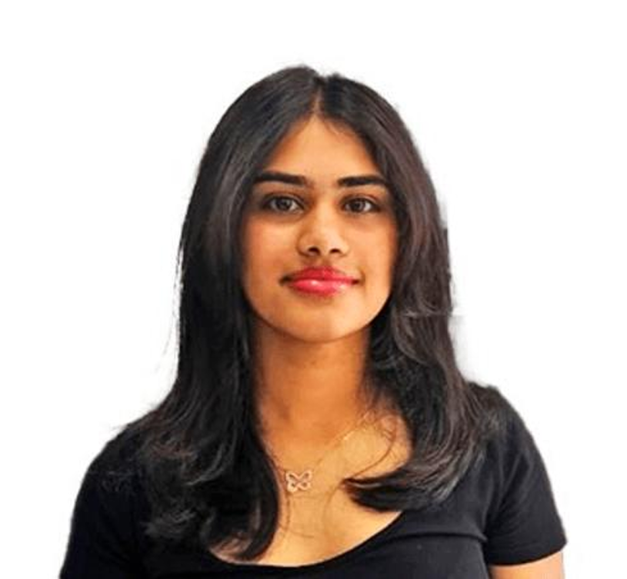
Ilakkiya S
Ilakkiya S is pursuing a B.Tech. degree in Computer Science and Engineering at the School of Computer Science and Engineering, Vellore Institute of Technology (VIT), Vellore, India (2023-2027). Within this work, the contributions covered dataset curation, the experimental runs and the visual presentation of results. Research interests include computer vision, affective computing and machine learning for education.

