**1.** **Business Logic. Main Service**  
   
 Worker addWorker(Worker newWorker) throws NoSupportedSubTypeException;  
 Worker getById(int id) throws NoWorkerFoundException;  
 List<Worker> searchByName(String name);  
 List<Worker> getAllWorkers();  
 Supervisor addSubworker(int supervisorId, int subworkerId) throws NoWorkerFoundException;  
 String getWorkerType(int workerId) throws NoWorkerFoundException;  
 int calculateMonthSalary(int workerId) throws NoWorkerFoundException;  
 int calculateMonthSalaryAllWorkers();  
 String getTreeView(int workerId) throws NoWorkerFoundException;  
  
**2. How to run**  
  
 1. install maven  
 2. ***git clone https://github.com/presly808/AsposeTask.git***  
 3. **cd ${PROJECT_DIR}**  
 4. build project ***mvn build*** 5. ***cd target***

6. run console app ***java -jar CompanyAsposeTask-1.0-jar-with-dependencies.jar***   
  
 You can also run tests only **mvn test**  
  
**3. Project Architecture**  
 **3.1. General App ClassDiagram**

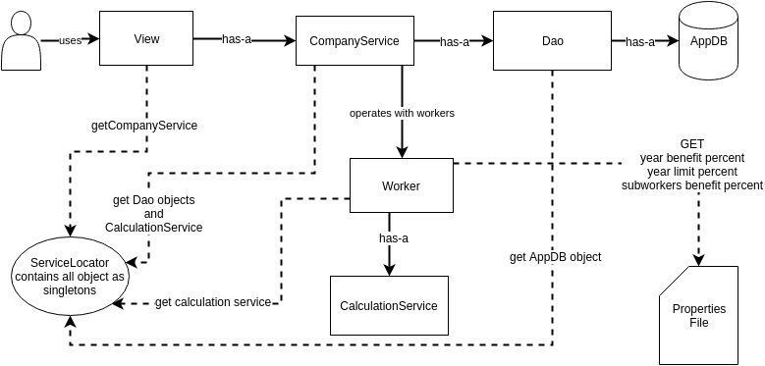

***3.2. ServiceLocator*** holds all singletons as dao, services and others. It takes all objects creation in one place

**3.3. Class Diagram**

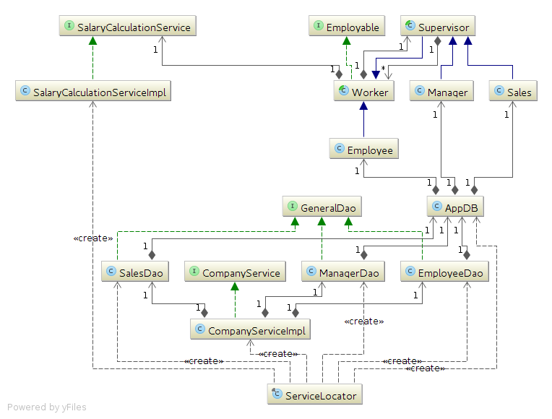

**3.4. Class Diagrams of the model package**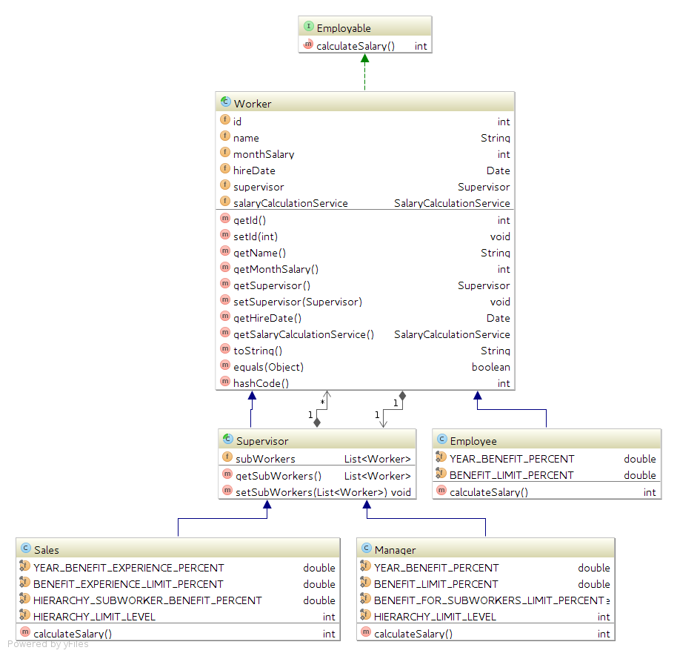  
  
**3.5 Important class for calculations of year benefit and subworkers hierarchy**  
 *public interface SalaryCalculationService {  
  
 int calculateYearBenefit(int fixedSalary, double yearBenefitPercent,*

*int fullYears, double limitOfYearBenefitPercent);  
  
 /**  
 * calculate benefits with level limitaion  
 *  
 * @param level limit a calculation level, if -1 we consider all hierarchy  
 * */  
 int calculateTeamBenefitByLevel(List<Worker> root, int level);  
 }*

**4. Pluses and minuses of the app**

* Pluses  
 * flexible arhcitecture  
 * configuration via a file  
 * separated little components  
 * app is ready to be scaled  
 * dependency injections using ServiceLocator  
 * calculation of complex hierarchy is readable  
 * tool for debugging calculations of tree   
  
* Minuses  
 * a lot of classes  
 * console view  
 * no persistence db]

**5. Future Issues**   
* add posibility to calculate salary choosing endDate  
* replace ServiceLocator by Spring  
* improve ```com.aspose.company.utils.visualization.PrintUtils``` to get more detailed debug info  
  
**6. Recommendations**  
* Use ```com.aspose.company.utils.visualization.PrintUtils``` to show hierarchy as a tree  
* Change benefit percents via ```app.properties``` which is located in the resources  
* Start point of the program is com.aspose.company.Run