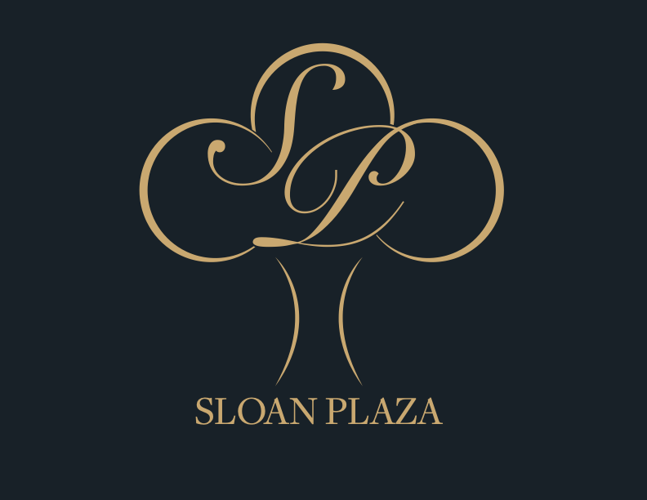

Welcome

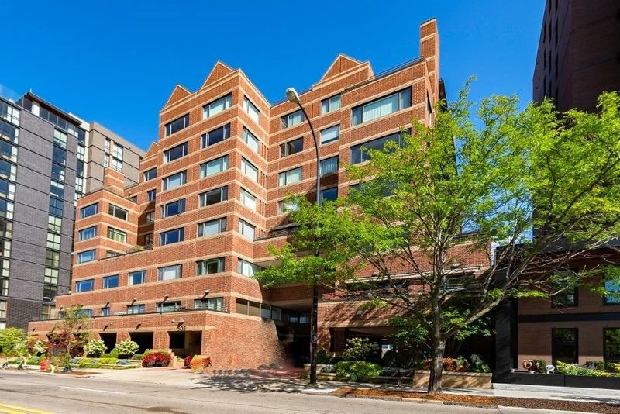
Sloan Plaza Condominiums, 505 E. Huron St, Ann Arbor, MI 48104



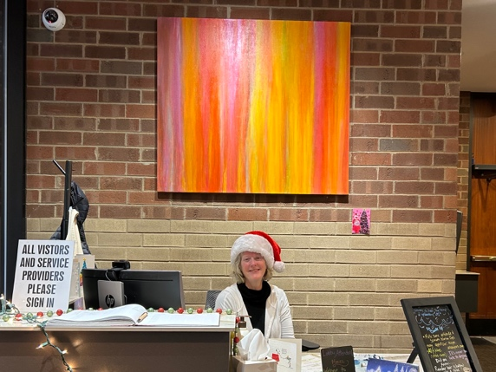

-----------------CONTACT INFORMATION----------------

Lobby Front Desk
734 662-6232
Attendant – Monica Love-R

Building Superintendent
(For All Emergencies)
Tom Daily
734-417-3682

Legacy Regional Manager
Anthony Barker
248-769-7396


CLICK HERE

BOARD OF DIRECTORS

President
Michael Hess

Vice President
Don Duquette

Treasurer
Mary Campbell

Secretary
Elise Weisbach

Member
Paul Resnick

Member
Bill Milliken

List of names, emails?, Maybe photos?

Social photos of Sloan Community -- if we can get them. Dogs too =-- And Cats

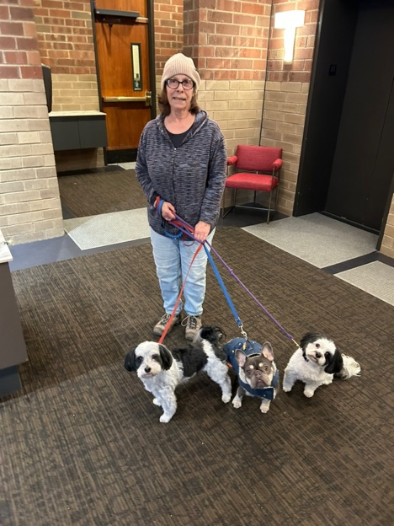

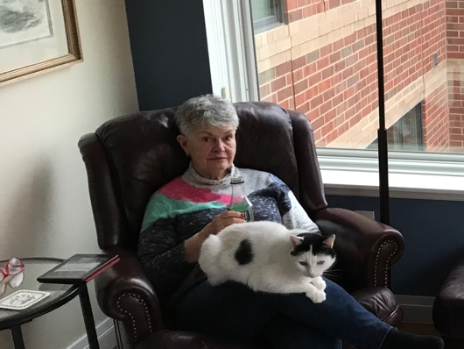

HISTORY OF SLOAN PLAZA CONDOMINIUM ASSOCIATION

Downtown Ann Arbor Highrise Elegance

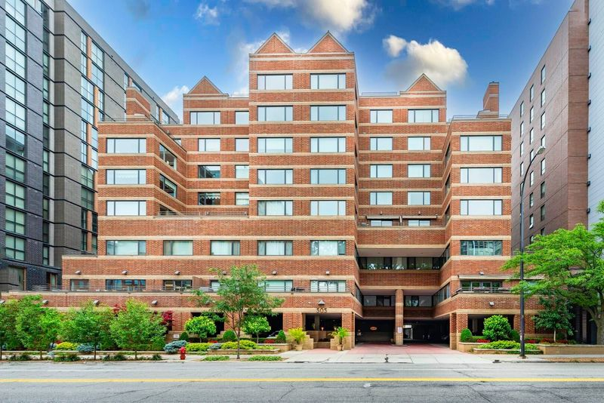

Sloan Plaza, an upscale high-rise luxury condominium with 47 units, is situated in the heart of downtown Ann Arbor. Sloan Plaza includes both ranch and penthouse style units with 1 to 3 bedrooms. Units provide spectacular views of the city and surrounding neighborhoods. A number of the condos include a large garden terrace. Sloan Plaza strives to create a neighborly community and non-owner rentals are strictly limited.

Location:
Main Street and Kerrytown are but a short walk away, offering a wide array of coffee shops, theaters and local art galleries. Sloan is within walking distance to local shops and gourmet restaurants and is convenient to bus routes. The central campus of The University of Michigan is only 1 block away which includes the Natural History Museum, the Art Gallery, and frequent lectures open to the public. The major venues for music and theatre are a 5-minute walk away - Hill Auditorium, Racham Auditorium, Mendelsohn Theatre, the Power Center for the Performing Arts, and the Michigan and State Theatres.

Community Amenities:
Sloan Plaza offers a premium secured entry way with a lobby attendant and easy access to reserved covered parking with private storage. Snow removal, landscaping, and exterior maintenance are the responsibility of the association. Pets, within guidelines, are allowed.

History and Musical Connection:
Sloan Plaza was built in 1986, 40 years ago, by O’Neal Construction. Developer Donald Sloan Chislom named the project after his mother, Margaret Sloan Chisholm. Chisholm owned one of the units in the building and installed his mother’s Steinway in it. There he often hosted gatherings and also made the apartment available to house classical and jazz artists who were performing in the city. Among those who stayed there were Shirley Horn, Chucho Valdes, Dizzy Gillespie, Toots Thielman, Bill Charlap, Freddy Cole, Diana Krall, Andre Previn, and Cedar Walton. All signed his guest book, the only form of payment he would accept, making it a who’s who of legendary signatures. An ardent jazz fan who helped the art form thrive in Michigan; Chisholm was a founding board member of the Southeastern Michigan Jazz Association. He received the Jazz Hero Award from the Jazz Journalists Association in 2015 and was a longtime major donor to Kerrytown Concert House.

MEMBER SITE (click here)
Leads to authentication:” Residents, Legacy officials, staff

Table of Contents

Governing Documents

- Sloan Plaza Rules and Regulations
- Bylaws
- Master Deed

Financial Information

Sloan Plaza Association Budget for 2026
Capital Reserve Accounts
Sloan Plaza Association Reserve Study

Monthly Financial Reports

Management Reports

Board of Directors Meeting Minutes

Member Directory
All with permission.
(by unit and alphabetical; email and phone)

Sloan Community Chat

