⛓
SOFTWARE SECURITY
Introduction to Blockchain

DAY 1 – Lab Report

Course | Software Security – Blockchain Lab
Report Type | Day 1 Lab Report
Sessions Covered | Session 1 (Setup), Session 2 (Cryptography), Session 3 (Smart Contract)
Group Size | 5 Students
Date | 28 May 2026
Lab Environment | Ubuntu 22.04 (WSL2 on Windows 11)

Section 1 – Group Information & Role Assignments

GROUP MEMBERS
- PRESTON SHEY NJAKOK LMUI2639894
- NEBA PRECIOUS SIRRI LMUI250885
- LOIS ANN MOJOKO
- NKEMBENI DABRAT LMUI250913
- MORDEPET

1.1 Day 1 Role Assignments
No. | Role | Assigned Member | Primary Responsibilities
1 | 🔧 Lead Developer | Preston Shey Njakoy | Set up core tools, led coding exercises, shared screen during demos
2 | 🔒 Security Analyst | Nkembeni Dabrat | Monitored for vulnerabilities, led Session 2 cryptography section
3 | 📝 Scribe / Documenter | Neba Precious Sirri | Recorded all commands, outputs, observations, and answers
4 | 🌐 Network Engineer | Lois Ann mojoko | Managed node configuration, Ganache deployment settings, port 8545
5 | 🧪 QA Tester | Mordepet | Ran all verification steps, confirmed expected outputs, flagged discrepancies

Section 2 – Session 1: Software Installation & Verification

The Network Engineer led the pre-installation checklist verification. All machines met the minimum requirements before proceeding with software installation.

2.1 System Requirements Checklist
- Operating System: Ubuntu 22.04 (WSL2 on Windows 11)
- RAM: 16 GB available
- Disk Space: >10 GB free
- Stable internet connection confirmed
- Administrator / sudo privileges confirmed
- Terminal emulator available (WSL2 Bash)

2.2 Node.js & npm Installation
Node Version Manager (NVM) was used to install Node.js v20 LTS. The following commands were executed:
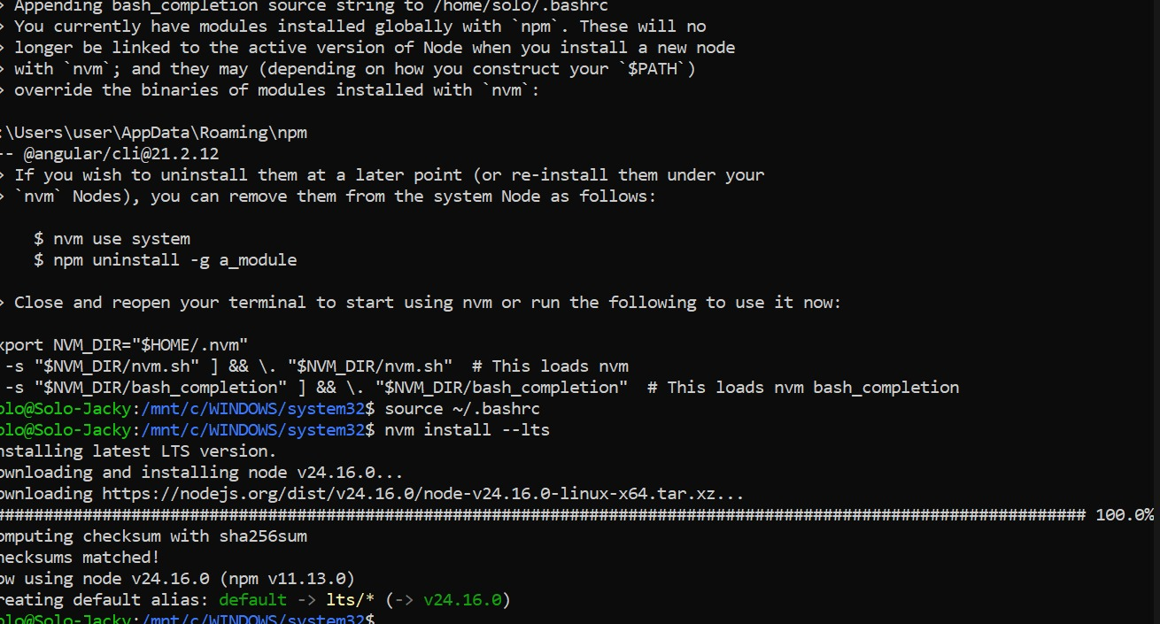

2.3 Git Installation & Configuration

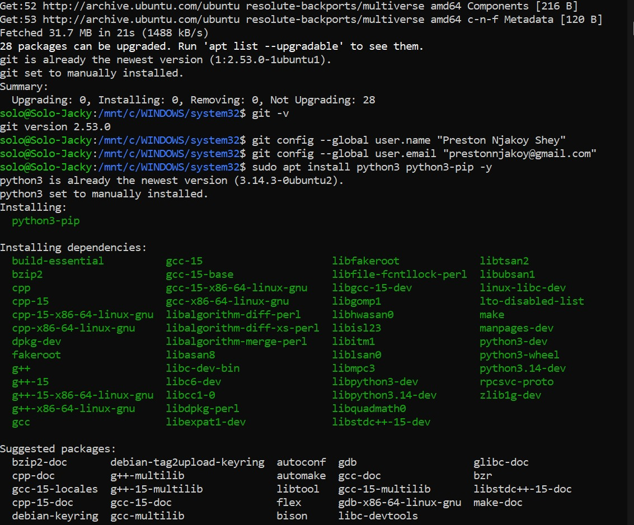

2.4 Python 3 & pip Installation


2.5 Hardhat Installation & Project Initialisation
The Lead Developer created the project directory and initialised Hardhat. Due to a version compatibility issue between the lab manual (written for Hardhat 2) and the latest npm packages (which install Hardhat 3 by default), the following resolution steps were taken:
Issue Encountered:
- npm install hardhat @nomicfoundation/hardhat-toolbox initially installed Hardhat 3, which uses ESM (ES Module) syntax incompatible with the lab's CommonJS scripts.
- The package.json had "type": "module" which caused ReferenceError: require is not defined errors.
Resolution:
- Removed the "type": "module" field from package.json using Python (to avoid the ESM chicken-and-egg problem).
- Uninstalled @nomicfoundation/hardhat-toolbox and reinstalled without it to allow Hardhat 2 to function.
- Installed @nomicfoundation/hardhat-ethers separately to provide the ethers object in deploy scripts.
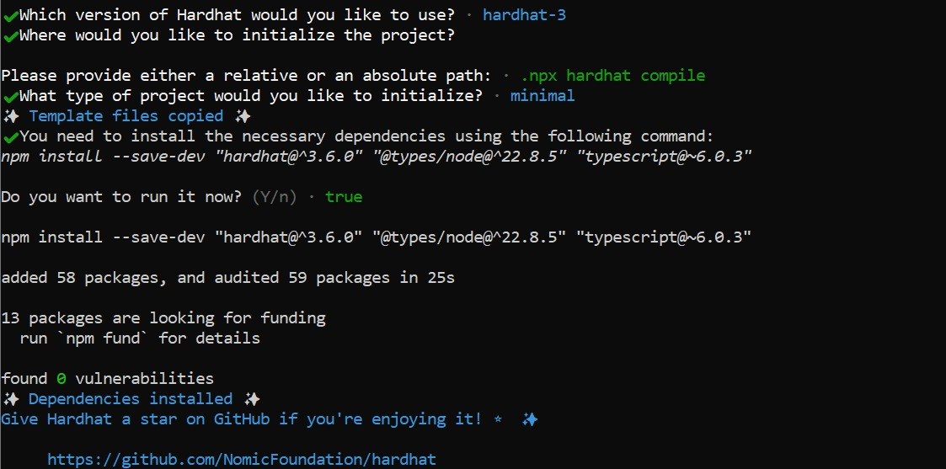

2.6 Ganache CLI Installation & Launch
Ganache CLI was installed globally and launched in a separate terminal window:
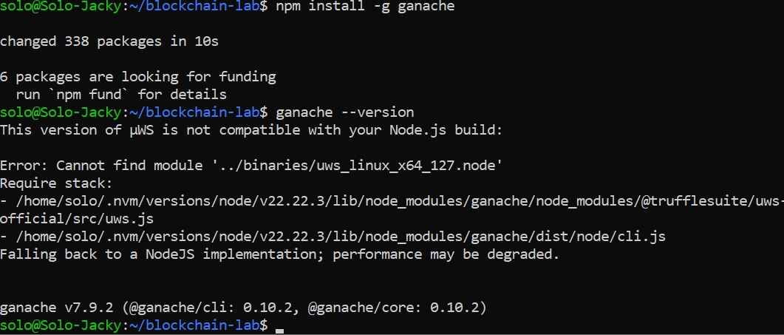

2.7 MetaMask Installation
MetaMask was installed as a browser extension in Chrome/Firefox and configured to connect to the local Ganache network:
- Navigated to https://metamask.io/download/
- Installed MetaMask extension and created a new wallet
- Secret Recovery Phrase saved securely
- Added local Ganache network manually:

2.8 VS Code & Solidity Extension
Visual Studio Code was already installed. The Solidity Extensions was installed.

2.9 Session 1 Completion Checklist
- Node.js v20+ installed and verified
- npm v10+ installed
- Git installed and user configured
- python 3.10+ installed
- Hardhat project initialised in blockchain-lab/
- npx hardhat compile runs without errors (solc 0.8.19)
- Ganache CLI installed (v7.9.2)
- Ganache running on port 8545 with 10 accounts visible
- MetaMask installed in browser and Ganache network added
- VS Code installed with Solidity extension active
- All group members have access to the shared project directory

Section 3 – Session 2: Blockchain Fundamentals & Cryptography

The Security Analyst led this session. All Python scripts were created and run from the ~/blockchain-lab/ directory.

3.1 Exercise 2.1.1 – SHA-256 Hash Exploration
The following script (hash_demo.py) was created to demonstrate the Avalanche Effect in SHA-256 hashing:
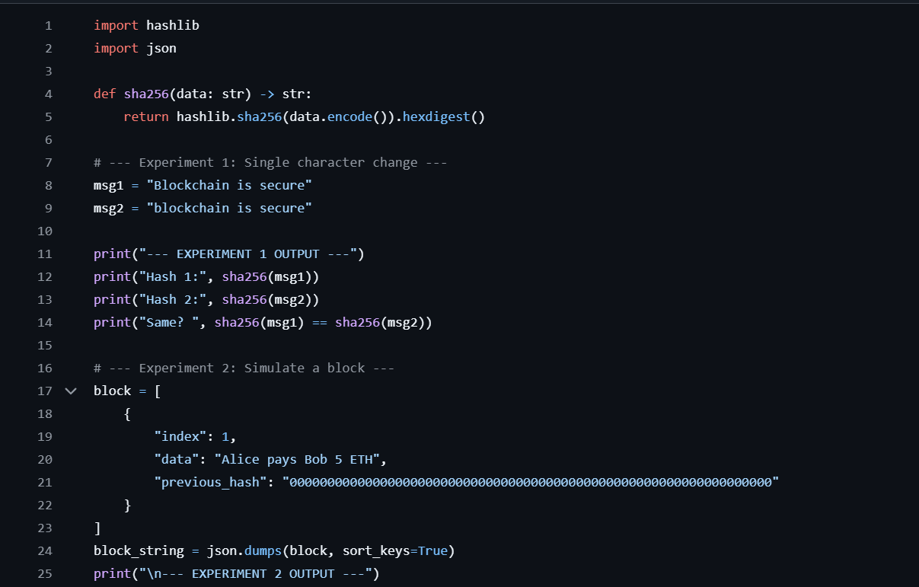
Terminal Output — hash_demo.py
Hash 1: de6411a3dd61522b5c6d536fa92723958973bd33fa28c74b2d6df411c0a4c4e4
Hash 2: 3cf9b98da9d7b02cf5b0cae2b49a262680d00494cf621fd2a3536ee320d5c36e
Same? False
--- EXPERIMENT 2 OUTPUT ---
Block Hash: da7fdb3855b6b6f9aa1f74afac8da77b50176dd520f0b6359eaa79193dcb856f

3.2 Exercise 2.1.2 – Proof of Work Simulation
The pow_demo.py script simulates the mining process by incrementing a nonce until the resulting SHA-256 hash starts with a required number of leading zeros (the difficulty target):
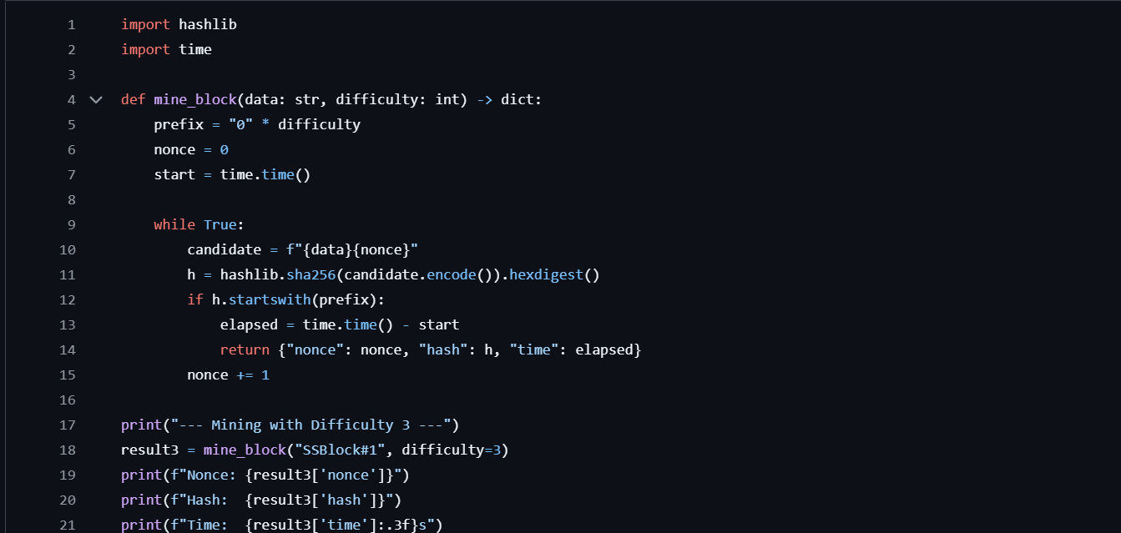
Results – Difficulty Comparison
--- Mining with Difficulty 3 ---
Nonce: 1120
Hash: 000147710b0b95a73090bc80ef6b065eb3b79adee85bfcaaae5e5cca39cc2014
Time: 0.005s
--- Mining with Difficulty 5 ---
Nonce: 273175
Hash: 000004ab82f1ccda4f6b2e86b568bdd372fad2084facb6cc62479d043ff5fee5
Time: 0.913s

3.3 Block Anatomy Diagram
A blockchain block contains five core components that chain blocks together immutably:

3.4 Consensus Mechanisms Discussion
As a group, the following questions were discussed and answered (10-minute discussion):

Q1: What is the primary security tradeoff between Proof of Work and Proof of Stake?
Alternative Phrasing: "The central security trade-off lies in the method of network protection. Proof of Work (PoW) relies on physical security, requiring miners to commit substantial computational power and electricity; this makes attacking the network prohibitively expensive but results in high energy consumption and slower transaction speeds. Conversely, Proof of Stake (PoS) shifts this to economic security, where validators lock up collateral. While PoS offers vastly superior efficiency and throughput, it introduces different challenges, such as the 'nothing at stake' problem, which requires robust slashing mechanisms to ensure validators remain honest and prevent malicious activity."

Q2: In a 5-node network, how many nodes must be compromised for a 51% attack?
Alternative Phrasing: "In a system comprised of 5 nodes, an adversary must seize control of at least 3 nodes to achieve a 51% attack. Holding 3 out of 5 nodes provides the attacker with a 60% majority, allowing them to manipulate the chain, censor specific transactions, or initiate double-spend attacks. This scenario highlights a major vulnerability in smaller, centralized networks: the threshold for gaining malicious control is remarkably low, making them significantly more fragile than global, highly distributed networks like Bitcoin."

Q3: Why is finality important for financial transactions on a blockchain?
Alternative Phrasing: "Finality serves as a guarantee that a transaction is permanent and irrevocable. This is indispensable for financial applications because entities require total assurance that a confirmed transfer cannot be reversed. Different blockchains handle this differently: Bitcoin relies on probabilistic finality, where a transaction's security increases over time as more blocks are added. In contrast, platforms like Ethereum 2.0 utilize deterministic, checkpoint-based finality, which renders blocks immutable after a set period. Without this mechanism, the network is susceptible to reorganization attacks, where a party could illicitly reclaim funds after completing a purchase, undermining the system's trustworthiness."

Section 4 – Session 3: First Smart Contract

4.1 SimpleStorage.sol — Contract Code
The Lead Developer created SimpleStorage.sol in blockchain-lab/contracts/ using VS Code with the Solidity extension. This contract demonstrates state variables, events, and access control via the onlyOwner modifier:
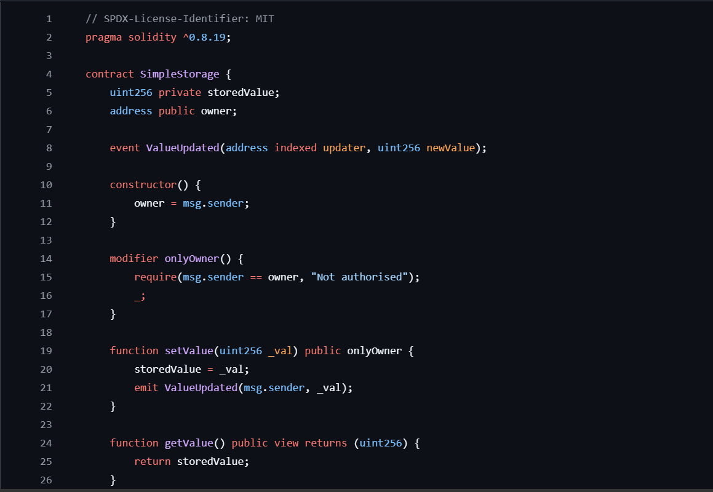

4.2 Compilation Output

4.3 Deployment Script — scripts/deploy.js
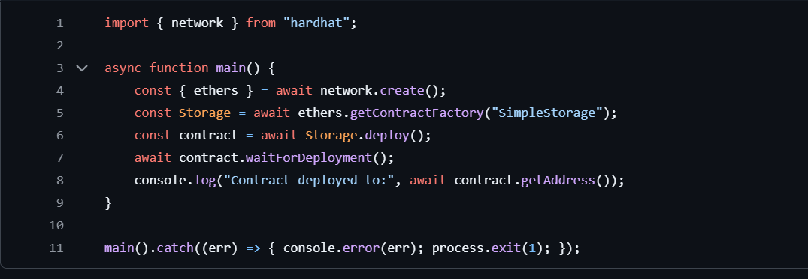

4.4 Deployment Output
With Ganache running on port 8545, the contract was deployed to the local network:

4.5 Contract Interaction via Hardhat Console
The Hardhat console was used to interact with the deployed contract. Note: the console is opened with npx hardhat console --network localhost. The ethers object is available globally in the console.
Successful Interaction (Owner Account)
Access Control Test (Non-Owner Account — Expected Failure)

4.6 Ganache Transaction Log
The Ganache terminal confirmed all transactions were mined in real time:

