**TASK 1**

1. Launch Zeus Learning Site - <https://www.zeuslearning.com/> and launch Network Tab from devtools
2. Go to Service Page(Files will load in Network tab)
3. Check the json file for the page

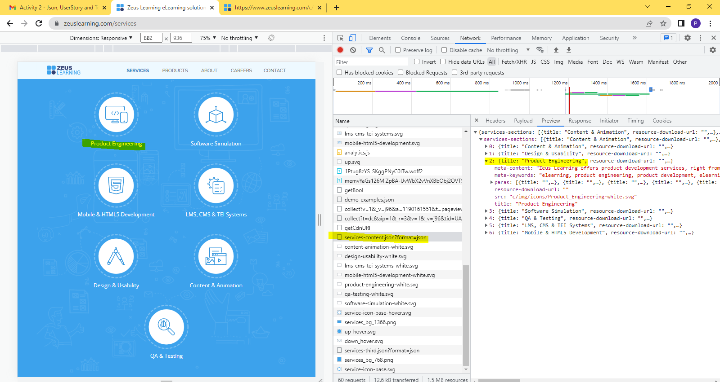

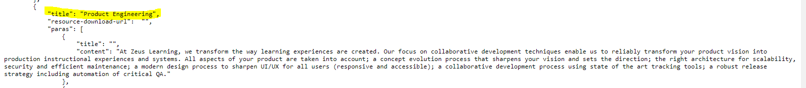

**TASK 2**

Write down the user stories sample for the Contact Us page(<https://www.zeuslearning.com/contact-us>) and note down the test data for it

**Description**

As a user, user must be able to view the name, email, phone, subject, message field and captcha. User must be able to enter data into the fields and on clicking the send button the message must be sent.

**Acceptance Criteria**

Heading must be shown as Contact us with font-color as blue and font-size 40px

Text shown below the heading must be: We would love to talk to you and explore ways in which Zeus could add value to your organization.

Text shown below the above text must be: For information on job openings or for submitting a resume, please see our Careers section. Careers section must be a link to careers page. On clicking on the careers section it must open the page in the same tab.

Different Fields

Name

E-mail Id

Phone Subject

Message

Captcha

Name

-It must be a mandatory field

-Label must be Name with a red asterisk indicating its mandatory field

-Name input field for the name must be on right

-Name input field must have blue borders on selecting the field

-Name input field must have minimum 3 alphabetical characters

-On entering less than 3 characters a warning message in red must be displayed below the input field stating “Please enter atleast 3 characters.” along with an warning icon on the left

-Name field must not allow numeric or special characters

-On entering an invalid input a warning message in red must be displayed below the input field stating “Please enter a valid name.” along with an warning icon on the left

E-mail Id

-It must be a mandatory field

-Label must be E-mail Id with a red asterisk indicating its mandatory field

-Email input field for the name must be on right

-Email input field must have blue borders on selecting the field

-Email input field must validate to check if entered text is an valid email

-On entering an invalid email address a warning message in red must be displayed below the input field stating “Please enter a valid e-mail address.” along with an warning icon on the left

Phone

-It is not a mandatory field

-Label must be Phone

-Phone input field for the name must be on right

-Phone input field must have blue borders on selecting the field

-Phone input field must validate to check if entered input is a valid phone number

-On entering an invalid phone a warning message in red must be displayed below the input field stating “Please enter a valid phone number with country code, e.g. +1-781-367-4228.” along with an warning icon on the left

Subject

-It is not a mandatory field

-Label must be Subject

-Subject input field for the name must be on right

-Subject input field must have blue borders on selecting the field

-Subject field must allow alphabets, numeric and special characters as well

Message

-It must be a mandatory field

-Label must be Message with a red asterisk indicating its mandatory field

-Message input field for the name must be on right

-Message input field must have blue borders on selecting the field

-On leaving the message field blank a warning message in red must be displayed below the input field stating “Message cannot be blank.” along with an warning icon on the left

-Message field must allow alphabets, numeric or special characters

Captcha

-It must be a mandatory field

-On not clicking on the verification checkbox a warning message in red must be displayed below the input field stating “Please complete this verification.” along with an warning icon on the left

Send Button

-If all the above criteria are met, on clicking the send button the message must be sent and an alert message must appear stating “Your message is sent” with a button to remove the alert

-In case if any criteria is not met the respective fields must be highlighted with a red border and warning message with warning icon in red font-color

**Test Data**

Name

“blank field”

Ab

12

Abcdef

Abc123

12312

Email

“blank field”

[name@email.com](mailto:name@email.com)

123

Abc

Abc123

Abc123@email.com

Phone

“blank field”

1234567890

+91-1234567890

Abc123

Abcdef

12

abc@123

Subject

“blank field”

1234567890

abc@123

abcdef

hello123

Message

“blank field”

1234567890

Message

Message1234

me

message@1234