**COURSE CODE: COMP 223, INTERNET PROGRAMMING**

**PROJECT NAME: MEASUREMENTS CONVERSION WEBSITE**

**Group Members**

**NAME REG NO PHONE NUMBER**

1. **KAGWI KAMIRI ALVIN SC/007/21 0758676248**
2. **KEVIN KIROP COM/063/21 0790104202**
3. **PRESTON MAYIEKA COM/047/21 0799078848**
4. **GABRIEL ACHOLA ANC/004/21 0713428169**
5. **BRAMWEL KHAEMBA ANC/040/21 0798920547**
6. **GRACE ADHIAMBO ANC/046/21 0706770988**

**Table of Contents**

Introduction 1

Layout 1

User manual 1

How to access the website? 1

Requirements 2

# Introduction

* This website was made for the purpose of being able to convert different Units  
  Currency, Length, Weight, from one unit to another
* It is made using HTML, CSS, and JavaScript
* HTML provides the structure
* CSS – for styling
* JavaScript – for functionality

## **Layout**

* The website uses single- column layout  
  ( the elements are organized in a vertical manner, one section after the other)

## User manual

### How to access the website?

* In order to access the website click the index.html file in the root directory or alternatively navigate to <https://measurementconversion.netlify.app/> link
* You will then be redirected to the Homepage
* 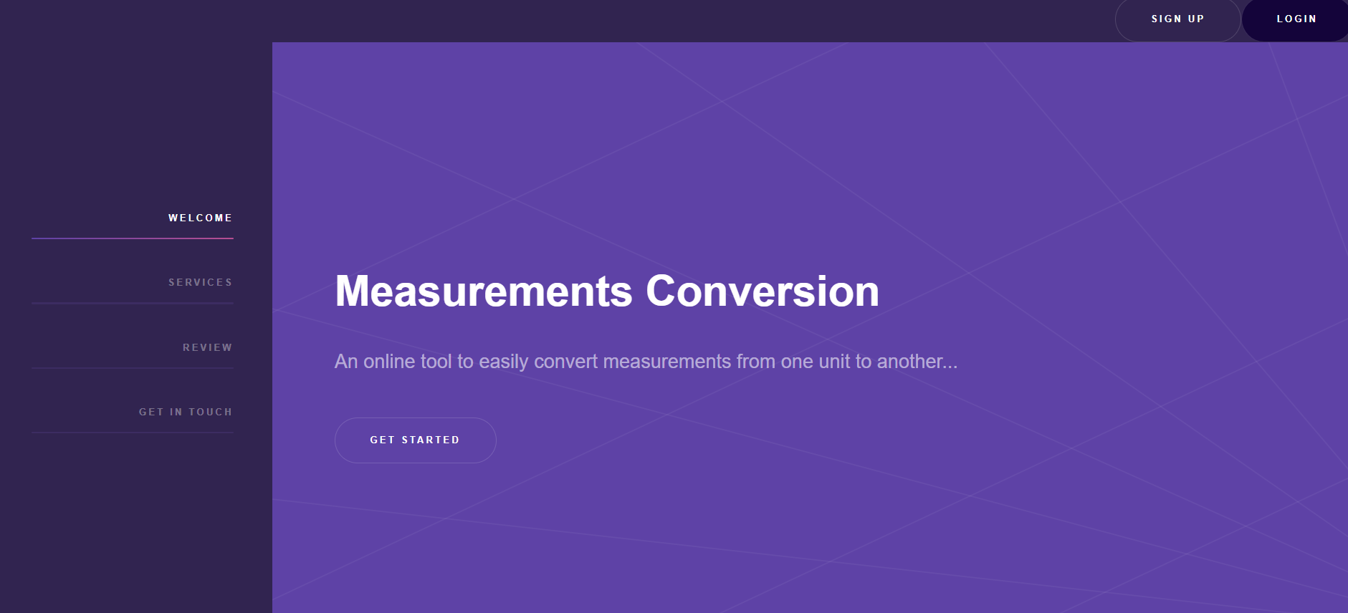

Click on the  button

From there select either **Currency**, **Length** or **Weight** and this will redirect you to the appropriate page to perform your service

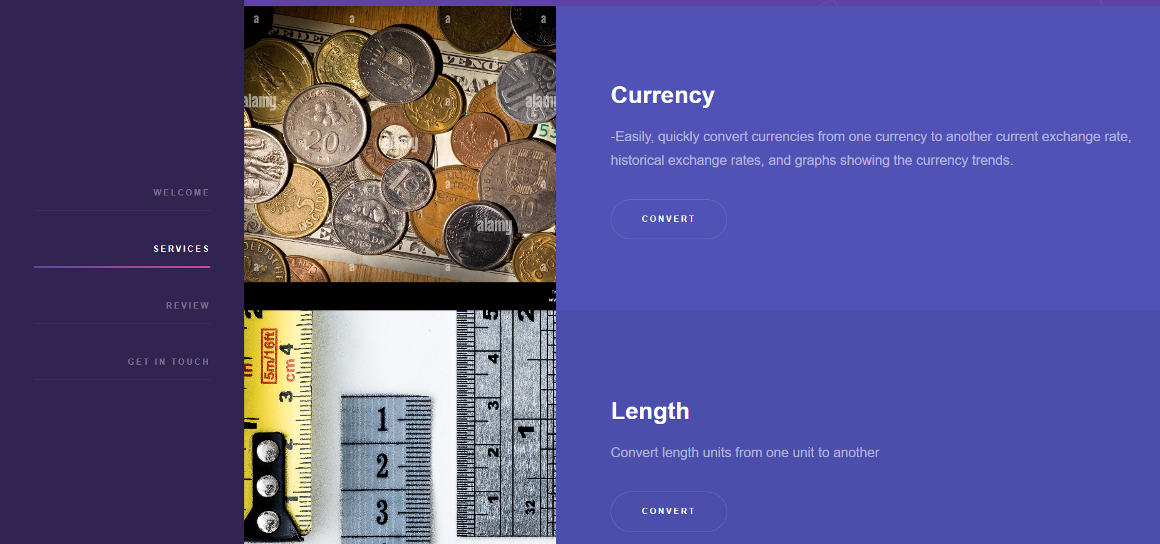

### **Requirements**

1. A web browser Google Chrome, Firefox, Microsoft Edge or any of your personal preference
2. For currency section, internet connectivity may be required to FETCH Realtime conversion rates
3. Input device (if PC then keyboard or touch input from smart device)