VOLT :::::Desktop:volt.jpg training instructions

In this lab, we study human memory, and the purpose of this experiment is to understand how people use their environment to learn that items belong together. During the training portion of the experiment, you will learn and be tested on the location of made up objects within a virtual environment.

First, we will have you experience movement within the virtual environment during a **free roam** phase. The free roam portion of the experiment is to help you feel comfortable with the computer controls and experience movement on the computer screen.

For all portions of the experiment when you’re navigating, pressing 1 will move you to the left, pressing 2 will move you straight ahead, and pressing 3 will move you to the right. You can hold two keys at once for smoother movement. Usually the best method is to hold 2 (straight) and tap 1 and 3 (left and right) as you move.

VOLT :::::Desktop:volt.jpg practice instructions

After the free roam portion, we will do **practice learning** and **practice testing** phases. During the **practice learning** phase, you will be shown a novel object within a virtual environment. You will then move yourself around the environment until you reach the location in which that object is located. When you reach this object location, the object will be shown again on the screen to confirm you found its location. You will do this four times for each object, until the object’s position is well known to you. Then you be shown a new object within the same virtual environment, and the process will be repeated until you know the location all the objects (four per environment).

Throughout the experiment you will navigate yourself around several different virtual environments. In order to be successful in learning the object locations, you should know a general overview of how the environments are setup.

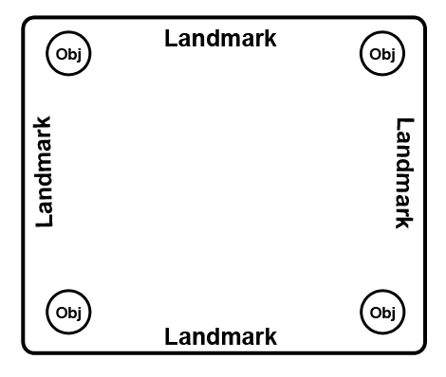

This is an aerial generalization of how each of the environments is organized. You can see that there is an arena in the center of the environment. Each object (regardless of environment) will always be in one of the four corners of the arena. It is your job to learn which objects are located in the corners of the environments. There are four unique objects located in each environment (no overlap across environments). On each side of the arena space, there will be a landmark. The landmarks may be solitary or groupings of objects. Regardless, you should use these landmarks to help you learn where the objects are located in the environments.

*Do you have any questions so far?*

After you have learned the locations of the objects in the practice environment, you will be tested on their locations. For the **practice testing** portion of the experiment, you will be shown one object on the screen within the environment in which you have learned the object is located. You will then move yourself to where you learned the object is located. Once you reach any of the object locations (correct or incorrect for that object), you will be moved on to the next object. You will not receive feedback in the testing portion.

*Do you have any questions about what I’ve explained so far before we move on to the practice?*

VOLT :::::Desktop:volt.jpg detection task instructions

The next part of the experiment I’ll explain is called the **detection task**.

In this task, you’ll see a single object presented on the screen. These pictures look like objects, but they don’t exist in the real world. The object will only be on the screen very briefly. There will be a black cross (or plus sign) superimposed on top of it.

Your job is to press a button when the cross changes color. It will turn either blue or green. If the cross turns blue, press 1. If it turns green, press 2. Try to respond as quickly and accurately as you can.

You can make your response when the object is still on the screen, or when the object has disappeared and the colored cross is on the screen alone. When the trial is over, the cross will turn black. Then, the next object will appear on the screen.

*Do you have any questions before you practice this task?*

VOLT :::::Desktop:volt.jpg navigation learning instructions

Now, we will be completing the learning and testing phases of the navigation task. These two phases will be exactly like the practice you completed earlier except that there will be new environments for you to learn new object locations. Just like in the practice, you will learn all the object locations for one environment and then be moved on to the next environment in the **learning phase**.

If you need to take a short break at any point during the learning phase, please hit the “esc” key. The game will pause. Hit the “esc” key again to start again.

Once you have learned all the object locations for the environments, you will do a short **test with feedback**. In this test, you will be shown an object on the screen within the environment in which you have learned the object is located. You will then move yourself to where you learned the object is located. Once you reach the correct object location, you will be shown the object again on the screen confirming that you are in the correct location for that object. You will then be moved on to the next object in a new environment.

It’s important that you learn the object locations relative to each other for each environment since you will jump between environments during the test. Building a “mental map” of the object locations for each environment may help you during the testing portion.

*Do you have any questions before you complete the learning phase of the experiment?*VOLT :::::Desktop:volt.jpg navigation testing instructions

In the **testing phase**, you will be tested on the object locations across all the environments in a random order. You will be shown one object on the screen within the environment in which you have learned the object is located. You will then move yourself to where you learned the object is located. Once you reach any of the object locations (correct or incorrect for that object), you will be moved on to the next object. You will not receive feedback in the testing portion. You will repeat this testing in a random order for all the objects you’ve learned across all the environments.

*Do you have any questions?*

VOLT :::::Desktop:volt.jpg detection task instructions part 2

For the last part of the experiment, there will be another **detection task**.

This detection task is exactly like the one you completed earlier. You’ll see a single object presented on the screen. The object will only be on the screen very briefly. There will be a black cross (or plus sign) superimposed on top of it.

Your job is to press a button when the cross changes color. It will turn either blue or green. If the cross turns blue, press 1. If it turns green, press 2. Try to respond as quickly and accurately as you can.

You can make your response when the object is still on the screen, or when the object has disappeared and the colored cross is on the screen alone. When the trial is over, the cross will turn black. Then, the next object will appear on the screen.

*Do you have any questions before you start this task?*