voltage :::::Desktop:volt.jpg training instructions

In this lab, we study human memory, and the purpose of this experiment is to understand how people use their environment to learn that items belong together. During the training portion of the experiment, you will learn and be tested on the location of “made up”, or novel, objects within a virtual environment. These “novel objects” look like objects, but they don’t exist in the real world.

First, we will have you experience movement within the virtual environment during a **free roam** phase. The free roam portion of the experiment is to help you feel comfortable with the computer controls and experience movement on the computer screen.

For all portions of the experiment when you’re navigating, press 1 to move to the left, press 2 to move straight ahead, and press 3 to move to the right. You can hold two keys at once for smoother movement. Usually the best method is to hold 2 (straight) and tap 1 and 3 (left and right) for continuous movement.

voltage :::::Desktop:volt.jpg practice learning instructions

We will now complete the **practice** phases, in which you will learn and be tested on object locations in the free roam environment you just experienced. During **practice learning**, you will be shown a novel object on the computer screen. Once it disappears, you will have 60 seconds to move yourself around the environment until you reach the location in which that object is located. When you reach the object’s location, the object will be shown again on the screen to confirm you found its location. You will then be shown a new object, and the process will be repeated until you know the location all the objects (four per environment).

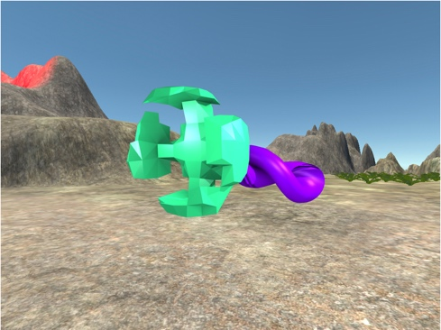

Throughout the experiment, you will be navigating through several different virtual environments. In order to be successful in learning the object locations for each environment, you should know a general overview of how the environments are setup.

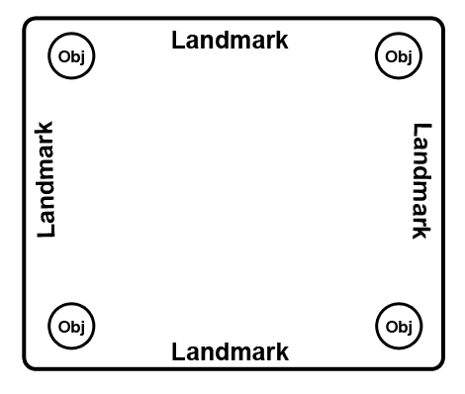

This is an aerial generalization of how each of the environments is organized. You can see that there is an arena in the center of the environment. Each object (regardless of environment) will always be in one of the four corners of the arena. It is your job to learn which objects are located in the corners of the environments. The objects are not placed in the apex of the corner, but in the arena around each of the corners (see picture above). It is important to explore around each corner thoroughly, so you can find the object if located in the corner. There are four unique objects located in each environment (no overlap). On each side of the arena space, there will be a landmark. The landmarks may be solitary or groupings of objects. Regardless, you should use these landmarks to help you learn where the objects are located in the environments.

*Do you have any questions about the practice learning?*

voltage :::::Desktop:volt.jpg practice testing instructions

After you have learned the locations of the objects in the practice environment, you will be tested on their locations. For the **practice testing** portion of the experiment, you will be shown an object on the screen within the environment you learned the object is located. You will have 20 seconds to then move yourself to where you learned the object is located. Once you reach **any** of the object locations (correct or incorrect), you will be moved on to the next object. You will not receive feedback in the testing portion.

*Do you have any questions about the practice learning?*

voltage :::::Desktop:volt.jpg detection task instructions part 1

While in the scanner, the first task we’ll have you do is called the **detection task**.

In this task, you’ll see a single object presented on the screen. The object will only be on the screen very briefly. There will be a black cross (or plus sign) superimposed on top of it.



Your job is to press a button when the cross changes color. It will turn either blue or green. If the cross turns blue, press 1. If it turns green, press 2.

Try to respond as quickly and accurately as you can. You can make your response when the object is still on the screen, or when the object has disappeared and the colored cross is on the screen alone. When the trial is over, the cross will turn black. Then, the next object will appear on the screen.

In the scanner, there will be four runs of the detection task.

*Do you have any questions before you practice this task?*

voltage :::::Desktop:volt.jpg navigation learning instructions

Now, we will be completing the learning phase of the navigation task. This phase will be similar to the practice you completed earlier except that there will be new environments for you to learn new object locations. In the **learning phase**, you will learn an object’s location in one environment and then be moved on to a different object in different environment (six repetitions per object total, two per run). There are six environments total.

It’s very important that you learn the object locations for each environment relative to each other since you will be jumping between environments. It may be helpful to associate an object’s location with the landmarks present in the environment (“the green blob is located to the right of the purple bushes” or your own helpful narrative), *but also with the other objects you learn are located in the environment*. Building a “mental map” of the object locations for each environment will help you during the testing portion.

There will be three runs for the learning phase.

*Do you have any questions before you complete the learning phase of the experiment?*voltage :::::Desktop:volt.jpg navigation testing instructions

You will now be tested on the object locations across all the environments in a random order. Similar to the practice test, you will be shown an object on the screen within the environment in which you have learned the object is located. You will then move yourself to where you learned the object is located. Once you reach any of the object locations (correct or incorrect for that object), you will be moved on to a different object from a different environment. You will not receive feedback in the testing portion. You will repeat this testing in a random order for all the objects you’ve learned across all the environments.

*Do you have any questions?*

voltage :::::Desktop:volt.jpg detection task instructions part 2

Now, we’re going to have you go back in the scanner, and we’re going to do another **detection task**.

In this task, you’ll see a single object presented on the screen. The object will only be on the screen very briefly. There will be a black cross (or plus sign) superimposed on top of it.



Your job is to press a button when the cross changes color. It will turn either blue or green. If the cross turns blue, press 1. If it turns green, press 2.

Try to respond as quickly and accurately as you can. You can make your response when the object is still on the screen, or when the object has disappeared and the colored cross is on the screen alone. When the trial is over, the cross will turn black. Then, the next object will appear on the screen.

In the scanner, there will be four runs of the detection task.