Homework #10 – Chapter 4 Part 1 – Processor Architecture
ECEN 324 - Brother Jones

Practice Problem 4.14 (10)

Fill in the right-hand column of the following table to describe the processing of the popq instruction on line 7 of the object code in Figure 4.17 (shown here).

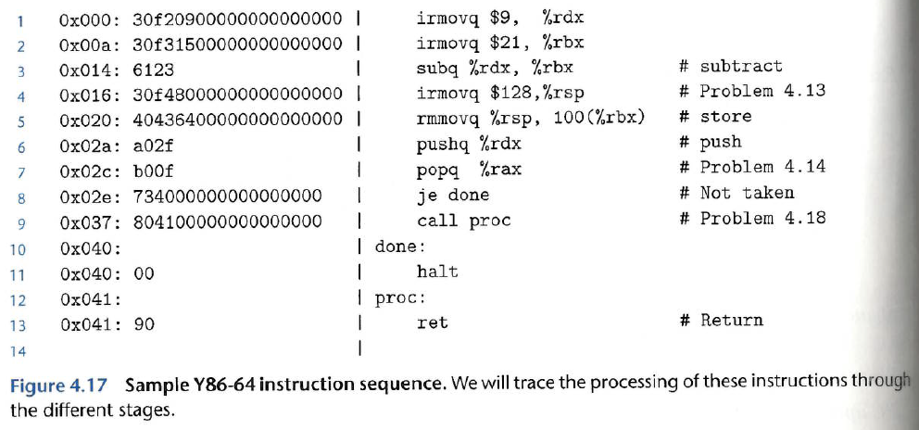

Generic Specific
Stage | popq, rA | popq %rax
Fetch | icode:ifun ← M₁[PC]  rA:rB ← M₁[PC + 1]  valP ← PC + 2 | icode:ifun <- M1[0x2c] = oif  rA:rB <- M1[0x2d]=0x02  valP<-0x2c+2=0x2e
Decode | valA ← R[%esp]  valB ← R[%esp] | valA<-R[%rsp]=120  valB<-R[%rsp]=120
Execute | valE ← valB + 8 | vale<-120+8=128
Memory | valM ← M₈[valA] | valM<-M8[120]=9
Write back | R[%esp] ← valE  R[rA] ← valM | R[%rsp]<-128  R[%rax]<-9
PC update | PC ← valP | 0x2c

Problem 4.51 (12)

In our example Y86-64 programs, such as the Sum function shown in Figure 4.8, we encounter many cases in which we want to add a constant value to a register. This requires first using an irmovq instruction to set a register to the constant, and then an addq instruction to add this value to the destination register. Suppose we want to add a new instruction iaddq with the following format:

Byte 0 1 2 3 4 5 6 7 8 9
iaddl V, rB
C | 0 | F | rB | V

This instruction adds the constant value V to register rB. Describe the computations performed to implement this instruction. Use the computations for irmovq and OP1 (Figure 4.16 as a guide)

Figure 4.16

Stage | op1 rA, rB | rrmovq rA, rB | irmovq V, rB
Fetch | icode:ifun ← M₁[PC]  rA:rB ← M₁[PC + 1]  valP ← PC + 2 | icode:ifun ← M₁[PC]  rA:rB ← M₁[PC + 1]  valP ← PC + 2 | icode:ifun ← M₁[PC]  rA:rB ← M₁[PC + 1]  valC ← M₈[PC + 2]  valP ← PC + 10
Decode | valA ← R[rA]  valB ← R[rB] | valA ← R[rA]
Execute | valE ← valB OP valA  Set CC | valE ← 0 + valA | valE ← 0 + valC
Memory
Write back | R[rB] ← valE | R[rB] ← valE | R[rB] ← valE
PC update | PC ← valP | PC ← valP | PC ← valP

Stage | iaddl V, rB
Fetch | icode:ifun<-Mi[PC]  rA:rB<-M1[PC+1]  valC<-M8[PC+2]
Decode | valA<-R[rB]
Execute
Memory
Write back
PC update

