**Day1: [27-03-2021] :**

1.Downloading Windows server 2012.

2.Booting it up on a VM.

3.Initial Walkthorugh on ServerManager startup software.

**Day2: [28-03-2021] :**

1.Making IP address of the server as static to function it as domain controller:

* In server manager goto local server then choose Ethernet from properties.
* A pop up will appear right click on the connection you want to make it as static.
* Choose status and on the popup choose details.
* Note down the ipv4 ,subnet mask ,default gateway and dns server address.

**Domain Controller:**

A **domain controller** (**DC**) is a [server computer](https://en.wikipedia.org/wiki/Server_(computing))[[1]](https://en.wikipedia.org/wiki/Domain_controller#cite_note-DomainControllerRoles-1)[[2]](https://en.wikipedia.org/wiki/Domain_controller#cite_note-2) that responds to security authentication requests within a computer [network domain](https://en.wikipedia.org/wiki/Network_domain). It is a [network](https://en.wikipedia.org/wiki/Network_(computing)) server that is responsible for allowing [host](https://en.wikipedia.org/wiki/Host_(network)) access to domain resources. It authenticates users, stores user account information and enforces [security policy](https://en.wikipedia.org/wiki/Security_policy) for a domain.[[3]](https://en.wikipedia.org/wiki/Domain_controller#cite_note-3) It is most commonly implemented in [Microsoft Windows](https://en.wikipedia.org/wiki/Microsoft_Windows) environments (see [Domain controller (Windows)](https://en.wikipedia.org/wiki/Domain_controller_(Windows))), where it is the centerpiece of the Windows [Active Directory](https://en.wikipedia.org/wiki/Active_Directory) service. However, non-Windows domain controllers can be established via [identity management](https://en.wikipedia.org/wiki/Identity_management) software such as [Samba](https://en.wikipedia.org/wiki/Samba_(software)) and [Red Hat](https://en.wikipedia.org/wiki/Red_Hat) [FreeIPA](https://en.wikipedia.org/wiki/FreeIPA" \o "FreeIPA).

2.Configuring Active Directory Services Roles:

In server manager click dashboard,choose add roles and features.A pop up will appear click next.

Choose Role based or feature based installation.

Select the desired servers you want to install this feature from the list of server pools.Click next.

In server roles,choose active directory domain services.

In Features ,you can add Group policy Management.

Click next ->next->install.

Once installation is done…..choose promote this server to a domain controller.

Choose Add a new forest.

Type a desired domain name……use ones that doesn’t belong to the internet.

Else computers connected within the local network might not be able to access the domain.

Good practice while testing is that use <domainname>.local.

Domain name ending with .local doesn’t resolve to a world wide web one.

Click next,in the next step choose forest functional level windows os version.

Forest => Set of server computers connected to the particular domain controller is called a forest.

Forest functional level version is the minimum server os version installed on a single server that is present in the forest.

Example consider if n servers are there in a forest and m servers use windows server os 2016 , k servers use windows server os 2012,and only one server use windows server os 2008 where (m+k+1=n) .In that case forest functional level is windows server os 2008.

Imagine you have upgraded that one server in the forest from windows server os 2008 to 2012 then now m servers will use 2016 and t(l+1) servers use 2012.Now the forest functional level will become windows server os 2012.

Domain functional level is the server os version of that particular server on which the configuration is going on.

Under domain controller capabilities….you could see one option called **Global Catalog(GC).**

**Global Catalog(GC) =>** A list of records that contains information about the resources present in the server and acts as advertising to the other domain controllers that is trying to use the server.

Type a DSRM password:

Skip DNS delegation option.

Leave the net BIOS domain name as default.

NetBIOS Domain name: is the first part of the root domain name that we set.

Next step is specifying the Active Domain Directory Services Database folder,Logs folder and SYSVOL folder.In most cases the default works fine.

Next review preview tab will show a preview of whatever the options that we have choosen.

Once you have done with the review click next.

Next a pre-requisite step will be done where the server is checked to be a valid server to serve as a domain controller.

After rebooting goto tools under server manager.

Consider this one as example of our organizational needs.

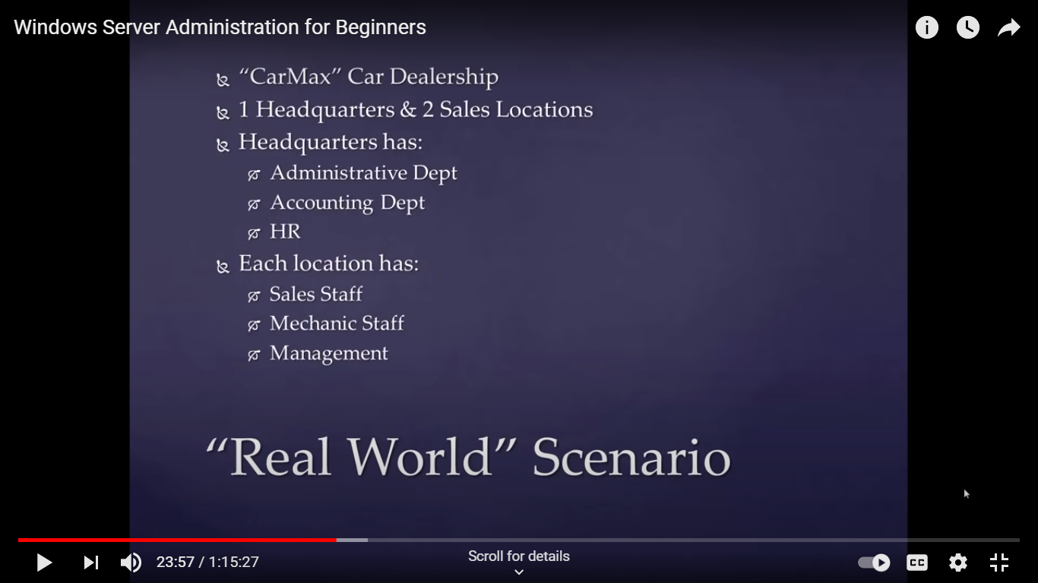

Choose Active Directory Users and Computers.

Choose the domain name that you have created from the left menu list.

Right click somewhere in the middle and choose new -> organizational unit.

Type the name of that organizational unit and click ok.

Follow the above steps and create three organizational unit like this.

1.Headquarters.

2.CM East.

3.CM West.

The two main objects that are the parts of the Organizational Unit is a user and a computer.

To distinguish between the two under each OU consider defining a separate OU under that OU.

For computers you can define a OU like this under root OU “computers - <OU>”